Cover page 1

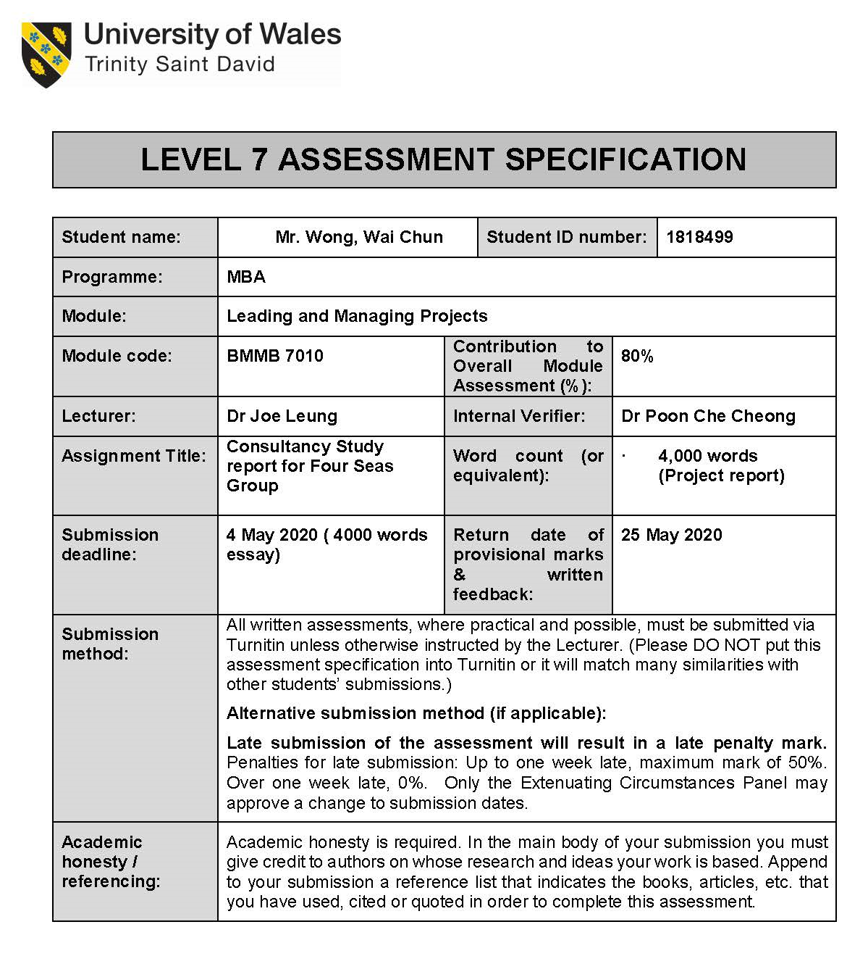

Cover page 2
Consultancy Study report  for Four Seas Group | 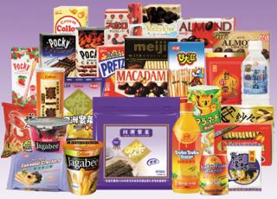

Executive summary
Based on the project initiation document (PID) of the Four Seas Mercantile Holdings Limited (we use “the Group” thereafter),
This report is feasibility study (Justis & Kreigsmann, 1979) to analyses the historical performance of Four Seas Mercantile Holdings Limited (or Four Seas Group) and describes the projected additional sales and profitability in coming three years though establishing the sales office and distribution centre in Malaysia.
It uses PESTLE (Political, Economic, Sociological, Technological, Legal and Environmental) framework to evaluate the factors of macro environment (Perera, 2017) that are influencing the Group to enter Malaysia market.
Furthermore, it provides critical success factors (CSF) in internal analysis (SWOT) that suggests the entry market strategies of the Group and then gives conclusion with recommendation to implement.
Along with this, this report provides three years project plan with its budget planning, revenue target, activities, related department and person in charge to achieve success the project.

Table of Contents
Cover page 1 i
Cover page 2 ii
Executive summary iii
Table of Contents iv
1. Introduction 1
2. Background of the Group 2
3. Marco Environmental (PESTLE) analysis 6
3.1. Political factor 6
3.2. Economic factor 6
3.3. Social factor 9
3.4. Technological factor 11
3.5. Legal factor 12
3.6. Environmental factor 12
4. Micro Environmental analysis and Critical success factors 13
5. Conclusion and recommendation 16
6. Implementation plan 20
Reference 23
Appendix 29

Introduction
Four Seas Mercantile Holdings Limited (we use “the Group” thereafter) is one of the famous food sector organisations of Hong Kong. From 2017 to 2019, the total revenues of the Group were slow growth and the new lowest profit attributable to the Group were recorded in 2019. Currently the organisation is facing different challenges such as lack of global presence and high level of competition. This report is suggested to the Group to adopt oversea market and product development strategies for revenue and profit growth in coming years.

Background of the Group
The Group was established in 1971, it trades and manufactures about confectionery, snack foods, frozen food and beverages products etc. (FMSL, 2019, pp6-8).
Table 1: The revenue of the Group in 2017 to 2019.
Products | Year 2017 Sales amount of major items | Year 2018 Sales amount of major items | Year 2019 Sales amount of major items
Products | Sale revenue (HK$M) and (% of total Sales)
Snacks | 1,249.561 | 1,270.89 | 1,301.81
 | (42.38%)* | (42%)* | (43%)*
Confectionery | 568.786 | 569.076 | 582.269
 | (19.29%)* | (18.95%)* | (19.22%)*
Ham and Sausage | 372.623 | 364.627 | 369.125
 | (12.64%)* | (12.14%)* | (12.19%)*
Beverage and dairy products | 235.076 | 264.281 | 223.01
 | (7.97%)* | (8.80%)* | (7.36%)*
Food materials/ ingredients | 227.505 | 222.408 | 235.048
 | (7.72%)* | (7.41%)* | (7.76%)*
Other | 294.738 | 311.155 | 317.724
 | (10.00%)* | (10.36%)* | (10.49%)*
Total | 2,948.289 | 3,002.437 | 3,028.987
 | (100%)* | (100%)* | (100%)*
Profit attributable to equity holders  of the Company | 50.274 | 347.703 | 30.161¹
Stock share price² (Adj Close HKD at year end) | 3.271 | 3.797 | 3.300
Note*: Figures in parentheses are “percent of total sales revenue” expressed in percentages.
Note ¹: The profit attributable to equity holders of the Group for the year was HK$30,161,000 (2018: HK$347,703,000) because of the absence of the one-off gain on the completion of the disposal of a property in 2018.
Note ²: See appendix 1 to 3.
Source: FMSL, 2018 and 2019, pp17-18 and p136.
In table 1, the total revenue of the Group was recorded HKD 2,948,289 in 2017, HKD 3,002,437 in 2018 and HKD 3,028,987 in 2019 (FSML, 2019, p24). The new lowest profit amount was recorded HKD 30,161,000 in 2019 comparing previous years in 2017 and 2018. The snacks and confectionery contributed more than 60% of sale revenue to the Group during 2017 to 2019 (FMSL, 2019, p.18). The stock share price at year end of the Group was declined from HKD 3.797 in 2018 to HKD3.3 in 2019 because some shareholders or investors had dissatisfied its performance due to declined profit attributable to equity holders of the Group in year 2019(FSML, 2019, p17).
Therefore, this report is suggested the Group to establish new company with merging oversea local distribution company in Malaysia that promotes its snacks and confectionery items to create growth with the sales of international market. For this project, the Group will be targeted to gain more revenue, profit and raise its stock price in coming years.

Background of chosen country.

The distance from Hong Kong to the Kuala Lumpur (the capital of Malaysia is about 2,541 kilometres (1,579 miles) in image 1(Airmilescalculator, 2020). Malaysia is becoming a lead among the emerging markets of Southeast Asia. As the populations of Malaysia has approximate 32.6million in 2019 (Department of statistics, Malaysia, 2019), it has flourished in retail modernization and mature consumers, especially compared with many Association of Southeast Asian Nations (or ASEAN) peers such as Vietnam, Indonesia, Myanmer, Cambodia etc.(HKTDC,2014). The Group may benefit to do business due to its transparent business environment, credibility and flexibility.

Image 1: The map of Hong Kong and Malaysia.
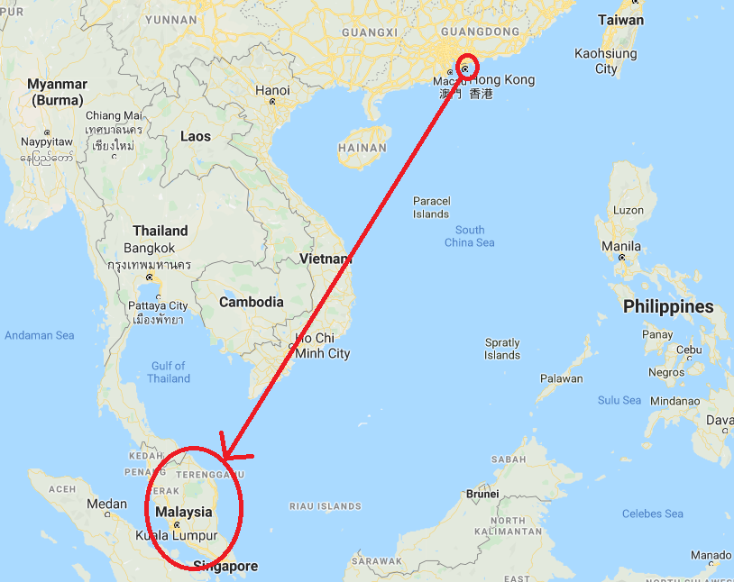
Source: Google maps, 2020.

The reason of expand business in new developing market like Malaysia as shown on below table.

Table 2: Ease of doing business (EDOB) comparison.
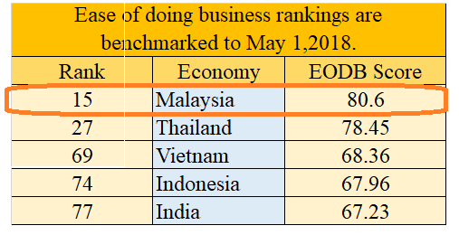
Source: World Bank Group, 2019.

The reason of chosen country is Malaysia because World bank group (2019) was benchmarked that ease of doing business rankings (EDOB) were Malaysia at 15 with score 80.60; Thailand at 27 with score 78.45; Vietnam at 69 with score 68.36; Indonesia at 74 with score 67.96 and India at 77 with 67.23 implied that Malaysia has seen more business-friendly than other Asian Markets.
In Figure 1, the statista(2020) reported that the sales value of manufactured snack products in Malaysia were recorded from RM830.86 million in 2015 to RM 1281.69million in 2018 that the amounts were increased year on year.

Figure 1: Sales value of manufactured snack products in Malaysia from 2015 to 2018 (In million Malaysian ringgit).
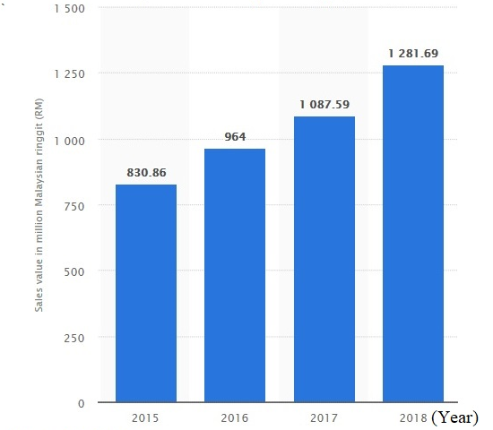
Source: Statista, 2020.
Furthermore, Imposes forecasts that snack industry will grow at a strong ccompound annual growth rate (CAGR) approximately 10.76% from 2018 to 2022 (HKEXnews,2019).

Marco Environmental (PESTLE) analysis
The Political, Economic, Social, Technological, Environmental and Legal (PESTLE) analysis (Perera, 2017) that are used to identify the macro environmental factors of Malaysia facing to the Group.

Political factor
Malaysia is political stable country and is leader within Association of Southeast Asian Nations (ASEAN) member and the organization of the Islamic conference (or OIC) (Pero, 2020). In formulating and implementing its foreign policy, it follows the principles of peace and neutrality.
Political factor involves the government regulated area such as trade tariff, taxation, conflict among countries related to trade restriction, fiscal policies etc. In 2019, Malaysia and other ASEAN members have agreed to reduce their trade tariff and taxation with a clear and step-step tariff reduction schedule on the goods originating from Hong Kong (HKTDC, 2019).
Refer to the Transparency International Corruption Perception Index (CPI) reported that Malaysia ranked 51st out of 180 countries in 2019, it showed that Malaysia was far lower than Hong Kong but it is still slightly higher than the Southeast Asian average (CPI, 2019). Therefore, Malaysia is business friendly and reducing its trade restriction for Hong Kong and China products exporting.

Economic factor
The real gross domestic product changed percentage is used to compare the macroeconomic statistic of Hong Kong, Malaysia and world average during 2010 to 2019 in figure 2 and table 3 as below.

Source: International Monetary Fund, 2020.

According to the data of International Monetary Fund, although the percentage of gross domestic product changed was decreased in Malaysia from 7.5% in 2010 to 4.5% in 2019 that was still higher than Hong Kong from 6.8% in 2010 to 0.3% in 2019 and World average from 5.4 in 2010 to 3.0 in 2019. Furthermore, the average of real gross product annual percent changed from 2010 to 2019 was calculated in Table 3.

Table 3: The average real gross domestic product changed percentage during year 2010 to 2019.
Source: International Monetary Fund, 2020.
The past 10 years average real gross domestic products of Malaysia was calculated in table 3 that is higher that Hong Kong and World average. Therefore, the Group may benefit to entry Malaysia because Malaysia had higher total spending including government spending, industry spending, total consumer spending and excess of exports over imports due to overall level of price changed in the economy.

Figure 3: Gross domestic product (GDP) per capita of Malaysia during year 2017 to 2020.

Note *: IMF staff estimated the GDP (PPP) data of the year 2019 and 2020.
Source: International Monetary Fund, 2019.

The gross domestic product (GDP) of Malaysia was increasing from US$358.58 billion in 2018 to US$365.3 billion in 2019. In figure 3, the gross domestic product per capita (at purchasing power parity) was recorded US$9960.323 in 2017 and US$11072.387 in 2018 and was estimated to increase by year on year from US$11136.812 in 2019 to US$ 11484.505 in 2020. (International Monetary Fund, 2019). It implied that Malaysia has a healthy economy and indicated the living standards of the country was increasing year on year.

As of Jan 2020, the unemployment rate in Malaysia was 3.2% (Ceicdata, 2020). It implied that Malaysia’s economy is strong and is moving towards from middle income to high income status.

Since 2019, the customs of Thailand, Malaysia and Philippines and Thailand will be exempted their 85% tariff lines within ten years and also decrease about another 10% on their customs duties of their tariff lines within fourteen years (HKTDC, 2019).

Malaysia received foreign direct investment (FDI) which was increasing from RM32.65billion in 2018 to RM 32.76 billion in 2019 (Tradingeconmics, 2020). The amounts of FDI were the highest FDI inflow in Malaysia because some China and Hong Kong factories were moving to Malaysia for cheaper operation costs and also avoid US-China trade war (Yean et al, 2019).

Social factor
The social factors are influencing the Group to entry strategies by looking at their language, population, religious and lifestyle.
Their official languages of Malaysia are Malay and also free to use English, Chinese, Tamil and Mandarin (Department of Information, Malaysia, 2016).

Figure 4: Current Malaysia population in 2018 and estimates in 2019.
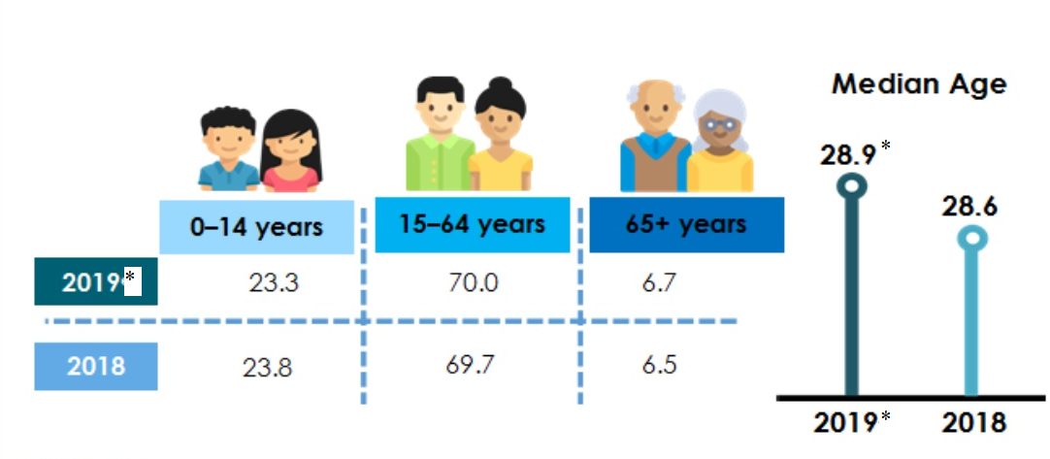
Note *: Estimates population of 2019.
Source: Department of statistics, Malaysia, 2019.

During 2018 and 2019, the composition of Malaysia population had 0 to 14 years old (young age) decreased from 23.8% to 23.3%, 15 to 64 years old (Working age) increased from 69.7% to 70% and over 65 year old (Old age) increased 6.5% to 6.5%. The median rose from 28.6 in year 2018 to 28.9 years old in year 2019. Malaysia has large population of working age and median will be expected to reach 30 years old in 2020 only.

It implied that Malaysia is younger age population market comparing to the median 45.6 years of Hong Kong (CIA, 2018). The Group may benefit to expand operation by its younger workers.
Chart 1: The percentage distribution of the population by religion, Malaysia in 2010.
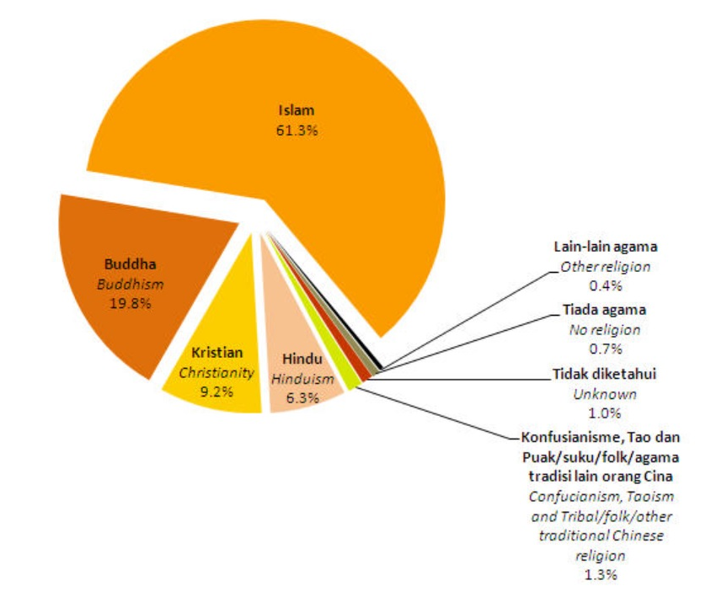
Source: Department of statistics, Malaysia, 2010.

In Chart 1, the main religion in Malaysia is Islam which has around 61.3% of the total population and 19.8% are belongs to Buddhism in 2019 (Shah, 2019). The Islam/Muslim religion is not allowed to eat foods that are not “Halal” because Halal means “permissible” in Arabic. According to Islamic law, its religion people needs to consume the Halal Food and beverage that cannot contains not hygienic ingredient such as dead animal meal, pig or pork meat etc. Islam people believes that eating halal food can prevent a person from punishment in the hereafter (Armanios & Ergene, 2018).

Image 2: Halal Logo.

Source: Department of Islamic development Malaysia, 2019.

Therefore, the Group also needs to provide the products with halal standard and Halal certification (Department of Islamic development, Malaysia, 2019). The products are required to put the logo in image 2 that will be also export to other Muslim population from other neighbouring countries such as India or Vietnam.

Malaysian has rich cultural life comparing with other upper-middle-income countries because they have the almost free health care, lower national income tax, the social welfare system, the low cost of local food and fuel.

Technological factor
Malaysia has about 80% of residents using internet, mobile networks and digital social media such as Facebook, Instagram, and YouTube etc. (Kumar 2019). It may be a good place for international technology companies such as HP, IBM, Cisco etc. because it has IT infrastructure and skilled labour. The Group can use social media or on line shopping to approach customers.

Legal factor
Malaysia is mainly a common law country with an independent Islamic law system.
Food regulation and safety standards are the major areas affected by law in Malaysia (Devadason, Govindaraju & Tuck Cheong, 2016)).The Group can meet its standard because it has high level hygiene production.
Since 2017, ASEAN and Hong Kong signed the Investment agreement and Free Trade Agreement (FTA). Malaysia and Hong Kong signed agreement a joint declaration on strengthening economic cooperation on 1 December 2009 (TID, 2020) that can increase the trade and investment flows between the two countries. These provide new opportunities for the Group to promote revenue growth in the long run.

Environmental factor
The challenges facing Malaysia are climate-related natural disasters, river and air pollution, increasing carbon dioxide emissions and excessive waste generation that may not affected to the Group because their products are produced in China and Hong Kong.

Overall of PESTLE analysis finds that the Group has great opportunity to expand business in Malaysia due to snack market size increasing, stable country policy; larger population than Hong Kong; bigger economic size than Hong Kong and Free Trade Agreement (FTA) advantage on the products of Hong Kong or China.

4. Micro Environmental analysis and Critical success factors
The micro environment analysis tool is used to determine all the strengths, weaknesses, opportunities and threats (SWOT) factors of the Group to entry Malaysia that will guides to figure out the critical success factors (CSFs) affecting the business in favourable or adverse manner (Gürel & Tat,2017) as follows:

Table 4: SWOT analysis and critical success factors to the Group
 | Threats:  - Stiff competition in local brands such as Nestle, Hup Seng Perusahaan Makanan and Munchy (SEBSEAM, 2015).  - Currency risks will influence to set pricing and profitability to Group. (Gherasim and Gherasim, 2019).  - Large Muslim pollution needs halal certificated products.  - High non-resident corporate tax rate at 24%. | Opportunities:  - Attract their health conscious consumers by introducing healthier based snack products.  - Launch products to target retailers such as Dairy Farm Group, Mydin Mohamed Holdings, Trendcell, Village, Grocer Holdings, and AEON Group (USDA,2019)  - With the innovation of upcoming technology and new taste, the group may new pricing strategies in new market such as Malaysia or other ASEAN Market...  (To be continued).
Source: From this research.
Weaknesses:  - Competition with similar products.  - Controversies in different countries of operation.  - Lacks halal certificated products.  - Different official language. | CSFs:  W1-T1: Provide a wide range of products different to competitors.  W2-T2: Make currency forward contract to hedge currency risk (Bash et al, 2018).  W3-T3: Apply halal certificated on their products in Hong Kong Muslim’s organisation.  W4-T4: Hire local consultant for better communication and merge local company to reduce tax rate from 24% to 19% (Inland Revenue Board of Malaysia, 2016). | CSFs:  W1-O1: The Group can provide its products differentiation from its competitors by more natural and healthier ingredients.  W2-W3-O2: Merge experienced local company to use its distribution channels to approach local retailers.  W3-O3: Provides old or new products with Halal certification for new market.
Strengths:  - Have high level hygiene production, good in resource and development of production to provide many differential of good products.  - High brand loyalty.  - Resource and development facilitates product innovation continuously. | CSFs:  S1-T1: Provide a high standard products differentiation to competitors and gain competitive advantage.  S1-S2-T2-T4: The Group has high quality differential products and brand loyalty for increase in the price of products.  S3-T3: All new product innovation should meet Halal requirement. | CSFs:  S1-O1: The high quality and differential healthy products help attract their health conscious consumers.  S2-O2: High brand loyalty can attract its retailers to accept.  S3-O3: Product innovation of new taste is able to set new pricing strategies in new market.
Source: From this research.

In table 4, the critical success factors in SWOT analysis found that although the group will facing stiff competition, currency risk, and different culture and higher cooperate tax in Malaysia, it should provide the products with differentiation from local competitors (Nestle, Hup Seng Perusahaan Makanan and Munchy etc.). These products will can be used more natural and healthier ingredients in order to meet the main market segment that large Muslim pollution needs halal certificated products. The entry strategies will be suggested to employ the experienced consultant and merge the local experienced food distribution company that can use its ready distribution channels for quick approaching to local retailers. The Group merges with local residence small medium enterprise that benefit to reduce the cooperation tax from 24% to 19% (Inland Revenue Board of Malaysia, 2016).

5. Conclusion and recommendation
The conclusion of the PESTLE and critical success factors in SWOT analysis find that Malaysia will have less trade restriction than other ASEAN markets and is a potential market for the Group to entry. It is recommended to export its differentiation products direct to new subsidiary local company to launch their goods. The Group should set up local website for advertisement and on line shipping to gain more revenue and profit.
The position of products are that natural and healthier of ingredients are reducing fat, less salty, less sweet and more functional food additives that will be set a little higher price. These differentiation snack and confectionery products will avoid direct competition with local product. These products should be certified by halal that will target to the segment who are genderless, not age limit, medium high income and health conscious (Lau, 2019).It is recommended to apply Halal approval on their products in Hong Kong by the Incorporated Trustees of the Islamic community fund of Hong Kong (Islamictrusthk,2020).

To minimize currency risk, the Group have to arrange a currency forward contract that allows the Group to lock in the price they pay for a currency to hedge currency risk (Bash et al, 2018).
These practices help the Group to have globalize branding and increase profitable business. As result, it creates value for stakeholders that are meet their customers’ needs, meets most customer needs, increase revenue and raises stock price for shareholders etc.
By adopting this, the Group is recommended to set up project team members and also hire local consultant such as Quantum consulting services (Quantum, 2019) or other experienced consultant to help dealing with merging local distributor. The consultant would help the Group to identify any issues from misunderstand their laws, different cultures, different official languages and tax tariff of Malaysia (Schuster and Holtbrügge,2017).The consultant may help the Group to solve some local issues and saving time to implement the merging plan (McKay,2016).
On the other hand, the advantage of new merge with experienced local distributor can help the group to understand their business culture, custom clearance, food regulations and tariff issues in order to operate effectively and also avoid any local issues (Jethu-Ramsoedh & Hendrickx, 2019). Therefore, it is recommended local distributor such as First Food Distribution (M) Sdn Bhd located at 47610 Subang Jaya, Selangor, Malaysia (First Food, 2020) or other experienced distributor company. The experienced local distributor has well developed distribution networks that helps the Group to launch the products into its local retailers such as Aeon Group, Dairy Farm Group, MYdin Mohamed Holdings, Grocer Holdings, Trendcell and village (USDA, 2019).

According to the profit for the year 2019 of the Group was HKD 37,944,000 (FSML,2019,p77), it is recommended to do self-franchising amount HKD10,000,000.and direct export to the new subsidiary joint venture company that will have better control market, easier decision making, tax reduction and fast approaching to local retailers. The budgeting, Sale forecasting and implementation planning of new subsidiary company has been estimated as below:

Table 5: Budget planning during years 2020 to 2022 (in HK$).
Source: From this research.

In table 5. the labour, rent, advertising, utilities, Mergers and acquisitions (M&A) cost and other expenses of capital requirement has been determined funding of around HKD7,550,000 in the first year. The total budget of investment has been estimated about HKD 10,000,000 within first three years. These investment will be forecasted to gain the sales and profit or loss in table 6.

Table 6: Sales, profit and loss forecast in new Malaysia (in HK$).
Profit/Loss= Sales – Investment and expenditure – costs of goods.
Profit/Loss (After tax) = “No tax on loss or break-even” or “Accumulated profit * (1- 0.19)”.
Source: From this research.
On 2020 of first fiscal year will be estimated to have minus profit about HKD 4 million+ that will be carry forwarded on next year opening balance and will be targeted break-even on “profit or loss” on fiscal year 2021. The targeted of additional sales will be increased about 10% of year 2019 total revenue that amount will be estimated about HKD 30,300,000 in 2022 and the amount of accumulated profit after tax will be targeted about HKD 8,804,700 in 2022 at the end of 2022 year and HKD 11,866,500 at end of 2023 year. The depreciation of equipment will be delayed in five years later. Under this plan, the Group will facing slow cash flow on first two years and targets to gain net profit on third year. These returns of investment will be estimated in table 7.

Table 7: The estimated return of investment (ROI) at each fiscal year-end.
Source: From this research.

In table 7, the return of investment (ROI) percentage is estimated about 88% at the fiscal year 2022 and 105% at the fiscal year 2023 that are the high ratio between total investment budget and accumulated profit. The Group will gain of total investment that compares favourably to its total costs. The back pay period of the project will target to occur on forth fiscal year. Therefore, the project is favourable to the Group.
As result, these project will benefits to the stakeholders which the business expansion and product development of Four Seas Mercantile Holdings Limited will be beneficial for all the stakeholders. Major benefits for them are listed below:

- The development of business will help the investors to increase possibility of getting higher returns on their monetary resources (Hughes et al, 2019).
- With the help of expansion and development of Four Seas Mercantile Holdings Limited the customers will be able to get good quality products which will satisfy their needs (Fuller, 2016).
- It will be beneficial for suppliers also because their supply will be increased when the organisation will expand its business (La Rocca et al, 2019).
- The shareholders or investors will also get benefited with the development strategies of the enterprise because with the higher growth of the company they will be able to get their money back in less time with lower possibility of bad debts (Hughes et al, 2019).
- The merger & acquisition of consultant provides past accomplishments to advise the shareholders to prevent some issues of local Legal or culture (Sahir & Brutus,2018).
- The local distribution partner and local retailers can gain the revenue by the Group’s quality products (Ortíz Soto & Orengo Serra, 2019).
By adopting this, it is recommended to form project team and implementation plan.

6. Implementation plan
The each transactional leadership will help for the development of the improved activities of the planning management and integration (Tiwari & Kumar Sharma, 2017).
Table 8: The task and transactional leader.
Task | Transactional leader | By when
Finding the data of emerging markets and formulating plan. | Project team manager and consultant. | Starting of the project
Determining new and unique changes that could be brought in existing products. | Marketing team | While planning for product development
Review and approve the plans for future. | Board of directors | When deciding for expansion
Hiring experienced staffs and consultants. | Human resource manager | While expansion
Determining cost of expansion and development. | Finance manager | While allocating funds
Finding local distributors in the new country. | Marketing team | While planning for expanding business in new country
Review the local food requirements and meet their requirement. | Research and development term | When expanding business in new country
Forming strategies for market research. | Marketing team | When deciding for launching new products
Shipment, inventory control and goods distribution. | Logistic team | When business starts in new country.
Design and propose local social media, new company website, on line shipping and mobile app. | Information technology (IT) | When deciding for expansion in new country.
Source: From this research.

Below table presents the timeline of implement for related departments and tasks.
Chart 2: Gantt chart for implementation.

Department | Task | Month
Department | Task | 0.5 | 0.5 | 2 | 3 | 4 | 5 | 6 | 9 | 12 | 18 | 24 | 30 | 36
Financial, sales and shareholder | Review annual reports and sales performance for planning.
Shareholders and financial | Review plan, select m & a partners and self-financing proposals.
Shareholders and M&A partner | Proposal approval and establish new merge company.
Human resourcing and administration. | Form the project team member and hire consultant.
Sales and project team | Review exiting products and marketing research.
Information technology (IT) | Design and propose local website and mobile app.
Research and Development | Find new ingredients and Halal certification approval.
Purchasing | Buying material after approval.
Production and Quality Check | Finish new product production.
Marketing and IT | Marketing advertise though Social media.
(To be continued).

Department | Task | Month
Department | Task | 0.5 | 0.5 | 2 | 3 | 4 | 5 | 6 | 9 | 12 | 18 | 24 | 30 | 36
Information technology, Sales and Logistic | Launching new products to online shops and retailers.
Communication | Celebrity endorsement.
Marketing and  Communication | Social media and on line shipping marketing.
Project term , Information technology, Marketing and Administration | Monitoring and Controlling.
Financial, IT and Communication | Evaluate financial performance and review on line engagement. Report to stakeholder.
Financial and Board director | Evaluate production and sales data to make currency forward contract.
Financial, marketing and stakeholder | Renew data, financial report and planning
Source: From this research.
The project team will be rewarded yearly by the well perform that rewarded amount will pay extra 5% of salary, but term member will be terminated if someone has failed to meet the task. If the business results badly, the Group should consider plan B that terminates the expanding in Malaysia but promotes the developed new items into other developed countries such as England, America. Their consumers of these developed countries may willing to try the new products by some promotions (McPoland, Furey & McLaughlin, 2020).

Reference
Airmilescalculator (2020) Distance between Hong Kong (HKG) and Kuala Lumpur (KUL). Air Miles Calculator. Available at: https://www.airmilescalculator.com/distance/hkg-to-kul/ (Assessed: 19th April.2020).

Armanios, F., & Ergene, B. A. (2018) Halal food: a history. Oxford University Press.

Bash, A., Al-Awadhi, A. M., Al-Abdulhadi, A. J., Al-Ibrahim, N. F., & Al-Ali, M. S. (2018) Survey of Hedging Techniques to Manage Foreign-Exchange Risk. International Research Journal of Finance and Economics, (167).

Ceicdata (2020) Malaysia Unemployment Rate.CEIC Data. Available at: https://www.ceicdata.com/en/indicator/malaysia/unemployment-rate (Assessed: 3rd April, 2020).

CIA (2018) CIA World Fact book 2018 est., East Asia/Southeast Asia. Central Intelligence Agency. Available at: https://www.cia.gov/library/publications/the-world-factbook/fields/343rank.html (Assessed: 16th Apil,2020)

CPI (2019) Corruption perceptions index 2019. Available at: https://www.transparency.org/cpi2019 (Assessed: 2nd April, 2020).

Department of Information, Malaysia (2016) Official language, Malaysia information. 2016. Available at: https://www.malaysia.gov.my/portal/content/30118 (Assessed: 29th March. 2020).

Department of Islamic development, Malaysia (2019) The recognised foreign Halal certification bodies & Authorities, February 13, 2019. Available at: http://www.halal.gov.my/v4/ckfinder/userfiles/files/cb2/LATEST%20CB%20LIST%20-%20AS%20OF%20FEBRUARY%2013TH%202019.pdf (Assessed: 15th April, 2020).
Department of statistics, Malaysia (2010) Population Distribution and Basic Demographic Characteristic Report 2010. 05/08/2011. Available at: https://www.dosm.gov.my/v1/index.php?r=column/ctheme&menu_id=L0pheU43NWJwRWVSZklWdzQ4TlhUUT09&bul_id=MDMxdHZjWTk1SjFzTzNkRXYzcVZjdz09 (Assessed: 11th April, 2020).

Department of statistics, Malaysia (2019) Current Population Estimates, Malaysia, 2018-2019. 15 July. 2019. Available at: https://www.dosm.gov.my/v1/index.php?r=column/cthemeByCat&cat=155&bul_id=aWJZRkJ4UEdKcUZpT2tVT090Snpydz09&menu_id=L0pheU43NWJwRWVSZklWdzQ4TlhUUT09 (Assessed: 11st April, 2020).

Devadason, E. S., Govindaraju, V., & Tuck Cheong, T. (2016) Food safety standards and regulations in Malaysia: Implications for the ASEAN Integrated Region. Available at SSRN 2735670.

FSML (2018) Four seas mercantile holdings limited annual report 2018. Available at: https://www1.hkexnews.hk/listedco/listconews/sehk/2018/0726/ltn20180726263.pdf (Assessed: 13rd March, 2020).
FSML (2019) Four seas mercantile holdings limited annual report 2019. Available at: http://file.finance.sina.com.cn/hkdata98/hk/hk_realtime_announcement/news/20190725/003567010-0.PDF (Assessed: 9th March, 2020).
Gherasim, A., & Gherasim, D. (2019) The Price in International Marketing. Economy Transdisciplinarity Cognition, 22(1), 40-49.
Google maps (2020) The map of Hong Kong and Malaysia. Google.com. Available at: https://www.google.com/maps/@13.1058122,99.0314762,5z (Assessed: 19th April, 2020).
Gürel, E., & Tat, M. (2017) SWOT analysis: a theoretical review. Journal of International Social Research, 10(51).
Finance Yahoo (2017) Historical data of Four Sea Mercantile Holding Limited (0374.HK).
Available at: https://finance.yahoo.com/quote/0374.HK/history?period1=1514505600&period2=1514678400&interval=1d&filter=history&frequency=1d (Assessed: 10th March, 2020).

Finance Yahoo (2018) Historical data of Four Sea Mercantile Holding Limited (0374.HK).
Available at: https://finance.yahoo.com/quote/0374.HK/history?period1=1545868800&period2=1546214400&interval=1d&filter=history&frequency=1d (Assessed: 10th March, 2020).

Finance Yahoo (2019) Historical data of Four Sea Mercantile Holding Limited (0374.HK).
Available at: https://finance.yahoo.com/quote/0374.HK/history?period1=1577404800&period2=1577750400&interval=1d&filter=history&frequency=1d (Assessed: 10th March, 2020).

Fuller, G. W. (2016). New food product development: from concept to marketplace. CRC Press.

HKEXnews (2019) Overview of the snacks industry in Singapore, Malaysia and China, 14 Jan., 2019. Available at: https://www1.hkexnews.hk/listedco/listconews/sehk/2019/0114/a16373/etwhl-20180718-14.pdf (Assessed: 2nd April. 2020).
HKTDC (2014) Malaysia Goes Global: The Hong Kong Benefit. Hong Kong Trade Development Council. Available at: https://hkmb.hktdc.com/en/1X09YRJ8/hktdc-research/Malaysia-Goes-Global-The-Hong-Kong-Benefit (Assessed: 10th April, 2020).
HKTDC (2019) The Hong Kong-ASEAN Free Trade Agreement: Capitalizing on the New Opportunities. Hong Kong Trade Development Council. Available at: https://hkmb.hktdc.com/en/1X0ADRED/hktdc-research/The-Hong-Kong-ASEAN-Free-Trade-Agreement-Capitalising-on-the-New-Opportunities (Assessed: 10th April, 2020).
Hughes, M., Hughes, P., Yan, J., & Sousa, C. M. (2019). Marketing as an investment in shareholder value. British Journal of Management, 30(4), 943-965.
Islamictrusthk (2020) THE INCORPORATED TRUSTEES OF THE ISLAMIC COMMUNITY FUND OF HONG KONG. Available at: http://www.islamictrusthk.org/halal-certification/ (Assessed: 11st April, 2020).
Inland Revenue Board of Malaysia (2016) "Inland Revenue Board of Malaysia 2016 Taxation Rates" Inland Revenue Board of Malaysia. Available at: http://www.hasil.gov.my/pdf/pdfam/11_BROCHURE_2016.pdf (Assessed: 21st Feb., 2020).

International Monetary Fund. Asia and Pacific Dept. (2019) Malaysia: 2019 Article IV Consultation-Press Release; Staff Report; and Statement by the Executive Director for Malaysia. IMF Country Report No. 19/71. Available at https://www.imf.org/en/Publications/CR/Issues/2019/03/08/Malaysia-2019-Article-IV-Consultation-Press-Release-Staff-Report-and-Statement-by-the-46651 (Assessed 14th April, 2020).
International Monetary Fund (2019) Malaysia: Gross domestic product per capita, World Economic Outlook Database, October 2019. Available at: https://www.imf.org/external/pubs/ft/weo/2019/02/weodata/weorept.aspx?pr.x=59&pr.y=4&sy=2017&ey=2021&scsm=1&ssd=1&sort=country&ds=.&br=1&c=548&s=NGDPD%2CPPPGDP%2CNGDPDPC%2CPPPPC%2CPCPIPCH&grp=0&a=#download (Assessed:14th April, 2020).
International Monetary Fund (2020) Real GDP growth Annual percent change. IMF Data Mapper. International Monetary Fund .Available at: https://www.imf.org/external/datamapper/NGDP_RPCH@WEO/WEOWORLD/HKG/MYS (Assessed: 2nd April, 2020).
Jethu-Ramsoedh, R., & Hendrickx, M. (2019) International business. Routledge.
Justis, R. T. & Kreigsmann, B. (1979) The feasibility study as a tool for venture analysis. Business Journal of Small Business Management 17 (1) 35-42.
Kumar, A. (2019) How technology is shaping Malaysia’s economy. Available at: https://www.computerweekly.com/news/252462116/How-technology-is-shaping-Malaysias-economy (Accessed 10th April. 2020).
La Rocca, A., Perna, A., Snehota, I., & Ciabuschi, F. (2019) The role of supplier relationships in the development of new business ventures. Industrial Marketing Management, 80, 149-159.
Lau, T. C. (2019) Regulations, opportunities, and key trends of functional foods in Malaysia. In Nutraceutical and Functional Food Regulations in the United States and around the World (pp. 561-573). Academic Press.
McKay, R. B. (2016) Hiring consultants during organizational change: politics and amalgamation. Journal of Behavioral and Applied Management, 3(3), 1053.
McPoland, A., Furey, S., & McLaughlin, C. (2020) Consumers’ Purchasing Decisions for Confectionery and Savoury Snack Food Items on and off Promotion. DBS Business Review, 3.
Nurrachmi, R. (2018) The Global Development of Halal Food Industry: A Survey. Tazkia Islamic Finance and Business Review, 11(1).
Ortíz Soto, M., & Orengo Serra, K. L. (2019) Factors Considered by Food Industry Retailers and Wholesalers in Purchase Intent for Foreign Products. Journal of Food Products Marketing, 25(5), 581-603.
Perera, R. (2017) The PESTLE analysis. Nerdynaut.
Pero, S. D. M. (2020) Malaysia’s Leadership Role in Asean: An Assessment. Journal of International Studies, 14, 65-79.
Sahir, R., & Brutus, S. (2018) A view of the role of expert in corporate consulting. Consulting Psychology Journal: Practice and Research, 70(2), 95.
SEBSEAM (2015) The Potential and Challenges of Confectionery Products in the Malaysian Market 2015. Support for European in South East Asia Markets, Malaysia companies. Available at: http://mblbc.org/wp-content/uploads/The-Potential-and-Challenges-of-Confectionery-Products-in-the-Malaysian-Market-2015.pdf (Assessed: 7th April.2020).
Shah, S. (2019) Ethnicity and the Making of Gay Muslims in Britain and Malaysia. In Young People and the Diversity of (Non) Religious Identities in International Perspective (pp. 183-201). Springer, Cham.
Sroufe, R. P., & Sroufe, R. P. (2018) Value Creation for Stakeholders and Shareholders', Integrated Management.
Statista (2020) Sales value of manufactured snack products in Malaysia. Available at: https://www.statista.com/statistics/642438/sales-value-of-manufactured-snack-products-in-malaysia/ (Assessed 4th April, 2020).
TID (2020) HONG KONG – Asean trade relations. Trade and Industry Department. The Government of the Hong Kong Special Administrative Region. Available at: https://www.tid.gov.hk/english/aboutus/publications/factsheet/asean.html (Assessed: 29th March, 2020).
Tiwari, K., & Kumar Sharma, A. (2017) Transactional leadership in total quality management. Internafional Journal of Engineering Technology Science and Research, 4(3), 97-100.
Tradingeconmics (2020) Malaysia foreign direct investment data. Trading Economic. Available at: https://tradingeconomics.com/malaysia/foreign-direct-investment (Assessed: 5th April,2020).
USDA (2019) Retail foods in Malaysia. United States Department of Agriculture. November 5 , 2019. Available at: https://www.fas.usda.gov/data/malaysia-retail-foods-annual-3 (Assessed: 8th April. 2020).
Yean Tham, S., Yi, A. K. J., & Ann, T. B. (2019) US–China Trade War: Potential Trade and Investment Spillovers into Malaysia. Asian Economic Papers, 18(3), 117-135.

Appendix
Appendix 1:
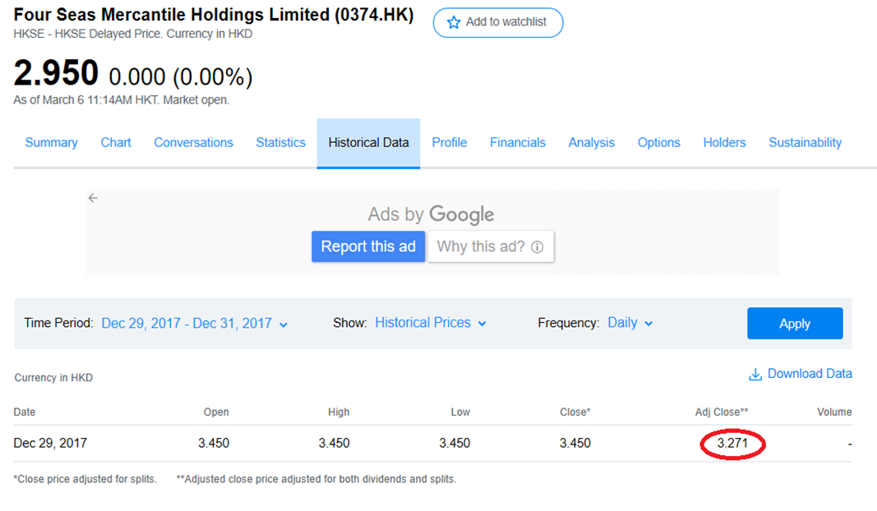Source: Finance Yahoo, 2017.

Appendix 2:
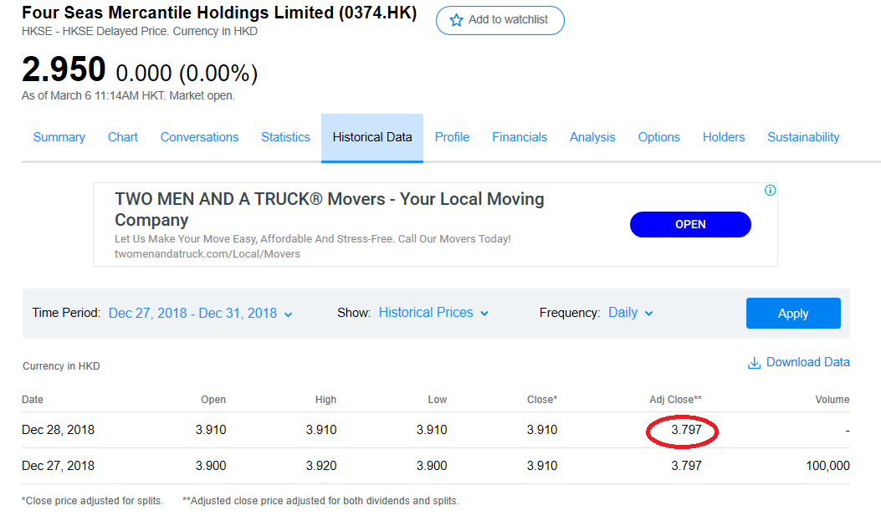
Source: Finance Yahoo, 2018.
Appendix 3:
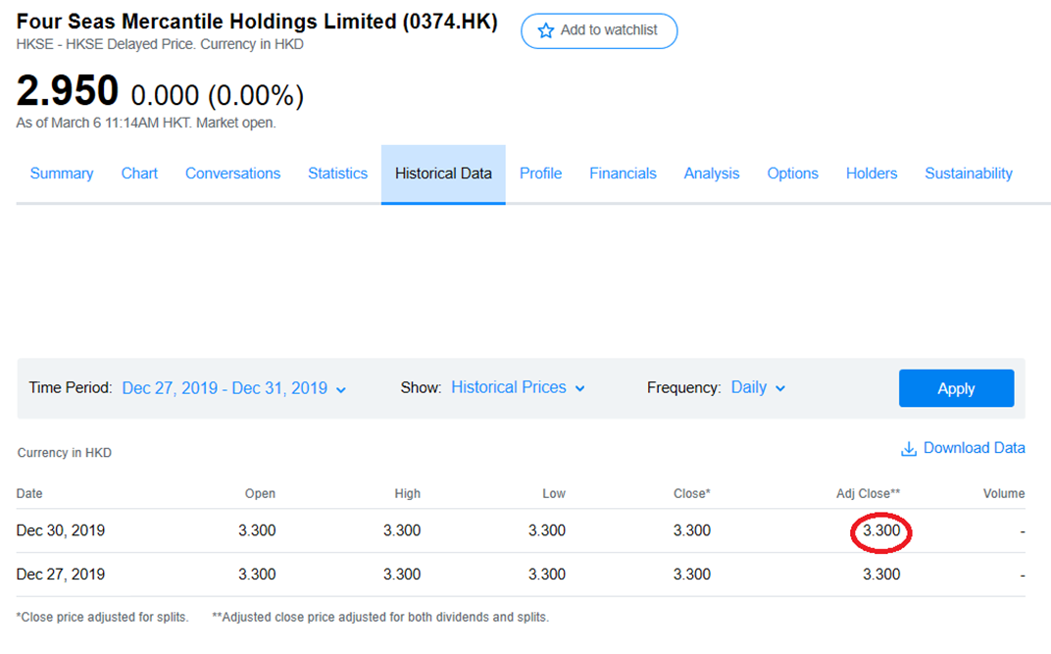
Source: Finance Yahoo, 2019.



