Research Title: The Impact of Electronic Health Records (EHRs), Primary and Secondary Data on Patient Care in Hospitals

Table of Contents
Introduction
Abstract
Research Methodology
Conclusion and Recommendation
References

Abstract
Impact of Electronic Health Records (EHRs)
Primary and Secondary Data on Patient Care in Hospitals. Improved Care Coordination. Improved Service User Safety. Increased Efficiency. Challenges.

Introduction
The introduction provides a brief overview of the significance of electronic health records (EHRs) and primary and secondary data in modern healthcare. It also discusses the potential benefits of data-driven strategies in health and social care, and the impact of the Health and Care Bill and the Wade-Gery review in transforming healthcare. The introduction highlights the aim of the report, which is to explore the impact of EHRs and primary and secondary data on individuals' care in hospitals.

Research Methodology:
This section discusses the methodology used in the research, such as data-driven tools and data analysis techniques. It highlights how data can be used to support outpatient users, reduce waiting times for treatments and diagnosis, and help the NHS in identifying inequalities and faults in the system.
The section also emphasizes the importance of good use of data for improvements in quality, identifying poor care services to patients, and evaluating efforts to integrate care.
The research methodology discusses the impact of service innovation and the significance of quality data in implementing evidence for long-term funding plans. Additionally, it highlights the impact of EHRs on care coordination, clinical decision support tools, and efficiency in hospitals, and the challenges associated with their implementation, such as the initial cost and concerns about data privacy and security.
Impact of Electronic Health Records (EHRs), Primary and Secondary Data on Patient Care in Hospitals:
This section highlights the impact of EHRs and primary and secondary data on patient care in hospitals. It discusses how EHRs provide healthcare professionals with full authority to individuals' complete health history, which enables providers to make accurate and informed conclusions in diagnosis and treatment. The section also emphasizes how EHRs improve care coordination between health promoters and minimize medical errors due to real-time access to users' data, enabling healthcare professionals to identify potential risks and provide appropriate support to users.
Additionally, it highlights how EHRs increase efficiency in hospitals by reducing points for time-consuming data entry and duplicate effort and how primary and secondary data can be used to identify patterns in individuals' care, enabling hospitals to optimize arrangements and improve performance.

Conclusion and Recommendation
The conclusion summarizes the impact of EHRs and primary and secondary data on patient care in hospitals and highlights their significant contribution to improving service user safety, reducing medical errors, increasing efficiency, and improving care coordination. Despite the challenges associated with their implementation, the benefits of EHRs and data outweigh the cost, and they are essential tools for modern healthcare and needs for contusions training of staff for improvement.
The recommendation is to continue to use and improve EHRs and data-driven strategies in health and social care.

Investigations
Further research areas related to the impact of EHRs and data on patient care in hospitals

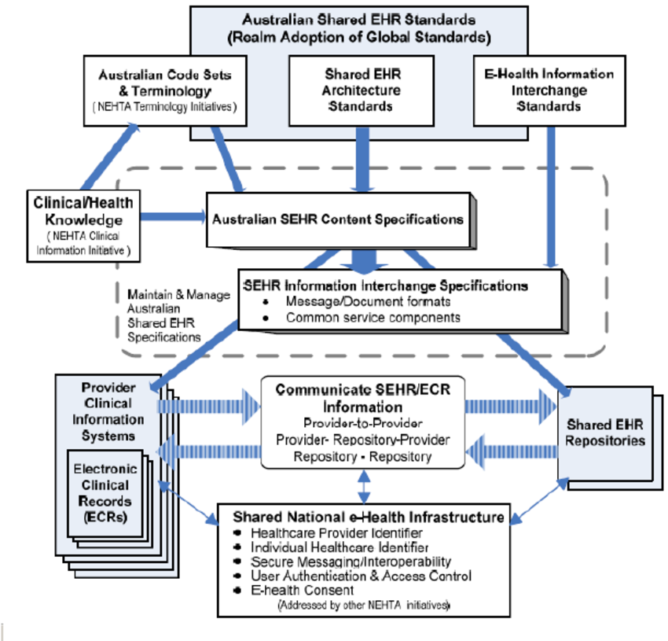
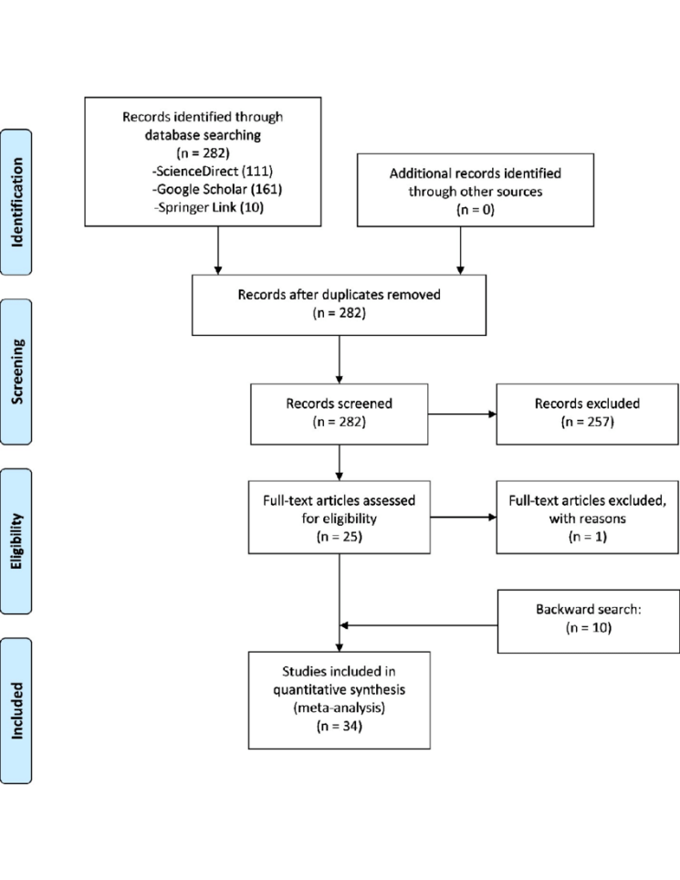
Figure 1 - uploaded by Tamir Tsegaye

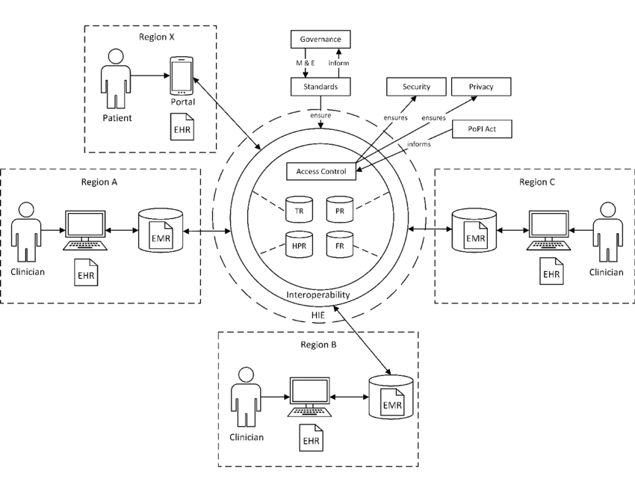
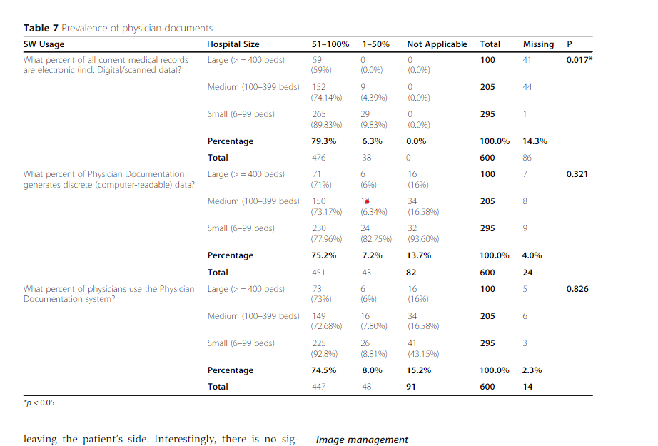
Figure 4 - uploaded by Tamir Tsegaye
The reference section lists all the sources used in the report, following the appropriate citation format.
Author links open overlay panelLemai Nguyen et al. (2014) Electronic Health Records implementation: An evaluation of information system impact and contingency factors, International Journal of Medical Informatics. Elsevier. Available at: https://www.sciencedirect.com/science/article/pii/S1386505614001233?casa_token=njKyri7kByEAAAAA%3A0i_SZeLxwF80a7m3HU0pV88MhVHKLhE_T4WFcZnQIm0sTqPTwsly6aqMGGDfQ32xLD3tLAVr9QUM (Accessed: April 13, 2023).

Digital Care Record (2023) Orion Health. Available at: https://orionhealth.com/uk/digital-care-record?gclid=CjwKCAjwrdmhBhBBEiwA4Hx5g0QYsikcofLSLs5C1WK_0zaHbngm5SrLICZ5XKI3ELatHomqUcB5hhoCIJkQAvD_BwE (Accessed: April 13, 2023).

Enonge, E. et al. (2021) Primary data vs secondary data: Definition, sources, advantages, Blog For Data-Driven Business. Available at: https://www.intellspot.com/primary-data-vs-secondary-data/ (Accessed: April 13, 2023).
Research help: NURS 3710 (RN to BS): Evidence-based practice in nursing: Primary research vs. Secondary Research (n.d.) Primary Research vs. Secondary Research - NURS 3710 (RN to BS): Evidence-based Practice in Nursing - Research Help at Fitchburg State University. Available at: https://fitchburgstate.libguides.com/c.php?g=841815&p=6015293 (Accessed: April 13, 2023).

Moher, D. et al. (2009) Preferred reporting items for systematic reviews and meta-analyses: The Prisma statement, BMJ (Clinical research ed.). U.S. National Library of Medicine. Available at: https://www.ncbi.nlm.nih.gov/pmc/articles/PMC2714657/ (Accessed: April 13, 2023).
What is an electronic health record (EHR)? (2019) What is an electronic health record (EHR)? | HealthIT.gov. Available at: https://www.healthit.gov/faq/what-electronic-health-record-ehr (Accessed: April 13, 2023).
Adoption rates of electronic health records in Turkish hospitals and ... (no date). Available at: https://www.researchgate.net/publication/344860229_Adoption_rates_of_electronic_health_records_in_Turkish_Hospitals_and_the_relation_with_hospital_sizes (Accessed: April 13, 2023).
Genomic diagnosis of rare pediatric disease in the United Kingdom and ... (n.d.). Available at: https://www.nejm.org/doi/full/10.1056/NEJMoa2209046 (Accessed: April 13, 2023).
Upadhyay, S. and Hu, H. (2022). A Qualitative Analysis of the Impact of Electronic Health Records (EHR) on Healthcare Quality and safety: Clinicians’ Lived Experiences. Health Services Insights, 15, pp.1–7. doi:https://doi.org/10.1177/11786329211070722.

NHS England (2022). NHS England. (online) England.nhs.uk. Available at: https://www.england.nhs.uk/ (Accessed 20 Apr. 2023).

