Name: Aled Phillips_____________________________

Student Number: 2507188 ________________________
__________________________________________________________

WORKSHEET 3 – TESTING (Olympic Athlete)

- Original code:
lap_times = []
second_place = []

for i in range(1, 6, 1):
print(f"Please enter lap {i}:")
flag = 0
while flag == 0:
try:
time = float(input())
if time >= 40 and time <= 100: # adding limits for max and min inputs
lap_times.append(time)
flag = 1
else:
print(f"Please enter valid number for lap {i}")
except ValueError:
print(f"Please enter valid number for lap {i}")

flag = 0

while flag == 0:
try:
print("What is the World record for this event?")
w_record = float(input())
if w_record >= 200 and w_record <= 300:
flag = 1
else:
print("Invalid entry")
except ValueError:
print("Invalid entry")

flag = 0

while flag == 0:
try:
print("What is the Olympic record for this event?")
o_record = float(input())
if o_record >= 200 and o_record <= 300:
flag = 1
else:
print("Invalid entry")
except ValueError:
print("Invalid entry")

print("Your statistics...")
print(" ")

# overall time

total = sum(lap_times)
print(f"1. Overall time for 5 laps was: {total}")

# average lap time

average = total/len(lap_times)
print(f"2. Average lap time was: {average}")

# fastest lap - add 1 to offest starting at 0

fastest_lap = min(lap_times)
fastest_index = lap_times.index(fastest_lap) + 1

print(f"3. Fastest lap time was lap {fastest_index}: {fastest_lap}")

# slowest lap

slowest_lap = max(lap_times)
slowest_index = lap_times.index(slowest_lap) + 1

print(f"4. Slowest lap time was lap {slowest_index}: {slowest_lap}")

# Record-breaking !!

if total < o_record:
print("A new Olympic record!")
else:
difference = round(total - o_record, 3)
print(f"You were {difference:.3f} seconds short of the Olympic record")

if total < w_record:
print("A new Olympic record!")
else:
difference = round(total - w_record, 3)
print(f"You were {difference:.3f} seconds short of the Olympic record")

print("-------------------------------------")

print("Please enter times for the 2nd placed competitor:")

for i in range(1, 6, 1):
print(f"Second place competitor: lap {i}:")
flag = 0
while flag == 0:
try:
second_place_time = float(input())
if second_place_time >= 40 and second_place_time <= 100:
second_place.append(second_place_time)
flag = 1
else:
print(f"Please enter valid number for lap {i}")
except ValueError:
print(f"Please enter valid number for lap {i}.")

# Comparison of laps

for i in range(len(lap_times)):
comparison = round(lap_times[i] - second_place[i], 3)
if comparison < 0:
print(f"Lap {i+1} was faster than second place competitor: ({comparison:.3f})")
elif comparison > 0:
print(f"Lap {i+1} was slower than second place competitor: (+{comparison:.3f})")
else:
print(f"Lap {i+1} was a draw: ({comparison:.3f})")

- Code Testing
For each test below, run your code and show the results of the scenarios below. Present a screenshot of what happened when the programme ran. Did the programme behave correctly or did it do something unexpected, and if so, why?

- Test a lap time for your programme:
- 56.7 seconds
- 5 seconds
- -4 seconds
- 53444 seconds

- Using the same five lap times for the winning athlete/2nd placed athlete as the sample output shown on the Worksheet:
- Examine each statistic (1-6) and comment on whether the correct answer(s) are displayed or not. (If any statistics were incomplete after Phase 1 (code completed in class) simply note “Unfinished” for that statistic)

- Test two further sets of lap times of your own choice.

- Check that the 2nd placed competitor’s times are reasonable (eg the overall time should not be faster than the winning athlete’s)

Template for tests:
Test: 56.7 seconds

Screenshot(s) of output:
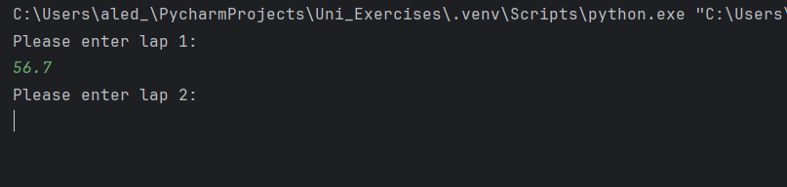
Result: Did the programme behave as expected ie syntactically and logically correct?

YES – The programme recognised the valid input and moved on to the next lap prompt.

Test: 5 seconds

Screenshot(s) of output:
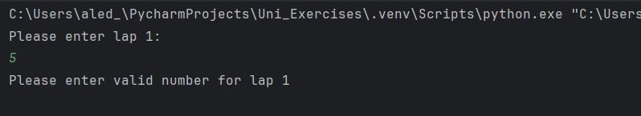
Result: Did the programme behave as expected ie syntactically and logically correct?

YES – The programme recognised 5 seconds as an invalid lap time (too low) and asks the user to input another valid value before proceeding to the next step.

Test: -4 seconds

Screenshot(s) of output:
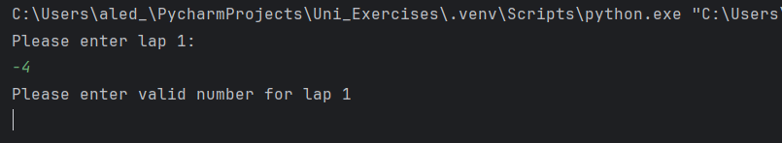
Result: Did the programme behave as expected ie syntactically and logically correct?

YES – The programme recognised that you cannot have a negative lap time and prompts the user to input a valid value before moving on to the next step.

Test: 53444 seconds

Screenshot(s) of output:
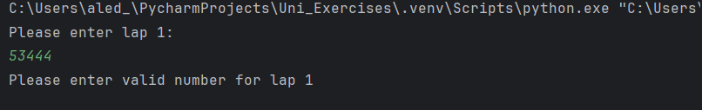
Result: Did the programme behave as expected ie syntactically and logically correct?

YES – The programme recognised that 53444 seconds is too long for a lap time and prompts the user to input a valid value before proceeding.

Test: b) Statistics – prints Olympic record for both

Screenshot(s) of output:
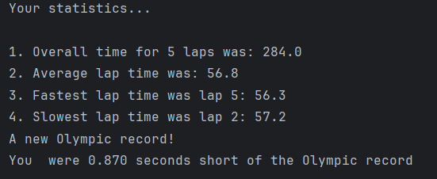

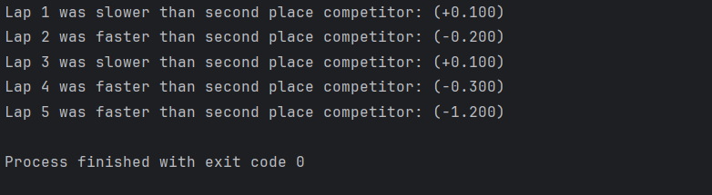
Result: Did the programme behave as expected ie syntactically and logically correct?

YES

1. Overall time: The programme has taken the valid user inputs and correctly calculated the overall time of the 5 laps, aligning with the example output provided. However, the code does not add the unit of measurement (seconds) at the end of any of the statistics. Whilst this does not directly affect the calculations, this should be rectified to avoid any confusion for the user.
2. Average lap time: The programme has taken the valid user inputs and correctly calculated the average lap time for the 5 laps, aligning with the example output provided.
3. Fastest lap time: The programme has taken the valid user inputs and correctly selected the fastest of the 5 laps, aligning with the example output provided.
4. Slowest lap time: The programme has taken the valid user inputs and correctly selected the slowest of the 5 laps, aligning with the example output provided.
5. Olympic/ World record: The programme has correctly measured the overall lap time against the Olympic and World records that were entered by the user. In the case where this breaks a record, it has come up with a message to say so. In the case where the time does not break a record, it has correctly calculated the difference between the user’s time and that record.
6. Time differences: When accounting for the second-place competitor, the programme has correctly calculated the difference between the time taken for each of the 5 laps, also advising if the lap was faster or slower than the first-place competitor.

Test: Two further sets of lap times

Screenshot(s) of output:

New Data 1:
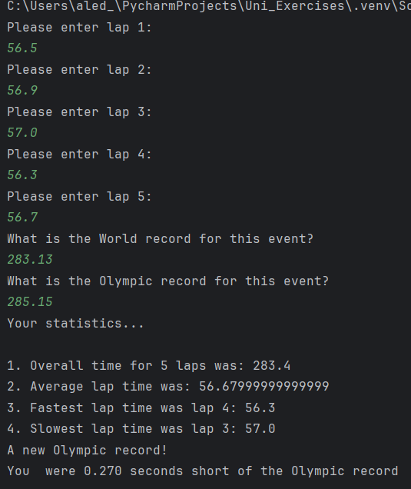

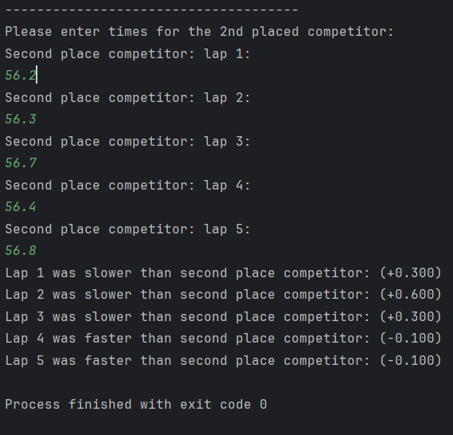

New Data 2:

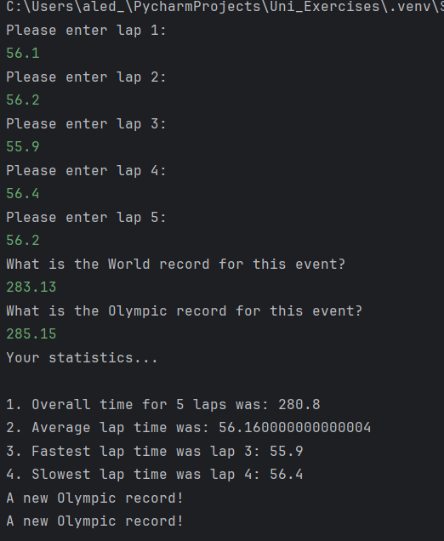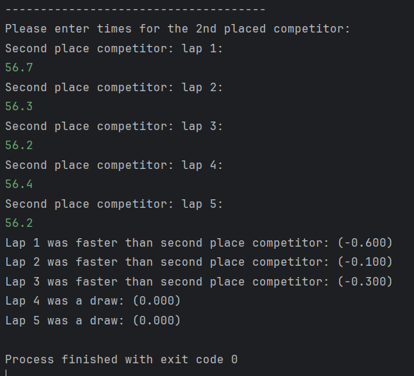

Result: Did the programme behave as expected ie syntactically and logically correct?

No – The statistics still calculated correctly:
- Total time
- Average lap time
- Fastest lap
- Slowest lap
- The difference between the laps of the first and second place competitor

As well as confirming if any records have been broken/ how close to the record the user was.

Issues:

- As the number of decimal places has not been limited in the code, the average lap time can easily have a large amount of numbers after the decimal point or become a recurring number. Whilst this isn’t logically or mathematically incorrect, the number should be presented to 2 decimal places for presentation purposes using the “.2f” feature of Python.
- Due to a simple human error when typing the code for the breaking the World record, the message states “A new Olympic record!”. This will need to be amended to state, “A new World record!”

Test: Are the second-place competitor’s times reasonable?

Screenshot(s) of output:

Result: Did the programme behave as expected ie syntactically and logically correct?

NO – In this example, the total time for the first-place competitor was 283.4 seconds. The second-place competitors total was 282.4, one second faster than first place.

In order for the programme to remain logically consistent, an if statement should be implemented to check whether the total time for the second competitor is faster than the total time for the first competitor. If this is the case, an error message should be presented to the user.

- Consider the results of the above tests and revisit your original code in order to address any tests that failed and/or improve code efficiency.

(Note: you may not be able to solve all of the problems that were encountered, but solve as many as you can.)

Paste your full revised code here :

## improvements ##
# Added unit of measurements (seconds) to statistics
# Amended World Record breaking message to state "World Record" instead of "Olympic Record"
# Limited the number of decimal places for the average lap time to 2
# Addition of a check at the end to ensure that the second-place competitor's time cannot be faster than first-place
lap_times = []
second_place = []
for i in range(1, 6, 1):
print(f"Please enter lap {i}:")
flag = 0
while flag == 0:
try:
time = float(input())
if time >= 40 and time <= 100: # adding limits for max and min inputs
lap_times.append(time)
flag = 1
else:
print(f"Please enter valid number for lap {i}")
except ValueError:
print(f"Please enter valid number for lap {i}")
flag = 0
while flag == 0:
try:
print("What is the World Record for this event?")
w_record = float(input())
if w_record >= 200 and w_record <= 300:
flag = 1
else:
print("Invalid entry")
except ValueError:
print("Invalid entry")
flag = 0
while flag == 0:
try:
print("What is the Olympic Record for this event?")
o_record = float(input())
if o_record >= 200 and o_record <= 300:
flag = 1
else:
print("Invalid entry")
except ValueError:
print("Invalid entry")
print("Your statistics...")
print(" ")
# overall time
total = sum(lap_times)
print(f"1. Overall time for 5 laps was: {total} seconds")
# average lap time
average = total/len(lap_times)
print(f"2. Average lap time was: {average:.2f} seconds")
# fastest lap - add 1 to offest starting at 0
fastest_lap = min(lap_times)
fastest_index = lap_times.index(fastest_lap) + 1
print(f"3. Fastest lap time was lap {fastest_index}: {fastest_lap} seconds")
# slowest lap
slowest_lap = max(lap_times)
slowest_index = lap_times.index(slowest_lap) + 1
print(f"4. Slowest lap time was lap {slowest_index}: {slowest_lap} seconds")
# Record-breaking !!
if total < o_record:
print("A new Olympic Record!")
else:
difference = round(total - o_record, 3)
print(f"You were {difference:.3f} seconds short of the Olympic Record")
if total < w_record:
print("A new World Record!")
else:
difference = round(total - w_record, 3)
print(f"You were {difference:.3f} seconds short of the World Record")
print("-------------------------------------")
print("Please enter times for the 2nd placed competitor:")
for i in range(1, 6, 1):
print(f"Second place competitor: lap {i}:")
flag = 0
while flag == 0:
try:
second_place_time = float(input())
if second_place_time >= 40 and second_place_time <= 100:
second_place.append(second_place_time)
flag = 1
else:
print(f"Please enter valid number for lap {i}")
except ValueError:
print(f"Please enter valid number for lap {i}.")
# Comparison of laps
for i in range(len(lap_times)):
comparison = round(lap_times[i] - second_place[i], 3)
if comparison < 0:
print(f"Lap {i+1} was faster than second place competitor: ({comparison:.3f})")
elif comparison > 0:
print(f"Lap {i+1} was slower than second place competitor: (+{comparison:.3f})")
else:
print(f"Lap {i+1} was a draw: ({comparison:.3f})")
second_place_total = sum(second_place)
if second_place_total < total:
print(f"There has been an error, second place ({second_place_total}) is faster than first place ({total}). Please try again!")
else:
print("Thanks for using our service!")

