Programme: BA International Hotel Management

Assignment Title: Intercultural Competence Report

Module code: BMIH5003
Module name: Foreign Languages & Cultural Awareness

Student name: Lavinia Dumitrita Bidasca
Student id: 2240974
Lecture’s Name: Antoinette Milne

Executive summary
This paper aims to brief the General Manager of Diversity Hotel & Spa on the cultural framework and leadership characteristics of Germany as outlined by the GLOBE Project. The differences in understanding between England and German cultures are discussed; focusing on the communication, punctuality, and food culture. It recommends cultural intelligence and intercultural competence as critical dimensions to be adopted and maintained by hotel staff to facilitate the integration process while respecting local cultures. It also discusses other leadership issues, specifically with an emphasis on those relating to cultural diversities in the hospitality industry, including issues to do with communication and perception to issues to do with hierarchy. Likewise, recommendations involve procuring cultural sensitivity programs, improving communication, creating diversity policies, applying transformational leadership, setting up feedback mechanisms, and individualizing accommodations. These strategies are expected to help create a good rapport within the places of work and boost the performance of the new hotel in Berlin.

Table of Contents
1 Introduction 3
2 Key differences between England and Germany 3
3 GLOBE Study Comparison 4
1.1 Cultural visualization 4
1.2 Leadership Visualization 6
4 Intercultural leadership challenges in the hospitality sector 8
5 Conclusion 8
6 Recommendations 9
7 References 10

Introduction
The purpose of this report is to inform the General Manager of Diversity Hotel & Spa about the German culture and manners to prepare for the visit to our new establishment in Berlin, Germany. This paper will seek to describe or identify cultural values and practices in Germany based on the culture and leadership project (Smith and Peterson, 2017). Furthermore, there is a link between the vital concepts of cultural intelligence and the cultural sensitivity of the hotel staff outlined in the critical dimension of intercultural competence and leadership. The objective is to apply the brand standards consistently while considering traditions and practices in the given region.

Key differences between England and Germany
Referring to cultural differences, there are a lot of distinctions between the people of England and Germany even though the two countries are neighbors. The first difference that can be highlighted encompasses how the two characters communicate. German people are culturally known to be very straightforward and do not hesitate to say exactly what they want. On the other hand, English people tend to be indirect and say more in-between and may indicate things rather than express them clearly (House, 2017). There is also a huge disparity in the manner in which both cultures perceive time and the importance of being punctual. As for nonverbal communication, Germans are accurate with time and always organized as they plan their day hour by hour. Punctuality is considered as an aspect of honouring both one's time and the time of others. On the other hand, punctuality is appreciated in England but overall, English people are less strict when it comes to time, and minor delays are tolerated (Alphatrad, 2024).
Fish and chips, bangers and mash, and other traditional dishes of British cuisine can be considered hearty meals. On the other hand, German cuisine comprises schnitzel and bratwurst that has more marinated meats than Sweden accompanied by sauerkraut among other strong textures. Furthermore, the preference for coffee has a different tradition compared to the UK which prefers tea (Lewis et al. 2017).
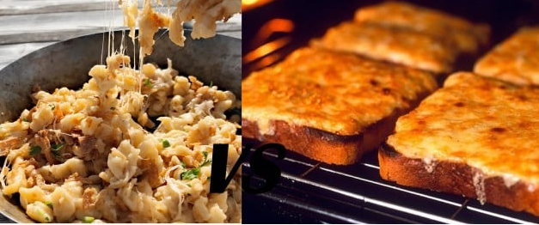
Figure 1: Food Differences German VS. England

GLOBE Study Comparison

Cultural visualization
As per the below graph norms of high performance orientation and assertiveness are evidenced for both East and West Germany revealing the business population's dedication to accomplishment and direct approach to communication. The attitudes towards the future are rather active in both regions as the rate of future orientation is rather moderate. Institutional collectivism and power distance, two of Hofstede's scales, reveal a higher level in East Germany than in West Germany meaning that group unity is more essential. These two regions exhibit moderate to relatively high levels of uncertainty avoidance, which means that they prefer structure and rules (GLOBE, 2024).
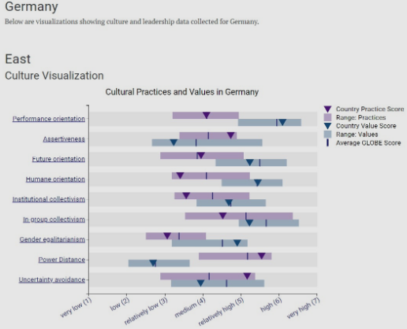
Figure 2: Cultural Values in Germany
(GLOBE, 2024)
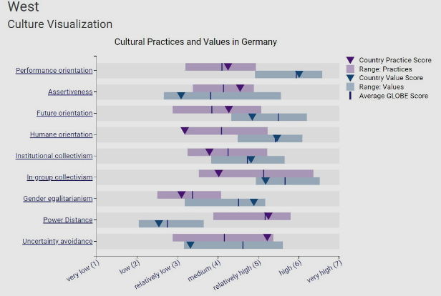
Figure 3: Cultural Visualisation of Germany
(GLOBE, 2024)
On the other hand, England is high in performance orientation and assertiveness which implies that this country has a competitive and direct culture. A relatively high future orientation and uncertainty avoidance reflect the corporative societies’ emphasis on planning and reducing uncertainty; modest collectivism and power distance scores reflect moderate scores GLOBE, 2024a).
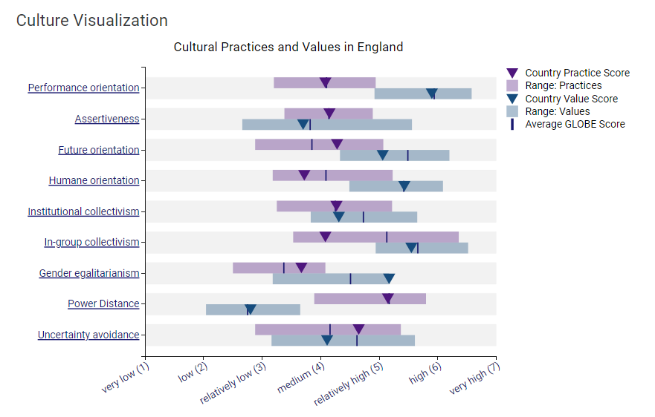
Figure 4: Cultural Visualization of England
(GLOBE, 2024a)

Leadership Visualization
The GLOBE Project reveals that the set of attributes for outstanding leadership in Germany is marked by charismatic and high scores in team-oriented elements, confirming the focus on inspiration and collaboration. Another relatively high-indexed value in the organisational culture of the firm is participative leadership. Humane-oriented leadership being positive, it is has a moderate score thus showing that while showing empathy, efficiency is also considered to some extent. Autonomous leadership is ranked as moderately important showing a high regard for individual decision making within a framed system. Self-protective leadership, which aims at rank preservation and face-saving, is lower which indicates that it is not as favourable in the German leadership environment (GLOBE, 2024).

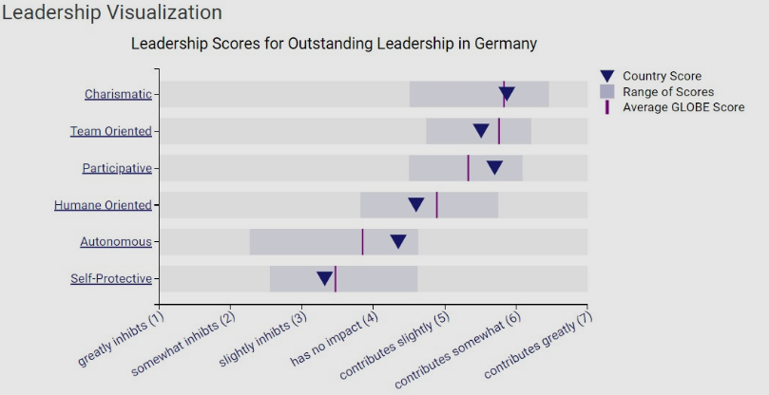
Figure 5: Leadership Visualisation of Germany
(GLOBE, 2024)
On the other hand, England reveals higher satisfaction with inspirational, team, and participative leadership styles that respond to the call for charisma, teamwork, and collaboration with employees. There is moderate support for humane-oriented leadership but comparatively low support for the autonomous and self-protective leadership styles, which, once again, is in line with the expectations of the participants for collaborative and empathetic leadership.

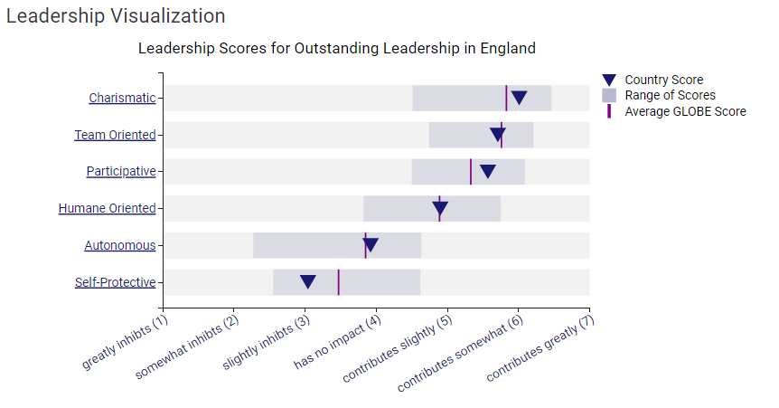
Figure 6: Leadership Visualization of England
(GLOBE, 2024a)

Intercultural leadership challenges in the hospitality sector
Inter-cultural leadership in the hospitality industry has several challenges because of the cultural differences between employees and customers (Vassou, Olsen and Johanson 2017). Specific cultural differences mean that what might be deemed appropriate and effective communication in one country may be seen as impolite in another. Managers and leaders of the organizations should ensure that they balance the cultural differences for the sake of cohesion and smooth communication (Ting-Toomey and Dorjee, 2018). Also, different expectations concerning top-bottom relations might cause conflicts and some appreciate equality while others respect the power to control.
Trevino and Nelson (2021) also noted that work practices and ethics across different cultures also create tension and conflict. For example, being on time and efficient are appreciated traits in some cultures, while in other cultures, there is no harm in being late. These factors should not be allowed to affect the quality of services that are provided to the people by the leaders. Besides, the fact that the guests coming from different countries have individual needs and expectations is yet another challenge (Qui et al. 2019).

Conclusion
It is concluded that embracing cultural values is a significant factor in leadership practices in this hospitality domain, especially in a diverse context such as Germany. With the help of the GLOBE Project, Diversity Hotel & Spa is capable of maximizing brand standards while acknowledging the cultural differences in the locale. Therefore, the need to support cultural intelligence and intercultural competence of staff at the workplace will be crucial for the success of the hotel in Berlin, as it will enhance the flow of services, customer satisfaction, and ultimately the success of the hotel.

Recommendations
Several recommendations for intercultural leadership in the hospitality sector include the following:
- Cultural Training: The various training sessions that must be completed include; The complete cultural awareness program for the organization for the other members of staff.
- Communication Workshops: Organize such courses as effective speaking to raise the concepts of audience and how to address audiences with different backgrounds.
- Inclusive Policies: Put and implement practices that would accept cultural diversity and practices as well as embrace multiculturalism.
- Flexible Leadership: Request the leaders to employ a dual androgynous leadership approach by maintaining the formal hierarchical system as well as embracing the equal opportunity principle depending on the team's cultural orientations.
- Guest Customization: Make sure to accommodate their cultural sensitivity and needs to make a lasting impression when interacting with foreign visitors.

References
GLOBE, 2024. [Online] Available at https://globeproject.com/results/countries/DEU%3Fmenu=list.html#list. [Accessed on 23rd May 2024]
GLOBE, 2024a. [Online] Available at https://globeproject.com/results/countries/GBR%3Fmenu=list.html#list. [Accessed on 23rd May 2024]
Smith, P.B. and Peterson, M.F., 2017. Cross‐cultural leadership. The Blackwell Handbook of Cross‐Cultural Management, pp.217-235.
House. J., 2017. Communication Styles in English and German. Available at https://onlinelibrary.wiley.com/doi/abs/10.1002/9781118783665.ieicc0240. [Accessed on 23rd May 2024]
Alphatrad, 2024. Cultural differences between Germany and Great Britain. Available at https://www.alphatrad.co.uk/news/cultural-differences-germany-great-britain. [Accessed on 23rd May 2024]
Lewis, K.E., Grebitus, C., Colson, G. and Hu, W., 2017. German and British consumer willingness to pay for beef labeled with food safety attributes. Journal of agricultural economics, 68(2), pp.451-470.
Vassou, C., Zopiatis, A. and Theocharous, A.L., 2017. Intercultural workplace relationships in the hospitality industry: Beyond the tip of the iceberg. International Journal of Hospitality Management, 61, pp.14-25.
Ting-Toomey, S. and Dorjee, T., 2018. Communicating across cultures. Guilford Publications.
Trevino, L.K. and Nelson, K.A., 2021. Managing business ethics: Straight talk about how to do it right. John Wiley & Sons.
Qiu, S., Alizadeh, A., Dooley, L.M. and Zhang, R., 2019. The effects of authentic leadership on trust in leaders, organizational citizenship behavior, and service quality in the Chinese hospitality industry. Journal of Hospitality and Tourism Management, 40, pp.77-87.

