Learning in the Digital Era Dev Diary
12 Oct – Barrel
This is the first custom model that I have made in Maya. It was mostly a way to practice using edge loops and extruding. Obviously, this could have been improved if I had started with a cylinder instead of a cube, but it would also be much harder to add details to a rounded surface.
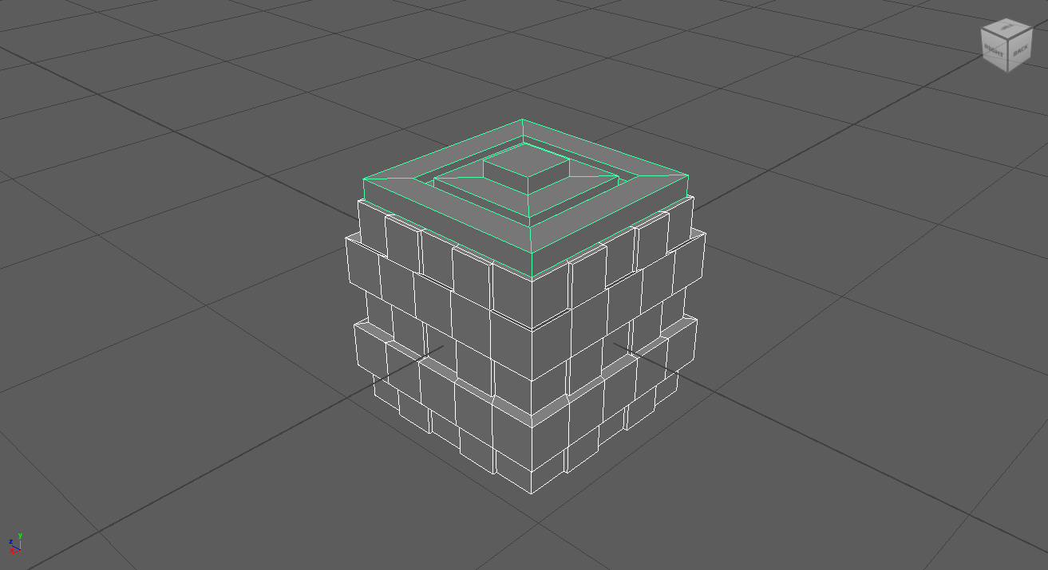

Oct 20 – Lamppost
This lamp (and bench) is the first of the assigned models for this module. The main lamppost pole is an extruded and scaled cylinder, and the top section is a rectangle extruded from the top. Since I had some extra time, I decided to also model a bench since that was one of the earliest models I made with Blender.
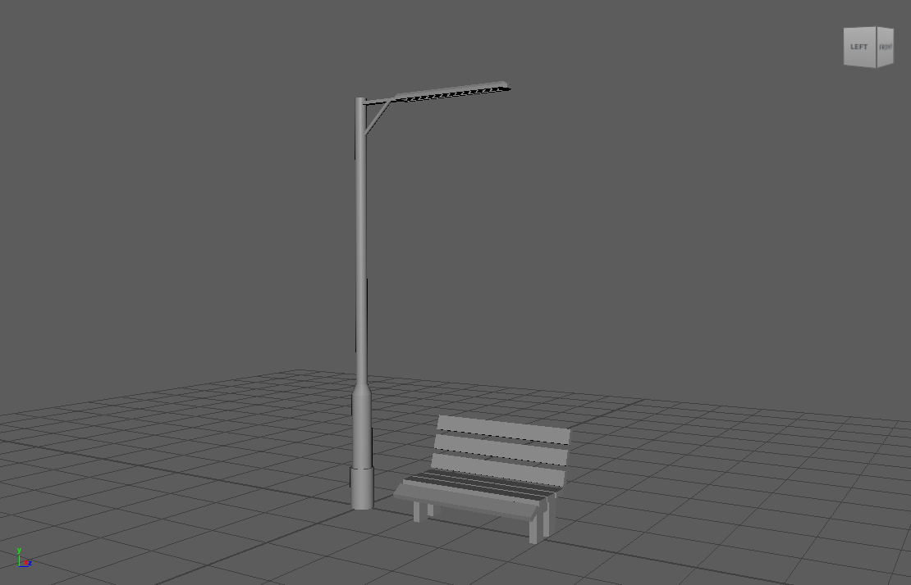
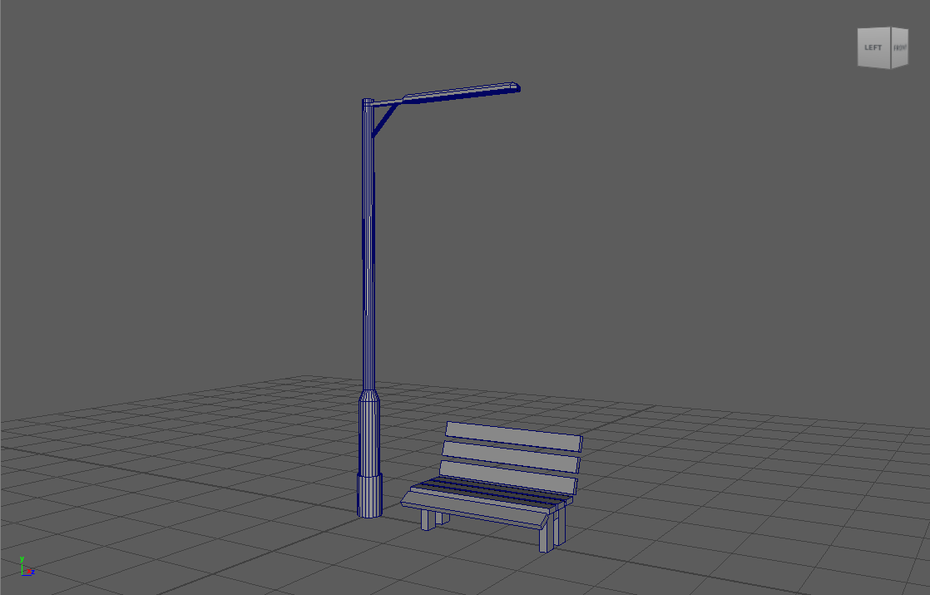

Oct 20 - Oct 26 – Dumpster
Before modeling this I watched through the introductory videos of the Maya 2024 Essential Training course [1], which helped me figure out more of Maya’s functions and shortcuts. A lot of my journey so far learning Maya has been asking myself “How do I do ______, but using Maya instead of Blender?,” so video tutorials like this are especially useful for helping to bridge the gap between software experience.
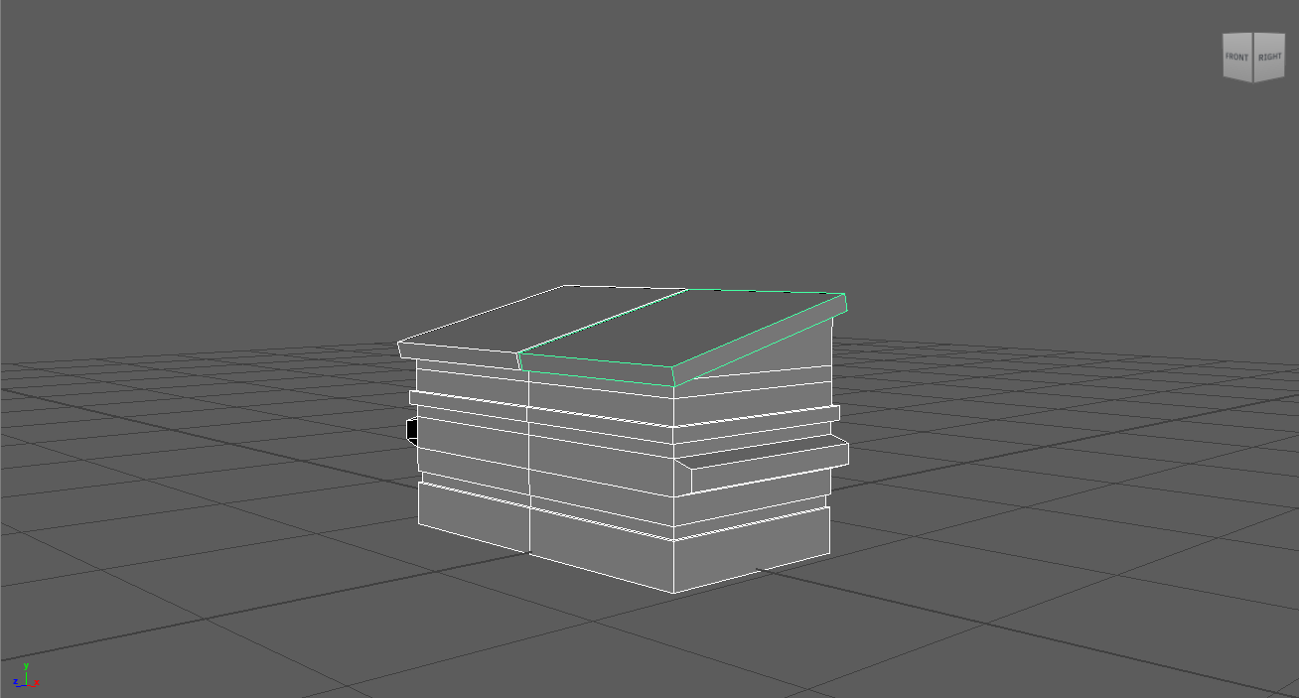

26 Oct – Screwdriver
The method for making the screwdriver was similar to the lamppost, scaling a cylinder vertically and expanding certain parts of the cylinder horizontally. The screw head was a bit more difficult. My eventual solution was manually moving the top vertices into a cross shape and extruding, then merging with the Merge Selected Vertices tool [2]
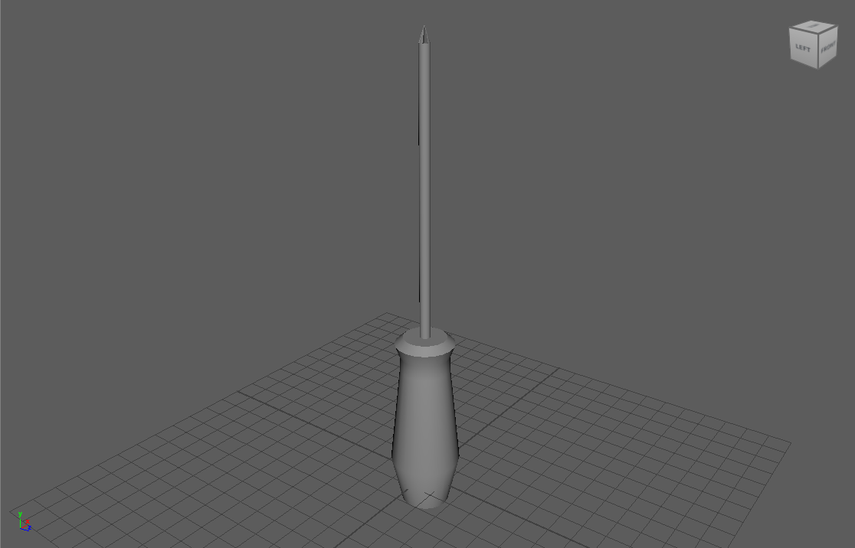
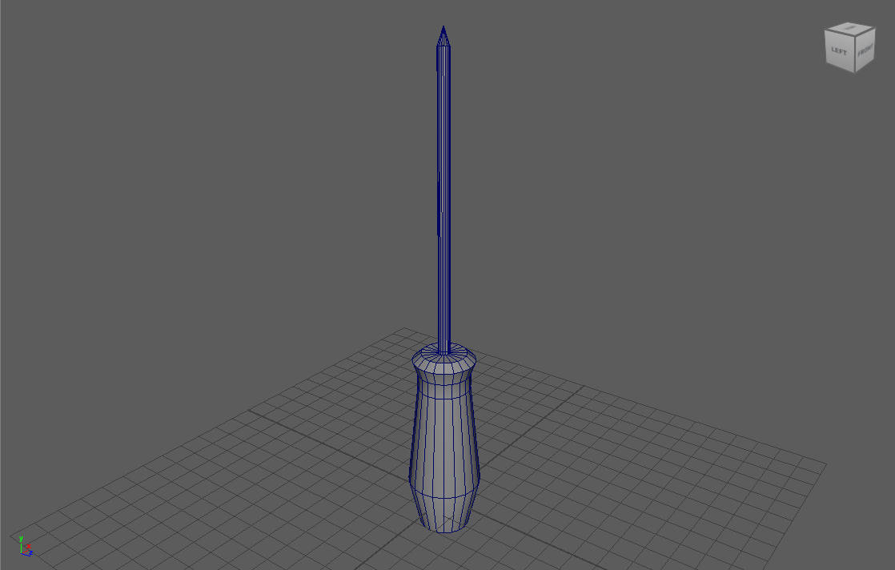

26 Oct – Kullen
For this model, I was able to find detailed schematics for the Kullen IKEA cupboard [3]. Since I had such a detail reference, I wanted to challenge myself by adding a removable drawer with an accurate interior.
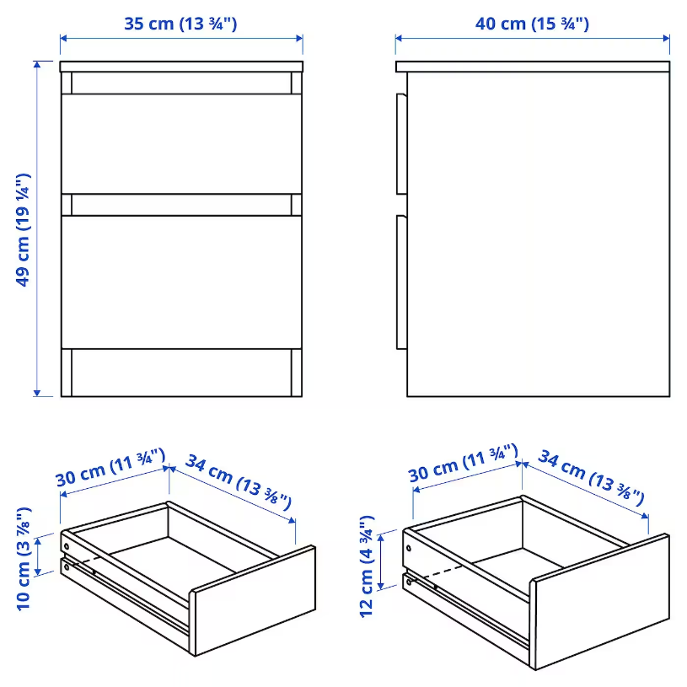
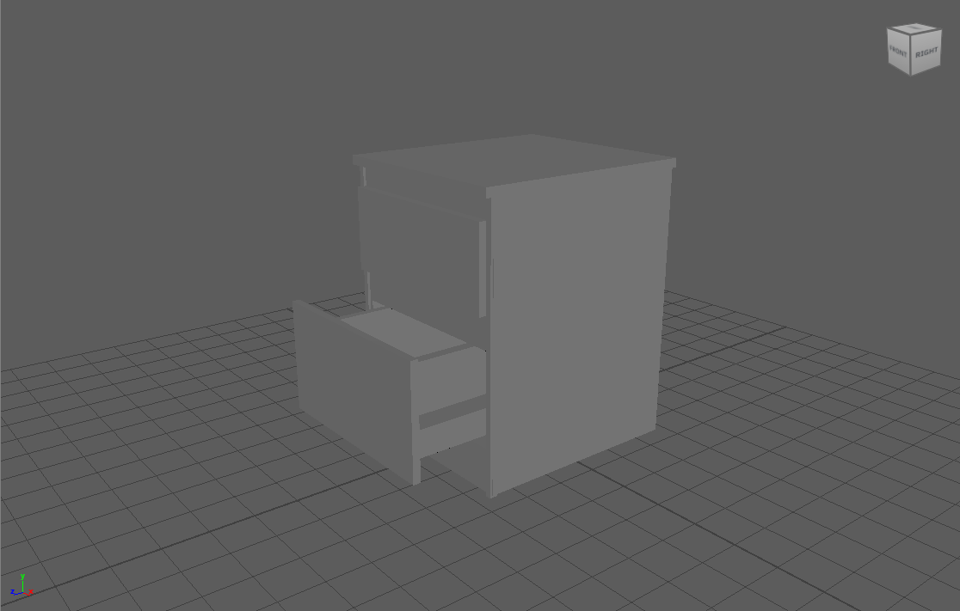
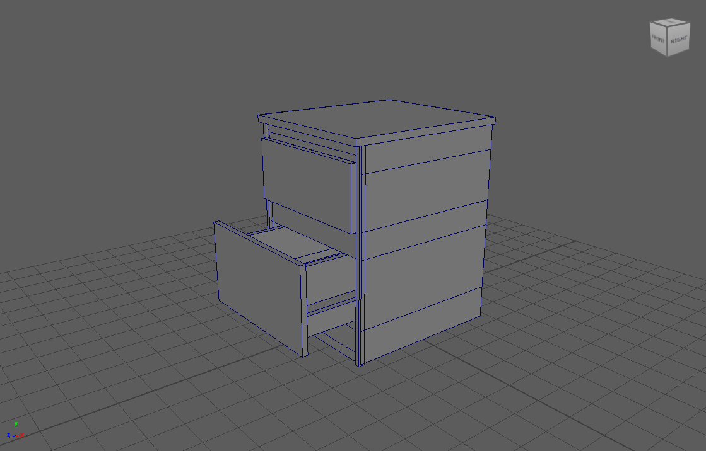

27 Oct – Can
While I was working on this project, one of the first problems I came across was that the reference image wasn’t perfectly orthographic, which made it a bit difficult to match in Maya’s orthographic view.
One thing that I found to be time consuming was selecting vertical parallel edges on a cylinder. As far as I have researched there isn’t a fast method or shortcut to do this. A feature that would make this easier would be something like Blender’s ‘Repeat last action’ function. Maya does have a feature with the same name, but it doesn’t count selections as an action, so it doesn’t work.
I also had an issue where I couldn’t add an edge loop in the center because symmetry was turned on.
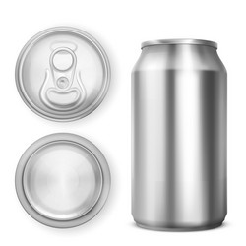

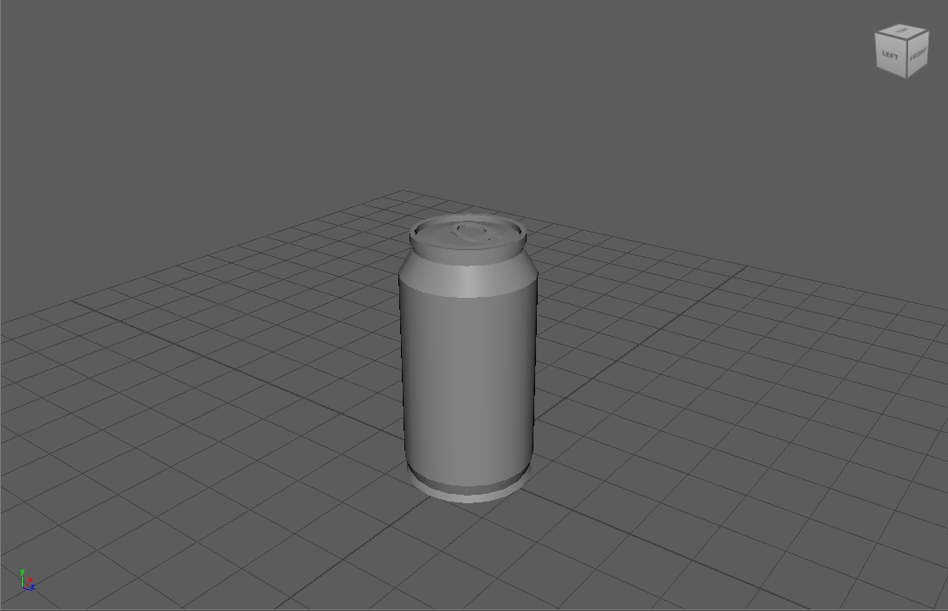
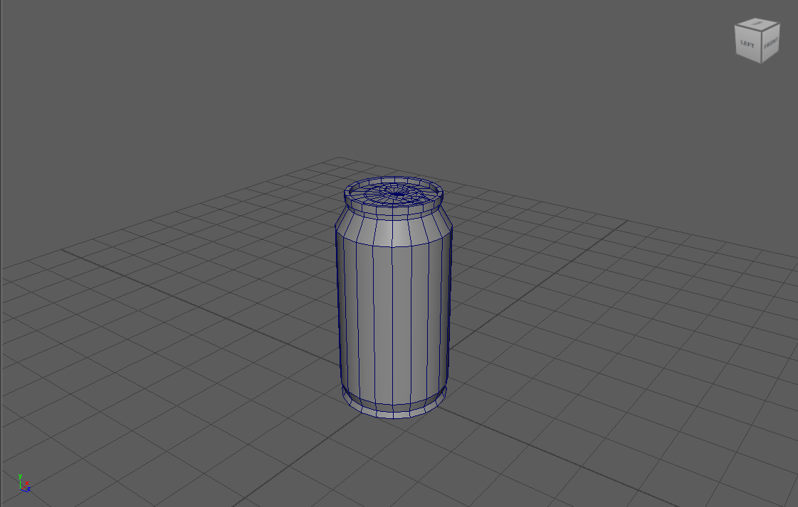

2 Nov – Minifig
I am happy with most of this model, but I had some trouble with getting the hands to look right. Since I was on a time limit for this project, I didn’t have time to try many different methods. My eventual method was to add a torus and remove a chunk of it to make a hand shape. It's not a perfect solution, but it works for the purpose of this challenge.
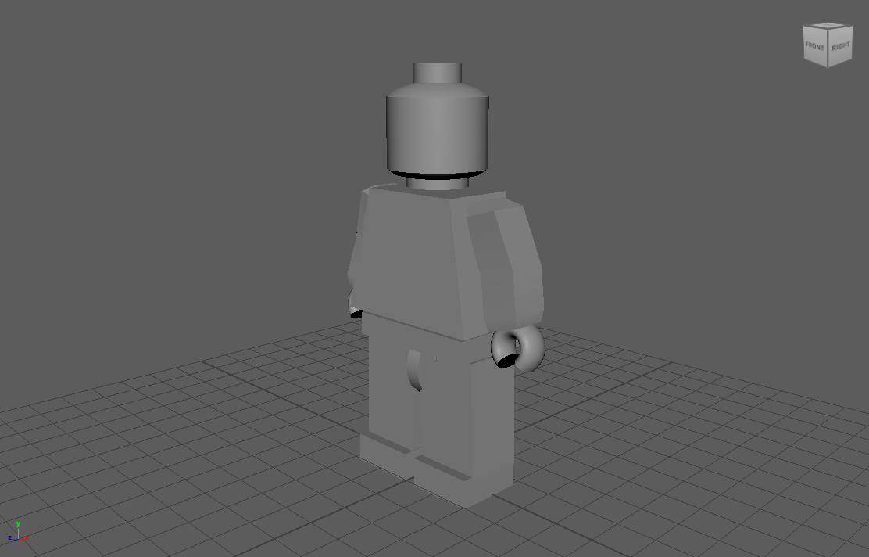
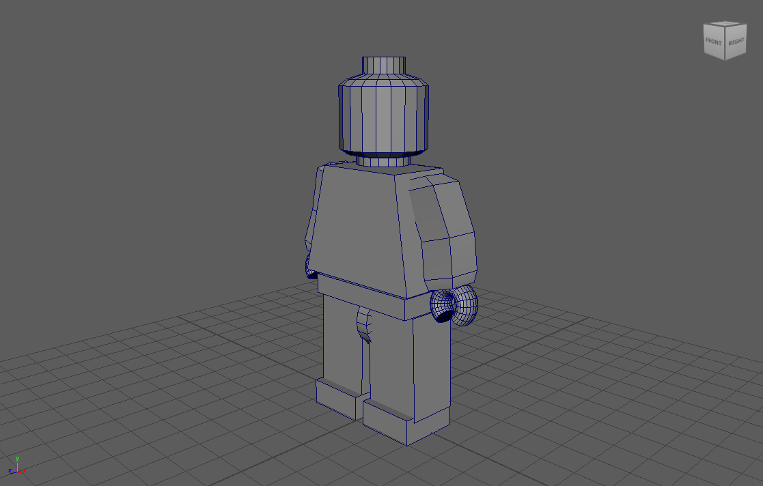

Horse
I knew I couldn’t make a realistic horse given the time limit, so instead I focused on getting the basic forms and shapes using cubes.
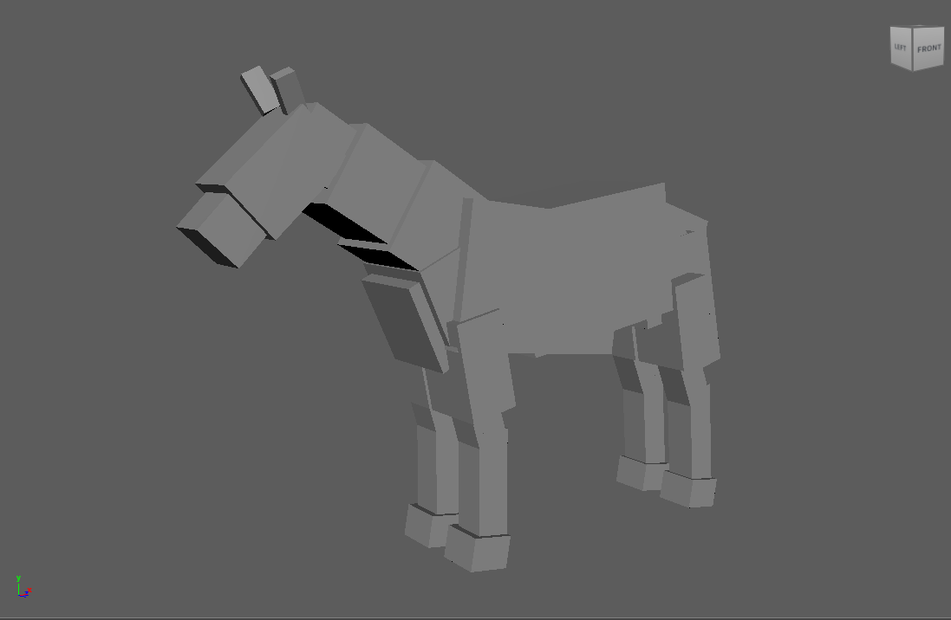
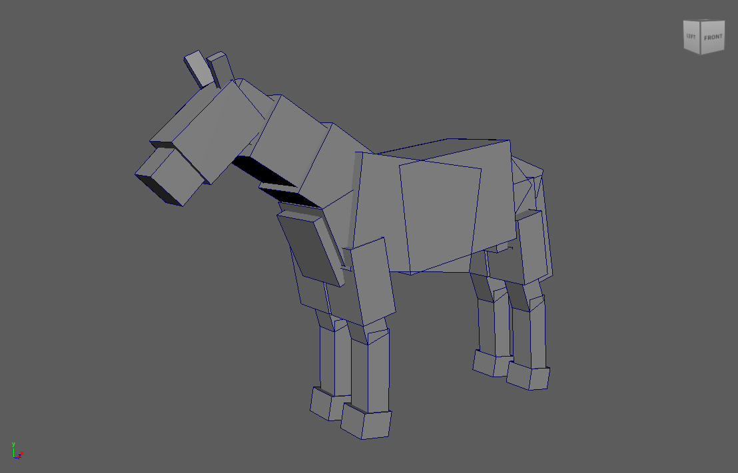

Chest (Mimic)
I started out just making a chest, then I added teeth to make it a mimic. I was inspired by the work of Miguel Zavala, who specializes in making models based off D&D creatures. [4]

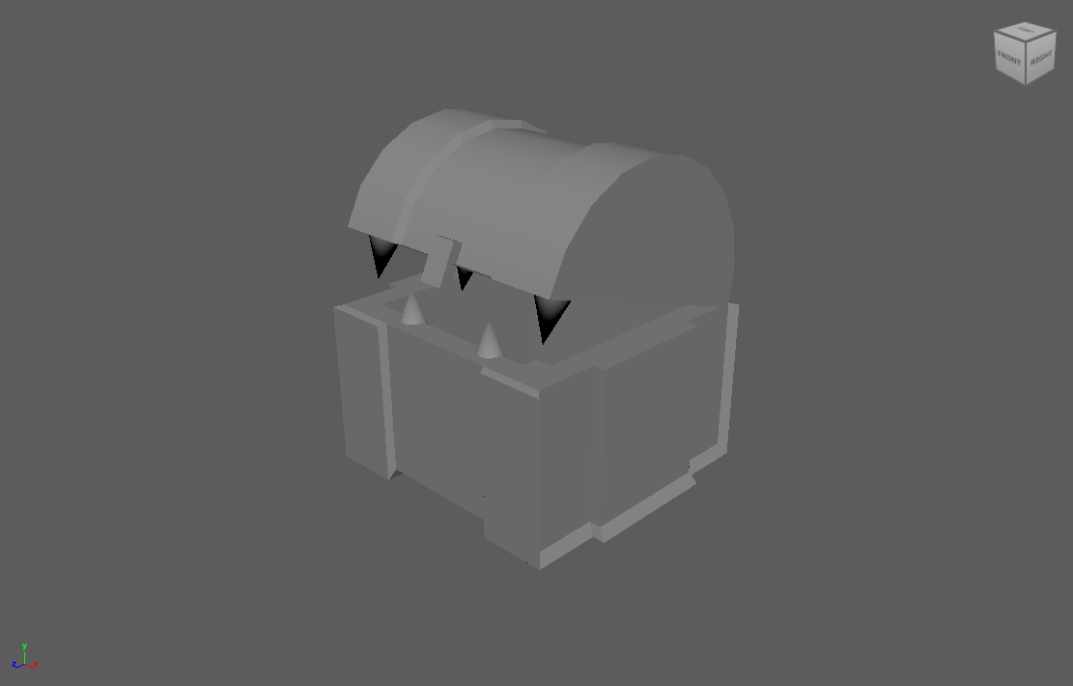
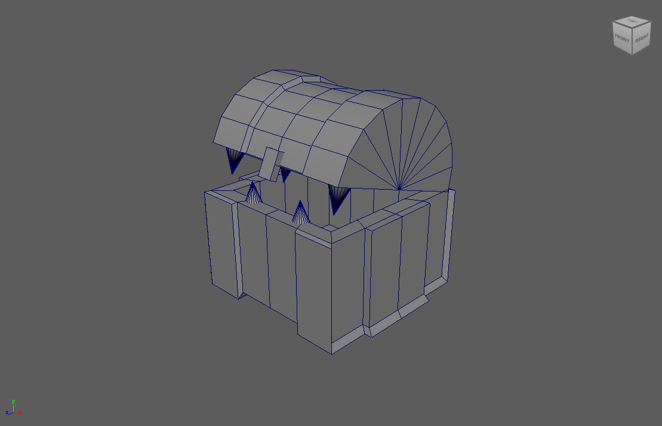

Monitor
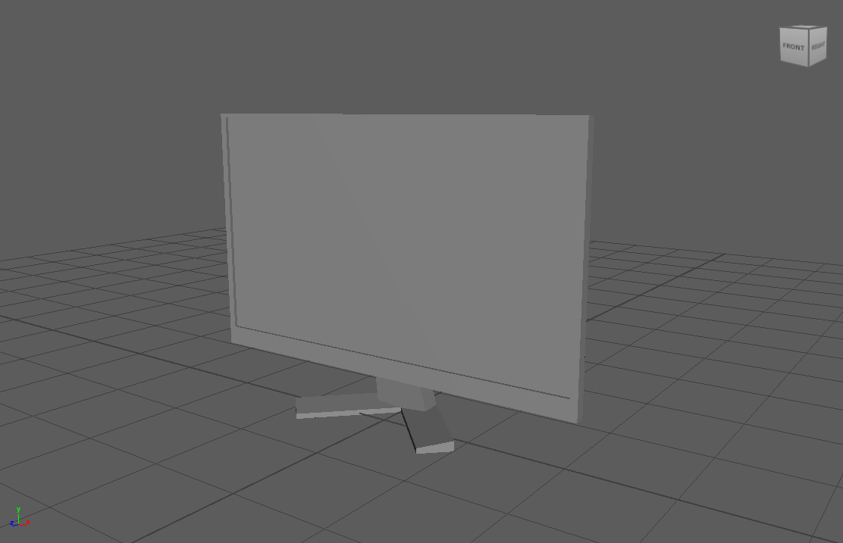
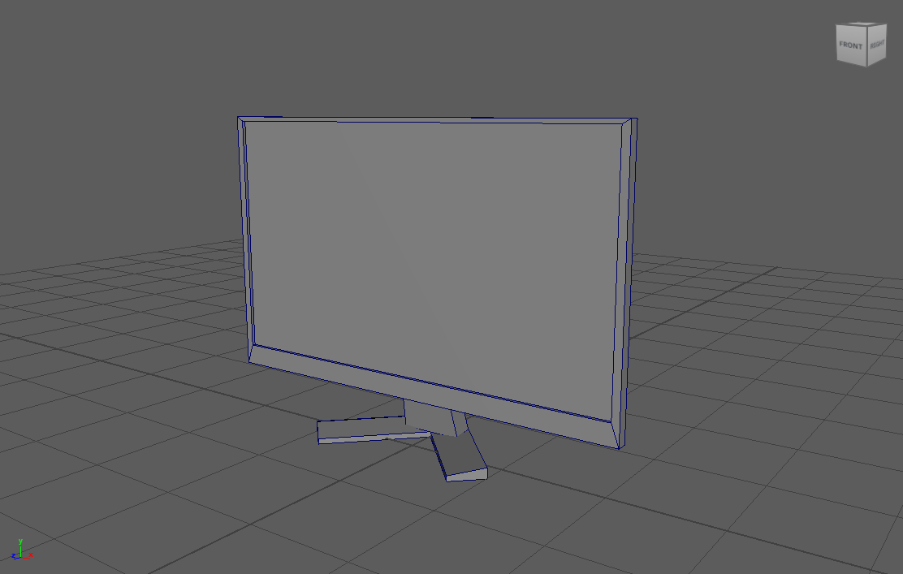

Axe
I wanted to make this more unique than simply an axe, so I made it also in the shape of a key. I had some trouble making it recognizable as a key, so I went back to looking at reference to try and find what I needed to change. The main design details of a key I included were the ring handle and the serrated edge, which made it look like a key.
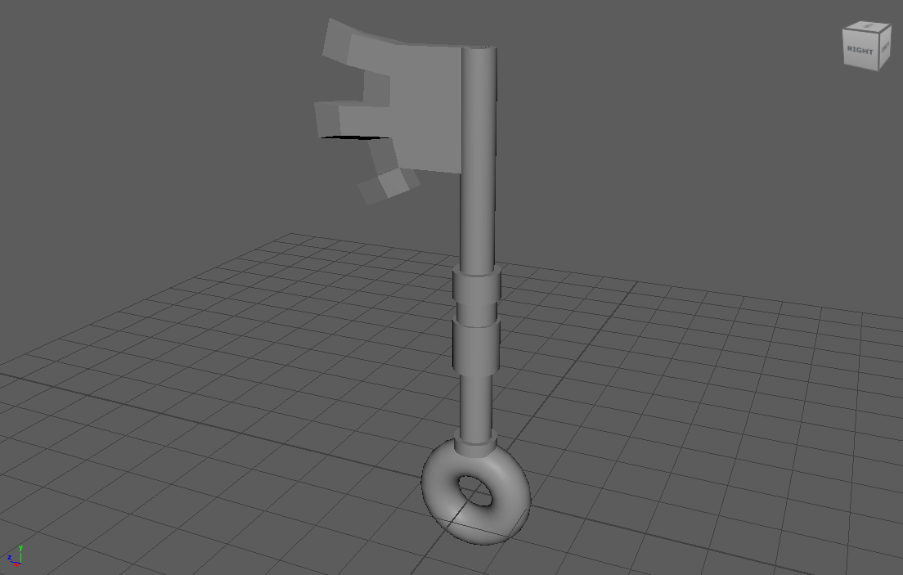
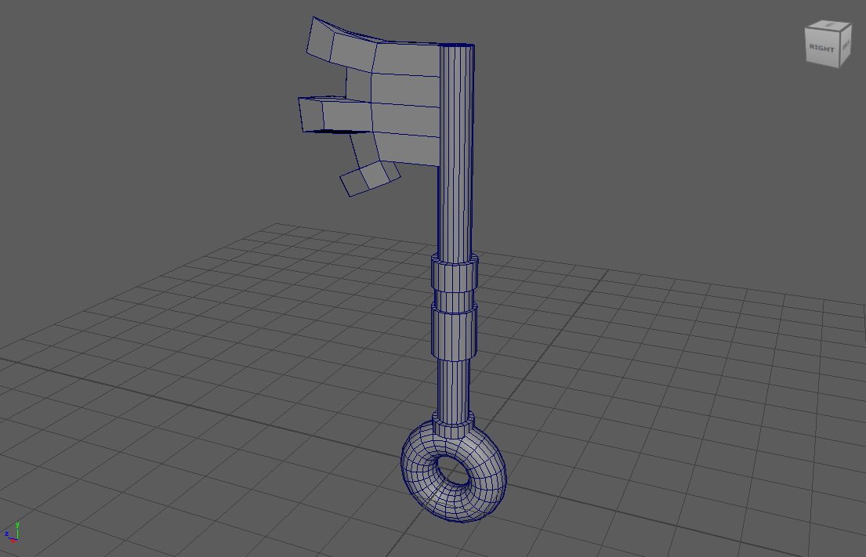

3 Nov – Dumpster Updated
I wasn’t happy with the previous version of the dumpster, so I went back and added some more detail using more references this time. I found another dumpster model online which had multiple views and versions, which was particularly useful. [5]
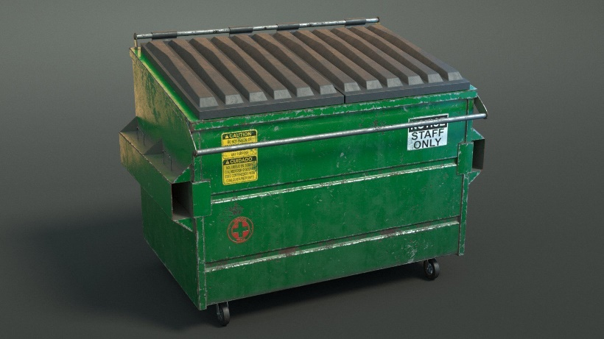[5]
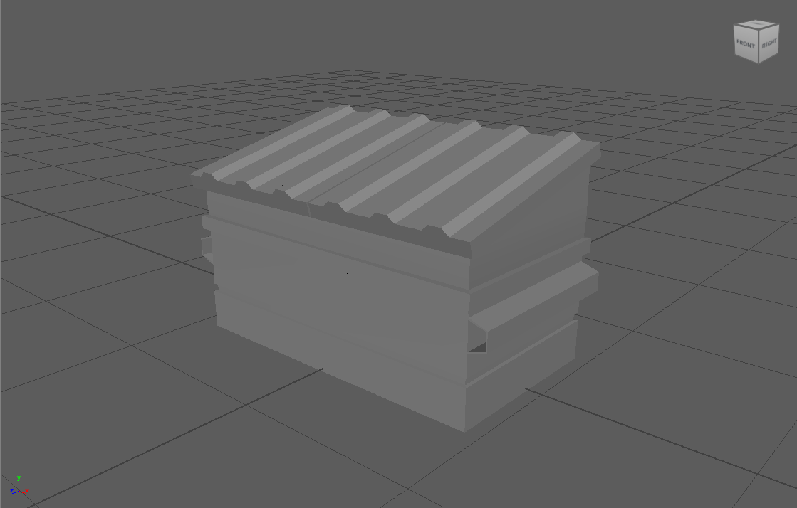
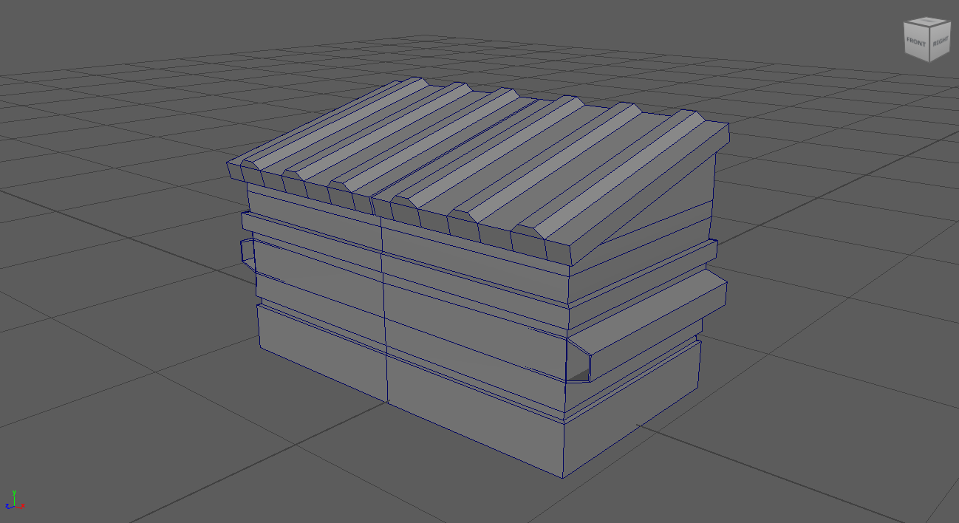

House – 10 Nov
This model is inspired by this concept art because I liked the shapes and creativity in its architecture. [6]
I had some trouble seeing the details of the house while modeling since I could not see the depth. I found that the best solution without adding full lighting was to add simple ambient occlusion [7].
Overall, this is my favorite model that I have made this term, because I spent a lot of time on it and the result turned out very good.
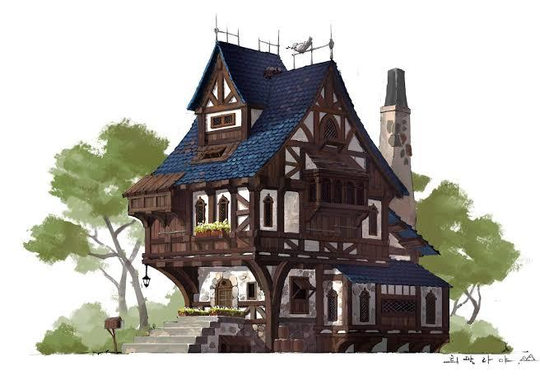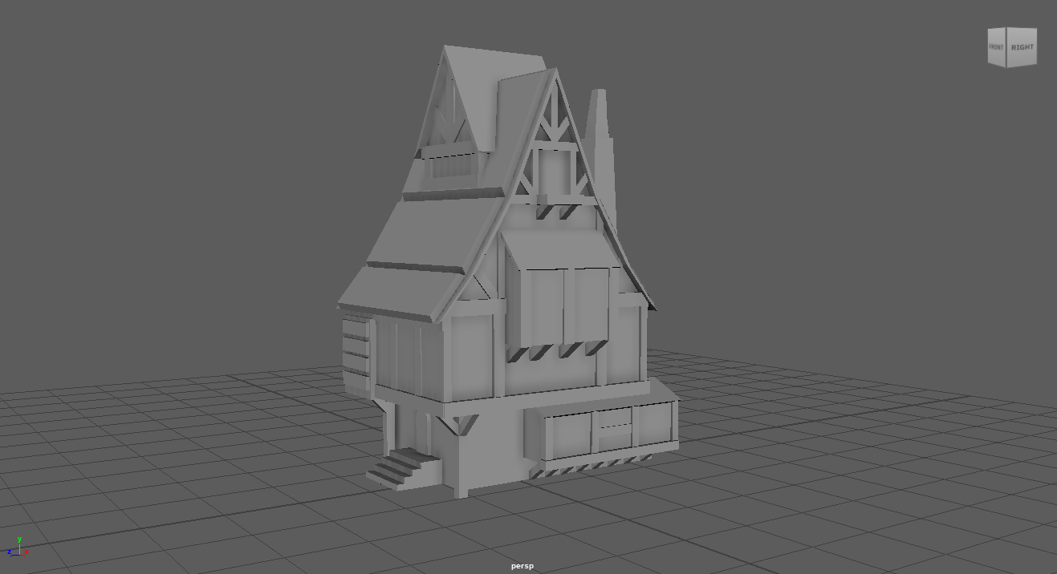
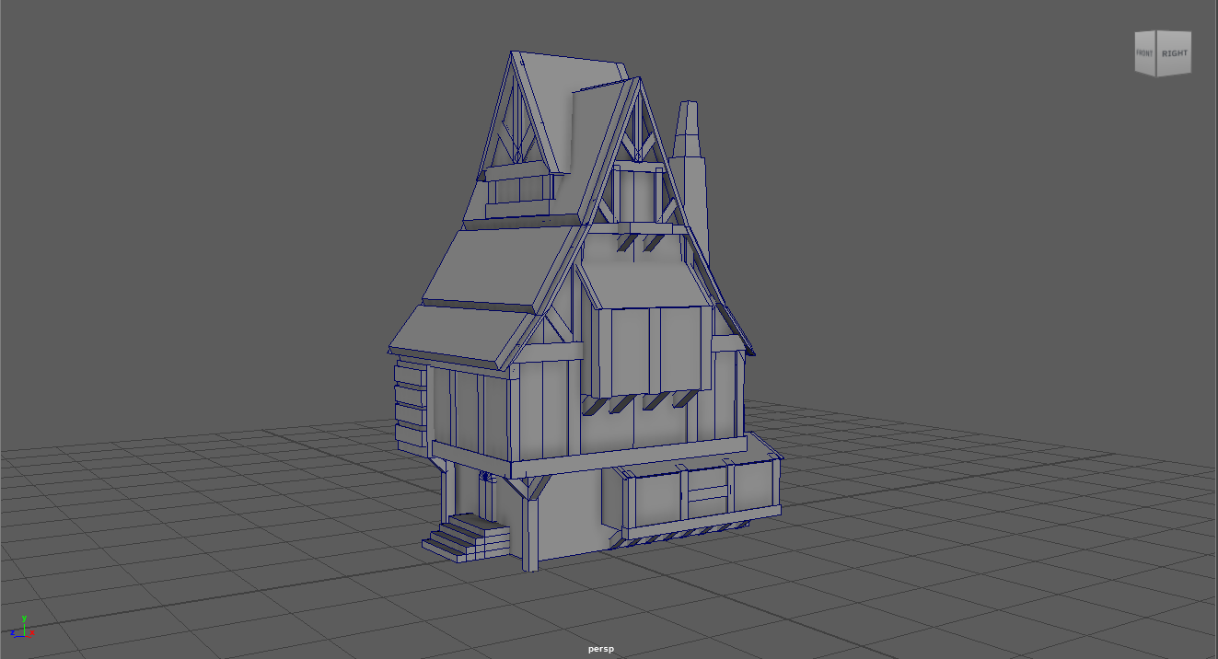

Cup and Saucer
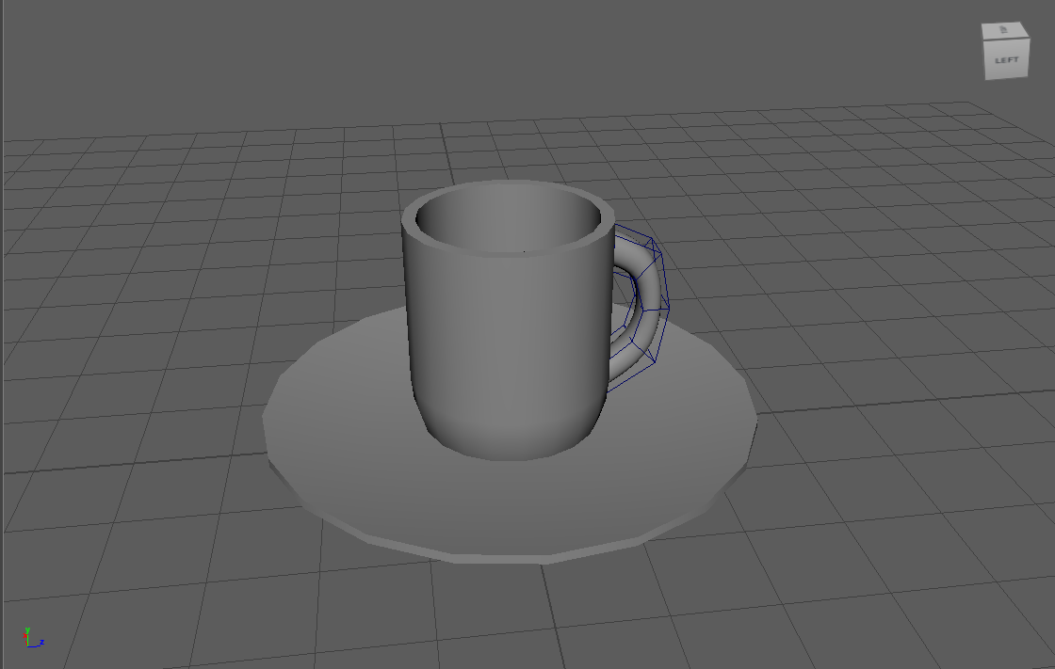
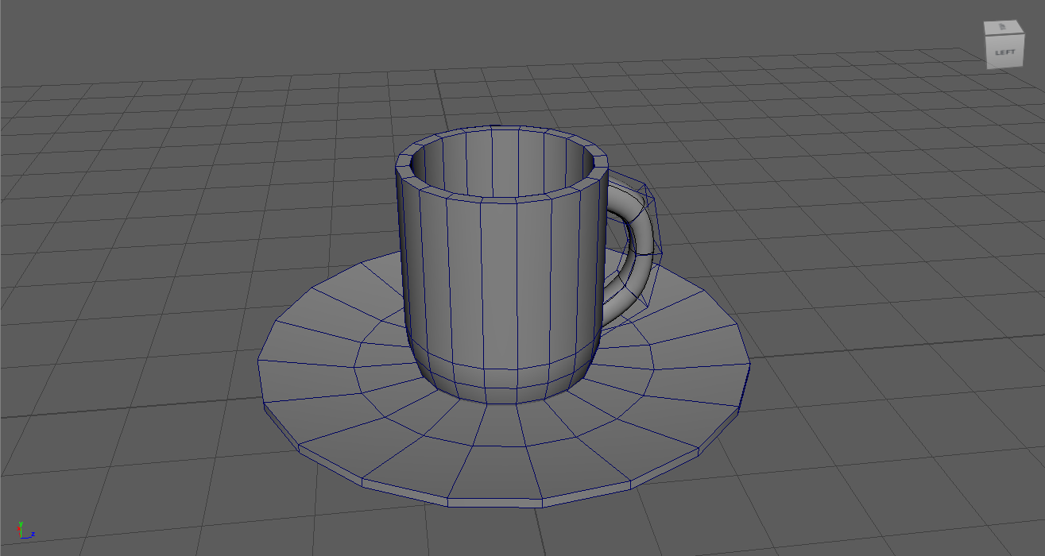

16 Nov – Knife Fork
I wanted to make something more creative than a simple knife and fork, so I made a completely useless knife fork combo with the knife being part of the handle of the fork.
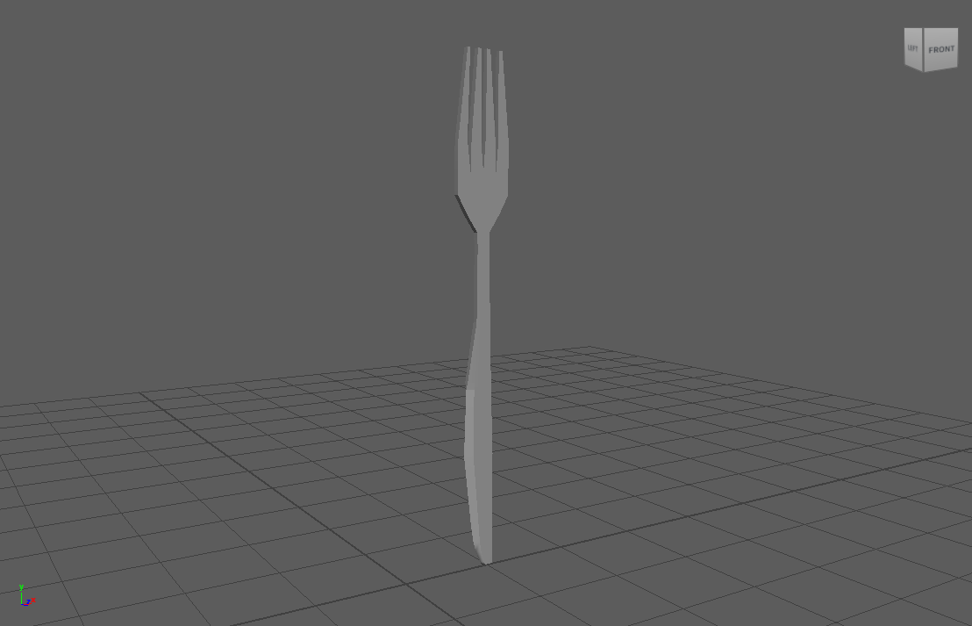
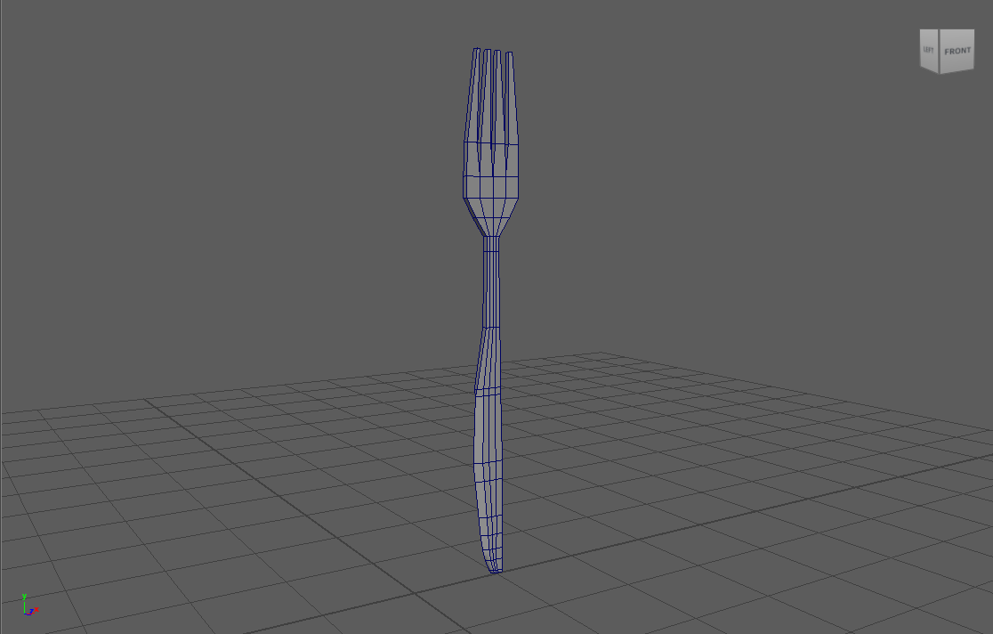

Flying Pan
The prompt was to make a “frying pan,” so I made a Flying pan instead. The wings are overly simplistic, and I wish I had spent more time making them look better. I like how the shape of the frying pan and handle came out.
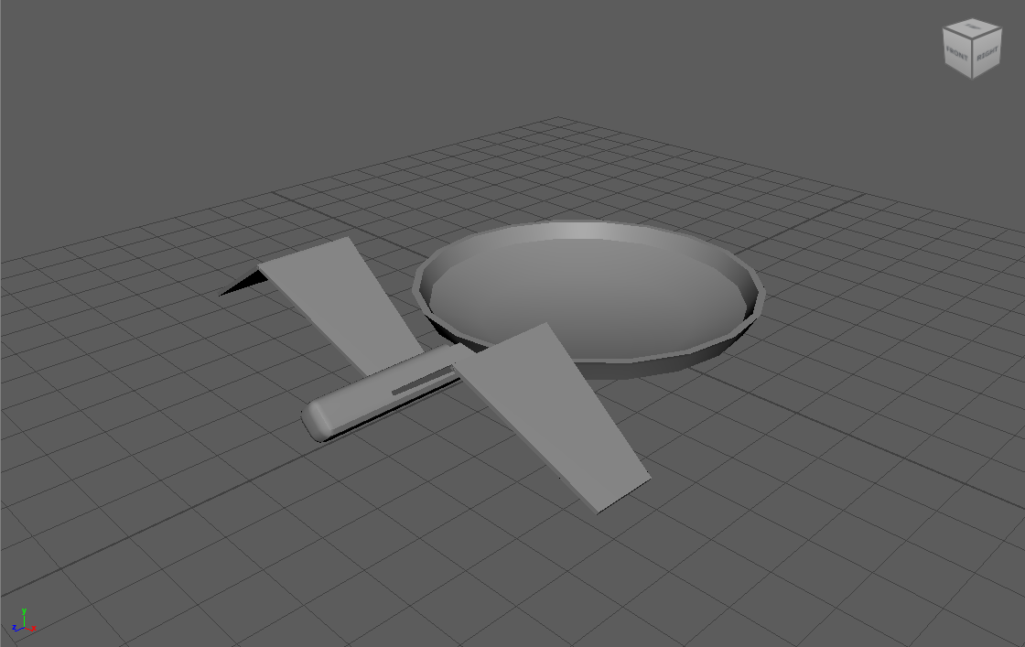
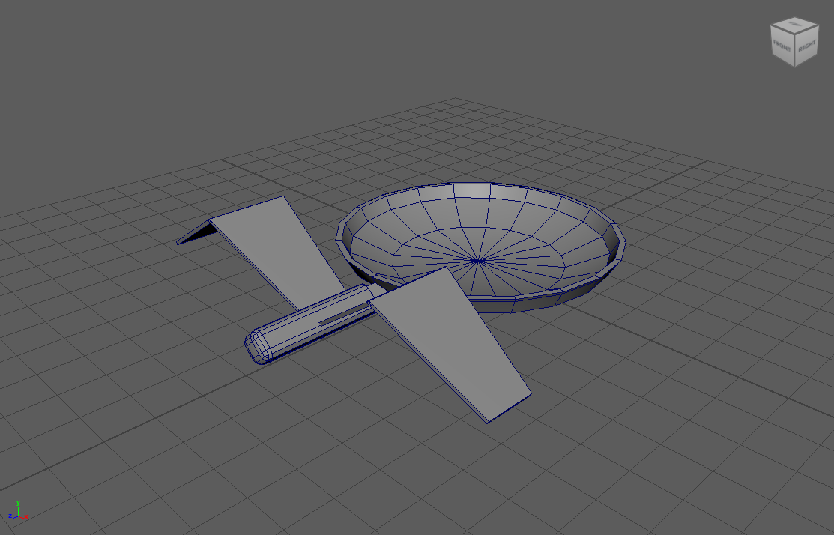

Bibliography
[1] G. Maestri, “Maya 2024 Essential Training,” LinkedIn, https://www.linkedin.com/learning/maya-2024-essential-training/setting-up-reference?u=77966930 (accessed Oct. 27, 2023).
[2] Autodesk Maya, Merge selected components, https://help.autodesk.com/view/MAYAUL/2023/ENU/?guid=GUID-2DF066DD-4C1C-462E-9F8C-FA52FA9D9B16 (accessed Nov. 21, 2023).
[3] “Kullen White, chest of 2 drawers, 35x49 cm,” IKEA, https://www.ikea.com/gb/en/p/kullen-chest-of-2-drawers-white-80309241/ (accessed Nov. 21, 2023).
[4] M. Zav., “Mimic - chest by MZ4250 on Shapeways,” Shapeways.com, https://www.shapeways.com/product/BCEVUY7G7/mimic-chest (accessed Nov. 23, 2023).
[5] gasparenigam, “Dumpster garbage can on Wheels: 3D model,” CGTrader, https://www.cgtrader.com/3d-models/industrial/other/dumpster-e9b71269-693c-48ee-a952-5bc70c2e0cbc (accessed Nov. 17, 2023).
[6] J. Millhauser, “Medieval House,” Artstation, https://jonathanmillhauser.artstation.com/projects/v1lVRx (accessed Nov. 17, 2023).
[7] F. Fröhlich, “Advanced maya viewport 2.0 setup,” Teach Desk, https://tech.gameschool.inn.no/maya-viewport-2-0/#:~:text=In%20the%20Viewport%20go%20to,maximize%20Samples%2C%20Radius%20and%20Filter. (accessed Nov. 15, 2023).

Conclusion
Overall, I think this module’s work went quite well. I already have some experience using Blender 3D for modeling and other 3D work, so the concepts and theory of 3D modeling were already familiar to me. However, the methods and practical problem solving were a lot more difficult to understand. Despite having similar functions, Maya and Blender are very different in terms of workflow. Especially during the beginning of this course, I spent a lot of time fighting against my Blender muscle memory and researching equivalent tools and functions to the features I was familiar with. Eventually I learned how to think in Maya terms and my speed and enjoyment of 3D modeling using Maya greatly increased.
In terms of the models themselves I think one of the main areas I need to improve on is consistency. Some of these models have quite a lot of detail and clear attention to references, while others are simple primitive shapes merged together. I think that it would be worthwhile to spend more time working on each model and getting them to a passable level before moving on to the next project, and to not spend too much time on a single model.
Most of these models have reasonably clean topology, however in the future I would also like to focus on adding good edge flow as well. Adding good edge flow is a good habit to have before working on more advanced topics in the future, such as deforming and rigging.

