



Changemakers: Building your Personal Brand for Sustainable Employment

Component 1: Online portfolio

Student name: Shengyul Mutafcheva
Student ID: 2324059
Module code : BMHP5015_LON
Lecture Name : Caroline Salami

Submitted :

Table of contents

Introduction
This paper presents my reflections on the "Changemakers: Building Your Brand for Sustainable Employment" course and offers key insights into personal and professional development. It assesses various concepts chosen from the four units of the course curriculum. Section 1 centres on motivation, goal setting, and emotional intelligence. Section 2 discusses the ideas of evaluation and persuasion. Section 3 reviews the concepts of work value and serendipity mind, while Section 4 highlights resilience and the significance of mentors.

Reflection on Unit 1
The first unit raised my awareness of essential concepts, such as motivation, setting goals, mastery, and emotional intelligence, all of which are related to personal and professional success and their impact on career development.
2.1. The Role of Motivation
Motivation is a psychological drive that influences how individuals behave, guiding their efforts towards goals, whether they are daily tasks or long-term aims such as career development (Psychology Today, 2020) and shaping their approach to challenges (Denys, 2025). It includes both intrinsic motivation, which originates from within, and extrinsic motivation, sourced externally (Wang and Chen, 2022). Balancing these motivations is vital for continuous success and satisfaction in the workplace.
A good real-life example is my motivation to pursue a career in HSC, which involves establishing attainable objectives and exhibiting resilience to overcome challenges and adapt to change. All these qualities are essential for job satisfaction, performance, and sustained professional development.
The key theories of motivation are Maslow's hierarchy of needs (Figure 1) and Vroom’s expectancy theory (Figure 2). Maslow's theory posits that basic needs must be fulfilled before individuals can address higher-level needs, thus organising human requirements from fundamental to complex (Bandhu et al., 2024). Vroom’s expectancy theory suggests that behaviour is driven by the expectation that efforts will lead to desired performance and rewards (Riggio, 2017).

.

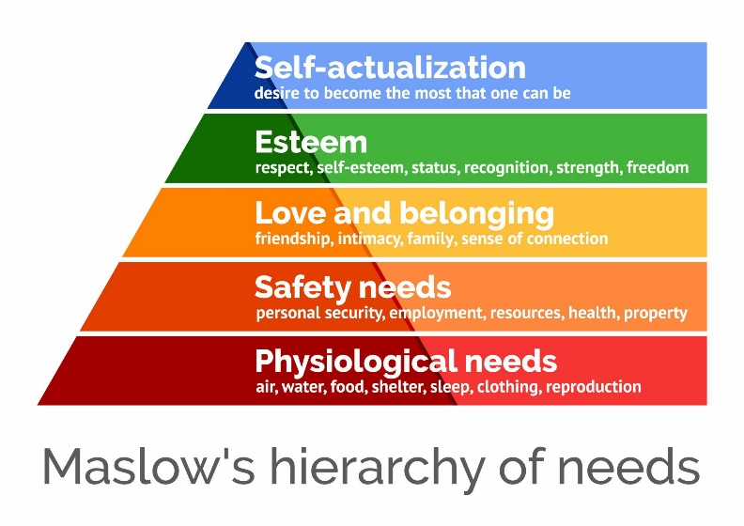
Figure 1: Maslow's hierarchy of needs (McLeod, 2025)

Figure 2: Expectancy theory (Sutton, 2024)

Forum activity

2.2. Setting goals

Goal setting is the systematic process of developing an action plan to attain specific objectives, providing guidance and motivation to individuals and organisations (Globy, 2025). Using the SMART framework when setting personal and career goals is beneficial for transforming general goals into specific, measurable, achievable, relevant, and time-bound objectives (Bjerke and Renger, 2017). SMART goals facilitate the clarification of priorities, ensuring focused and adequate progress toward desired outcomes, whether for personal development, career advancement, or corporate expansion (Globy, 2025).

This course offered insights into SMART goals and strategies for effectively setting them. I often use the SMART method for my academic aims, such as for my independent research paper (Figure 3). However, I find it difficult to establish more complex SMART goals, especially those related to my career development.

Forum activity

Figure 3: My SMART goal for my independent research

The most well-known theory for goal-setting interventions is Goal-Setting Theory (GST). GST establishes a connection between intentional objectives and task performance (Locke and Latham, 2019), suggesting that goal setting enables individuals to focus on appropriate actions, increases motivation, enhances perseverance for challenging objectives, and supports the development of effective solutions (Jeong et al., 2023). GST helped me understand how objectives shape actions, and how factors, including task complexity, self-efficacy, commitment, goal importance, and goal qualities (like difficulty and specificity) might influence these outcomes (Laranjo, 2016).

2.3. Emotional intelligence
Emotional intelligence (EI), is the capacity to identify and label one's own emotions and those of others, use emotional information for decision-making, and manage emotions to adapt to various situations and achieve goals (Bru-Luna et al., 2021. It plays a vital role in effective communication, stress alleviation, empathy, problem-solving, and conflict mitigation (Segal et al., 2025)..
The course increased my awareness of EI and helped me understand concepts such as self-awareness, self-regulation, social awareness (empathy), and relationship management. I also learned how to improve my emotional and social skills. EI now helps me manage stress, speak clearly, overcome obstacles, and form meaningful connections. Despite these improvements, I still struggle to understand others' emotions, which hampers my communication.
A key model of EI is Goleman's Emotional Intelligence Performance Model. Goleman states that EI comprises a set of skills and competencies, outlining five key components of EI and their relationship to performance (Figure 4). These elements help individuals understand and manage their own emotions while recognising and influencing others' emotions, leading to improved leadership, collaboration, and overall effectiveness (Craig, 2019).
Forum activity
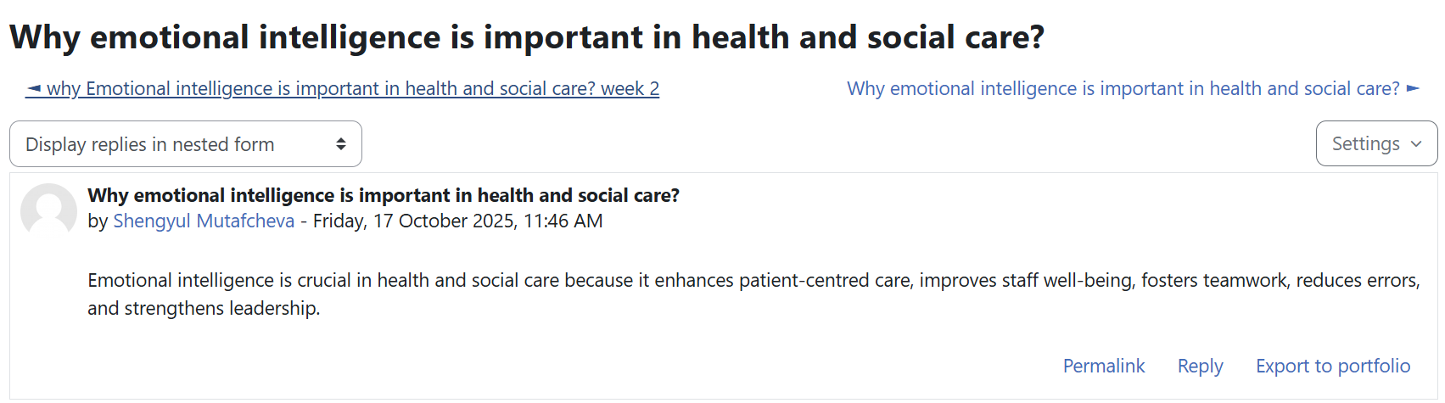

Figure 4: Goleman's Emotional Intelligence Performance Model (Uluc, 2023)

- Reflection on Unit 2
The second unit heightened my awareness of concepts related to evaluation and persuasion, helping me understand different types of evaluation and the applications of persuasion on individuals and communities.
3.2. Evaluation
It is proven that learning and making judgments about work can be facilitated by the evaluation process, which involves working through an organised approach. Evaluation includes collecting information to enhance understanding of the work's design, implementation, and subsequent outcomes (DHSC, 2022). Evaluation in health and social care is defined as a systematic and methodical examination of a policy, program, or intervention to ascertain its effectiveness, identify its strengths and weaknesses, and inform future decision-making (Faculty of Public Health, 2018). The course helped me understand and differentiate between the different types of evaluation (Figure 5).
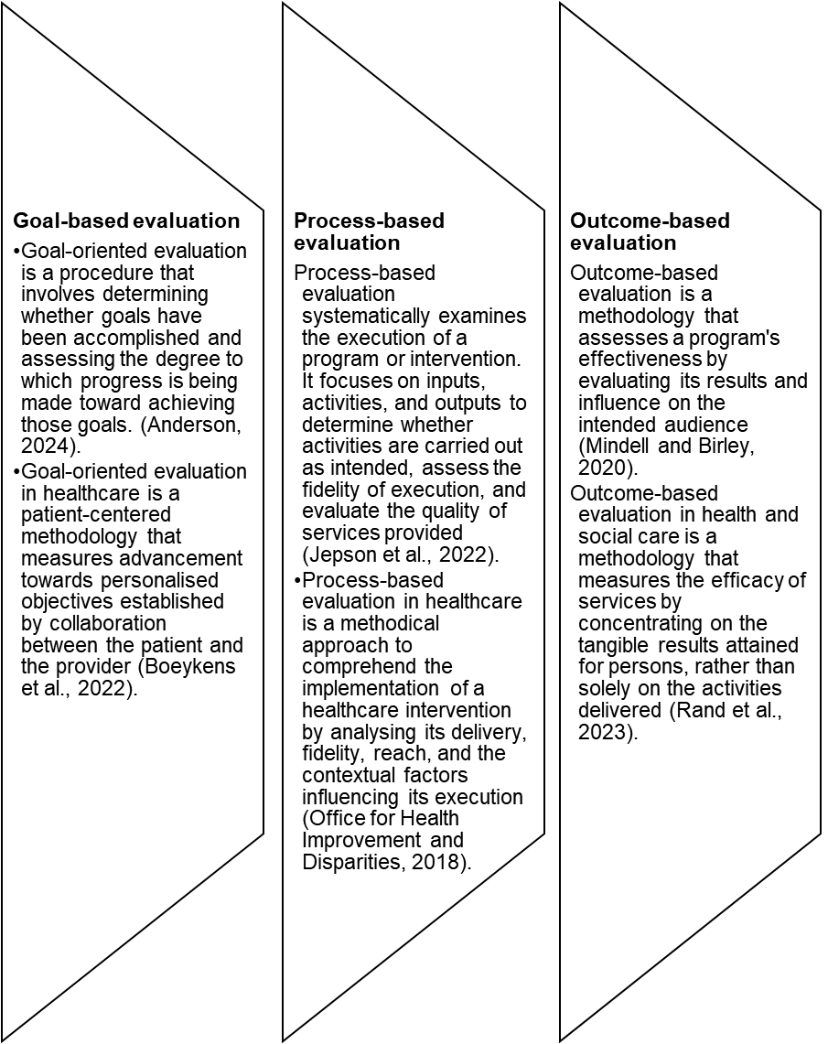

Figure 5: Types of evaluation

I typically use goal-based evaluation to assess the achievement of my objectives and to measure progress toward them. A good example of outcome-based evaluation is the Adult Social Care Outcomes Framework, which assesses care effectiveness and enhances transparency and accountability (DHSC, 2024). Notably, it assesses the effectiveness of care and support services in achieving the outcomes that are most important to individuals. However, concentrating on quantifiable results may oversimplify complex processes, resulting in a "teach to the exam" approach instead of promoting genuine understanding (Nguyen, 2024).
The framework of process-based evaluation employs intervention theories like the theory of change to assess intervention implementation and effectiveness. This theory articulates the mechanisms and rationale behind a program (Government Analysis Function, 2025) and aids in planning and evaluation by mapping the relationship between actions and outcomes (Australian Institute of Family Studies, 2021).
3.3. Persuasion
Persuasion is a form of social influence that changes the views or behaviours of individuals or groups (Cherry, 2023). It can be explicit or implicit and often shapes decisions and actions (Communication of Governance and Accountability Program, 2025). Persuasive messages utilise symbols like words, images, and sounds to influence responses. In healthcare contexts, effective persuasion is crucial for communication and empowering professionals to influence decision-making (Figure 6).

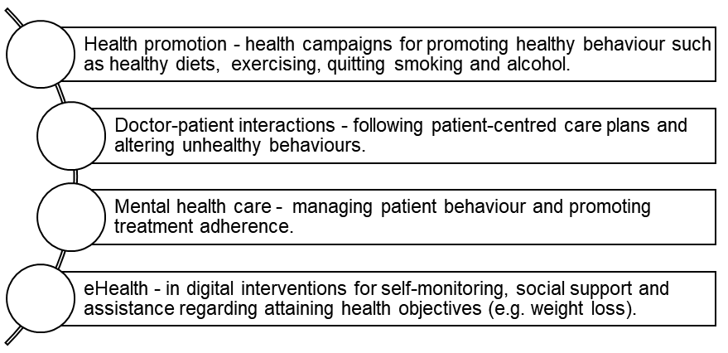
Figure 6: Application of persuasion in HSC (Rubinelli, 2013; Reardon, 2016; Asbjørnsen et al., 2019; Rossi, 2021)

A good example of persuasion in HSC is rational persuasion — employing reasoning and evidence to assist patients in making informed decisions that align with their objectives (Geurts et al., 2021). Persuasion in HSC contexts involves influencing individuals' attitudes and behaviours to enhance health and well-being, while respecting their autonomy and ensuring informed choice.
The theoretical framework of persuasion includes Cognitive Dissonance Theory (CDT) and Social Judgment Theory (SJT). CDT sheds light on the factors that influence people to alter their perspectives, focusing on the interplay of the individual's motivations, perceptions, and cognitions (Cooper, 2015). SJT, on the other hand, explains how people form opinions on persuasive messages by contrasting them with their own preconceived notions, or "anchor" attitudes (Cooksey, 2014).

Forum activity

4.Reflection on Unit 3

The course material of this unit increased my awareness of work values and helped me understand the concept of the serendipity mindset. I am aware that both can influence my career advancement, leading to sustainable growth and success.
4.2. Serendipity mindset
The serendipity mindset emphasises turning unexpected events into positive outcomes through deliberate effort (Busch, 2024). A "serendipity mindset" greatly influences career development by transforming unexpected events and interactions into opportunities for growth, creativity, and new pathways (Collins et al., 2025). Serendipity is an active rather than a passive process (Figure 9). It involves active strategies and specific skills rather than mere chance, emphasising the importance of non-linear phenomena and serendipitous triggers (University of Cambridge, 2023).

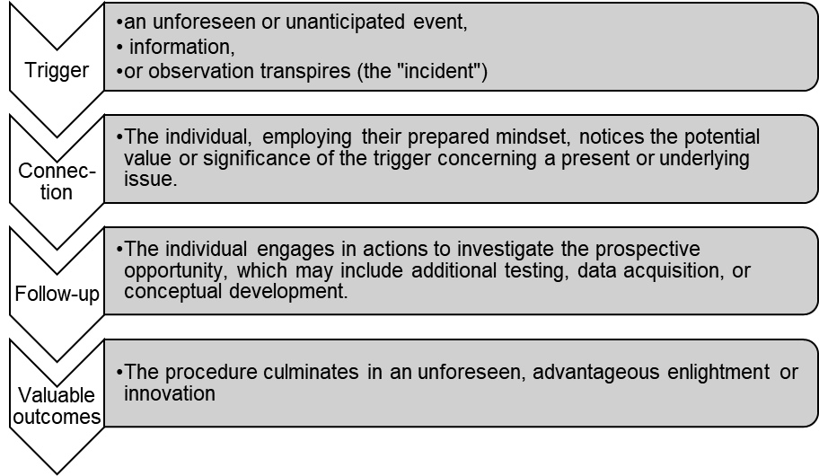
Figure 9: The process of serendipity University of Cambridge, 2023)

A good real-life example of a serendipity mindset is how I turned an unexpected interaction into an opportunity for a new career. A casual conversation with a retired university lecturer at a community gathering prompted me to apply to the university where I am currently pursuing my HSC degree.
The theory underlying the serendipity mind is the Serendipitous Cognition Model (SCM). It provides a framework for understanding how individuals make lucky, unintentional discoveries by viewing cognition as a process that involves the environment (Ross, 2024). The approach highlights the dynamic interplay between an individual and their environment, rather than perceiving cognition as solely internal. SCM conceptualises serendipity as a three-part cognitive process (Figure 10).
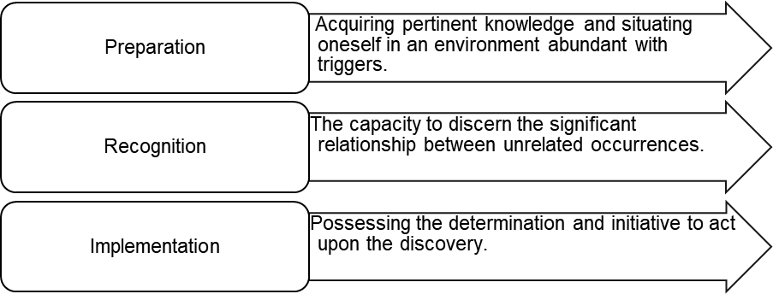
Figure 10: The SCM process
Forum activity

4.3. Work value
Work values refer to a set of attributes, concepts, ideals, and beliefs that are pertinent to an individual’s workplace. They support their motivation, attitude, and behaviours that shape their work style and the decisions they make in their professional life. Work values are linked to the indicators of successful employment transition (e.g., employment status) and job quality (e.g., the extent of person-job alignment) (Noori, 2023). The course material helped me understand and differentiate between "extrinsic” and “intrinsic” values. While the former are based on factors such as financial stability and job security, the latter are based on factors such as the opportunity to utilise one's skills, autonomy, and enjoyment of one's work (Sortheix et al., 2015).
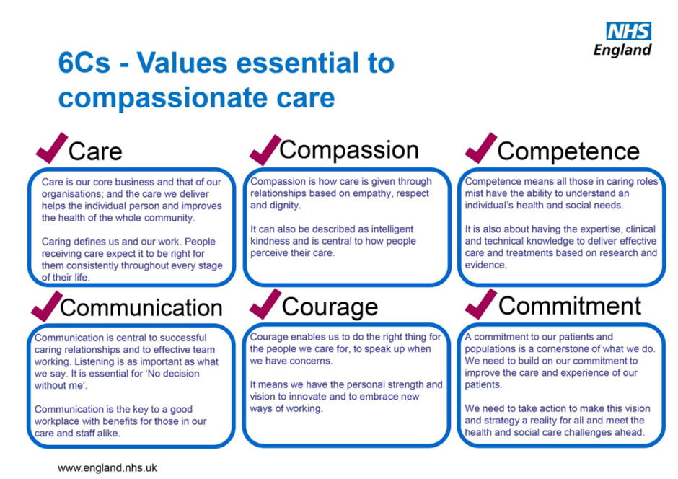Figure 7: Six Cs Values in Care (Hodder, 2022)
A good example of work values in HSC is the 6 Cs of Care (Figure 7), which govern professional behaviour in the NHS and create the groundwork for person-centred and ethical practice (Northern Healthcare, 2025). Apart from them, respect, dignity, and a focus on the individual's well-being, rights, and needs are good examples of work values in HSC (Future Learn, 2025). The values that shape my work are autonomy, innovation, teamwork, diversity and inclusion. I value both working independently and, in a team, using creativity and innovative technology at work, and respecting all colleagues regardless of their gender, age, disability, and ethnicity.
The theory supporting work value is Schwartz's Theory of Basic Values, which identifies ten core values that are universal across cultures, grouped into four higher-order dimensions: Openness to Change, Conservation, Self-Enhancement, and Self-Transcendence (Figure 8). This model is based on the idea that values help individuals and groups navigate universal human requirements related to individual needs, social interaction, and group survival (Schwartz, 2022).
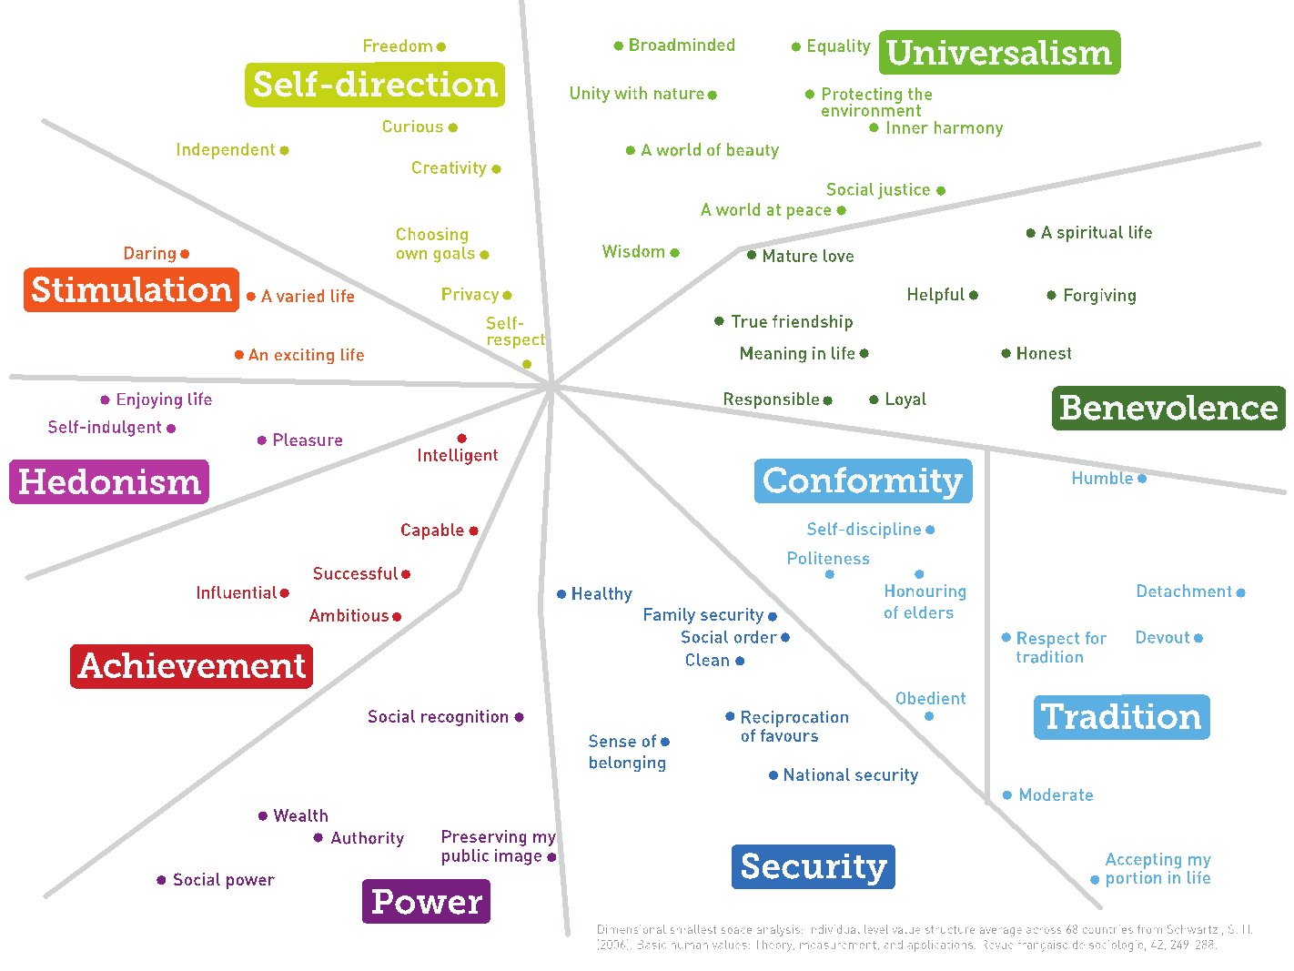
Figure 8: Schwartz's Theory of Basic Values (Potts, 2015)

5. Reflection on Unit 4
The fourth unit materials helped me realise how important resilience and mentors might be in my career development.
5.2. Resilience
Broadly defined, resilience is the process of effectively adapting to adversity, trauma, and significant stressors (APA, 2014, para 4). Evidence suggests that individuals with strong resilience effectively manage stress and recover faster than those with lesser resilience (Rosenberg et al., 2019). In a career context, resilience involves persisting toward career goals using already developed resources and techniques (Seibert et al., 2016).
I am now aware of the role of resilience in my academic and career development. I have realised that I have the resilience to cope with academic stress. However, I find it challenging to adapt to new educational and career situations. To improve my resilience. I can develop stress-management techniques (e.g. mindfulness) and self-regulation skills, and perceive new situations as opportunities for learning and growth rather than as setbacks.
The theoretical framework of resilience encompasses Resiliency Theory, which emphasises both internal strengths (e.g. self-efficacy) and external supports (e.g. mentors and programs) (Zimmerman, 2013). While resilience is defined as a personality attribute, resiliency is described as a process or capacity that can be developed or instructed (Park et al., 2021). Research indicates that the Resiliency theory was used in resilient treatment, increasing patients’ resilience to cope with chronic stress by developing fundamental coping strategies (Park et al., 2021).
5.3.Importance of mentors and their roles
A mentor is a reliable, experienced individual who offers direction, support, and advice to a less experienced individual (mentee) to facilitate skill development and the attainment of personal or professional objectives (University of Oxford, 2025). Although mentoring resembles coaching, mentors typically have more hands-on expertise in the mentee's chosen career path and serve as role models, sharing knowledge and personal experience and facilitating career progression (University of Southampton, 2025). The key roles of the mentors are summarised in Figure 8.
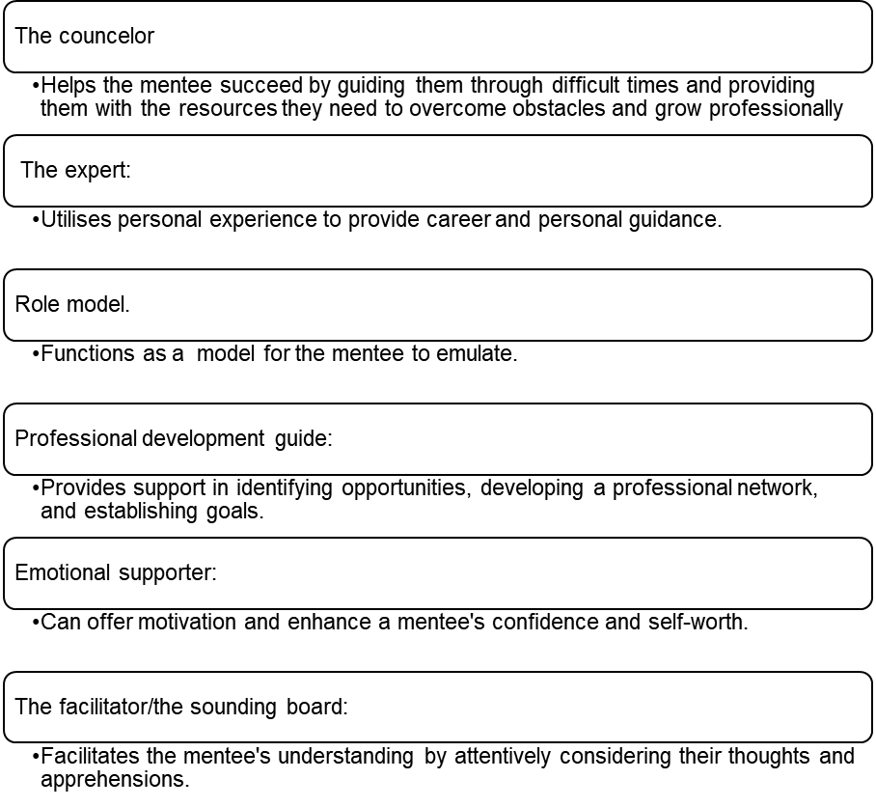
Figure 8: Roles of the mentors (Dahlberg and Byars-Winston, 2019)

A good real-life example is my experience with my mentor at the nursery where I worked for three years. She helped me gain knowledge about infant psychological and emotional development. She was a good role model and guide. She emotionally supported me when I struggled to deal with naughty children.
The Social Cognitive Career Theory (SCCT) provides a theoretical foundation for mentorship. SCCT discusses the development of career interests, decision-making about career paths, and the attainment of success, highlighting the interactions among self-efficacy (confidence in one's capabilities), outcome expectations (anticipations of the outcomes of actions), and goal formulation (Yao and McWha-Hermann, 2025). Personal characteristics are shaped by an individual's learning experiences and contextual effects, such as social support and cultural factors, resulting in a dynamic interplay that determines career trajectories (Wang et al., 2022).
Forum activity

6. Conclusion
In this paper, I have reflected on several concepts covered in this course and demonstrated my understanding. Evaluating the selected concepts and connecting them to relevant theories helped me develop my reflective, analytical, and critical skills. The knowledge gained from this course broadened my horizons and changed my beliefs and attitudes about the covered topics. The course also provided me with practical resources for my professional growth.

7. References
‌Asbjørnsen, R.A., Smedsrød, M.L., Solberg Nes, L., Wentzel, J., Varsi, C., Hjelmesæth, J. and van Gemert-Pijnen, J.E. (2019) ‘Persuasive System Design Principles and Behavior Change Techniques to Stimulate Motivation and Adherence in Electronic Health Interventions to Support Weight Loss Maintenance: Scoping Review’, Journal of Medical Internet Research, 21(6), p.e14265. Available at: https://doi.org/10.2196/14265.
Australian Institute of Family Studies (2021) What is theory of change? Available at: https://aifs.gov.au/resources/practice-guides/what-theory-change (Accessed: 29 November 2025).
Bandhu, D., Mohan, M.M., Nittala, N.A.P., Jadhav, P., Bhadauria, A. and Saxena, K.K. (2024) ‘Theories of motivation: A comprehensive analysis of human behavior drivers’, Acta Psychologica, 244(1), pp.1–16. Available at: https://doi.org/10.1016/j.actpsy.2024.104177.
‌Bjerke, M.B. and Renger, R. (2017) ‘Being smart about writing SMART objectives’, Evaluation and Program Planning, 61(1), pp.125–127. Available at: https://doi.org/10.1016/j.evalprogplan.2016.12.009.
Bru-Luna, L.M., Vilar, M.M., Soto, C.M. and Santiago, J.L.C. (2021) ‘Emotional Intelligence Measures: a Systematic Review’, Healthcare, 9(12). Available at: https://doi.org/10.3390/healthcare9121696.
‌Busch, C. (2024) ‘Towards a Theory of Serendipity: A systematic Review and Conceptualization’, Journal of Management Studies, 61(3), pp.1110-1151.
Cherry, K. (2023) How Today’s Approach to Persuasion Differs From the Past. Available at: https://www.verywellmind.com/what-is-persuasion-2795892 (Accessed: 15 November 2025).
Chiodo, D., Turpin, A., Wolfe, J., Darnay, K. and Henderson, J. (2025) ‘Measuring Goal Progress Using the Goal‐Based Outcome Measure in Youth Wellness Hubs Ontario—An Integrated Youth Services Network’, Health Expectations, 28(2). Available at: https://doi.org/10.1111/hex.70240.
Collins II, R. T., Roth, S., Singh, M., and Sanford, R. (2025) ‘The Nature of Serendipity and Its Effect on Success in Academic Medicine’, American Journal of Qualitative Research, 9(3), pp. 47-60. Available at: https://doi.org/10.29333/ajqr/16533.
Communication of Governance and Accountability Program (2025) Persuasion Defining Persuasion. Available at: https://assets.publishing.service.gov.uk/media/57a08b6d40f0b64974000b44/Persuasionweb.pdf (Accessed: 15 November 2025).
Cooper, J. and Carlsmith, K.M. (2015) ‘Cognitive Dissonance’, International Encyclopedia of the Social & Behavioral Sciences, pp.76–78. Available at: https://doi.org/10.1016/b978-0-08-097086-8.24045-2.
Craig, H. (2019) The Theories of Emotional Intelligence Explained. Available at: https://positivepsychology.com/emotional-intelligence-theories/ (Accessed: 10 November 2025).
Creel, A. (2011) Social Judgment Theory: Summary. Available at: https://smashtyn.wordpress.com/2011/04/21/social-judgment-theory/ (Accessed: 15 November 2025).
Dahlberg, M.L. and Byars-Winston, A. (2019) The science of mentoring relationships: What is mentorship? National Academies Press (US). Available at: https://www.ncbi.nlm.nih.gov/books/NBK552775/.
Denys, A. (2025) The Role of Motivation in Achieving Career Goals. Available at: https://psychotricks.com/role-of-motivation-in-achieving-career-goals/ (Accessed: 27 October 2025).
Department of Health and Social Care (2022) DHSC: evaluation strategy. Available at: https://www.gov.uk/government/publications/dhsc-evaluation-strategy/dhsc-evaluation-strategy#:~:text=dhsc%2Devaluation%2Dstrategy-,Introduction,%2C%20culture%2C%20capacity%20and%20capability (Accessed: 29 November 2025).
Department of Health and Social Care (2022) DHSC: evaluation strategy. Available at: https://www.gov.uk/government/publications/dhsc-evaluation-strategy/dhsc-evaluation-strategy (Accessed: 15 November 2025).
Department of Health and Social Care (2024) The adult social care outcomes framework: handbook of definitions. Available at: https://www.gov.uk/government/publications/adult-social-care-outcomes-framework-handbook-of-definitions/the-adult-social-care-outcomes-framework-handbook-of-definitions (Accessed: 15 November 2025).
Faculty of Public Health (2018) Study design for assessing effectiveness, efficiency and acceptability of services including measures of structure, process, service quality, and outcome of health care. Available at: https://www.healthknowledge.org.uk/public-health-textbook/research-methods/1c-health-care-evaluation-health-care-assessment/study-design-assessing-effectiveness (Accessed: 29 November 2025).
Future Learn (2025) Social Care Values and Behaviours. Available at: https://www.futurelearn.com/info/courses/step-into-social-care/0/steps/159258 (Accessed: 16 November 2025).
Geurts, E.M.A., Pittens, C.A.C.M., Boland, G., van Dulmen, S. and Noordman, J. (2021) ‘Persuasive communication in medical decision-making during consultations with patients with limited health literacy in hospital-based palliative care’, Patient Education and Counseling, 105(5). Available at: https://doi.org/10.1016/j.pec.2021.08.022.
Globy (2024). What is Goal Setting? Available at: https://gogloby.io/glossary/goal-setting/ (Accessed: 10 November 2025).
Government Analysis Function (2025) The Theory of Change Process – Guidance for Outcome Delivery Plans – Government Analysis Function. Available at: https://analysisfunction.civilservice.gov.uk/policy-store/the-analysis-function-theory-of-change-toolkit/ (Accessed: 23 November 2025).
Hodder, D. (2022) The 6 Cs of Health and Social Care. Available at: https://www.davidhodder.com/the-6-cs-of-health-and-social-care/ (Accessed: 16 November 2025).
Jeong, Y.H., Healy, L.C. and McEwan, D. (2023) ‘The Application of Goal Setting Theory to Goal Setting Interventions in sport: a Systematic Review’, International Review of Sport and Exercise Psychology, 16(1), pp.1–26. Available at: https://www.tandfonline.com/doi/full/10.1080/1750984X.2021.1901298.
Jepson, R., Baker, G., Sivaramakrishnan, D., Manner, J., Parker, R., Lloyd, S. and Stoddart, A. (2022) ‘Process evaluation: methods and results’, National Library of Medicine. Available at: https://www.ncbi.nlm.nih.gov/books/NBK587733/.
Laranjo, L. (2016) ‘Social Media and Health Behavior Change’, Participatory Health Through social media, 6, pp.83–111. Available at: https://doi.org/10.1016/b978-0-12-809269-9.00006-2.
Locke, E. A. and Latham, G. P. (2019) ‘The development of goal setting theory: A half century retrospective’, Motivation Science, 5(2), 93–105. Available at: https://doi.org/10.1037/mot0000127.
‌McLeod, S. (2025) Maslow’s hierarchy of needs. Available at: https://www.simplypsychology.org/maslow.html. (Accessed: 1 November 2025).
Nguyen, N. (2024) Measure learning outcomes: Challenges and best strategies. [online] Feedbackfruits.com. Available at: https://feedbackfruits.com/blog/measuring-learning-outcomes-benefits-and-challenges (Accessed: 23 November 2025).
Noori, R. (2023) What Are Work Values? 21 Examples and How To Define Your Own. Available at: https://spotlight.beapplied.com/posts/what-are-work-values-21-examples-and-how-to-define-your-own (Accessed: 15 November 2025).
Northern Healthcare (2021) The 6 Cs in Health and Social Care. Available at: https://www.northernhealthcare.org.uk/news-resources/the-6-cs-in-health-and-social-care/ (Accessed: 16 November 2025).
Office for Health Improvement and Disparities (2018) Process evaluation: evaluation in health and wellbeing. Available at: https://www.gov.uk/guidance/evaluation-in-health-and-wellbeing-process (Accessed: 15 November 2025).
Park, E.R., Luberto, C.M., Chad-Friedman, E., Traeger, L., Hall, D.L., Perez, G.K., Goshe, B., Vranceanu, A.-M., Baim, M., Denninger, J.W., Fricchione, G., Benson, H. and Lechner, S.C. (2021) ‘A comprehensive resiliency framework: theoretical model, treatment, and evaluation’, Global Advances in Health and Medicine, 10(10), p.216495612110003. Available at: https://doi.org/10.1177/21649561211000306.
Psychology Today (2020) Motivation. Available at: https://www.psychologytoday.com/gb/basics/motivation (Accessed: 1 November 2025).
Rand, S., Collins, G., Zhang, W., Milne, A. and Silarova, B. (2023) ‘Applying Outcomes in Community-Based Social Care Practice in England’, Journal of long-term care, pp.33–44. Available at: https://doi.org/10.31389/jltc.169.
Reardon, K. (2016) ‘The Role of Persuasion in Health Promotion and Disease Prevention: Review and Commentary’, Annals of the International Communication Association, 11(1), pp.277–297. Available at: https://doi.org/10.1080/23808985.1988.11678691.
Riggio, R.E. (2017) Introduction to Industrial/Organizational Psychology. Seventh Edition. New York: Routledge. Available at: https://doi.org/10.4324/9781315620589.
Rosenberg, A.R., Bradford, M.C., Junkins, C.C., Taylor, M., Zhou, C., Sherr, N., Kross, E., Curtis, J.R. and Yi-Frazier, J.P. (2019) ‘Effect of the Promoting Resilience in Stress Management Intervention for Parents of Children With Cancer (PRISM-P): A Randomized Clinical Trial’, JAMA network open, 2(9), p.e1911578. https://doi.org/10.1001/jamanetworkopen.2019.11578.
Ross, W. (2024) ‘Accidental Thinking: A Model of Serendipity’s Cognitive Processes’, Review of General Psychology. Available at: https://doi.org/10.1177/10892680241254759.
Rossi, M.G. (2021) ‘Metaphors and Persuasion in Healthcare Communication’, Langages, 222(2), pp.59–76. Available at: https://doi.org/10.3917/lang.222.0059.
Rubinelli, S. (2013) ‘Rational versus unreasonable persuasion in doctor–patient communication: A normative account’, Patient Education and Counselling, 92(3), pp.296–301. Available at: https://doi.org/10.1016/j.pec.2013.06.005.
Segal, J., Smith, M. and Robinson, L. (2025) Improving emotional intelligence (EQ). Available at: https://www.helpguide.org/mental-health/wellbeing/emotional-intelligence-eq. (Accessed: 10 November 2025).
Seibert, S.E., Kraimer, M.L. and Heslin, P.A. (2016) ‘Developing Career Resilience and Adaptability’, Organizational Dynamics, 45(3), pp.245–257. Available at: https://doi.org/10.1016/j.orgdyn.2016.07.009.
Sortheix, F.M., Chow, A. and Salmela-Aro, K. (2015) ‘Work values and the transition to work life: A longitudinal study’, Journal of Vocational Behavior, 89, pp.162–171. Available at: https://doi.org/10.1016/j.jvb.2015.06.001.
Sutton, J. (2024) Victor vroom’s expectancy theory of motivation. Available at: https://positivepsychology.com/expectancy-theory/ (Accessed: 1 November 2025).
Tueanrat, Y.& Alamanos, E. (2025) Cognitive Dissonance Theory: A review. In S. Papagiannidis (Ed), TheoryHub Book. Availabel at: https://open.ncl.ac.uk/theories/7/cognitive-dissonance-theory/#:~:text=Cognitive%20dissonance%20theory%20was%20first,%2C%20attitudes%2C%20beliefs%20or%20behaviours.
‌Uluç, Ö.S. (2023) A Milestone of Intelligent Development: Daniel Goleman’s Emotional Intelligence Theory - Experianta. Available at: https://experianta.com/directory/concepts/a-milestone-of-intelligent-development-daniel-golemans-emotional-intelligence-theory/ (Accessed: 10 November 2025).
University of Cambridge (2023) Innovation at work: the power of serendipity. Available at: https://www.jbs.cam.ac.uk/2023/innovation-at-work-the-power-of-serendipity/ (Accessed: 29 November 2025).
University of Oxford (2025) Mentoring. Available at: https://pod.admin.ox.ac.uk/mentoring (Accessed: 23 November 2025).
University of Southampton (2025) What is mentoring and what does it offer? Available at: https://www.southampton.ac.uk/professional-development/mentoring/what-is-mentoring.page (Accessed: 23 November 2025).
Wang, D., Liu, X. and Deng, H. (2022) ‘The perspectives of social cognitive career theory approach in current times’, Frontiers in Psychology, 13(1023994). Available at: https://doi.org/10.3389/fpsyg.2022.1023994.
Wang, L. and Chen, Y. (2022) ‘Success or growth? Distinctive roles of extrinsic and intrinsic career goals in high-performance work systems, job crafting, and job performance’, Journal of Vocational Behavior, 135. Available at: https://doi.org/10.1016/j.jvb.2022.103714 (Accessed: 27 October 2025).
Yao, C. and McWha-Hermann, I. (2025) ‘Contextualizing career development: Cultural affordances as the missing link in social cognitive career theory’, Journal of Vocational Behavior, 159, p.104114. Available at: https://doi.org/10.1016/j.jvb.2025.104114.
Zimmerman, M.A. (2013) ‘Resiliency Theory: a Strengths-Based Approach to Research and Practice for Adolescent Health’, Health Education & Behavior, 40(4), pp.381–383. Available at: https://doi.org/10.1177/1090198113493782.

‌

‌

‌

‌

‌

‌

‌

‌

‌

‌

‌

‌

‌

‌

‌

‌

‌

‌

‌

‌

‌

‌

‌

‌

