7/23/2026
Data Security and Compliance
Module: ACCA5034
Lecturer: Dr. Dipo Dunsin
Higor Scaffi Dutra do Nascimento (2413595)
University of Wales Trinity Saint David – East london
Contents
Introduction 2
Zero Trust Architecture: A Critical Analysis of its Principles, Implementation Challenges, and Efficacy Compared to Traditional Security Models 3
Traditional Security Model Limitations 3
Core Principles of Zero Trust Architecture 4
Technologies Supporting Zero Trust 4
Implementation Challenges 5
Zero Trust and Regulatory Compliance 5
Task 2: Designing a Zero Trust Cybersecurity Programme for Equifax: A Governance, Risk and Compliance Framework Following the 2017 Data Breach 7
Organisational Structure and Accountability 7
Proposed Cybersecurity Governance Structure 8
Cybersecurity Reporting and Escalation Process 9
Governance Responsibility Matrix (RACI) 10
Zero Trust Governance Model 11
Policies and Procedures 11
Enterprise Cybersecurity Policy Framework 12
Governance and Strategic Alignment 13
Strategic Alignment of Cybersecurity Using the NIST Cybersecurity Framework 2.0 14
Risk Management and Assessment 15
Enterprise Cybersecurity Risk Assessment Matrix 16
Compliance, Incident Response and Protection Controls 17
Enterprise Incident Response Lifecycle 18
Critical Evaluation 19
Conclusion 20
References (Task 1) 22
References (Task 2) 22

Introduction
The increasing sophistication of cyber threats has exposed the limitations of traditional perimeter-based security models, particularly within cloud-based and digitally connected environments. Zero Trust Architecture (ZTA) has emerged as a modern cybersecurity approach based on continuous verification, least-privilege access, and continuous monitoring to reduce organisational risk.
This report is divided into two tasks. Task 1 critically examines the principles, technologies, implementation challenges, and regulatory relevance of Zero Trust Architecture compared with traditional security models. Task 2 applies these concepts to the 2017 Equifax data breach by proposing a Zero Trust cybersecurity programme that addresses governance, policies, risk management, compliance, and incident response. Together, the report demonstrates how Zero Trust can strengthen organisational resilience and support effective cybersecurity governance.
Task 1:

Zero Trust Architecture: A Critical Analysis of its Principles, Implementation Challenges, and Efficacy Compared to Traditional Security Models

Traditional Security Model Limitations
Traditional enterprise security follows a perimeter-based approach in which internal users and systems are considered trustworthy once they have successfully authenticated. Firewalls, Virtual Private Networks (VPNs) and intrusion prevention systems were designed to protect the organisational boundary while allowing relatively unrestricted communication inside the network. Although effective in the past, this model has become increasingly inadequate as organisations adopt cloud services, remote working and mobile technologies [1].
One major weakness is the concept of implicit trust. After initial authentication, users frequently receive broad access to organisational resources without additional verification. If attackers obtain valid credentials through phishing, credential theft or malware, they can often move laterally across systems while appearing to be legitimate users. Many advanced persistent threats (APTs) and ransomware attacks exploit this weakness by remaining undetected for long periods before encrypting or stealing sensitive data [5].
The growth of cloud computing has further reduced the effectiveness of perimeter-based security. Modern organisations often store data and applications across multiple cloud providers and SaaS platforms that exist outside the traditional corporate network. Security policies based solely on network location cannot consistently protect these distributed environments. Consequently, organisations frequently struggle to maintain visibility over sensitive information and user activity [2].
Hybrid working introduces additional challenges. Employees routinely access organisational resources using personal devices and home networks that may not meet corporate security standards. Traditional VPNs provide network-level access rather than application-level access, increasing the attack surface if credentials become compromised. Furthermore, vulnerabilities within VPN software itself have become common attack vectors exploited by cybercriminals [6].
Another limitation is the lack of integrated visibility. Traditional security solutions often operate independently, making it difficult for security teams to correlate events across cloud platforms, identity systems, endpoints and networks. This fragmented visibility delays threat detection and increases attacker dwell time. Security Information and Event Management (SIEM) platforms have improved monitoring capabilities, but perimeter-based architectures still struggle to provide comprehensive visibility across modern digital ecosystems [7].
Traditional security models also provide limited protection against software supply chain attacks. Organisations increasingly depend on third-party software libraries, cloud services and open-source components. Vulnerabilities within these trusted dependencies can allow attackers to compromise organisations indirectly, bypassing conventional perimeter controls. Incidents such as SolarWinds and Log4Shell demonstrated that perimeter security alone cannot defend against attacks targeting trusted software suppliers [8].
Finally, traditional approaches often separate cybersecurity from organisational governance. Security decisions may be treated as technical responsibilities rather than strategic business risks, limiting executive oversight and reducing the organisation's ability to respond effectively to emerging threats. Modern cybersecurity therefore requires governance frameworks that integrate security with organisational objectives, risk management and regulatory compliance [4].

Core Principles of Zero Trust Architecture
Zero Trust Architecture is based on the idea that no user, device or application should automatically be trusted, regardless of whether they are inside or outside the organisation's network. Unlike traditional security models, where trust is granted after a single authentication, Zero Trust requires continuous verification throughout every user session. This approach helps organisations reduce the likelihood of unauthorised access and limits the damage that attackers can cause if credentials are compromised [1].
One of the key principles is continuous verification. Every request to access a system or application is evaluated using several factors, including the user's identity, device security, location and current level of risk. Access is therefore dynamic rather than permanent. If suspicious behaviour is detected, permissions can be reduced or removed immediately without waiting for the session to end. This provides a much stronger defence against modern cyber threats than traditional authentication methods [3].
Another important principle is least-privilege access. Employees should only have access to the information and systems necessary to perform their job roles. Restricting permissions reduces the risk of insider threats and limits the opportunities for attackers to move laterally across networks after compromising an account. Many organisations now combine least privilege with Privileged Access Management (PAM), allowing administrative access only when required and for limited periods of time [8].
Micro-segmentation also plays a significant role in Zero Trust. Instead of allowing unrestricted communication between systems, networks are divided into smaller segments with their own security policies. Even if one segment is compromised, attackers cannot easily move to other parts of the infrastructure without additional authentication. This approach significantly improves containment during security incidents and reduces the overall impact of a breach [1].
Identity management has become the foundation of modern cybersecurity. Strong authentication methods such as Multi-Factor Authentication (MFA), password less authentication and hardware security keys reduce the risk of compromised credentials. NIST recommends combining these technologies with continuous identity validation to improve trust decisions throughout each user session [3].

Technologies Supporting Zero Trust
Although Zero Trust is a security strategy rather than a single product, several technologies help organisations implement its principles effectively.
One of the most important is Zero Trust Network Access (ZTNA). Unlike traditional VPNs, which provide access to large parts of a corporate network, ZTNA only allows users to connect to specific applications they have permission to use. This greatly reduces the attack surface and prevents unauthorised discovery of internal resources [1].
Another important technology is Endpoint Detection and Response (EDR). Since many employees now work remotely using laptops and mobile devices, endpoints have become common targets for attackers. EDR continuously monitors endpoint activity, detects unusual behaviour and can automatically isolate compromised devices before malware spreads throughout the organisation [10].
Security Information and Event Management (SIEM) systems provide centralised monitoring by collecting logs from servers, cloud services, applications and network devices. Modern SIEM platforms often integrate with Security Orchestration, Automation and Response (SOAR) tools to automate routine security tasks such as disabling compromised accounts or blocking malicious IP addresses. This reduces response times and improves an organisation's ability to detect sophisticated attacks [10].
Cloud Security Posture Management (CSPM) has also become increasingly important as organisations migrate to cloud platforms. CSPM tools continuously identify configuration errors, excessive permissions and compliance issues within cloud environments. Since misconfigured cloud resources remain one of the leading causes of data breaches, automated monitoring significantly improves overall security [2].
Rather than relying on one technology, Zero Trust combines these tools to provide multiple layers of protection. Identity management, endpoint security, monitoring and cloud security work together to reduce organisational risk while maintaining secure access across distributed environments.

Implementation Challenges
Despite its advantages, implementing Zero Trust Architecture is not straightforward. Many organisations continue to rely on legacy systems that were designed for traditional network environments and cannot easily support modern identity-based security controls. Updating or replacing these systems often requires considerable time, financial investment and technical expertise [1].
Identity management also presents significant challenges. Large organisations frequently operate multiple identity repositories that have developed over many years through mergers, acquisitions or different technology platforms. Integrating these systems into a single Identity and Access Management solution requires careful planning and ongoing governance. Poor identity management can create new vulnerabilities instead of improving security [3].
Another challenge involves organisational culture. Employees may view continuous authentication and stricter access controls as inconvenient, particularly if they are accustomed to unrestricted access. Successful implementation therefore depends not only on technology but also on effective communication, user training and support from senior management. Research has shown that organisational awareness and leadership are essential for long-term cybersecurity success [11].
Cost is another important consideration. Zero Trust requires investment in technologies such as IAM, MFA, SIEM, EDR and cloud security platforms, together with ongoing staff training and governance activities. While these costs may appear significant, they are often considerably lower than the financial impact of a major cyberattack, regulatory fines or reputational damage.
Finally, Zero Trust should be viewed as a continuous improvement process rather than a one-time implementation project. Cyber threats constantly evolve, meaning organisations must regularly review security policies, monitor emerging risks and update security controls to remain effective. Continuous improvement is therefore essential if Zero Trust is to provide long-term protection against modern cyber threats.

Zero Trust and Regulatory Compliance
Zero Trust Architecture not only improves technical security but also helps organisations meet modern legal and regulatory requirements. As businesses increasingly rely on cloud services and remote working, governments and regulatory bodies expect organisations to adopt stronger security controls that protect sensitive information and improve operational resilience. Zero Trust supports these expectations by enforcing continuous authentication, restricting access through least-privilege principles and providing comprehensive monitoring of user activity.
One of the most important regulations is the General Data Protection Regulation (GDPR), which requires organisations to implement appropriate technical and organisational measures to protect personal information. Zero Trust contributes to GDPR compliance by ensuring that only authorised users can access sensitive data and by maintaining detailed audit logs that support accountability and incident investigations [12].
The NIS2 Directive also encourages organisations to strengthen cybersecurity risk management and improve their ability to detect, respond to and recover from cyber incidents. Through continuous monitoring, identity verification and network segmentation, Zero Trust helps organisations reduce the impact of attacks while supporting regulatory reporting requirements [6].
Similarly, the Digital Operational Resilience Act (DORA) focuses on improving the resilience of organisations operating within the financial sector. DORA requires continuous risk management, vulnerability monitoring and effective incident response capabilities. Zero Trust aligns well with these objectives because it assumes that breaches may occur and therefore prioritises rapid detection, containment and recovery instead of relying solely on preventative controls [4].
The updated NIST Cybersecurity Framework (CSF) 2.0 further demonstrates the growing importance of governance in cybersecurity. The introduction of the Govern function highlights that cybersecurity should be considered a business responsibility rather than simply an IT issue. Zero Trust supports this approach by integrating identity management, continuous monitoring and risk management into organisational decision-making, helping organisations improve both security and compliance [5].
Overall, Zero Trust provides organisations with a practical framework for meeting regulatory obligations while improving operational resilience and protecting valuable information assets.

Task 2: Designing a Zero Trust Cybersecurity Programme for Equifax: A Governance, Risk and Compliance Framework Following the 2017 Data Breach

Organisational Structure and Accountability
The Equifax data breach demonstrated that cybersecurity failures often arise from deficiencies in organisational governance rather than technical shortcomings alone. Although the Apache Struts vulnerability exploited by attackers had already been publicly disclosed and a security patch was available, ineffective governance processes, inadequate accountability, and poor communication prevented timely remediation [1], [2]. Consequently, attackers maintained unauthorised access to Equifax's systems for approximately seventy-six days before the breach was detected, exposing the personal information of approximately 147 million individuals [2]. This incident illustrates that effective cybersecurity requires robust governance structures, clearly defined accountability, and executive oversight that integrates cybersecurity into enterprise risk management.
As discussed in Task 1, Zero Trust Architecture (ZTA) assumes that no user, device, or application should be inherently trusted regardless of network location. The National Institute of Standards and Technology (NIST) identifies governance and identity-centric security as fundamental principles for implementing Zero Trust successfully [3]. Therefore, an effective cybersecurity programme for Equifax should establish governance structures that support continuous risk assessment, executive accountability, secure system design, and proactive security operations.
Unlike traditional organisational models where cybersecurity responsibilities are embedded within Information Technology (IT) departments, the proposed governance model positions cybersecurity as an enterprise-wide business function. This ensures that cyber risk receives the same strategic consideration as financial, legal, and operational risks. The Board of Directors should therefore maintain ultimate accountability for cybersecurity governance through a dedicated Risk and Cybersecurity Committee, while the Chief Information Security Officer (CISO) reports independently to both the Chief Executive Officer (CEO) and the Board. Such reporting independence strengthens organisational transparency and enables timely escalation of cyber risks without conflicts arising from operational IT priorities [4].

Proposed Cybersecurity Governance Structure
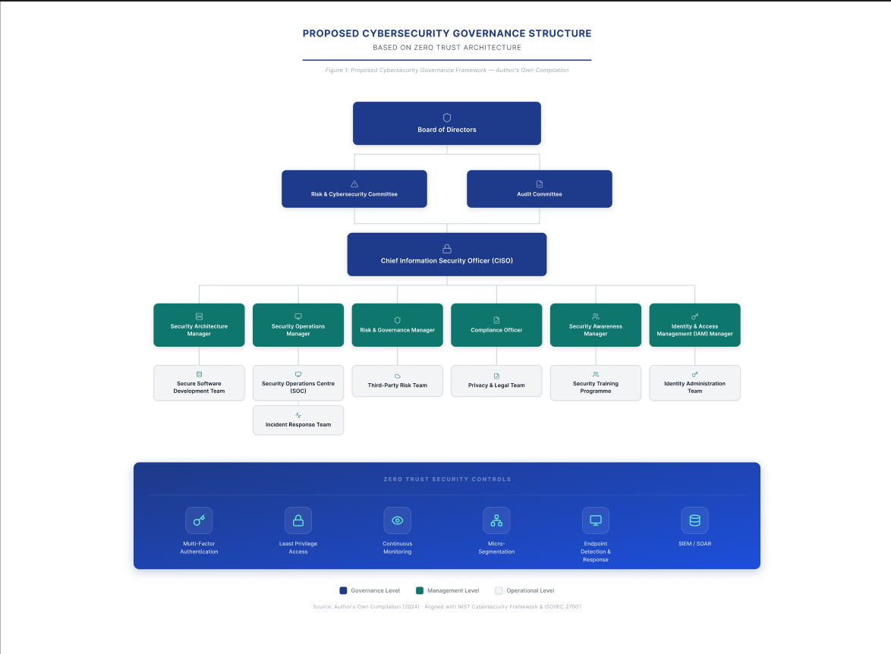
Figure 1. Proposed governance structure integrating executive oversight with operational cybersecurity functions.
Within this structure, the Chief Information Security Officer (CISO) is responsible for translating business objectives into cybersecurity strategy while ensuring organisational compliance with regulations such as GDPR, NIS2, and DORA. Direct reporting to the Board enables cybersecurity risks to be communicated without organisational filtering, supporting better strategic decision-making and improving overall cyber resilience [5].
The Security Architecture Manager oversees enterprise security architecture, ensuring that Zero Trust principles—including identity verification, micro-segmentation, secure cloud adoption, and least-privilege access—are incorporated throughout the technology lifecycle. By embedding security into infrastructure planning rather than implementing controls retrospectively, the organisation reduces architectural vulnerabilities that frequently contribute to large-scale cyber incidents [3].
Operational monitoring is managed through the Security Operations Centre (SOC) under the supervision of the Security Operations Manager. The SOC continuously analyses security events using Security Information and Event Management (SIEM), Endpoint Detection and Response (EDR), threat intelligence, and Security Orchestration, Automation and Response (SOAR) technologies. Continuous monitoring significantly reduces attacker dwell time by enabling rapid detection, automated investigation, and coordinated incident response [6].
The Risk and Governance Manager maintain the enterprise cyber risk register, conducts periodic risk assessments, and evaluates third-party supplier security. Supply-chain vulnerabilities have become increasingly significant following incidents such as SolarWinds and Log4Shell, demonstrating that cybersecurity governance must extend beyond organisational boundaries [7].
The Compliance Officer independently monitors adherence to legal and regulatory obligations including GDPR, NIS2, ISO/IEC 27001, and DORA. Maintaining independent compliance oversight prevents conflicts of interest while ensuring security controls remain aligned with legislative requirements and organisational policies [8].
Finally, the Security Awareness Manager coordinates organisation-wide cybersecurity education programmes. Human error continues to represent one of the largest contributors to successful cyberattacks; therefore, regular phishing simulations, mandatory awareness training, and executive cyber exercises significantly improve organisational resilience [9].

Cybersecurity Reporting and Escalation Process
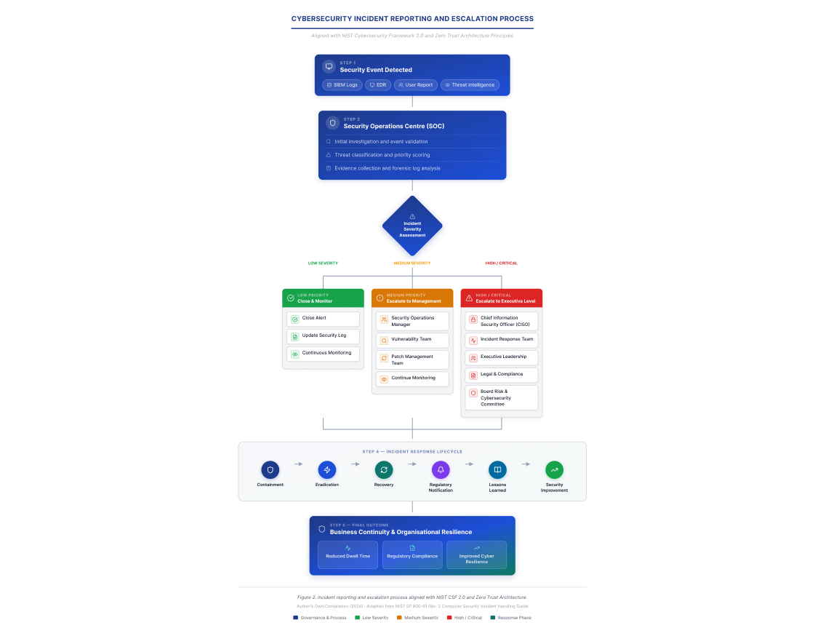
Figure 2. Cybersecurity Reporting and Escalation Process
This escalation framework addresses one of the primary governance failures identified during the Equifax breach. Rather than allowing security incidents to remain isolated within technical teams, critical events are escalated rapidly to executive leadership and the Board, enabling timely strategic decisions concerning business continuity, regulatory notification, legal obligations, and public communication. Such governance structures align closely with the Govern function introduced in the NIST Cybersecurity Framework (CSF) 2.0, which recognises governance as a fundamental component of effective cybersecurity management [4].

Governance Responsibility Matrix (RACI)
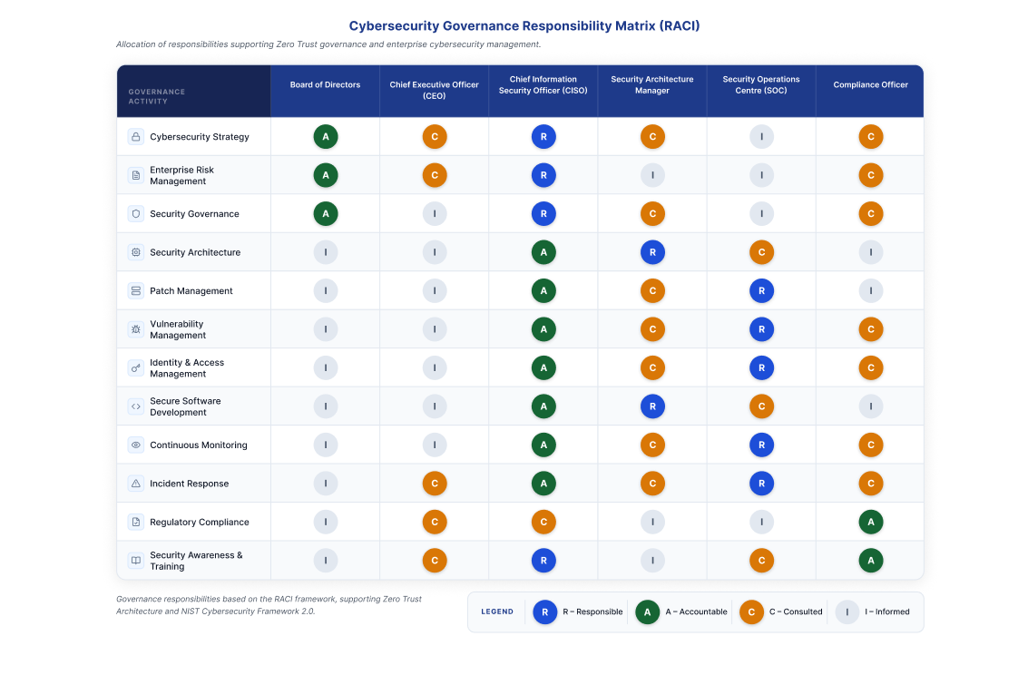
Figure 3: Governance Responsibility Matrix Table (RACI)

Zero Trust Governance Model
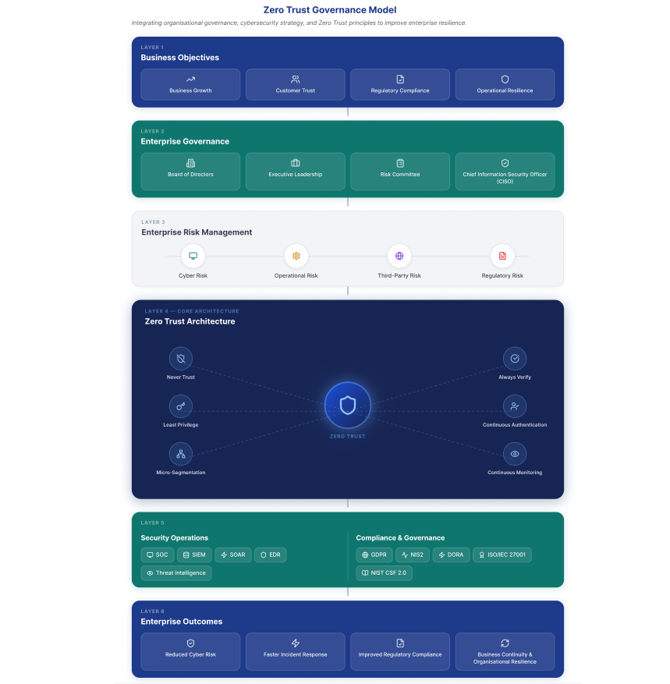
Figure 4. Zero Trust Governance Model

Policies and Procedures
The Equifax breach highlighted that effective cybersecurity depends not only on technical controls but also on robust organisational policies and enforceable operational procedures. Although a security patch for the Apache Struts vulnerability had been released prior to the attack, ineffective patch management and poor governance meant the vulnerability remained unaddressed, allowing attackers to gain prolonged unauthorised access to sensitive systems [1], [2]. This demonstrates the need for structured policies that support proactive risk management, continuous monitoring, and executive accountability.
To address these weaknesses, the proposed cybersecurity programme establishes an integrated policy framework based on the principles of Zero Trust Architecture (ZTA) and the NIST Cybersecurity Framework (CSF) 2.0. Rather than relying on reactive security practices, the framework introduces formal policies that are measurable, auditable, and aligned with enterprise risk management [3], [4].

Enterprise Cybersecurity Policy Framework
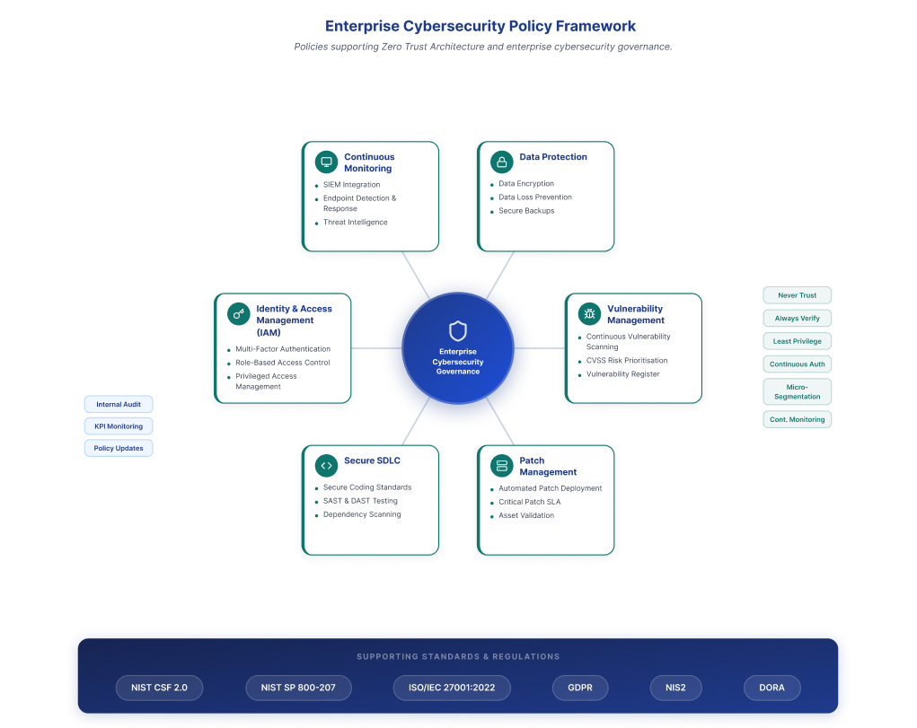
Figure 5. Enterprise Cybersecurity Policy Framework supporting governance, operational security, and Zero Trust implementation.

The Vulnerability Management Policy requires continuous vulnerability assessments across all organisational assets using automated scanning tools. Identified vulnerabilities should be prioritised according to the Common Vulnerability Scoring System (CVSS) and business impact, ensuring that critical weaknesses are remediated before they can be exploited [5]. Regular reporting to senior management ensures that unresolved vulnerabilities remain visible and are addressed within defined service-level agreements.
Supporting this policy, the Patch Management Policy establishes mandatory deployment timelines based on risk severity. Critical security patches should be implemented within 72 hours of release, while all updates must be validated following deployment to confirm successful installation. Integrating automated patch management with the organisation's asset inventory improves visibility and reduces the likelihood of systems remaining unpatched, directly addressing one of the primary failures identified in the Equifax breach [6].
The Secure Software Development Lifecycle (Secure SDLC) Policy embeds security throughout application development by incorporating secure coding standards, code reviews, vulnerability testing, and software dependency analysis. Automated security testing within Continuous Integration and Continuous Deployment (CI/CD) pipelines enables vulnerabilities to be identified before applications enter production, reducing long-term security risks and improving software quality [7].
The programme also introduces an Identity and Access Management (IAM) Policy based on Zero Trust principles. Multi-Factor Authentication (MFA), Role-Based Access Control (RBAC), and Privileged Access Management (PAM) ensure that users receive only the minimum permissions required to perform their roles while continuous authentication reduces the risk of compromised credentials [3].
Finally, the Continuous Monitoring and Data Protection Policies strengthen organisational resilience by combining Security Information and Event Management (SIEM), Endpoint Detection and Response (EDR), encryption, Data Loss Prevention (DLP), and secure backup procedures. These controls improve threat detection, reduce attacker dwell time, and protect sensitive customer information throughout its lifecycle [8].
Collectively, these policies transform cybersecurity from a reactive operational activity into a structured governance process. Regular policy reviews, internal audits, and performance indicators—including patch compliance rates, vulnerability remediation times, and incident response metrics—ensure continuous improvement while supporting compliance with regulatory frameworks such as GDPR, NIS2, and DORA [4], [9].
Governance and Strategic Alignment
The Equifax data breach demonstrated that cybersecurity should be integrated into organisational strategy rather than being treated solely as an operational IT function. Although technical controls existed, ineffective governance and poor strategic oversight prevented the organisation from responding effectively to a known software vulnerability, ultimately resulting in one of the largest data breaches in history [1], [2]. Modern organisations must therefore align cybersecurity initiatives with business objectives to improve resilience, maintain stakeholder trust, and support long-term organisational performance.
The proposed cybersecurity programme adopts the National Institute of Standards and Technology Cybersecurity Framework (NIST CSF) 2.0 as the primary governance framework. Unlike previous versions, NIST CSF 2.0 introduces the Govern function, recognising that cybersecurity is a strategic business responsibility requiring executive leadership, risk management, and continuous organisational oversight [3]. This framework provides a structured approach for integrating cybersecurity into corporate decision-making while supporting Zero Trust Architecture (ZTA), regulatory compliance, and operational resilience.

Strategic Alignment of Cybersecurity Using the NIST Cybersecurity Framework 2.0
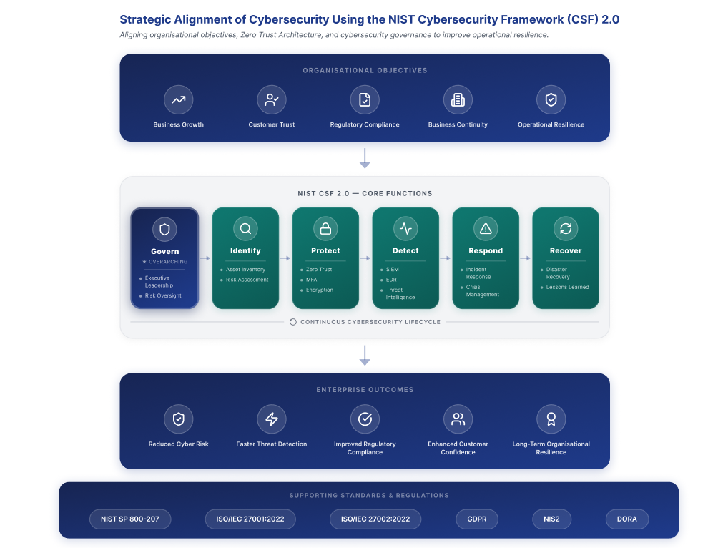
Figure 6. Alignment of organisational objectives with the NIST Cybersecurity Framework 2.0 to strengthen enterprise resilience and Zero Trust implementation.

Within the proposed programme, the Govern function establishes cybersecurity policies, defines organisational risk appetite, allocates responsibilities, and ensures continuous Board-level oversight. This governance structure enables executive management to make informed investment decisions while embedding cybersecurity into enterprise risk management and business strategy. The Identify function supports comprehensive asset management, vulnerability assessments, and risk analysis, ensuring that internet-facing systems, cloud resources, and critical information assets remain visible and continuously evaluated. These activities directly address the asset visibility deficiencies observed during the Equifax breach [2].
The Protect function incorporates Zero Trust principles including Multi-Factor Authentication (MFA), Role-Based Access Control (RBAC), encryption, and secure software development practices. These controls minimise the likelihood of unauthorised access while reducing opportunities for lateral movement following credential compromise [4]. Continuous monitoring under the Detect function integrates Security Information and Event Management (SIEM), Endpoint Detection and Response (EDR), and threat intelligence platforms to identify malicious activity in real time, enabling faster investigation and containment of security incidents [5].
The Respond and Recover functions ensure that organisations maintain structured incident response procedures, disaster recovery capabilities, and post-incident review processes. Rapid containment, regulatory reporting, and business continuity planning minimise operational disruption while enabling continuous improvement through lessons learned and security maturity assessments. This proactive approach strengthens organisational resilience and supports regulatory expectations established by GDPR, NIS2, and DORA [6], [7].
Strategic alignment also requires cybersecurity performance to be measured using business-focused metrics rather than solely technical indicators. Key Performance Indicators (KPIs), including Mean Time to Detect (MTTD), Mean Time to Respond (MTTR), patch compliance rates, and regulatory audit outcomes, should be regularly reviewed by executive leadership and the Board Risk Committee. Monitoring these metrics enables evidence-based decision-making while ensuring cybersecurity investments continue to support organisational objectives and customer trust.

Risk Management and Assessment
The Equifax data breach demonstrated the consequences of ineffective cyber risk management and the failure to identify and prioritise critical vulnerabilities within the organisation's technology infrastructure. Although the Apache Struts vulnerability had been publicly disclosed and a security patch released before the attack occurred, the organisation failed to remediate the vulnerability in a timely manner, exposing internet-facing systems to exploitation [1], [2]. This highlights the importance of implementing a structured risk management process capable of continuously identifying, assessing, and mitigating cybersecurity risks before they impact business operations.
The proposed cybersecurity programme adopts a risk-based approach aligned with the NIST Cybersecurity Framework (CSF) 2.0 and ISO/IEC 27005, ensuring that cybersecurity risks are evaluated according to both their technical severity and potential business impact [3], [4]. Rather than treating all vulnerabilities equally, risk assessment should consider the likelihood of exploitation, operational consequences, regulatory implications, and the sensitivity of affected information assets. This enables security teams to allocate resources effectively while supporting informed decision-making at executive level.

Enterprise Cybersecurity Risk Assessment Matrix
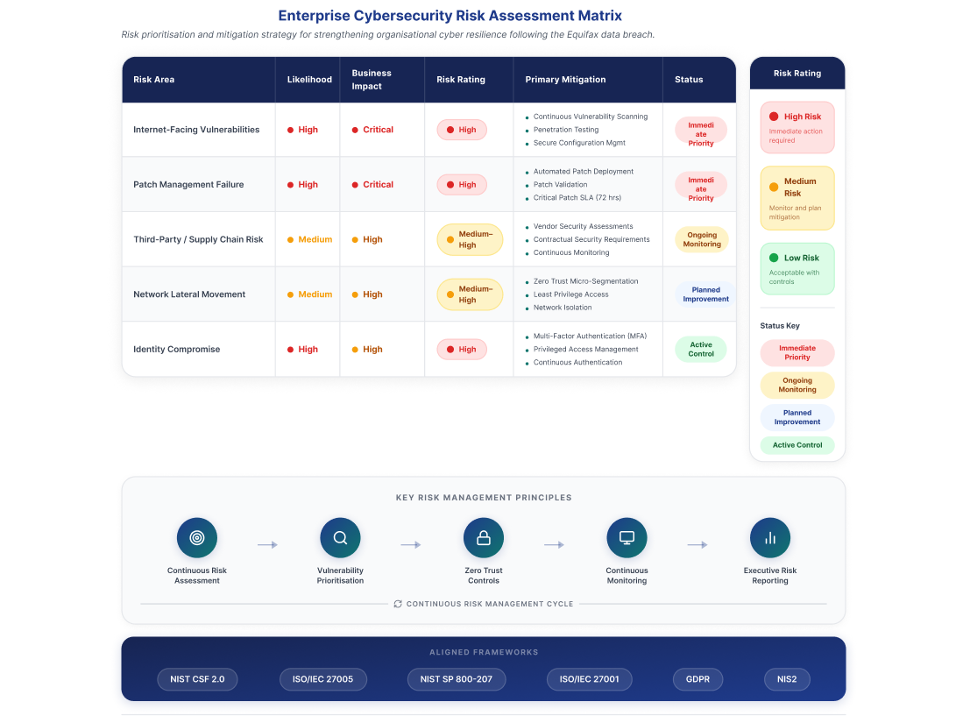Figure 7. High-level risk assessment identifying key organisational cyber risks, business impact, and proposed mitigation strategies.

The first priority identified within the proposed risk assessment is internet-facing vulnerabilities, particularly externally accessible applications and web services. These systems present attractive targets because they provide direct access to organisational infrastructure. Continuous vulnerability scanning, penetration testing, and automated configuration monitoring should be implemented to identify and remediate weaknesses before exploitation occurs [5].
A second critical risk is patch management failure, which was a primary cause of the Equifax breach. Delayed deployment of security updates significantly increases the likelihood of exploitation. Automated patch management supported by defined service-level agreements (SLAs) should ensure that critical vulnerabilities are remediated promptly and verified after deployment [6].
The programme also addresses third-party and supply chain risks, recognising that reliance on external vendors, cloud providers, and open-source software increases the attack surface. Organisations should conduct regular supplier security assessments, enforce contractual security requirements, and continuously monitor third-party risks to minimise potential exposure [7].
Another significant concern is insufficient network segmentation. Flat network architectures enable attackers to move laterally after compromising a single system. Implementing Zero Trust micro-segmentation and least-privilege access limits unnecessary communication between systems and reduces the overall impact of a security breach [8].
Finally, identity compromise remains one of the most common attack vectors. To mitigate this risk, the proposed programme incorporates Multi-Factor Authentication (MFA), Privileged Access Management (PAM), and continuous identity verification to prevent unauthorised access and privilege escalation [3].
Effective risk management requires continuous monitoring rather than periodic compliance reviews. Key Risk Indicators (KRIs), including patch compliance, vulnerability remediation times, privileged account activity, and third-party security performance, should be reviewed regularly by executive leadership to support proactive decision-making and strengthen organisational resilience [4].

Compliance, Incident Response and Protection Controls
The Equifax data breach demonstrated that regulatory compliance alone cannot protect organisations from sophisticated cyber threats. Despite operating within an established regulatory environment, failures in vulnerability management, incident detection, and governance resulted in the exposure of sensitive personal data belonging to approximately 147 million individuals [1], [2]. Modern cybersecurity programmes must therefore integrate compliance with proactive security controls and effective incident response capabilities.
The proposed programme aligns with ISO/IEC 27001:2022, ISO/IEC 27002:2022, GDPR, NIS2, DORA, and the NIST Computer Security Incident Handling Guide (SP 800-61 Rev. 2) [3], [7]. Rather than treating compliance as a checklist, these standards are embedded within organisational governance to strengthen accountability, support regulatory obligations, and improve overall cyber resilience.

Enterprise Incident Response Lifecycle
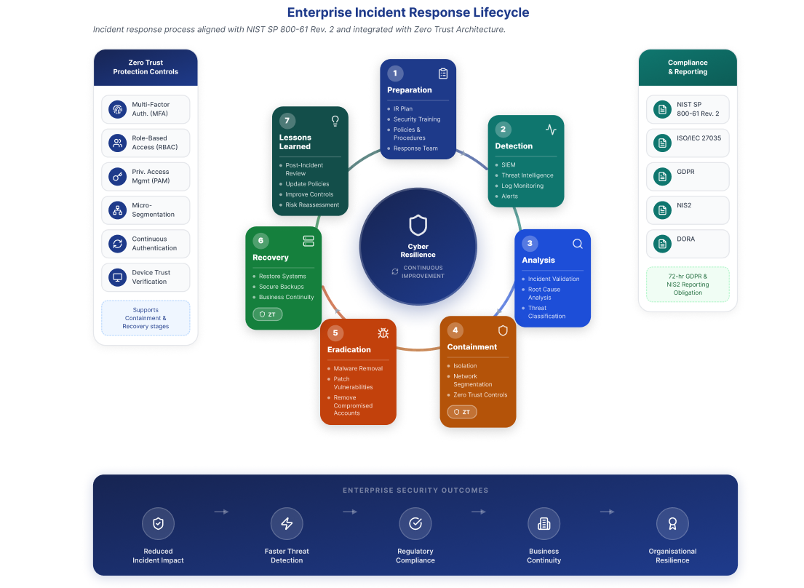

Figure 8. Enterprise Incident Response Lifecycle aligned with NIST SP 800-61 and integrated with Zero Trust Architecture.
A structured Incident Response Plan (IRP) forms the foundation of organisational resilience. Consistent with the NIST incident handling lifecycle, the proposed programme establishes six continuous phases: Preparation, Detection, Analysis, Containment, Eradication, Recovery, and Post-Incident Review [7]. Preparation includes the development of incident response policies, clearly defined stakeholder responsibilities, communication procedures, and regular simulation exercises. Security personnel should receive periodic training to ensure incidents can be managed consistently and efficiently under operational conditions.
Early detection is supported through the integration of Security Information and Event Management (SIEM) platforms, Endpoint Detection and Response (EDR) solutions, threat intelligence feeds, and continuous log monitoring. Automated correlation of security events enables analysts to identify malicious behaviour rapidly, significantly reducing attacker dwell time compared with the delayed detection experienced during the Equifax breach [2], [8].
Once malicious activity is confirmed, the programme applies Zero Trust protection controls to contain the incident while limiting lateral movement across organisational systems. These controls include Multi-Factor Authentication (MFA), Role-Based Access Control (RBAC), Privileged Access Management (PAM), micro-segmentation, continuous authentication, and device trust verification. Unlike traditional perimeter-based security, Zero Trust assumes that compromise is always possible and continuously validates users, devices, and workloads before granting access to protected resources [9]. This significantly reduces the opportunity for attackers to escalate privileges or access sensitive information after the initial compromise.
Following containment, eradication activities remove malicious code, eliminate compromised accounts, and remediate exploited vulnerabilities before systems are restored through secure recovery procedures. Encrypted backups, disaster recovery planning, and business continuity arrangements ensure that critical business services can resume with minimal operational disruption while maintaining the integrity of organisational data [3]. Regulatory obligations require that reportable incidents are communicated promptly to supervisory authorities and affected individuals where appropriate, reinforcing transparency and organisational accountability under frameworks such as GDPR and NIS2 [5], [6].
Continuous improvement remains a fundamental element of the proposed programme. Every security incident should conclude with a structured post-incident review to identify root causes, evaluate the effectiveness of response activities, and update organisational policies, technical controls, and employee awareness programmes. Lessons learned should also inform future risk assessments and governance decisions, creating a continuous feedback loop that strengthens organisational resilience against evolving cyber threats.

Critical Evaluation
This report demonstrates that Zero Trust Architecture provides a more effective approach to cybersecurity than traditional perimeter-based security by eliminating implicit trust and adopting continuous verification. However, the analysis also shows that technology alone cannot prevent cyber incidents. Successful implementation depends on effective governance, executive leadership, risk management, and employee awareness.
The Equifax case study highlights those organisational failures, rather than technical limitations, were the primary causes of the breach. By integrating Zero Trust principles with recognised frameworks such as the NIST Cybersecurity Framework 2.0 and ISO/IEC 27001, organisations can improve resilience, regulatory compliance, and incident response. Nevertheless, Zero Trust should be viewed as a continuous improvement strategy requiring regular review, monitoring, and adaptation to emerging cyber threats.

Conclusion
In conclusion, this report has shown that Zero Trust Architecture is a more suitable cybersecurity model for modern organisations than traditional perimeter-based approaches. Through continuous authentication, least-privilege access, and proactive monitoring, Zero Trust significantly reduces cyber risk while supporting regulatory compliance and organisational resilience.
The Equifax case study demonstrated how weaknesses in governance, risk management, and vulnerability management can lead to severe security incidents. The proposed cybersecurity programme addressed these weaknesses by integrating Zero Trust principles with recognised governance, compliance, and incident response frameworks. Overall, cybersecurity should be regarded as a strategic business function that combines technology, governance, and continuous improvement to protect organisational assets against an evolving threat landscape.

References (Task 1)
[1] National Institute of Standards and Technology, Zero Trust Architecture, NIST Special Publication 800-207, Gaithersburg, MD, USA, Aug. 2020.
[2] National Institute of Standards and Technology, The NIST Cybersecurity Framework (CSF) 2.0, Gaithersburg, MD, USA, Feb. 2024.
[3] National Institute of Standards and Technology, Digital Identity Guidelines, NIST Special Publication 800-63B, Gaithersburg, MD, USA, Aug. 2020 (updated).
[4] International Organization for Standardization and International Electrotechnical Commission, ISO/IEC 27001:2022 Information Security, Cybersecurity and Privacy Protection — Information Security Management Systems — Requirements, Geneva, Switzerland, 2022.
[5] National Institute of Standards and Technology, Security and Privacy Controls for Information Systems and Organizations, NIST Special Publication 800-53 Rev. 5, Sept. 2020.
[6] European Union, Directive (EU) 2022/2555 on Measures for a High Common Level of Cybersecurity Across the Union (NIS2 Directive), Official Journal of the European Union, 2022.
[7] European Union, Regulation (EU) 2022/2554 on Digital Operational Resilience for the Financial Sector (DORA), Official Journal of the European Union, 2022.
[8] European Union Agency for Cybersecurity, ENISA Threat Landscape 2024, Heraklion, Greece, 2024.
[9] Cloud Security Alliance, Zero Trust Guidance for Critical Infrastructure, 2023.
[10] D. B. Rawat and A. Alshahrani, "Zero Trust Architecture for Cybersecurity: Principles, Challenges, and Future Directions," IEEE Access, vol. 11, pp. 117204–117223, 2023.
[11] S. Rose, O. Borchert, S. Mitchell, and S. Connelly, "Zero Trust Architecture: Current Trends and Future Research Challenges," Computer, vol. 56, no. 7, pp. 42–51, Jul. 2023.
[12] European Union, Regulation (EU) 2016/679 (General Data Protection Regulation), Official Journal of the European Union, 2016.

References (Task 2)
[1] S. Rose, O. Borchert, S. Mitchell and S. Connelly, Zero Trust Architecture, NIST Special Publication (SP) 800-207, National Institute of Standards and Technology, Gaithersburg, MD, USA, Aug. 2020.
[2] European Union Agency for Cybersecurity (ENISA), ENISA Threat Landscape 2024, ENISA, Heraklion, Greece, 2024.
[3] National Institute of Standards and Technology, Digital Identity Guidelines, NIST Special Publication (SP) 800-63-3, Gaithersburg, MD, USA, 2017.
[4] National Institute of Standards and Technology, Cybersecurity Framework (CSF) 2.0, National Institute of Standards and Technology, Gaithersburg, MD, USA, 2024.
[5] European Parliament and Council of the European Union, Directive (EU) 2022/2555 on Measures for a High Common Level of Cybersecurity Across the Union (NIS2 Directive), Official Journal of the European Union, Brussels, Belgium, 2022.
[6] European Parliament and Council of the European Union, Regulation (EU) 2022/2554 on Digital Operational Resilience for the Financial Sector (DORA), Official Journal of the European Union, Brussels, Belgium, 2022.
[7] N. F. Syed, Z. Baig, A. Ibrahim and C. Valli, "Zero Trust Architecture: A Comprehensive Survey," IEEE Access, vol. 10, pp. 57143-57179, 2022.
[8] National Institute of Standards and Technology, Security and Privacy Controls for Information Systems and Organizations, NIST Special Publication (SP) 800-53 Revision 5, Gaithersburg, MD, USA, 2020.
[9] Y. He, D. Huang, L. Chen, Y. Ni and X. Ma, "A Survey on Zero Trust Architecture: Challenges and Future Trends," Wireless Communications and Mobile Computing, vol. 2022, Article ID 6476274, 2022.
[10] Y. Cao, S. R. Pokhrel, Y. Zhu, R. Doss and G. Li, "Automation and Orchestration of Zero Trust Architecture: Potential Solutions and Challenges," Machine Intelligence Research, vol. 21, no. 2, pp. 294-317, 2024.
[11] European Parliament and Council of the European Union, Regulation (EU) 2016/679 (General Data Protection Regulation), Official Journal of the European Union, Brussels, Belgium, 2016.
[12] S. Rose, Planning a Zero Trust Architecture: A Starting Guide for Federal Administrators, NIST Cybersecurity White Paper 20, National Institute of Standards and Technology, 2022.

