
Becoming carbon neutral: The challenge that all businesses face.

Global warming.
Environmental change has an impact on every country, society and individual on earth. Scientific evidence gathered by Nasa shows that the earth's average surface temperature has risen around 1.14 degree Celsius since the beginning of the industrial revolution. (1) The evidence also shows that the majority of global warming has taken place within the last 40 years. The industrial revolution paved the way for the modern world, and since the late 19th century the world has seen rapid economic growth. The burning of fossil fuels has created tremendous wealth for countries predominantly in the West and created new opportunities for developing countries. However, the burning of fossil fuels has had substantial ecological impacts. Carbon dioxide ‘C02’ emissions are the primary factor to global warming, the graph below created by ‘Our World in Data’, shows the alarming increase in ‘C02’ emissions worldwide since the late 19th century.
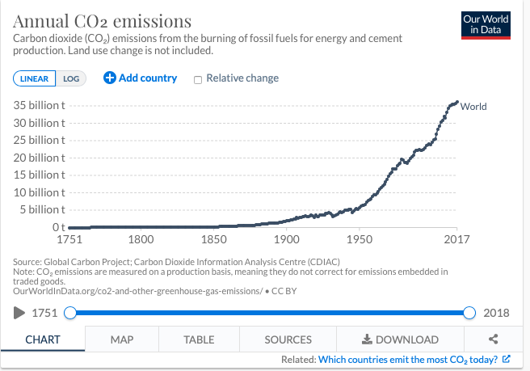
(2)

The high levels of ‘C02’ in the earth’s atmosphere traps heat near the surface of the earth, and this causes temperatures to rise. This creates a domino effect within the eco-system and has devastating consequences. According to data gathered by the International Energy Agency (IEA), coal supplies one-third of global electricity generation. ‘C02’ emissions directly attributed to the burning of coal accounts for almost half of the world total. (3) Society has become dependent on fossil fuels, and it is evident that this is not sustainable. Nicholas Stern estimated that without coordination and intervention from governments worldwide, climate change would reduce global ‘GDP’ by more than 1% each year. (4) The statistics highlight a global challenge. It is the responsibility of governments, and business leaders both at a regional and national level, to address the issue of ‘C02’ emissions and promote sustainable development across all industries.
Global trend.
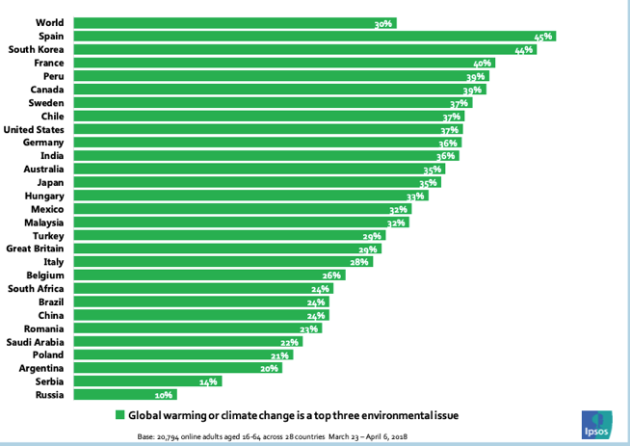
In recent decades society and more specifically, climate activist groups have scrutinised business leaders and governments for the environmental damage that globalisation has caused. A poll conducted by 'Ipsos' in 2018 gathered responses across 28 countries from adults aged 16-64. Respondents were asked to list the three most critical environmental challenges facing the world today. The graph below shows that 30% of respondents are now concerned about global warming. In Spain, 45% of respondents said they were most concerned about global warming. The statistics show there is deep concern within communities across the world. Society agrees that global warming is a significant threat and action needs to be taken. (5)

Political leaders from around the world have acknowledged the threat of climate change, and the Paris Agreement highlights the global commitment to combat climate change. The main objective of the Paris Agreement is to strengthen the global response to climate change by keeping the global temperature below 2 degrees Celsius. One hundred ninety-seven countries have signed up to the Paris Agreement. (6) In 2019 the 'UK' became the first major economy to pass legislation which commits to achieving a target of net zero emissions by 2050. (7)
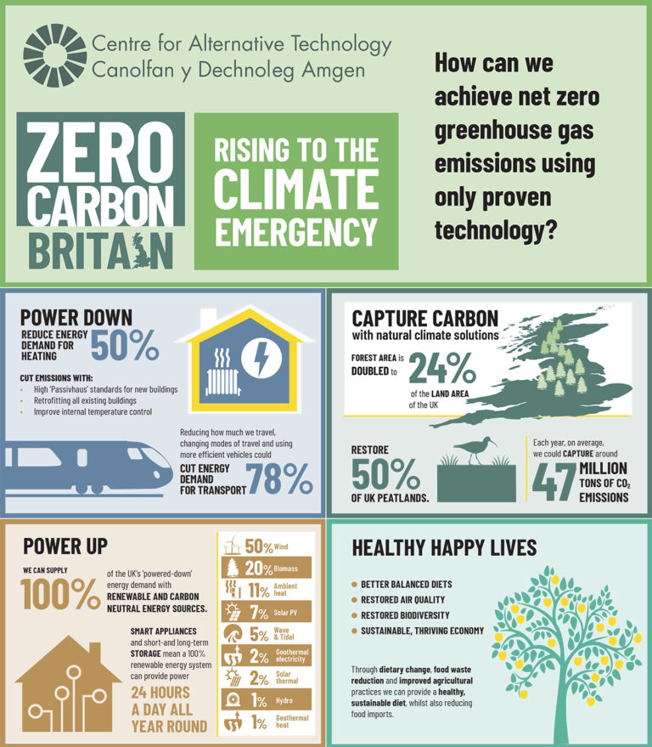
(8)

The infographic used in the Zero Carbon Britain report shows changes that need to be made within society if the UK is going to meet its target. If the UK is going to be successful in achieving its goal, then businesses will need to invest in sustainable development. There are a variety of practical measures that businesses can implement to help achieve net zero ‘C02’ emissions. However, each business will have a unique approach. Investment in sustainable development depends on the size of the organisation. Multi-national or national organisations have more resources compared to small or medium-sized businesses. Smaller businesses may find it challenging to implement significant sustainable measures throughout the supply chain and organisation. Secondly, business owners need to assess whether sustainable development will benefit the organisation financially and help improve efficiency. That being said, businesses of all sizes are moving towards sustainable development because they recognise an opportunity for growth.
Sustainable development.
For businesses, sustainable development refers to meeting present needs without comprising the ability to meet those of the future. (9) With increasing pressure from a variety of stakeholders, businesses have shifted their focus towards sustainable development. The 2019 ‘HSBC- Now, next and how for business’ report provides insight to business owners attitudes towards sustainable development. The report is based on survey responses from 9,000 businesses across 14 countries.
(10)
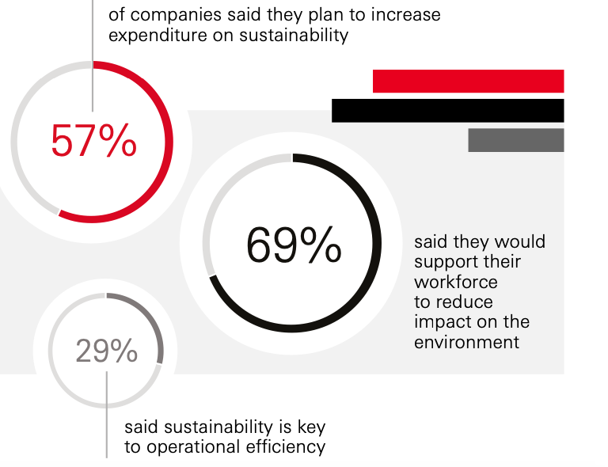

The infographic used in the report shows that over half of respondents said they plan to increase expenditure on sustainability within their business. Almost 70% of respondents said they would support their workforce to use technology to help reduce the impact on the environment. The evidence highlights a global trend that is happening across all industries. The graph below is from a section of the report, which looks specifically at responses from UK businesses.
(11)
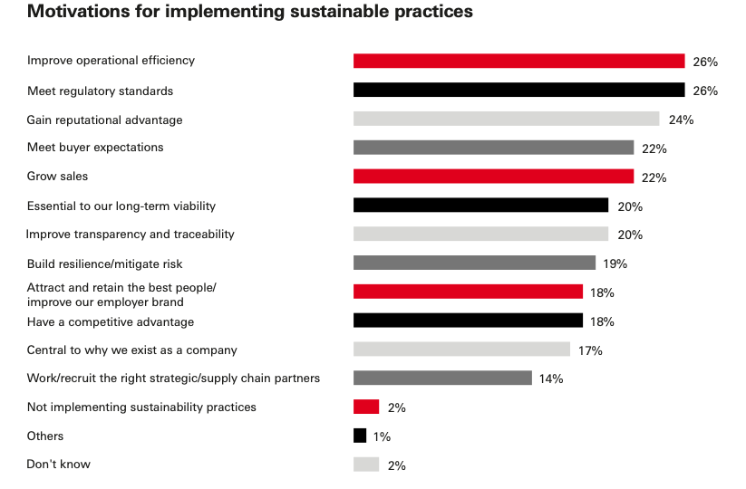

The graph highlights the motivations for why businesses have implemented or plan to implement sustainable practices. The figures show there are a variety of motivations as to why business owners invest in sustainable development. The three main reasons are to improve operational efficiency, meet regulatory standards and gain a reputational advantage. Improving operational efficiency has many benefits which include reducing costs, a more productive workforce and an increase in profits. Businesses around the world realise the opportunities that come with reducing emissions.
What actions can businesses take?
There are several measures that businesses can implement to reduce C02 emissions. There are many factors that business owners must consider before they implement sustainable practices. Firstly, businesses need to calculate the levels of ‘C02’ emissions that they produce. This will allow businesses to measure the size of the problem. Secondly, businesses need to create a budget and decide how much capital they are going to invest. Thirdly, once the budget has been determined, businesses must decide what actions they are going to take. Targets need to be set, and a clear strategy for achieving the targets needs to be outlined. The targets need to be broken down into ‘S.M.A.R.T’ objectives; small, measurable, realistic, attainable and timely.
Energy generation is the main consequence of high levels of C02 emissions. For businesses to become more efficient with energy use, they must have an energy strategy in place. An energy strategy aims to, supply the energy requirements efficiently, minimise energy use and use renewable energy. Step one of the energy strategy could be to switch to a green energy tariff. In the UK a green energy tariff works by the supplier matching some of or all of the electricity used by customers with renewable energy, which it feeds back to the National Grid. Not all of the energy used on a green tariff is renewable, but it does help increase the percentage of renewable energy used on the National Grid. (12) The energy supplier will share the fuel mix with customers which will allow them to see what percentage of the energy they use is renewable. There are different types of energy tariffs available these include fixed, variable and flexible. The type of green energy tariff will depend on the size of the business and how much energy they use. Large organisations that have multiple premises will tend to have several energy suppliers, whereas a small or medium-sized business may only have one energy supplier. Businesses that switch to green energy tariffs have a competitive advantage and can incorporate their use of renewable energy into marketing campaigns to help promote the business. This will improve the brand image and help retain and attract new customers. A disadvantage of green energy tariffs is that they are generally more expensive than tariffs which use only fossil fuels. Currently, it is challenging to generate renewable energy at the same quantities as fossil fuel generators. However, prices will gradually fall as technological investment increases, and renewable energy generation methods become more efficient.
The next step that businesses can take is to generate their power instead of using an energy supplier. There are several renewable energy generation methods which are currently available. These include hydro, wind, solar, geothermal, biomass and tidal. Renewable energy technologies are dependent on weather-related factors such as wind speed and sunlight exposure. The location and size of a business will help determine which type of renewable source is most appropriate.
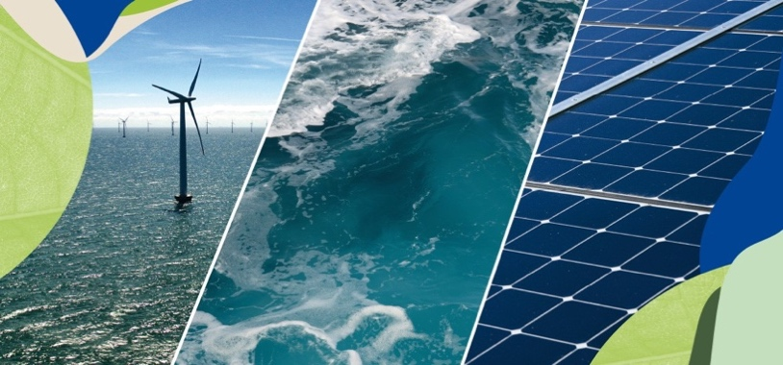

(13)
There are several benefits to generating power independently. Firstly, businesses can lower their overheads by eliminating the energy supplier from their energy supply chain. This protects them from fluctuating energy prices and provides them with stability. Another positive is the possibility of having the option to sell excess energy to the grid. This would provide businesses with a new source of revenue and increase the percentage of renewable energy used on the grid. A third positive is that some businesses will be eligible for government support schemes which offer financial support for the implementation of renewable technology. This is beneficial for businesses which have a limited budget such as small local businesses.
However, there are also potential downsides. Firstly, there may be restrictions for implementing renewable technology in some areas. For example, installing wind turbines requires planning permission from local authorities. The process could take a considerable amount of time and use up many resources. This may deter businesses from pursuing renewable technologies. Secondly, due to the reason that renewables rely on the climate to work effectively, there is always a risk that not enough energy will be generated. This brings an element of uncertainty, and some business owners would prefer the reliability of traditional fossil fuel generation methods. A third disadvantage is that some businesses will not have suitable space to implement renewable technology and therefore, will be limited. There are advantages and disadvantages to generating power independently, but overall, it is an effective method in reducing ‘C02’ emissions. According to a report conducted in the 'USA' by Deloitte, over 55% of large businesses generate at least some of their own power. (14)
Amazon is an example of a multi-national organisation that has committed to powering its operational activities using 100% renewable energy by 2025. Currently, Amazon uses 45% renewable energy across its business. Amazon has 60 on-site solar panel systems installed in their fulfilment centres across the world, including India, UK and the USA. Amazon has seven fulfilment centres in India, all of which use renewable energy technologies. In total, the buildings produce a total of 10 megawatts of energy which is used to power all operational activities. (15) Additionally, all of Amazons buildings in India are installed with energy management systems which enable employees to optimise energy use. All of the buildings use sensors to control lighting and heating, which ensures energy is only used when buildings are occupied. Amazon continues to invest in sustainable development and has demonstrated how businesses can reduce their ‘C02’ emissions by generating their own energy. Small or medium-sized businesses will not be able to invest in renewable energy to the same scale as Amazon but can still implement small changes such as sensors to control light and heating systems to ensure optimal efficiency.

Another area of the energy strategy that is vital in reducing ‘C02’ emissions is transportation. Transportation plays a crucial role in operational activities for the majority of businesses and is essential for business success. According to statistics gathered by ‘Our World in Data’ transport accounts for 20% of global ‘C02’ emissions. From all the ‘C02’ emissions caused by transport, 34% is caused by road freight, 11% from vessels and 11% from aviation.

(16)
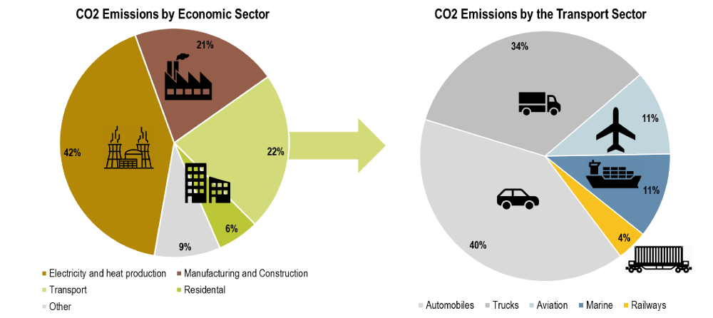

Businesses have a duty to address the environmental issues related to transport and must help create a sustainable transportation system. The majority of businesses currently use petrol or diesel to power vehicles. There are several alternative fuels available these include biodiesel, electricity, hydrogen, ethanol, propane and natural gas. Businesses could make the switch from petrol and diesel to any these alternative fuels to power fleets of vehicles. However, there are both advantages and disadvantages of alternative fuels. An advantage of electrically powered vehicles is they have fewer components compared to petrol which means they require less maintenance. If businesses switched their vehicles to 100% electricity, they could significantly reduce maintenance and operating costs. A downside to using electric vehicles is that they have a limited range compared to petrol-powered vehicles and can take several hours to charge. This could create several logistical issues for businesses and impact operational performance. Businesses need to ensure that vehicles can meet operational demands and serve customers effectively. One of the main advantages of biodiesel is that all diesel vehicles can run on biodiesel without any mechanical adjustments being made to existing vehicles. This would ensure that the transition from diesel to biodiesel is convenient and would not require any extra investment. However, a downside to biodiesel is that it is less powerful compared to diesel which will have an impact on vehicle performance. Similar to petrol, prices for alternative fuels fluctuate and price depends on several factors such as location and political climate. Petrol is currently one of the cheapest fuels to purchase, which is why many businesses across the world are reluctant to make the switch in fear of higher operating costs and lower profits. In contrast, authors Nidumolu and Prahalad argue that sustainability is crucial for development and becoming environmentally friendly will help reduce costs. (17)
FedEx is an example of a multi-national business that has implemented a mixed fuel strategy to power its fleet. The business has increased the number of electric and hybrid vehicles to 482 worldwide. Out of that number, 118 are powered by electricity and FedEx has announced it will be adding a further 87 electrical vehicles to its fleet. FedEx has committed to reducing its aircraft emissions by 30% by 2030 and increase the use of alternative fuels to 30% by the same year. FedEx uses software systems on its aircrafts which helps with optimising fuel consumption. The actions taken by FedEx are vital for success in an environment that is heavily focused on sustainability. (18)
As discussed in this article, there are several actions that businesses can implement to reduce their 'C02' emissions significantly. With increasingly more consumers and political leaders shifting the global focus to sustainable development, businesses must act now and invest. The main barrier of implementation for businesses is cost. With the current global crisis, some businesses are in financial turmoil and the possibility of a large investment may be unrealistic in the current climate. Other businesses may have financial power but are reluctant to invest during these uncertain times. However, there is enough evidence to suggest that sustainable improvements aimed at reducing emissions will most likely lead to substantial savings in costs over time. Businesses need to look beyond the present and invest for future success. Environmental regulations around the world will become stricter, and businesses will be required to make significant changes. The logical thing for business leaders to do is take action now so that they are best prepared for future challenges. If society is going to be successful in reducing global 'C02' emissions, then-current behaviours, and systems must be altered.

Bibliography
- NASA. (2020). Global climate change: https://climate.nasa.gov/evidence/ - (Accessed on 9/11/2020)

- Our World in Data. (2018). Annual C02 emissions: https://ourworldindata.org/co2-emissions - (Accessed on 9/11/2020)

- International Energy Agency. (2018): https://www.iea.org/topics/coal - (Accessed 10/11/2020)

- The Economics of Climate Change: Stern Review (2007). Nicholas Stern

- Ipsos Mori. (2019). Consumer concern about environmental issues: https://www.ipsos.com/en/global-warming-and-waste-reduction-take-center-stage-environmental-discussion - (Accessed 10/11/2020)

- United Nations Framework Convention on Climate change. (2018), The Paris Agreement: https://unfccc.int/process-and-meetings/the-paris-agreement/the-paris-agreement - (Accessed 11/11/2020)

- Department for Business, Energy & Industrial Strategy. 2019, UK becomes first major economy to pass net zero emissions law:https://www.gov.uk/government/news/uk-becomes-first-major-economy-to-pass-net-zero-emissions-law – (Accessed on 11/11/2020)

- Centre for Alternative Technology, Zero Carbon Britain infographic: https://www.cat.org.uk/zero-carbon-britain-social-media-pack/ - (Accessed on 11/11/2020)

- Brundtland Commission, 1987, Our Common Future, Oxford University Press.

- HSBC, 2019, Now, Next and How for business Global, Navigator: https://www.business.hsbc.com – (Accessed 11/11/2020)

- HSBC, 2019, Now, Next and How for business UK, Navigator: https://www.business.hsbc.com/navigator/uk/the-sustainable-future?pid=HBEU:RA:1743:GEN:XX:CAM:1019:033:NAV19_GD – (Accessed 11/11/2020)

- Energy Saving Trust. (2019). Switching your energy supplier: https://energysavingtrust.org.uk/advice/switching-your-energy-supplier/ - (Accessed 11/11/2020)

- European Commission. (2020). Renewable Energy in Europe- https://ec.europa.eu/info/news/focus-renewable-energy-europe-2020-mar-18_en (Accessed 12/11/2020)

- Motyka and Clinton, Deloitte, (2015). Energy management passes the point of no return.

- Amazon, (2020). Sustainability in India. - https://sustainability.aboutamazon.com/about/around-the-globe/india- (Accessed 13/11/2020)

- Our World in Data, (2020). Where do C02 emissions from transport come from? https://ourworldindata.org/co2-emissions-from-transport- (Accessed 15/11/2020)

- Nidumolu. R, Prahalad. C.K, Rangaswami. M.R, (2009). Why Sustainability Is Now the Key Driver of Innovation- https://hbr.org/2009/09/why-sustainability-is-now-the-key-driver-of-innovation - (Accessed 15/11/2020)

- FedEx, (2018). FedEx and the Environment- http://www.fedex.com/sc/about/sustainability/environment.html - (Accessed 15/11/2020)

