

Strategic Management Analysis of Nestlé UK: Navigating Competitive Advantage, CSR Alignment, and Strategic Change

Programme: Master of Business Administration
Module Name: Strategic Management
Module Code: LCMB7003

Lecturer Name: Dr. Hoang Nguyen

Student Name: Durjoy Kumar Kundu
Student ID: 2503600

Submission Date: 30th April 2026

AI use Acknowledgement

I acknowledge the use of multiple AI tools on 01st April 2026 to 29th April 2026 to support my research work, proofreading, paraphrasing, writing of this assignment. The following AI tools were used, along with specific prompt examples relevant to this report:
1. Grammarly https://www.grammarly.com/ used To rephrase selected source excerpts for improved academic clarity and flow, correct grammatical errors, and ensure consistent formal tone across the final draft. For example, Prompt: ‘’Ran the complete final draft through the ‘Academic’ and ‘Formal’ tone detectors to eliminate passive voice overuse, correct comma splices, and ensure consistent terminology (HFSS regulations vs high fat, sugar, and salt restrictions)’’.
2. ChatGPT OpenAI https://chatgpt.com/ used to assist in structuring comparative tables ( VIRO analysis, Balanced Scorecard perspectives), refining subsection logic, and serving as a non-judgmental sounding board for structuring the Gibbs Reflective Cycle (Section 2). For example, Prompt: “Help me design a clear VRIO evaluation table for Nestlé UK’s strategic capabilities: manufacturing facilities, brand portfolio, R&D in nutrition, and supply chain integration. Include columns for Value, Rarity, Imitability, Organisation, and competitive implication.”
3. Semantic Scholar https://www.semanticscholar.org/ used to locate peer‑reviewed studies, literature support for theoretical frameworks (Porter’s Generic Strategies, VRIO, Balanced Scorecard, Ansoff Matrix, Lewin’s Change Model), and evidence‑based conclusions regarding strategic implementation and CSR alignment. For example, Prompt: ‘’Find recent peer-reviewed papers criticising the application of the Balanced Scorecard in multinational consumer goods companies’’.
I confirm that I have not presented any AI generated text as my own work. I confirm I have copies of my drafts, notes, and other resources I used before, and after the use of AI tools which I may be asked to provide in evidence.
Contents
1. Organisational Context and Overview 4
1.1 Brief History of Nestlé UK 4
1.2 Mission, Vision, and Business Model 4
1.3 Industry and Market Position 5
2. External and Internal Environment Analysis 6
2.1 PESTEL Analysis: External Factors Impacting Strategic Decisions 6
Political Factors 7
Economic Factors 7
Social & Cultural Factors 7
Technological Factors 8
Environmental Factors 9
Legal Factors 9
2.2 Strategic Challenges and Critical Success Factors (CSFs) 9
2.3 Internal Environment: Resources, Capabilities, and Core Competencies 10
2.4 VRIO Analysis of Strategic Capabilities 11
2.5 Internal Strengths and Contribution to Competitive Advantage 11
3. CSR Strategy and Sustainability 12
3.1 Critically discuss the company's CSR strategy and its alignment with business objectives 12
4. Comprehensive and Holistic view 13
4.1 Balanced Scorecard 13
4.2 The Four Core Perspectives 14
4.3 Evaluation of Framework Success/Failure 14
5. Strategic Choices and Implementation 15
5.1 Business Level Strategic Choices: 15
5.2 Corporate Level Strategic choices 16
Recommended Strategic Choices and Justification 17
5.3 Critical Assessment: How well has the organisation managed change and its impact on strategic implementation? 18
5.4 The Impact on Strategic Implementation 19
6. Strategic Evaluation and Recommendations 19
6.1 Ansoff Matrix as a strategic planning tool: 20
6.2 Justification with Theoretical Concepts and Real‑World Examples 21
Section 2: Reflective Account Using Gibbs’ Reflective Cycle 22
Description 22
Feelings 22
Evaluation 23
Analysis 24
Conclusion 24
Action Plan 25
Conclusion 26
References 27

Section 1: A Critical Analysis of Strategic Management Practices
Introduction
A strategic management analysis of Nestlé UK, a subsidiary of Nestlé S.A., the world’s largest food and beverage company, is presented in this report. The strategic management practices of Nestlé UK are critically evaluated, and the manner in which the organisation navigates the competitive UK food and beverage market while a sustainable competitive advantage is pursued is examined (Porter, 1985). The analysis is comprised of external and internal environmental assessments, an evaluation of strategic capabilities, alignment with corporate social responsibility (CSR), balanced scorecard perspectives (Kaplan and Norton, 1992), strategic choices, and evidence-based recommendations. In section two, a reflective account of the research and analytical process is provided through the application of Gibbs' Reflective Cycle (Gibbs, 1988).

1. Organisational Context and Overview

Brief History of Nestlé UK
The origins of Nestlé UK are traced to the 1905 merger of the Anglo-Swiss Condensed Milk Company, established in 1866 in Cham, Switzerland, and Farine Lactée Henri Nestlé, founded in 1867 (Nestlé, 2023). A presence in the United Kingdom was established in the early twentieth century, and headquarters are now located in Crawley, England (Nestlé, 2023). Over time, Nestlé UK has been developed into a significant participant within the British food and beverage industry (Statista, 2024). Multiple manufacturing facilities are operated across the country, including the historic Dalston factory in Cumbria, where Nescafé products have been produced since 1962 (Nestlé, 2023).

Mission, Vision, and Business Model
The corporate mission of Nestlé S.A., “Good Food, Good Life,” is positioned as a reflection of the organisation’s commitment to enhancing quality of life through improved nutrition (Nestlé, 2023). The vision is centred on being recognised as a trusted leader in nutrition, health, and wellness (Nestlé, 2023). In the United Kingdom, operations are conducted through a diversified business model in which multiple product categories are managed, including coffee (Nescafé and licensed Starbucks products), confectionery (KitKat and Quality Street, dairy (Carnation), pet care (Purina), bottled water (Perrier and San Pellegrino, and infant nutrition (SMA) (Euromonitor, 2024). The business model is supported through the integration of direct retail distribution, foodservice channels, and digital commerce platforms (Johnson et al., 2020).

Industry and Market Position
The UK food and beverage industry is characterised by intense competition, heightened regulatory scrutiny, and continuously evolving consumer preferences toward health, sustainability, and convenience (Food and Drink Federation, 2024; Euromonitor, 2024). Direct competition is faced by Nestlé UK from major multinational corporations, including Unilever, Mondelēz International, and Associated British Foods, alongside a growing number of private label brands (Statista, 2024). Within the chocolate confectionery segment, high levels of brand awareness are reported, with Cadbury and Galaxy each recorded at 96%, while KitKat is recorded at 94% (YouGov, 2024). Across most product categories, a premium market positioning is maintained by Nestlé through the strategic utilisation of strong brand heritage and consistent product quality (Porter, 1985).
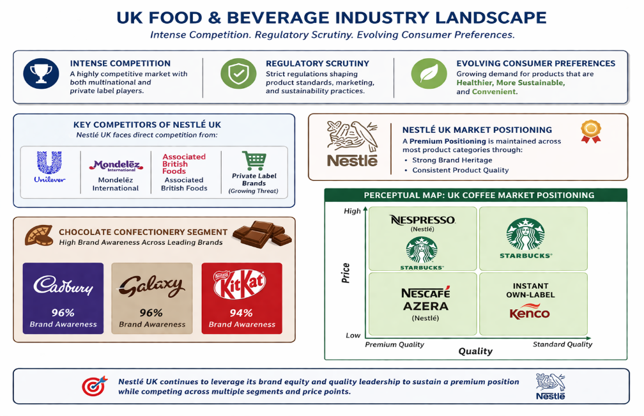

Fig 1: Perceptual mapping demonstrates Nestlé's strategic coverage across quality and price dimensions
Source: (Self-Anlayzed- Designed with Canva)

2. External and Internal Environment Analysis
The external and internal environments fundamentally shape organisational strategy. The external environment comprises factors beyond organisational control that create opportunities and threats, whilst the internal environment encompasses resources, capabilities, and competencies that management can directly influence.

2.1 PESTEL Analysis: External Factors Impacting Strategic Decisions
External factors influencing strategic decisions are systematically examined through PESTLE analysis in this report. Macro-environmental forces are identified and evaluated to assess their impact on Nestlé UK, where key opportunities and threats are recognised to inform strategic planning and adaptation.

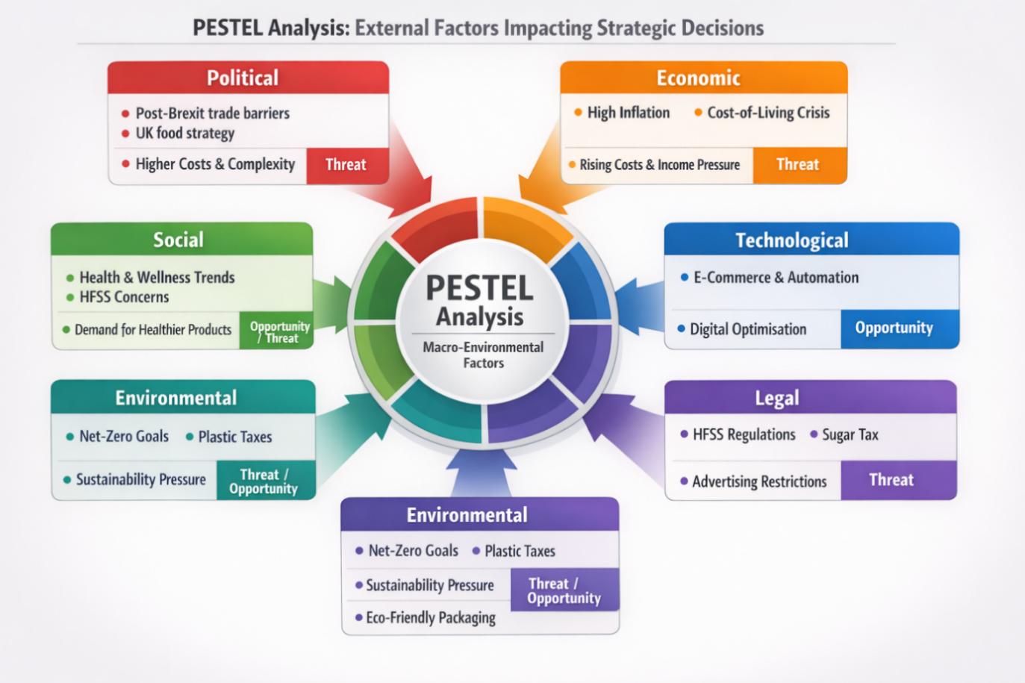

Fig: 02 PESTLE Analysis for Nestle in the UK Market (Self Analyzed, Source: Nestle)

Political Factors
Political factors are shaped by post-Brexit trade arrangements, where increased customs procedures and regulatory divergence have been introduced. Greater emphasis has also been placed on domestic food production within UK policy frameworks (Grant, 2022). As a result, higher operational complexity and supply chain costs are experienced by firms such as Nestlé. Strategic responses are required, including localisation of sourcing and supplier diversification. These pressures are generally interpreted as external threats influencing cost structures and operational efficiency (Johnson et al., 2020).

Economic Factors
Economic conditions in the UK are characterised by high inflation, rising energy prices, and an ongoing cost-of-living crisis. Increased production and logistics expenses are consequently experienced, while consumer purchasing power is reduced (IMF, 2023). Demand sensitivity to price is therefore heightened, affecting revenue stability for companies such as Nestlé. Profit margins are often compressed under such conditions, requiring efficiency improvements and value-based pricing strategies to be implemented. These economic pressures are typically classified as threats within strategic analysis (Sloman et al., 2021).

Social & Cultural Factors
Social trends are increasingly driven by consumer preferences for health, wellness, and sustainability, while concerns regarding high fat, sugar, and salt (HFSS) products are amplified. Cultural insights derived from Hofstede's cultural dimensions theory indicate that individual choice is prioritised in the UK, while shorter-term decision-making is often observed (Hofstede, 2011). Consequently, demand for transparent and healthier products is strengthened. Opportunities are created through product innovation, although risks remain for legacy offerings, requiring reformulation and targeted marketing strategies (Euromonitor, 2022). UK consumers prioritise individual choice and short-term decision-making, driving demand for transparent, healthier products and creating both opportunities for innovation and reformulation risks (Hofstede, 2011).

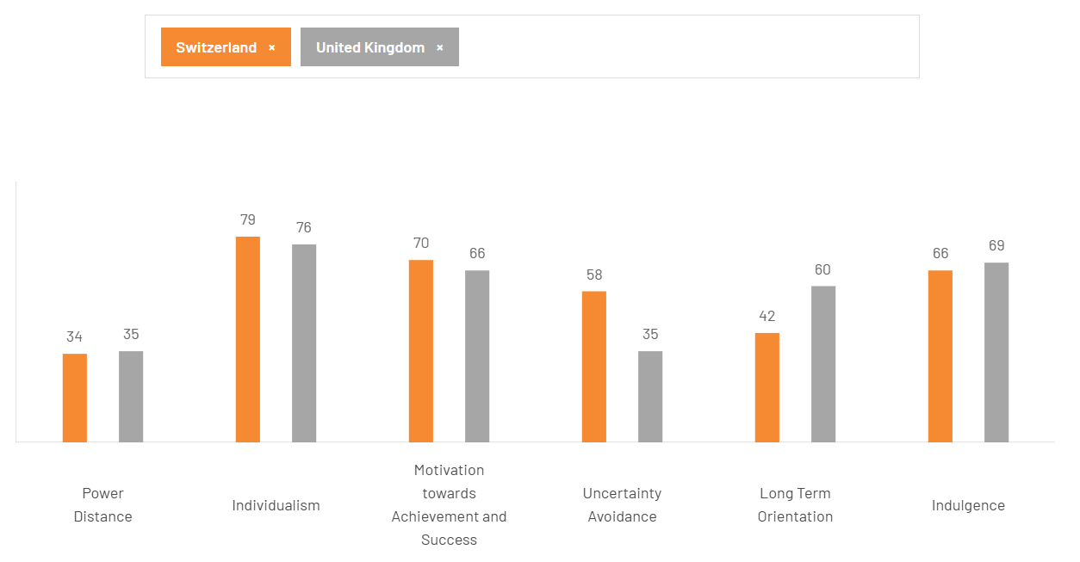

Fig: 03 Cultural Dimension analysis for Nestle between UK & Switzerland
It is indicated by the cultural dimension analysis that low power distance (34 vs. 35) and high individualism (79 vs. 76) are demonstrated by both Switzerland and the United Kingdom, reflecting egalitarian and independent workplace cultures. A stronger achievement orientation (70) and higher uncertainty avoidance (58) are shown by Switzerland compared to the UK (35), suggesting a greater preference for structure. Conversely, a higher long-term orientation (60 vs. 42) and higher indulgence (69 vs. 66) are recorded by the UK, indicating that a more future-focused and flexible social culture is possessed.

Technological Factors
Technological advancements are characterised by the growth of e-commerce platforms, artificial intelligence-driven supply chains, and automation in production processes. These developments are increasingly adopted to enhance operational efficiency and customer engagement (Porter & Heppelmann, 2015). For organisations such as Nestlé, opportunities are created through improved logistics optimisation, data-driven marketing, and enhanced traceability. Strategic investments in digital infrastructure and direct-to-consumer channels are therefore prioritised. Such technological progress is generally viewed as a significant opportunity for competitive advantage ( Brynjolfsson & McAfee, 2017).

Environmental Factors
Environmental pressures are intensified by UK net-zero commitments and increasing regulatory measures, including plastic packaging taxes. Greater expectations from consumers regarding sustainability practices are also observed (UN, 2021). As a result, reductions in carbon emissions, improvements in water management, and redesign of packaging systems are required for companies such as Nestlé. Although compliance costs are incurred, opportunities for brand differentiation through sustainable innovation are simultaneously created. Strategic initiatives are therefore directed towards circular packaging and carbon neutrality (DEFRA, 2022).

Legal Factors
Legal factors are influenced by regulations such as HFSS advertising restrictions, sugar taxes, and evolving labour laws within the UK. These policies directly affect product formulation, promotional strategies, and retail placement decisions (UK Government, 2022). For firms like Nestlé, reformulation of products and adjustments in marketing channels are required to ensure compliance. Budget allocations are often shifted towards permissible communication platforms. These legal constraints are typically categorised as threats, as they impose limitations on traditional revenue-generating activities (WHO, 2020).

2.2 Strategic Challenges and Critical Success Factors (CSFs)
Strategic challenges are defined as specific obstacles by which the achievement of organisational strategic objectives is impeded. Post-Brexit supply chain disruption has been experienced, whereby increased border checks and administrative requirements have been imposed, resulting in delays to imports and exports and higher operational costs (Dhingra et al., 2021). Health and regulatory pressure has been intensified through HFSS legislation, under which the marketing of key confectionery and ready-meal products has been restricted (Department of Health and Social Care, 2020). Intense private label competition has been observed, as supermarket own-brand products of comparable quality have been offered at lower prices, thereby eroding branded market share (Euromonitor International, 2023). Additionally, sustainability investment costs have been incurred, as the transition towards recyclable packaging and net-zero logistics has required substantial capital expenditure (McKinsey & Company, 2022).
Critical Success Factors (CSFs) are defined as the essential areas in which superior performance must be achieved by Nestlé in order to outperform competitors. Brand heritage and trust are leveraged through over 150 years of historical presence to sustain consumer loyalty, which is reflected in enhanced premium pricing capability (Keller, 2013). Continuous product innovation for health is undertaken through reformulation practices to ensure alignment with evolving health regulations, thereby supporting regulatory compliance and sustained market access (Euromonitor, 2023). Supply chain resilience is strengthened through the development of flexible and localised sourcing networks, enabling resistance to political and economic disruptions while influencing cost efficiency and operational reliability (Christopher, 2016). Leadership in sustainable packaging is pursued through early adoption of circular economy initiatives, whereby brand image is enhanced and favourable regulatory relationships are facilitated (Ellen MacArthur Foundation, 2019).

2.3 Internal Environment: Resources, Capabilities, and Core Competencies
The internal environment is composed of tangible assets, intangible assets, and organisational capabilities, through which competitive advantage is sustained (Barney, 1991). Manufacturing facilities, such as the Dalston Cumbria factory, are identified as key tangible resources, through which production scale and quality control are ensured. A strong brand portfolio, including KitKat, Nescafé, and Purina, is recognised as a critical intangible resource, by which premium pricing and customer loyalty are generated (Keller, 2013). Integrated supply chain management is utilised as a core capability, enabling efficient distribution across retail, foodservice, and digital channels (Christopher, 2016). Additionally, Research and Development (R&D) in nutrition is leveraged to support product reformulation and health-oriented innovation. Core competencies are reflected in global–local ambidexterity, through which global brands are adapted to local UK preferences, and in consumer insight analytics, where digital commerce data is employed to predict evolving market trends (Prahalad & Hamel, 1990).

2.4 VRIO Analysis of Strategic Capabilities
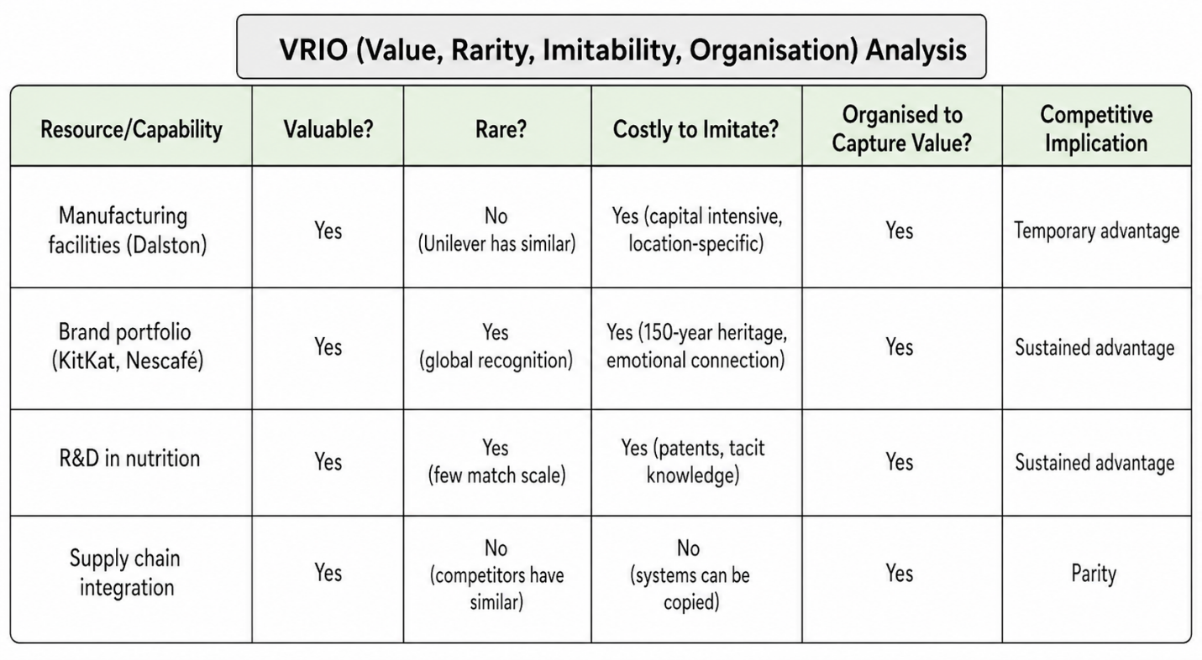

Fig: 04 VIRO Analysis of Strategic Capabilities of Nestle
It is indicated that manufacturing facilities are valuable but not rare, and although costly to imitate, only a temporary advantage is achieved. The brand portfolio is identified as valuable, rare, and difficult to replicate, resulting in sustained competitive advantage. R&D in nutrition is similarly recognised for its rarity and inimitability, supporting long-term advantage. Supply chain integration is considered valuable but not rare or difficult to imitate, leading to competitive parity. Overall, competitive advantage is primarily driven by intangible resources and innovation capabilities.

2.5 Internal Strengths and Contribution to Competitive Advantage
Drawing from Sections 2.1–2.4, Nestlé UK’s internal strengths are identified in terms of key resources and capabilities that support competitive positioning. Strong brand heritage and trust are recognised as critical intangible resources, through which premium pricing and customer retention are facilitated (Keller, 2013). Advanced Research and Development (R&D) in nutrition is utilised as a core capability, enabling proactive product reformulation in response to HFSS regulations, thereby transforming regulatory threats into strategic opportunities (Porter, 1985). Global scale combined with local agility is reflected as a core competency, through which efficient sourcing is achieved while adaptation to UK-specific consumer trends, such as plant-based offerings, is ensured (Prahalad & Hamel, 1990). Collectively, these strengths are seen to contribute to a differentiation-based competitive advantage, by which premium pricing is sustained and customer loyalty is maintained despite competition from lower-priced private labels.

3. CSR Strategy and Sustainability
CSR strategy is defined as a proactive plan through which social, environmental, and ethical responsibilities are integrated into business operations and stakeholder interactions, including employees, customers, communities, and investors (Johnson et al., 2020). It is considered to extend beyond legal compliance, as positive societal impact is pursued alongside long-term business performance (Porter, 1985).
Sustainability is defined as the principle by which present needs are met without compromising future generations (UN, 2021). In a business context, it is conceptualised through three pillars: economic viability, environmental protection, and social equity, commonly referred to as the Triple Bottom Line (Ellen MacArthur Foundation, 2019).

3.1 Critically discuss the company's CSR strategy and its alignment with business objectives
Nestlé UK’s CSR strategy is framed through the Creating Shared Value (CSV) approach, by which social and environmental objectives are integrated with long-term business performance. Alignment with business objectives is demonstrated in several areas(UK Government, 2022). Product reformulation is undertaken to reduce sugar and salt content in response to HFSS regulations, whereby regulatory compliance and market access are maintained (Euromonitor, 2023). Sustainable packaging initiatives are implemented to reduce virgin plastic usage, through which regulatory and reputational risks are mitigated (DEFRA, 2022). Furthermore, net-zero commitments are established to address climate-related supply chain vulnerabilities, thereby supporting operational resilience and long-term sustainability goals (UN, 2021).
However, critical contradictions are also identified. Lobbying activities against public health guidance have been reported, despite the company’s health-oriented positioning. Withdrawal from climate initiatives has raised concerns regarding environmental commitment (Ellen MacArthur Foundation, 2019). Additionally, persistent issues such as child labour within cocoa supply chains and legal challenges related to recyclability claims have been documented, exposing gaps between CSR communication and operational practice (McKinsey & Company, 2022). Consequently, the CSV framework is considered to be selectively applied, as it is prioritised where commercial benefits are evident, while more complex trade-offs are limited.

4. Comprehensive and Holistic view

4.1 Balanced Scorecard
The Balanced Scorecard is defined as a strategic performance framework through which organisational strategy is translated into measures across financial, customer, internal process, and learning perspectives (Kaplan and Norton, 1992). A holistic evaluation is enabled, linking short-term actions with long-term objectives, and supporting performance monitoring for sustainable competitive advantage (Johnson et al., 2020). This framework is considered useful as strategic objectives are translated into measurable outcomes, organisational alignment is ensured, and performance across multiple dimensions is monitored, supporting informed decision-making and long-term competitiveness (Kaplan and Norton,1992)

4.2 The Four Core Perspectives
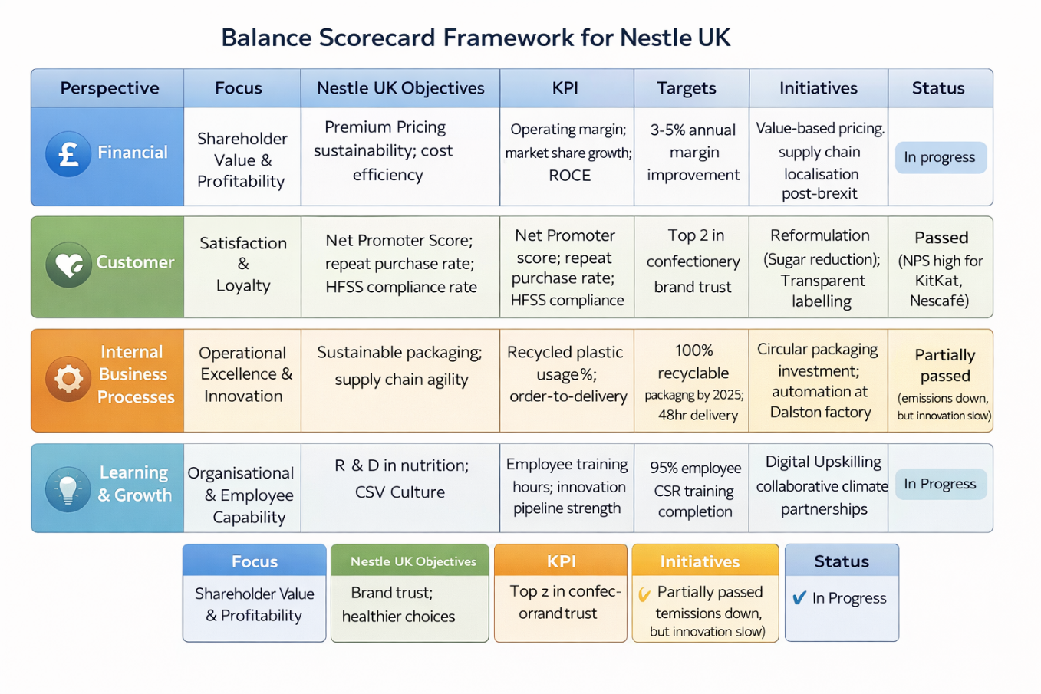

Fig: 05 Balance Scorecard Framework for Nestle UK
The Balanced Scorecard framework is applied to Nestlé UK to align strategic objectives with measurable performance outcomes across four perspectives (Kaplan and Norton, 1992). Financial performance is prioritised through profitability and cost efficiency, supported by value-based pricing and supply chain localisation. Customer satisfaction is enhanced through brand trust, healthier product reformulation, and transparent labelling. Internal processes are optimised via sustainable packaging and operational innovation, including circular investments and automation. Learning and growth are strengthened through R&D in nutrition and employee capability development, supported by training and partnerships. Through this integrated approach, short-term performance is linked with long-term strategic goals, enabling sustainable competitive advantage (Johnson et al., 2020).

4.3 Evaluation of Framework Success/Failure
The Balanced Scorecard is considered to have been only partially failed for Nestlé in the UK, not due to conceptual limitations, but because of its application and lack of strategic coherence. From a financial perspective, alignment with a differentiation strategy is achieved, as premium pricing and cost efficiency are supported by measurable KPIs such as operating margin and ROCE (Kaplan and Norton, 1992). However, within the customer perspective, contradictions are observed, as brand trust and healthier choices are promoted through reformulation, while lobbying against UK health regulations undermines credibility (UK Government, 2022).
In the internal processes perspective, clear and time-bound targets, such as recyclable packaging commitments, are established, and investments in sustainability are made. Nevertheless, selective disclosure is identified, as environmental criticisms and withdrawal from climate initiatives indicate gaps in transparency (DEFRA, 2022; Ellen MacArthur Foundation, 2019). Within the learning and growth perspective, employee training targets are defined, yet shortcomings in human rights training and discontinued partnerships are reported (Johnson et al., 2020).
Critically, trade-offs between financial and CSR priorities are not fully addressed, as financial objectives are prioritised when conflicts arise. Consequently, the Balanced Scorecard is applied as a performance tool with limitations, where governance integrity and balanced evaluation are not consistently maintained.

5. Strategic Choices and Implementation
Strategic choice is defined as the process through which alternative courses of action are evaluated and selected to determine how an organisation will compete and create value (Johnson et al., 2020). Decisions regarding target markets, competitive differentiation, and resource allocation are made to achieve and sustain competitive advantage (Porter, 1985).

5.1 Business Level Strategic Choices:
Business-level strategies are defined as approaches through which firms compete within specific markets to achieve competitive advantage. Cost leadership and differentiation are identified as primary strategies (Porter, 1985). For Nestlé UK, differentiation is preferred, as intangible assets support premium pricing and competitive positioning (Barney, 1991)
A cost leadership strategy would be defined as the pursuit of the lowest operational costs in the industry, through which lower prices are offered to attract price-sensitive consumers (Porter, 1985). However, this strategy is considered unsuitable for Nestlé UK because premium brand heritage and intangible resources, including KitKat and Nescafé, are strongly emphasised. It has been identified through VRIO analysis that only temporary advantages are provided by tangible assets (Barney, 1991). Furthermore, intense competition from Tesco and Aldi has been recognised within the cost-based segment (Euromonitor, 2023; Keller, 2013).
A differentiation strategy is defined as an approach through which unique products and superior brand experiences are developed to enhance customer loyalty and premium pricing (Porter, 1985). This strategy is considered highly suitable for Nestlé UK because valuable and difficult-to-imitate resources, including brand heritage, consumer trust, and advanced R&D capabilities, are possessed (Barney, 1991). Furthermore, differentiated offerings are supported by UK consumer culture and regulatory pressures relating to HFSS compliance and health-oriented innovation (Hofstede, 2011; UK Government, 2022; Euromonitor, 2023).

5.2 Corporate Level Strategic choices
Corporate-level strategies are defined as decisions determining organisational scope across markets and business units. Diversification and international expansion are identified as key choices shaping value creation and risk distribution (Johnson et al., 2020). For Nestlé UK, such strategies are guided by parent company objectives and global growth priorities (Porter, 1985).
Diversification is defined as a corporate-level strategy through which new markets and products are entered, either through related or unrelated expansion (Johnson et al., 2020). Related diversification is achieved by leveraging existing capabilities, brands, and technologies, while unrelated diversification is pursued to spread risk across industries (Ansoff, 1965). For Nestlé UK, expansion into plant-based alternatives would be supported by existing R&D and distribution networks, whereas entry into unrelated sectors, such as financial services, would lack strategic synergies (Porter, 1985).
International expansion is defined as a corporate-level strategy through which organisational operations, products, or services are extended beyond domestic borders into foreign markets (Johnson et al., 2020). This strategy is implemented through modes such as exporting, licensing, joint ventures, or wholly owned subsidiaries (Ansoff, 1965). For Nestlé UK, the subsidiary may be utilised as a testbed for health-reformulated products developed in response to HFSS regulations, after which successful innovations are transferred to other international markets, including emerging economies, thereby leveraging global scale and local responsiveness (Porter, 1985).

Recommended Strategic Choices and Justification

At the business level, a differentiation strategy is adopted, through which competitive advantage is derived from brand heritage, R&D capabilities, and consumer trust rather than cost efficiency (Barney, 1991; Porter, 1985). HFSS regulations are interpreted as threats; however, opportunities are created through low-sugar reformulation and transparent labelling (UK Government, 2022). Furthermore, private label competition is mitigated because differentiated products cannot be easily replicated (Euromonitor, 2023). Premium positioning and long-term competitiveness are reinforced through investment in sustainable packaging and personalised direct-to-consumer experiences (Johnson et al., 2020).
International expansion is selected as a corporate-level strategy due to the maturity of the UK market, where low growth and high regulatory pressure are observed, thereby limiting domestic opportunities (Euromonitor, 2023; Johnson et al., 2020). Higher growth potential is identified in emerging economies, where market expansion is facilitated (Porter, 1985). Nestlé UK’s innovations, including HFSS-compliant product reformulations, are leveraged and transferred across subsidiaries, through which R&D costs are spread and returns are enhanced (UK Government, 2022).
Furthermore, global–local adaptability is utilised, whereby global brands are locally adapted and innovations are internationally scaled (Prahalad and Hamel, 1990). An “Innovation Export Unit” is proposed to be established within Nestlé UK.

5.3 Critical Assessment: How well has the organisation managed change and its impact on strategic implementation?
The effectiveness of organisational change management is critically evaluated through the transition from the current state to the desired strategic position. Guidance is provided by Lewin’s Three-Step Model, where communication, operational adjustments, and behavioural reinforcement are assessed to determine whether strategic implementation has been supported or constrained (Lewin, 1947).
The unfreezing stage of Nestlé UK’s change process was considered reasonably effective, as awareness of the urgent need for strategic transformation was successfully created through the communication of external pressures, including HFSS regulations and supply chain disruptions (Lewin, 1947). Although resistance was observed within legacy divisions, the case for change was ultimately reinforced (Burnes, 2020). During the moving stage, positive initiatives were implemented through sugar reduction, sustainable packaging trials, and digital supply chain investments to improve efficiency (Kaplan and Norton, 1996). However, inconsistencies were identified because lobbying activities and climate initiative withdrawals contradicted sustainability commitments, while employee retraining progressed slowly (Porter and Kramer, 2011). The refreezing stage remained incomplete, as sustainability targets were only partially embedded into organisational KPIs, and governance integrity continued to be perceived as inconsistent due to unresolved tensions between financial and CSR objectives (Crane et al., 2019).

5.4 The Impact on Strategic Implementation
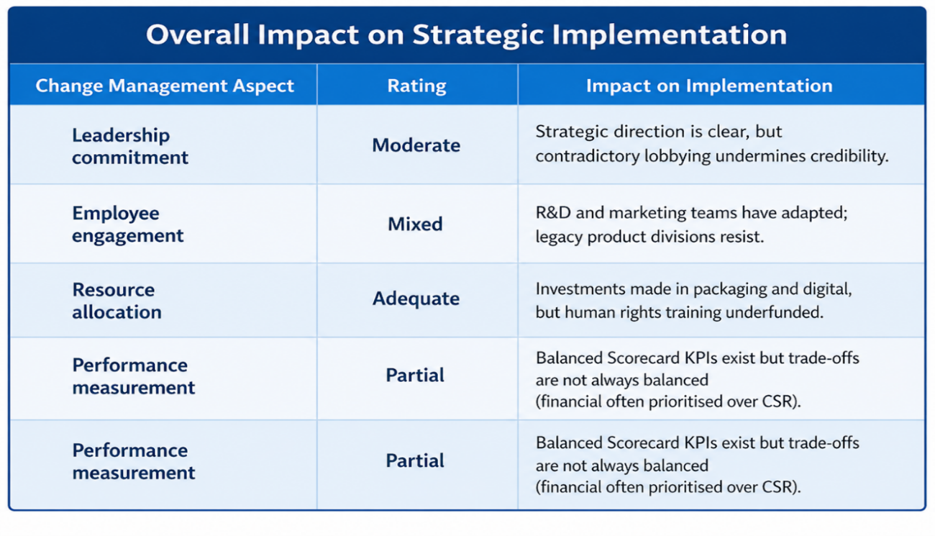

Fig: 06 Impact of Strategic Implementation analysis (Self-Analyzed, Designed with Canva)

Overall, the impact of change management on strategic implementation has been assessed as moderate, with progress having been achieved across organisational dimensions. Leadership direction has been communicated clearly; however, credibility has been weakened by inconsistencies between strategic commitments and operational actions (Kaplan and Norton, 1996). Employee engagement has been partially achieved, while technological and sustainability initiatives have been supported through resource allocation. Nevertheless, financial priorities have frequently been emphasised over corporate social responsibility objectives, indicating incomplete strategic alignment within the Balanced Scorecard framework. Cultural and governance dimensions have also been less successfully addressed (Burnes, 2020).

6. Strategic Evaluation and Recommendations
Strategic evaluation is defined as the systematic assessment of organisational strategies, performance, and environmental changes to identify weaknesses, measure effectiveness, and support evidence-based corrective actions and future strategic decision-making (Johnson et al., 2020).

6.1 Ansoff Matrix as a strategic planning tool:
The Ansoff Matrix is defined as a strategic planning tool through which four growth strategies are identified based on combinations of products and markets: market penetration, product development, market development, and diversification (Ansoff, 1957). Different levels of risk are associated with each strategy, with the lowest risk linked to market penetration and the highest to diversification. In the context of Nestlé UK, it is used as a structured framework through which strategic positioning is assessed and future growth options are evaluated (Johnson et al., 2020).
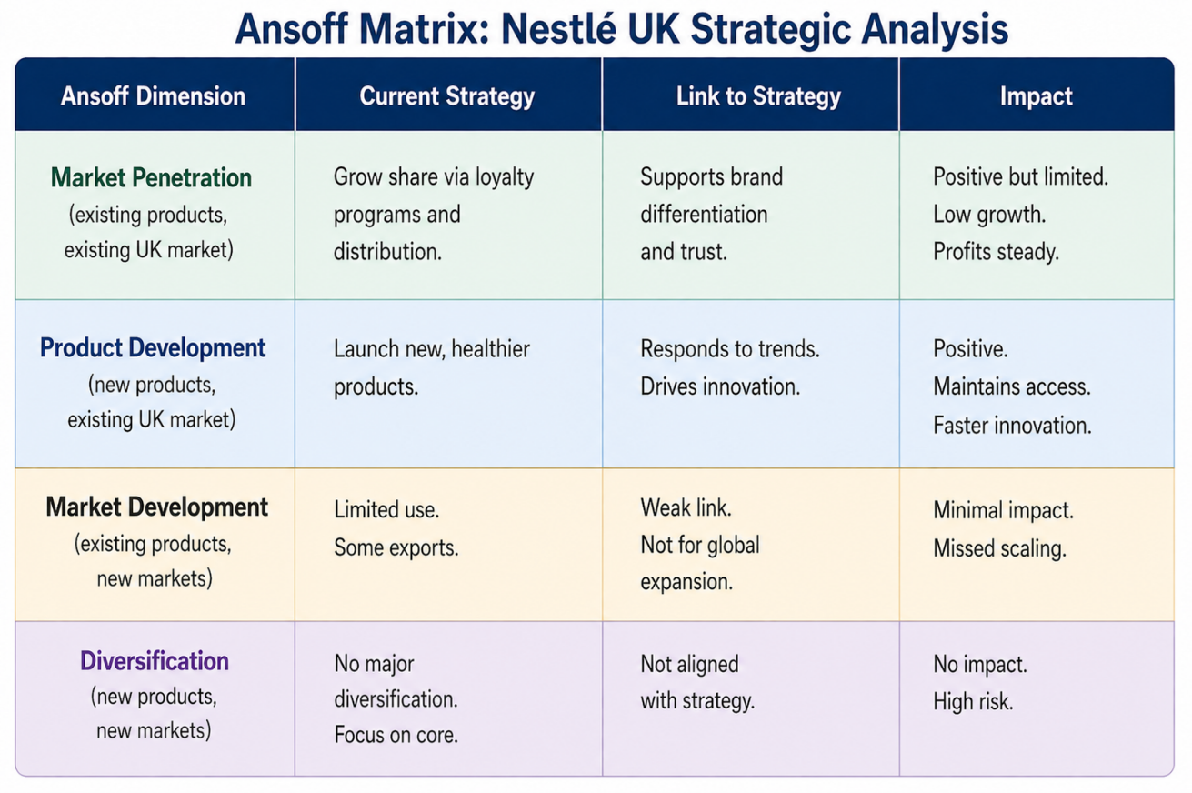

Fig: 07 Nestlé UK’s current strategy is evaluated across the four Ansoff dimensions (Self-analyzed)

Overall, it is observed that market penetration and product development strategies are primarily pursued by Nestlé UK within the mature UK market. While differentiation and regulatory compliance are sustained through these approaches, market development—particularly in terms of international expansion—is comparatively underutilised as a growth strategy. Consequently, the current strategic approach is characterised as largely defensive rather than proactive, whereby potential growth opportunities remain insufficiently exploited (Johnson et al., 2020; Ansoff, 1957).
Recommendation: Based on the Ansoff Matrix, several strategic recommendations are proposed for Nestlé UK. Product development is the main priority, focusing on health-driven innovation through a “Better Choice” sub-brand with low-sugar and reduced-fat options. Market development is secondary, using the UK as a testbed before expanding successful products to emerging markets. Market penetration remains supportive via digital loyalty and direct-to-consumer strategies. Diversification is not advised, ensuring focus stays on core categories and avoids high-risk expansion.

6.2 Justification with Theoretical Concepts and Real‑World Examples
For Product Development (Primary Recommendation): Dynamic capabilities refer to an organisation’s ability to sense opportunities and respond through innovation and resource reconfiguration. In this context, Nestlé UK’s nutrition-focused R&D acts as a key dynamic capability, enabling rapid product reformulation to meet regulatory and consumer changes. A real-world example is Lucozade Ribena Suntory, where Ribena was reformulated after UK sugar taxes using reduced sugar and alternative sweeteners, preserving taste and market share. Nestlé UK can apply a similar approach within its confectionery segment.
For Market Development (Secondary Recommendation): The Internationalization Process Model explains how firms expand abroad gradually as knowledge and commitment grow. Companies first enter psychically close markets like Ireland or Australia before moving into distant emerging economies. This staged approach reduces uncertainty through learning. For example, Unilever tested low-salt products in the UK before launching them in Southeast Asia. Similarly, Nestlé UK can export HFSS-compliant products to subsidiaries such as Nestlé India and Nestlé Brazil to support gradual internationalisation.
By adopting these recommendations, a transformation is enabled whereby Nestlé UK is repositioned from a defensive market penetrator into a proactive growth engine. Product development is leveraged to ensure regulatory compliance and continuous innovation, while market development is utilised to support long-term international expansion and sustainable growth (Johnson et al., 2020).

Section 2: Reflective Account Using Gibbs’ Reflective Cycle
A reflective account of the process undertaken in researching, analysing, and preparing the strategic management report on Nestlé UK is provided in this section. The Graham Gibbs Reflective Cycle is applied as a structured framework through which the experience is systematically examined, learning outcomes are identified, and future practice is informed. The six stages of the cycle—Description, Feelings, Evaluation, Analysis, Conclusion, and Action Plan—are followed to ensure a comprehensive and critical reflection (Gibbs, 1988).

Description
A strategic management report on Nestlé UK was required to be produced, in which the external and internal environments, strategic capabilities, CSR alignment, balanced scorecard perspectives, strategic choices, and implementation were critically analysed. A detailed structural template was provided, within which sections such as PESTEL with Hofstede’s cultural dimensions, VRIO analysis, CSF identification, and the application of Lewin’s change model were specified. Evidence-based recommendations and a reflective account using Gibbs’ cycle were also required (Gibbs, 1988; Hofstede, 2001).
The process was initiated through a review of the provided source document, where foundational data on Nestlé UK’s history and strategic context had been outlined (Porter, 2008). This information was cross-referenced with the template to ensure completeness. Secondary research was undertaken using academic and industry sources to validate the analysis (Kaplan & Norton, 1996). Each section was systematically developed, and reflection was structured accordingly.

Feelings
At the beginning, a sense of being overwhelmed was experienced due to the comprehensiveness of the structural template and the extensive range of theoretical models required. The simultaneous application of PESTEL, VRIO, Hofstede’s cultural dimensions, CSFs, the Balanced Scorecard, and Lewin’s model was perceived as demanding. Frustration was encountered when specific KPIs were absent, necessitating assumptions based on industry norms (Kaplan & Norton, 1996).
As progress was made, confidence was gradually developed, and satisfaction was achieved when VRIO analysis demonstrated sustained competitive advantage (Barney, 1991). Cultural comparisons were initially challenging but later enriched analysis (Hofstede, 2001). The process was recognised as iterative, where frameworks complemented one another (Porter, 2008). Critical reflection revealed limitations in CSR alignment and Balanced Scorecard effectiveness. Overall, the experience was found to be intellectually stimulating, while highlighting the importance of critical evaluation, data triangulation, and structured reflection for future strategic management practice (Gibbs, 1988).

Evaluation
Positive aspects were identified in the use of a structured template, through which critical elements such as CSFs, strategic challenges, and the learning and growth perspective of the Balanced Scorecard were systematically included (Kaplan & Norton, 1996). Analytical rigour and visual clarity were enhanced by the application of perceptual mapping and Hofstede’s cultural dimensions (Hofstede, 2001). Reflection was structured effectively through the use of Gibbs’ cycle, preventing superficial evaluation (Gibbs, 1988). The incorporation of real-world examples strengthened recommendations, while the VRIO framework facilitated the clear summarisation of competitive implications (Barney, 1991). Furthermore, strategic implementation was deepened through the application of Lewin’s change model.
However, limitations were observed, as structural rigidity led to repetition across sections. The absence of precise KPIs necessitated reliance on industry benchmarks, reducing accuracy. Cultural analysis required cautious interpretation, and dependence on secondary data sources constrained the overall validity of findings (Porter, 2008).

Analysis
Through this process, it was recognised that strategic management analysis is iterative rather than linear, as interconnections between analytical stages were continuously observed. Internal strengths identified through the VRIO framework were seen to influence strategic choices, while external pressures identified through PESTEL analysis were found to shape CSFs and subsequent growth strategies (Barney, 1991; Porter, 2008). It was also understood that theoretical frameworks are complementary, with PESTEL evaluating external conditions, VRIO assessing internal capabilities, the Balanced Scorecard translating strategy into measurable outcomes, and the Ansoff Matrix guiding strategic direction (Kaplan & Norton, 1996; Ansoff, 1957).
A critical insight was gained regarding CSR inconsistencies, which were found to undermine strategic coherence when organisational actions diverge from stated commitments. It was demonstrated that strategic analysis must critically evaluate corporate behaviour rather than rely solely on reported strategies. Furthermore, limitations in Balanced Scorecard implementation highlighted the importance of governance in ensuring effectiveness. Reflection through Gibbs’ cycle enabled learning gaps to be identified and emphasised the importance of proactive data sourcing and the use of visual tools to enhance analytical clarity (Gibbs, 1988).

Conclusion
From this experience, several key lessons were identified. The importance of structure was recognised, as comprehensive templates were found to ensure coverage of critical elements, although careful management was required to minimise repetition. The necessity of critical evaluation beyond available data was emphasised, particularly in assessing CSR claims against actual practices. Cultural analysis using Hofstede’s dimensions was understood to require contextual interpretation (Hofstede, 2001). Gaps in KPI availability highlighted the need for data triangulation across multiple sources. Effective time management was also acknowledged as essential for integrating reflection throughout the process (Gibbs, 1988; Kaplan & Norton, 1996).

Action Plan
Based on this reflection, I commit to the following actions for future strategic management assignments or professional practice:
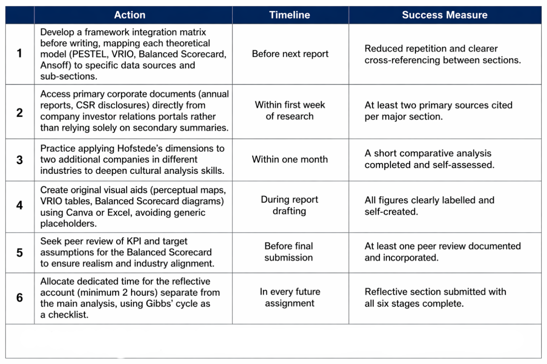

Fig: 08 Action plan with success measure and timeline

By following this action plan, I aim to enhance the critical depth, and practical relevance of future strategic analyses, while continuously improving my own reflective practice as a management learner.

Conclusion
It is concluded that Nestlé UK maintains a differentiation-based competitive advantage, which is supported by strong brand heritage, advanced R&D capabilities, and high levels of consumer trust (Porter, 2008). However, significant external pressures, including HFSS regulations, Brexit-related disruptions, and increasing private label competition, are required to be addressed through strategic adaptation. Although the Balanced Scorecard has been partially implemented, inconsistencies between CSR commitments and corporate lobbying activities are observed to undermine strategic coherence (Kaplan & Norton, 1996).
It is recommended that product development, particularly health-focused reformulation, and market development strategies be prioritised in alignment with the Ansoff Matrix (Ansoff, 1957). Furthermore, change initiatives are suggested to be aligned with Lewin’s change model to ensure effective implementation (Lewin, 1947). By leveraging dynamic capabilities and strengthening strategic alignment, regulatory challenges are expected to be transformed into opportunities for sustainable growth (Teece, 2007).

References
Adams, Carol. (2008). A commentary on: Corporate social responsibility reporting and reputation risk management. Accounting, Auditing & Accountability Journal. 21. 365-370. 10.1108/09513570810863950.
Ansoff, H. I. (1957) Strategies for Diversification. Harvard Business Review.
Ansoff, H.I. (1965). Corporate Strategy.
Brynjolfsson, E., & McAfee, A., (2017). The Business of Artificial Intelligence. Harvard Business Review.
Barney, J. (1991). Firm resources and sustained competitive advantage. Journal of Management, 17(1), 99–120.
Burnes, B. (2020) Kurt Lewin and the Harwood studies: The foundations of OD. Journal of Applied Behavioral Science, 56(3), pp. 255–273.
Christopher, M. (2016). Logistics & Supply Chain Management (5th ed.). Pearson.
Crane, A., Matten, D., Glozer, S. and Spence, L.J. (2019) Business ethics: Managing corporate citizenship and sustainability in the age of globalization. 5th edn. Oxford: Oxford University Press.
Department for Environment, Food and Rural Affairs –DEFRA, (2022). UK Environmental Policy Report.
Department of Health and Social Care (2020) Restricting promotions of products high in fat, sugar and salt by location and by price: government response to public consultation. London: DHSC.
Dhingra, S., Huang, H., Ottaviano, G., Pessoa, J.P., Sampson, T. and Van Reenen, J. (2021) ‘The costs of Brexit’, Economic Policy, 36(106), pp. 1–52.
Euromonitor, (2022). Health and Wellness Trends in the UK.
Euromonitor (2023) Health and Wellness Trends in Packaged Food.
Euromonitor International (2023) Private Label in the United Kingdom. London: Euromonitor.
Euromonitor International (2024) Coffee in the United Kingdom. Available at: https://www.euromonitor.com/coffee-in-the-united-kingdom/report (Accessed 15.04.2026)
Ellen MacArthur Foundation (2019) Completing the Picture: How the Circular Economy Tackles Climate Change.
Euromonitor International (2024) UK Food and Beverage Industry Analysis. Available at: https://www.euromonitor.com/ (Accessed: 22 April 2026).
Food and Drink Federation (2024) Industry Overview. Available at: https://www.fdf.org.uk/ (Accessed: 22 April 2026).
Gibbs, G. (1988) Learning by Doing: A Guide to Teaching and Learning Methods. Oxford: Oxford Polytechnic.
Grant, R. (2022). Contemporary Strategy Analysis. Wiley.
Hofstede, G. (2011). Dimensionalizing Cultures.
IMF, (2023). World Economic Outlook. Available at: https://www.imf.org/en/publications/weo/weo-database/2023/october. (Accessed 09.04.2026)
Johnson, G., Scholes, K., & Whittington, R., (2020). Exploring Corporate Strategy. Pearson.
Keller, K. L. (2013). Strategic Brand Management (4th ed.). Pearson.
Kaplan, R.S. and Norton, D.P. (1992) ‘The Balanced Scorecard: Measures that Drive Performance’, Harvard Business Review, 70(1), pp. 71–79.
Lewin, K. (1947) Frontiers in group dynamics. Human Relations, 1(1), pp. 5–41.
McKinsey & Company (2022) The net-zero transition: What it would cost, what it could bring.
Mendes, T., González-Loureiro, M., Braga, V. and Silva, C., (2026). Move fast and break things: Mapping the intellectual structure of the speed of the internationalization process to develop a research agenda for further inquiry. International Entrepreneurship and Management Journal, 22(1), p.1.
Nestlé, (2023) Nestlé Company History. Available at: https://www.nestle.com/about/history (Accessed 15.04.2026)
Prahalad, C.K. and Hamel, G., (1990). The Core Competence of the Corporation.
Porter, M.E. and Kramer, M.R., (2011) Creating shared value. Harvard Business Review, 89(1–2), pp. 62–77
Porter, M. E., & Heppelmann, J. E. , (2015). How Smart, Connected Products Are Transforming Competition. Harvard Business Review.
Porter, M.E., (1985) Competitive Advantage: Creating and Sustaining Superior Performance.
Prahalad, C. K., & Hamel, G. (1990). The core competence of the corporation. Harvard Business Review, 68(3), 79–91.
Shenkar, O., Luo, Y. and Chi, T., (2021). International business. Routledge.
Sloman, J., Garratt, D., & Guest, J. , (2021). Economics. Pearson.
Statista (2024) Nestlé UK – Market Data and Industry Position Available at: https://www.statista.com/statistics/311477/nestle-leading-products-in-the-uk/ (Accessed 15.04.2026)
Statista, (2024). Food Industry in the United Kingdom. Available at: https://www.statista.com/ (Accessed: 22 April 2026).
Teece, D. J. (2007) ‘Explicating Dynamic Capabilities: The Nature and Microfoundations of (Sustainable) Enterprise Performance’, Strategic Management Journal, 28(13), pp. 1319–1350.
UK Government, (2022). HFSS Regulations Guidance.
United Nations, (2021). Net Zero Coalition Report. available at: https://www.un.org/en/climatechange/net-zero-coalition (Accessed 10.04.2026)
United Nations, (2021). Sustainability Frameworks.
World Health Organization (2020). Guidelines on Sugar Intake. Available at: https://www.who.int/europe/news-room/fact-sheets/item/nutrition---maintaining-a-healthy-lifestyle (Accessed 10.04.2026)
YouGov (2024) Brand Awareness Rankings: UK Confectionery Market. Available at: https://yougov.co.uk/ (Accessed: 22 April 2026).

