A guidance Handbook for Keyworkers in early years to support transitions.

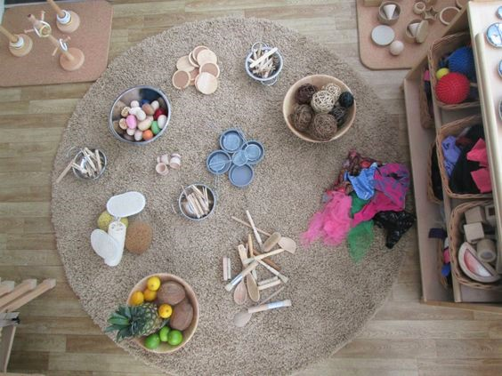

(Source: Journeying into enquiry, 2017)

Molly Scanlan 2011582
EAEE4003
Contents Page number

Introduction to transitions in the early years 3
How to use the Guidance Handbook 5
The role of the adult 6
The needs of the child 9
Working in Partnership 11
Interventions 13
Outcomes 14

Introduction
What are Transitions?
“Transitions are the moves children and young people make from home to an early learning and childcare (ELC) setting, from there to primary, from stage to stage, from primary to secondary, between schools and from secondary to further education and beyond.” (Parent Zone Scotland, 2020)
Transitions are not just events that happen in a child’s life, they are milestones that influence a child’s development. Although they may be an exciting time to further development, they can also make children feel a great amount of uncertainty due to unfamiliar people and surroundings (Early Years Matters, 2020).
Allingham (2020) defines transitions as an event that may cause change to not only the child’s usual routine but also the adults. The transition may not just be the child moving settings or a room within the setting, it can be a simple change such as a change in staff or the child being dropped off or collected by someone else.
The way in which children experience the transitions they go through can have an influence on the development of the child and their well-being. The way a child experiences transitions can be explored through Bandura’s theory that children learn through observation and going through their own transition could be made to feel less un-nerving or scary by observing the positive transitions of others.

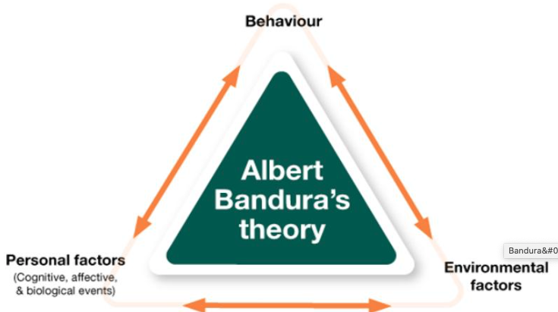

(Source: Kurt, 2020)

Although there are a number of transitions children will go through before the age of five, transitioning from their home to an early years setting is the first significant transition they will face (O’Connor, 2013). To create a smooth transition, it is important for the child to create a secure attachment with the care giver within the setting or make the most of the attachment they already have with someone. According to Bowlby’s attachment theory, there is a higher possibility children will manage new and potentially harming situations with confidence, or ask for help if they need it, when they have secure attachments (Pacey, 2014).
When a young child begins their transition from home into an early years setting it will offer many exciting and challenging times, although can cause anxiety and mixed emotions for the whole family, therefore, it is important that the transition is managed in an effective way as well as taking a sensitive approach. The way in which a child experiences their first transitions can have not only a short term impact on them, it can also have long term effects on their ability to cope with change as well as their emotional well being and development (Croner-I, 2019).
“By managing transitions carefully, we can ease the process of adjustment, reassuring both children and their families” (Teach Early Years, 2020).

How to use this handbook.

This handbook has been specifically created as a guide for keyworkers working within a day care setting, specifically in a baby or toddler room with the ages birth – two years old. It should be used as a guide for key workers to further their knowledge on how the way a young child experiences transitions can impact their development and well-being, as well as the way they are able to cope with change and transitions in the future.
When a child has experienced early education and childcare that is of a high quality the long term benefits and future life chances that are available to them are of a greater chance (Welsh Government, 2017).
As a keyworker, you play an important role in ensuring a smooth transition into the setting, not only for the child starting but for their parents or primary care givers. Keyworkers build a positive and trusting bond with parents and primary care givers to ensure that the relationship between the home and the setting is positive for all that are involved. As well as being there to help the child settle as quickly as possible and feel happy and comfortable within the new setting, keyworkers also provide comfort and reassurance to the parent or primary care giver when the child is transitioning from home into the new setting (Kelly, 2015).
In Bronfenbrenner’s ecological systems theory, he states that a child’s microsystem is the immediate and smallest environment in which a child lives in. The microsystem involves the people in which the child has personal relationships with such as, members of their family, other care givers, teachers and classmates. Having positive relationships with the people in the child’s microsystem will improve the child’s development (The Psychology Notes HQ, 2020).
As well as using this handbook as a guide to what you can do as a keyworker within an early years setting it also provides guidance on how to support a child’s needs when they are transitioning from home into a setting. Having visits to the new setting can be an important part of making the transition into the setting seem less daunting, not only for the child but for the parent or primary care giver as well. A good procedure needs to be in place for this to be effective, allowing time for parents to see the setting and get to know staff as well as the children having time to explore their new environment and create a trusting relationship with their new keyworker (Drake, 2006).
The role of the adult.

As an adult we need to consider the impact that can be had on very young children when they are experiencing these new transitions. Most children will gain their confidence from the adult they have a trusting relationship to, but even the slightest change to routine or environment can cause high levels of stress in a young child (Early Childhood Consultation Partnership, 2020).
The child’s new keyworker will play a vital role in helping the child to have as smooth transition from the home into the setting as possible. Research has shown high levels of toxic stress in babies for prolonged periods of time can have a significant impact on the development of their brain, therefore the transition needs to be made as stress free as possible. It is important as the child’s keyworker that you get to know the child’s needs, likes, dislikes and routine before the child starts in the setting. This will not only help you to comfort the child when they are distressed but will also help to create a secure attachment between you and the child as they will feel comforted knowing their needs can be met in a familiar manner. Although a nurturing environment will be beneficial to the child, not all children will experience comfort in the same way. For example, one child may experience comfort through being cuddled and having their face caressed, but doing this to another child may cause more distress as they would prefer you to sit near them while they have their own space with their own comforters (Dewar, 2020). While the child is in the setting, as a key worker you will play the role of the primary care giver. Forming a secure attachment to a primary care giver is biologically programmed in a child when they come into the world according to Bowlby’s theory of attachment. Long term and possibly irreversible consequences will be present if the attachment to the main care giver is disrupted or broken during the child’s cognitive, social and emotional skills may be affected. Bowlby states the permanent affects may be:
- ‘delinquency’
- ‘reduced intelligence’
- ‘increased aggression’
- ‘depression’
- ‘affectionless psychopathy’ (McLeod, 2017).
Similarly to Bowlby, Erikson’s theory of the stages of psychosocial development state that if a babies care is consistent and they can rely on their primary care giver, a feeling of trust will develop which will lead to a secure attachment, meaning even when the child is in an un-nerving situation, having that trusting relationship will help them to feel secure. The first stage of Erikson’s theory is trust vs. mistrust; the infant will experience this between birth up to 18 months of age. It is at this stage the baby will need reassurance from their primary care giver as the world around them can offer new and uncertain experiences, it is when these needs are not met a child will start to show signs of mistrust, be suspicious of the environment and people around them and develop anxiety (McLeod, 2018).
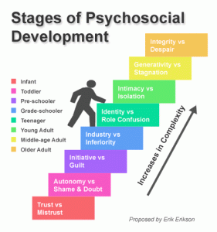

(Source: Career Research, 2020)

As an early years practitioner you need to ensure the environment the children will be transitioning in to is inviting and stimulating with age and stage appropriate activities and resources, this will not only help to settle the child when they first join the setting by distracting them with exciting opportunities but will also help to further their development by being highly involved and engaged in activities. The setting needs to be viewed as one whole area taking into account the indoors and outdoors and seeing it from an adult’s perspective as well as the child’s. To support the child and their families emotional well-being and their needs, having a space where children and their families feel welcomed and comforted will support good communication and positive relationships between families and the setting (Jarman, No date). There are similarities between the environments of a Montessori and Reggio Emilia setting, both believe the space should be open for children to take their own lead in learning and learn through hands on experiences and children are encouraged to follow their interests and be the one to take charge of their learning. However, there are some slight differences in the approaches, Montessori schools will follow a curriculum of general subjects that the resources and materials will relate to for the subjects of that day. Reggio Emilia schools on the other hand, do not have a set curriculum that they follow, they are less formal and the education is lead completely by the imagination and curiosity of the child and what has sparked interest for them (Goodwin University, 2019).

The needs of the child.

To ensure the transition process is a smooth one for the child they need to be able to build relationships with not only the new adults that will be caring for them, they also need to build positive relationships with their peers. Having these secure attachments will help the child to feel safe and secure in the new environment (Lodge, 2020).
The key worker will be the main person in the setting to support the child during their transition, if the child goes through the transition period being cared for by too many adults they wont be able to form a secure attachment to a main care giver. Trying to form too many attachments to many different adults will affects a child’s development and emotional stability, this will then impact the ability to further independence and self confidence (Bernstein, 2001). There are a number of theorists whose theories can be linked to how a key person is important for a child when they attend a setting. Albert Bandura stated in his theory that observing, imitating and modelling are the ways in which human behaviour is learnt, however, it may not be the case that something is learnt through observation alone, there are an additional four steps that need to happen for a behavioural change, attention, retention, reproduction and motivation. Having key workers in the setting as role models for the children, with activities that interest the children, hold their attention and engage learning follow banduras theory that children learn through observation and modelling (Serhat, 2020). A key worker will also support a child through the stages of Vygotsky’s theory of the zone of proximal development, he states the zone of proximal development is the space between what the child is capable of doing independently and what they may find more challenging and need support from the adult to complete. Vygotsky describes children as apprentices who will learn from those with more experience and understands their abilities by learning alongside them (First Discoveries, 2020).
The needs of the child can be described through Maslow’s Hierarchy of needs. The needs at the bottom of the pyramid are the most basic needs of the child working their way up to the more complex needs at the top. Although the hierarchy may not be fulfilled in its original pyramid order due to individual priorities being different, children must be supported through their development and have their basic needs met in order to reach the ultimate goal of self-actualization (Cherry, 2020). Good communication is a key factor in making children feel secure and comfortable while in the care of the adults in the setting, not only between staff members and between staff and parents but with the children also. The communication is not just verbal, children can be very observant of facial expressions and body language and adults communicating with and caring for the child need to be mindful of this and the way in which they speak with the children. Having the correct methods of communicating throughout the setting can be beneficial to the children who attend (Stallard, 2015).

Partnerships.

As a practitioner the Care Inspectorate Wales states in their outcome of Standard 6 “Parents are kept fully involved in and informed about their child’s activities, achievement and progress” (Welsh Government, 2016: 22). To meet the individual needs of the child and the needs as a group, as well as respecting the primary responsibility of the parents The Welsh Government (2016) states that staff and parents work in partnership. As well as setting making policies and procedures available to parents, they must also give access to any records or documents containing information about a child to the parents. For children under the age of two who attend day care settings, key workers need to provide daily information of the child’s care routine including routines and developmental needs.
Bronfenbrenner highlighted in his ecological systems theory how working together will support the child’s best interests. He believed children would not develop in isolation and argued in his theory that stronger links between families, schools, the community and society would support the development of the child. Bronfenbrenner defined the environment of the child as systems, each contained within another. If there is a change or disruption within one of these systems and impact will be had on the others, therefore the systems need to work together to support the child’s development and create individual experiences for them (Aubrey and Riley, 2019).
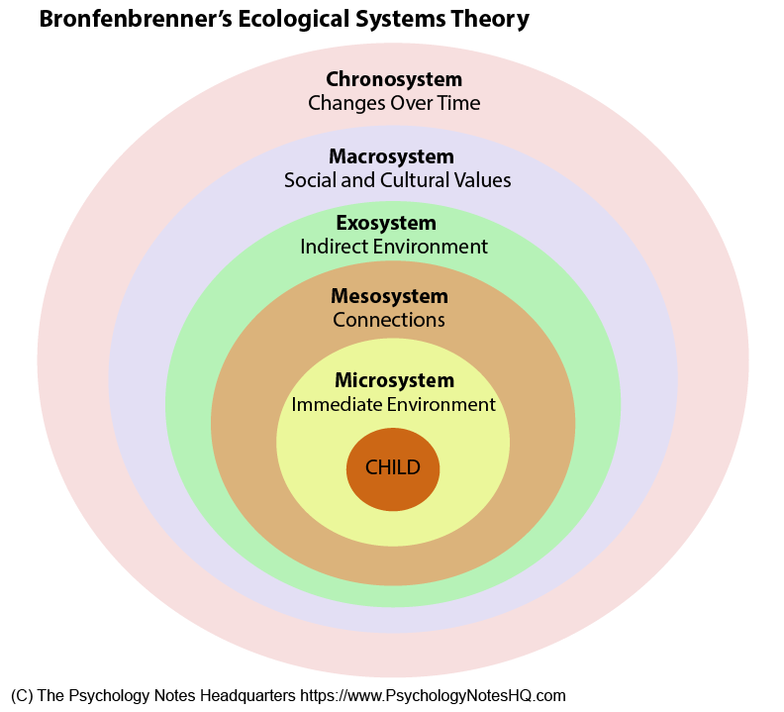

(Source: Psychology Notes HQ, 2020)

Article 3 of the United Nations Convention on the Rights of the Child states all who work with children and make decisions regarding them should always do what is best for the child (Children’s Commissioner for Wales, 2020). The role of members within a multiagency team must be understood by all within the team according to NSPCC Learning (2019). When sharing information that will impact the well-being of a child, effective methods of communication need to be in place. When there are a number of agencies working together having one individual who will communicate with parents will ensure they are receiving all information from all agencies involved (NSPCC Learning, 2019). Outside agencies that may work with the setting to provide the appropriate care and support for not only the child but their family’s needs may be the Early Years Inclusion Team who will offer support to the family at home and the setting so the child’s needs are supported consistently at home and in the setting. Health visitors are another agency who will work with families to support the developmental needs of the child such as nutrition, emotional well being and the development of speech and language (The Ely and Caerau Children’s Centre, 2015).

Interventions.
Transitioning into an early years setting can be an unsettling time for children and their parents, there are a number of interventions that with positive communication and planning can make the transition smoother. Before children start at the setting staff should ensure they have details of the children including allergies and routines that young children may follow, important information should be shared with all staff in the setting, not just the keyworker (First Discoveries, 2020).
According to the Ely and Caerau Children’s Centre transition policy (2017), before starting the setting, children have a chance to make a number of visits to the setting on an informal basis to become familiar with the environment and staff members while with a parent or familiar adult. This time can be used for parents to ask questions and for staff to get to know the needs of the child. When the child starts at the setting informal discussions between parents and staff will ensure the needs of the child are met and the parents are informed of their child’s day, this information will also be given to the parents in a communication book that will go home with the child each day.
One of the first theorists to recognise that the first few years of a child’s life were important for future development was Maria Montessori. She states in her theory, as a child from birth to six years is in the stage of an unconscious and absorbent mind, they are able to make sense of their surrounding environment, helping to form their personality. Montessori also states at this stage of development children need to feel secure within their development and need structure within their routine (Aubrey and Riley, 2019).

Outcomes.
Attending a high-quality provision from an early age can lead to positive outcomes for children in the short term and can still have an impact later in life and offer lasting effects. These early years interventions are in place to prepare young children for education and future academic success according to the Education Endowment Foundation (2020). The Welsh Government (2015) states the contribution staff are making to influence outcomes should be able to be noticed by all. Positive and effective communication is a proposed outcome during transitions in the early years, especially between staff and parents. Parents and main care givers will want to know who is caring for their child, the typical routine during the child’s day at the setting and updates on their child’s needs and developments once they are settled within their new environment. The relationship between staff and parents should be positive and reassuring so parents feel they can ask as many questions as they need to make the transitions smooth according to Mayo (2020). Piaget stated in his theory of cognitive development that a child’s development should not be measured by testing their problem solving, numeracy or literacy skills. Children develop at different stages and a child’s way of thinking is different to the that of an adult. Although all children will go through the stages of cognitive development in the same order, not all children will do it at the same pace (McLeod, 2018). A positive outcome through transitions is sustained shared thinking, this a positive way for children to learn key skills and not just remember facts they have been told. By having these experiences with adults in the setting will provoke curiosity and problem solving, in turn leading children to become lifelong learners (Arnerich, 2019).

