15/3/2018
University of Wales
University of Wales Trinity Saint David
Jordan coller
Fieldwork Report
BMSP4005 Distinctiveness and Regeneration

Introduction
In this report, I will be providing a personal reflection of the trip to the world heritage site of Blaenavon which took place on Thursday 1st March 2018. The town of Blaenavon contains a vast amount of historical infrastructure such as; Iron works, school, museums, mines, worker housing and working men’s memorial halls. These buildings were occupied for work in the 18th-19th century and were crucial to the historical development and reputation of the town. For this visit Ruth-Taylor Davies and volunteers will be the main source of references, along with pamphlets we acquire on our visit.

The Location of Blaenavon
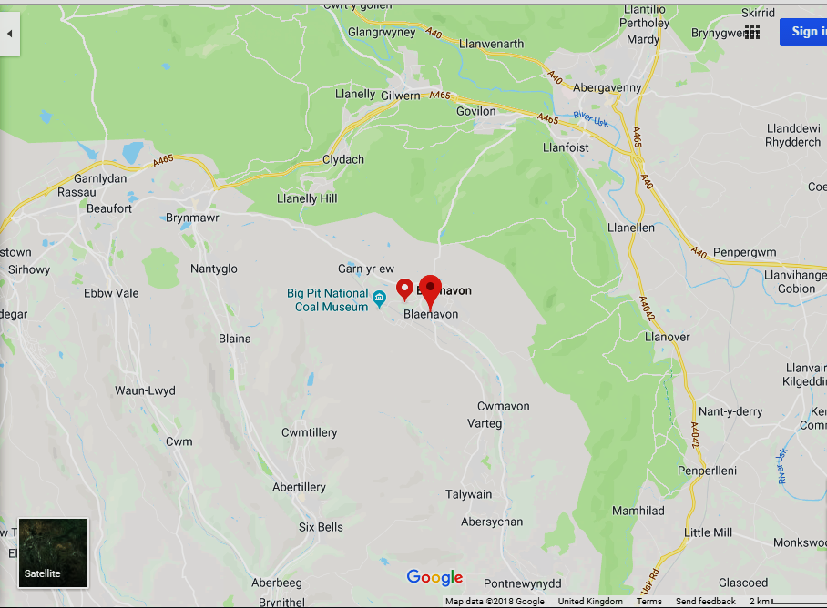

The World Heritage Centre
Finding a car park was moderately easy as the car park was vacant, this emphasised that the town wasn’t a busy location for tourism this time of year. We then proceeded to The World Heritage Centre to acquire a map of the attractions we shall be visiting. I then progressed to watch a 3D video that showed what the blast furnace would be like in the 18th-19th century, this was a completely different experience to the empty atmosphere I shall be witnessing later.

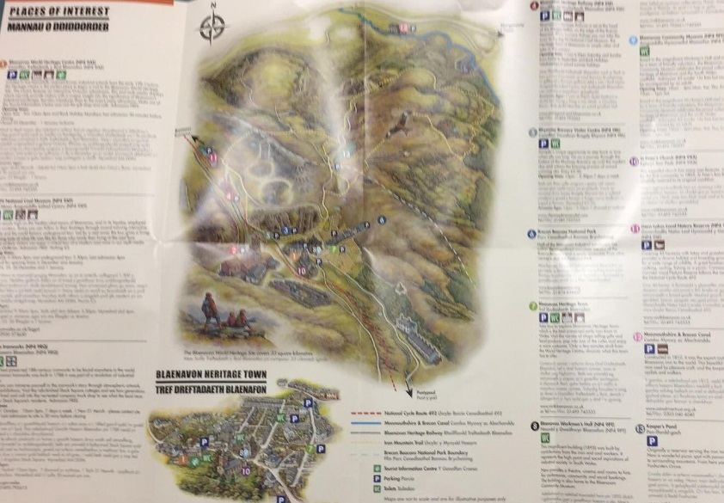
The Map

Ironworks of Blaenavon
As we approached the ironwork’s we noticed the furnace of where Blaenavon workers would smelt iron and steel. Since it was a Thursday we were allowed to walk inside the furnace, it was dark, damp, and the blast furnace itself had the same appearance of a large chimney. Close to the Ironwork’s we discovered several cottages, these were white with two floors. Inside they seemed very aged and dusty. This is where the worker’s lived, I assume the living conditions were not to the standards we have today.
An e-mail was provided to each attending student, this e-mail was comprised of a script with information regarding the Blaenavon Ironworks, in which Ruth-Taylor Davies (Tour guide and industrial heritage and regeneration specialist) would have provided students with on the day of the visit. Information gained from this is as follows;
  - The Ironworks in Blaenavon helped start the Industrial Revolution. In 1789, three businessmen; Thomas Hill, Thomas Hopkins and Benjamin Pratt, all three acquiring prior experience in the iron industry decided to exploit the iron manufacturing and coal mining potential of Blaenavon, as the area offered vast amounts of iron, coal, limestone, sandstone and clay. All of which aided in the creation of iron and infrastructure. (R. T. Davies, 2018)
  - In 1812 iron and limestone was transported over Hill’s Tramroad, at the time this method was called “etching” and is still done to this day and was a new beneficial breakthrough to the industry for its time for marketing purposes. However, the tramroads weren’t always effective as inclines became difficult to overcome when traveling 20 miles to Newport docks. They became tourist attractions later on. During 1850’s steam was introduced to the industry, this lead to a more effective means of transport long with the mass production of steal railway lines and high-speed, steam powered locomotives such as trains to carry cargo from Blaenavon to Brynmawr. The era of steam powered locomotives reigned strong through the mid-19th century to 1980. The railways nowadays are also typically used for tourism purposes. (R. T. Davies, 2018)

Ironworks Sketches

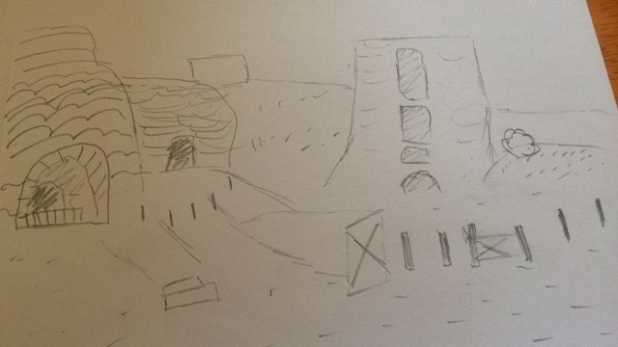
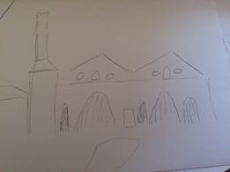

Broad Street (Stream Street)
This shopping town thrived with business during the 19th century and Broad Street and included many public houses, this was to suit the workers but now only 4 public houses remain. Today the town centre is used for tourism due to the unfortunate decline impacting the town during the 20th century. However, It has somewhat regenerated once more presently by becoming an “attractive shopping street.” I noticed while walking to The Workmen’s Hall was the majority of residents who walked by seemed to be elderly, I assume this may regard many of the younger generation migrating to more built up areas for better job prospect opportunities, whilst the elderly staying in the town they grew up in. Another topic about the town I had noticed would concern the town’s condition, it seemed the buildings were very old and many were closed or vacant. (Volunteer worker 1, 2018)

Workmen’s Hall
The Workmen’s Hall looks to be a very well-built building. The Workmen’s Hall was built in the late 18th century, this building was built by deducting each worker’s weekly waged by half a penny to help fund its production. Inside the Workmen’s hall, that once held its main source of recreational activities and entertainment, it now holds rooms such as museums that are used to adapt the building to tourism. However, the building still hosts a number of recreational and productive purposes such as concerts, conferences and cinema. The workers that work there today are voluntary. I assume this could be down to of the lack of income the hall generates. Shortly after leaving the Workmen’s hall we entered the “Coffee and Cards” café. (Volunteer worker, 2018)

The Workmen’s Hall Sketch

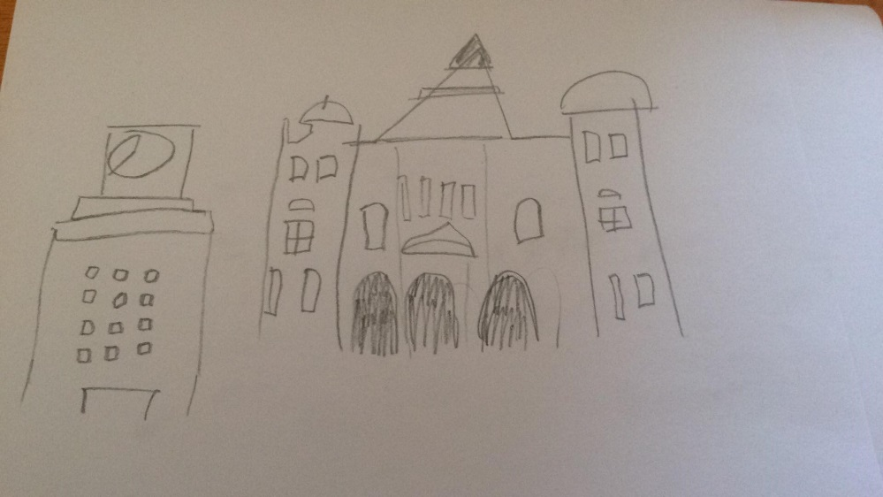

Blaenavon community museum
This is a museum that resides within the Workmen’s Hall. The displays that related to trade unionism interested me as they helped convey the severity concerning management approaches towards Blaenavon workmen. They emphasise the lack of health and safety standards within that time period, along with the neglect for human relations that the workers received. However, accommodation was available to workers although it was not comparable to the standards management uphold within the western culture today. (Volunteer 2, 2018)

The Big Pit
As we entered “Big Pit” it came apparent that we could not descend into the mine itself due to the snowy weather, so the email regarding Ruth’s script is the only source of relevant information we could obtain on the day. The Big Pit is a major attraction within Blaenavon and the mine’s shaft exceeds 300ft. was the main source of fuel for the industrial revolution during the 18-19th century. The term “king coal” was brought up a number of times while above the pit. This emphasised that coal was the main source of fuel for the industrial revolution during the 18-19th. The mines were damaging to Blaenavon’s environment and Garn lakes it became a spoil heap. However, it has now become a beautiful nature reserve.
During the industrial revolution, children from the age of 10 were able to work in the mines as financial difficulties may arise for many of their families and in many cases forces them to work. I also watched a video about the hardships of the miners. This is something that would not happen in western society presently. The risk of working in a mine was high, for example; in 1890, 178 miners were killed in an explosion. During 1980, Margaret Thatcher decided to close the mine. This enraged the mining community and forced “The Miner’s Strike”, but they were unsuccessful stopping the closures. This led to the decline of the mining community and is why Blaenavon is what you see today. (R. T. Davies, 2018)

Conclusion
When visiting the tourist attraction and national heritage town that is Blaenavon, the historical evidence obtained by participating the field trip was recognised to be comparable to how the town has changed over time, however the level of information gained may be varied as certain dates may hinder a group’s or an individual’s ability to obtain such information. For example; during the winter, The Big Pit mine will most likely become closed due to the weather. Another example may regard the Blaenavon Ironworks as it is closed from November to March and I was lucky for the Iron works to be open for when I arrived. My personal reflection would regard the town’s efforts to regenerate its culture through tourism and education. I feel it has succeeded in doing so, however many variables could be improved, for instance; the lack of availability could be seen as detrimental, this has been concluded within the previous statements of this conclusion. Another concern would regard the lack of jobs available for the younger residents, as many of the jobs that are solely related to the history of the town appear to be voluntary work. Rectifying this may increase the income of the town, therefore indirectly improving tourism for the town of Blaenavon. ("Blaenavon Community Museum - Blaenavon World Heritage Site", 2018)

References

- Blaenavon Community Museum - Blaenavon World Heritage Site. (2018). Visitblaenavon.co.uk. Retrieved 15 March 2018, from http://www.visitblaenavon.co.uk/en/VisitBlaenavon/ThingsToDo/Blaenavon-Community-Museum.aspx
- Ruth-Taylor Davies, industrial heritage and regeneration specialist, March 2018)
- Volunteer Worker 1, Workmen’s Hall, 1st March 2018
- Volunteer Worker 2, Blaenavon community Museum, 1st March 2018

