Problem Solving and Decision Making
Stress In the United Kingdom


Student Name: Adriana Camelia Grigore
Student ID: 2024754
Module code: BMSW4004_BIRM
Assignment section: Problem Solving and Decision Making
Lecturer’s name: Yohan Mendis

Table of Contents
Theories 3
Introduction 4
Define the problem 4
Stress level in United Kingdom for the past few years 5
PESTLE analysis 6
Political 8
Economical 8
Social 8
Technological 8
Legal 8
Environmental 8
Fishbone Diagram 9
Too many responsibilities 10
Motivation 10
Bullying 10
Alternative Solution – Teambuilding 11
PMI & GRID Analysis 11
Solution 1 : Improving working standars 11
Solution 2 : Improving diversity in the workplace 12
Solution 3 : Consider flexible workers 12
Action Plan 13
Conclusion 15
Bibliography 16
Reference 16

Theories

‘’Stress has been characterized in numerous ways by numerous distinctive individuals. It has been a topic of intrigued to restorative experts, social researchers, anthropologists, psychologists, and indeed zoologists. For our purposes, it appears most illuminating to look at it from several diverse points of view, in this manner getting a comprehensive outline of the phenomenon and its roots within the history of humanity.’’
(Hans, 1956)

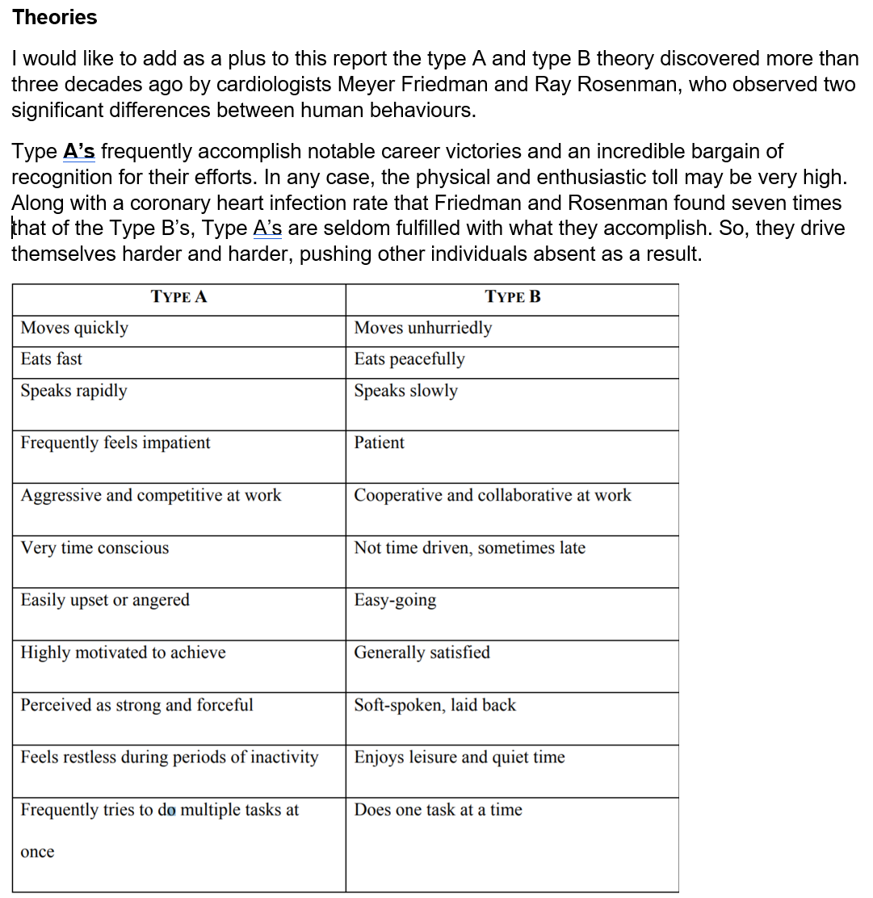

(H Selye - Metabolism, 1956)

Introduction
This report will talk about the definition of stress as and how stress affects the population of the United Kingdom. What would be the main reasons and how specific tools can reduce stress in the United Kingdom. The report will include the impact, analysis of problems from an environmental point of view called PESTLE, and the specific analysis of causes and problems called Fishbone. Once the causes and effects of stress in the United Kingdom have been considered, the continuation will lead to solutions where the following tools, PMI analysis and GRID analysis, intervene. Given the latter comes with an implementation of the solution that leads to stress reduction.

Define the problem
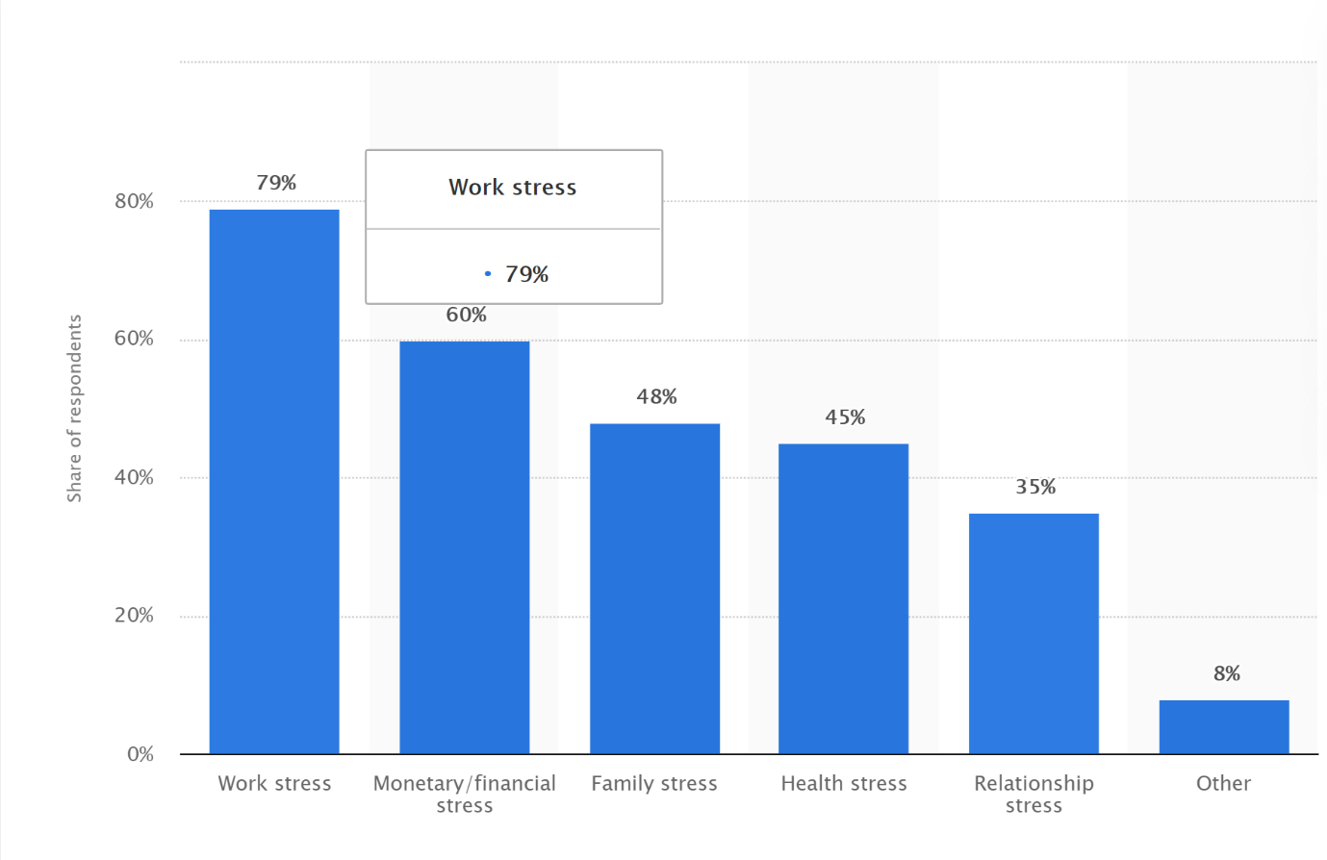

(Statista, 2020)
What is stress? A few individuals might say that stress could be a response to a changing, requesting environment. However, stress is more about our capacity to handle changes, whether making us feel great or bad. What are the triggers? Can be many factors such as depression, health issue, self-esteem, behavioural impact, bullying, pay rate and long hours of work. In the United Kingdom the stress is at a very high level.

Scope and Impact

Stress is a universal factor, and people from all walks of life are subjected to it.
Several pressures, ranging from poisons to the vicissitudes of climate change, may alter the functioning of organisms in our continually changing world. However, the eventual impact of such stress is determined by the stressed system's dynamic behaviour. The evaluation of the combined effects of environmental stress is one area where this topic is particularly significant. Despite the fact that the term "stress" is used in a variety of contexts, it has been consistently demonstrated that people who suffer from stress and related disorders have impaired physical and mental functioning, lost more workdays, are less productive at work, and use a lot of health care services.

Stress level in United Kingdom for the past few years

(Source: Author)

Millions of people in the UK are under a lot of stress, affecting their health. Stress is one of the most pressing public health issues of our time, but it is still not treated with the same urgency as physical health issues.
Stress has a significant role in mental health issues, including anxiety and depression. It is also associated with physical health issues like heart disease, immune system disorders, sleeplessness, and digestive problems.
As individuals, people must recognise what is causing stress and learn how to lessen it for themselves and the people around them.

PESTLE analysis

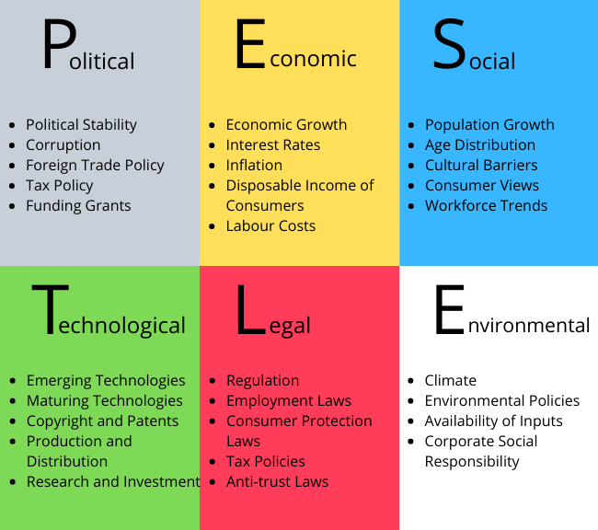

(Source: Boyce, 2021)

‘’A PESTLE analysis is a method for gaining a broad view of an industry's environment. It is an acronym that stands for Political, Economic, Social, Technological, Legal, and Environmental (PESTLE) It enables a business to understand the factors that might influence a new business or sector. Different types of firms may prioritise other elements, and a PESTLE analysis will aid in identifying risk factors.’’
(The University Of Sydney, 2021)

The author used PESTLE analysis to identify the factors from a macro environment that cause and feed stress to the entire UK population.

Political
As has been widely reported in recent years, the United Kingdom has been mired in uncertainty due to BREXIT. As a result, this component of politics has had a significant impact, followed by stress and work unhappiness.

Economical
Other factors can create stress in the current economic trend, such as growth, stagnation, and decline. But also, Covid-19 is taking part in creating stress from an economic perspective, such as all expenses get higher. All prices have been influenced by the pandemic Covid-19

Social
From a sociological standpoint, the population growth rate continues to rise, causing concern among those who do not have enough for a better living.

Technological
This factor has a significant impact, as evidenced by the shift from manual to artificial labour over time because of technological advancements.

Legal
Even if there is anti-discrimination legislation in place, people continue to endure discrimination, particularly in the job. Being a big source of stress in a dramatic way

Environmental
Climate change, for example, has both beneficial and harmful consequences. In truth, the UK government has implemented legislation targeted at addressing a variety of environmental concerns. They are lowering carbon emissions by imposing a daily levy on persons whose cars do not meet CO2 emission requirements, which must be paid while entering certain cities. Consider how much money persons who work or study in those cities will have to spend.

Fishbone Diagram

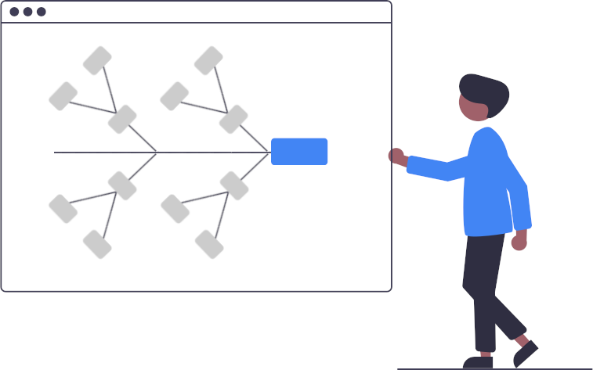

(Source: Kanbaltool, 2021)

‘’A fishbone diagram is a visual representation of a problem's causes and effects. Through the creation of the graphic, teams can explain an issue, making it easier to pinpoint the source of the problem. Ishikawa or cause-and-effect diagrams are other names for fishbone diagrams. They are beautiful tools for deciphering a situation.’’
(Kanbaltool, 2021)

The author used Fishbone Analysis related to the main stress problem, stress in the workplace, to discover the causes and problems.
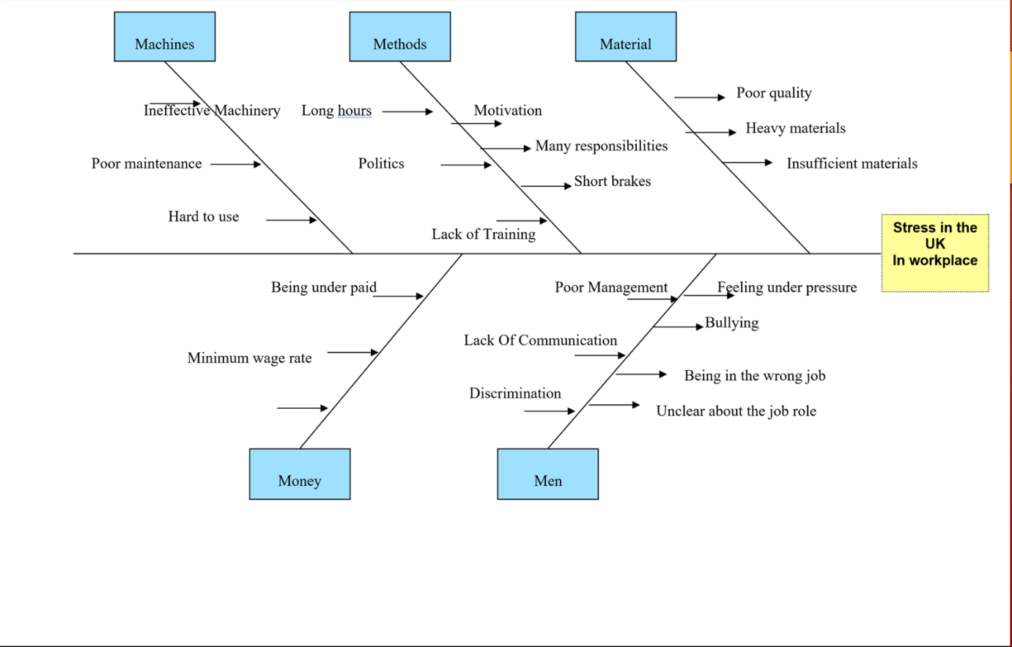
(Source: Author)

To better grasp the fundamental problem and how it has been divided into causes, several of them will be discussed in greater depth.

Too many responsibilities
Employees are frequently promised or assigned a large number of duties, far more than they should have, in exchange for a compensation that is not commensurate with their work.

Motivation
In any organisation, the management staff plays a critical role. Managers are in charge of encouraging personnel, planning, organising, and controlling the company's operations. Managers with low leadership qualities are more likely to give negative comments to their employees. Being unmotivated can have a significant impact on stress levels.

Bullying
A significant factor for having a higher level of stress is humiliation or intimidation, which can be understood as bullying.

Alternative Solution – Teambuilding
Companies desire to put together teams and improve their performance. The entire team-building process revolves around the company's requirements. Participants will be immersed in the world of gaming and development as part of a managed team. This is merely one viewpoint among executives; on the other hand, it is seen as an opportunity to have fun and drink on the company's money.
Employees who are under stress, when things can get out of hand or become impossible to handle, have the option to mix work and personal interests. This has a demonstrable positive impact on making life easier, calmer, and more manageable. Because teambuilding may be done both at work and at home by incorporating games and relaxation time while taking advantage of the company's resources, also, it can be done in a short-term movement in various locations, such as at sea or in the mountains.

PMI & GRID Analysis

Brainstorming is another term for it. PMI is a brainstorming, decision-making, and critical thinking method that helps people talk about the benefits, drawbacks, and implications of a certain idea or notion.
According to our Fishbone, our three solutions were identified using Plus Minus and Interesting Strategy.

Solution 1 : Improving working standars

Plus | Minus | Interesting
More motivation +4 | Higher cost for companies - 5 | Attracts more workers  (4)
Communication + 3 | Lack of efficiently - 4 | Keeping people longer (4)
Healthy body and mind +5 | Time consuming - 2
Happier environment + 3
Total = 15 | Total = - 11 | Total = 8
Grand Total = 12

Solution 2 : Improving diversity in the workplace
Plus | Minus | Interesting
Employee wellbeing + 5 | Higher cost for companies - 3 | Reputation (5)
Performance + 5 | Time consuming - 5 | Attract winder range of talents workers (3)
Creativity +4
Self-esteem + 5
Total = 19 | Total = - 8 | Total = 8
Grand Total = 19

Solution 3 : Consider flexible workers
Plus | Minus | Interesting
Remote work + 5 | Lack of time for technology training - 3 | Become a good option (4)
Save travel money + 3 | Distraction - 4 | Learning another communication channel (2)
Comfortable environment + 5 | Frustration – 4
Total = 13 | Total = - 11 | Total = 6
Grand Total = 8

(Source: Author)

The second solution was deemed to be the best after completing the PMI analysis for discovering solutions linked to Fishbone. It will be dissected in great detail in the form of a new analysis GRID.
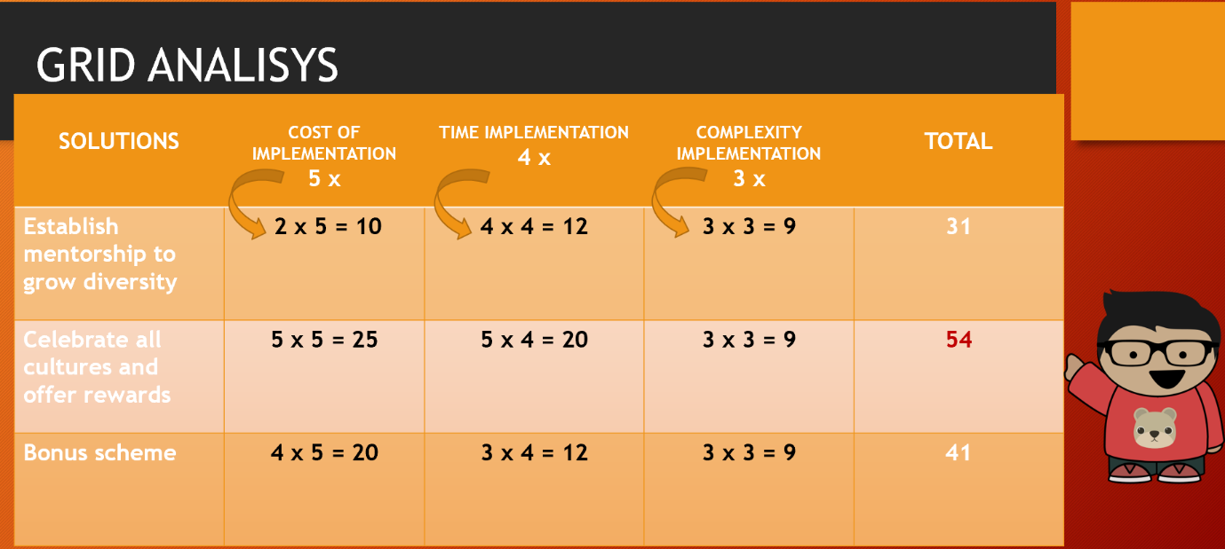
(Source: Author)

The first step is to rank the three factors at the top of the table: the cost of implementation, implementation time, and implementation complexity, from 1 to 5. The number 5 denotes the most significant.

We can see a few potential remedies in the left column of our table above: establish mentorship to grow diversity, celebrate all cultures and offer rewards and bonus schemes.
The second phase assigns them a score ranging from 0 to 3, with three being the most significant.
To make an informed judgement, we must perform the following calculations.
The first step is to multiply each of the top numbers by the numbers below them one by one.

Example: Cost of Implementation (5) x establish mentorship to grow diversity (2) =10
Implementation time (4) x establish mentorship to grow diversity (4) =12
Complexity of Implementation (3) x establish mentorship to grow diversity (3) =9
10 + 12 + 9 = TOTAL= 26

TOTAL= 26

Action Plan

Problem:
Stress in UK in the workplace

Chosen Solution:
Celebrate all cultures and offer rewards

Actions | Description | Time frame | Staff responsible
Develop a multicultural calendar | Mark all religious holidays or events | 15nd November 2021–  19th November 2021 | HR
Plan for festive activities to celebrate the event | Decision regarding choosing specific days for the celebrations | 22th November 2021 –  26th November 2021 | HR  &  Shift Manager
Establish a game day | Choose an hour of a specific day each month to play games between staff managers and employees in exchange of rewards | 29th November 2021 –  01th December 2021 | Line Manager
Create a Budget | Calculate to ensure that the company manages to reassure a good sum to allocate to the new strategy | 6rd December 2021 –  10th December 2021 | Accounting Manager

An action plan is a detailed plan that lays out the steps that must be taken to achieve one or more objectives. It may also be defined as a set of actions or activities that must be followed for a strategy to be successful.

Conclusion

Finally, all of the steps we have just seen are critical. However, proper application reaps only benefits, particularly when it comes to resolving issues that arise over the course of a company's operations. In our case, we had a stress problem in the United Kingdom, and through patience and effort, we were able to locate the best appropriate answer for our situation.

Bibliography
Harrington, R. (2013) Stress, health & well-being : thriving in the 21st century. Belmont, CA: Wadsworth Cengage Learning.
Available at: https://librarysearch.uwtsd.ac.uk/discovery/fulldisplay?docid=alma99100119157002421&context=L&vid=44WHELF_UWTSD:44WHELF_UWTSD_VU1&lang=en&search_scope=MyInst_and_CI&adaptor=Local%20Search%20Engine&tab=Everything&query=any,contains,stress&offset=10
(Accessed 23th November 2021)
International journal of stress management. (1994). New York, N.Y: Kluwer Academic/Plenum Publishers. 1(1).
Available at: https://librarysearch.uwtsd.ac.uk/discovery/fulldisplay?docid=alma99100106822702421&context=L&vid=44WHELF_UWTSD:44WHELF_UWTSD_VU1&lang=en&search_scope=MyInst_and_CI&adaptor=Local%20Search%20Engine&tab=Everything&query=any,contains,stress&offset=0 (Accessed 25th November 2021)
The University of Sydney (2021) Marketing: PESTLE Analysis
Available at: https://libguides.library.usyd.edu.au/c.php?g=508107&p=5994242
(Accessed 26th November 2021)
Wolff, H. G. (1953). Stress and disease. Charles C Thomas Publisher. DOI: https://doi.org/10.1037/11785-000
(Accessed 26th November 2021)

Reference
DESAI, K.J., DESAI, M.S. and OJODE, L., 2015. Supply Chain Risk Management Framework: A Fishbone Analysis Approach: Quarterly Journal. S.A.M.Advanced Management Journal, 80(3), pp. 34-56,2. Available at: https://www.proquest.com/docview/1725174906?pq-origsite=gscholar&fromopenview=true
(Accessed 23th November 2021)
Harrington, R. (2013) Stress, health & well-being : thriving in the 21st century. Belmont, CA: Wadsworth Cengage Learning.
Available at: https://librarysearch.uwtsd.ac.uk/discovery/fulldisplay?docid=alma99100119157002421&context=L&vid=44WHELF_UWTSD:44WHELF_UWTSD_VU1&lang=en&search_scope=MyInst_and_CI&adaptor=Local%20Search%20Engine&tab=Everything&query=any,contains,stress&offset=10
(Accessed 23th November 2021)
International journal of stress management. (1994). New York, N.Y: Kluwer Academic/Plenum Publishers. 1(1).
Available at: https://librarysearch.uwtsd.ac.uk/discovery/fulldisplay?docid=alma99100106822702421&context=L&vid=44WHELF_UWTSD:44WHELF_UWTSD_VU1&lang=en&search_scope=MyInst_ and_CI&adaptor=Local%20Search%20Engine&tab=Everything&query=any,contains,stress&offset=0 (Accessed 25th November 2021)
J. N. Kozhaya, S. R. Nassif and F. N. Najm, "A multigrid-like technique for power grid analysis," in IEEE Transactions on Computer-Aided Design of Integrated Circuits and Systems, vol. 21, no. 10, pp. 1148-1160, Oct. 2002, DOI: 10.1109/TCAD.2002.802271 (Accessed 23th November 2021)
Lafferty, K. D. (2003) How should environmental stress affect the population dynamics of disease?
DOI :https://doi.org/10.1046/j.1461-0248.2003.00480.x
(Accessed 26th November 2021)

Madhu, K. (2002) Assessing the economic impact of stress. The modern day hidden epidemic.
51(6), pp. 41-53
DOI : https://doi.org/10.1053/meta.2002.33193
(Accessed 26th November 2021)
Mental Health Foundation (2020) Stressed nation: 74% of UK 'overwhelmed or unable to cope' at some point in the past year
Available at:https://www.mentalhealth.org.uk/news/stressed-nation-74-uk-overwhelmed-or-unable-cope-some-point-past-year
(Accessed 26th November 2021)

Statista (2020) Most common types of stress experienced in the United Kingdom (UK) in 2020*
Available at: https://www.statista.com/statistics/1134359/common-types-of-stress-in-the-uk/
(Accessed 25th November 2021)
The University of Sydney (2021) Marketing: PESTLE Analysis
Available at: https://libguides.library.usyd.edu.au/c.php?g=508107&p=5994242
(Accessed 26th November 2021)

