What has been the impact of the rise of the Chinese economy, especially since 2000, on the world order, as it affects the challenges facing poorer countries in particular? (HPAN 4008)
The Chinese economy, especially since 2000, has risen almost vertically which, I am sure, amazed the whole world. Regardless of its triggering reason or the fundamental base of its growth, the outcome of the Chinese economy pushed the world economy a few steps ahead. Hence, I am going to explore more about Chinese economic growth, aiming to answer its impact on the world order and further discussion will be made beyond how that growth affects the challenges facing poorer countries. To accomplish this purpose, I will break the topic down into sub-topics which, I think, will be convenient for the reader.
Every action, I think, philosophically speaking, can be questioned in three ways which are ‘Why?’, ‘How?’ and ‘Consequences?’. Thus the sub-topics that will attempt to answer our main question, are as follows;
- Why did the Chinese economy grow rapidly?
- How did the Chinese economy grow sustainably?
- Which particular areas did Chinese economic growth affect?
- How did it contribute to the world order?
- Possible ways that Chinese economic expansion affects the challenges of poorer countries.
China’s rise from a poor developing country to a major economic power in about four decades has been spectacular. From 1979 to 2017, China’s real gross domestic product (GDP) grew at an average annual rate of nearly 10% (The World Bank, 2024). This economic growth began with China’s economic reform process in December 1978 when the Third Plenum of the Eleventh Central Committee of the Communist Party adopted Deng Xiaoping’s economic proposals and implementation of the reforms began in 1979. According to the World Bank, China has “experienced the fastest sustained expansion by a major economy in history—and has lifted more than 800 million people out of poverty.” (The World Bank, 2023). China has emerged as a major global economic power. For example, it ranks first in terms of economic size on a purchasing power parity (PPP) basis, value-added manufacturing, merchandise trade, and holder of foreign exchange reserves (Morrison, 2019).
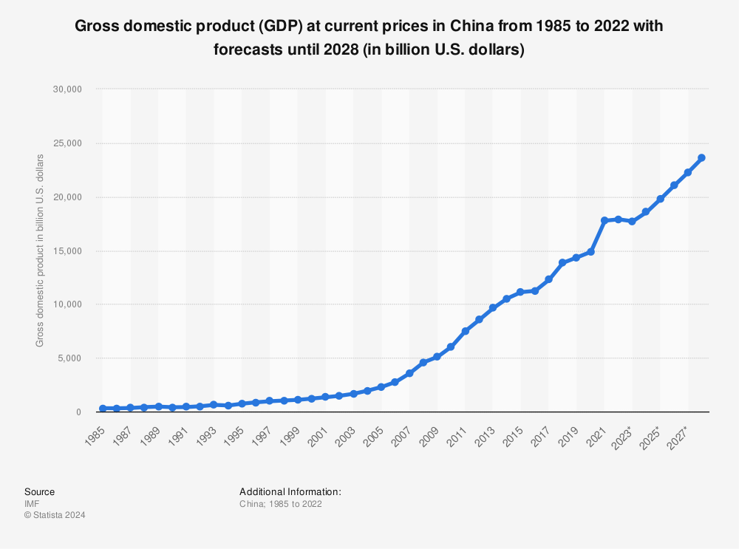(statista, 2024)

Why did the Chinese economy grow rapidly?
Economists generally attribute much of China’s rapid economic growth to two main factors: large-scale capital investment (financed by large domestic savings and foreign investment) and rapid productivity growth (Morrison, 2019). These two factors appear to have gone together hand in hand.
Economic reforms led to higher efficiency in the economy, which boosted output and increased resources for additional investment in the economy. China has historically maintained a high rate of savings. When reforms were initiated in 1979, domestic savings as a percentage of GDP stood at 32% (Morrison, 2019). However, most Chinese savings during this period were generated by the profits of State Owned Enterprises, which were used by the central government for domestic investment. Economic reforms, which included the decentralisation of economic production, led to substantial growth in Chinese household savings as well as corporate savings. As a result, China’s gross savings as a percentage of GDP is the highest among major economies. The large level of domestic savings has enabled China to support a high level of investment. In fact, China’s gross domestic savings levels far exceed its domestic investment levels, which has made China a large net global lender. The productivity improvements were caused largely by a reallocation of resources to more productive uses, especially in sectors that were formerly heavily controlled by the central government, such as agriculture, trade, and services. For example, agricultural reforms boosted production, freeing workers to pursue employment in the more productive manufacturing sector. China’s decentralisation of the economy led to the rise of non-state enterprises such as private firms, which tended to pursue more productive activities than the centrally controlled SOEs and were more market-oriented and more efficient. Additionally, a greater share of the economy, mainly the export sector, was exposed to competitive forces. Local and provincial governments were allowed to establish and operate various enterprises without interference from the government. In addition, Foreign Direct Investment in China brought with it new technology and processes that boosted efficiency.
How did the Chinese economy grow sustainably?
Since the introduction of economic reforms, China’s economy has grown substantially faster than during the pre-reform period, and, for the most part, has avoided major economic disruptions. Moreover, China’s economic growth slowed significantly following the aftermath of the Tiananmen massacre that occurred in July 1989. Several countries, including the United States, imposed trade sanctions against China, and Chinese economic reforms were essentially put on hold. China’s real GDP growth rate fell from 11.3% in 1988 to 4.2% in 1989 and declined to 3.9% in 1990. In 1991, economic reforms were restarted and foreign sanctions against China were reduced or removed, and real GDP grew by 9.2% (Morrison, 2019). From 1979 to 2018, China’s annual real GDP averaged 9.5%. This has meant that on average China has been able to double the size of its economy in real terms every eight years. The global economic slowdown, which began in 2008, had a significant impact on the Chinese economy. China’s media reported in early 2009 that 20 million migrant workers had returned home after losing their jobs because of the financial crisis and that real GDP growth in the fourth quarter of 2008 had fallen to 6.8% year-on-year. The Chinese government responded by implementing a $586 billion economic stimulus package, aimed largely at funding infrastructure and loosening monetary policies to increase bank lending (Xinhua News Agency, 2009). Such policies enabled China to counter the effects of the sharp global fall in demand for Chinese products. From 2008 to 2010, China’s real GDP growth averaged 9.7%. However, the rate of GDP growth declined slowed for the next six consecutive years, falling from 10.6% in 2010 to 6.7% in 2016. Real GDP ticked up to 6.8% in 2017 but slowed to 6.6% in 2018. The IMF’s April 2019 World Economic Outlook projects that China’s real GDP growth will slow each year over the next six years, falling to 5.5% in 2024 (OECD, 2019).
Which particular areas did Chinese economic growth affect?
China's rapid economic growth has made an important contribution to the development and prosperity of the world economy, especially to the world economic stability and recovery in recent years. Over the past 20-odd years of reform and opening up, China has witnessed sustained, rapid economic growth, with the total GDP volume exceeding 10 trillion yuan in 2002 and 10 trillion dollars in 2014 (statista, 2024). Along with rapid economic development, China's impoverished population, a population with a daily living cost of less than one US dollar, has decreased by 147 million, accounting for 84.5 per cent of the total volume of reduction in the poverty-stricken population of the East Asian region (Anon., 2021). China's absolute impoverished population has also decreased to around 30 million. Poverty has always been a difficult problem plaguing various countries around the world, it has seriously affected the stability and sustainable development of the world economy. As a large developing country, China has sustained rapid economic development and provided constantly improving living standards for its people.
Also, as the United Nations Millennium Development Goals report has shown in 2015, Eastern Asian development was relatively higher overall compared to other regions (UNDP, 2017). And it was mainly due to the huge development of China during those periods.
How did it contribute to the world order?
China’s rise is, perhaps, the single most important economic and political phenomenon in the twenty-first century. China’s status in international trade is especially noteworthy, it is also growing by other measures of international power. China’s growing clout in international production and financial markets are evident in terms of its global leadership in overall manufacturing, in the offshore assembly of electronics and textiles, and its growing financial leadership through owning the world’s four largest banks. China is also growing in global leadership through the development of new institutions such as the Asian Infrastructure Investment Bank (AIIB), the Regional Comprehensive Economic Partnership (RCEP), and its Belt and Road Initiative (Soong, 2019).
In terms of total market size, China is nearly as large as the US and much larger than any other country, whether measured in current dollars or in purchasing power parity dollars. In 2019, US GDP was $US 21.4 trillion, while Chinese GDP was $US 14.1 trillion in nominal terms and in purchasing power parity terms, Chinese GDP was $US 27 billion. In terms of company competitiveness, China had 119 Fortune Global 500 companies and the US had 121 in 2019. In terms of innovation, measured as R&D spending in the country, the US led the world by far with spending of $US 581 billion in 2018, while China was second with $US 293 billion, and both countries were far ahead of the third leader, which was Japan at $US 193 billion.
China has also modernised the People’s Liberation Army (PLA) to counter potential invasion (Montgomery, 2014) while asserting its dominance over the South China Sea. Likewise, China has become a major producer of science and technology, owing to public investment in the sciences such as the 2006 Medium to Long Term Program of Science and Technology (MLP) and the Made in China 2025 initiative. Taken together, this expansion of Chinese power suggests the emergence of a new world order, in which there is a roughly equal distribution of power between the United States and China.
Possible ways that Chinese economic expansion affects the challenges of poorer countries
The effects of China’s trade in primary products such as energy, raw materials and food, intermediate products and finished products on other Asian economies are both direct and indirect. Direct effects arise from bilateral trade and investment between China and other countries. Indirect effects arise from how China's trade and investment (inward and outward) changes the trade and investment conditions faced by other countries. Because the Chinese economy is so big and open, these indirect effects are particularly important. China's energy consumption more than doubled between 1980 and 2000, and it had been projected to double again by 2015, driven by economic growth, industrialisation, urbanisation and increased motorisation. This is, I think, one of the reasons for the rises in energy prices that have benefited oil and gas exporters in Western and Central Asia and disadvantaged energy-importing countries in the region. The current scramble for energy has important consequences not only for energy-importing developing countries but also for regional and global stability. Moreover, China's rapidly growing economy is broad-based and therefore requires many different types of raw materials. Imports of these products increase as domestic demand outstrips domestic supply and China's industrial development replaces imports of finished products with imports of raw materials. Some of the biggest impacts of this rising demand have been out outside the region — in Africa and Latin America. However, there are specific products for which Asian countries are important suppliers to China. One product which is supplied from Southeast Asian countries to China on a large scale is timber. The timber trade has significant consequences for the environment and the livelihoods of the poor. Timber exports to China seem to have particularly negative effects because the gains are rarely available for enhancing economic development, the wood comes from illegal sources causing deforestation and it induces local furniture producers to compete by using cheaper illegal wood, further undermining the sustainability of the furniture industry. The sustainable use of natural resources is particularly important if the poorer and less developed Asian economies are to benefit from the rapid growth of the region as a whole.
In Southeast Asia, countries such as Myanmar have tried to move away from a perceived overdependence on China by redoubling their efforts to find alternative commercial and diplomatic partners, such as the United States and Japan. In South Asia, the Hambantota port deal in Sri Lanka where Sri Lanka ended up selling a port to China to pay off the debt accrued by building it, has crystalised concerns that some Chinese loans-for-infrastructure deals might create unsustainable debt burdens that harm countries’ development aims (Abi-Habib, 2018).
Conclusion; Challenges vs. Opportunity?
Despite its dramatic increases in wealth and global influence over the last four decades, China still insists on seeing, and promoting, itself as a developing country. Indeed, China’s GDP in Purchasing Power Parity sits around $18,000, placing it behind countries like Mexico, Equatorial Guinea, and the Maldives (Economy, 2024). This highlights the distance between China and the world’s wealthiest countries, at least in per capita terms. However, even if that is the case, Chinese economic growth was a real thing. As we have seen above, China uplifted not only its people’s life quality but also regionally people’s life quality, especially in eastern and south-eastern Asia. We have also seen that this huge development could challenge the countries that are having affairs with China, particularly the poorer countries. Nevertheless, those challenges can be an opportunity instead of difficulty in the sense that having an economically growing neighbour is better than an economically static neighbour.

Bibliography
Abi-Habib, M., 2018. How China Got Sri Lanka to Cough Up a Port. [Online]
Available at: https://www.nytimes.com/2018/06/25/world/asia/china-sri-lanka-port.html
[Accessed 04 February 2024].
Xinhua News Agency., 2009. Beijing Review. [Online]
Available at: https://www.bjreview.com/se/txt/2009-02/03/content_176531.htm
[Accessed 02 February 2024].
Anon., 2021. EMBASSY OF THE PEOPLE’S REPUBLIC OF CHINA IN NEPAL. [Online]
Available at: http://np.china-embassy.gov.cn/eng/78085/bd/200410/t20041027_1998103.html
[Accessed 02 February 2024].
The World Bank., 2023. The World Bank. [Online]
Available at: https://www.worldbank.org/en/country/china/overview
[Accessed 02 February 2024].
The World Bank., 2024. The World Bank. [Online]
Available at: https://data.worldbank.org/indicator/NY.GDP.MKTP.CD
[Accessed 02 February 2024].
The Global Economy., 2024. The Global Economy. [Online]
Available at: https://www.theglobaleconomy.com/rankings/gdp_per_capita_ppp/
[Accessed 04 February 2024].
Montgomery, E. B., 2014. International Security. Contested Primacy in the Western Pacific: China's Rise and the Future of U.S. Power Projection, IV(38), pp. 115-149.
Morrison, W. M., 2019. China’s Economic Rise: History, Trends, Challenges, and Implications for the United States, s.l.: Congressional Research Service.
OECD, 2019. OECD ilibrary. [Online]
Available at: https://www.oecd-ilibrary.org///sites/b2e897b0-en/1/2/3/8/index.html?itemId=/content/publication/b2e897b0-en&_csp_=d2743ede274dd564946a04fc1f43d5dc&itemIGO=oecd&itemContentType=book#
[Accessed 02 February 2024].
Soong, J.-J., 2019. The Chinese Economy. China’s One Belt and One Road Initiative Meets ASEAN Economic Community: Propelling and Deepening Regional Economic Integration?, pp. 291-297.
statista, 2024. statista. [Online]
Available at: https://www.statista.com/statistics/263770/gross-domestic-product-gdp-of-china/
[Accessed 02 February 2024].
UNDP, 2017. United Nations Development Programme. [Online]
Available at: https://www.undp.org/publications/millennium-development-goals-report-2015
[Accessed 03 February 2024].

