International Financial Management
LCBB6002

Assessment 1

Name: Vanya Nikolova
Student Number: 1920484
Module Title: International Financial Management
Module Lecturer: Isaiah Oino
Assignment Title: Analysis of the International Financial Management of British American Tobacco

Contents
Analysis and evaluation of the importance of International Financial Management 3
Challenges that British American Tobacco is facing in the international markets 3
Dividend distribution policy of British American Tobacco 3
Efficient market hypothesis and international financial management theories 5
BAT’s methods of appraising projects 7
References 9

Analysis and evaluation of the importance of International Financial Management
It is not easy for multinational corporations (MNCs) to operate in foreign markets and stay remain profitable. The market is new for any organization, and there is a certain number of risks it has to deal with. British American Tobacco PLC is a market leader in more than 55 countries in tobacco-based products (Bat, 2022). International financial management provides it with the following advantages-
- Management of exchange rates- The business can save money by managing its international transactions. Since two currencies are involved, the business's finance department can decide when to make payments and how to reduce the expenses of currency translation.
- Comparison of interest rates- The BAT PLC can know where to invest by studying the country's inflation trends. It would shift the production processes from the countries in the grip of inflation (Thompson, 2018). As a result, costs will be low, and the business can profit more.

Challenges that British American Tobacco is facing in the international markets
The business of BAT has been facing several issues in the financial markets, which are-
- High product costs- The business has been facing issues in managing costs because of inflation in raw materials prices (Bat, 2022). The global supply chains were already disrupted due to the pandemic. The growing inflation has recently added to the company's worries.
- Health and safety regulations- The health standards may vary from country to country, and the business has to comply with the policies wherever it is doing business. An increasing number of nations are prohibiting products that are dangerous to customers' health.

Dividend distribution policy of British American Tobacco
The company has a dividend yield of 6.21% (Annual report, 2021). It follows a regular dividend policy whereby the dividends are paid each year. The company pays cash dividends directly into the bank accounts that the shareholders have provided. It is called payment utilizing mandatory direct credit. The company has discontinued the issue of cheques for dividend payment purposes.
On 11 February 2022, the company declared its latest interim dividend of 217.8 p per share. It pays quarterly dividends to UK shareholders and the ADSs (American depositary Shares).
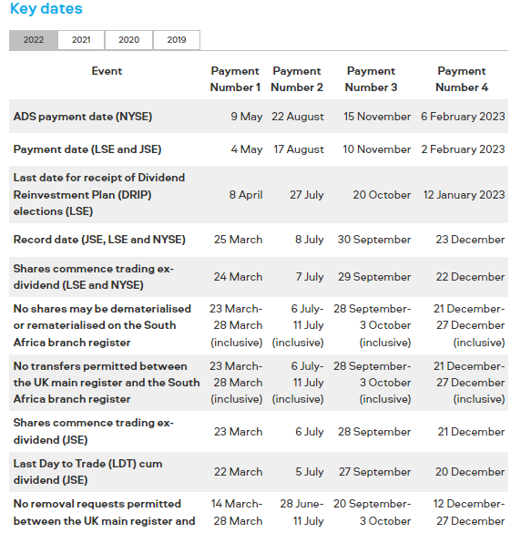
(Souce: bat.com)
The table above presented the essential dates when the company declared the dividends. The trend of dividend payments in the last few years can be seen in the figure below-
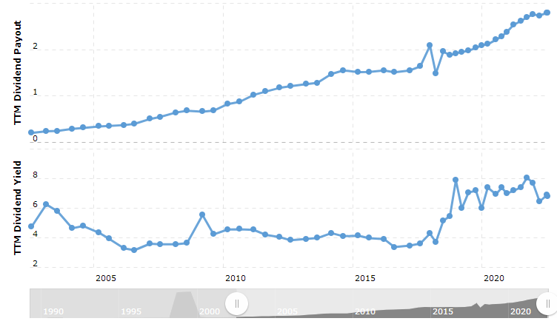
(Source: Macrotrends.com)
The company's dividend yield has increased over the period. After the year 2018, tremendous growth in dividend payments has been observed. It can be seen that the dividend yield has remained close to 4% between the years 201-2018, but after that, the yield was as high as 8% in 2019 and has been hovering between 6% to 8% in the last few years (Bat, 2022). The company also paid dividends during the pandemic while other businesses struggled to make a profit.
The constant dividend payment policy of BAT PLC has been effective and protects the company from higher or lower dividend payments. The dividends are paid each quarter, which helps it attract more investors. The dividends are essential as these can significantly increase the profits made by investors. These also contribute as an extra metric for evaluations and fundamental analysis, have tax advantages, and reduce the portfolio's overall risk.

Efficient market hypothesis and international financial management theories
The efficient market hypothesis strengthens the belief that the shares of a business are already fairly priced. There is no scope for the investors to acquire shares when they are under or overvalued (Rossi and Gunardi, 2018). The profit here can be made only through speculations. This theory has three main forms: weak, semi-strong, and strong.
The weak form firmly believes in the idea that the current stock price of a company reflects all information about it, and here shareholders cannot get much assistance from the technical analysis to make profits. In the semi-strong form, it is believed that profits can be made only when the investors know some information about the company that is unknown to the company. However, it is not a common practice as the shareholders also access the same information in the public domain.
In the strong form of the market, it is suggested that no information, whether public or private, can affect the share prices. Since the current share price reflects all public and private information, the investors cannot predict when security can be purchased for profitable investments. Hence, the likelihood is less than BAT Ltd acquires a stake in a company and turns the investments profitable in the short run.
Main theories of international financial management
- Interest rate parity
This theory establishes the relationship between exchange rates of currency and interest rates. The basic idea behind this theory is that when the funds are invested in some currencies, the hedged returns would be the same, despite the differences in their interest rates. If British American Tobacco PLC invests funds in two different countries, there will be equilibrium in earnings as there is no opportunity to make riskless profit in any specific country. Thus, investors here are unable to make a profit by investing at a low exchange rate in a currency that is priced low and then purchasing the currency which has a higher interest rate
- Fisher effect
As per this theory, the interest rates of an economy follow the inflation rates. When a country experiences a high rate of inflation, the real interest rate will be decreased by its government. The real interest rate of an economy is equal to the nominal interest rate less the inflation rate (He, 2018). As a result, when inflation increases, the nominal interest rates increase while the real interest rate falls. The company can study the Fisher effect to study the interest rates and inflations in the countries where it is doing business. During inflation, its investments might not generate good returns as the real interest rates are falling, generating fewer returns on the investments.

- Purchasing power parity
It is the analysis of prices in some countries to determine the purchasing power of the country's currency and make estimates about its population's standard of living. The business can launch its premium tobacco products in countries with a high purchasing power parity (Nagayasu, 2021). It is because in those locations, the customers would have more purchasing power and the scope of profits for the business are high in those territories.

BAT's methods of appraising projects
As part of its international financial management, the company adopts several techniques for appraising its products. Since a large amount of capital is required with the selection of a project, it is thus necessary to know if the project can provide returns over the period. Whenever the business decides to invest in a foreign country, it would estimate the cash flows over time. It would also estimate the total initial capital required to initiate the project. The project appraisal in the company is done through the methods such as NPV and the payback method.
- NPV method
The NPV method is used in its business when the projects are of long-term duration and involve a large cash flow. Since it is necessary to recover the capital invested in a certain number of years, the annual cash flows are written, and their discounted value is calculated (Garcia, 2017). This method of appraisal takes into account the time value of money. It tells that business the value of future cash flows in the current period. A project might look promising, but the pound would lose its value when terminated. Thus, NPV helps establish the present worth of future money and is a very reliable method of project appraisal.
- Payback method
The internal management of BAT PLC uses the payback method when the project duration is several months. Since, during the short phase, the pound does not lose much of its value, the payback method is more useful. For example, the cash inflows for a few months are estimated when a new product is launched. The company can then know the number of months it can fully recover the invested capital. This method does not consider the time value concept and is hence unsuitable for long-term projects.
Other than the above methods, there are some ways in which the management of BAT PLC assesses the suitability of a project. It can analyze company ratios before investing or acquiring a company (Bat, 2022). Strategic advantage analyses and risk assessment are also ways the business undertakes to check for the suitability of projects.

References
- Annual report (2021). British American Tobacco PLC. [online] Bat. Available at: https://www.bat.com/group/sites/UK__9D9KCY.nsf/vwPagesWebLive/DOAWWGJT/$file/BAT_Annual_Report_and_Form_20-F_2021.pdf [Accessed on: 18 July 2022]
- Bat.com (2022). Quarterly dividend payments. [online] Bat. Available at: https://www.bat.com/group/sites/UK__9D9KCY.nsf/vwPagesWebLive/DOALSC3V [Accessed on: 18 July 2022]
- Garcia, M. (2017). How to calculate Net Present Value (NPV). [online] Bizfluent. Available at: https://bizfluent.com/how-2187130-calculate-net-present-value-npv.html [Accessed on: 18 July 2022]
- He, Y. (2018). A Study on the International Fisher Effect: An Investigation from South Korea and China. The Journal of Industrial Distribution & Business, 9(7), pp.33-42.
- Nagayasu, J. (2021). Causal and frequency analyses of purchasing power parity. Journal of International Financial Markets, Institutions and Money, 71, p.101287.
- Rossi, M. and Gunardi, A. (2018). Efficient market hypothesis and stock market anomalies: Empirical evidence in four European countries. Journal of Applied Business Research (JABR), 34(1), pp.183-192.
- Thompson, J. (2018). How an Exchange Rate Affects a Business. [online] Bizfluent. Available at: https://bizfluent.com/facts-6818189-exchange-rate-affects-business.html [Accessed on: 18 July 2022]s

