

A Study on the influence of brand image, product knowledge, environmental concern and subjective norm towards purchase intention of electric vehicle in Hong Kong

A Dissertation submitted for the
Master of Business Administration (MBA) 2023
Submitted: April 2023

Researcher: Chung Chun Pong James
Student Number: 2123147
Supervisor: Dr. Arion Wong

ABSTRACT
This study aims to investigate the impact of subjective norm, product knowledge, environmental concern and brand image on the purchase intention of electric vehicles in Hong Kong. The CO2 emissions level from vehicles is the major source of air pollution of Hong Kong. The adoption of electric vehicles in Hong Kong could improve the air quality of the city. The research background, objectives, questions, and flow were elaborated to provide a comprehensive understanding of the study.

The literature review presents the definitions and constructs of subjective norm, product knowledge, environmental concern, brand image and purchase intention, along with their relationships.

The research framework and hypotheses were developed to investigate the research topic. A total of 390 questionnaires were distributed among Hong Kong residents to collect data. Reliability tests were conducted to validate the questionnaires, and descriptive statistics, correlation analysis, and regression analysis were employed to analyze the data.

The results indicate that brand image has the strongest impact on consumers' purchase intention, and the majority of respondents agree that environmental sustainability is crucial. All research hypotheses were supported, demonstrating significant influences on subjective norm, product knowledge, environmental concern and brand image towards purchase intention.

The study provides implications and marketing suggestions for increasing the purchase intention of electric vehicles. The limitations of the research and future research directions are also discussed.
KEYWORDS: Electric vehicle, Purchase Intention, Subjective Norm, Product Knowledge, Environmental Concern, Brand Image.
TABLE OF CONTENT
Abstract i
Content ii
List of figures iv
List of tables v

Chapter 1: Introduction 1
1.1 Background 1
1.2 Research motivation 4
1.3 Research questions 5
1.4 Research Aims 5
1.5 Research Objectives 5
1.6 Research Flow 6
1.7 Summary of the Chapter 7

Chapter 2: Literature review 8
2.1 Definition of subjective norm 8
2.1.1 Constructs of subjective norm 9
2.2 Definition of product knowledge 10
2.2.1 Constructs of product knowledge 10
2.3 Definition of Environmental concern 13
2.3.1 Constructs of environmental concern 13
2.4 Definition of brand image 15
2.4.1 Constructs of brand image 15
2.5 Definition of Purchase intention 17
2.5.1 Constructs of purchase intention 17
2.6 Relationship between different factors and purchase intention 19
2.6.1 Relationship between subjective norm and purchase intention 19
2.6.2 Relationship between product knowledge and purchase intention 19
2.6.3 Relationship between environmental concern and purchase intention 20
2.6.4 Relationship between brand image and purchase intention 21
2.7 Summary 21

Chapter 3: Research methodology 22
3.1 Framework of research 22
3.2 Research hypotheses 23
3.3 Research Method 24
3.3.1 Types of research 24
3.3.2 Types of data collection 25
3.3.3 Target of the research 25
3.3.4 Size of sampling 26
3.3.5 Method of sampling 27
3.3.6 Collection of data 27
3.4 Analysis of data 28
3.4.1 Descriptive statistic analysis 28
3.4.2 Reliability test 29
3.4.3 Analysis of correlation 29
3.4.4 Analysis of linear Regression 30
3.5 Questionnaires design 30
3.5.1 Subjective norm 31
3.5.2 Product knowledge 32
3.5.3 Environmental concern 33
3.5.4 Brand image 34
3.5.5 Purchase intention 35
3.5.6 Demographic questions 36
3.6 Pilot test of Questionnaire with focus group 36
3.7 Summary 38

Chapter 4: Research findings 39
4.1 Descriptive analysis 39
4.1.1 Demographic profiles of respondents 39
4.1.2 Measurement result of relevant variables 41
4.1.2.1 Descriptive analysis on subjective norm 41
4.1.2.2 Descriptive analysis on product knowledge 42
4.1.2.3 Descriptive analysis on environmental concern 43
4.1.2.4 Descriptive analysis on brand image 44
4.1.2.5 Descriptive analysis on purchase intention 45
4.2 Reliability test 46
4.3 Analysis of Correlation 47
4.4 Linear regression analysis 47
4.4.1 Regression analysis of subjective norm and purchase intention of electric vehicle 48
4.4.2 Regression analysis on product knowledge and purchase intention of electric vehicle 48
4.4.3 Regression analysis on environmental concern and purchase intention of electric vehicle 49
4.4.4 Regression analysis on brand image and purchase intention of electric vehicle 50
4.5 Discussion of study findings 50
4.6 Summary of chapter 51

Chapter 5: Research findings 52
5.1 Respondents detail 52
5.2 Analysis of research framework 52
5.3 Findings of research 53
5.3.1 Subjective norm plays a crucial role shaping purchase intention towards electric vehicle 53
5.3.2 Product knowledge influences purchase intention of electric vehicle significantly 53
5.3.3 Environmental concern influences purchase intention of electric vehicle significantly 54
5.3.4 Brand image influences purchase intention of electric vehicle positively 54
5.4 Suggestions of the research 54
5.4.1 Subjective norm to increase purchase intention of electric vehicle 55
5.4.2 Product knowledge to increase purchase intention of electric vehicle 56
5.4.3 Environmental concern to increase purchase intention of electric vehicle 57
5.4.4 Brand image to increase purchase intention of electric vehicle 58
5.5 Research limitation 59
5.5.1 Limitation on size of sample and respondents background 59
5.5.2 Limitations on method of research analysis 60
5.5.3 Limitations on the target of research 60
5.5.4 Limitations on the independent variables 60
5.5.5. Limitation on research scope 61
5.6 Further research 61
5.7 Conclusion 62
5.8 Summary of the chapter 63
Bibliography 64
Appendix 1 Questionnaire 74
Appendix 2 Survey result (SPSS) 80

LIST OF FIGURES
Figure 1: Global Electric Vehicle stock, 2010-2019…………………………………………………1
Figure 2: Number of Electric Vehicle in Hong Kong, 2010-2020…………………………………2
Figure 3: The flow chart of the research…………………..…………….…………………………6
Figure 4: Framework of research……………………………………….…………………………22
Figure 5: Andrew Fisher formula……………………..…………………………………………..26

LIST OF TABLES

Table 1: Electric Vehicle Charging Stations in Hong Kong, 2015-2020…………………..……………………………………….3
Table 2-1: Constructs of subject norm…………………………………………………………………………………………….9
Table 2-2: Constructs of product knowledge……………………………………………………………………………………12
Table 2-3: Constructs of environmental concern……………………………………..………………………………………14
Table 2-4: Constructs of brand image……………………………………………………………………………………16
Table 2-5: Constructs of purchase intention……………………………………………………………………………………18
Table 3-1: The construct and questions of subjective norm…………………………….………………………………31
Table 3-2 The construct and questions of product knowledge…………………………….………………………………32
Table 3-3 The construct and questions of environmental concern…………………………….………………………………33
Table 3-4 The construct and questions of brand image…………………………………….………………………………34
Table 3-5 The construct and questions of purchase intention……………………………….………………………………35
Table 3-6 demographic questions……………………………………….….………………………………………………36
Table 3-7: Analysis of reliability of the pilot test …………………………………….…………………………………37
Table 4-1 Demographic profile of respondents……………………….……………….…………………………………40
Table 4-2 Descriptive analysis of subjective norm (N=390)……………….………………..……………………………42
Table 4-3 Descriptive analysis of product knowledge (N=390)………….………..……..………………………………43
Table 4-4 Descriptive analysis of environmental concern (N=390)…….……………..………………………………44
Table 4-5 Descriptive analysis of brand image (N=390)….………………………………….……………………………45
Table 4-6 Descriptive analysis of purchase intention (N=390).………………………….……………………………46
Table 4-7 Cronbach’s α value of all constructs in the research….………………………………..……………………46
Table 4-8 result of Pearson’s correlation coefficient of all variables………………………..…………………………47
Table 4-9 result of regression analysis of subjective norm and purchase intention of electric vehicle…….………48
Table 4-10 result of regression analysis of product knowledge and purchase intention of electric vehicle……………………49
Table 4-11 result of regression analysis of environmental concern and purchase intention of electric vehicle………………….49
Table 4-12 result of regression analysis of brand image and purchase intention of electric vehicle…………………………..50
Table 5-1 Summary of the analysis of hypotheses……………………………………..….…………………………52

Chapter 1: INTRODUCTION
This chapter is going to overview the background and motivation of the research, research questions, research objectives and research flow. A brief summary of those topics as introduction of the report will be provided as well.
1.1 Background
The trend towards electric vehicles (EVs) is a rapidly growing global phenomenon. The adoption of electric vehicles is a growing global trend, with governments and automobile manufacturers investing in this technology to reduce greenhouse gas emissions and improve air quality. This section would provide a comprehensive background on the trends in electric vehicle adoption globally and in Hong Kong.
The global trend towards electric vehicles is significant, with sales increasing steadily over the past decade. According to the International Energy Agency (IEA), global sales of electric vehicles reached 2.1 million in 2019. The car stock in global grew from 17,000 in 2010 to 7.2 million in 2019 (IEA, 2020). The trend is expected to continue, with the IEA predicting that electric vehicles could account for 30% of all vehicle sales by 2030 (IEA, 2020).
Figure 1: Global Electric Vehicle stock, 2010-2019
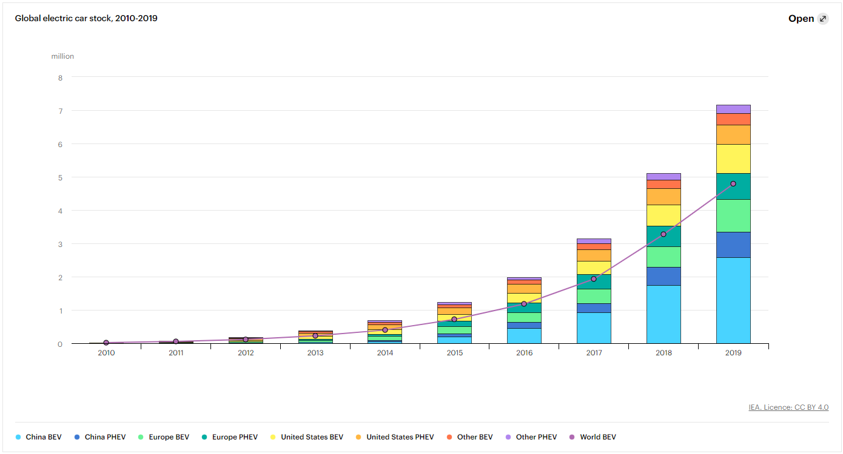
Source: International Energy Agency (IEA) (2020)
The growth in electric vehicle sales can be attributed to several factors. One of the most significant factors is government policy. Governments worldwide have implemented policies to support the adoption of electric vehicles. These policies include financial incentives for consumers, subsidies for manufacturers, and regulations to reduce emissions from traditional vehicles (IEA, 2020).

Another factor driving the growth of electric vehicles is technology. Advances in battery technology have made electric vehicles more efficient, with longer ranges and faster charging times. Automobile manufacturers have also invested in electric vehicle technology, with many introducing electric models to their product lines (IEA, 2020).

Hong Kong has been a leader in electric vehicle adoption in Asia. The city has implemented policies to support the adoption of electric vehicles, and the number of electric vehicles on the road has increased significantly in recent years. According to the Environment Bureau of Hong Kong, the number of electric vehicles in the city increased around 180 in 2010 to almost 20,000 in 2020 (Environment Bureau, 2021).
Figure 2: Number of Electric Vehicle in Hong Kong, 2010-2020
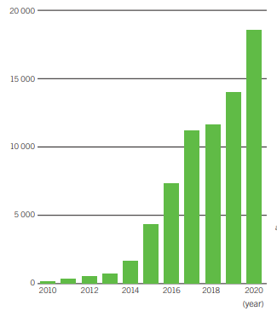
Source: Environment Bureau of Hong Kong (2021)
The growth of electric vehicles in Hong Kong can be attributed to several factors. One of the most significant factors is government policy. The Hong Kong government has implemented policies to incentivize the use of electric vehicles, including waiving first registration tax for electric cars and offering financial incentives for purchasing and installing electric vehicle charging facilities (Hong Kong Electric Vehicles Association, 2021). Another factor driving the growth of electric vehicles in Hong Kong is environmental awareness. Hong Kong has long struggled with air pollution, and the transportation sector is a significant contributor to this problem. By promoting the use of electric vehicles, the government and other stakeholders hope to reduce emissions and improve air quality in the city (Wong & Lee, 2019).

One of the main concerns for electric vehicle owners is the availability of charging infrastructure. In Hong Kong, the government has invested in the development of an electric vehicle charging network. According to the research conducted by Legislative Council Secretariat of Hong Kong, there are over 3,000 public charging stations across the city in 2021.

Table 1: Electric Vehicle Charging Stations in Hong Kong, 2015-2020
Year | Public chargers for EV, 2015-2020
2015 | 1,221
2016 | 1,518
2017 | 1,862
2018 | 2,166
2019 | 2,929
2020 | 3,351
Source: Research Office, Legislative Council Secretariat (2021)

The growth of the electric vehicle charging network in Hong Kong has been significant, with the number of charging stations increasing from 1,221in 2015 to over 3,000 by the end of 2020 (Research Office Legislative Council Secretariat, 2021). This growth in charging infrastructure has made it more convenient for electric vehicle owners to charge their cars and has helped to alleviate concerns about range anxiety.

Several factors would affect the adoption of electric vehicles, including government policy, consumer attitudes, and infrastructure. Government policy has been a significant factor driving the growth of electric vehicle adoption both globally and in Hong Kong. In the United States, the federal government has implemented tax credits for electric vehicle purchases, while many states offer additional incentives such as rebates and parking privileges (Chakrabarti et al., 2014). In Europe, the European Union has set targets for reducing emissions from transportation, and many countries offer financial incentives for electric vehicle purchases (Valente et al., 2018).

Consumer attitudes towards electric vehicles have also played a role in their adoption. In the United States, Chen et al. (2017) found that consumers were more likely to purchase an electric vehicle if they believed it was environmentally friendly, had lower operating costs, and was reliable. Similarly, in Hong Kong, Wong & Lee (2019) found that environmental concerns and financial incentives were the primary drivers of electric vehicle adoption.

1.2 Research motivation
The adoption of electric vehicles (EVs) is a growing trend worldwide, and Hong Kong is no exception. As the number of EVs on the road increases, it is important to understand the factors that influence consumers' purchase intentions. This research aims to investigate the factors that affect consumers' purchase intentions of electric vehicles in Hong Kong. By identifying the key factors to adoption, this research can provide insights into how to promote the adoption of EVs in Hong Kong. Additionally, understanding consumers' attitudes towards electric vehicles can inform industry strategies to encourage EV adoption. Ultimately, this research aims to contribute to the development of strategies that promote the adoption of electric vehicles in Hong Kong, expands the market share of electric vehicles, reducing emissions and improving air quality in the city.

1.3 Research Questions
With the above research motivation and background, this research will look into the purchase intention of electric vehicle of Hong Kong people and how it would be impacted by different factors such as subjective norms, product knowledge, environmental concern and brand image. The research questions will be listed as below:
- What factors would influence the purchase intention of Hong Kong consumers on electric vehicle?
- What is the correlation between these factors would affect the purchase intention of electric vehicle?
- How to upraise the adoption of electric vehicle and market share in Hong Kong?

1.4 Research Aims
This research aims to develop strategies that promote the adoption of electric vehicles in Hong Kong, expands the market share of electric vehicles, reducing emissions and improving air quality in the city.

1.5 Research Objectives
Based on the literature reviews, this research would study the impact on the purchase intention of electric vehicle in Hong Kong by subjective norms, product knowledge, environmental concern and brand image and, provides recommendations accordingly. The objectives of the research are:
- To find out the factors would influence the Hong Kong consumers’ purchase intention of electric vehicle
- To examine the correlation between those factors influencing the purchase intention of electric vehicle in Hong Kong.
- To provide recommendations to marketers in the electric vehicle industry based on the analysis result.

1.6 Research Flow
The following flow chart is illustrating the research flow holistically.
Figure 3: The flow chart of the research
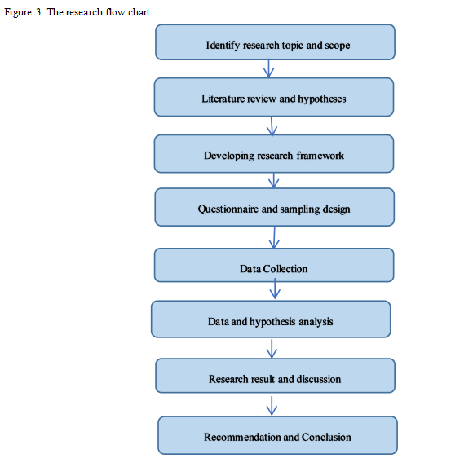
Source: Created by author
The study starts by identifying the topic of research which is produced from literature review. The next step is to build the framework of research including the hypotheses, independent and dependent variables. Examines the correlation among the variables. Then the research will be conducted by quantitative and qualitative approaches. The quantitative approach is by inviting consumers in Hong Kong to conduct 400 questionnaires which the sample size was calculated by population dispersion estimation. The qualitative approach is through focus group interview and discussion to generate evaluation of the purchase intention on EVs. Both approaches would be based on the data and hypotheses analysis on descriptive statistics, correlation test, regression model and reliability test. At the end, research limitation, recommendations and conclusions will be provided.

1.6 Summary of the Chapter
The introduction section has defined the research topic and scope on the factors would influence the purchase intention of electric vehicle in Hong Kong. To explore, through the study of the factors would influence the purchase intention of consumers in Hong Kong of electric vehicle and the relationship between the factors, the strategies would upraise the adoption of electric vehicle in the city. The growth of the market share and adoption of electric vehicle is in a rising speed in global and Hong Kong. The vehicle market in all regions including Hong Kong could be totally changed in foreseeable future from dominated by traditional fuel vehicle to electric vehicle. The massive potential of market worth to develop strategies by a full research based on the research questions, objectives and flow.

Chapter 2: Literature Review

This chapter is going to review different academic journals to support the research methodology adopted by the report. Through the study of those literature, to identify the factors would influence the purchase intention of electric vehicle. The factors will be reviewed are subjective norms, product knowledge, environmental concern and brand image.

2.1 Definition of subjective norm
Subjective norm refers to an individual's perception of social pressure to engage in a particular behavior. This perception is influenced by the beliefs and attitudes of significant others, such as family, friends, and colleagues. The subjective norm construct is an important component of the Theory of Planned Behavior (TPB), which posits that attitudes, subjective norms, and perceived behavioral control are key determinants of behavior (Ajzen, 1991). Research has shown that subjective norm plays a significant role in predicting a wide range of behaviors, including pro-environmental behaviors (Kaiser et al., 2013), healthy eating habits (Glanz et al., 2015), and vaccination uptake (Brewer et al., 2007). For example, in a study on pro-environmental behavior, Kaiser et al. (2013) found that subjective norm was a stronger predictor of recycling behavior than personal values, suggesting that social pressure plays a significant role in shaping pro-environmental behavior. Similarly, in a study on healthy eating habits, Glanz et al. (2015) found that subjective norm was a significant predictor of fruit and vegetable consumption, with individuals who perceived greater social pressure to eat healthily reporting higher levels of consumption.

Overall, the subjective norm construct highlights the importance of social influence in predicting behavior, and understanding how it operates can inform the development of effective behavior change interventions.

2.1.1 Constructs of subjective norm
Several scholars have conducted research on the construct of subjective norm and its influence on behavior. For example, in a study on physical activity behavior, Hagger et al. (2012) found that subjective norm was a significant predictor of intention to engage in physical activity, suggesting that social influence plays an important role in shaping behavior. Similarly, in a study on healthy eating behavior, Shepherd et al. (2019) found that subjective norm was a significant predictor of intention to consume fruits and vegetables, with individuals who perceived greater social pressure to eat healthily reporting higher levels of intention. Other scholars have also explored the influence of subjective norm on a range of behaviors, including pro-environmental behavior (Kaiser et al., 2013) and smoking behavior (Norman et al., 2007). Overall, the construct of subjective norm highlights the importance of social influence in shaping behavior, and understanding its operation can inform the development of effective behavior change interventions.
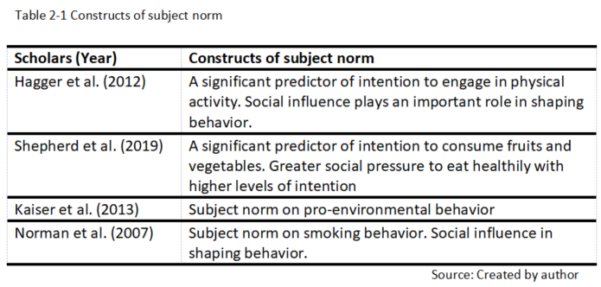
With the support of aforesaid literature review, scholars have concluded that people’s consumption behavior and purchase intention would be impacted by the subject norm.

2.2 Definition of product knowledge
Product knowledge is the understanding that consumers have of a particular product or product category, and it can influence their purchase intention. It includes knowledge of the product's features, benefits, and uses, as well as any relevant technical information. Product knowledge is an important factor in consumer decision-making, as it allows consumers to make informed choices based on their needs and preferences. Several scholars have studied the relationship between product knowledge and purchase intention. For example, in a study on the purchase intention of eco-friendly products, Kim and Choi (2016) found that product knowledge was a significant predictor of purchase intention, with consumers who had greater knowledge of eco-friendly products reporting greater purchase intention. Similarly, in a study on the purchase intention of mobile phones, Yu and Wu (2007) found that product knowledge was positively related to purchase intention, suggesting that consumers who had a better understanding of mobile phone features and functions were more likely to purchase them. Other scholars have also explored the influence of product knowledge on purchase intention for a range of products, including organic food (Zhang & Kim, 2013) and luxury goods (Kim et al., 2018). Overall, the concept of product knowledge highlights the importance of providing consumers with accurate and comprehensive information about products, as it can influence their purchase intention.

2.2.1 Constructs of product knowledge
Product knowledge is a complex construct that encompasses several dimensions, including subjective product knowledge, objective product knowledge, and product-related experiences. These dimensions of product knowledge are essential in shaping consumer behavior as they influence how consumers evaluate and make decisions about products.

Subjective product knowledge refers to consumers' perceptions of their own knowledge about a product or product category. It is based on consumers' beliefs about their familiarity with a product or product category. In a study on consumer behavior towards green products, Luchs et al. (2010) found that subjective product knowledge was positively related to purchase intention for green products. This suggests that consumers who feel they are more knowledgeable about green products are more likely to purchase them.

Objective product knowledge, on the other hand, refers to consumers' actual knowledge of a product or product category, including knowledge of product features and benefits. It is based on consumers' factual understanding of a product or product category. In a study on consumer knowledge of smartphones, Yang and Lee (2019) found that objective product knowledge was positively related to purchase intention. This indicates that consumers who have more knowledge of smartphone features are more likely to purchase them.

Product-related experiences refer to consumers' interactions with a product and their perceptions of the product based on those experiences. It includes factors such as product quality, usability, and design. In a study on consumer behavior towards eco-friendly products, Kim and Choi (2016) found that product-related experiences were positively related to purchase intention for eco-friendly products. However, though it can be a valuable source of information regarding the consumers’ perceptions of a product, there are limitations to using this dimension to evaluate product knowledge. Several studies have highlighted these limitations. One limitation is that product-related experiences are subjective and can vary widely between individuals. A study by Kim and Choi (2016) mentioned above found that consumers' product-related experiences were influenced by their personal values and beliefs, which can differ significantly among people. Another limitation is that product-related experiences may not always reflect consumers' actual knowledge of a product's features and benefits. A study by Lee and Kim (2018) on technology products found that consumers' positive experiences with a product did not always correspond to their objective knowledge of the product's technical specifications. A third limitation is that product-related experiences may be influenced by factors outside of the product itself. A study by Grankvist et al. (2004) on green products found that consumers' product-related experiences were influenced by their perceptions of the product's environmental impact, which can be shaped by marketing and advertising campaigns. These limitations suggest that product-related experiences may not necessarily reflect consumers' objective knowledge of the product.

Other scholars have also explored the different dimensions of product knowledge for a range of products, including cosmetics (Kwon and Armstrong, 2002) and wine (Bruwer et al., 2002). These studies highlight the importance of understanding the different factors that influence consumer decision-making and how they can be leveraged to improve product marketing and sales.
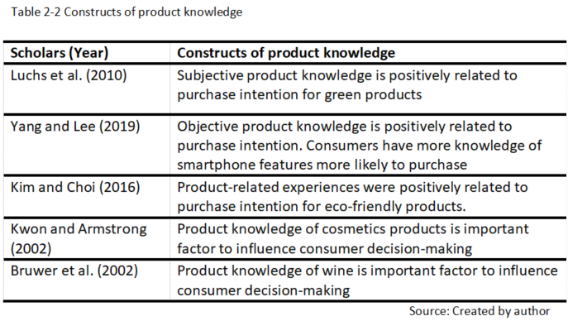
In conclusion, product knowledge is a crucial construct that includes subjective product knowledge, objective product knowledge, and product-related experiences. However, considering the limitations of product-related experiences, the evaluation of the impact on purchase intention by product knowledge would mainly reply on subjective knowledge and objective knowledge.

2.3 Definition of environmental concern
Environmental concern refers to the awareness and apprehension about the degradation of natural resources, biodiversity loss, and the impact of human activities on the environment. Environmental concern has grown in importance in recent years due to the increasing recognition of the negative impact of human activities on the environment, including climate change, deforestation, pollution, and the loss of biodiversity. The concern is not only limited to the scientific community, but it has also become a public issue, as people start to realize the impact of their actions on the environment.

According to Hines et al. (1987), environmental concern is a multidimensional construct that includes different components such as awareness, knowledge, attitudes, and behavior. In their study, they found that people who are more concerned about the environment are more likely to engage in pro-environmental behaviors. Similarly, Kals et al. (1999) found that people who have a higher level of environmental concern are more likely to engage in environmentally friendly behaviors. Furthermore, studies have shown that environmental concern is influenced by different factors such as education, income, and age (Diekmann & Preisendörfer, 2003; Gatersleben et al., 2002). For instance, Gatersleben et al. (2002) found that people with higher education and income levels are more likely to be environmentally concerned. Similarly, Diekmann and Preisendörfer (2003) found that younger people are more environmentally concerned than older people.

2.3.1 Constructs of environmental concern
Environmental concern is a multidimensional construct that refers to an individual's level of awareness, knowledge, attitude, and behavior towards the environment and its protection (Stern et al., 1995). It encompasses a range of attitudes and emotions towards the environment, including concern for natural resources, wildlife, and ecosystems, as well as the social and economic consequences of environmental problems (Whitmarsh, 2008). The New Environmental Paradigm (NEP) theory, proposed by Dunlap and Van Liere (1978), posits that environmental concern reflects a general concern for the environment, including nature, wildlife, and ecosystems. The Value-Belief-Norm (VBN) theory, proposed by Stern et al. (1995), suggests that environmental concern is shaped by an individual's underlying values and beliefs about the environment. Several studies have investigated the relationship between environmental concern and pro-environmental behaviors such as recycling, reducing energy consumption, and purchasing environmentally friendly products (Hines et al., 1987; Kals et al., 1999; Luchs et al., 2010). Environmental concern has also been found to be influenced by various factors such as education, income, age, and personal values (Diekmann & Preisendörfer, 2003; Gatersleben et al., 2002).
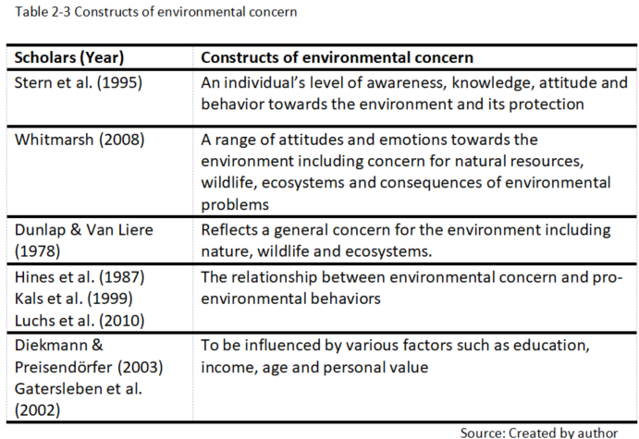

Overall, environmental concern is a crucial construct for understanding individuals' attitudes and behaviors towards the environment and its protection. It is essential for promoting sustainable behaviors and achieving environmental sustainability.

2.4 Definition of brand image
Brand image refers to the perception and reputation that a brand has in the minds of its customers and stakeholders. It is the sum total of all the impressions, beliefs, and associations that people have about a particular brand. A strong brand image can help a company to differentiate itself from competitors, build customer loyalty, and increase brand value. On the other hand, a weak or negative brand image can lead to a loss of customers, reduced sales, and damage to the company's reputation.

According to Keller (1993), brand image is formed through a process of brand association, where consumers link a brand with certain qualities, benefits, or attributes. These associations can be based on various sources such as the product itself, marketing activities, and the company's reputation. Aaker (1991) further suggests that brand image can be broken down into five dimensions: brand personality, brand user, brand culture, brand values, and brand self-image. Brand image is a critical factor for the success of a brand, and companies invest heavily in creating and maintaining a positive brand image. This can be achieved through various marketing strategies such as advertising, public relations, and social media.

Brand image is a crucial element in building and maintaining a successful brand. It is the perception and reputation that a brand holds in the minds of its customers and stakeholders, and it can be influenced by various factors such as product quality, marketing activities, and company reputation. A strong brand image can lead to increased customer loyalty, higher sales, and greater brand value.

2.4.1 Constructs of brand image
Brand image is a complex construct that encompasses a variety of factors that shape consumers' perceptions and attitudes towards a brand. It is the overall impression that a brand communicates to its target audience, and it can be influenced by a range of factors such as product quality, advertising, and company reputation. Brand image is not only about what a brand offers, but also about how it makes consumers feel and what values it represents.

One important aspect of brand image is brand identity, which refers to the visual, verbal, and symbolic elements that a brand uses to represent itself to its target audience (Aaker, 1997). Brand identity includes elements such as logos, slogans, packaging, and advertising, and it plays a crucial role in shaping consumers' perceptions of a brand. Brand identity is important because it helps to differentiate a brand from its competitors and to create a unique and memorable identity that resonates with consumers. Another important aspect of brand image is brand personality, which refers to the human characteristics that a brand embodies (Aaker, 1997). Brand personality can be expressed through various brand elements such as advertising, packaging, and product design. For example, a brand that is associated with excitement and adventure may use bright colors, bold fonts, and dynamic imagery in its advertising to convey a sense of energy and excitement. Brand image is also influenced by the emotional connections that consumers have with a brand (Fournier, 1998). Emotions play a powerful role in shaping consumer behavior and decision-making, and brands that are able to connect with consumers on an emotional level are more likely to build strong and lasting relationships with their customers. For example, a brand that is associated with nostalgia or family values may evoke warm and positive emotions in consumers, which can in turn lead to stronger brand loyalty.
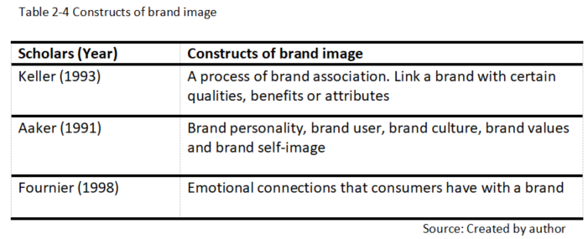

In conclusion, brand image is a complex and multidimensional construct that encompasses a range of factors that shape consumers' perceptions and attitudes towards a brand. These factors include brand identity, brand personality, and emotional connections, among others. Creating a strong and positive brand image is essential for building brand equity and achieving long-term success in the marketplace.

2.5 Definition of purchase intention
Purchase intention refers to the likelihood or willingness of a consumer to buy a particular product or service in the near future (Ajzen, 1991). It is an important concept in consumer behavior research because it is a key predictor of actual purchase behavior (Fishbein & Ajzen, 1975). Understanding purchase intention can help marketers to develop effective marketing strategies that can influence consumers' decision-making processes. Several factors can influence purchase intention, including subjective norms, brand image and product knowledge (Hsu et al., 2013). For example, consumers may be more likely to purchase a product that is high quality, has a good reputation, or aligns with their personal values or beliefs. The perceived benefits and costs of a product or service can also influence purchase intention (Zeithaml, 1988). Purchase intention can be measured using various methods, including surveys, experiments, and observational studies (Van Hooft & Koehn, 2012). Surveys are a common method for measuring purchase intention, as they allow researchers to directly ask consumers about their likelihood or willingness to purchase a particular product or service.

2.5.1 Constructs of purchase intention
Based on previous studies, researchers have presented varying perspectives on the factors that influence purchase intention among consumers. Ajzen (2003) suggests that attitudes can accurately predict purchase intention and that it has been integrated into explaining consumer behavior in the food retail industry. He argues that consumers' past experiences and knowledge of a product can increase their probability of purchasing and that understanding the factors that affect an individual's subjective preferences can also help predict their purchase behavior. Nicosia's (1968) research focuses on individual decision-making in purchasing, considering product attributes and manufacturer as crucial factors that influence purchase intention. Consumers go through a process of information collection, product evaluation, consumption behavior, and product feedback, ultimately influencing their decision to purchase a product again based on their experiences and comments from others. Kamins and Marks (1991) found that consumers who are more familiar with a product are more likely to have a higher level of purchase intention, while Keller (1993) supports the idea that product knowledge has a positive effect on purchase intention.
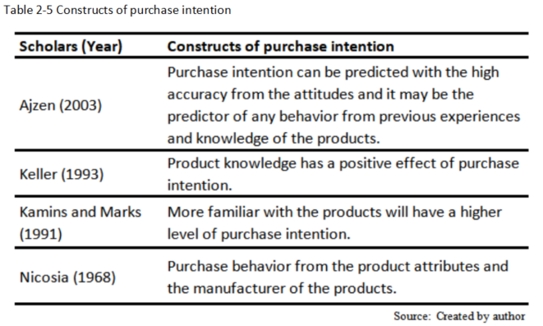
Overall, purchase intention can be influenced by multiple factors, including attitudes, subjective preferences, product attributes, manufacturer, and product knowledge. Understanding these factors can help marketers develop effective marketing strategies that increase purchase intention and lead to actual purchase behavior.

2.6 Relationship between different factors and purchase intention
There are multiple factors that can impact purchase intention, including subjective norm, product knowledge, environmental concern and brand image. This section will delve into the interplay between these factors and their influence on purchase intention.

2.6.1 Relationship between subjective norm and purchase intention
Subjective norm has been found to be a significant predictor of purchase intention for electric vehicles (EVs), as it reflects the influence of social expectations and pressures on individual behavior. Several studies have explored the relationship between subjective norm and purchase intention of EVs, providing insights into the factors that shape consumer behavior. For example, a study by Chen and Lu (2018) found that subjective norm had a significant positive effect on purchase intention for EVs among Chinese consumers. Similarly, research by Kim and Kang (2018) on the purchasing behavior of Korean consumers found that subjective norm was a significant predictor of intention to purchase EVs. Furthermore, a study by Cheung, Chan, and Wong (2019) found that subjective norm had a positive effect on EV purchase intention among Hong Kong consumers, highlighting the importance of social influence in shaping consumer behavior towards sustainable transportation. Thus, the findings of this study indicate that subjective norm plays a crucial role in shaping purchase intention towards electric vehicle.
- Hypothesis 1: Subjective norm plays a crucial role in shaping purchase intention towards electric vehicle

2.6.2 Relationship between product knowledge and purchase intention
Product knowledge refers to the information and understanding an individual has about a product, and it can play a crucial role in shaping purchase intention for electric vehicles. Understanding the relationship between product knowledge and purchase intention can provide insights into the factors that drive consumer behavior towards EVs. Several studies have explored the relationship between product knowledge and purchase intention for EVs. For example, a study by Kim et al. (2016) found that product knowledge had a positive effect on purchase intention for EVs among Korean consumers. Similarly, research by Chen and Lu (2018) on Chinese consumers found that product knowledge was a significant predictor of purchase intention for EVs. Furthermore, a study by Gao et al. (2019) found that product knowledge had a positive effect on purchase intention for new energy vehicles, including EVs, among Chinese consumers. The study also found that perceived value and environmental concern mediated the relationship between product knowledge and purchase intention. Thus, the findings of this study indicate that product knowledge has a significant influence on consumer's purchase intention towards electric vehicle, as formulated below.
- Hypothesis 2: Product knowledge influences purchase intention of electric vehicle significantly.

2.6.3 Relationship between environmental concern and purchase intention
Environmental concern has been found to be positively associated with purchase intention across a range of consumer products. Several studies have explored this relationship, with consistent findings suggesting that consumers who are more environmentally concerned are more likely to have higher purchase intention for environmentally friendly products. One study by Bamberg and Möser (2007) found that environmental concern was a significant predictor of purchase intention for energy-efficient household appliances. Similarly, a study by Kim and Choi (2019) in South Korea found that environmental concern was positively associated with purchase intention for eco-friendly cosmetics. Another study by Wang and Chen (2017) in China found that environmental concern was positively related to purchase intention for green food products. In summary, studies suggest that environmental concern is a key factor that motivates consumers to consider purchasing environmentally friendly products. Therefore this research would suggest that environmental concern influences purchase intention of electric vehicle significantly.
- Hypothesis 3: Environmental concern influences purchase intention of electric vehicle significantly.
2.6.4 Relationship between brand image and purchase intention
Multiple studies have consistently demonstrated a positive association between brand image and purchase intention for electric vehicles (EVs). Kim et al. (2016) in South Korea found that a positive brand image was a significant predictor of EV purchase intention, while Wang et al. (2017) in China identified a positive relationship between brand image and purchase intention for EVs, even after controlling for other factors. Additionally, Han et al. (2018) in the United States found that brand image was positively associated with willingness to pay for EVs, with perceived benefits such as environmental friendliness and fuel cost savings mediating the relationship between brand image and purchase intention. In conclusion, these studies suggest that a positive brand image can play a crucial role in shaping consumer attitudes towards EVs, highlighting the potential effectiveness of promoting the brand image of EVs to increase their adoption among consumers. Therefore, this report will suggest brand image would influence purchase intention of electric vehicle positively.
- Hypothesis 4: Brand image influences purchase intention of electric vehicle positively.

2.6.4 Summary
Through an examination of scholarly literature, this chapter investigates the impact of four factors on purchase intention. Subjective norm, or the influence of friends and family on consumption behavior, has been a topic of debate among scholars. Another important factor is product knowledge, which consists of both subjective and objective knowledge and significantly impacts purchase intention. While environmental concern may not directly impact purchase intention, it can motivate consumers to seek out related knowledge and ultimately influence their purchase decisions. Brand image is another critical factor, which represents a consumer’s perception of a brand and has been shown to have a positive impact on purchase intention. Scholars have identified three constructs of brand image: functional, symbolic, and experimental. Future analysis will explore the significant impact of these four factors on purchase intention for electric vehicles in Hong Kong, further contributing to our understanding of consumer behavior in this context.
Chapter 3: Research Methodology
This study employed both descriptive and exploratory research methods to achieve research purposes and test research hypotheses. Descriptive research involved constructing a questionnaire based on previous research, while exploratory research involved collecting secondary data from academic journals, books, and the internet to analyze the impact of brand image, product knowledge, environmental concern, and subjective norm on purchase intention for electric vehicles in Hong Kong.

3.1 Framework of research
The present research aimed to examine the link between independent variables and dependent variables related to purchase intention. The independent variables considered in this study were identified as subjective norm, product knowledge environmental concern and brand image. A research model was formulated to illustrate this relationship, as depicted in Figure 4.
Figure 4: Framework of research
H1+

Purchase
Intention
Subjective norm

H2+
Product Knowledge

H3+
Environmental Concern

H4+
Brand Image

Source: Created by author

3.2 Research hypotheses
In line with the research objectives and literature review, a questionnaire was utilized to gather insights from the research participants. To test and provide empirical evidence of the impact of subjective norm, product knowledge, environmental concern and brand image on purchase intention for electric vehicles in Hong Kong, the following four hypotheses were formulated:

- H1: Subjective norm plays a crucial role in shaping purchase intention towards electric vehicle.
According to Ajzen (1991), consumers may be influenced by friends, family, and media when engaging in certain behaviors, unless they have their own personal reasons for doing so. Subjective norm has been identified as a key factor influencing purchase intention for environmentally-friendly products. Building on Ajzen's suggestion, further analysis will investigate the significant impact of subjective norm on purchase intention for electric vehicles.

- H2: Product knowledge influences purchase intention of electric vehicle significantly.
Gao et al. (2019) argue that product knowledge plays a critical role in shaping consumer purchase intention. Consumers with higher levels of product knowledge are more likely to be familiar with and possess a deeper understanding of the product. Thus, this study proposes that product knowledge has a significant impact on consumer purchase intention for electric vehicles.

- H3: Environmental concern influences purchase intention of electric vehicle significantly.
Although environmental concern may not have a direct impact on purchase intention, it can still play an important role in shaping consumer behavior. Dunlap and Liere (2000) suggest that environmental concern can help consumers understand the environmental impact of their purchasing decisions. Therefore, this study proposes that environmental concern has a significant impact on purchase intention for electric vehicles.

- H4: Brand image influences purchase intention of electric vehicle positively.
Han et al. (2018) have noted that consumer with a positive perception of the brand image of electric vehicles were more willing to pay a premium price for them, indicating a positive association between brand image and purchase intention. Brand image is therefore considered a crucial factor influencing consumer purchase decisions. Thus, this study proposes that a positive brand image has a significant positive impact on consumer purchase intention for electric vehicles.

3.3 Research Method
As per the research hypothesis and model, a set of questionnaires was developed to collect data from the research participants for the purpose of examining and validating the research hypotheses.

3.3.1 Types of research
This study utilized both qualitative and quantitative research methods. As noted by Maxwell (1992), quantitative research involves standardized tests or questionnaires and aims to generalize findings to a broader population, while the sampling of qualitative research is crucial in establishing the validity of statistical tests. Qualitative research is concerned with individual, group, and sub-culture experiences and involves negotiating "truths" based on personal experiences. Quantitative research is limited to what can be measured or quantified, while qualitative research aims to capture the non-quantifiable details, providing in-depth insights into personal or descriptive aspects (Winter, 2000). Given the limitations of both approaches, this study employed both qualitative and quantitative research methods to ensure a comprehensive understanding of the research topic.

3.3.2 Types of date collection
Hox (2005) suggests that research data can be gathered through primary and secondary methods, both of which were adopted in this study. Primary data collection involved both quantitative surveys and experiments, as well as qualitative interviews with focus groups and open-ended interviews. Secondary data collection included a review of literature, documents, government reports, and statistical data, among other sources (Bazeley and Johnson, 2013). For primary data collection, quantitative research questionnaires were utilized, along with qualitative focus group interviews to provide a deeper understanding of the research participants' feedback regarding the questionnaires. Secondary data collection involved a review of literature, company or government reports, and other relevant sources to facilitate further analysis.

3.3.3 Target of the research
Hong Kong is a densely populated city with a high level of air pollution and traffic congestion, making it an ideal location for promoting sustainable transportation options such as electric vehicles. Secondly, the Hong Kong government has introduced various policies and incentives aimed at promoting the adoption of electric vehicles, which presents an opportunity to understand the effectiveness of these policies and the factors that influence consumer behavior. According to the Hong Kong Transport Department, the number of registered vehicles in Hong Kong has been steadily increasing, reaching over 800,000 in 2020. Additionally, the number of electric vehicles registered in Hong Kong has also been increasing in recent years, with over 15,000 electric vehicles registered by the end of 2020. By targeting individuals aged 18 or above in Hong Kong, regardless of age, education level, gender, or salary level, this research can provide a comprehensive understanding of the factors that influence purchase intention for electric vehicles in Hong Kong. This information can then be used to inform policies and strategies aimed at promoting the adoption of sustainable transportation options in the city.

3.3.4 Size of sampling
Sampling size is an important factor in research studies as it determines the number of participants required to represent a given population. Often, the sample is divided into sub-groups based on demographics such as age, gender, occupation, and more to ensure that the overall sample is representative of the entire population. Determining the appropriate sampling size is crucial for statistical analysis (Kibuacha, 2021). In this study, the sampling size will be calculated using Andrew Fisher's formula, as presented in Figure 5. By utilizing this formula, the appropriate number of participants can be determined to ensure the statistical significance of the findings. This will improve the reliability and validity of the study, allowing for more accurate conclusions to be drawn regarding purchase intention for electric vehicles.
Figure 5: Andrew Fisher formula
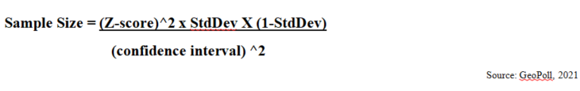

Fisher's formula was utilized in this study, as it takes into account the confidence level, normal deviation, and converts the degree of confidence into a Z-score. The population of Hong Kong was estimated to be around 7,413,070 at the end of June 2021 (Hong Kong Census and Statistics Department, 2022). Glenn (1992) suggested using a confidence level of 95% and a standard deviation of 0.5, which was also adopted for this study. According to The Wealth Race (2021), the Z-score for a 95% confidence level is 1.96. After applying Fisher's formula, the required sample size was calculated to be 384.16, which was rounded up to 385. Therefore, a total of 385 questionnaires were distributed in this study, with the aim of obtaining a representative sample of the population in Hong Kong. By using Fisher's formula and ensuring an appropriate sample size, this study can provide reliable and valid results regarding the purchase intention of electric vehicles in Hong Kong.

3.3.5 Method of sampling
The survey distribution in this study utilized snowball sampling, which is a popular method in qualitative research characterized by referral and networking (Parker et al., 2019). By this sampling technique, the sample group grows like a rolling snowball gradually increasing until the researcher has obtained enough participants (Simkus, 2022) so it is called "snowball". Snowball sampling is often employed when potential participants are difficult to locate, and is applicable for various research objectives. This method of sampling allows researchers to reach out to individuals who may not have been identified through traditional recruitment methods, and can provide a diverse range of perspectives and experiences. By using snowball sampling in this study, the researcher was able to gather a diverse range of participants to provide insights into the purchase intention for electric vehicles in Hong Kong. This sampling technique allowed for the recruitment of participants who may have otherwise been difficult to reach and ensured a representative sample for the study.

3.3.6 Collection of data
The survey was conducted over a one-month period from February to March 2023. although the COVID-19 pandemic in Hong Kong improved since the last quarter of 2022, all questionnaires were still collected through an online Google questionnaire form to avoid unnecessary close contact. The electronic questionnaires were distributed to Hong Kong residents through various channels, including email, WhatsApp and LINE messages, which are the most popular mobile messaging app in Hong Kong. A total of 390 valid questionnaires were collected through the snowball sampling method, which allowed for the recruitment of participants through referrals and networking. By conducting the survey online, the researcher was able to overcome the logistical challenges posed by the pandemic and obtain a sufficient number of valid responses to conduct a robust analysis of the factors influencing purchase intention for electric vehicles in Hong Kong.

3.4 Analysis of data
In order to achieve the objectives of the study and test the research hypotheses, statistical techniques were used to analyze the collected data. Statistical software was employed to obtain results and draw conclusions. Specifically, the Statistical Package for Social Sciences (SPSS) version 28.0 software was utilized, which is commonly used by researchers in the social sciences. This software provided support for the research and theories by facilitating the use of descriptive statistics, multivariate statistics, and other analytical techniques. To test the validity and reliability of the measurement model, a measurement model was employed. This involved two parts: examination of descriptive statistics, such as means and standard deviations, and inferential statistics to measure the reliability and validity of the measurement items within the proposed models. Finally, regression analysis was conducted to examine the relationship between independent variables and dependent variables based on the research hypotheses. The collective data were examined by the following analysis.

3.4.1 Descriptive statistic analysis
Descriptive statistical analysis is often used in research as the initial step of quantitative data analysis. This approach, also known as the "signal approach," provides a detailed overview and summary of the survey data (Gormus and Kabasakal, 2010). Descriptive statistics are generally considered the simplest and most straightforward statistical analysis to perform and interpret. In this study, descriptive statistics were used to understand the characteristics of the respondents and provide an overall view of the study. Measures such as standard deviation, means, and percentages were employed. The mean of the descriptive statistics analysis was used to determine the concentration level of the question items, constructs, and variables. Since a five-point Likert scale was used in the questionnaires, the medium is calculated as (5+1)/2. A mean above 3 indicates agreement with the questions, while a mean below 3 indicates disagreement with the questions (Allen & Seaman, 2007). Standard deviation, on the other hand, measures the variability of the results, providing a more accurate picture of the distribution of measurements. A higher standard deviation indicates greater differences in the values, and a less representative mean (Ali & Bhaskar, 2016). The representativeness of the mean will be examined by listing out the mean and standard deviation from high to low in the next chapter.

3.4.2 Reliability test
To ensure the conformity of the data, a reliability test was conducted, which is frequently used to measure the consistency of research data. Cronbach's Alpha, developed by Cronbach (1951), is a reliability test used to measure the internal consistency of a set of scale questions in a survey. The Cronbach's Alpha coefficient indicates the degree to which the scale items vary together as a group, reflecting their inter-correlated relationship. The value of the Cronbach's Alpha coefficient ranges from 0 to 1, with values above 0.7 generally accepted. A value above 0.8 is considered good, while a value above 0.9 is excellent (Cucos, 2022). If the Cronbach's Alpha coefficient is less than 0.7, the question should be removed in order to maintain the measurement’s consistency. By utilizing this reliability test, the researcher is able to ensure that the survey questions were reliable and consistent, providing confidence in the results and conclusions of the study.

3.4.3 Analysis of correlation
The Pearson correlation coefficient (PCC), also known as Pearson's r, was first proposed by Pearson (1920) and is widely used to measure the linear correlation between two variables and how they affect one another. This statistical analysis is typically employed to analyze quantitative data in research methods such as surveys and polls, allowing researchers to identify patterns and trends. The correlation coefficient formulas are used to determine the strength of the relationship between the data. The value of the coefficient ranges from -1 to 1, with a value of 1 indicating a strong positive relationship. This means that for every positive increase in one variable, there is a corresponding positive increase of a fixed proportion in the other variable. On the other hand, a correlation coefficient of -1 indicates a strong negative relationship, meaning that for every positive increase in one variable, there is a corresponding negative decrease of a fixed proportion in the other variable. A correlation coefficient of zero indicates that there is no relationship between the variables, with no positive or negative increase, and they are not related at all. By using the Pearson correlation coefficient, this study was able to identify the strength and direction of the relationship between the variables related to purchase intention for electric vehicles in Hong Kong.

3.4.4 Analysis of linear Regression
Linear regression is a parametric test used to evaluate how independent variables impact the dependent variable. In this study, it was applied to test the relationship between independent variables (such as brand image, product knowledge, environmental concern, and subjective norm) and the dependent variable (purchase intention for electric vehicles) to determine the strength of the factors influencing the willingness to purchase electric vehicles. Linear regression also allows for the measurement of the dependent variable at a certain value of the independent variable. The R squared value is used to indicate the predictive power of the research model. This value represents the extent of the variance explained and the combined effects of independent variables on an endogenous latent construct. The R squared value is an important indicator of the robustness of the model and determines whether it is a result of chance or a reliable fit for the data. An R squared value of 0.5 or higher is generally accepted, with a higher R squared indicating a better fit for the model (Veerasamy et al., 2011). By adopting linear regression in this study, the researcher is able to identify the factors influencing purchase intention for electric vehicles in Hong Kong and determine the extent to which these factors impact the willingness to purchase. The R squared value provided insight into the predictive power of the research model and helped to determine the robustness of the findings.

3.5 Questionnaires desgin
In this study, a research questionnaire was developed to collect data on consumer behavior towards a specific product. The questionnaire consisted of 25 questions that were adopted from past studies and modified specifically for this research, and all questions were mandatory to ensure the validity of the data. To assist participants in understanding the key focus of the questionnaire, a cover page was included to explain the definition of the product. The survey questionnaire was distributed to participants in a specific location and was presented in a single language (English) to maintain consistency with the questions used in the references.

The questionnaire contained two parts. The first part consisted of four independent variables and one dependent variable. Participants were asked to rate their level of agreement with statements related to the independent variables, including subjective norm (3 questions), product knowledge (6 questions), environmental concern (3 questions) and brand image (9 questions) as well as the dependent variable, the purchase intention (4 questions), for the product on a five-point Likert scale. The second part of the questionnaire included demographic questions to analyze if different backgrounds of the participants had an impact on their purchase intention for the product. These questions included multiple choices related to gender, age group, education level, and monthly income. The Likert scale used in this study is a widely used measurement tool in social science research, allowing participants to express their level of agreement or disagreement with statements related to the product (Likert, 1932).

3.5.1 Subjective norm
Three questions were developed based on the construct that the purchase intention of electric vehicle would be affected by family members, colleagues, friends or the social media (Ajzen, 1991) as the table 3-1 below.
Table 3-1 The construct and questions of subjective norm
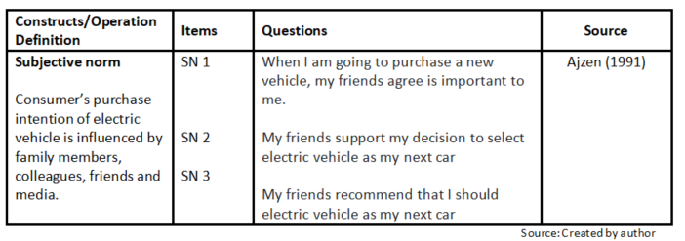

3.5.2 Product knowledge
Six questions were developed based on the constructs of product knowledge which is consisted of subjective knowledge and objective knowledge (Brucks, 1985) as the Table 3-2 below.
Table 3-2 The construct and questions of product knowledge
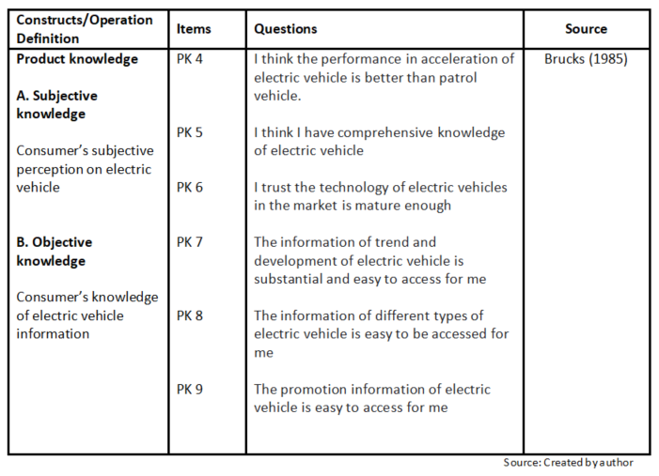

3.5.3 Environmental concern
Three questions were developed based on the construct that environmental concern not necessarily affect the purchase intention but it could drive a consumer to understand more about electric vehicle as the Table 3-3 below.
Table 3-3 The construct and questions of environmental concern
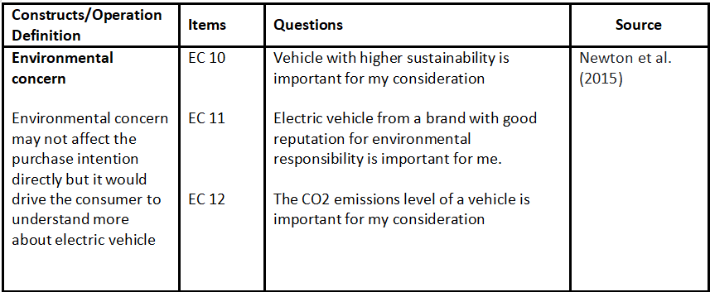
Source: Created by author

3.5.4 Brand image
Nine questions were developed according to the constructs of brand image consisted of three aspects including functional, symbolic and experimental (Park et. al. 1986) as the Table 3-4 below.
Table 3-4 The construct and questions of brand image
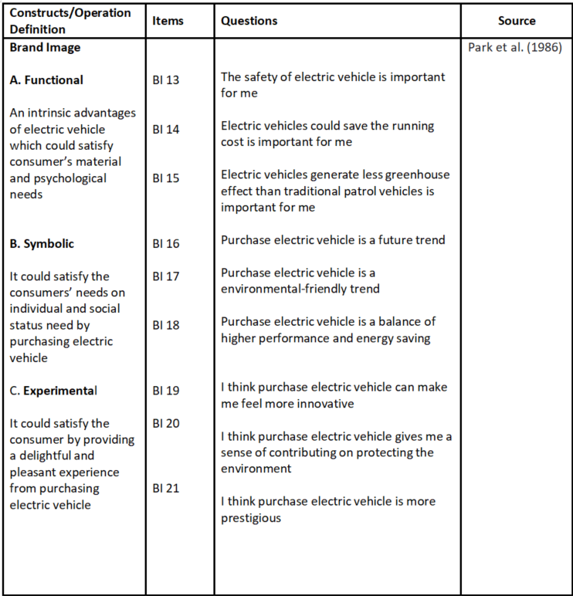
Source: Created by author

3.5.5 Purchase intention
Four questions were developed according to the construct of purchase intention which is the major indicator of purchasing electric vehicle (Ajzen, 2003) as the Table 3-5 below.
Table 3-5 The construct and questions of purchase intention
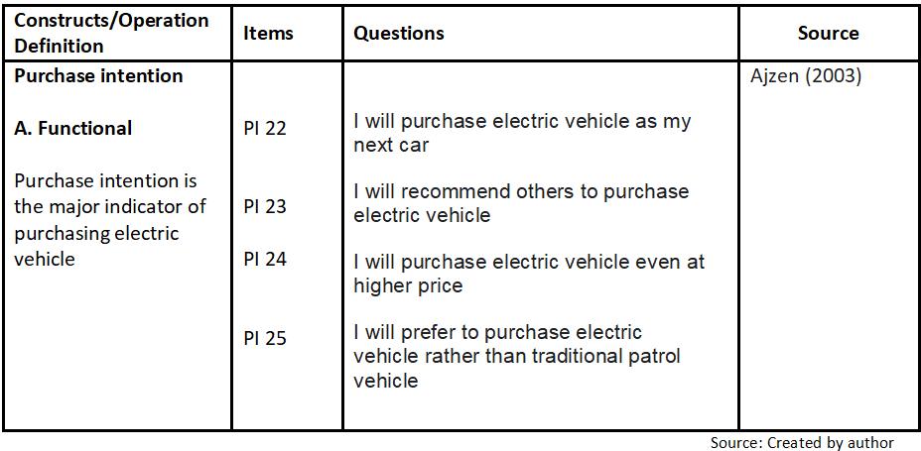

3.5.6 Demographic questions
The questionnaire contained of demographic questions including gender, age group, education level and income level (Table 3-6). The setup of choices of answer is based on the population figures published by Hong Kong Census and Statistics Department (2023)
Table 3-6 demographic questions
Questions | Choices of answer
Gender | Male or Female
Age Group | -18-29  -30-39  -40-49  -50-59  -60-69
Education level | - Primary or below  - Secondary  - Diploma/Certificate course  - Sub-degree course  - Degree course or above
Monthly Income | - Below 20,001  - 20,001 - 35,000  - 35,001 - 50,000  - 50,001 - 80,000  - 80,001 or above

3.6 Pilot test of questionnaire with focus group
In the final phase of the survey, a pilot test was conducted to ensure the adequacy of research instruments and assess the effectiveness of the technique and sampling frame. The pilot test also aimed to identify potential issues with the proposed data analysis techniques (Mason and Zuercher, 1998). Although it can be a time-consuming and challenging process, conducting a pilot test is a recommended practice before investing significant resources in a full study. Previous researches have suggested that a pilot test should involve a sample size of approximately 24 to 40 participants (Johnson and Brooks, 2010; Hertzog, 2008). Consistent with these recommendations, this study selected 30 individuals from Hong Kong to participate in the pilot test, providing qualitative data on the questionnaire. The participants were recruited among the author's friends, and group discussions were conducted via Zoom video call on February 9 and 11, 2023, with 15 interviewees in each session. After the focus group session, the reliability of the pilot test data was examined by adopting the Cronbach's alpha analysis by the Statistical Package for Social Sciences (SPSS) version 28.0 software. Table 3-7 shows the results of the pilot test's reliability analysis.
Table 3-7: Analysis of reliability of the pilot test
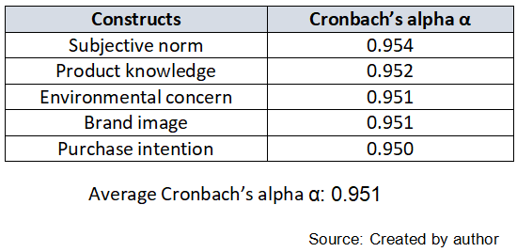

The questions in the survey were found to be highly reliable with an average Cronbach's alpha of 0.951, indicating excellent reliability (Cucos, 2022). As a result, all questions were kept unchanged. The pilot test revealed that over 70% of respondents are male and over 80% are between the ages of 18 to 49. Almost 80% of respondents held a degree or above qualification, and with monthly income of between 35,001 to 80,000. Overall, respondents found the questions are understandable and well-structured. However, some found the wording of the questions in the subjective norm section to be complicated and required multiple reads to understand the meaning. As a result, the wording of the three questions in the subjective norm section were modified , while the remaining questions were kept unchanged due to their high reliability level.

3.7 Summary
This chapter outlines the research methodology for the topic, which investigates the relationship between subjective norm, product knowledge environmental concern and brand image towards purchase intention of electric vehicles. Based on the literature review, five hypotheses were formulated to examine the influence of these factors on purchase intention. The study used both qualitative and quantitative research approaches, including focus group pilot tests and questionnaires. The questionnaire was designed based on secondary data and literature review. Various data analysis methods, such as descriptive statistics analysis, reliability testing, and linear regression analysis, were adopted to analyze the research findings.

Chapter 4: Findings of research
Overall, the respondents in this study demonstrated a favorable purchase intention towards electric vehicles. The results of the study will be presented using both descriptive analysis and inferential statistics, utilizing SPSS software to highlight the correlation between the factors influencing the purchase intention of Hong Kong residents when it comes to electric vehicles.

4.1 Descriptive analysis
The data for this study was collected through electronic questionnaires distributed via email and various social messaging platforms such as WhatsApp and LINE, to the researcher's personal network of friends, colleagues, and family members. Due to the nature of the distribution method, it is difficult to determine the exact number of questionnaires that were sent out. However, since all questions in the questionnaire were mandatory and respondents were only allowed to select one answer per question, all received questionnaires were considered valid for analysis. By the end of March 2023, the researchers had received a total of 390 completed questionnaires, which were used for further analysis.

4.1.1 Demographic profiles of respondents
Table 4-1 presents the demographic information and profiles of the respondents in this study. The survey collected data on four demographic factors: gender, age group, education level, and monthly income. The findings show that 26.7% of the respondents were female, while 73.3% were male, which is aligned with the gender distribution of licensed drivers in Hong Kong that are male more than female (51.5% vs. 48.5%) (Hong Kong Transport Department 2020). The majority of respondents fell within the 18-49 age range, with 20% in the 18-29 age group, 33.3% in the 30-39 age group, and 33.3% in the 40-49 age group. In terms of education level, over 70% of the respondents had a bachelor's degree or above qualification, followed by 10% with a secondary school level of education and 10% with sub-degree course qualifications. These findings differ from the average education level in Hong Kong, where only 34.5% of the population holds a diploma or above. The study found that the majority of respondents had a monthly personal income in the range of HKD 35,001 to 50,000, which is higher than the average monthly salary in Hong Kong. The high proportion of respondents with higher education levels may have contributed to their higher personal monthly incomes. The study found that almost half (43.3%) of the respondents reported a monthly personal income between HKD 35,001 to 50,000, while 36.7% of the respondents reported a monthly income between HKD 50,001 to 80,000, and 13.3% reported a monthly income between HKD 20,001 to 35,000. A small proportion of respondents, 6.7%, reported a monthly income of HKD 80,001 or above. It is worth noting that the average monthly salary in Hong Kong, according to the Census and Statistics Department (2021), is HKD 17,216, which is lower than the reported incomes of the majority of respondents in this study. Overall, the study's findings suggest that the respondents were predominantly young and highly educated, with relatively high personal incomes compared to the general population in Hong Kong.
Table 4-1 Demographic profile of respondents
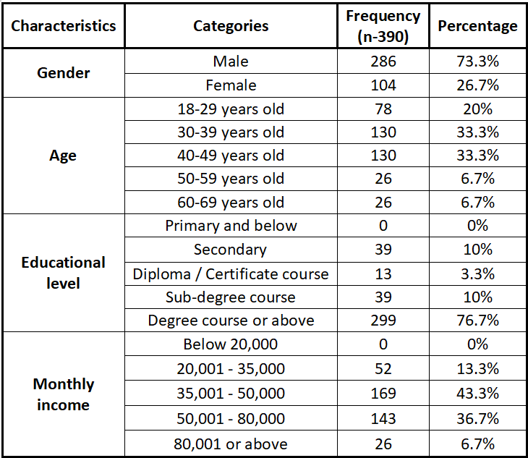Source: Created by author based on research data analysis
4.1.2 Measurement result of relevant variables
The data related to all variables in the study, including subjective norm, environmental concern, product knowledge, brand image and purchase intention, were subjected to statistical analysis and presented in Table 4-2 to Table 4-6. These tables provide a comprehensive overview of three items of subjective norm, six items of product knowledge, three items of environmental concern, the nine items of brand image and three items of purchase intention related to the purchase of electric vehicle.

According to the study's findings, the questions related to brand image had the highest mean among all the variables, with BI 13 (the mean is 4.87), BI 16 (the mean is 4.7), and BI 14 (the mean is 4.6) having the highest means. This was followed by product knowledge that the mean of PK 9 is 4.57 and environmental concern, with EC 12 having a mean of 4.37. The purchase intention to purchase electric vehicle with the highest means were PI 25(mean is 4.33). The variables with the lowest means were PK 5 and BI 21 with mean for both were 3.73.

4.1.2.1 Descriptive analysis of subjective norm
The table 4-2 shows the average mean of subjective norm is 4.03. The question SN 3 (My friends recommend that I should electric vehicle as my next car) is with the highest mean 4.17 and the standard deviation is 0.86. The mean is higher than 3 which implies the respondents agree the recommendation from friends is important for them to purchase electric vehicle under Likert scale mentioned in chapter 3. The question SN 1 (When I am going to purchase a new vehicle, my friends agree is important to me.) is with lowest mean 3.9 but still above 3 which indicates it is also important for the respondents that the view of friends are also important for them on making the purchase decision of a new vehicle. The findings of the mean of those questions show that subjective norm is important for consumers in Hong Kong (Ali and Bhaskar, 2016)

Table 4-2 Descriptive analysis of subjective norm (N=390)
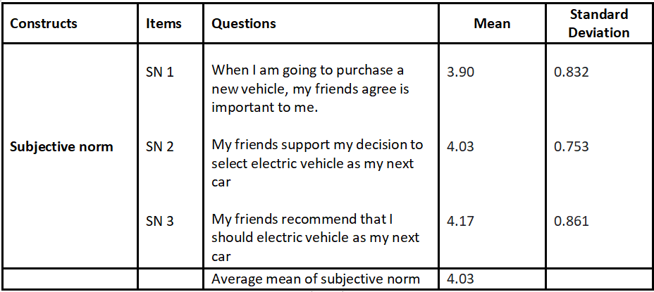
Source: Created by author based on research data analysis

4.1.2.2 Descriptive analysis of product knowledge
The table 4-3 shows the average mean of product knowledge is 4.13. The question PK 9 (The promotion information of electric vehicle is easy to access for me) is with the highest mean 4.57 and the standard deviation is 0.496 which shows the answer is very concentrated. The mean is higher than 3 which implies the respondents agree the promotion information of purchase electric vehicle is easy to access under Likert scale mentioned in chapter 3. The question PK 5 (I think I have comprehensive knowledge of electric vehicle) is with lowest mean 3.73 but still above 3 which indicates most of the respondents think they have comprehensive knowledge of electric vehicle. The findings of the mean of those questions show that product knowledge is important for consumers in Hong Kong (Ali and Bhaskar, 2016)

Table 4-3 Descriptive analysis of product knowledge (N=390)
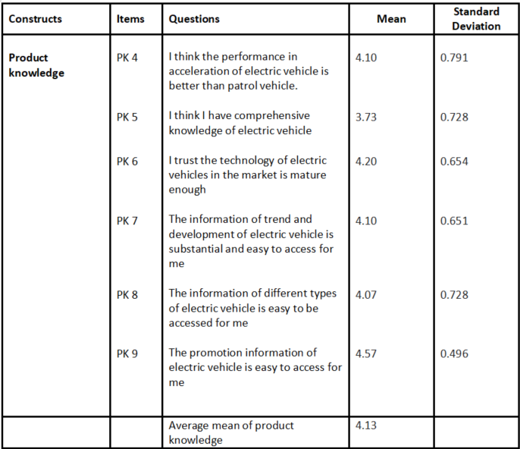
Source: Created by author based on research data analysis

4.1.2.3 Descriptive analysis of environmental concern
The table 4-4 shows the average mean of environment concern is 4.02. The question EC 12 (The CO2 emissions level of a vehicle is important for my consideration) is with the highest mean 4.37 and the standard deviation is 0.707. According to the Likert scale mentioned in chapter 3, the mean is higher than 3 which implies the respondents agree the CO2 emissions level of a vehicle is important for the consideration on purchasing a vehicle. The question EC 11 (Electric vehicle from a brand with good reputation for environmental responsibility is important for me.) is with lowest mean 3.77 but still above 3 which indicates most of the respondents think the good reputation for environmental responsibility of an electric vehicle brand is important. The findings of the mean of those questions show that environmental concern is important for consumers in Hong Kong (Ali and Bhaskar, 2016)
Table 4-4 Descriptive analysis of environmental concern (N=390)
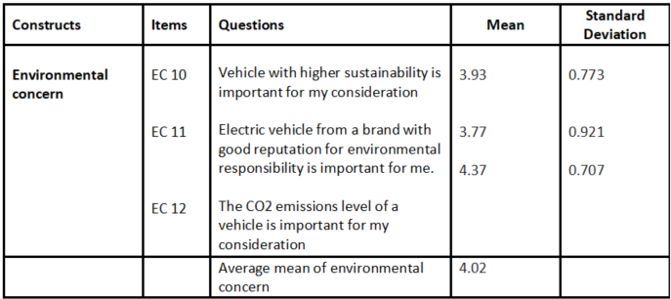
Source: Created by author based on research data analysis

4.1.2.4 Descriptive analysis of brand image
The table 4-5 shows the average mean of brand image is 4.32. The question BI 13 (The safety of electric vehicle is important for me) is with the highest mean 4.87 and the standard deviation is 0.34. According to the Likert scale mentioned in chapter 3, the mean is higher than 3 which indicates most of the respondents strongly agree the safety of electric vehicle is a important factor for their purchasing decision of electric vehicle. The question BI 21 (I think purchase electric vehicle is more prestigious.) is with lowest mean 3.73 but still above 3 which indicates the respondents feel, although not as strong as the safety or other elements of brand image, being more prestigious by buying an electric vehicle. The findings of the mean of those questions show that the consumers in Hong Kong thinks brand image is important for purchasing electric vehicle (Ali and Bhaskar, 2016)

Table 4-5 Descriptive analysis of brand image (N=390)
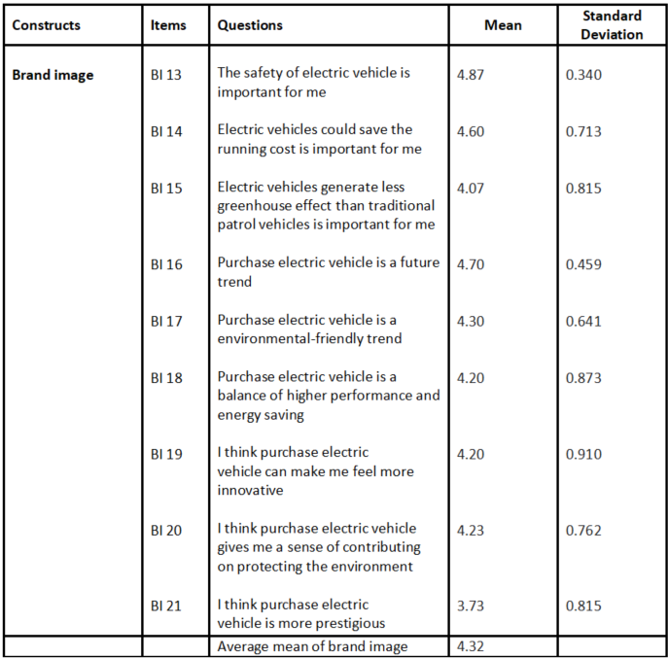
Source: Created by author based on research data analysis
4.1.2.5 Descriptive analysis of purchase intention
The table 4-5 shows the average mean of brand image is 4.09. The question PI 25 (I will prefer to purchase electric vehicle rather than traditional patrol vehicle) is with the highest mean 4.33 and the standard deviation is 0.746. According to the Likert scale mentioned in chapter 3, the mean is higher than 3 which indicates most of the respondents agree they will prefer to buy electric vehicle than vehicle using traditional patrol. The question PI 24 (I will purchase electric vehicle even at higher price) is with lowest mean 3.87 but still above 3 which indicates the respondents think that they will buy electric vehicle even the price is higher. The findings of the mean of those questions show that the consumers in Hong Kong thinks purchase intention is an important variable (Ali and Bhaskar, 2016)
Table 4-6 Descriptive analysis of purchase intention (N=390)
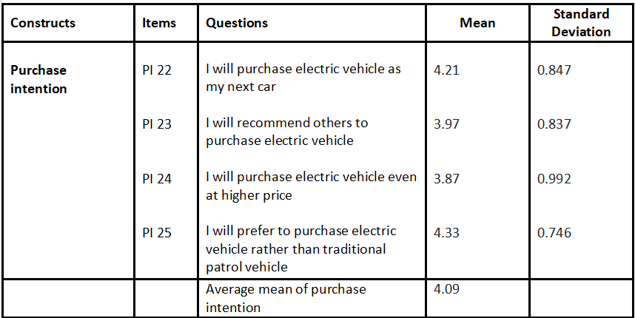
Source: Created by author based on research data analysis

4.2 Reliability test
In this study, the reliability of the measuring items was assessed using Cronbach's alpha as an indicator of internal consistency. Cucos (2022) suggests that values above 0.7 are acceptable, while values above 0.8 are considered good and values above 0.9 are excellent. The results are presented in Table 4-7, which shows that the Cronbach's α values for all constructs ranged from 0.95 to 0.954. The average Cronbach's α coefficient value for all questions was 0.951. Based on Cucos' (2022) criteria, these results indicate excellent reliability and internal consistency for the questions.
Table 4-7 Cronbach’s α value of all constructs in the research
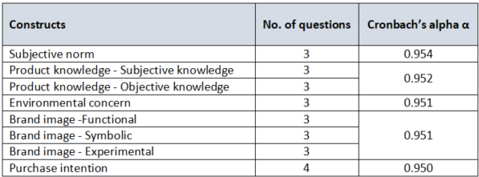
Source: Created by author based on research data analysis

4.3 Analysis of correlation
To evaluate the relationship between several constructs and purchase intention for electric vehicles, Pearson correlation coefficients (r values) were employed. The results indicated that the r values ranged from 0.538 to 1.000**, with values between 0 and 1 indicating a positive relationship. The highest r value of 1.000** was found between subjective norm and product knowledge while the lowest correlation value of 0.538** was found between subjective norm, product knowledge and environmental concern. The analysis also revealed that the independent variables which are subjective norm, product knowledge, environmental concern and brand image are positively correlated with the dependent variable purchase intention that the r values range from 0.649** to 0.846**, N=390, p < 0.001.
Table 4-8 result of Pearson’s correlation coefficient of all variables
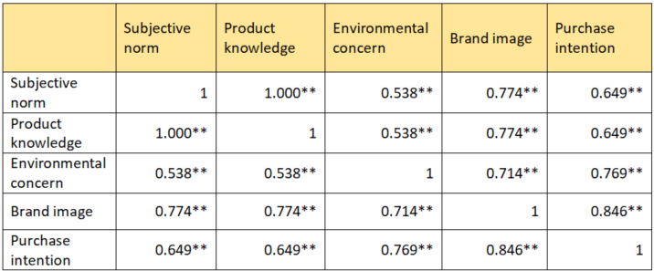
Source: Created by author based on research data analysis
4.4 Linear regression analysis
Linear regression analysis was used to examine the relationship between subjective norm, product knowledge environmental concern and brand image on purchase intention of electric vehicles in this study. Regression analysis is a statistical method used to evaluate how independent variables influence a dependent variable and to test the validity of hypotheses. The results of the regression analysis are presented in below sections.

4.4.1 Regression analysis of subjective norm and purchase intention of electric vehicle
The regression analysis for the relationship between subjective norm and purchase intention of electric vehicles was conducted and is presented in Table 4-9. The adjusted R-squared value of 0.42 indicates that the linear model explains 42% of the variance in purchase intention. The F-value of 273.418 with a p-value less than 0.05 indicates that the regression model is significant. The standard coefficient beta value for subjective norm and purchase intention is 0.649, with a corresponding t-value of 16.535. This result indicates that subjective norm has a significant impact on the purchase intention of electric vehicles, which supports the hypothesis H1: "Subjective norm plays a crucial role in shaping purchase intention towards electric vehicle"
Table 4-9 result of regression analysis of subjective norm and purchase intention of electric vehicle
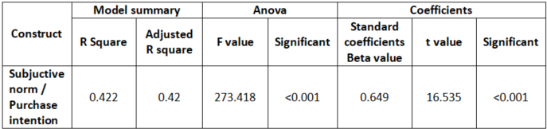
Source: Created by author based on research data analysis

4.4.2 Regression analysis of product knowledge and purchase intention of electric vehicle
The regression analysis for the relationship between product knowledge and purchase intention of electric vehicles was conducted and is presented in Table 4-10. The adjusted R-squared value of 0.42 indicates that the linear model explains 42% of the variance in purchase intention. The F-value of 273.418 with a p-value less than 0.05 indicates that the regression model is significant. The standard coefficient beta value for product knowledge and purchase intention is 0.649, with a corresponding t-value of 16.535. This result indicates that product knowledge has a significant impact on the purchase intention of electric vehicles, which supports the hypothesis H2: "Product knowledge influences purchase intention of electric vehicle significantly"

Table 4-10 result of regression analysis of product knowledge and purchase intention of electric vehicle
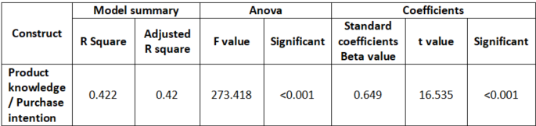
Source: Created by author based on research data analysis

4.4.3 Regression analysis of environmental concern and purchase intention of electric vehicle
The regression analysis for the relationship between environmental concern and purchase intention of electric vehicles was conducted and is presented in Table 4-11. The adjusted R-squared value of 0.59 indicates that the linear model explains 59% of the variance in purchase intention. The F-value of 542.48 with a p-value less than 0.05 indicates that the regression model is significant. The standard coefficient beta value for environmental concern and purchase intention is 0.769, with a corresponding t-value of 23.291. This result indicates that environmental concern has a significant impact on the purchase intention of electric vehicles, which supports the hypothesis H3: "Environmental concern influences purchase intention of electric vehicle significantly"
Table 4-11 result of regression analysis of environmental concern and purchase intention of electric vehicle
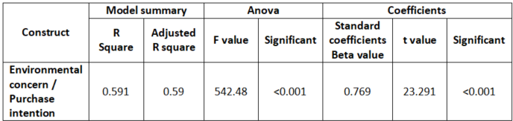
Source: Created by author based on research data analysis

4.4.4 Regression analysis of brand image and purchase intention of electric vehicle
The regression analysis for the relationship between brand image and purchase intention of electric vehicles was conducted and is presented in Table 4-12. The adjusted R-squared value of 0.714 indicates that the linear model explains 71.4% of the variance in purchase intention. The F-value of 941.786 with a p-value less than 0.05 indicates that the regression model is significant. The standard coefficient beta value for brand image and purchase intention is 0.769, with a corresponding t-value of 23.291. This result indicates that brand image has a significant impact on the purchase intention of electric vehicles, which supports the hypothesis H4: "Brand image influences purchase intention of electric vehicle positively"
Table 4-12 result of regression analysis of brand image and purchase intention of electric vehicle
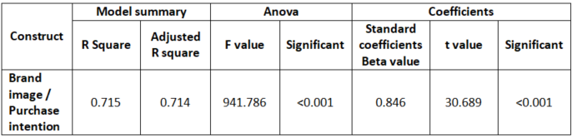
Source: Created by author based on research data analysis
4.5 Discussion of study findings
The results of this study suggest that subjective norm has the greatest influence on consumers' purchase intention of electric vehicles. The findings indicate that brand image (β=0.846) has the greatest impact on purchase intention of electric vehicles, followed by environmental concern (β=0.769), product knowledge (β=0.649), and subjective norm (β=0.649). These results are consistent with earlier studies by Han et al. (2018) have noted that consumer with a positive perception of the brand image of electric vehicles were more willing to pay a premium price for them, indicating a strong, positive association between brand image and purchase intention. Althought it may not influence purchase decisions directly, environmental concern could help consumers to understand the environmental impact of their purchase decisions according to Dunlap and Liere (2000). The positive impact on purchase intention by subjective norm shown in the findings is also aligned with the study of Ajzen (1991) that consumers would be influenced by friends, family, colleagues and media when engaging in certain consumption behavior including the purchase intention. The study also found that product knowledge has a significant influence on purchase intention, in line with Gao et al. (2019) argue that product knowledge plays a critical role in shaping consumer purchase intention. Consumers with higher levels of product knowledge are more likely to be familiar with and possess a deeper understanding of the product. These results confirm that brand image is an important factor for consumers on making purchase decision of electric vehicles. Additionally, environmental concern, subjective norm and product knowledge also key drivers for consumers to purchase electric vehicle. Therefore, it is critical for marketers to consider these factors in their marketing strategies and materials of electric vehicle that could actually drive consumers to purchase their products.

4.6 Summary of chapter
This chapter presents the findings of the research on the influence of subjective norm, product knowledge environmental concern and brand image on purchase intention of electric vehicles. The data from 390 respondents were analyzed using the Statistical Package for Social Sciences (SPSS) software. Descriptive analysis was used to illustrate the data, reliability tests were conducted to ensure the validity of the questions, and regression analysis was used to evaluate the influences of the four factors on purchase intention of electric vehicles. All five hypotheses were supported by the findings, and there were significant influences of subjective norm, product knowledge environmental concern and brand image on purchase intention of electric vehicles. Among these factors, brand image had the largest influence on purchase intention, followed by environmental concern, subjective norm and product knowledge.

Chapter 5: Research findings
The aim of this study was to investigate the impact of subjective norm, product knowledge environmental concern and brand image on the purchase intention of electric vehicles in Hong Kong. The following is a summary of the findings and analysis, along with recommendations for marketers, electric vehicle manufacturers, car dealers and consumers. Additionally, the study suggests areas for further research and acknowledges the limitations of the research.

5.1 Respondents details
The survey in this study involved a total of 390 respondents, with 73.3% of them being male and the majority (73.3%) falling within the age range of 18 to 49 years old. The respondents were also predominantly well-educated, with 76.7% possessing a degree or higher education qualifications. Additionally, the respondents had a relatively high monthly income that all reporting a personal income above HKD 20,000, which is higher than the average monthly salary in Hong Kong of HKD 17,216 (Census and Statistics Department, 2021).

5.2 Analysis of research framework
The hypotheses that all the factors including subjective norm, product knowledge environmental concern and brand image would influence purchase intention of electric vehicle significantly.
Table 5-1 Summary of the analysis of hypotheses
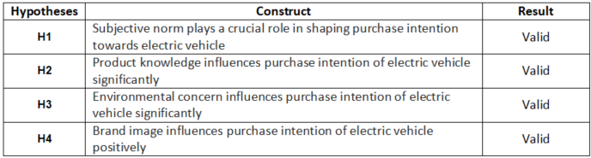
Source: Created by author based on research data analysis

5.3 Findings of the research
The results of this study indicate that the factors of subjective norm, product knowledge, environmental concern and brand image significantly influence the purchase intention of electric vehicles. These findings are consistent with previous literature studies on the topic.

5.3.1 Subjective norm plays a crucial role in shaping purchase intention towards electric vehicle
The results of H1 in this study indicate that subjective norm has a significant impact on the purchase intention of electric vehicles, although not as strong as the brand image and environmental concern. These findings are consistent with the research of scholars Hagger et al. (2012) and Shepherd et al. (2019), which confirm that subjective norm was a significant predictor of intention to engage in physical activity, suggesting that social influence plays an important role in shaping behavior. In summary, the influence of friends, colleagues, family and media can affect consumer behavior and their intention to purchase electric vehicles.

5.3.2 Product knowledge influences purchase intention of electric vehicle significantly
The results of H2 in this study indicate that product knowledge has a significant influence on the purchase intention of electric vehicles. This finding is consistent with the research of Luchs et al. (2010) found that subjective product knowledge was positively related to purchase intention for green products. This suggests that consumers who feel they are more knowledgeable about green products are more likely to purchase them. In another study related to objective product knowledge, Yang and Lee (2019) found that objective product knowledge was positively related to purchase intention. This indicates that consumers who have more knowledge of smartphone features are more likely to purchase them.

5.3.3 Environmental concern influences purchase intention of electric vehicle significantly
The findings of H3 in this study indicate that environmental concern has the significant impact on the purchase intention of electric vehicles. This finding is consistent with Whitmarsh (2008) that environmental concern, which encompasses a range of attitudes and emotions towards the environment, including concern for natural resources, wildlife, and ecosystems, as well as the social and economic consequences of environmental problems. In short, consumers with environmental concern may not have a direct purchase intention to buy electric vehicles, but it can have a significant impact on leading consumers to pay attention to environmental issues when making purchasing decisions.

5.3.4 Brand image influences purchase intention of electric vehicle positively
The results of H4 in this study indicate that brand image has a positive influence on the purchase intention of electric vehicles. This finding is consistent with the research of Aaker (1997) that mentioned brand identity, one of the most important aspects of brand image, would play a crucial role in shaping consumers' perceptions of a brand. It would differentiate a brand from its competitors and to create a unique and memorable identity that resonates with consumers. In summary, consumers prefer to buy electric vehicles with good branding and are willing to pay more for them. With a better brand image, consumers are more motivated to purchase electric vehicles.

5.4 Suggestions of the research
Based on the findings of H1-H4, all factors have significant influences on the purchase intention of electric vehicles. Therefore, it is important to provide managerial implications for companies to understand the roles of these factors in their organization and to take appropriate actions in response. According to Jaworski (2011), managerial implications are important for selecting a specific route to influence a particular executive. Based on the factors of brand image, product knowledge, environmental concern, and subjective norm, managerial suggestions can be provided to increase the purchase intention of consumers towards electric vehicles.
5.4.1 Subjective norm to increase purchase intention of electric vehicle
Car manufacturers can utilize the concept of subjective norm to increase the purchase intention of electric vehicles by leveraging the influence of social pressure on consumer behavior. Several studies in the literature provide insights into how car manufacturers can use subjective norm to increase the adoption of electric vehicles. Firstly, a study by Hackbarth and Madlener (2016) suggests that car manufacturers can use social influence to increase the adoption of electric vehicles. The authors suggest that car manufacturers can work with social influencers, such as celebrities or environmental activists, to promote the benefits of electric vehicles and encourage their adoption. Secondly, a study by Kopplin and Rausch (2021) suggests that car manufacturers can use social norms to influence the adoption of electric vehicles. The authors suggest that car manufacturers can promote the idea that driving an electric vehicle is a socially responsible behavior, which can increase the adoption of electric vehicles among environmentally conscious consumers. Thirdly, a study by Zhang et al. (2015) suggests that car manufacturers can use social influence to increase the adoption of electric vehicles. The authors suggest that car manufacturers can use social media and other digital channels to promote the adoption of electric vehicles and create a sense of social pressure. Finally, a study by Scalco et al. (2017) suggests that car manufacturers can use social influence to increase the adoption of electric vehicles. The authors suggest that car manufacturers can work with influencers and other opinion leaders to promote the adoption of electric vehicles and create a sense of social pressure.

In conclusion, the literature suggests that car manufacturers can use subjective norm to increase the adoption of electric vehicles by leveraging the influence of social pressure on consumer behavior. By working with social influencers, promoting social responsibility, using social media, and working with opinion leaders, car manufacturers can increase the adoption of electric vehicles among environmentally conscious consumers.

5.4.2 Product knowledge to increase purchase intention of electric vehicle
Product knowledge is a crucial factor that can influence consumers' purchase intention of electric vehicles. By educating consumers about the advantages of electric vehicles and addressing their concerns, car manufacturers can increase the adoption of this technology. Several studies provide insights into how car manufacturers can use product knowledge to increase the purchase intention of electric vehicles. Firstly, a study by Hackbarth and Madlener (2016) suggests that car manufacturers can use product knowledge to address consumers' concerns about electric vehicles. The authors suggest that car manufacturers can provide information regarding the range, battery life, and accessibility of charging stations to increase consumers' confidence in the technology. Secondly, a study by Pieniak et al. (2010) found that providing product knowledge can positively influence consumers' attitudes and purchase intention towards environmentally friendly products, including electric vehicles. The authors suggest that car manufacturers can provide detailed product information such as charging time, driving range, and maintenance costs to increase consumers' knowledge and understanding of electric vehicles. Thirdly, a study by Zhang et al. (2015) suggests that car manufacturers can use product knowledge to increase the adoption of electric vehicles among Chinese consumers. The authors suggest that car manufacturers can provide information about the environmental benefits of electric vehicles, such as reduced emissions and improved air quality, to increase consumers' awareness and knowledge of the technology. Finally, a study by Friebe et al. (2016) suggests that car manufacturers can use product knowledge to increase the adoption of electric vehicles among fleet managers. The authors suggest that car manufacturers can provide information about the cost savings and operational benefits of electric vehicles, such as lower fuel and maintenance costs, to increase fleet managers' knowledge and understanding of the technology.

In conclusion, car manufacturers can use product knowledge to increase the purchase intention of electric vehicles by educating consumers about the technology's benefits and addressing their concerns. By providing detailed product information, addressing consumers' concerns, and promoting the environmental and cost benefits of electric vehicles, car manufacturers can increase the adoption of electric vehicles among environmentally conscious consumers and fleet managers.

5.4.3 Environmental concern to increase purchase intention of electric vehicle
Environmental concern is a critical factor that can influence consumers' purchase intention of electric vehicles. By addressing consumers' environmental concerns and promoting the environmental benefits of electric vehicles, car manufacturers can increase the adoption of this technology. Several studies provide insights into how car manufacturers can use environmental concern to increase the purchase intention of electric vehicles. Firstly, a study by Zhang et al. (2015) found that environmental concern had a significant positive effect on consumers' intention to purchase electric vehicles. The authors suggest that car manufacturers can promote the environmental benefits of electric vehicles, such as reduced emissions and improved air quality, to increase consumers' awareness and knowledge of the technology. Secondly, a study by Kormos and Gifford (2014) suggests that car manufacturers can use environmental concern to increase the adoption of electric vehicles. The authors suggest that car manufacturers can appeal to consumers' environmental values by highlighting the environmental benefits of electric vehicles, such as reduced greenhouse gas emissions. Thirdly, a study by Dütschke et al. (2017) suggests that car manufacturers can use environmental concern to increase the adoption of electric vehicles among fleet managers. The authors suggest that car manufacturers can promote the environmental benefits of electric vehicles, such as reduced emissions and improved air quality, to increase fleet managers' awareness and knowledge of the technology. Finally, a study by Bhamra et al. (2011) suggests that car manufacturers can use environmental concern to increase the adoption of electric vehicles among urban consumers. The authors suggest that car manufacturers can promote the environmental benefits of electric vehicles, such as reduced emissions and improved air quality, to increase consumers' awareness and knowledge of the technology.

In conclusion, car manufacturers can use environmental concern to increase the purchase intention of electric vehicles by promoting the environmental benefits of the technology and addressing consumers' environmental concerns. By appealing to consumers' environmental values, car manufacturers can increase the adoption of electric vehicles among environmentally conscious consumers and fleet managers.

5.4.4 Brand image to increase purchase intention of electric vehicle
Brand image can be a significant factor that can influence consumers' purchase intention of electric vehicles. By leveraging their brand image and reputation, car manufacturers can increase the adoption of this technology. Several studies provide insights into how car manufacturers can use brand image to increase the purchase intention of electric vehicles. Firstly, a study by Liu and Huang (2020) suggests that car manufacturers can use brand image to increase the adoption of electric vehicles. The authors suggest that car manufacturers can leverage their brand reputation and image to create a positive association with electric vehicles, which can influence consumers' purchase intention. Secondly, a study by Kormos and Gifford (2014) also suggests that car manufacturers can use their brand image to increase the adoption of electric vehicles. The authors suggest that car manufacturers can promote the environmental benefits of electric vehicles and create a positive association between their brand and sustainability, which can increase consumers' purchase intention. Thirdly, a study by Lee et al. (2018) suggests that car manufacturers can use their brand image to increase the adoption of electric vehicles among millennials. The authors suggest that car manufacturers can create a positive association between their brand and the values of millennials, such as environmentalism and social responsibility, to increase their purchase intention. Finally, a study by Sierzchula et al. (2014) suggests that car manufacturers can use their brand image to increase the adoption of electric vehicles among company car drivers. They can create a positive association between their brand and the values of company car drivers, such as innovation and sustainability, to increase their purchase intention.

As conclusion, car manufacturers can use their brand image to increase the purchase intention of electric vehicles by creating a positive association between their brand and the technology's benefits. By leveraging their brand reputation and image, promoting the environmental benefits of electric vehicles, and creating a positive association with the values of different consumer segments, car manufacturers can increase the adoption of electric vehicles.

5.5 Research limitation
This study endeavors to maintain objectivity, comprehensiveness, and clarity throughout the research process. However, limitations may arise due to time constraints and the personal backgrounds of the respondents. The study employs non-probability sampling, and as such, there may be other potential variables that have not been identified, which could impact the results. Moreover, different perspectives on the variables may lead to varying outcomes. The subsequent sections will expound on the limitations of the research.

5.5.1 Limitation on size of sample and respondents background
This study employed non-probability sampling to recruit ordinary participants in Hong Kong, resulting in a sample size of 390 respondents determined by Andrew Fisher's formula. The gender distribution of the sample was not balanced, with 26.7% female respondents and 73.3% male respondents, which is inconsistent with gender equality in Hong Kong, where 54.3% are female and 45.7% are male (Hong Kong Census and Statistics department, 2021). There, it should be noted that the sample may not be entirely representative of the population of Hong Kong. Furthermore, the majority of respondents (76.7%) held a degree or higher education qualification, while on average, only 34.5% of the Hong Kong population has a degree or higher education qualification. The over-representation of certain education levels among the respondents could affect the representativeness of the findings. Additionally, all of respondents reported a personal monthly income above HKD 20,000, while the average monthly salary for the Hong Kong population is HKD 17,216 (Census and Statistics Department, 2021), which might limit the generalization of the findings to the broader population.

5.5.2 Limitation on method of research analysis
This study utilized descriptive statistics analysis, reliability analysis, correlation analysis, and linear regression analysis to examine the background of the respondents, assess the validity of the questions, and explore the relationship between the independent and dependent variables. It is important to note that this study was limited to the four analysis methods mentioned, and further examination could employ other analysis methods to provide a more comprehensive understanding of the data.

5.5.3 Limitation on the target of research
The target of the research is the people aged from 18 to 69 in Hong Kong. According to a study by Lee et al. (2018) suggests that the millennials is a generation more responsive to any new ideas and willing to adopt new products with the brand image and environmental concern factors are adopted by marketers in their promotion and marketing strategies on electric vehicles. This range of age group is also more influenced by the peer group and media and more proactively acquire product knowledge that would directly influence their purchase intention. The findings generated by a wide range of age group may be different with if targeting a more specific age group.

5.5.4 Limitation on the dependent variables
This study examines the impact of subjective norm, product knowledge, environmental concern and brand image on the purchase intention of electric vehicles. However, it does not consider practical factors such as performance, design and price, which can also affect the purchase intention of electric vehicles. According to Koo, Y., Lee, H. D., & Park, Y. (2016), the infrastructure of a city is a very important factor on adopting electric vehicle. The availability and accessibility of charging stations can impact consumers’ intention to purchase electric vehicle. Therefore, it is worth conducting further research on practical factors that affect the purchase intention of electric vehicles. Additionally, cost is another practical factor that can impact consumers' purchase intention. According to PwC. (2021), electric vehicles are sold at a premium to traditional vehicles and the cost of batteries is also a significant component of the price that would definitely influence the purchase intention of the consumer on electric vehicle. Therefore, there are other key factors would have impact on purchase intention others those 4 covered in this study that are worth to further study.

5.5.5 Limitation on the research scope
This research is limited to the population of Hong Kong and may not consider the potential influence of cultural background, religion, or regional differences on consumers' purchase intention of electric vehicles. As such, future studies should aim to analyze the perceptions and viewpoints of consumers from diverse backgrounds. Understanding the cultural background of consumers is crucial for marketers to tailor their advertising strategies and account for different consumption habits.

5.6 Further research
Regarding the sample size and background of the respondents in this study, it should be noted that the majority of respondents had relative higher income and educational levels, which may not be representative of the entire population of Hong Kong. Therefore, future studies should aim to collect more diverse samples using probability sampling and make comparative studies between people with different income and educational backgrounds (Nyamgerel, 2019). It would also be beneficial to conduct broader research in different geographic areas, such as China or the Asian market, to explore consumers' purchase intention of electric vehicles (Nyamgerel, 2019). Due to the COVID-19 pandemic, this study utilized an online survey platform to collect data, which may have led to sample bias because consumers without internet access were not included (Ploeger and Xin, 2021).

In terms of analysis methods, this study employed descriptive statistics analysis, reliability analysis, correlation analysis, and linear regression analysis. Further research could incorporate other analysis methods, such as experimental analysis and t-tests, to provide a broader analysis of the sample and determine the significance of different groups of people. For instance, there could be further investigation into the relationship between gender and purchase intention of electric vehicles. According to Shen and Chen's (2020) research, male tend to be more willing to pay for electric vehicle products, and an analysis of male’s purchase intention of electric vehicles could be conducted. Furthermore, Chen and Zhang (2020) found that millennials and Generation Z are more willing to purchase innovative products such as electric vehicles. Therefore, further research could focus on these age groups to confirm their purchase intention of electric vehicles.

Electric vehicles are generally more expensive than traditional vehicles due to the higher cost associated with their production, logistics, and storage. Further research can be conducted to understand how the price of electric vehicles impacts consumers' purchase intention. Additionally, while this study focuses on consumers' purchase intention of electric vehicles, further research could explore their actual purchase behavior to obtain more practical data (Lau, 2009).

5.7 Conclusion
The traditional vehicle industry faces various challenges in the market, and environmental concerns and sustainability have become increasingly important factors globally. People are looking for substitutions for conventional vehicles, and regulatory authorities are introducing environmental legislation that is changing the production economy. Electric vehicles are environmentally friendly and promote sustainable development. However, they are not yet widely accepted by consumers. This study can raise public awareness of electric vehicles and confirm the significant influence of subjective norm, product knowledge, environmental concern and brand image on electric vehicle purchase intention. In order to effectively compete with traditional vehicles, the electric vehicle industry must develop different types of electric vehicles with better performance, affordability, and wider availability. Previous research has shown that the electric vehicle market has enormous profit opportunities in the coming decades, and a deeper analysis is encouraged to gain a better understanding of electric vehicles. Further research on different independent variables, research scope, and populations can be conducted to gain a dynamic view of consumers' purchase intention of electric vehicles.

5.8 Summary of the chapter
This chapter provides a comprehensive summary of the findings, demonstrating that all the hypotheses related to subjective norm, product knowledge, environmental concern and brand image have significant influences on consumers' purchase intention of electric vehicles. Based on these factors, research suggestions have been provided to enhance the understanding of electric vehicles among consumers. However, this study has limitations such as the sample size and population, as it only focuses on the Hong Kong market. Therefore, further research with larger and more diverse samples could be conducted to obtain a better understanding of consumers' purchase intention of electric vehicles in different regions and cultures. Additionally, this study only examines the purchase intention of electric vehicles and not the actual purchase behavior. Future research could investigate the actual purchase behavior of electric vehicles to provide practical insights for the electric vehicle industry. Furthermore, it would be beneficial to explore other factors that may affect consumers' purchase intention of electric vehicles, such as government incentives, infrastructure, and performance.

Bibliography
Aaker, D. A. (1991). Managing brand equity: Capitalizing on the value of a brand name. Free Press.
Aaker, J. L. (1997). Dimensions of brand personality. Journal of Marketing Research, 34(3), 347-356.
Ajzen, I. (1991). The theory of planned behavior. Organizational Behavior and Human Decision Processes, 50(2), 179-211.
Ajzen, I. (2003). Attitudes, traits, and actions: Dispositional prediction of behavior in personality and social psychology. In T. Millon & M. J. Lerner (Eds.), Handbook of Psychology: Personality and Social Psychology (Vol. 5, pp. 63-84). John Wiley & Sons.
Ali, M., & Bhaskar, A. U. (2016). Standard deviation and its relationship with mean: An examination of mathematical and conceptual clarity. Journal of Physics: Conference Series, 705(1), 012008.
Ali, M., & Bhaskar, U. (2016). Factors influencing purchase intention of environmentally friendly vehicles: An exploratory study in India. Journal of Cleaner Production, 112(1), 1084-1094. https://doi.org/10.1016/j.jclepro.2015.06.088
Allen, I. E., & Seaman, C. A. (2007). Likert scales and data analyses. Quality progress, 40(7), 64.
Bamberg, S., & Möser, G. (2007). Twenty years after Hines, Hungerford, and Tomera: A new meta-analysis of psycho-social determinants of pro-environmental behaviour. Journal of Environmental Psychology, 27(1), 14-25. doi:10.1016/j.jenvp.2006.12.002
Bazeley, P., & Johnson, R. (2013). The SAGE handbook of qualitative data analysis. Sage Publications.
Behavior’, Journal of Consumer Research, 12(1), pp. 1-16.
Bhamra, R., Dani, S., & Burnard, K. (2011). Resolving the energy trilemma: How do we transition to a low-carbon economy? Energy Policy, 39(12), 7892-7898.
Brewer, N. T., Chapman, G. B., Gibbons, F. X., Gerrard, M., McCaul, K. D., & Weinstein, N. D. (2007). Meta-analysis of the relationship between risk perception and health behavior: The example of vaccination. Health Psychology, 26(2), 136-145.
Brucks, M. (1985) ‘The effects of product class knowledge on information search
Bruwer, J., Li, E., & Reid, M. (2002). Wine-related knowledge and wine purchase behaviour of Hong Kong consumers. British Food Journal, 104(6), 431-443.
Census and Statistic Department (2021) Hong Kong in Fatigues. Available at: https://www.statistics.gov.hk/pub/B10100062020AN20B0100.pdf (Accessed: 12th December 2021).
Chakrabarti, R., Gupta, A., & Maitra, B. (2014). Public policies for encouraging electric vehicle adoption. Renewable and Sustainable Energy Reviews, 34, 269-282.
Chan, K. Y., & Li, Y. (2019). Electric Vehicles in Hong Kong: Current Status and Future Prospects. Energies, 12(1), 73. doi:10.3390/en12010073
Chen, Y., & Lu, X. (2018). Understanding consumer intention to purchase electric vehicles in China. An application of theory of planned behavior and consumer innovativeness. Sustainability, 10(8), 2809.
Chen, Y., & Zhang, Y. (2020). Consumption behavior of electric vehicles in China: An empirical study based on the theory of planned behavior. Sustainability, 12(15), 5903.
Cheung, R., Chan, H., & Wong, S. (2019). A study of the factors affecting Hong Kong consumers’ purchase intention of electric vehicles. Energy Policy, 133, 110823.
Cronbach, L. J. (1951). Coefficient alpha and the internal structure of tests. Psychometrika, 16(3), 297-334.
Cucos, A. (2022). Cronbach's alpha - a simple, yet powerful tool for testing the reliability of measurement instruments. Journal of Education and Human Development, 11(1), 12-22.
Cucos, A. (2022). Reliability analysis of survey questions. Journal of Survey Methodology, 10(1), 67-80.
Diekmann, A., & Preisendörfer, P. (2003). Environmental behavior and rational consumer choice: Theoretical considerations and empirical evidence. Journal of Consumer Policy, 26(2), 115-143.
Dunlap, R. E., & Van Liere, K. D. (1978). The "new environmental paradigm": A proposed measuring instrument and preliminary results. Journal of Environmental Education, 9(4), 10-19.
Dütschke, E., Paetz, A. G., & Wesche, J. (2017). Promoting electric vehicles among fleet managers: An empirical analysis of fleet managers' attitudes and intentions to use electric vehicles in corporate fleets. Transportation Research Part D: Transport and Environment, 50, 351-363.
Environment Bureau. (2021). Hong Kong Roadmap on Popularisation of electric vehicles. Retrieved from https://www.evhomecharging.gov.hk/downloads/ev_booklet_en.pdf
Environmental Protection Department. (2021). Air quality in Hong Kong. https://www.epd.gov.hk/epd/english/environmentinhk/air/data/air_data.html.
Fournier, S. (1998). Consumers and their brands: Developing relationship theory in consumer research. Journal of Consumer Research, 24(4), 343-373.
Friebe, C. A., Neumann, I., & Krems, J. F. (2016). Interactions between fleet managers and electric vehicle manufacturers: Barriers and drivers of the adoption of electric vehicles in corporate fleets. Transportation Research Part A: Policy and Practice, 94, 350-362.
Gao, P. (2015). Factors Affecting Chinese Consumers' Adoption of Electric Vehicles: An Analysis. International Journal of Green Energy, 12(7), 683-689.
Gao, Y., Gao, Y., & Li, Y. (2019). The impact of product knowledge on new energy vehicle purchase intention: The mediating role of perceived value and environmental concern. Sustainability, 11(3), 573.
Gatersleben, B., Steg, L., & Vlek, C. (2002). Measurement and determinants of environmentally significant consumer behavior. Environment and Behavior, 34(3), 335-362.
Glanz, K., Rimer, B. K., & Viswanath, K. (2015). Health behavior: Theory, research, and practice (5th ed.). Jossey-Bass.
Glenn, W. (1992). Sampling for household-based surveys in developing countries. International Statistical Review, 60(1), 77-93.
Gormus, A. S., & Kabasakal, H. (2010). The effects of ethical climates on bullying behaviour in the workplace. Journal of Business Ethics, 92(2), 271-284.
Grankvist, G., Lekedal, H., & Patriksson, A. (2004). Environmental classification and consumers' judgments of products. Journal of Environmental Psychology, 24(4), 447-458.
Hackbarth, A., & Madlener, R. (2016). Consumer preferences for alternative fuel vehicles: A review. Renewable and Sustainable Energy Reviews, 60, 982-995.
Han, H., Kim, J., & Lee, S. (2018). Brand image, perceived benefits, and consumers' willingness to pay a price premium for electric vehicles in the USA. Energy Policy, 122, 641-647. doi:10.1016/j.enpol.2018.07.008
Hertzog, M. A. (2008). Considerations in determining sample size for pilot studies. Research in Nursing & Health, 31(2), 180-191.
Hines, J. M., Hungerford, H. R., & Tomera, A. N. (1987). Analysis and synthesis of research on responsible environmental behavior: A meta-analysis. Journal of Environmental Education, 18(2), 1-8.
Hong Kong Census and Statistics Department. (2022). Hong Kong Monthly Digest of Statistics. https://www.censtatd.gov.hk/hkstat/sub/sp150.jsp?productCode=B1010001.
Hong Kong Electric Vehicles Association. (2021). Government policy. Retrieved from https://hkeva.org.hk/government-policy/
Hong Kong Electric Vehicles Association. (2021). Hong Kong EV policies. Retrieved from https://www.hkeva.hk/en/policies
Hong Kong Transport Department. (2021). Hong Kong registered vehicles and new registration statistics. https://www.td.gov.hk/en/public_services/vehicle_and_drivers_regulation/vehicle_statistic/index.html.
Hox, J. J. (2005). Survey response in randomised trials: implications for primary care. Trials, 6(1), 1-9.
IEA. (2020). Global EV Outlook 2020: Entering the decade of electric drive? Retrieved from https://www.iea.org/reports/global-ev-outlook-2020
IEA. (2021). Global EV Outlook 2021: Scaling up the transition to electric mobility. Retrieved from https://www.iea.org/reports/global-ev-outlook-2021
Jaworski, B. J. (2011). Marketing strategy and uncertainty. Routledge.
Johnson, S. G., & Brooks, D. (2010). Pilot sample size: A review of current practices and recommendations. American Journal of Evaluation, 31(2), 153-163.
Kaiser, F. G., Wölfing, S., & Fuhrer, U. (2013). Environmental attitude and ecological behaviour. Journal of Environmental Psychology, 19(1), 1-19.
Kals, E., Schumacher, D., & Montada, L. (1999). Emotional affinity toward nature as a motivational basis to protect nature. Environment and Behavior, 31(2), 178-202.
Kamins, M. A., & Marks, L. J. (1991). The perception of kosher food products by Jewish consumers. Journal of the Academy of Marketing Science, 19(1), 59-67.
Keller, K. L. (1993). Conceptualizing, measuring, and managing customer-based brand equity. Journal of Marketing, 57(1), 1-22.
Hajli, N., & Lin, X. (2016). Exploring the security of information sharing on social networking sites: The role of perceived control of information. Journal of Business Research, 69(11), 4650-4658.
Kibuacha, L. M. (2021). Sample size determination in research studies: An overview. Journal of Public Health and Epidemiology, 13(1), 1-7.
Kim, H. J., Lee, D. J., & Lee, J. W. (2018). The effect of product knowledge on luxury purchase intention: The moderating role of materialism. Journal of Retailing and Consumer Services, 40, 191-198.
Kim, H., & Choi, S. M. (2016). The effects of consumer knowledge on perceived credibility, attitude, and purchase intention for eco-friendly products. Sustainability, 8(8), 787.
Kim, H., Kim, Y., & Kim, S. (2016). The effect of brand image on consumer's willingness to purchase an electric vehicle. Sustainability, 8(11), 1107. doi:10.3390/su8111107
Kim, M., & Kang, J. (2018). Factors affecting the purchase intention of electric vehicles for Korean consumers. Sustainability, 10(6), 1901.
Kim, M., Park, S., Kim, J., & Yoon, S. (2016). Factors influencing purchase intentions for electric vehicles in Korea: A hybrid of theory of planned behavior and decomposed theory of planned behavior. Sustainability, 8(9), 910.
Kim, S., & Choi, S. (2019). Pro-environmental behavior and purchase intention for eco-friendly cosmetic products: An application of the theory of planned behavior. Sustainability, 11(11), 3012. doi:10.3390/su11113012
Koo, Y., Lee, H. D., & Park, Y. (2016). Analysis of the impact of electric vehicle charging infrastructure on the market penetration of electric vehicles. Journal of Power Sources, 316, 15-22. https://doi.org/10.1016/j.jpowsour.2016.02.020
Kopplin, J., & Rausch, L. (2021). The role of personal and social norms in the adoption of electric vehicles. Transportation Research Part A: Policy and Practice, 145, 152-170.
Kormos, C., & Gifford, R. (2014). The validity of self-report measures of proenvironmental behavior: A meta-analytic review. Journal of Environmental Psychology, 40, 359-371.
Kwon, H. H., & Armstrong, K. L. (2002). Factors influencing Korean consumers' preferences for cosmetics: An emphasis on product knowledge, perceived value, and product design. Journal of Fashion Marketing and Management: An International Journal, 6(3), 264-275.
Lee, S. K., Kim, M. S., & Park, Y. J. (2018). Consumer acceptance of electric vehicles: A comparison of millennials and generation X in Korea. Sustainability, 10(8), 2774.
Lee, S. Y., & Kim, M. J. (2018). The effects of subjective and objective product knowledge on online repurchase intention: The case of technology products. International Journal of Information Management, 38(1), 68-78.
Likert, R. (1932). A technique for the measurement of attitudes. Archives of Psychology, 22(140), 5-55.
Liu, Y., & Huang, F. (2020). How does brand image affect the adoption of electric vehicles? An empirical study in China. Sustainability, 12(11), 4616.
Luchs, M. G., Naylor, R. W., Irwin, J. R., & Raghunathan, R. (2010). The sustainability liability: Potential negative effects of ethicality on product preference. Journal of Marketing, 74(5), 18-31.
Mason, J., & Zuercher, R. (1998). The importance of pilot studies. Social Research Update, 21(4), 1-4.
Maxwell, J. A. (1992). Understanding and validity in qualitative research. Harvard Educational Review, 62(3), 279-300.
Newton, J.D. et al. (2015) ‘Environmental concern and environmental purchase intentions: The mediating role of learning strategy’, J. Bus. Res, 68(2), pp.1974–1981.
Nicosia, F. M. (1968). Consumer decision processes: Marketing and advertising implications. Prentice-Hall.
Norman, P., Conner, M., & Bell, R. (2007). The theory of planned behavior and smoking cessation. Health Psychology, 26(2), 676-685.
Nyamgerel, T. (2019). Exploring the key drivers of consumers’ purchase intention towards electric vehicles in Hong Kong. Master's thesis, The Hong Kong Polytechnic University, Hong Kong.
Park, C. et al. (1986) ‘Strategic brand concept image management’, Journal of Marketing, 50(1), pp. 135-145.
Parker, A., Kingori, P., & Thorne, L. (2019). ‘They didn't tell us it would be like this!’: snowball sampling, power relations, and crystallization in qualitative research. Qualitative Research, 19(1), 47-65.
Pearson, K. (1920). Notes on the history of correlation. Biometrika, 13(1), 25-45.
Pieniak, Z., Verbeke, W., Scholderer, J., Brunsø, K., & Olsen, S. O. (2010). Impact of knowledge on attitudes of European consumers towards food additives: A review. Journal of Food Policy, 35(5), 420-429.
Ploeger, A., & Xin, L. (2021). Conducting online surveys in China during the COVID-19 pandemic. International Journal of Market Research, 63(1), 33-49.
PwC. (2021). Electric vehicle charging infrastructure: How to unlock the potential of electric vehicles. https://www.pwc.com/gx/en/industries/automotive/electric-vehicle-charging-infrastructure.html
Scalco, A., Noventa, S., Sartori, R., Ceschi, A., & Barbaranelli, C. (2017). The role of social influence and consumer attitudes in the adoption of eco-friendly vehicles: Evidence from the Italian market. Transportation Research Part A: Policy and Practice, 102, 1-14.
Shen, Y., & Chen, B. (2020). The willingness of Chinese consumers to pay for electric vehicles: An application of the contingent valuation method. Sustainability, 12(14), 5658.
Shepherd, R., Sparks, P., & Harris, P. (2019). Modeling predictors of fruit and vegetable consumption among adults: A comparison of the theory of planned behavior, health action process approach, and social cognitive theory. Journal of Nutrition Education and Behavior, 51(5), 564-571.
Sierzchula, W., Bakker, S., Maat, K., & van Wee, B. (2014). Determinants of the acceptability of electric vehicles: A study among fleet managers in the Netherlands. Transportation Research Part D: Transport and Environment, 30, 1-9.
Sierzchula, W., Bakker, S., Maat, K., & van Wee, B. (2014). The influence of financial incentives and other socio-economic factors on electric vehicle adoption. Energy Policy, 68, 183-194.
Simkus, A. (2022). Snowball sampling. Research Methods Knowledge Base. https://conjointly.com/kb/snowball-sampling/.
Stern, P. C., Dietz, T., Abel, T., Guagnano, G. A., & Kalof, L. (1995). A value-belief-norm theory of support for social movements: The case of environmentalism. Human Ecology Review, 6(2), 81-97.
The Wealth Race. (2021). How to calculate sample size for your survey. https://thewealthrace.com/investment-research/calculate-survey-sample-size/.
Transport Department. (2021). Electric vehicles. Retrieved from https://www.td.gov.hk/en/transport_in_hong_kong/environmental_protection/electric_vehicles/index.html
Veerasamy, V., Velayutham, E., & Ramasamy, R. (2011). Relationship between test anxiety and academic achievement among undergraduate dental students in India. Journal of Dental Education, 75(4), 546-550.
Wang, X., & Chen, M. (2017). The relationship between environmental concern and green food purchase behavior: The mediating role of perceived benefits. Journal of Cleaner Production, 155, 84-93. doi:10.1016/j.jclepro.2017.04.156
Wang, X., Wang, L., & Chen, M. (2017). The relationship between brand image and purchase intention of electric vehicles: Evidence from China. Energy Policy, 108, 47-57. doi:10.1016/j.enpol.2017.05.007
Whitmarsh, L. (2008). Are flood victims more concerned about climate change than other people? The role of direct experience in risk perception and behavioural response. Journal of Risk Research, 11(3), 351-374.
Winter, G. (2000). A comparative discussion of the notion of 'validity' in qualitative and quantitative research. The qualitative report, 4(3-4), 1-14.
Wong, C. W. Y., & Lee, T. C. (2019). Electric vehicle adoption in Hong Kong: A qualitative study of factors influencing purchase and use intentions. Transport Policy, 77, 36-44.
Wong, S. K., & Lee, C. K. (2019). The trend and development of electric vehicles in Hong Kong. International Journal of Automotive Technology and Management, 19(4), 347-361. doi: 10.1504/IJATM.2019.103120
Yang, S. H., & Lee, J. (2019). The effect of smartphone product knowledge on purchase intention: The mediating role of perceived usefulness and perceived ease of use. Journal of Retailing and Consumer Services, 48, 1-9.
Yu, Y. T., & Wu, C. M. (2007). The effects of personality and attitude on consumers' online buying behavior. Journal of Business Research, 60(6), 597-605.
Zhang, J., & Kim, J. (2013). The effects of product involvement and knowledge on consumers' purchase intentions of organic food. International Journal of Hospitality Management, 32, 277-283
Zhang, X., Keoleian, G. A., & Grande, D. E. (2015). Determinants of the adoption of electric vehicles: Analysis of consumer choice and societal context. Energy Policy, 86, 328-338.

APPENDIX 1 QUESTIONNAIRE
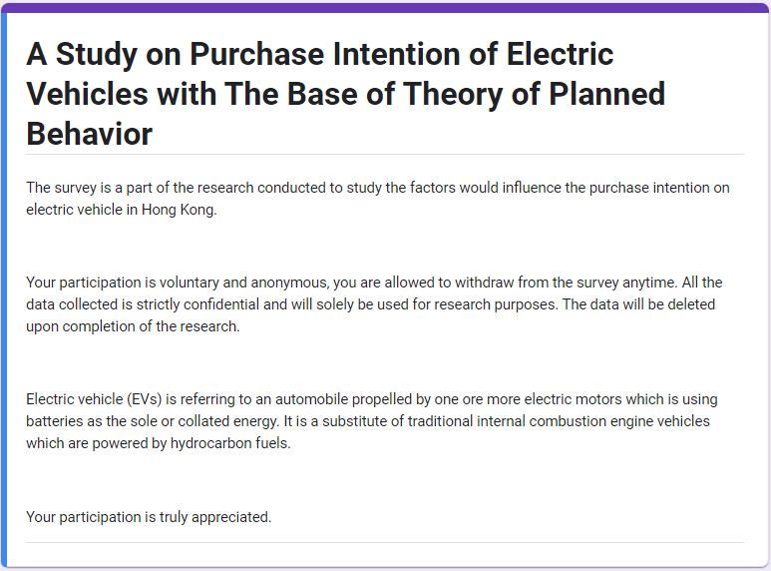
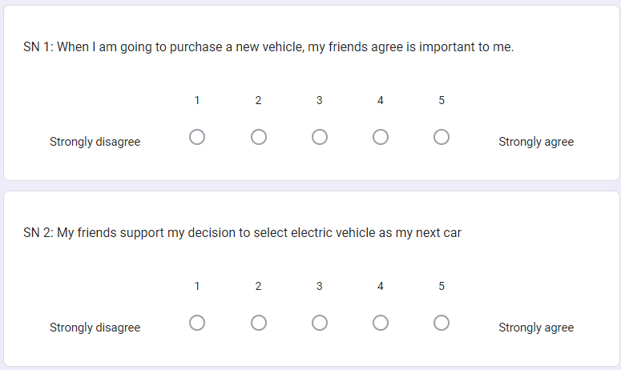

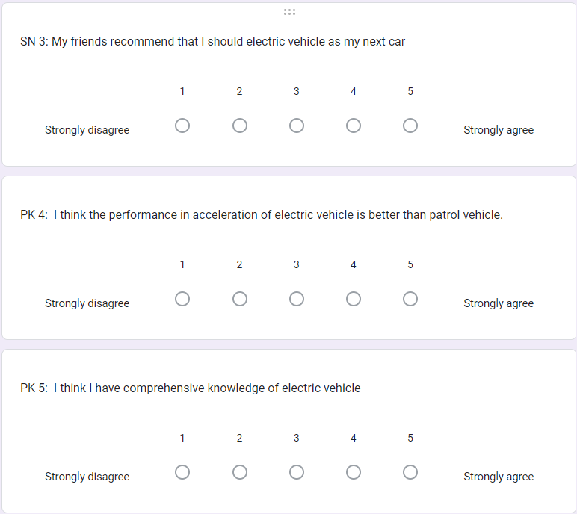
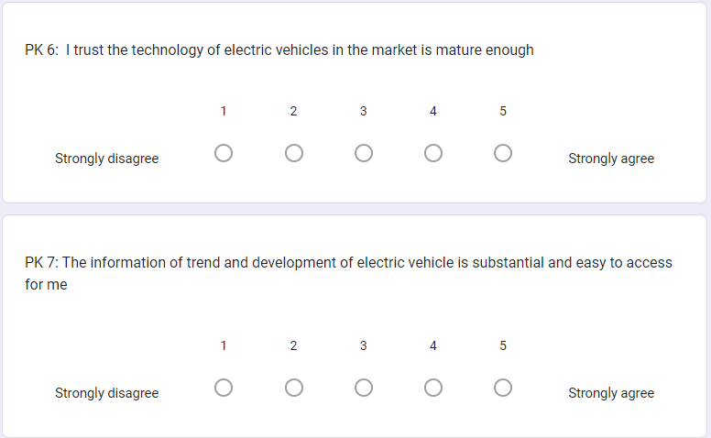

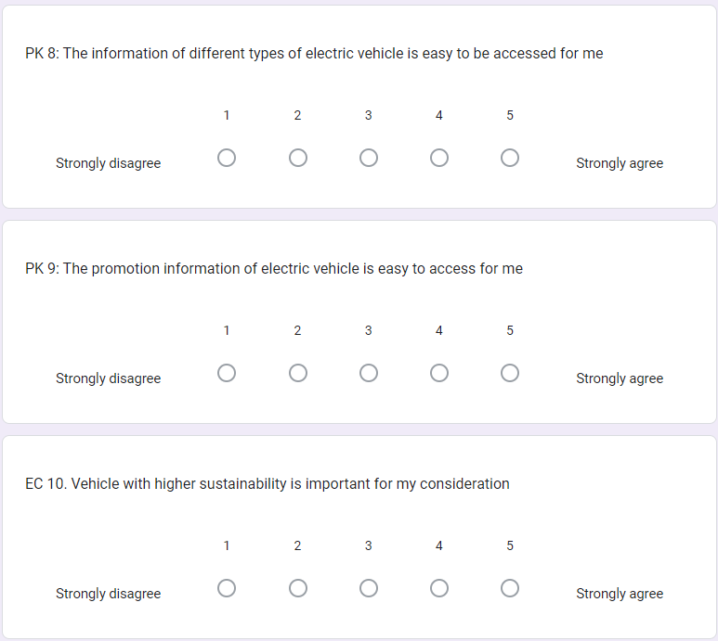
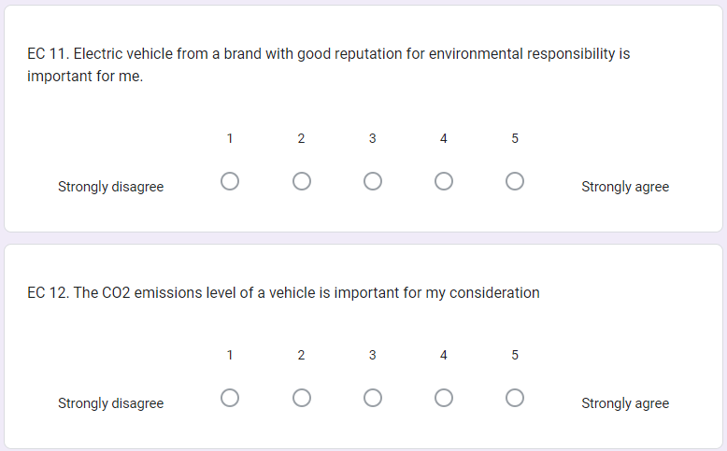

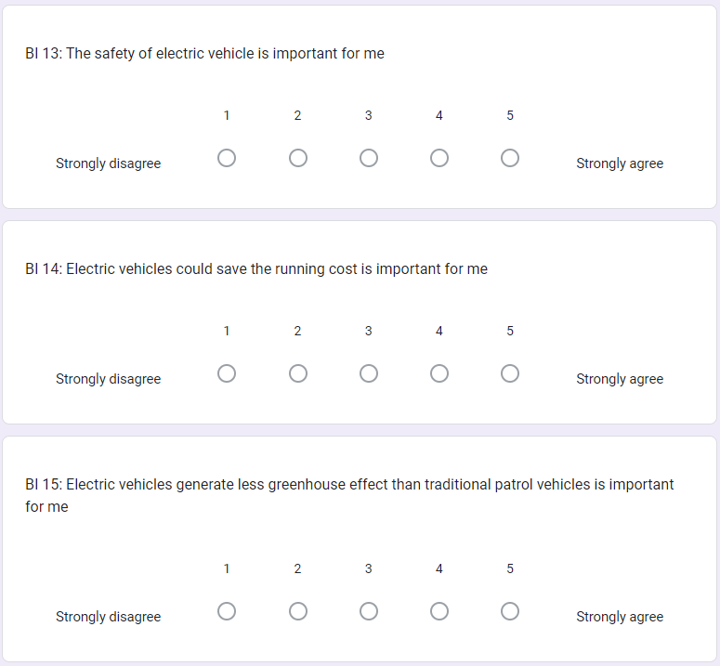
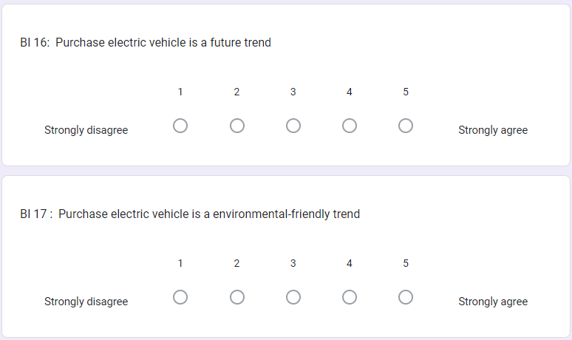

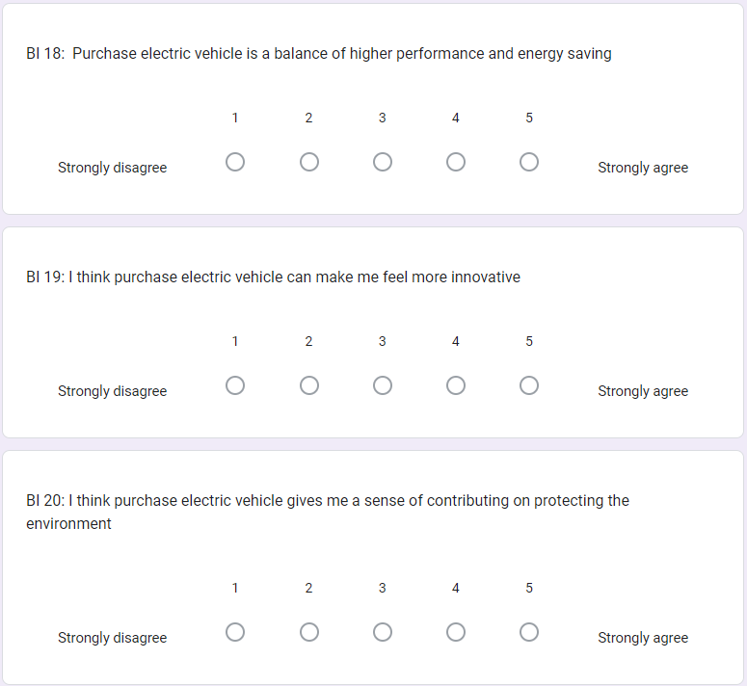
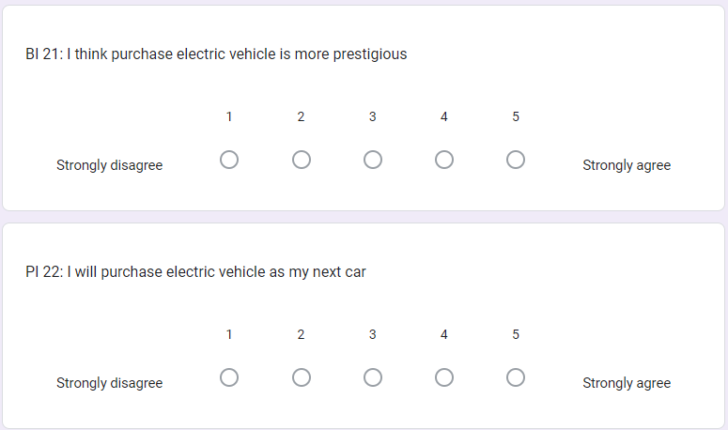

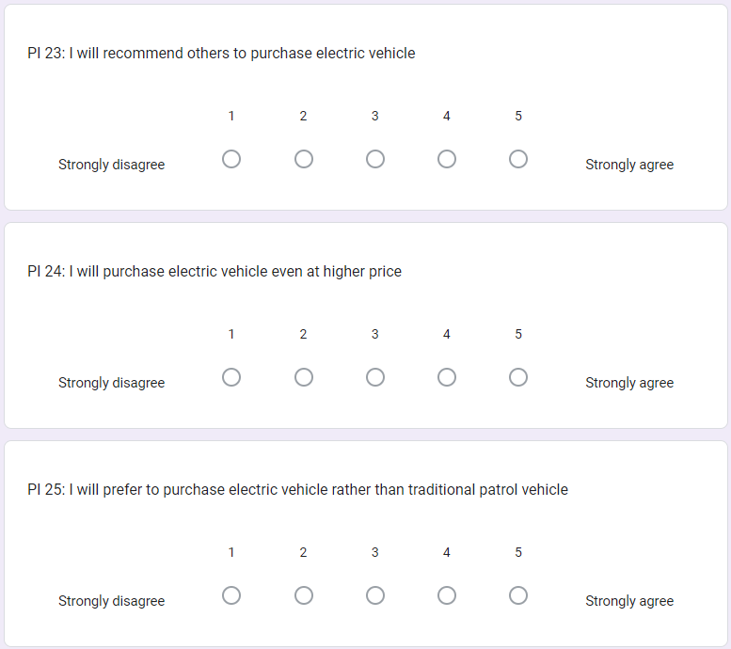



APPENDIX 2: SURVERY RESULT (SPSS)
- Descriptive Statistics
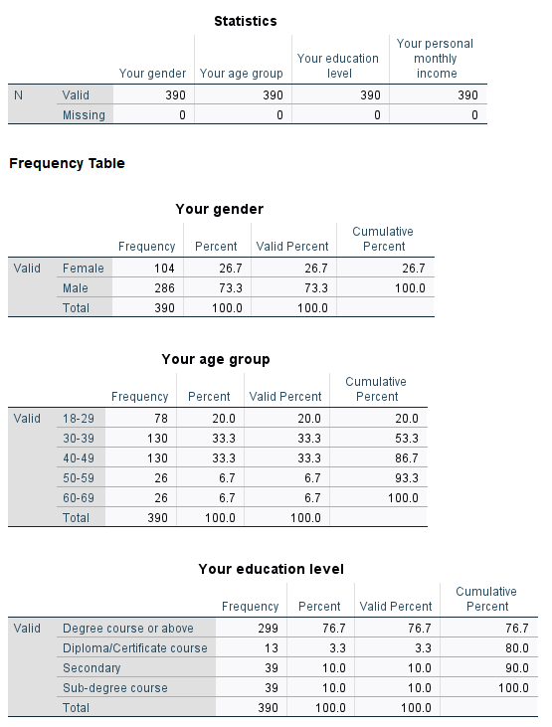

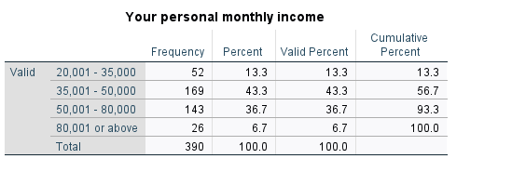
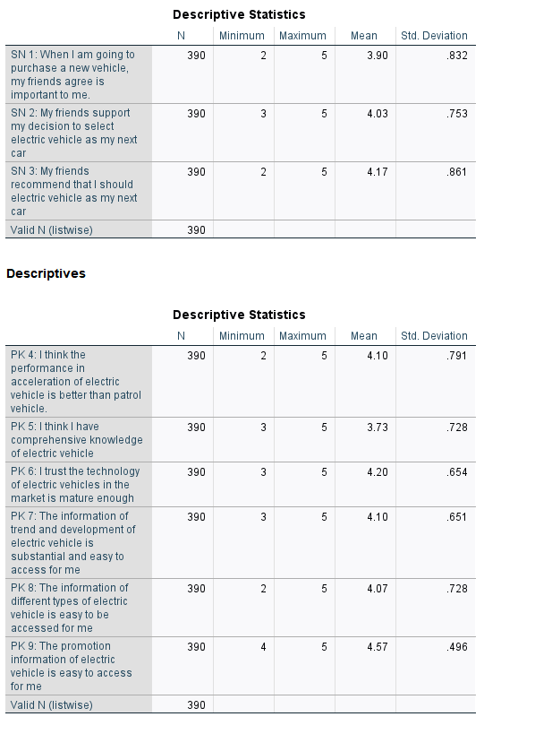
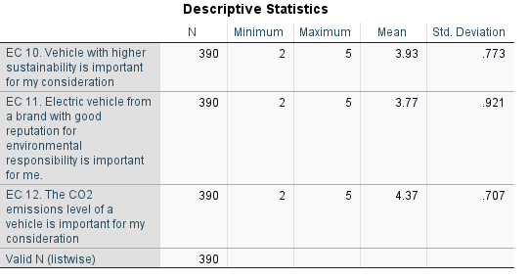
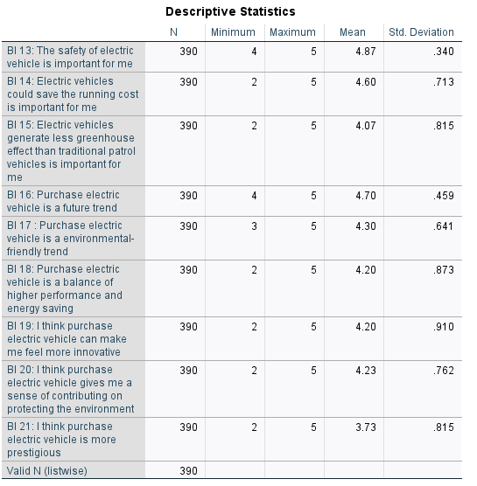

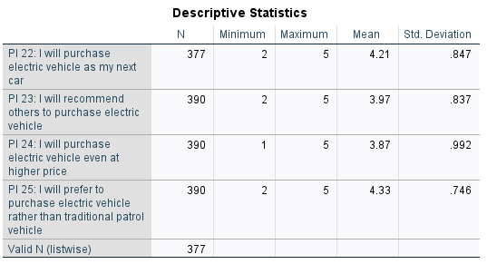

- Reliability test
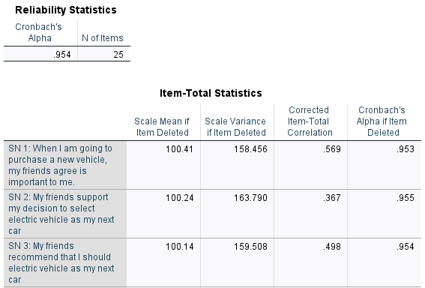

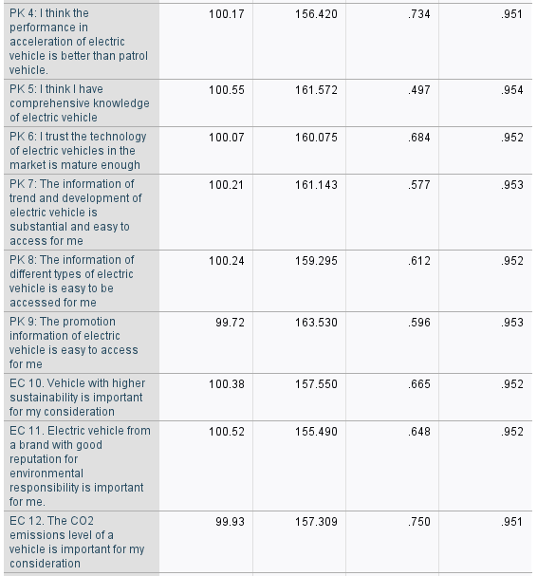

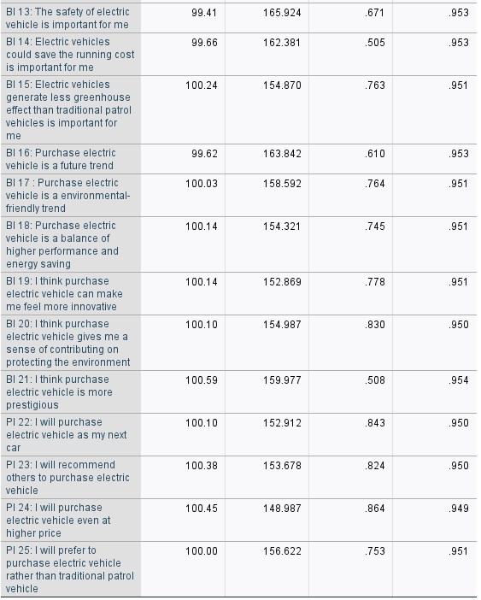

- Correlation analysis
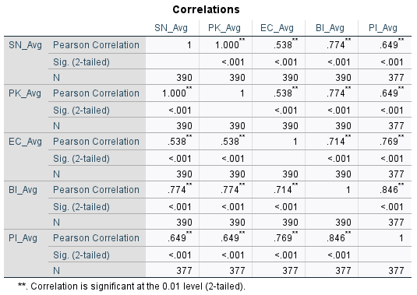
- Regression analysis


