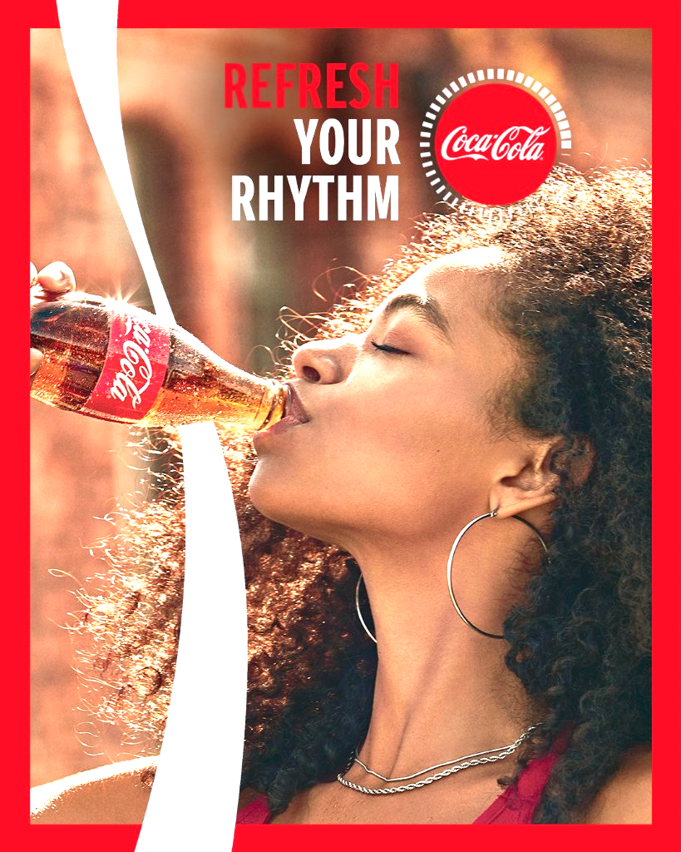  REPORT | MODULE: MBA MARKETING MANAGEMENT  LECTURER: TUSHERA BALENDRAN  STUDENT NAME/ID:  AKASHDEEP/2223250

Table of Contents
1 INTRODUCTION 2
2 COMPANY BACKGROUND 4
3 COMMUNICATION IN MARKETING PROCESS 5
3.1 Shannon and Weaver model of communication 6
3.2 Integrated Marketing Communication 8
4 ONLINE AND OFFLINE NEW PROMOTIONAL STRATEGY TO RAISE BRAND AWARENESS. 11
4.1 ONLINE 11
4.2 OFFLINE 13
5 BRAND EQUITY 14
5.1 Keller models 15
6 CUSTOMER JOURNEY MAP 19
6.1 PRE-PURCHASE STAGE: 21
6.2 DURING THE PURCHASE 21
6.3 POST PURCHASE STAGE 22
7 TOTAL ENGAGEMENT MODEL 23
8 RECOMMENDATIONS 25
9 CONCLUSION 26
10 REFERENCES 27

Table Of Figures
Figure 1 Shannon & Weaver Model of communication 7
Figure 2 IMC (Integrated Marketing Communication) model of communication by author 2023 9
Figure 3 Keller’s customer-based brand equity (CBBE) model at Coca-Cola made by author 2023. 16
Table 1 Source: Customer Journey Map of Coca-Cola by Mallory Michael………………………...20

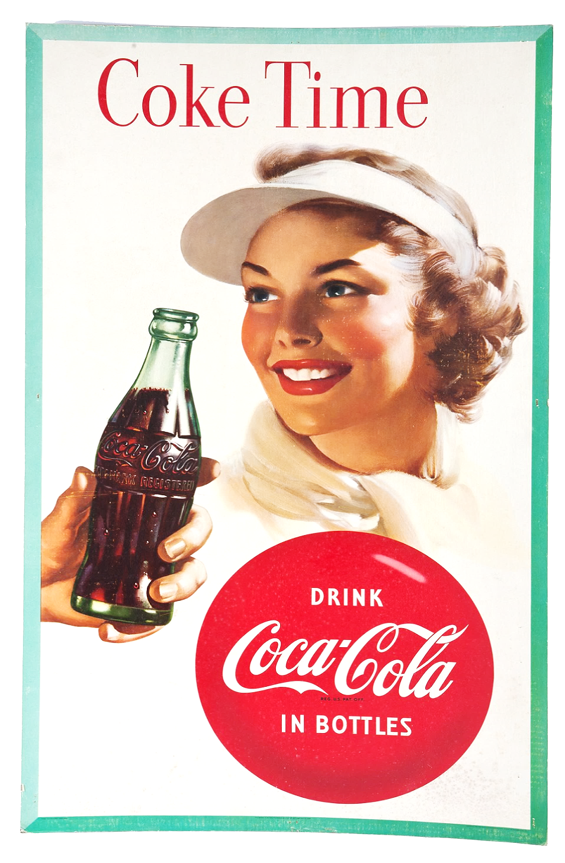
INTRODUCTION
The Coca-Cola Company (Coca-Cola is a world-renowned beverage brand that has a global presence and a rich history dating back to 1886. The company was founded by pharmacist Dr. John S. Pemberton in Atlanta, Georgia, USA, and has since become one of the most recognized and beloved brands around the world. Coca-Cola's flagship product, the Coca-Cola beverage, is a carbonated soft drink that is enjoyed by millions of people in over 200 countries.
Coca-Cola has established itself as a leader in the non-alcoholic beverage industry, with a diverse portfolio of brands that includes Diet Coke, Sprite, Fanta, Dasani, Powerade, and many more. The company is known for its innovative marketing strategies, iconic logo, and commitment to quality and customer satisfaction.
As a global brand, Coca-Cola operates in a complex and dynamic business environment, facing various challenges and opportunities. These include changing consumer preferences, evolving regulatory landscape, increasing competition, and growing demand for sustainable and healthier beverage options. (*Pemberton, John. “Overview of The Coca Cola Company.”*)
Coca-Cola Mission: To refresh the world, inspire moments of optimism and happiness, and create value and make a difference.
Coca-Cola's mission statement is centered around its commitment to refreshment and its belief that its products can inspire moments of happiness and optimism. The company aims to create value for its stakeholders and make a positive difference in the world through its business practices and community involvement.

Coca-Cola Vision: To become the world's leading beverage company, and to provide refreshment to everyone, anytime, anywhere.
Coca-Cola's vision statement is focused on its goal to become the world's leading beverage company. The company aims to provide refreshment to everyone, anytime, anywhere through its diverse portfolio of products and its commitment to innovation and sustainability.
(Cuofano, Gennaro. “Coca-Cola Mission Statement and Vision Statement in a Nutshell.”)

COMPANY BACKGROUND
Coca-Cola, one of the most iconic brands in the world, has a long and storied history dating back to the late 19th century. The origins of Coca-Cola can be traced back to 1886 when Atlanta-based pharmacist, Dr. John Pemberton, created a syrup that he believed could cure various ailments. Pemberton's syrup was made from coca leaves and kola nuts, both of which contained natural stimulants.
Pemberton initially sold his syrup as a medicine in local pharmacies, but it wasn't until he mixed it with carbonated water that he realized its true potential as a refreshing beverage. Pemberton's creation, which he named "Coca-Cola," quickly gained popularity, and he began selling it at soda fountains and drugstores throughout Atlanta.
In 1892, Pemberton sold the rights to Coca-Cola to Atlanta businessman Asa Griggs Candler, who was determined to turn the beverage into a global brand. Under Candler's leadership, Coca-Cola's marketing and distribution efforts expanded rapidly, and by the turn of the century, the company had become one of the most recognizable brands in the United States.
In the decades that followed, Coca-Cola continued to grow and innovate, introducing new products such as Sprite, Fanta, and Diet Coke, and expanding its operations to new markets around the world. The company's iconic red and white logo, which was created in 1887, has become one of the most recognizable symbols in the world, and the company's advertising campaigns have become legendary for their creativity and impact.
Over the years, Coca-Cola has faced several challenges and controversies, including accusations of contributing to obesity and other health problems due to its high sugar content. The company has responded to these criticisms by introducing new low- and no-sugar products and by promoting healthier lifestyles through its marketing campaigns. Despite these challenges, Coca-Cola remains one of the world's most valuable brands, with a presence in more than 200 countries and territories. Today, Coca-Cola continues to be a beloved and iconic brand that is synonymous with refreshment, happiness, and good times.

COMMUNICATION IN MARKETING PROCESS
Coca-Cola corporate communication aims to develop an effective internal and external structure of the communication system which is based on creating a friendly working for all the employees, free exchange of new ideas at all levels of management, and between employees and management external communication to Maintaining successful business relationships with stakeholders and consumers.
Coca-Cola is a beverage company that has become synonymous with the soft drink industry. Its marketing strategy is built around creating a strong brand image and building a deep emotional connection with customers. Communication is an essential component of the marketing process of Coca-Cola. In this essay, we will discuss the various communication channels that Coca-Cola uses to reach its target audience and convey its marketing message effectively. To do this, the administrator selects the messages sent on the intranet and controls who can access and comment on the message. In fact, today the media is the most important tool for conveying messages to customers.

Shannon and Weaver model of communication
The Shannon-Weaver model of communication is a mathematical model that was developed in 1949 by Claude Shannon and Warren Weaver. The model provides a framework for understanding the process of communication and is used in the field of communication studies.
When applied to Coca-Cola's communication strategy, the Shannon-Weaver model highlights several important factors that contribute to effective communication. The model consists of five basic elements: sender, message, channel, receiver, and feedback.

Message
Recipient (public, stake holder, shareholder)
Coca-Cola
(Messenger)

Advertising
Decoding of the message

Sales, Promotion
Publicity

Media

Figure 1 Shannon & Weaver Model of communication

- Sender: In the case of Coca-Cola, the sender is the company itself. Coca-Cola sends messages to its target audience through various channels such as television, social media, print advertisements, and sponsorships.
- Message: The message is the content that is being communicated by Coca-Cola. This could include information about the company, its products, or its marketing campaigns.
- Channel: The channel is the medium through which the message is transmitted from Coca-Cola to its target audience. Coca-Cola uses a variety of channels to communicate with its customers, including television, print media, social media, and events.
- Receiver: The receiver is the person or audience who receives the message from Coca-Cola. This could include consumers, stakeholders, or other interested parties.
- Feedback: Feedback is the response that Coca-Cola receives from its target audience. This could include comments, reactions, or actions taken by consumers in response to Coca-Cola's messages.
The Shannon-Weaver model of communication emphasizes the importance of clear and effective communication. In the case of Coca-Cola, this means developing messages that resonate with its target audience and using channels that are appropriate for reaching that audience. The model also highlights the importance of feedback, which can be used by Coca-Cola to refine its messaging and improve its communication strategy over time.
Overall, the Shannon-Weaver model provides a useful framework for understanding the process of communication and can be applied to a wide range of industries and contexts, including Coca-Cola's communication strategy. (Valentine, M. (2022, February 10). Coca-Cola claims revamped marketing model is already delivering 'strong results'.)

Integrated Marketing Communication
Integrated Marketing Communication (IMC) is a strategic approach that involves the coordination and integration of all marketing communication tools and tactics to deliver a consistent and compelling brand message to the target audience. Coca-Cola is a global beverage company that has been successful in implementing an integrated marketing communication strategy to build a strong brand image and connect with customers on an emotional level. In this essay, we will discuss the various components of Coca-Cola's integrated marketing communication strategy and how they work together to create a cohesive and effective marketing message.
“Coca-Cola Business Communication in Practice - 1947 Words: Report Example.” Free Essays, June 22, 2021

Figure 2 IMC (Integrated Marketing Communication) model of communication by author 2023

ONLINE AND OFFLINE NEW PROMOTIONAL STRATEGY
Coca-Cola is a globally recognized brand with a long-standing history of successful marketing campaigns. As a leading beverage company, Coca-Cola is constantly seeking innovative ways to promote its products and engage with consumers. In today's fast-paced digital world, it is crucial for Coca-Cola to leverage new online and offline promotional strategies to stay relevant and connect with its target audience.

ONLINE
In the digital age, online promotional strategies play a crucial role in reaching and engaging consumers. Here are some recommendations for new online promotional strategies for Coca-Cola:
- Social Media Gamification: Coca-Cola could develop gamified campaigns on social media platforms to drive consumer engagement. For example, they could create interactive games, quizzes, or challenges related to Coca-Cola products, and reward participants with discounts, coupons, or exclusive offers. This would not only increase brand awareness but also provide an entertaining and memorable experience for consumers, encouraging them to share and participate in the campaign.
- User-Generated Content Campaigns: Coca-Cola could encourage user-generated content (UGC) creation as part of its promotional strategies. They could run UGC campaigns, such as photo contests, video testimonials, or creative challenges, where consumers can showcase their experiences, stories, or creativity related to Coca-Cola. This would not only generate authentic content but also foster consumer engagement and advocacy, as consumers share their UGC on social media and other platforms.
- Influencer-Driven Campaigns: Coca-Cola could leverage influencer marketing as a new promotional strategy. They could collaborate with social media influencers who have a strong following among their target audience and align with Coca-Cola's brand values. These influencers could create sponsored content, such as product reviews, endorsements, or branded challenges, and share them on their social media platforms. This would help Coca-Cola to reach new audiences and leverage the influencers' influence and credibility to promote their products.
- Chatbot and AI-driven Promotions: Coca-Cola could implement chatbot and artificial intelligence (AI) technologies to create personalized and interactive promotions. They could develop chatbots on social media platforms or their website to engage with consumers, provide product recommendations, offer discounts or promotions, and collect consumer data for future marketing efforts. This would provide a seamless and personalized experience for consumers while allowing Coca-Cola to collect valuable consumer insights.
- E-commerce Promotions: Coca-Cola could develop targeted promotions for their e-commerce channels. For example, they could offer exclusive discounts, bundle deals, or limited time offers for consumers who purchase Coca-Cola products through their online store or other e-commerce platforms. They could also implement personalized promotions based on consumer purchasing behavior or preferences, using data-driven insights to deliver relevant and compelling offers to consumers, driving online sales and brand loyalty.

OFFLINE
Even in the digital era, offline promotional strategies still hold value in engaging consumers. Here are some recommendations for new offline promotional strategies for Coca-Cola:
- Experiential Marketing Events: Coca-Cola could create unique experiential marketing events to provide memorable brand experiences. For instance, they could organize pop-up events, product tastings, or brand activations in high-traffic areas, such as shopping malls, airports, or tourist spots. These events could feature interactive displays, sampling stations, or engaging activities related to Coca-Cola products, creating an immersive experience for consumers, and generating word-of-mouth marketing.
- Collaborations with Local Businesses: Coca-Cola could collaborate with local businesses to create co-branded promotions. For example, they could partner with local restaurants, cafes, or entertainment venues to create Coca-Cola-themed menus, promotions, or events. This would not only create buzz and excitement among consumers but also support local businesses and strengthen Coca-Cola's community engagement.
- Sponsorship and Events: Coca-Cola could leverage sponsorship and event marketing as a new offline promotional strategy. They could sponsor or participate in popular events, festivals, or sports tournaments to increase brand visibility and engage with consumers. For example, they could sponsor music festivals, sports events, or charity runs and create branded activations, sampling booths, or interactive experiences at these events. This would allow Coca-Cola to connect with their target audience in a meaningful way and associate their brand with positive experiences.
- Product Packaging Promotions: Coca-Cola could use innovative product packaging as a promotional strategy. They could create limited-edition packaging designs or collaborate with artists, designers, or influencers to create unique packaging designs that resonate with their target audience. These special packaging designs could create a sense of exclusivity, collectability, and uniqueness among consumers, driving product sales and brand loyalty.
- Localized Promotions: Coca-Cola could develop localized promotions to cater to regional or cultural preferences. They could create region-specific promotions, such as special edition flavors, packaging, or promotions that are tailored to the local taste preferences, cultural festivals, or traditions. This would show Coca-Cola's understanding and appreciation for local cultures and create a strong emotional connection with consumers in different regions.

BRAND EQUITY
Coca-Cola's brand equity is a result of many factors that have contributed to the brand's recognition, reputation, and trustworthiness. One of the primary drivers of brand equity for Coca-Cola is its brand identity, including its recognizable logo, color scheme, and messaging. The company has maintained consistency in its brand identity over time, making it easy for customers to recognize and associate with the brand.
Coca-Cola's reputation for quality is another key factor contributing to its brand equity. This consistency has helped to build trust with customers and has made Coca-Cola a household name.
Emotional connection with customers is also a significant contributor to Coca-Cola's brand equity. The company's marketing campaigns often focus on themes of happiness, togetherness, and enjoyment, tapping into universal human desires and emotions. This emotional connection can lead to strong brand loyalty and advocacy, as customers feel a deeper sense of attachment to the brand.

Keller models
The Keller Model, also known as the Customer-Based Brand Equity Model, is a framework that helps organizations to understand and manage the observations and associations that consumers have with their brand. The model was developed by marketing professor Kevin Keller and focuses on building strong brand equity by creating a positive brand image, strong brand awareness, and a strong brand reputation.
Coca-Cola is a firm that has successfully implemented the Keller Model in its marketing strategy. The company has worked hard to build a strong brand image through consistent messaging and branding across all its products and marketing channels. Coca-Cola's iconic red and white branding, its classic logo, and its recognizable tagline "Taste the Feeling" all contribute to the brand's strong image and recognition. The company has also invested heavily in building brand awareness through various marketing campaigns and initiatives. Coca-Cola's advertising campaigns, such as the "Share a Coke" campaign, have been highly successful in generating buzz and getting people talking about the brand. Additionally, the company has used sponsorships and partnerships with major events and organizations to increase visibility and build brand recognition. “In this way, and thanks to the high value of both brands, the most important adjectives related to the brand can be easily identified, as can be seen in the basement pyramid below:

Feelings: attachment, self-respect, family, and friends, sharing
Judgments: Leader, preference, brand identification
Performance: refreshment, energy, tasty, unique flavors
Imagery: happiness, moments, social and fun
Figure 3 Keller’s customer-based brand equity (CBBE) model at Coca-Cola made by author 2023.
Brand Salience: This refers to the degree to which a brand is recognized and recalled by customers. Coca-Cola has invested heavily in building strong brand salience through various marketing campaigns, sponsorships, and partnerships. For instance, the brand's iconic logo and red and white color scheme have become instantly recognizable across the world. Coca-Cola has also partnered with major events like the Olympics, World Cup, and Super Bowl, further enhancing its brand salience.
Brand Performance: This refers to how well the brand meets clients' functional needs. Coca-Cola has built a reputation for delivering consistent quality and taste across its products. The brand has also diversified its product portfolio to cater to different customer needs, including low-calorie and caffeine-free options. Additionally, Coca-Cola has implemented efficient distribution networks to ensure its products are readily available to customers.
Brand Imagery: This refers to the unique and favorable associations customers have with a brand. Coca-Cola has worked to build a strong brand imagery by associating its products with positive emotions like happiness, joy, and togetherness. The brand's iconic Christmas campaigns, featuring Santa Claus and the iconic "Holidays are Coming" ad, have become a cultural phenomenon and synonymous with the festive season. Coca-Cola has also used various celebrity endorsements and collaborations to reinforce its brand imagery.
Brand Judgments and Feelings: This component refers to the overall customer attitudes and perceptions towards the brand. Coca-Cola has built a strong emotional connection with its customers, which has resulted in a high level of brand loyalty. The brand has also implemented various customer engagement programs, including personalized packaging and interactive vending machines, to further enhance the customer experience.
Overall, Coca-Cola has successfully implemented Keller's CBBE model to build a strong and valuable brand. By focusing on brand salience, performance, imagery, and judgments and feelings, Coca-Cola has been able to drive consumer behavior and business outcomes. The brand has become an integral part of popular culture and continues to innovate and adapt to changing customer needs and preferences.
Advantages of Keller’s model
- Comprehensive: Keller's model provides a comprehensive framework for analyzing the various dimensions of brand equity, including brand salience, brand performance, brand imagery, brand judgments, brand feelings, and brand resonance. This makes it easier for companies like Coca-Cola to understand the drivers of brand equity and develop effective marketing strategies.
- Customer-focused: Keller's model emphasizes the importance of understanding and meeting the needs and expectations of customers. By focusing on the customer's perspective, companies like Coca-Cola can build stronger relationships with consumers and create a more loyal customer base.
- Measurable: Keller's model provides a structured and systematic way to measure the strength of brand equity. This can help companies like Coca-Cola to track changes in brand equity over time and identify areas for improvement.
Disadvantages of Keller’s model:
- Complex: Keller's model can be complex and difficult to understand, especially for companies that are new to the concept of brand equity. This can make it challenging to implement and apply in practice.
- Resource-intensive: Implementing Keller's model requires significant time and resources, including market research, data analysis, and brand management. This can be a significant investment for companies like Coca-Cola.
- Limited applicability: Keller's model may not be suitable for all types of brands or industries. The model is best suited for consumer brands and may not be as relevant for business-to-business (B2B) brands or other types of products or services.
Overall, Keller's model of brand equity can provide valuable insights for companies like Coca-Cola looking to strengthen their brand and improve their marketing efforts. However, it is important to consider the potential advantages and disadvantages of the model and determine whether it is the best fit for a particular brand or industry.

CUSTOMER JOURNEY MAP
The Customer Journey Map is a tool for visualizing the brand experience from the customer's point of view. This map is important because it forces the company to look at how their customers perceive the brand, not what it really is. The customer experience futurist: "You have to invest to become an experienced company, which means that optimizes every customer touch point." By understanding the customer journey, B2B Companies that stay one step ahead of customers guide them along the path to an exceptional experience and a quality product or service. “The foundation of successful relationships between a successful business and consumers are empathizing with customers' wants and needs. By creating a customer journey map, you can learn more about potential and current customers. This comprehensive picture will help you get a better return on your business' marketing spend and enable your entire business to better engage with prospects and consumers.
Michaelis, Mallory. “Creating a Better Omni-Channel Experience.” customer journey map, 2022
Table 1 Source: Customer Journey Map of Coca-Cola by Mallory Michael
Stages | Awareness | Discovery | creative | Logging | Earning | Sharing
Thinking | Cool a Coca-Cola app!  There’re other enthusiasts like me!” | “Oh, that’s far!”  “This would pair well with a meal” | “How do I save my mix?”  “Why can’t I add-ons separately?” | “Is my mix is saved for next time?” | “There is no reward at this location.”  “I want the points” | “Where is the coke community?”  “Why would I share this on Facebook?”
Doing | Download app | find nearest location | explore trends | Mix flavors | Collect rewards | Share mix to social media
Feeling |  |  |  |  |  | 
opportunity |  |  | Increase incentives for creation | Localization |  | Strengthen community

PRE-PURCHASE STAGE:
According to the map, the initial stage of the customer journey is awareness. In this stage, potential customers become aware of Coca-Cola through various channels such as advertising, social media, or word-of-mouth. For example, a person may see a Coca-Cola advertisement on TV or social media. The main problem is solved, how to buy a cosmetic product for allergy sufferers. Since consumers have already tried many cosmetics and spent money on previous cosmetics due to allergies and skin irritations to most perfumes, they end up not using them at all. As a customer, I pay attention to product design, brand reputation, attractive shopping, and delivery options. Before purchasing the product, I looked for alternative products in the price comparison, visited several online shops, read consumer reviews, read ingredient information, called shop hotlines, and even visited a few shops to test.

DURING THE PURCHASE
Once the customer becomes aware of Coca-Cola and its products, the next stage is the purchase decision. In this stage, the customer evaluates the different options available in the market and decides which product to buy. Coca-Cola has a expansive range of products, including carbonated drinks, juices, and water, to cater to the diverse needs of its customers. The company uses various marketing strategies to influence the customer's decision. For example, Coca-Cola has introduced various packaging sizes to cater to the different needs of its customers. The company has also introduced personalized bottles and cans that allow customers to customize their drinks with their names or messages. The customer has expressed his opinion or made a comment over the phone face book based on valuable information, Coca-Cola has developed or improved new product sold products that can satisfy a wide range of customers or any group of customers.
For example, light cola for diabetics or overweight people. Coca-Cola can develop mobile apps or loyalty programs to incentivize repeat purchases and foster customer loyalty. For example, they can offer exclusive discounts or rewards for customers who download and use their mobile app or participate in their loyalty program. For example, Coca-Cola can send out post-purchase surveys to gather feedback from consumers about their experience with their products. This can help identify areas for improvement and address any concerns, showing that Coca-Cola values customer feedback and is committed to providing a positive experience.

POST PURCHASE STAGE
The final stage of the customer journey is retention and advocacy. The retention tactic started when customers wanted to leave the system based on a continuous period. However, over the past nine months, the company has rolled out more AI to try to detect when customers are slacking off. When they find that moment, they make the client an offer that makes it easier and more enjoyable to stay engaged and active. The retention tactic started when customers wanted to leave the system based on a continuous period. Coca-Cola invests in creating a memorable customer experience that inspires customers to share their positive experiences with others. The company also uses social media and influencer marketing to encourage customers to share their experiences and promote the brand to their networks. Coca-Cola can send out personalized offers or promotions to customers who have made a purchase in the past, to encourage repeat purchases and foster customer loyalty. For example, they can send out exclusive discounts or rewards to customers who have purchased Coca-Cola products multiple times within a certain time frame.
Michaelis, Mallory. “Creating a Better Omni-Channel Experience.” customer journey map

TOTAL ENGAGEMENT MODEL
The Total Engagement Model of Coca-Cola is a marketing strategy that focuses on engaging customers through various touchpoints, with the aim of creating a loyal customer base.
- Corporate Culture: Corporate culture refers to the shared values, beliefs, norms, and practices that shape the behavior and mindset of employees within an organization. Coca-Cola's corporate culture plays a crucial role in shaping its brand identity and customer experience. Coca-Cola has a long-standing culture of promoting happiness, togetherness, and enjoyment through its products. This culture is reflected in its marketing campaigns, messaging, and overall brand image.
- The Brand: Coca-Cola is one of the most important and iconic products in the world. Its brand image is built on a foundation of trust, reliability, and emotional connection with consumers. Coca-Cola's brand is characterized by its red color, iconic logo, and memorable tagline "Taste the Feeling." The brand is associated with positive emotions, social gatherings, and moments of joy, which creates a strong emotional bond with consumers. Coca-Cola's brand is consistently communicated through various touchpoints, including packaging, advertising, sponsorships, and social media, to reinforce its brand identity and engage with consumers.
- Customer Value Proposition: Coca-Cola's customer value proposition is centered on providing refreshment, enjoyment, and satisfaction to its consumers. Coca-Cola positions itself as a premium beverage brand that offers a wide range of refreshing and delicious options to quench consumers' thirst and elevate their experience. Coca-Cola focuses on delivering consistent taste and quality across its product portfolio, while also offering a variety of flavors, packaging sizes, and formats to cater to diverse consumer preferences.
- Customer Experience: Customer experience refers to the overall impression and perception that consumers have about a brand based on their interactions and touchpoints with the brand. Coca-Cola strives to create a positive and memorable customer experience at every stage of the customer journey, from awareness and consideration to purchase and post-purchase. Coca-Cola's customer experience is shaped by its marketing strategies, product quality, packaging, in-store displays, customer service, and digital engagement.
Coca-Cola has implemented several initiatives to enhance customer experience, such as:
- Product Innovation: Coca-Cola continuously introduces new flavors, packaging sizes, and formats to keep its product portfolio fresh and relevant to changing consumer preferences.
- Personalization: Coca-Cola has launched various personalized marketing works, such as the "Share a Coke" campaign, which allows consumers to customize Coke bottles with their names or messages, creating a sense of personal connection and engagement.
- Digital Engagement: Coca-Cola leverages digital platforms which including social media, mobile apps, and e-commerce, to engage with consumers, share brand stories, and offer exclusive promotions or rewards.
- Coca-Cola also prioritizes customer feedback, actively listening to consumers' opinions, concerns, and suggestions, and incorporating them into their business decisions and strategies. This customer-centric approach helps Coca-Cola to continually improve its products, services, and overall customer experience.
How Coca Cola conquered marketing over multiple new customer touch points | Reuters Events | Marketing. (n.d.). Retrieved April 19, 2023, from

RECOMMENDATIONS
Based on the analysis of Coca-Cola's marketing strategies and customer engagement models, the following recommendations can be made:
- Expand the use of digital marketing: Coca-Cola should continue to invest in digital marketing strategies to engage with customers online. This could include creating more interactive social media campaigns and partnering with popular influencers to promote the brand.
- Focus on sustainability: Coca-Cola should prioritize sustainability in all aspects of its business, from packaging to manufacturing processes. This will help the company appeal to socially conscious consumers and build a positive brand image.
- Enhance customer experiences: Coca-Cola should continue to focus on creating memorable customer experiences through interactive promotions, events, and other touchpoints. This will help to increase customer loyalty and advocacy.
- Innovate new products: Coca-Cola should explore opportunities to expand its product offerings and develop new flavors or variations of its existing products to stay competitive in the market.
- Build partnerships: Coca-Cola should continue to build partnerships with other brands, organizations, and communities to enhance its brand image and engage with new customer segments. This could include collaborating with sports teams, charities, or other companies with similar values.
Overall, Coca-Cola should continue to focus on building strong customer relationships through innovative marketing strategies, sustainability initiatives, and partnerships while staying true to its brand identity and values.

CONCLUSION

Coca-Cola is a global brand that has maintained its position as a market leader in the beverage industry. The success of the company can be attributed to its strong brand identity, innovative marketing strategies, and commitment to sustainability.
Throughout this report, we have analyzed the company's history, business model, marketing strategies, and new promotional strategies to raise brand awareness. We have also highlighted the pros and cons of the Keller model and the Shannon and Weaver model of communication in the context of Coca-Cola. We have seen that Coca-Cola has evolved its marketing strategies to stay relevant in today's dynamic market. The company has embraced digital technology and social media to connect with consumers and create brand awareness. At the same time, it has maintained its offline presence by sponsoring events, distributing product samples, and creating branded merchandise. In terms of sustainability, Coca-Cola has implemented various initiatives to reduce its environmental footprint and support local communities. The company's commitment to sustainability is not only ethical but also helps to strengthen its brand reputation.
Overall, Coca-Cola's success can be recognized to its strong brand identity, innovative marketing strategies, commitment to sustainability, and ability to adapt to changing market trends. With a continued focus on these key areas, Coca-Cola is well-positioned for long-term success and continued growth in the global beverage industry.

REFERENCES
Pemberton, John. “Overview of The Coca Cola Company.” 1548 Words | 123 Help Me, April 30, 2021. https://www.123helpme.com/essay/Overview-of-the-Coca-Cola-Company-383470.
Cuofano, Gennaro. “Coca-Cola Mission Statement and Vision Statement in a Nutshell.” FourWeekMBA. What is The FourWeekMBA, February 15, 2023. https://fourweekmba.com/coca-cola-vision-statement-mission-statement/.
Valentine, M. (2022, February 10). Coca-Cola claims revamped marketing model is already delivering 'strong results'. Marketing Week. Retrieved April 19, 2023, from https://www.marketingweek.com/coca-cola-marketing-model/
Nganga, Carol. “Coca-Cola Company. History, SWOT Analysis, Marketing Strategies.” GRIN, September 7, 2014. https://www.grin.com/document/280535.
Conover, Theodore. “Coca-Cola Business Communication in Practice - 1947 Words: Report Example.” Free Essays, June 22, 2021. https://ivypanda.com/essays/coca-cola-business-communication-in-practice/.
Angelica And Mrithula, Post author By. “Coca-Cola: Current Marketing Communications Strategy.” Global Marketing Professor, May 27, 2019. https://globalmarketingprofessor.com/coca-cola-current-marketing-communications-strategy/.
Jain, Sorav. “Case Study- Coca-Cola's Digital Marketing Strategies [PDF/PPT].” India's First Agency Styled Digital Marketing Training Institute, November 24, 2022. https://digitalscholar.in/coca-colas-digital-marketing-strategies/#coca-colas-digital-marketing-strategies.
Lauren, Kathey. “25 Ingenious Offline Marketing Examples.” Bizzabo, December 13, 2022. https://www.bizzabo.com/blog/offline-marketing-examples/.
Forbes, Jain. “Mktg2508 Coca-Cola Brand Resonance Pyramid - Coca-Cola Brand Resonance Pyramid Coca-Cola Has Equally.” Studocu, March 20, 2019. https://www.studocu.com/en-au/document/university-of-queensland/brand-management-and-strategy/mktg2508-coca-cola-brand-resonance-pyramid/7423994.
Sushmith, Rakhan. “Coca Cola Marketing Strategy - A Case Study of 2022.” Sprintzeal.com. Sprintzeal Americas Inc, November 7, 2022. https://www.sprintzeal.com/blog/coca-cola-marketing-strategy
Michaelis, Mallory. “Creating a Better Omni-Channel Experience.” customer journey map, 2022. https://www.mallorymichaelis.me/bridging-the-physical-and-digital-world.
The Coca-Cola Company's purpose is to refresh the world and make a difference. Our Approach to Stakeholder Engagement and Research | The Coca-Cola Company. (n.d.). Retrieved April 19, 2023, from https://www.coca-colacompany.com/policies-and-practices/transparency.html
batheoriesBATheories.com is managed by a group of educators from Mumbai. We also manage the website StudyMumbai.com. Our panel includes experienced professionals and lecturers with a background in management. BATheories is where we talk about the various. (2022, May 30). Keller's Brand Equity Model (CBBE model). BA Theories (Business Administration & Management). Retrieved April 19, 2023, from https://www.batheories.com/kellers-brand-equity-model/
Brand marketing. How Coca Cola conquered marketing over multiple new customer touchpoints | Reuters Events | Marketing. (n.d.). Retrieved April 19, 2023, from https://www.reutersevents.com/marketing/brand-marketing/how-coca-cola-conquered-marketing-over-multiple-new-customer-touchpoints

