Student Name: Svetlana Dimitrova
Student Number: 1714890
Module Number: BMSK 4003
Module Title: Digital Skills and Research Methods
Lecturer Name: Mr. Balan Kandasamy

Content Page
Importance of the technology in business 3
Effective use of the technology 4
Comparing two different cloud storage services 5
Comparing two devices 6
Explore social media as a tool for marketing information gathering and communication within the workplace 6
Evidence of my online presence 8
Reference page 11

Importance of the technology in business

“Technology is a body of knowledge devoted to creating tools, processing actions and the extracting of materials. The term ‘Technology” is wide, and everyone has their way of understanding its meaning. We use technology to accomplish various tasks in our daily lives, in brief; we can describe technology as products and processes used to simplify our daily lives. We use technology to extend our abilities, making people the most crucial part of any technological system.
Technology is also an application of science used to solve problems. But it is vital to know that technology and science are different subjects which work hand-in-hand to accomplish specific tasks or solve problems.” (1)
Technology is an important part of any business despite of how big or small it is. Technology allows better communication with the customers as it enable employees to interact with clients in the fastest and most efficient way possible (e.g. Through an online customer service chat). Technology enables the business to have a website in which the clients can find answers to their questions, buy products or perform other tasks depending on the type of business.
Technology is also used to store documents and perform calculations such as cash flow needs for example. This allows the company to save physical space as all documents would be stored electronically and save time and money as it would allow the management processes to be performed quicker and more efficiently.
Technology also allows the use of tools such as cloud services. For example, a business can use cloud storage to back up their files. It can also use it to share files and applications as well as online collaborations over a project over which a few people can work at the same time over the internet.
Social media websites are also an important aspect of business as they can be used to advertise the business, to communicate with clients and employees to communicate with each other without the need of being at the same physical location. This allows the company and their employees to save time and money as they won’t be required to constantly be at the same place together.

Effective use of the technology

We cannot imagine our lives without technology. Modern business is impossible without a working computer and internet advertising. New technologies are entering fast because they meet the people needs. They allow people not only to feel more comfortable working with them, but also to be more flexible. The technologies which the staff use to do their jobs are wide range from applications, emails, instant messaging, enterprise social media tools to portals. Information systems store a wide variety of information about people, events, territories and many other things, both from the environment and within the organization itself. They prepare and provide user-friendly information to assist managers and employees of various business organizations in solving current problems or in making ongoing decisions. They use computer technology to carry out the maximum amount of input, processing, and output operations.
The importance of SD cards and built-in memory in the devices is getting weaker due to cloud storage services that give users much more power. In only a few years, cloud services have become the most important computer technology for our lives. The cloud has become a place where everyone wants to store information - not only temporarily but also permanently.
“Cloud storage is a cloud computing model in which data is stored on remote servers accessed from the internet, or "cloud." It is maintained, operated and managed by a cloud storage service provider on a storage server that are built on virtualization techniques.” (2)
“OneDrive integrates with Microsoft Office, so users can access Word, Excel and PowerPoint documents in OneDrive. The system allows users to simultaneously edit Office documents, edit documents in browsers, and create and share folders. OneDrive also offers Facebook integration, automatic camera roll backup and the ability for users to email slide shows.” (3)
OneDrive is an online storage where we can share and keep safely documents, photos and different kind of files from our devices
Google Drive is a free cloud-based storage service that enables users to store and access files online. The service syncs stored documents, photos and more across all of the user's devices, including mobile devices, tablets and PCs.

“Google Drive integrates with the company's other services and systems -- including Google Docs, Gmail, Android, Chrome, YouTube, Google Analytics and Google+. Google Drive competes with Microsoft OneDrive, Apple iCloud, Box, Dropbox and Sugar Sync. “ (4)
Google Drive is a free online storage service that allows users to store and access files online. The service syncs stored documents, photos and any files across mobile devices, tablets and PCs.

Comparing two different cloud storage services
################ | OneDrive Free | OneDrive Paid | Google Drive Free | Google One
Storage Space | Up to 5GB | Up to 50GB | Up to 15GB | Up to 200GB
Price | FREE | £18/mo | FREE | £2.49/mo
Benefits | Comes with office 365, faster file sharing and synchronization | Comes with office 365, faster files sharing and synchronization | More cloud applications and better security | More cloud applications and better security
(5); (6)

Comparing OneDrive free version against the Google Drive free version we can see that OneDrive allows only up to 5GB storage space while Google Drive allows up to 15GB. Although Google Drive provides more free storage space it lacks some features such as fast file sharing and fast synchronization, but it provides more cloud applications and better security which is important for a business as they might be storing important and confidential information.
Comparing the paid versions of the two we can see that OneDrive overtakes with its faster file sharing and synchronization features while Google Drive allows the use of more applications and better security. One Drive allows up to 50GB of storage space for the price of £18/mo while Google Drive allows more storage on a lower price 200GB for £2.49/mo.
Looking at both cloud storage providers I think that Google Drive is the better option for a business as it provides bigger storage space on lower prices and better security. This is important for a business as they will be able to save more money and have more storage while also storing sensitive information without the risk of getting hacked.

Comparing two devices
############## | Samsung Galaxy S9 | iPhone X
Release Date | February 2018 | September 2017
Screen | 5.8-inch Super AMOLED - 2960 x 1440 (570ppi) | 5.8-inch OLED - 2436 x 1125 (458ppi)
Rear Camera | 12-megapixel | 12-megapixel wide-angle
Front Camera | 8-megapixel | 7-megapixel
Chipset | Qualcomm Snapdragon 845 | Apple A11 Bionic
RAM | 4GB | 3GB
Storage space | 64/256GB | 64/256GB
Battery | 3000mAh | 2716mAh
Finger print scanner | YES | NO
Price | £500 | £650

Looking at the specs of the two devices, I would recommend the Samsung Galaxy S9 as it uses a slightly better screen with higher display resolution (2960 x 1440 (570ppi)), better front camera with 8-megapixels compared to the 7-megapixel camera of the iPhone. The rear camera of the S9 is not as good as the rear camera of the iPhone as it has 12-megapixel wide-angle camera while the S9 doesn’t have the wide-angle camera feature but that doesn’t affect my choice as much, as it’s still has a 12-megapixel camera which produces great quality images. The Samsung phone also outruns the iPhone as it uses a better chipset (Qualcomm Snapdragon 845) and RAM of 4GB while the iPhone has only 3GB of RAM. The Galaxy S9 has higher battery live of 3000mAh and has a finger print scanner built in. While on the other hand the iPhone has lower battery live of 2716mAh and has no finger print scanner. The Samsung phone is also cheaper as it’s priced around the £500 mark while the iPhone sells for as much as £650.

Explore social media as a tool for marketing information gathering and communication within the workplace

Social media greatly change the way of interaction between businesses and their customers. They stand out as a powerful tool through which a significant number of users can be reached for free, regardless of the size of the firm and its economic power. Opportunities to explore user preferences and recruit great amount of custom profile information about needs, interests, values, and persuading potential buyers - with a much lower cost of money, time and effort different marketing studies are presented in the social network. Making fast and quality communication with customers, business partners, suppliers and staff. Using social media as a platform for online transactions and increase income - trader can successfully sell. Retails can have an e-shop built into the social site using an application for integration into the social site. Social networks reveal opportunities to expand company activity and increase its efficiency. Social commerce seems to be moving at a faster rate than anything we have seen in recent years, and while social networks also continue to grow, the potential income base will continue to increase. Creating an e-shop reduces staff expensive by automating almost all sales activities. The well-developed e-shop offers much easier access to any item than is possible in traditional shops. The company can sell around the world with a single online store. The development of Internet sales allows to find new customers, suppliers or partners anywhere in the world and puts a small store on equal terms with large retail chains.
No doubt Facebook is one of the most popular and influential social media that connects the world. Every second person has a Facebook profile. Facebook is a platform to share for many people in terms of photos, interests, news and more. You can enjoy games, get invitations to events, and many other interesting things. All this is at your disposal. Gradually, Facebook has become a mini industry. Nowadays, without any hesitation, we can say that besides a successful means of communicating with friends and family, this social media is an indispensable marketing and business tool. Facebook pages dedicated to different brands, stores, online business companies, small, independent businesses, and more. These pages increase the number of fans by using various promotional techniques such as games, competitions, attractive offers and discounts. This is useful not only for promoting the business, but also for creating a true group of clients. Many small businesses use Facebook to promote their products. This helps them reach a wider audience almost for free. Social media is an extremely important business tool ... photos, descriptions, clips - all can be uploaded and shared on Facebook. It is also useful as you can get feedback and customer feedback.



Evidence of my online presence
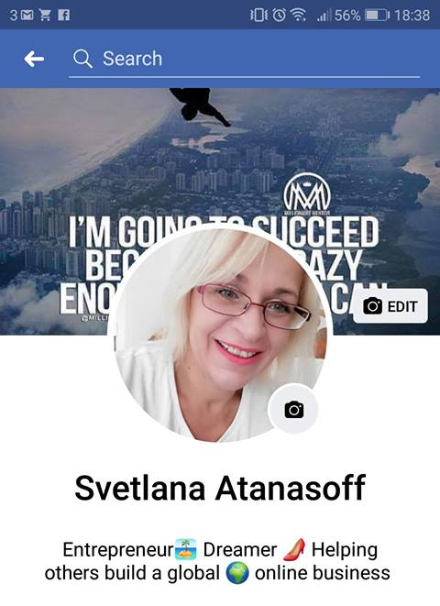
https://www.facebook.com/alena.dimitrova.3
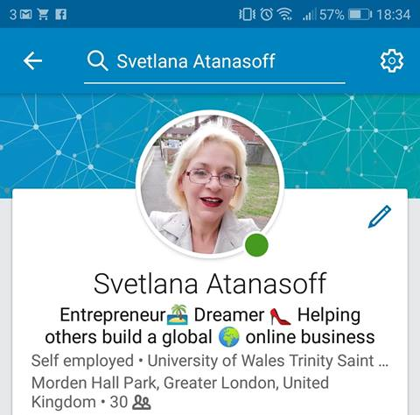
https://www.linkedin.com/in/svetlana-atanasoff-719566172?fbclid=IwAR3LEXi4oFx3NR61MBFGbB_xDE1cwLEZbEjtB0nYWbylO0ufRU4FstBFyrI

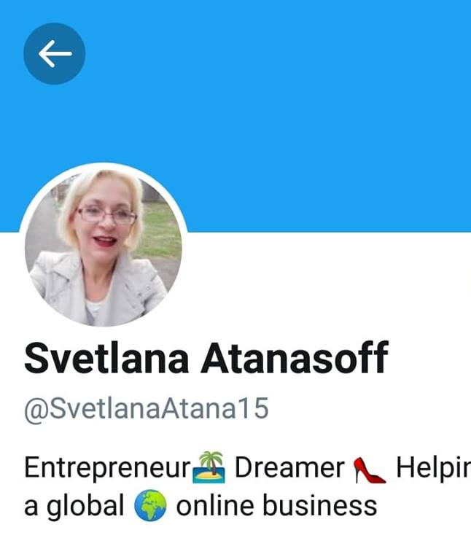

https://twitter.com/SvetlanaAtana15?s=07&fbclid=IwAR0m7zfVrzfvcR_Ka3Dze11POEnV5jZBv4QkRfn0mVpmqH1HMxl7PZhglmU

Reference page

- https://www.useoftechnology.com/what-is-technology
- https://www.techopedia.com/definition/26535/cloud-storage
- https://searchmobilecomputing.techtarget.com/definition/Microsoft-OneDrive
- https://searchmobilecomputing.techtarget.com/definition/Google-Drive
- https://onedrive.live.com/about/en-hk/plans/
- https://one.google.com/storage

