albert Education Partnership:
Student Toolkit Guide

Introduction

The albert student toolkit is an online toolkit in which your students will be able to create carbon footprints for Assessment 3 of the module, and where you will be able to assess them. This is a toolkit based off of albert’s industry one and will prepare your students for the process almost all major UK broadcasters mandate. Please note: this toolkit is separate from the industry toolkit, and only offer the carbon footprint tool (it does not feature the Carbon Action Plan tool).

Using the Student Toolkit

Once your students have accessed their user accounts, they can start creating productions and footprints.

Creating a production
- Once logged in, click the PRODUCTIONS tab at the top of the page
- Click the ADD NEW button on the top right hand side of the page
- Fill in the starred fields (e.g. production name, genre, production method etc)
Please note: if unsure of any category, please input the option that is closest to your production
- The reviewer field should automatically fill with the name of the course leader who will be assessing the footprint, but you can amend this is need be by inputting the name of the tutor
Please note: only tutors with permissions for the course the student is logging into will be able to be input as reviewers

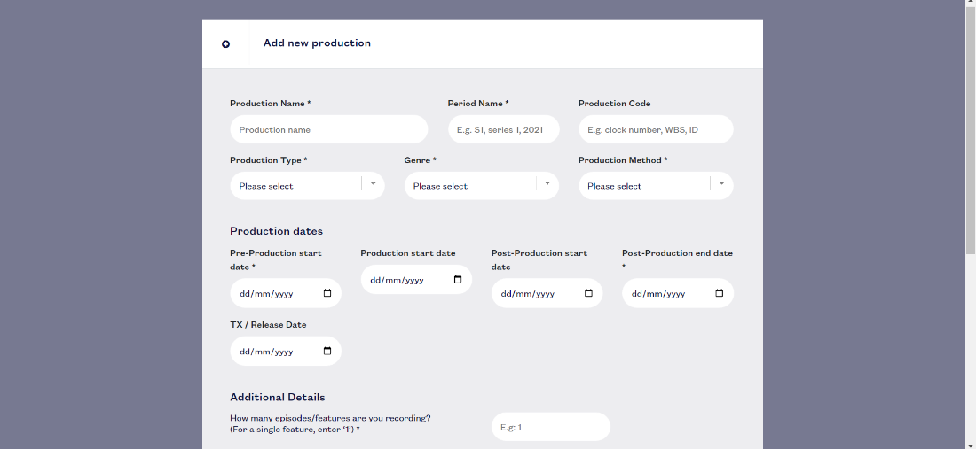
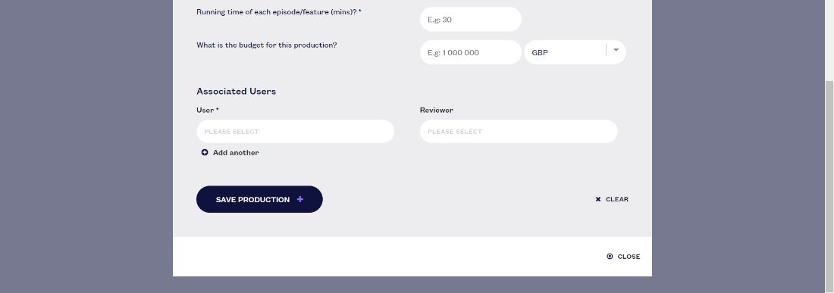

- Click the ‘save production’ button at the bottom of the page when you’re ready. You should be redirected to the footprint page of your new production

Using the carbon footprint tool for students
- You can start inputting information into your carbon footprint by clicking the ‘add new’ button on each category. Various tailored options are available for each category and everything you might need to input, so it’s a good idea to have a little look around before you get going
Please note: there’s a help bar and notifications tab that can offer advice, and lecturers are trained in how to help with footprint questions. They can reach out directly to albert for specific queries

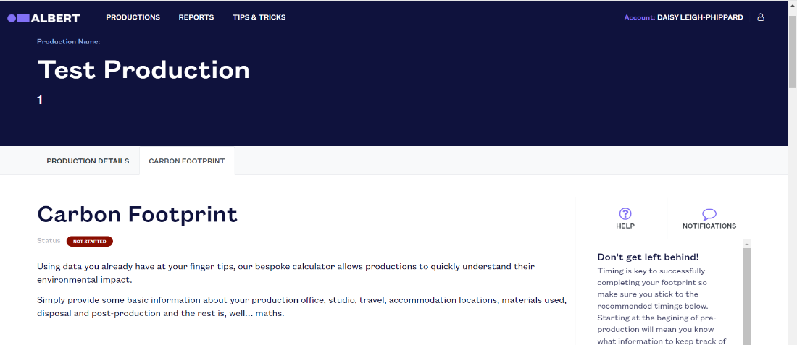
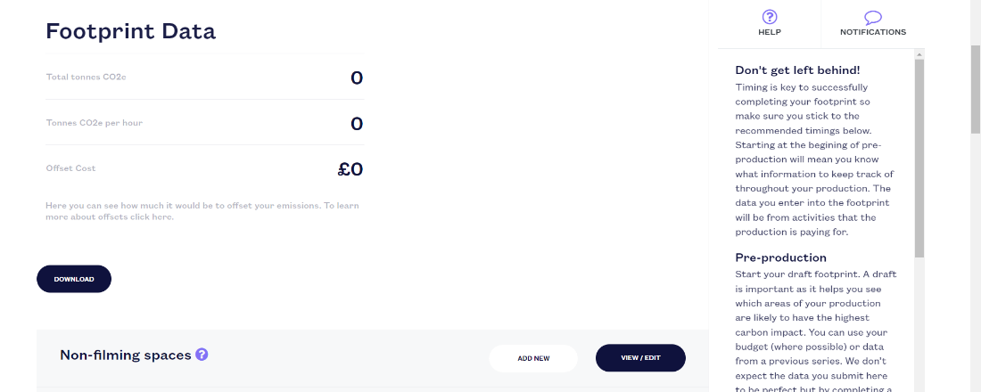
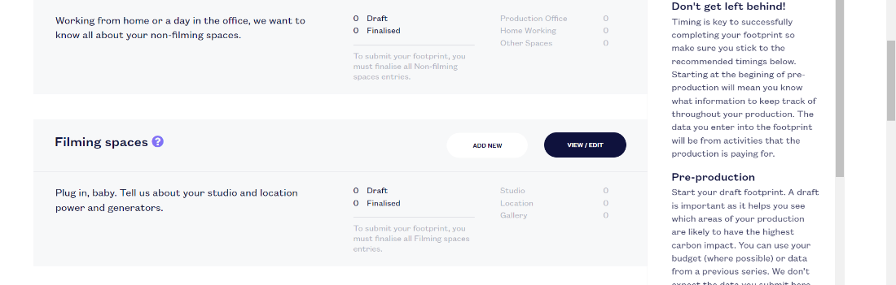
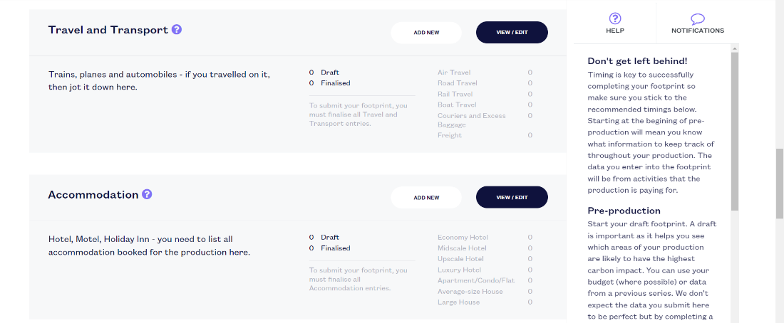
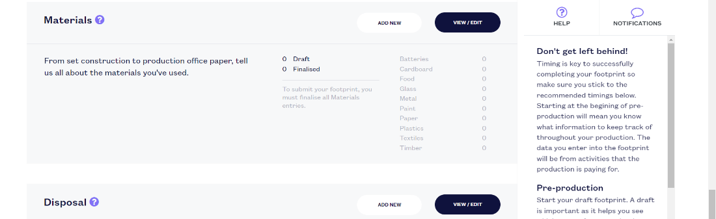
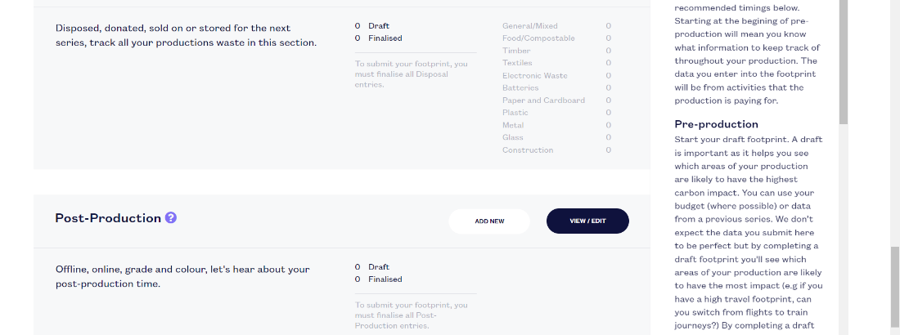

- A pie chart will appear once you have inputted details, showing how your production’s emissions are split across the six categories
- Make sure to finalise each entry by clicking the ‘finalise’ button instead of the ‘save draft’ one once it’s set in stone (you can save as a draft until then)
Please note: you won’t be able to submit the footprint until all your entries are finalised
- Once your carbon footprint is ready, you can click the ‘submit for audit’ button that will appear at the bottom of the page – this will send it to your tutor (the ‘reviewer’) for assessment

Once students have submitted their footprints, tutors can find them in the PRODUCTIONS tab of their reviewer account (make sure to select the reviewer account on the login screen!).

Recommendations on assessing footprints
- Use the case studies provided for your students’ assessment, asking them to transfer the relevant information onto their own footprint
-This way all your student’s footprints will be similar and assessed against the same evidence
-Student productions do not reflect a TV or film production very well as they are managing different resource and supplier workflow, as well as many discrepanices in budget and scope. This can make footprints for student productions slightly more challenging to assess
-This is best for real-life experience of albert’s carbon footprint tool as the case studies we provide are based off of real life industry productions
- Setting a deadline for students to submit their footprint by allows for marking in one batch, and early flagging of any tech issues
- Attend albert’s Train the Trainers session, or watch these recordings back, as they will walk you through how to go about assessing your student’s work
- Reach out to albert with any support you may need

FAQs

The toolkit won’t upload the bulk user spreadsheet?
Make sure that there aren’t any blank spaces at the beginning, middle or end of all fields. If you need a space for a student’s name make sure to use _ (underscore).
My students say they can’t log in?
Firstly, check with them that they have reset their password, either through the automatic email sent from the toolkit upon you creating their accounts, or through the ‘forgot your password’ option on the login page if this link has expired.
My student can’t submit their footprint?
Make sure that all of the student’s entries have been finalised (rather than saved as drafts) as the toolkit won’t allow submission until this has happened. They can check this by opening up each entry and clicking ‘finalise’ rather than ‘save draft’.
I can’t find my student’s footprint to assess?
Firstly, check that your student has submitted their carbon footprint. Then, make sure you are selecting the reviewer account for the relevant course on the login page. If you don’t have this option, then contact albert as they may need to give your account extra permissions. If you are logging onto your reviewer account and still cannot see the student’s production ask them to check that you are the listed reviewer on their production by checking their production details page.
Can my students create an emissions report?
Yes, students can generate emissions reports breaking down the production details, emissions, potential offset cost and links to similar case studies by selecting the REPORTS tab at the top of the toolkit.

If you are unable to resolve any of the above FAQs please contact us at albert@bafta.org or directly through your albert contact.

