NAME: Telma Ariana Ramos Andrade
Student ID number: 2328861
Module code: BMHP5014
Lecturer Name: Laila Surani
Assignment Title: Assignment 2 Report

Project Timeline
The development of Health Connect Youth follows a phased approach:
Year 1: Co-design with young people, development and pilot testing
Year 2: Regional rollout and evaluation of outcomes
Year 3: National implementation and continuous improvement
Ongoing evaluation will assess engagement, wellbeing outcomes and cost-effectiveness to ensure sustainability and value creation.
Dissemination and Promotion `
The app be promoted through education settings, NHS services and social media campaigns targeting young people. Partnerships with youth organisations and charities will support outreach to underserved groups. Co- production and youth ambassadors will play a key role in maintaining relevance and engagement.
Conclusion
Health Connect Youth represents an innovative and preventative digital health solution addressing key gaps in physical and mental wellbeing support for young people in the UK. By combining technology, evidence-based practice and youth-centred design, the app empowers self-management, improves access to support and reduces pressure on health services. This innovation creates values by supporting early intervention, promoting health equity and contributing to long-term improvements within the UK health and social care system.
Furthermore, the app supports long-term sustainability by encouraging digital engagement, prevention and early self-management, helping to future-proof health and social care services while responding creatively to the evolving needs of young people in the UK

Implementation
Health Connect Youth would be implemented through schools, colleges, universities, youth centres, GP Practices and local authorities. Public health practitioners, youth workers and primary care professionals would support the promotion and safe use of the app, ensuring that it complements existing NHS and community services rather than replacing them.
The app would also support social prescribing approaches by signposting young people to local physical activity groups, wellbeing services and community resources.
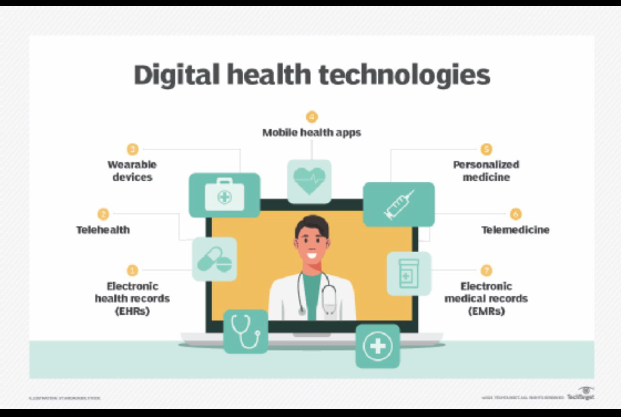
Technology Integration
The app integrates a range of digital features designed to improve engagement and wellbeing outcomes. These include step tracking and movement goals to encourage physical activity, mod check-ins to support emotional awareness, and Cognitive Behavioural Therapy (CBT)-informed exercises to promote positive coping strategies. AI-Supported wellbeing goals allow users to receive personalised feedback while maintaining ethical standards and transparency.
Gamification features, such as rewards and progress tracking, enhance motivation and sustained engagement. Secure signposting directs users to appropriate NHS services when additional support is needed, reinforcing safety and professional integration.
Development, Regulation and Ethics


Health Connect Youth complies with the UK General Data Protection Regulation (UK GDPR) and the Data Protection Act (2018), ensuring the secure, lawful and transparent handling of personal data. The app adopts privacy-by-design principles, including data minimisation, informed consent and clear user control over personal information, which is particularly important when working with children and young people.

The development of the app aligns with NHS Digital and National Institute for Health and Care Excellence (NICE) guidance for digital health technologies (NICE, 2022). This ensures that the intervention is evidence-based, clinically safe and appropriate for use within health and social care contexts. Regular evaluation and governance processes would support ongoing quality assurance and accountability.

Safeguarding policies are central to the ethical design of Health Connect Youth. Clear risk escalation pathways are embedded within the app to ensure that users who disclose distress or risk are signposted to appropriate professional support. The ethical use of digital technology and AI is prioritised to maintain trust, confidentiality and user safety, supporting responsible innovation within health and social care.
Innovation Overview
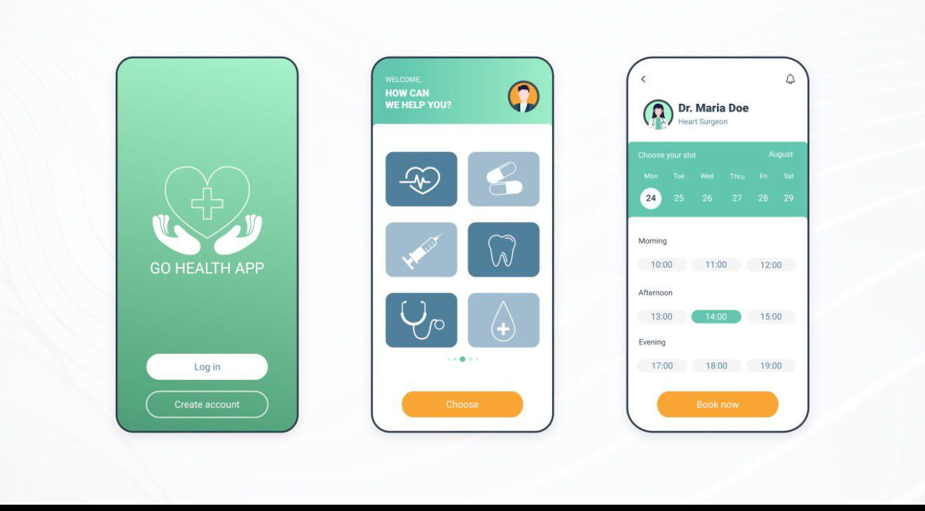
Health Connect youth is a digital health mobile application designed to improve physical and mental wellbeing among young people age 13-25 in the UK. The app integrates physical activity tracking, mental health self-support tools and NHS-aligned information into one safe, accessible digital Platform. It promotes prevention, early intervention and self-management while complementing existing health and social care services.
By using technology that young people already engage with daily, the app provides an innovative solution that meets users in their own digital environments.
In addition, Health Connect Youth reflects principles of digital innovation and value creation within health and social care. The app is designed to be scalable, cost-effective and inclusive, allowing it to be implemented across different regions and communities in the UK. By supporting preventative health behaviours and self-management, the innovation aims to reduce long-term demand on health services.
The co-design of the app with young people ensures that content, language and functionality are relevant, engaging and culturally appropriate. This participatory approach enhances user trust and engagement.
The Issue: Gaps in Health and Social Care
Mental health problems among young people in the UK have increased significantly in recent years, with rising levels of anxiety, depression and emotional distress reported (NHS Digital, 2023). At the same time, physical activity levels among adolescents have declined, increasing the risk of long-term physical health conditions (Sport England, 2023). Access to timely support remains a challenge, with long waiting times for NHS mental health services and inequalities affecting young people from disadvantaged backgrounds.
Despite high levels of smartphones ownership, many existing digital health tools lack regulation, safeguarding and professional integration. This creates a gap for a trusted, evidence-based digital solution that supports young people safely.
Target Group and Expected Impact
The primary target group is young people aged 13-25, particularly those facing barriers to accessing health and wellbeing support. Expect impacts include improved physical activity levels, enhanced emotional resilience, increased health literacy and reduce pressure on GP and mental health services. By supporting early intervention, the app contributes to improved long-term outcomes and value creation within the health and social care system.
Beyond individual benefits, the innovation has wider social and economic impacts. By encouraging early intervention and healthier behaviours, Health Connect Youth has the potential to reduce health inequalities and improve long-term population health outcomes.
From a systems perspective, the app contributes to value creation by supporting prevention, improving service efficiency and strengthening collaboration between health, education and community sectors. This aligns with UK public health priorities and demonstrates how creative digital solutions can support the common good within health and social care systems.
HealthConnect Youth App
A Digital Health Innovation to Improve Physical and Mental Wellbeing Among Young People in the UK

Pitch: HealthConnect Youth App
Expanding a digital health innovation to improve physical and mental wellbeing among young people in the UK

Introduction

HealthConnect Youth is a digital health innovation designed to respond to the growing physical and mental health challenges faced by young people aged 13–25 in the United Kingdom. While the accompanying poster outlines the core features and structure of the app, this pitch provides a deeper narrative to persuade stakeholders, professionals, and the wider public to support and engage with the initiative. The app aligns with national health priorities, addresses current service gaps, and promotes early intervention, prevention, and self-management in a way that is accessible, ethical, and youth-centred.
Young people today are navigating increasing academic pressures, social inequalities, digital overload, and limited access to timely health support. HealthConnect Youth offers a practical and scalable solution that complements existing NHS and community services while empowering young people to take an active role in their own wellbeing.

Rationale and Need for the Innovation

Recent evidence highlights a significant rise in anxiety, depression, and emotional distress among young people in the UK (NHS Digital, 2023). At the same time, physical activity levels have declined, increasing the risk of long-term health conditions such as obesity, cardiovascular disease, and poor mental wellbeing (Sport England, 2023). Despite growing demand, access to mental health services remains constrained by long waiting times and inequalities linked to socioeconomic background.
Digital technology presents an opportunity to bridge this gap. Most young people already engage daily with smartphones and apps, yet many existing digital health tools lack regulation, safeguarding, or integration with professional services. HealthConnect Youth responds to this gap by offering a trusted, evidence-based platform that aligns with NHS standards and public health priorities.

Target Population and Impact on Health and Wellbeing

The primary target group for HealthConnect Youth is young people aged 13–25, particularly those who face barriers to accessing traditional health and wellbeing services. This includes young people from disadvantaged backgrounds, those experiencing mild to moderate mental health difficulties, and individuals who may be reluctant to seek face-to-face support due to stigma or fear.

The app supports both physical and mental wellbeing through a holistic approach. By encouraging regular physical activity, emotional awareness, and positive coping strategies, HealthConnect Youth aims to build resilience and promote healthier lifestyles. Over time, this approach has the potential to reduce reliance on crisis services, improve emotional regulation, and enhance health literacy among young people. At a systems level, this contributes to reduced pressure on GP practices and mental health services, supporting more sustainable care delivery.

Policy, Legislation and Professional Alignment

HealthConnect Youth is firmly grounded in UK health policy and legislation. The app complies with the UK General Data Protection Regulation (UK GDPR) and the Data Protection Act (2018), ensuring that personal data is handled securely and transparently. Safeguarding is central to the design, with clear escalation pathways for risk and age-appropriate content for children and young people.
The app aligns with NHS Digital and NICE guidance for digital health technologies (NICE, 2022), ensuring that interventions are evidence-based and ethically delivered. Features such as mood tracking, goal setting, and CBT-informed exercises are designed to complement, not replace, professional care. Secure signposting directs users to appropriate NHS and community services when additional support is required.
HealthConnect Youth also supports wider public health strategies focused on prevention, early intervention, and reducing health inequalities. By integrating health promotion theory and behaviour change principles, the app aligns with national priorities for improving population health outcomes.

Role of Professionals and Multi-Agency Collaboration

A key strength of HealthConnect Youth is its collaborative approach. The app is designed to be implemented across schools, colleges, universities, youth centres, GP practices, and local authorities. Public health practitioners, youth workers, and primary care professionals play a role in promoting safe and effective use of the app.
This multi-agency approach encourages collaboration between health, education, and social care sectors. Professionals can use the app as a supportive tool to reinforce healthy behaviours, signpost services, and engage young people who may otherwise disengage from traditional support pathways. This integration strengthens continuity of care and enhances trust in digital health solutions.

Public Engagement and Community Involvement

Engaging the public is essential to the success of HealthConnect Youth. Young people are not passive recipients of the innovation but active participants in its development and dissemination. Co-production with young users ensures that the app remains relevant, culturally appropriate, and responsive to evolving needs.
Public involvement is encouraged through education settings, social media campaigns, and partnerships with youth organisations and charities. Youth ambassadors play a key role in promoting the app, reducing stigma around mental health, and encouraging peer engagement. This participatory approach not only increases uptake but also empowers young people to take ownership of their health and wellbeing.
Families, carers, and community stakeholders also benefit from improved awareness and understanding of youth health needs. By fostering a shared responsibility for wellbeing, HealthConnect Youth contributes to stronger, healthier communities.

Sustainability and Value Creation

HealthConnect Youth is designed to be scalable, cost-effective, and sustainable. By focusing on prevention and early intervention, the app has the potential to reduce long-term demand on health and social care services. Improved self-management and health literacy contribute to better outcomes for individuals and cost savings for the system.
From a value creation perspective, the app demonstrates how digital innovation can support the common good within health and social care. It strengthens service efficiency, supports collaboration, and aligns with public health priorities. Importantly, it addresses both individual wellbeing and wider social determinants of health, reinforcing its long-term relevance.

Conclusion
HealthConnect Youth represents a timely and innovative response to the complex health challenges facing young people in the UK. By combining digital accessibility with evidence-based practice, strong governance, and meaningful public engagement, the app offers a credible and impactful solution.

Supporting HealthConnect Youth means investing in prevention, empowerment, and sustainable care. The initiative not only improves physical and mental wellbeing for young people but also contributes to a more resilient and responsive health and social care system. Stakeholder and public support are essential to ensure the successful adoption and long-term impact of this innovation.

POSTER References:
NHS Digital (2023) Mental Health of Children and Young People in England 2023. London: NHS Digital.

NICE (2022) Evidence Standards Framework for Digital Health Technologies. London: National Institute for Health and Care Excellence.

Sport England (2023) Active Lives Children and Young People Survey 2022–23. London: Sport England.

UK Government (2018) Data Protection Act 2018. London: HM Government.

World Health Organization (2022) Adolescent Mental Health. Geneva: World Health Organization.

PITCH References:
Firth, J. et al. (2017) ‘The efficacy of smartphone-based mental health interventions for depressive symptoms’, World Psychiatry, 16(3), pp. 287–298.

Hollis, C. et al. (2017) ‘Digital health interventions for children and young people’, Journal of Child Psychology and Psychiatry, 58(4), pp. 474–503.

Information Commissioner’s Office (ICO) (2023) Guide to the UK GDPR. Wilmslow: ICO.

NHS Digital (2023) Mental Health of Children and Young People in England 2023. London: NHS Digital.

NICE (2022) Evidence Standards Framework for Digital Health Technologies. London: NICE.

Sport England (2023) Active Lives Children and Young People Survey 2022–23. London: Sport England.

UK Government (2018) Data Protection Act 2018. London: HM Government.

World Health Organization (2022) Adolescent Mental Health. Geneva: WHO.

