AI Cover Sheet
I acknowledge the use of Grammarly
https://www.grammarly.com/
20th of May- 9th of June 2025 to check my grammar and spelling

I acknowledge the use of Google scholar
https://scholar.google.com/
20th of May- 9th of June 2025 to research

I acknowledge the use of Canva
https://www.canva.com/design/DAGoefqhn3c/WqJmxjNDZWq7U28tfsqfWg/edit
20th of May- 9th of June to create an academic poster

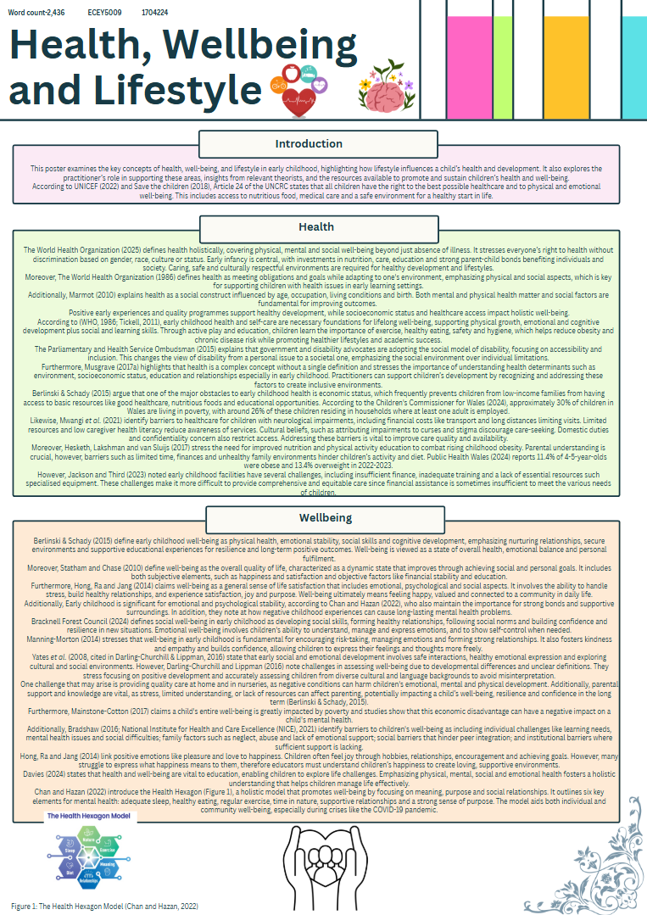
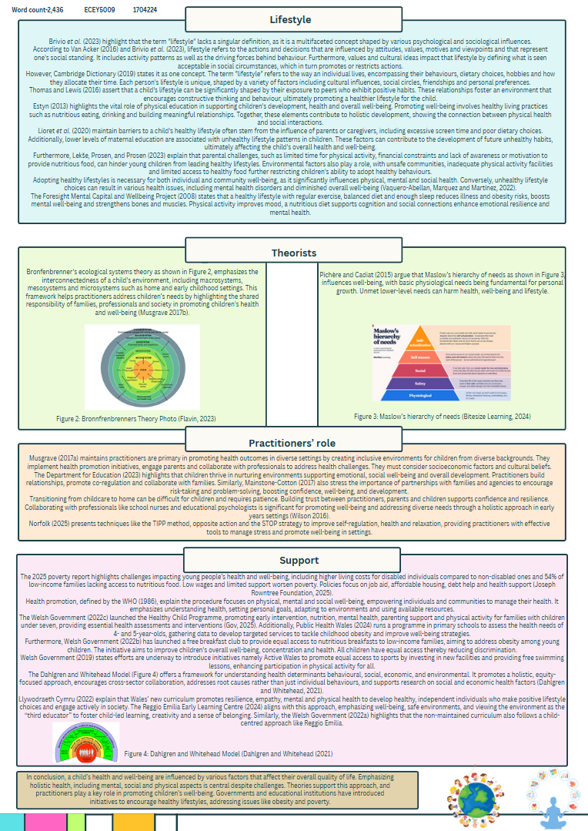

Reference List for Part 1 (Academic poster) & Part 2 (Presentation)
Balasundaram, P. and Krishna, S. (2023) Obesity Effects on Child Health. Florida: StatPearls Publishing.
Berlinski, S. & Schady, N. (2015) The Early Years : Child Well-Being and The Role of Public Policy. New York: Springer Open.
Bitesize Learning (2024) Maslow’s hierarchy of needs, explained. Available at: https://www.bitesizelearning.co.uk/resources/maslows-hierarchy-of-needs-theory. (Accessed: 23 May 2025).
Bracknell Forest Council (2024) Personal, social and emotional development in early years Available at: https://www.bracknell-forest.gov.uk/children-and-family-services/childcare/information-early-years-providers/resources-early-years-providers/play-and-learning-resources/personal-social-and-emotional-development-early-years. (Accessed: 24 May 2025).
Bradshaw, J. (2016). The Well-being of children in the UK. Bristol: Policy Press.
Brivio, F., Viganò, A., Paterna, A., Palena, N. and Greco, A. (2023) ‘Narrative Review and Analysis of the Use of ‘Lifestyle’ in Health Psychology’, International Journal of Environmental Research and Public Health, 20(5), pp. 4427. doi:https://doi.org/10.3390/ijerph20054427.
Cambridge Dictionary (2019) LIFESTYLE Available at: https://dictionary.cambridge.org/dictionary/english/lifestyle (Accessed: 24 May 2025).
Chan, C.S. and Hazan, H. (2022) ‘The Health Hexagon Model: Postulating a holistic lifestyle approach to mental health for times and places of uncertainty’, SSM - Mental Health, 2, pp.100071. doi:https://doi.org/10.1016/j.ssmmh.2022.100071.
Cheung, R. (2018) International comparisons of health and wellbeing in early childhood. Available at: https://www.nuffieldtrust.org.uk/research/international-comparisons-of-health-and-wellbeing-in-early-childhood (Accessed: 28 May 2025).
Children's Commissioner for Wales (2024) Child Poverty. Available at: https://www.childcomwales.org.uk/our-work/policy-positions/child-poverty/. (Accessed: 25 May 2025).
Cleveland Clinic (2024) Obesity in Children.Available at: https://my.clevelandclinic.org/health/diseases/9467-obesity-in-children (Accessed: 25 May 2025).
Czyzewski, A. (2024) Soaring childhood obesity from pandemic could cost UK. London: Imperial News.
Dahlgren, G. and Whitehead, M. (2021) ‘The Dahlgren-Whitehead Model of Health Determinants: 30 Years on and Still Chasing Rainbows’, Public Health, 199(1), pp.20–24. doi:https://doi.org/10.1016/j.puhe.2021.08.009.
Darling-Churchill, K.E. and Lippman, L. (2016) ‘Early childhood social and emotional development: Advancing the field of measurement’, Journal of Applied Developmental Psychology, 45, pp.1–7. doi:https://doi.org/10.1016/j.appdev.2016.02.002.
Davies, J. (2024) Articles - Hwb. hwb.gov.wales. Available at: https://hwb.gov.wales/news/articles/c01847ed-53c7-4a8e-b34a-7f280d89b082. (Accessed: 24 May 2025).
Department for Education (2023) Help for early years providers: Mental health for early years children. help-for-early-years-providers.education.gov.uk. Available at: https://help-for-early-years-providers.education.gov.uk/health-and-wellbeing/mental-health-for-early-years-children (Accessed: 23 May 2025).
Department of Health and Social Care (2022) Better Health Childhood Obesity. Available at: https://campaignresources.dhsc.gov.uk/campaigns/better-health-childhood-obesity/ (Accessed: 25 May 2025).
Dooru, N. (2024) The Impact of Food Environment in Childhood Obesity in the UK. Thesis. University of Wales Trinity Saint David. Available at: https://repository.uwtsd.ac.uk/id/eprint/3276/ (Accessed: 25 May 2025).
Estyn. (2013) Supplementary Guidance: Healthy Living. Cardiff: WAG
Flavin, G. (2023) Theorist in the Spotlight: Urie Brofenbrenner and the EYLF. Available at: https://www.sticksandstoneseducation.com.au/blogs/educators-notebook-the-early-years-edition/theorist-in-the-spotlight-urie-brofenbrenner (Accessed: 25 May 2025).
Foresight Mental Capital and Wellbeing Project (2008) Mental Capital and Wellbeing: Making the most of ourselves in the 21st century Available at: https://assets.publishing.service.gov.uk/media/5a7ce5afed915d36e95f0526/mental-capital-wellbeing-summary.pdf. (Accessed: 24 May 2025).
Gov (2025) STATISTICS, DOCUMENT. Available at: https://www.gov.wales/sites/default/files/pdf-versions/2025/5/3/1747816237/healthy-child-wales-programme-contacts-children-october-december-2024.pdf (Accessed: 24 May 2025).
GOV.UK (2022) Childhood obesity: applying All Our Health. Available at: https://www.gov.uk/government/publications/childhood-obesity-applying-all-our-health/childhood-obesity-applying-all-our-health (Accessed: 28 May 2025).
Hesketh, K.R., Lakshman, R. and van Sluijs, E.M.F. (2017) ‘Barriers and facilitators to young children’s physical activity and sedentary behaviour: a systematic review and synthesis of qualitative literature’, Obesity Reviews, 18(9), pp.987–1017. doi:https://doi.org/10.1111/obr.12562.
Hong, Y., Ra, Y. and Jang, H. (2014) ‘A Study on Young Children’s Perceptions and Experiences of Happiness’,Asia-Pacific Journal Of Research In Early Childhood Education, 9(1), pp.39–64. doi:https://doi.org/10.17206/apjrece.2015.9.1.39.
INEOS (2018) About the Daily Mile | the Daily Mile UK. The Daily Mile. Available at: https://thedailymile.co.uk/about/. (Accessed: 27 May 2025).
Jackson, B. and Third, S. (2023) 7.8 Barriers Impacting Wellness in the Early Years. Available at: https://ecampusontario.pressbooks.pub/holisticwellnessece/chapter/7-8-barriers-impacting-wellness-in-the-early-years/ (Accessed: 23 May 2025).
Joseph Rowntree Foundation (2025) UK Poverty 2025: The essential guide to understanding poverty in the UK. Available at: https://www.jrf.org.uk/uk-poverty-2025-the-essential-guide-to-understanding-poverty-in-the-uk (Accessed: 13 March 2025).
Kenney, E.L., Barrett, J.L., Bleich, S.N., Ward, Z.J., Cradock, A.L. and Gortmaker, S.L. (2020)’ Impact of the Healthy, Hunger-Free Kids Act on Obesity Trends’, Health Affairs, 39(7), pp.1122–1129. doi:https://doi.org/10.1377/hlthaff.2020.00133.
Lekše, R., Prosen, M. and Prosen, M. (2023) ‘Determining the Impact of Lifestyle on the Health of Primary School Children in Slovenia Through Mixed Membership Focus Groups’, J Community Health, 48, pp. 857-869. https://doi.org/10.1007/s10900-023-01231-7
Lioret, S., Campbell, K.J., McNaughton, S.A., Cameron, A.J., Salmon, J., Abbott, G. and Hesketh, K.D. (2020) ‘Lifestyle Patterns Begin in Early Childhood, Persist and Are Socioeconomically Patterned, Confirming the Importance of Early Life Interventions’, Nutrients, 12(3), pp. 724. doi:https://doi.org/10.3390/nu12030724.
Lister, N.B., Baur, L.A., Felix, J.F., Hill, A.J., Marcus, C., Reinehr, T., Summerbell, C. and Wabitsch, M. (2023). Child and adolescent obesity. Nature Reviews Disease Primers, 9(1), pp.1–19. doi:https://doi.org/10.1038/s41572-023-00435-4.
Llywodraeth Cymru (2022) Curriculum for Wales. Available at: https://hwb.gov.wales/curriculum-for-wales (Accessed: 24 May 2025).
Lynne Alexandra Kennedy (2011) Figure 1: ‘Rainbow’ model of the determinants of health. ResearchGate. Available at: https://www.researchgate.net/figure/Rainbow-model-of-the-determinants-of-health_fig1_49951184. (Accessed: 29 May 2025).
Mainstone-Cotton, S. (2017) Promoting young children’s emotional health and wellbeing: a practical guide for professionals and parents. London: Jessica Kingsley Publishers.
Manning-Morton, J. (2014) Exploring Wellbeing in the Early Years. NYC: McGraw Hill Publishing.
Marmot, M. (2010) Fair Society, Healthy Lives: Strategic review of health inequalities in England Post-2010. Available at: https://www.parliament.uk/globalassets/documents/fair-society-healthy-lives-full-report.pdf (Accessed: 23 May 2025).
Musgrave, J. (2017a) Children’s Health is Every Professional’s Responsibility. London: SAGE Publications Ltd.
Musgrave, J. (2017b) Supporting Children’s Health and Wellbeing. London: SAGE Publications Ltd.
Mwangi, L.W., Abuga, J.A., Cottrell, E., Kariuki, S.M., Kinyanjui, S.M. and Newton, C.R.J.C. (2021) ‘Barriers to access and utilization of healthcare by children with neurological impairments and disability in low-and middle-income countries: a systematic review’, Wellcome Open Research, 6, p.61. doi:https://doi.org/10.12688/wellcomeopenres.16593.1.
National Institute for Health and Care Excellence (NICE) (2021) Barriers and facilitators for promoting physical, mental and emotional health and wellbeing of looked-after children and young people and care leavers: Looked-After Children and Young People: Evidence review G. Available at: https://www.ncbi.nlm.nih.gov/books/NBK575879/. (Accessed: 23 May 2025).
Norfolk (2025) Help for your body and mind. Available at: https://www.nsft.nhs.uk/help-for-your-body-and-mind/ (Accessed: 23 May 2025).
Parliamentary and Health Service Ombudsman (2015) Introduction to the Social and Medical Models of Disability. Available at: https://www.ombudsman.org.uk/sites/default/files/FDN-218144_Introduction_to_the_Social_and_Medical_Models_of_Disability.pdf (Accessed: 24 May 2025).
Pichère, P. and Cadiat, A.C. (2015) Maslow’s hierarchy of needs. Namur: Lemaitre Publishing.
Public Health Wales (2024) Child Measurement Programme - Public Health Wales. Available at: https://phw.nhs.wales/services-and-teams/child-measurement-programme/ (Accessed: 27 May 2025).
Public Health Wales (2024) Child Measurement Programme - Public Health Wales. Available at: https://phw.nhs.wales/services-and-teams/child-measurement-programme/. (Accessed: 23 May 2025).
Rankin, J., Matthews, L., Cobley, S., Han, A., Sanders, R., Wiltshire, H.D. and Baker, J.S. (2016) ‘Psychological Consequences of Childhood Obesity: Psychiatric Comorbidity and Prevention’, Adolescent Health, Medicine and Therapeutics, 7(7), pp.125–146. doi:https://doi.org/10.2147/ahmt.s101631
Reggio Emilio Early Learning Centre (2024) Reggio Emilia Childcare Centres. Available at: https://reggioemilia.com.au/blog/how-the-reggio-emilia-approach-nurtures-a-childs-well-being/. (Accessed: 24 May 2025).
Rolland-Cachera, M.F. (2011)’ Childhood obesity: current definitions and recommendations for their use’, International Journal of Pediatric Obesity, 6(5-6), pp. 325–331. doi:https://doi.org/10.3109/17477166.2011.607458.
Safaiyan, A., Zarei, F., Moghaddam, H.R., Maasoumi, N. and Matlabi, H. (2021) ‘How do Mothers Explain the Causes of Childhood Obesity? Community-Based Approach in Preschool Centers’, Child Care in Practice, pp.1–14. doi:https://doi.org/10.1080/13575279.2021.1946012.
Save the Children (2018) Little pieces Big Picture. Harnessing Early Childhood Education and Care to make sure no child in Wales is left behind, Save the Children. https://www.savethechildren.org.uk/content/dam/global/reports/education-and-child-protection/stc-wales-childcare-report-2017.pdf (Accessed: 23 May 2025).
Statham, J. and Chase, E. (2010) Childhood Wellbeing: A brief overview. Loughborough: Childhood Wellbeing Research Centre.
Stiebahl, S. (2025) Obesity statistics. Available at: https://researchbriefings.files.parliament.uk/documents/SN03336/SN03336.pdf (Accessed: 25 May 2025).
Thomas, A. and Lewis, A. (2016) An introduction to the Foundation Phase. London: Bloomsbury Publications.
Tickell, D.C. (2011) The Early Years: Foundations for life, health and learning An Independent Report on the Early Years Foundation Stage to Her Majesty’s Government Dame Clare Tickell. Available at: https://core.ac.uk/download/pdf/5911613.pdf (Accessed: 23 May 2025).
UNICEF (2022) The Convention on the Rights of the child: the Children’s Version. Available at: https://www.unicef.org/child-rights-convention/convention-text-childrens-version. (Accessed: 23 May 2025).
Union of Concerned Scientists (2022) Healthy School Meals, Healthy Children: How Stronger Federal Policy Can Help Address Childhood Obesity. Available at: https://www.jstor.org/stable/pdf/resrep17300.pdf?refreqid=fastly-default%3A7fd4dca9f2caa7c10cce8036f258920a&ab_segments=0%2Fbasic_search_gsv2%2Fcontrol&initiator=&acceptTC=1 (Accessed: 25 May 2025).
Ure, K. (2021) ‘Childhood obesity - giving the best care’, Wellington, 27(3), pp.16–18.
Van Acker, V. (2016) ‘Lifestyle and modal choices: Defining, measuring and using the ‘lifestyle’ concept’, Transportation Research Record, (1), pp.74-82.
Vaquero-Abellan, M., Genil Marquez, F. and Aparicio Martínez, P. (2022) ‘The importance of healthy lifestyles in helping achieving wellbeing’, Fertility, Pregnancy, and Wellness, pp.1–19. doi:https://doi.org/10.1016/b978-0-12-818309-0.00020-4.
Welsh Government (2019) Sport and active recreation Available at: https://www.gov.wales/sport-and-active-recreation (Accessed: 24 May 2025).
Welsh Government (2020) £5.5m to help prevent and reduce obesity in Wales. Available at: https://www.gov.wales/ps55m-help-prevent-and-reduce-obesity-wales (Accessed: 25 May 2025).
Welsh Government (2022) A curriculum for funded non-maintained nursery settings. Available at: https://hwb.gov.wales/api/storage/b1801d78-38c3-4320-9818-d9996c21aef8/220914-a-curriculum-for-funded-non-maintained-nursery-settings.pdf. (Accessed: 23 May 2025).
Welsh Government (2022) An overview of the Healthy Child Wales Programme. Available at: https://www.gov.wales/sites/default/files/publications/2022-03/an-overview-of-the-healthy-child-wales-programme.pdf (Accessed: 24 May 2025).
Welsh Government (2022) Free breakfast in primary schools: information for parents and carers. Available at: https://www.gov.wales/free-breakfast-primary-schools (Accessed: 24 May 2025).
WHO (2025) Obesity and Overweight. Available at: https://www.who.int/news-room/fact-sheets/detail/obesity-and-overweight (Accessed: 25 May 2025).
Wilson, T. (2016). Working with parents, Carers and Families in the Early Years: The Essential Guide. London: Routledge.
World Health Organisation (1986) Ottawa Charter for Health Promotion. Available at: https://iris.who.int/bitstream/handle/10665/349652/WHO-EURO-1986-4044-43803-61677-eng.pdf. (Accessed: 23 May 2025).
World Health Organization (2020) THE DOUBLE BURDEN OF MALNUTRITION: PRIORITY ACTIONS ON ENDING CHILDHOOD OBESITY. Available at: https://www.jstor.org/stable/pdf/resrep27942.13.pdf?refreqid=fastly-default%3A147ddb8b11d4c51135cb776780c2b9d6&ab_segments=&initiator=&acceptTC=1 (Accessed: 25 May 2025).
World Health Organization (2025) Constitution of the World Health Organization. Available at: https://www.who.int/about/governance/constitution. (Accessed: 24 May 2024).

