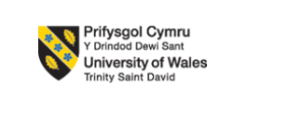
PRACTICE BASED RESEARCH
ASSESSMENT 2
PROGRAMME: M. Sc PUBLIC HEALTH AND SOCIAL CARE AND PRACTICE PROGRAMME
STUDENT NAME: SIVAANILKUMAR LELLA
STUDENT ID: 2241658
MODULE CODE: LCHS7001

LECTURE NAME: Dr. DIOLA BIJLHOUT

PROFESSIONAL BEHAVIOR OF POSTGRADUATE PHSC

STUDENTS

TABLE OF CONTENTS
Introduction 3
Background 3
Research Aim 4
Research Objectives 4
Research Question 4
Research Hypothesis 4
Research Rationale 5
Methodology 5
Research Approach 5
Research design 6
Sampling method 7
Sample Size 8
Study Participants 9
Procedure 10
Data Collection 11
Data Analysis 11
Ethical Consideration 12
Expected Results 12
Discussion 13
Conclusion 13
Reference list 14
Appendices 16

Introduction
The influence of professional behaviour in Public Health and Social Care (PHSC) is being discussed in this research. Professional behaviour at a workplace demonstrates leadership that upholds authoritative guidelines for accountability, competence, decency, and honesty. Workplace etiquette norms and willingness become more important as globalisation brings people from different countries together and age differences widen. The purpose of this research is to evaluate the relationships that exist between professional success, communication skills, timeliness, ethical integrity, and trust-building.

Background
An analysis found that in the public health and social care (PHSC) workplace, strong moral standards, interpersonal skills, dependability, and boundaries consistently predicted results. Regardless, expectations vary among social classes and historical eras. For example, people who live in the electronic age prefer to learn over talk on the phone and value a healthy balance between work and play over leisure time that is accessible later. As the workforce grows, pioneers find it unbelievable that all professionals have systematised preparation in decency or have parental shows. Modern innovations like remote employment also lessen the opportunities to see other people. Concerns over consistency, the delivery of useful information, and security assurance may arise among staff members without any discernible official guidance. In order to overcome these challenges and safeguard the organization's standards, proactive professional development is crucial (Bartel et al. 2020).
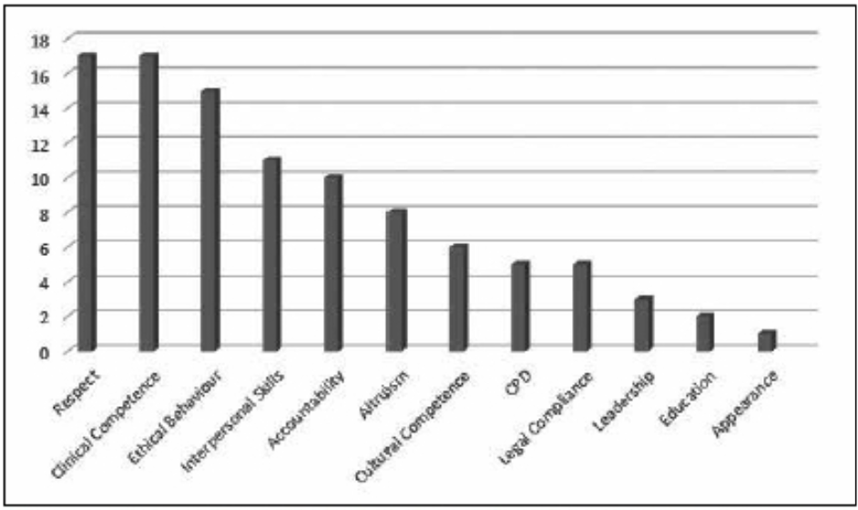
Figure 2: Features that indicate professionalism as averaged throughout the group
(Source: https://www.scielo.org.za/)

Maintaining a culture's areas of strength is becoming more and more dependent on competent leadership in growing organisations. Moral deficiencies, difficult communication, lateness, and susceptibility may develop hostility among colleagues and ages, producing costly turnover. The review's conclusions show that 60% of employees often see instances of dishonest behaviour, such as lying, breaching confidentiality, dressing inappropriately, and using offensive language (Belcher et al. 2021). These violations are often traced back to a lack of preparation in demonstrating and preparing for appropriate leadership as globalisation and remote work schedules increase the number of groups outside those with traditional institutional upbringings. These days, it is hard to raise questions about the extent to which employees understand pleasantness rules.

Research Aim
This study helps to focus on the review of moral honesty, communication skills, dependability, and trust-building in Physical Health and Social care (PHSC). It examines the components of the work environment conducted in the scope of old enough gatherings and working settings.

Research Objectives
- To assess what appropriate behaviour is intended by ethical issues such as categorization, independent handling, and difficult circumstances
- To evaluate the extent to which the development of beneficial corporate relationships is dependent upon competent communication skills, such as focused attention, well-written commands, and deliberate relational cooperation
- To examine how dependability, quick task completion, and schedule synchronization affect each person's consistency and aspects of the workplace
- To explore and study the effects of developing trust through sincerity, truthfulness, optimism, and a capable leader on the character of expert collaborations.

Research Question
RQ1 How do ethical issues, such as categorization, independent handling, and addressing difficult circumstances, shape appropriate behaviour in various contexts?
RQ2Upto what extent does the development of beneficial corporate relationships depend on competent communication skills, including focused attention, well-written commands, and deliberate relational cooperation?
RQ3 How do dependability, quick task completion, and schedule synchronization impact individual consistency and workplace dynamics?
RQ4 What are the effects of developing trust through sincerity, truthfulness, optimism, and effective leadership on the character of expert collaborations?

Research Hypothesis
H0: Ethical considerations, effective communication abilities, and workplace characteristics have no noticeable effects on professional behaviour.
H1: Professional behaviour is greatly influenced by ethical considerations, effective communication abilities, and workplace characteristics.

Research Rationale
The rationale discussed in this study is the complex aspects of the professional behaviour of Public Health and Social Care (PHSC) students in their respective environments. Previous studies highlight the critical impact that moral considerations, effective communication abilities, and workplace characteristics play in determining professional behaviour. Research shows that deficient treatment, errors in the grouping, and inconveniences overseeing unsolvable conditions are impediments to a moral way of behaving. Unfortunate relational abilities could obstruct the development of favourable business organizations using ways of behaving including carelessness, ineffectively communicated guidelines and an absence of social cooperation (Bello-Medina et al, 2021). Schedule synchronisation, job completion, and dependability deficiencies may affect workplace dynamics and individual consistency. The effects of moral considerations, effective communication techniques, and workplace characteristics can be examined and assessed on professional behaviour, this assignment aims to solve these problems. When studying methodically the study topics and goals, it will shed light on practical methods for encouraging moral behaviour, improving communication skills, and maximising workplace features to support good professional conduct.

Methodology
This will help to facilitate statistical analysis of the links between professionalism, ethics, communication, timeliness, trust, and demographics, a single-method qualitative research design will be used in this study of Public Health and Social Care (PHSC). Overviews enable the collection of feedback from a vastly diverse representative sample to provide light on work and generational preferences.

Research Approach
The positivist research methodology helps in predicting the observation and measurement of objective facts of professional behaviours using empirical methods of Public Health and Social Care (PHSC). Qualitative data, which helps to enable statistical analysis of phenomena, are central to positivism. Positivist research on professional behaviours can formulate the claim that "professional employees exhibit greater productivity than non-professional employees." The crucial factors of "productivity" and "professionalism" would need precise, quantifiable operational definitions. Systematic data collection techniques, like as questionnaires or workplace observations, would be used to gauge a sample of workers' impressions of professionalism and productivity indicators. After adjusting for other variables, the data would be statistically examined to see whether there was a link between the two variables. If a strong positive connection is found, the researcher may discuss that better output is predicted by professional rank, confirming the initial hypothesis. Factual evidence would be prioritised above subjective interpretations (Charubin et al, 2020). Negativist studies, according to critics, are unable to adequately capture how people understand intricate social structures like "professionalism." Finding legal, dependable partnerships that enable management and explanation of professional output in organisations is the aim.

Research design
Unlike positivist research, which focuses on uncovering the connections between variables, descriptive research seeks to present an accurate picture of phenomena or event as it happens. Rather than limiting professionalism to measurable data points, descriptive research on professional behaviours of Public Health and Social Care (PHSC) students would aim to characterise what it means to perform professionally in diverse working circumstances. Instead of being strictly preset, the study design would be flexible and somewhat emergent. An overall inquiry, such as "What constitutes professional behaviour among nurses in hospital settings?" would replace any explicit hypothesis. Field observations, in-depth interviews with nurses from various departments, and examination of hospital policy papers about behaviour are all possible components of an ethnographic technique (Gil-Guirado et al, 2022). The objective would be to compile qualitative accounts and descriptions that highlight the complexities and nuanced aspects of acting professionally at work. This involves being aware of potential ambiguities if actions that are considered "professional" differ across nurses or between shifts. The final product would be a thorough descriptive account with major themes and illustrative examples that explain what constitutes professional nursing behaviour in real-world settings. Descriptive designs help to point out the less objective and rigorous hypothesis-led positivist research that uses statistical analysis. Using an inductive analytical lens, however, descriptive research excels in fostering contextualised, fine-grained understandings of the particular meanings participants assign to concepts like workplace professionalism as reflected via behaviours.

Sampling method
Interviews Detailed qualitative data regarding being professional at work may be gathered via interviews with Public Health and Social Care (PHSC) students. However, if results are to be representative of the workforce as a whole, sampling strategies need to be carefully considered. Say, for instance, that researchers want to investigate diverse interpretations of "professionalism"; in this case, picking interview subjects at random prevents sample biases from distorting the findings. First, the target audience would be identified, for example, as all staff members who deal directly with customers in a retail organisation that employs. The company's personnel database, which included job titles and locations, was available to researchers. This ensures that any employee who interacts with customers, regardless of position or shop, has an equal chance of being chosen (Hutchings, 2020). After that, participants would be called to arrange one-hour interviews to gather viewpoints on appropriate behaviour while attending to customers. Inquiries may focus on things like manners, looks, brand awareness, and building connections.
When the sample is randomly selected, it is possible to properly argue that the results reflect the opinions of all staff members who interact with customers (Isaia et al. 2021). It is possible to deduce that company-wide trends revolving around certain service professionalism themes probably exist. Conversely, using consistently non-random procedures runs the danger of results being biased because of researcher accessibilities or unconscious selection biases. Finally, a random interview sample, when paired with open-ended questions, provides valuable qualitative insights about professionalism viewpoints across a range of retail roles, not just localised regions. These insights are crucial for organisational activities that seek to codify behavioural requirements.

Sample Size
The number of participants is 5. It is possible to achieve a 95% confidence level with a 5% safety buffer for the target participants; an example size of at least 385 respondents shows demonstrably considerable results. As an example, goal n = 5 allows the finding of more moderate effect sizes across orders by working on possibilities for faulty passages.

Study Participants
In the discussions, the participants who represent a variety of professional backgrounds and international experiences for their post-graduate studies uncovered a wealth of information that informed their nuanced opinions on appropriate behaviour in Public Health and Social Care (PHSC). The participants ultimately agreed on the long-held belief that effective communication is essential for operating proficiently in the workplace. They emphasised how critical it is to ignite interest, deal with problems, and develop the connection overall. Grabbing plagued the conversations on the value of moral integrity and connection (Liu et al, 2020). While some saw it as an essential trait for managing change, others emphasised the difficulties in striking a balance between flexibility and maintaining a healthy balance between engaging and important workouts. These interactions provided a nuanced picture of the participants' viewpoints on successful behaviours, with a focus on how standards are setting-focused within the dynamic context of their life goals (Malik et al. 2023). The conference attendees' opinions on appropriate behaviour of physical health and a detailed picture that highlighted the similarities and differences in their experiences. These views may guide the development of complete and practical workplaces and are a good tool for understanding the complex concept of expert behaviour.
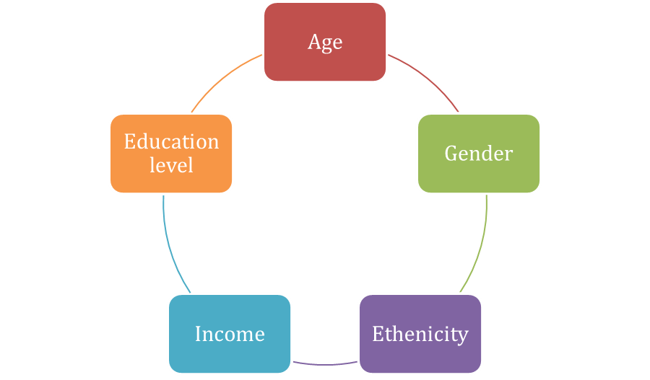
Figure 4: Sociodemographic variables
(Source: Self-created in MS Word)

Procedure
Meetings will last around 45 minutes, according to best practices for preserving rich subjective data collection while also considering master time constraints. With preplanned centre questions on shifts seen in morality, correspondence, practicality, trust-building, and longings for precursor or mediation tactics, the researcher will facilitate talks using a semi structured interview. Unrestricted modified follow-up inquiries will examine emerging concepts in further detail. Discussions will take place via video conference following the preferences of the participants and remain confidential next to anonymous examples. Meetings will be thoroughly inspected, documented, and interpreted in Public Health and Social Care (PHSC).

Data Collection
Five PHSC students chosen at random will participate in structured interviews to provide qualitative data on professionalism warning signs. Response scales will be used to gauge the frequency of timeliness, polite email correspondence, proper classroom dress, and prepared responses to closed-ended questions (1 being never, 5 being often). Other inquiries will gauge how much students believe peer professionalism affects their behaviour and the classroom (1 being not at all, and 5 being significant effects). Using descriptive statistics, subgroups will be highlighted by first summarising average ratings and then comparing any differences in the five students' scores. Following that, correlations and regressions will be used to examine relationships between outcomes such as academic accomplishment and perceived professionalism among peers and one's professional behaviour. Testing theories about factors influencing students' professional behaviour is made easier by the data from these standardised interviews.

Data Analysis
The primary qualitative analysis of the postgraduate PHSC primary qualitative analysis professional behaviour, in light of an overview of 5 members, used elucidating measurements to evaluate key behavioural dimensions and identify trends. The information was exposed to a spellbinding connection investigation. The spellbinding investigation was utilized, to sum up the critical parts of expert conduct displayed by postgraduate PHSC understudies. It gives any significant differences in proficient conduct across different segment factors, like morality, communication, practicality, and trustworthiness. The qualitative data analysis is meant to give a comprehensive understanding of the current state of professional behaviour among postgraduate PHSC students, offering valuable insights for academic institutions and policymakers to enhance educational strategies and support systems in the field.

Ethical Consideration
- Informed Consent: This ensures that members know the methodology, review targets, and any dangers before providing their educated assent.
- Confidentiality: The study guarantees that the privacy of members requires removing the information and protecting it to prevent unwanted access (Zaninotto et al, 2022).
- Data Protection Act 2018: Regarding the rules of the “Data Protection Act 2018” for managing individual information given by the Data Protection Act of 2018 is vital. It will suggest social affairs and manage information rationally and legally, guaranteeing that it assures characterized and legal purposes.

Expected Results
Based on previous research, it appears that the traits of morality, communication, practicality, and trustworthiness are all strongly associated with exceptional performance and the development of relationships. Different findings were reached by the respondents: 20% showed no impact, 26% moderate impact, 22% small impact, and a staggering 32% credited great impact in Public Health and Social Care (PHSC) (Troiano and Lazzeri, 2020). The effects of social associations varied: 29% perceived a basic influence, 25% slight impact, 24% moderate impact, and 22% inconsequential effect. The interview results will include background information on concerns related to timeliness, techniques for fostering trust, and evolving communication modalities (Sunand Duan, 2022). Triangulation using broad insights will highlight the gravity of these situations and determine procedures for addressing hierarchical cultures, such as welcoming arrangements for meetings, adjustable scheduling, and social authority practice.

Discussion
The research findings highlight the multifaceted nature of professional behaviour in Public Health and Social Care (PHSC). The determined characteristics of morality, communication, practicality, and trustworthiness align with past examinations relating these characteristics to outstanding performance and relationship advancement. Respondents fluctuated in their appearance of the effect of these traits, showing a nuanced understanding of the PHSC setting. The variety of responses, with 32% crediting a great impact and 20% showing no impact, presents the complicated interplay of these characteristics and their differential outcomes(Village and Francis, 2021).
In the domain of social affiliations, the review uncovered various perceptions, with 29% perceiving a basic influence and 22% considering the impact immaterial (Zaninotto et al, 2022). This assortment contains the prerequisite for a fitted method for managing social components inside PHSC, noticing that the impact of social affiliations isn't generally uniform. The interview results, diving into concerns connected with idealness, trust-building strategies, and developing correspondence modalities, give significant subjective experiences. Locating these findings with more extensive points of view stresses the gravity of these issues. Procedures, for example, adaptable planning and social power readiness arise as possible arrangements, flagging the significance of adjusting hierarchical societies to foster professional behaviour effectively.

Conclusion
Worries may have a remarkable negative impact on hierarchical work cultures and procedures. Workplace decorum coaching maintains consistent, polite behaviour in the face of shifting era preferences and an increasingly diverse labour force. This study helps to discuss the relationships between morality, communication ability, reliability, trust, and excellent working relationships across all age groups and professional levels. A pleasant, cross-generational work environment can be maintained and, the information gathered is intended to guide preparation drives and hierarchical structures. Association conflicts may result from uneven complex media that is nonconcurrent and biased towards responsiveness. Tailored guidelines, training programmes, and behaviour preparedness are fundamental medications that value meaningful relationships and achieve a certain degree of balance between work and play. Through these meetings, the data collection method provided a wealth of information on the intricate concept of a specialised mode of action. Whatever the shifts, the information gathered is useful in differentiating problems in the area that students are working on. Considering how much employees of all ages and skill levels want assistance in adapting to the evolution of capable principles, the company should consider allocating resources to these interventions. Reviving institutional accountability, solidarity, and trust needs competent risk management in areas with enough workspace and planning.

Bibliography
Bartel, S.J., Sherry, S.B., Farthing, G.R. and Stewart, S.H., 2020. Classification of orthorexia nervosa: further evidence for placement within the eating disorders spectrum. Eating behaviors, 38, p.101406.
Belcher, B.R., Wolff-Hughes, D.L., Dooley, E.E., Staudenmayer, J., Berrigan, D., Eberhardt, M.S. and Troiano, R.P., 2021. US population-referenced percentiles for wrist-worn accelerometer-derived activity. Medicine and science in sports and exercise, 53(11), p.2455.
Bello-Medina, P.C., Hernández-Quiroz, F., Pérez-Morales, M., González-Franco, D.A., Cruz-Pauseno, G., García-Mena, J., Díaz-Cintra, S. and Pacheco-López, G., 2021. Spatial memory and gut microbiota alterations are already present in early adulthood in a pre-clinical transgenic model of Alzheimer’s disease. Frontiers in Neuroscience, 15, p.595583.
Charubin, K., Modla, S., Caplan, J.L. and Papoutsakis, E.T., 2020. Interspecies microbial fusion and large-scale exchange of cytoplasmic proteins and RNA in a syntrophic Clostridium coculture. Mbio, 11(5), pp.10-1128.
Clark, C.J., Johnson, N.P., Soriano Jr, M., Warren, J.L., Sorrentino, K.M., Kadan-Lottick, N.S., Saiers, J.E., Ma, X. and Deziel, N.C., 2022. Unconventional oil and gas development exposure and risk of childhood acute lymphoblastic leukemia: a case–control study in Pennsylvania, 2009–2017. Environmental Health Perspectives, 130(8), p.087001.
Cruess, S.R., Cruess, R.L. and Steinert, Y., 2019. Supporting the development of a professional identity: general principles. Medical teacher, 41(6), pp.641-649.
Faraz, N.A., Ahmed, F., Ying, M. and Mehmood, S.A., 2021. The interplay of green servant leadership, self‐efficacy, and intrinsic motivation in predicting employees’ pro‐environmental behavior. Corporate Social Responsibility and Environmental Management, 28(4), pp.1171-1184.
Gil-Guirado, S., Pérez-Morales, A., Pino, D., Peña, J.C. and Martínez, F.L., 2022. Flood impact on the Spanish Mediterranean coast since 1960 based on the prevailing synoptic patterns. Science of the Total Environment, 807, p.150777.
Hutchings, R., 2020. The impact of Covid-19 on the use of digital technology in the NHS. Nuffield Trust, 27, pp.2002-2008.
Isaia, R., Di Giuseppe, M.G., Natale, J., Tramparulo, F.D.A., Troiano, A. and Vitale, S., 2021. Volcano‐tectonic setting of the Pisciarelli fumarole field, Campi Flegrei caldera, southern Italy: Insights into fluid circulation patterns and hazard scenarios. Tectonics, 40(5), p.e2020TC006227.
Kautish, P. and Sharma, R., 2020. Determinants of pro‐environmental behavior and environmentally conscious consumer behavior: An empirical investigation from emerging market. Business Strategy & Development, 3(1), pp.112-127.
Kim, S.H. and Seock, Y.K., 2019. The roles of values and social norm on personal norms and pro-environmentally friendly apparel product purchasing behavior: The mediating role of personal norms. Journal of Retailing and Consumer Services, 51, pp.83-90.
Lange, F. and Dewitte, S., 2019. Measuring pro-environmental behavior: Review and recommendations. Journal of Environmental Psychology, 63, pp.92-100.
Li, D., Zhao, L., Ma, S., Shao, S. and Zhang, L., 2019. What influences an individual’s pro-environmental behavior? A literature review. Resources, Conservation and Recycling, 146, pp.28-34.
Liobikienė, G. and Poškus, M.S., 2019. The importance of environmental knowledge for private and public sphere pro-environmental behavior: modifying the value-belief-norm theory. Sustainability, 11(12), p.3324.
Liu, J., Rehm, C.D., Onopa, J. and Mozaffarian, D., 2020. Trends in diet quality among youth in the United States, 1999-2016. Jama, 323(12), pp.1161-1174.
Malik, M.E., Falkentoft, A.C., Jensen, J., Zahir, D., Parveen, S., Alhakak, A., Andersson, C., Petrie, M.C., Sattar, N., McMurray, J.J. and Køber, L., 2023. Discontinuation and reinitiation of SGLT-2 inhibitors and GLP-1R agonists in patients with type 2 diabetes: a nationwide study from 2013 to 2021. The Lancet Regional Health–Europe, 29.
Mamluk, L., Jones, T., Ijaz, S., Edwards, H.B., Savović, J., Leach, V., Moore, T.H., von Hinke, S., Lewis, S.J., Donovan, J.L. and Lawlor, D.A., 2020. Evidence of detrimental effects of prenatal alcohol exposure on offspring birthweight and neurodevelopment from a systematic review of quasi-experimental studies. International Journal of Epidemiology, 49(6), pp.1972-1995.
Pinzone, M., Guerci, M., Lettieri, E. and Huisingh, D., 2019. Effects of ‘green’training on pro-environmental behaviors and job satisfaction: Evidence from the Italian healthcare sector. Journal of cleaner production, 226, pp.221-232.
Reis, C.P., Morales, J.C.P., Gomes, C.M.A., Pereira, F.D.A.A. and Ibáñez, S.J., 2021. Construct validation of a new instrument to measure declarative tactical knowledge in basketball. Perceptual and Motor Skills, 128(4), pp.1712-1729.
Safari, Y., Khatony, A., Khodamoradi, E. and Rezaei, M., 2020. The role of hidden curriculum in the formation of professional ethics in Iranian medical students: A qualitative study. Journal of Education and Health Promotion, 9.
Shafiei, A. and Maleksaeidi, H., 2020. Pro-environmental behavior of university students: Application of protection motivation theory. Global Ecology and Conservation, 22, p.e00908.
statista.com, 2023, To what extent do you agree or disagree that politicians are behaving in a more professional way than they were a few years ago?Accessed at: https://www.statista.com/statistics/398132/perception-professional-levels-politicians-parliament-united-kingdom/ [Accessed on: 19.12.2023]
Steinberg, E.R., Bressa, M.J. and Mudry, M.D., 2022. Sex chromosome systems in Neotropical Primates: What have we learnt so far from cytogenetics and genomics?. Journal of Evolutionary Biology, 35(12), pp.1589-1600.
Sun, X. and Duan, W., 2022. Evidence-based strength intervention in multiple contexts. Frontiers in Psychology, 13, p.1081610.
Troiano, G. and Lazzeri, G., 2020. A review of quality of life of patients suffering from ichthyosis. Journal of Preventive Medicine and Hygiene, 61(3), p.E374.
Village, A. and Francis, L.J., 2021. Wellbeing and perceptions of receiving support among Church of England clergy during the 2020 Covid-19 pandemic. Mental health, religion & culture, 24(5), pp.463-477.
Vriend, T., Said, R., Janssen, O. and Jordan, J., 2020. The dark side of relational leadership: Positive and negative reciprocity as fundamental drivers of follower’s intended pro-leader and pro-self unethicalbehavior. Frontiers in Psychology, 11, p.1473.
Yuriev, A., Dahmen, M., Paillé, P., Boiral, O. and Guillaumie, L., 2020. Pro-environmental behaviors through the lens of the theory of planned behavior: A scoping review. Resources, Conservation and Recycling, 155, p.104660.
Zaninotto, P., Iob, E., Demakakos, P. and Steptoe, A., 2022. Immediate and longer-term changes in the mental health and well-being of older adults in England during the COVID-19 pandemic. JAMA psychiatry, 79(2), pp.151-159.

Appendices
- How do you define professional behaviour?
- What does professional behaviour look and fuse like practice?
- When you think about professional behavior which is called characteristic things about?
- Would you clarify yourself as behaving professionally, as university or the workplace?
- How do you engage your classmates by professional behavior?
- How do you define on professional behavior and what kind be reason for this behavior?
- Do you engage in professional behavior and why yes or no?
- How can you discourage on professional behavior in the university?
- How can you attempt professional behavior?
- Where do you look for information about professional behavior?

