

Reconstruction of Local Infrastructures in British Columbia after the 2022 Flooding
Portfolio with:
Part A - Project proposal poster
Part B - Reflections based on poster feedback
Part C - Project Management Plan

Student Name: Katiuscia Rodrigues Casagrande
Student ID: 2331413
Module Code: LCLM5003
Module Name: Project Management
Lecturer:

28 November 2025

Part A
Project Proposal Poster

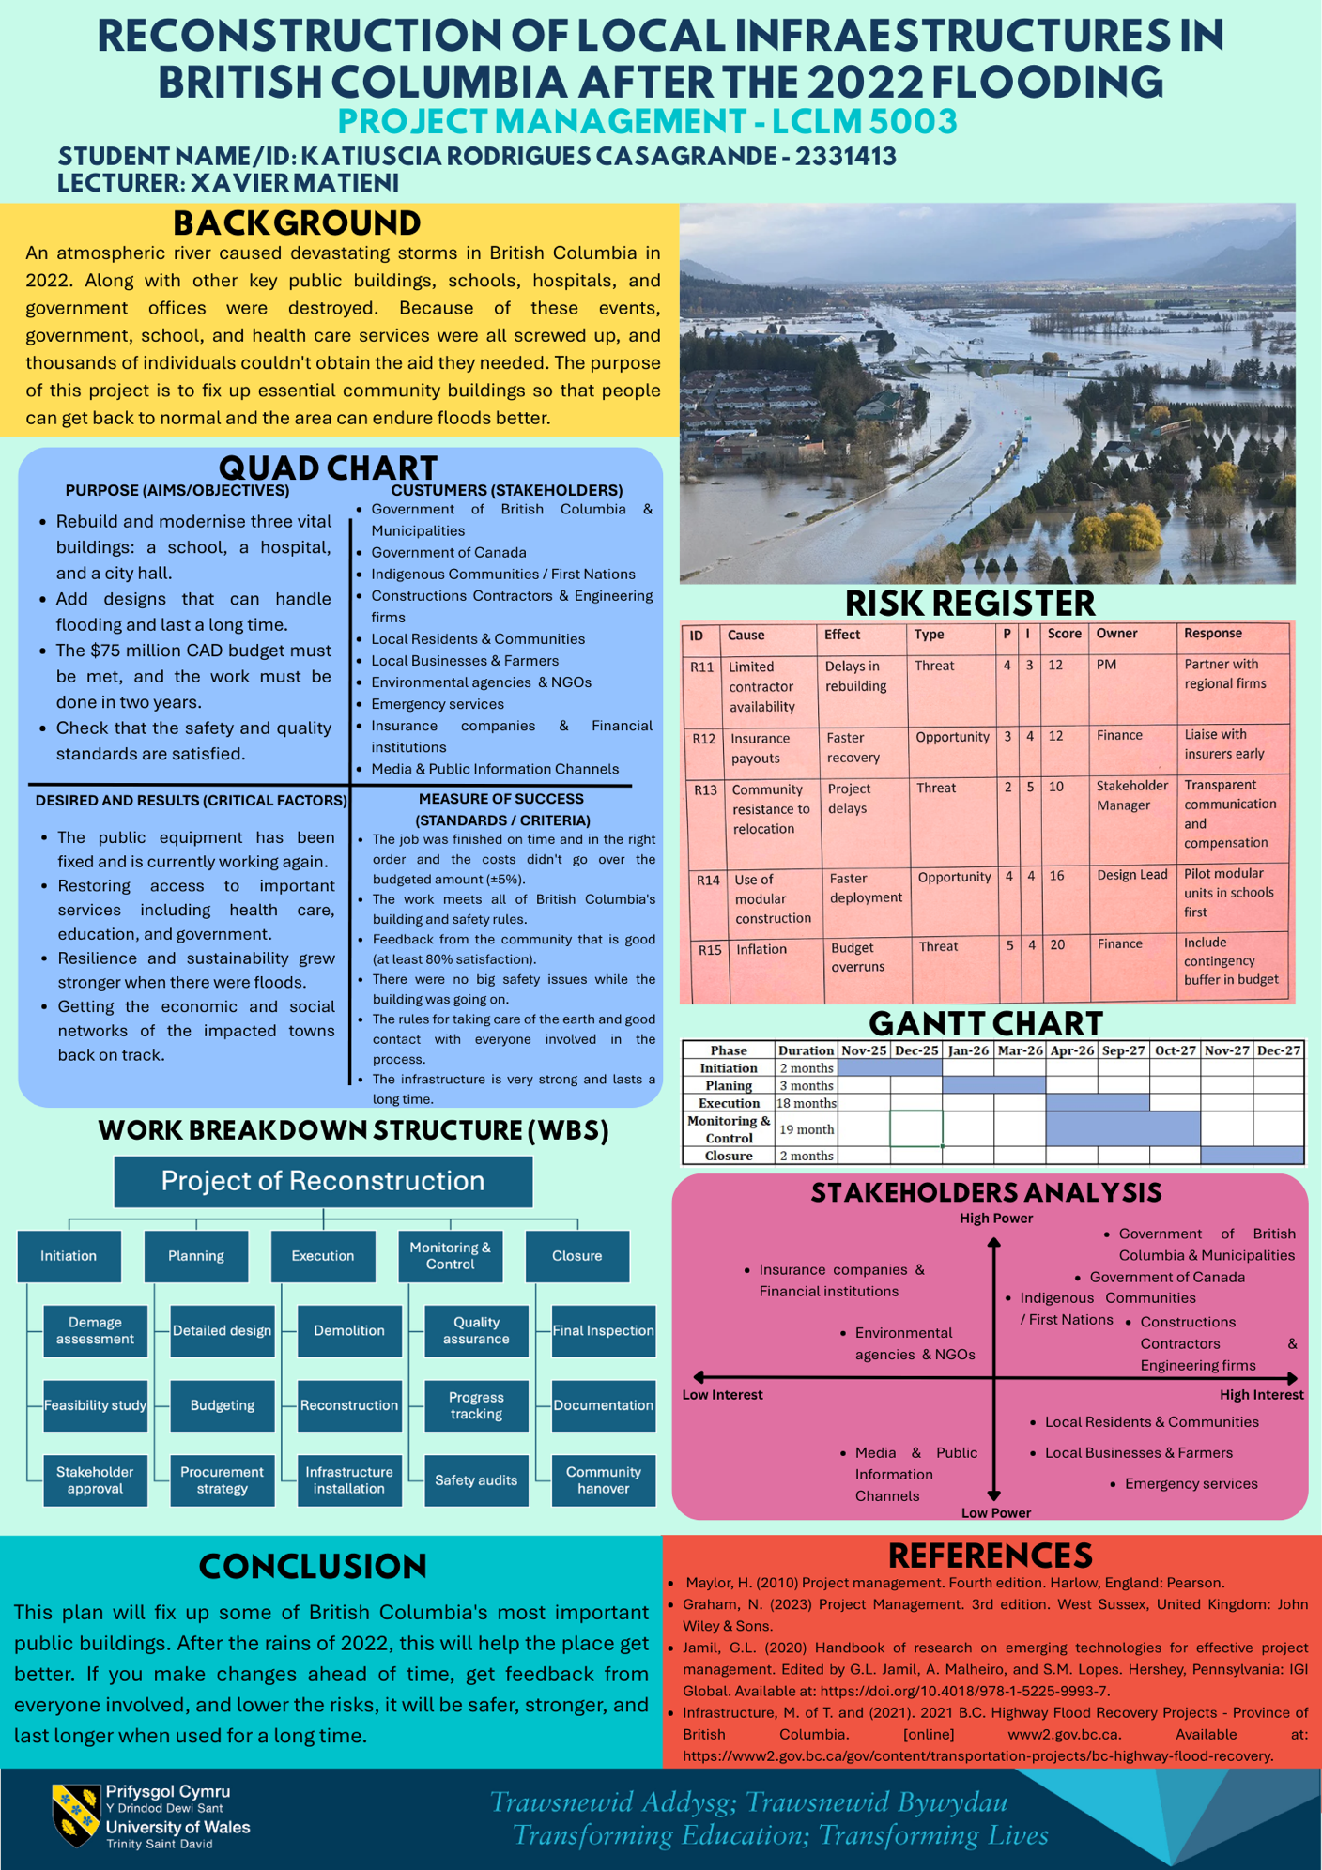

Part B
Reflections based on poster feedback

GIBB’S REFLECTIVE CYCLE: REFLECTION ON THE FEEDBACK FROM THE POSTER PRESENTED IN PART A

Based on the feedback from my lecturer and peers I made this reflection using Gibbs' Reflective Cycle (1988). This method is an organized structure that helps reflect on our experiences in a clear and systematic way. This model divides reflection into six stages, as seen below. By making this division, the model allows for deeper thinking, to evaluate our reactions in a block-like manner, critically analysing what worked or didn't work in our strategy/project/plan and consequently helping us understand how things happened, supporting critical thinking and continuous improvement.

My feedback was positive, but I need to improve the Gantt chart and speed up the timeline to make it more realistic. Using Gibb’s made me rethink my original plans and how they would affect the quality and success of the project, to develop a more effective plan. It helped me find errors and develop better ways to prepare, manage my time, and present the final work.

Description: I developed this project management poster to show how the 2022 storms impacted British Columbia's infrastructure and to propose the reconstruction of important community buildings. After reviewing the Gantt chart, some people told me it needed improvement. The biggest problem was that the timeline didn't make sense, and the project took too long to complete. The stages were too lengthy, and it wasn't clear how the tasks fit together or the order in which they would be executed. This comments didn't refer to the poster's content in general, but rather to the plan's clarity, precision, and speed.

Feelings: I was nervous to present it, but confident about my work. After the feedback and comparing my chart to when most projects jobs are done, I realised the Gantt chart wasn’t easy to read. I discovered that the Gantt chart is one of the most significant tools for managing a project and that a plan could not be as excellent if the timeframe isn't clear or possible. That made me want to modify things and learn how to better show when tasks will be done.

Evaluation: I think the feedback was beneficial because it motivated me to make a change to the project's execution timeline, which will make my project more efficient. The comments also revealed what needed to be corrected. My original Gantt chart gave the impression that the project wasn't responding to an emergency. In fact, it didn't seem to be working well.

Analysis: I realised that a Gantt chart should reflect not just the stages but also how well time is being used. In disaster recovery, people frequently undertake things at the same time to get them done faster. Because my chart didn't display these overlaps, it seemed like the project was proceeding slowly. It's also highly crucial for rebuilding jobs to be able to move rapidly, use modular building methods, and buy materials at the same time. I talked about these items in other portions of my board, such the risk register and the WBS. The Gantt chart didn't back up these ideas. When I looked at my chart, I found that it didn't match the goals put on other parts of the board. This made the project strategy less clear overall.

Conclusion: I understood how vital it is to build a Gantt chart that is easy to read and makes sense for the job. Also, deadlines should be reasonable, especially when you need to bring things back together quickly when something bad happens.

Action Plan: Shorten the steps and add tasks that occur simultaneously in the schedule. Use the project management concepts of acceleration and interruption when it makes sense. Compare my schedule with actual reconstruction plans to ensure it makes sense. To make the chart easier to understand, I will include clearer visual components such as varied bars, overlapping colours, and milestones. Furthermore, I will not wait until the last minute to ask for feedback; I will do so as soon as I start planning.

Part C
Project Management Plan

Table of Contents
1. INTRODUCTION 9
2. PROJECT DESCRIPTION 10
3. SCOPE 11
4. WORK BREAKDOWN STRUCTURE 12
5. QUAD CHART 13
6. GANTT CHART 14
7. STAKEHOLDERS' INVOLVEMENT 15
8. ALLOCATION OF RESOURCES 16
9. RISK ANALYSIS 17
10. CONCLUSION 17
11. REFERENCES 18

1. INTRODUCTION

An atmospheric river caused devastating storms in British Columbia in 2022. This led to major flooding and immeasurable damage to public and private buildings. As shown in the figures 1 and 2 below, roads and bridges were completely destroyed by the severe weather (Infrastructure, 2021). The natural phenomenon called Fiona caused such a serious situation that, in many places, people could not access basic services, and public buildings such as schools, hospitals, and government offices were damaged or destroyed. Because of these events, government, school, and health care services were all screwed up, and thousands of individuals couldn't obtain the aid they needed.

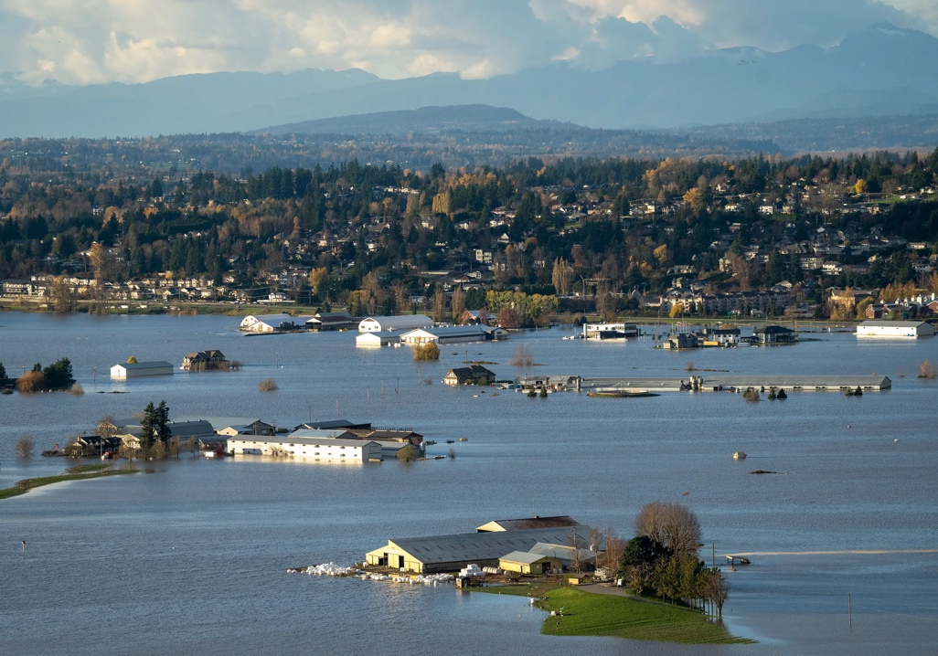

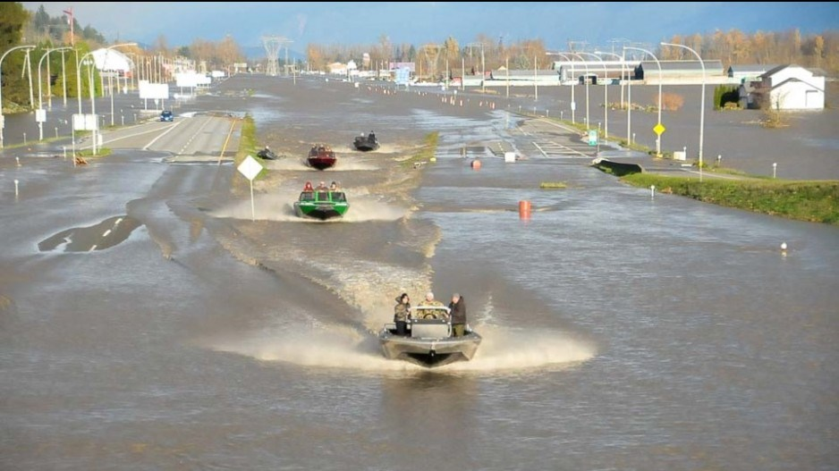
With the help of the Canadian government and the government of British Columbia, programs were established to respond to and recover from those emergencies (Canada, 2022). These projects aimed to repair the damage and provide aid to the most affected areas. Through emergency measures, short-term risks were reduced; however, the reconstruction of important infrastructure requires more careful planning. Conversely, it is known that daily life depends on public buildings such as schools, hospitals, etc. When such infrastructure is lost, the population of that community faces greater difficulties in rebuilding, which inevitably further burdens economic and social systems.

This Project Management Plan addresses a methodical way to rebuild three important public buildings: a school, a hospital, and a government office. In order to make these buildings better able to withstand possible future floods, this project aims to use better materials and plan the structures to make them less prone to flooding (Bentley, 2020) It is important to emphasize that the work must be completed on schedule, and that, as reflected in Part B of this project, a time adjustment will be made to the quad chart. In addition, money must be spent wisely, avoiding waste or unnecessary acquisitions. Established project management tools and methods will be used in this plan to help the stakeholders make intelligent decisions based on accurate analyses, in order to work together and keep risks under control (Roads, 2024) A good decision-making plan helps everyone involved to clearly understand how the work will be planned, executed, supervised, and completed.

2. PROJECT DESCRIPTION

The purpose of this project is to fix up essential community buildings so that people can get back to normal and the area can endure floods better. These buildings were chosen because they are important to the health and well-being of the community and to providing services (PMI, 2021). The school helps with learning and child development, the hospital provides basic medical care, and the government office handles public business and emergency planning. Instead of just putting the buildings back the way they were before, the project will update them, so they are more resistant to floods in the future. This includes making the supports stronger, letting water drain better, and using materials that can better handle water damage. The project's main goal is to make the buildings safer, more durable, and ready for long-term use. It does not add any extra emergency shelter features. The project will take about 12 months to complete and will have a structured lifecycle, starting with planning and starting with building and ending with handover. The budget for the whole thing is expected to be CAD 75 million, which will come from both municipal and federal recovery programs.

3. SCOPE

This project includes all activities necessary for the reconstruction of the three selected buildings that were damaged by the floods. This means that initial damage assessments, feasibility studies to ensure both technical and financial viability, as well as the duly detailed architectural and engineering design are within the scope. The project also covers the demolition of the destroyed structures, contracting of contractors, necessary materials and equipment to be used for the reconstruction of the buildings, using and guaranteeing improved systems so that they are resistant to possible new floods (Porter, 2020). It is important to emphasize that the guarantee of the quality of the project, safety inspections and compliance with construction standards are also ensured within the scope of the project so that the desired results at the end meet the required standards. Nevertheless, keeping stakeholders engaged throughout the process, maintaining good communication, and ensuring that final inspections, document verification, and formal handover of the works are part of the project scope are crucial. All these actions will promote greater transparency and accountability throughout the project execution, aiming to guarantee the best for the entire local community.

Also, it is important to emphasize that this project does not include the following activities: repair of roads, bridges, or transport routes; reconstruction of private homes or businesses; maintenance that persists after delivery; insurance or compensation arrangements. Heagney (2022) clarifies that this matter helps keep costs, deadlines, and quality under control and reduces the possibility of misunderstandings between stakeholders.

4. WORK BREAKDOWN STRUCTURE

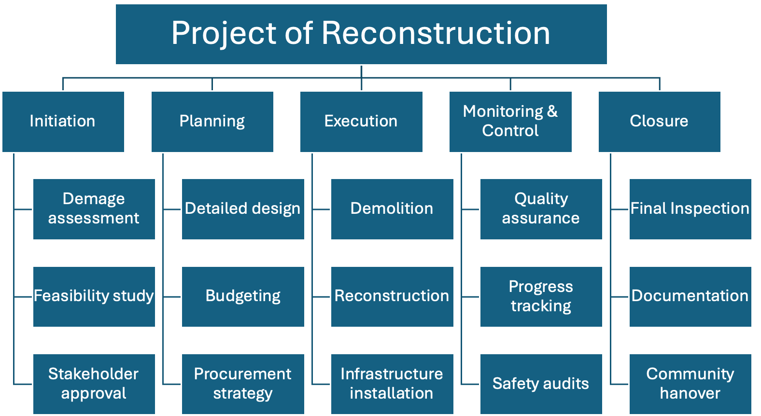

A Work Breakdown Structure (WBS) helps you keep track of projects by breaking them down into smaller tasks that are easier to handle. This helps you understand and do the job better (Datola, 2025) This method helps you organise your time, keep prices low, and plan. It's also easy to give out tasks and talk to people who matter. As part of the project to rebuild local infrastructure in British Columbia, the WBS is broken up into three levels. Initiation, Planning, Execution, Monitoring and Control, and Closure are the main stages of the project that make up Level 2. The important tasks that need to be done in each phase are covered in Level 3, such as checking for quality, assessing damage, designing in detail, tearing down, and handing over the keys. By setting up the project in this way, the WBS makes sure that all the work that needs to be done is clearly put out and given to the right people (Vázquez, Solís and Marrero, 2024). This makes it easier to plan, budget, and manage resources. It also lowers the chance of skipping jobs or having gaps in the scope.

5. QUAD CHART

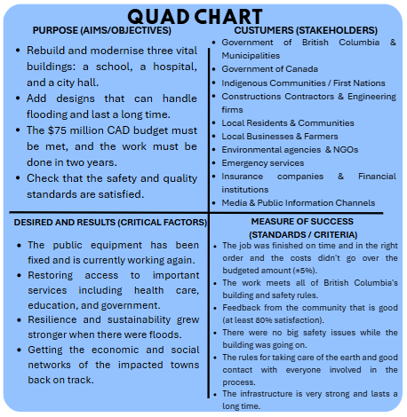
(change chart – 2 years, its 12 months now)

The Quad Chart breaks down information into four easy-to-understand parts that can be used to communicate effectively (Ford and Wei, 2015). The main objective is to provide decision-makers and other project stakeholders with a quick yet complete description of the objectives, stakeholders, expected results, and success criteria. This leads to more honesty and better decision-making, as visual summary tools like Quad Chart helps engage everyone, ensure everyone knows what to expect, and clarify any doubts.

For example, in the project in question, three important public buildings need to be replaced and revitalized. The cost is 75 million Canadian dollars, the completion deadline is 12 months, and the work must meet safety and quality standards (Shirley, 2020). The fact that there are so many public, private, and community partners in the Clients (partners) quadrant demonstrates the complexity of the task. This makes it clear that the government and the community need to work together. Based on the Success Measures, it becomes clear what the rules are for time, money, safety, rule compliance, and long-term security. Helping people recover after a disaster, restoring essential public services, and making cities and industries less prone to flooding are all aspects of the Desired Outcomes. The project objectives, the people involved, and the ways to measure its progress are all aligned, as demonstrated by the Quadrant Chart.

6. GANTT CHART

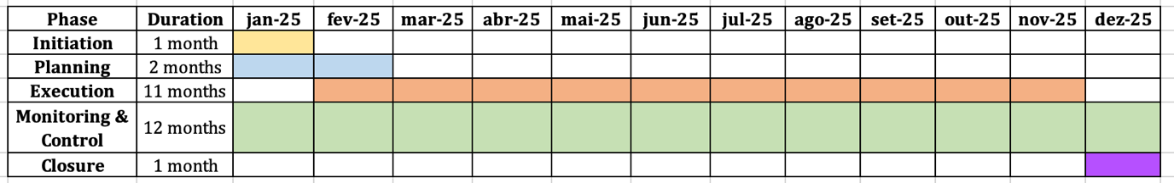

The Gantt chart is one of the most common tools for planning projects. It represents how tasks will be done over time. It tells you what jobs need to be done, how long they will take, when they will start and stop, and how they fit in with other things. The basic purpose of a Gantt chart is to assist project managers plan, keep track of, and manage time so that work gets done in the appropriate order and on time (Maylor, 2010). A decent Gantt chart can help with planning, transparency, and making sensible choices when working on big projects, especially ones that involve public infrastructure and disaster recovery. A Gantt chart can do more than just show the steps of a job. It should show how to use time well, like what chores may be done at the same time. After a disaster, time is of the essence, and processes like design, procurement, and early construction planning typically need to be done at the same time to get the job done faster (Graham, 2023). If a Gantt chart doesn't display these overlaps, it could look like things are going slowly and not illustrate how recovery actually works. When the original project plan was looked over, this was one of the biggest concerns that came up.

The timeline appeared overly long and didn't match how quickly the project needed to be done. After understanding that, the Gantt Chart for the project was updated to show shorter phases and tasks that happened at the same time (Bentley, 2020). In early January 2026, work will begin on the project, including planning, monitoring, and regulating it. This proves that approvals, design development, and project management all happen at the same time. Because of quick building methods, modular building approaches, and procuring supplies early, the work will start in February 2026 and last for eleven months (Jamil, 2020). The project ends in December 2026 with a one-month Closure phase that provides everyone time to check things over, fill out paperwork, and pass things off. This new Gantt chart works better with the project's Work Breakdown Structure and risk register. It also supports the overall project plan. The Gantt chart shows tasks that overlap, important milestones, and realistic deadlines, which makes the timetable clearer and gives people more faith in the project's success (Morris, 2022). This is especially significant for persons who work on disaster recovery programs in the public sector.

7. STAKEHOLDERS' INVOLVEMENT

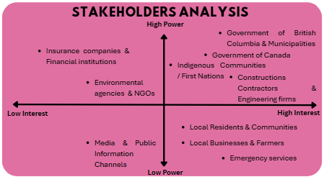

Those who have a voice in a project or will be affected by its outcomes are called stakeholders (Harrin, 2020). For public construction projects, especially after a disaster, managing people with varying levels of power and interest is crucial for the project's success and community acceptance. The participants in this project's stakeholder analysis are grouped based on their power and interests. This helps define the best way to engage them. The governments of British Columbia and Canada, the affected cities, construction companies, engineering firms, and Indigenous communities are just a few of the powerful and interested groups that need to be involved closely and regularly. This is because they have significant influence on government decisions, funding, and approvals. Environmental groups, insurance companies, and banks are important stakeholders who may not be interested in your work. Provide them with regular reports to keep them satisfied. They can influence the flow of funds and compliance requirements. To maintain public trust and reduce opposition, people who care deeply about the project but lack significant power should be kept informed and involved, even if they don't have official control over it. This includes residents, communities, businesses, farmers, and emergency services. The media and public information channels, which don't have much power or stake, also need simple oversight to ensure they disseminate accurate information. It's possible to discuss the project more clearly, avoid arguments, and ensure everyone on the team knows what is expected of them through this planning. This is especially important when working on complex and sensitive disaster recovery projects.

8. ALLOCATION OF RESOURCES

It is really important to make good planning and use your resources effectively to get back on normal life after a calamity. The Project Manager has the responsibility to make sure that everything proceeds according to plan (Mircea and Nguyen, 2023). Engineers and architects make sure that the technical and design needs are addressed, as do the construction teams that conduct the job on site. Health and safety officers make sure that safety laws are observed, and stakeholder engagement personnel help the authorities and the communities that may be affected talk to each other. People can stay on target and make swift decisions when they work together.

The 75 million Canadian dollars will be needed to plan, develop, acquire materials, and administer the project. In case of inflation, problems with the supply chain, or modifications that weren't accounted for on site, there is an extra budget for the project. Maylor (2010) says that planning ahead for what could go wrong will help keep costs down and minimise the possibility that intricate projects would go over budget. The site needs building materials, specialised tools, and portable toilets for safety and to keep things running smoothly (Jamil, 2020). These tools need to be ready to go all the time so that work may go on. To ensure that money and resources are being used correctly, it is necessary keep track of spending, report on progress, and check quality every single day. Distributing people, money, and resources always can help projects stay on track, handle risks, and meet their goals. When government needs to be fast and go back to work right away, this is crucial.

9. RISK ANALYSIS

In projects after a disaster, managing risk is very important (Holmes and APM, 2015). The following risks have been found:

ID | CAUSE | EFFECT | TYPE | P | I | SCORE | OWNER | RESPONSE
R11 | Limited contractor availability | Delays in rebuilding | Threat | 4 | 3 | 12 | PM | Partner with regional firms
R12 | Insurance payouts | Faster recovery | Opportunity | 3 | 4 | 12 | Finance | Liaise with insurers early
R13 | Community resistance to relocation | Project delays | Threat | 2 | 5 | 10 | Stakeholder Manager | Transparent communication and compensation
R14 | Use of modular construction | Faster deployment | Opportunity | 4 | 4 | 16 | Design Lead | Pilot modular units in schools first
R15 | Inflation | Budget overruns | Threat | 5 | 4 | 20 | Finance | Include contingency buffer in budget

Depending on the project's progress, risks will be analysed, and mitigation actions will be updated as needed (Grit, 2021). In other words, the entire project lifecycle will be meticulously monitored.

10. CONCLUSION

As is well known and has been extensively demonstrated in this project, the 2022 floods in British Columbia caused severe damage to essential public infrastructure, disrupting community life on an unimaginable scale. This Project Management Plan provides a clear and structured approach to the reconstruction of important public buildings, aiming to support long-term recovery and resilience. By applying established project management tools, setting realistic timelines, and effectively engaging stakeholders, the project seeks to deliver safe, modern, and durable facilities. This plan will fix up some of British Columbia's most important public buildings and reflects lessons learned and is aligned with public sector recovery priorities. This will help the place get better. If you make changes ahead of time, get feedback from everyone involved, and lower the risks, it will be safer, stronger, and last longer when used for a long time.

11. REFERENCES

Bentley, C. (2020) Adaptable project management : a combination of agile and project management for All (PM4A). Cambridgeshire, England: IT Governance Publishing.

Canada, P.S. (2022). The Government of Canada marks one year since the historic and tragic floods in British Columbia. [online] Canada.ca. Available at: https://www.canada.ca/en/public-safety-canada/news/2022/11/the-government-of-canada-marks-one-year-since-the-historic-and-tragic-floods-in-british-columbia0.html [Accessed 7 Dec. 2025].

Datola, G. et al. (2025) ‘The feasibility of Nature-Based Solution (NBS) interventions: estimating the cost using the Work Breakdown Structure (WBS): La fattibilità degli interventi Nature-Based Solutions (NBS): la stima dei costi attraverso il modello Work Breakdown Structure (WBS)’, Valori e valutazioni, 37, pp. 183–208. Available at: https://doi.org/10.48264/VVSIEV-20253711.

Maylor, H. (2010) Project management. Fourth edition. Harlow, England: Pearson.

Morris, D. (2022) Agile project management in easy steps, 3rd edition. Leamington Spa: In Easy Steps. Available at: https://ezproxy.uwtsd.ac.uk/login?url=https://www.vlebooks.com/product/openreader?id=TrinityStD&accId=8886856&isbn=9781840789881&uid=^u.

Mircea, M. and Nguyen, T.M. (eds) (2023) Project Management - New Trends and Applications. London: IntechOpen.

Ford, J.D. and Wei, T. (2015) ‘Quad Charts in the Classroom to Reinforce Technical Communication Fundamentals’, Journal of technical writing and communication, 45(3), pp. 275–284. Available at: https://doi.org/10.1177/0047281615578848.

Graham, N. (2023) Project Management. 3rd edition. West Sussex, United Kingdom: John Wiley & Sons.

Grit, R. (2021) Project management : a practical approach. 5th ed. London ; Routledge.

Harrin, E. (2020) Engaging stakeholders on projects : how to harness people power. Princes Risborough, Buckinghamshire: Association for Project Management.

Heagney, J. (2022) Fundamentals of Project Management. 6th ed. Nashville: HarperCollins Leadership.

Holmes, G. and Association for Project Management. (2015) Planning, scheduling, monitoring and control : the practical project management of time, cost and risk. Princes Risborough, Buckinghamshire: Association For Project Management.

Jamil, G.L. (2020) Handbook of research on emerging technologies for effective project management. Edited by G.L. Jamil, A. Malheiro, and S.M. Lopes. Hershey, Pennsylvania: IGI Global. Available at: https://doi.org/10.4018/978-1-5225-9993-7.

Infrastructure, M. of T. and (2021). 2021 B.C. Highway Flood Recovery Projects - Province of British Columbia. [online] www2.gov.bc.ca. Available at: https://www2.gov.bc.ca/gov/content/transportation-projects/bc-highway-flood-recovery.

Porter, B.E. and The American Society of Mechanical Engineers, publisher (2020) International Project Management for Technical Professionals, Second Edition. Second edition. New York, N.Y: The American Society of Mechanical Engineers,. Available at: https://doi.org/10.1115/1.883563.

Project Management Institute. (2021) A guide to the project management body of knowledge (PMBOK guide). Seventh edition. Newtown Square, Pa: Project Management Institute.

Roads, R. (2024). Reconnecting Roads After Massive Flooding. [online] Pmi.org. Available at: https://www.pmi.org/business-solutions/case-studies/reconnecting-roads-after-massive-flooding.

Shirley, D.L. (2020) Project management for healthcare. Second edition. Boca Raton: CRC Press, Taylor & Francis Group.

Vázquez-López, E., Solís-Guzmán, J. and Marrero, M. (2024) ‘A Work Breakdown Structure for Estimating Building Life Cycle Cost Aligned with Sustainable Assessment—Application to Functional Costs’, Buildings (Basel), 14(4), p. 1119. Available at: https://doi.org/10.3390/buildings14041119.

