Student Name: Ayesha Siddiqua
Student number: 2233548
Module: Marketing Essentials (BMIH4005)
Lecturer's Name: Ruth Taylor Davies
Word count:1373

Table of Contents
Introduction 3
Situation Analysis 3
Company: SWOT Analysis of Premier Inn 3
Customers: Segmentation and Target market 4
Competitors: Perceptual Positioning Map for Premier Inn 4
Collaborators: B2B Relationships with other Parties for Premier Inn 5
Climate: PESTLE Analysis of Premier Inn 5
Objectives 6
SMART Target 6
Strategy 6
Tactics 7
Marketing Mix of Premier Inn 7
Product 7
Place 7
Price 8
Promotion 8
Action 9
Gantt Chart Marketing Activities 9
Control 9
Conclusion 10
References 11
Appendix 13

Introduction
The marketing plan provides detailed planning about the business. In this study, the marketing plan of Hotel Premier Inn will be discussed. For understanding the market and introducing its service to the clients, the report has very important. SOSTAC model includes six steps. Situation, objectives, strategy, tactics, action and control are the steps of that model. Marketing plan will be done through this model (Stephenson, 2020).The four Ps of the marketing mix will be discussed to understand the business position. Also, a SWOT analysis will be conducted to understand the condition of the hotel. SMART objectives will be used to understand the organisational goal. The report will brief the whole in the discussion section.

Situation Analysis

Company: SWOT Analysis of Premier Inn
The strength of Premier Inn will be its dedicated workforce. They work for the organisation and also do good for the organisation. Also, Premier Inn has good financial stability. So, it is also a strength for the business. The major weakness is it has less facility for training. The employees do not get proper training. Premier in has potential customers in the market, and they are very keen to get service from the hotel. This is an opportunity for the hotel. Also, there
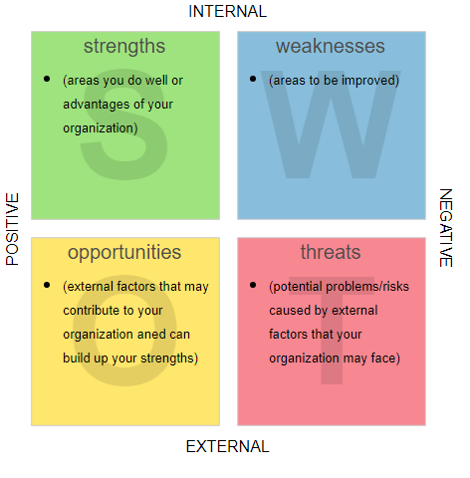
Figure 1: SWOT analysis
Source: (Caldito et al., 2015)
are a threat to the organisation. Existing competitors like Holiday Inn, Sheraton, and others make the business more competitive (Caldito et al., 2015).

Customers: Segmentation and Target Market
Premier Inn's market will be segmented on the basis of demography, geography, Psychograph, and behavior. Premier Inn can target customers who are above 16, and they have the right to stay in a hotel. Also, they are open to both males and females. They provide a couple-room and family room beside a single room(Dolnicar, S., 2020). They also hope that the customers' behavior will be good enough. The hotel provides service to every class of people. From reach to lower-income people both have access to the hotel (Ahani et al, 2019).

Competitors: Perceptual Positioning Map for Premier Inn
A perceptual map provides the scenario of the standing of the business in the market and the condition of its competitors. The main competitor of Premier Inn is Hilton Hotel, Holiday Inn, Travelodge, and Raffles (Holliman and Rowley, 2014). Among all the competitors, the Premier Inn has a very good position.
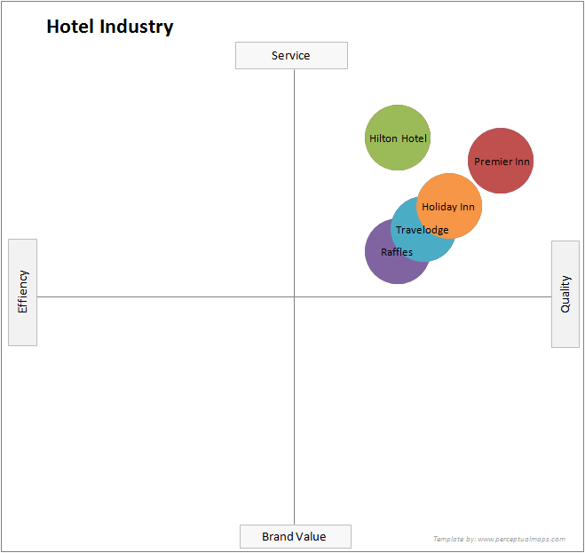
Figure 2: Perceptual Map (Source: Own)

Collaborators: B2B Relationships with other Parties for Premier Inn
Any business organisation needs many parties for its operation. There should be a proper relationship between the parties. The most important one is the business-to-business relationship. The Premier Inn has a partnership with Emirates Group and Whitbread Plc. Those are the main collaborators of the business (Minerbo et al., 2021).

Climate: PESTLE Analysis of Premier Inn
Premier Inn will look for political stability in the region where it will start its journey. Also, the tax rate of that country needs to be followed. More tax rates can make the profit lower. Also, to do business successfully, they should consider economic stability. Now the inflation rate is getting high in almost every country. Premier Inn should keep that in mind(Li, 2018). Also, the business should use some advanced technology in its operation. The use of the latest technology will make the business more updated than its competitors. Also, the business should be careful

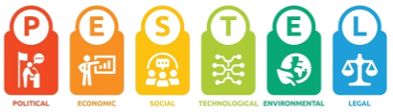
Figure 3: PESTLE analysis
Source: (Rastogi and Trivedi, 2016)
towards the environment. They should provide dustbins on every floor of their hotel. Also, they should encourage the customers not to misuse water(Rastogi and Trivedi, 2016). And finally, they should consider the law and regulations of that country to run the business.

Objectives

SMART Target
Objectives should be SMART. Specific objectives are a powerhouse of the marketing plan. Premier Inn is a hotel business organisation, and they will provide the best service to their customers. These objectives should be measurable. They will try to provide the service on a scale of 10. Their target will be to achieve 10 out of 10. These objectives are achievable if the organisation provides the best service to its customers(Burlton, 2014). Also, if they provide the service at a standard rate, the other competitors are giving the services at their best level. So to compete with them and survive, they should provide the service at their best in the market. From the beginning, it should try to fulfill the SMART objectives.

Strategy
The value proposition is the advantages or offers that a service or product serves to its customers. In the hotel business, the best quality service is the main offer that is delivered to its customers. But the customers should know about the offers and feel that the offers are attractive. Premier Inn will provide complimentary breakfast for the guest(Bocken et al., 2016). Also, it will offer different kinds of packages. It will have Ac and non-AC rooms, and every room will be well-decorated. They will also provide a WiFi facility, and in every room, there will be a television.

Tactics

Marketing Mix
The marketing mix has four elements.

Product: The product of Premier Inn will be its service. They will have quality service, and they will target more than 90 percent of the client who will have a positive review of their service(Londhe, 2014). Also, their breakfast facilities, taxi facilities, and other opportunities are a product of their business. The hotel will also provide water and other necessary things like towels, soap, and an air freshener free of cost.

Place: The appropriate place for a hotel should be beside some attractive place or some necessary place. It could be beside the bus stand, railways, airport, or some tourist point. The place of the Premier Inn will be beside the tourist spot. The main customers of the business are the
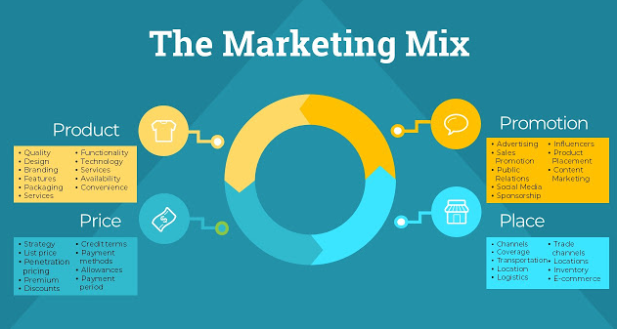
Figure 4: Marketing Mix
Source: (Darmawan and Grenier, 2021)
tourist. But the main thing is reaching the target customers(Darmawan and Grenier, 2021). For that, the hotel will update its location on Google Maps and also will have banners and a billboard beside every important point, and there the location's address will be written.
Price: The price should be based on the service provided and it will be adjustable with the quality. There are many hotels that provide lower quality service but has a huge amount of staying cost(Nagle and Muller, 2018). But Premier Inn will have a standard price for its services. They will have a luxury package, an economical package, and a standard package (Londhe, 2014).

Promotion: Promotion is an important weapon for marketing. Premier Inn will use promotion as a tool for reaching its customers. They will select online and offline modes. They will advertise on social media and also in newspapers. Also, they will provide advertising on television and give advertise on some target countries' television as they will have many customers from them (Darmawan and Grenier, 2021).

Action

Gantt Chart Marketing Activities
Gantt Chart helps the business to finish its goal in time. When one wants to finish the goals within a desired time period, he or she uses the chart to understand the progress of the task (Sharon and Dori, 2017.). Premier Inn uses Gantt Chart to fulfilling the marketing plan.
Activities | 01/03/23 | 08/03/23 | 15/03/23 | 20/03/23 | 25/03/23 | 30/03/23
Promotion
Direct Service
Client Relation
Media Marketing
Figure 5: Gantt Chart
Source: Own

Control
The Premier Inn hotel is one of the best hotels that is serving in the UK. The marketing plan will give them new ideas about business, and through this, they will capture the market. The success of the business will be determined by how many clients the business can achieve. Premier Inn will have a good management group(Geetha et al, 2017). They will emphasize bringing new and potential customers. If new customer increases, the business will be successful (Cserháti and Szabó, 2014).

Conclusion
A marketing plan is essential for every business. Service businesses like hotels, travel agencies, airlines, and others should have a proper marketing plan. For this reason, Premier Inn also makes a marketing plan. It is not easy to make a marketing plan. There are lots of challenges associated with it. It is time-bound. The project should be finished within a time period. Also, there is a financial crisis.

References
- Ahani, A., Nilashi, M., Ibrahim, O., Sanzogni, L. and Weaven, S., 2019. Market segmentation and travel choice prediction in Spa hotels through TripAdvisor’s online reviews. International Journal of Hospitality Management, 80, pp.52-77.
- Bocken, N.M., De Pauw, I., Bakker, C. and Van Der Grinten, B., 2016. Product design and business model strategies for a circular economy. Journal of industrial and production engineering, 33(5), pp.308-320.
- Burlton, R.T., 2014. Delivering business strategy through process management. In Handbook on Business Process Management 2: Strategic Alignment, Governance, People and Culture (pp. 45-78). Berlin, Heidelberg: Springer Berlin Heidelberg.
- Caldito, L.A., Dimanche, F., Mazina, A., Fedulin, A.A., Vetitnev, A., Artal-Tur, A., Apukhtin, A., Sánchez, A.G., Rangel, C.R., Allen, D. and Ward-Perkins, D., 2015. Business tourism in Russia: overview and SWOT analysis. NETOUR.
- Cserháti, G. and Szabó, L., 2014. The relationship between success criteria and success factors in organisational event projects. International journal of project management, 32(4), pp.613-624.
- Darmawan, D. and Grenier, E., 2021. Competitive Advantage and Service Marketing Mix. Journal of Social Science Studies (JOS3), 1(2), pp.75-80.
- Dolnicar, S., 2020. Market segmentation analysis in tourism: a perspective paper. Tourism Review, 75(1), pp.45-48.
- Geetha, M., Singha, P. and Sinha, S., 2017. Relationship between customer sentiment and online customer ratings for hotels-An empirical analysis. Tourism Management, 61, pp.43-54.
- Holliman, G. and Rowley, J., 2014. Business to business digital content marketing: marketers' perceptions of best practice. Journal of research in interactive marketing, 8(4), pp.269-293.
- Li, S., 2018. A PESTLE Analysis of the Cryptocurrency Industry: An Investment Perspective.
- Londhe, B.R., 2014. Marketing mix for next-generation marketing. Procedia Economics and Finance, 11, pp.335-340.
- Minerbo, C., Kleinaltenkamp, M. and Brito, L.A.L., 2021. Unpacking value creation and capture in B2B relationships. Industrial Marketing Management, 92, pp.163-177.
- Nagle, T.T. and Muller, G., 2018. The strategy and tactics of pricing. Routledge.
- Rastogi, N.I.T.A.N.K. and Trivedi, M.K., 2016. PESTLE technique–a tool to identify external risks in construction projects. International Research Journal of Engineering and Technology (IRJET), 3(1), pp.384-388.
- Sharon, A. and Dori, D., 2017. Model‐Based Project‐Product Lifecycle Management and Gantt Chart Models: A Comparative Study. Systems engineering, 20(5), pp.447-466.
- Stephenson, R., 2020. How to write a digital marketing plan using PR Smith’s SOSTAC planning model. Verfügbar unter: https://digitaldimensions4u. com/how-to-write-a-digital-marketingplan-sostac-model/(Zugriff am 31.07. 2021).

Appendices:

Activities | 01/03/23 | 08/03/23 | 15/03/23 | 20/03/23 | 25/03/23 | 30/03/23
Promotion
Direct Service
Client Relation
Media Marketing
Figure 5: Gantt Chart
Source: Own

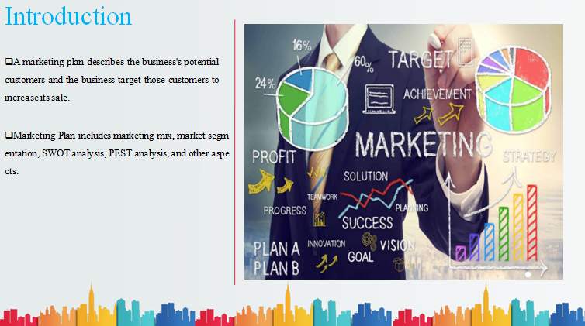

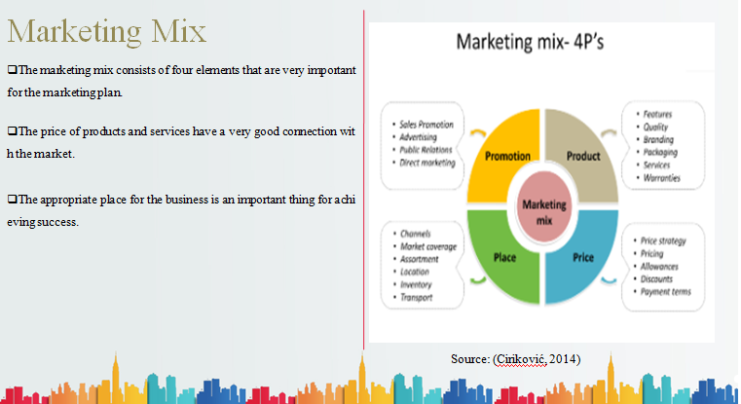
Source: (Cinkovic,2014)

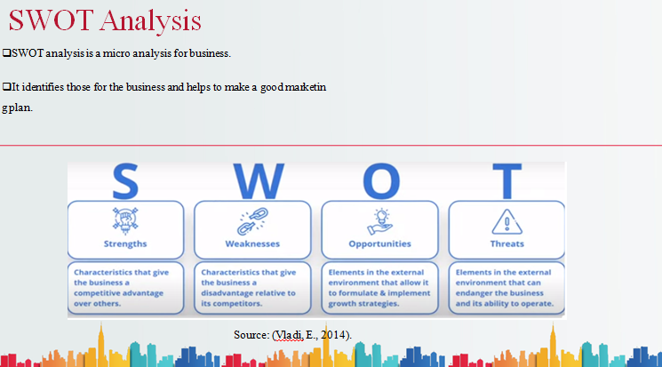
Source: (Vladi.,E.,2014)

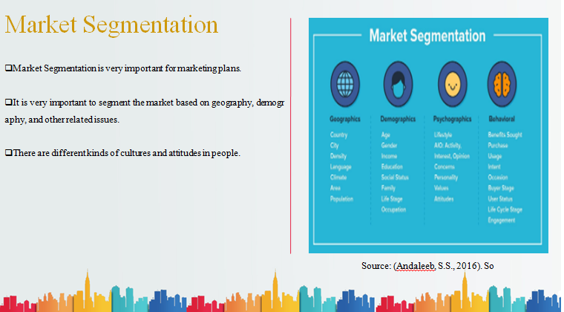
Source: (Andaleeb,S.S.,2016)

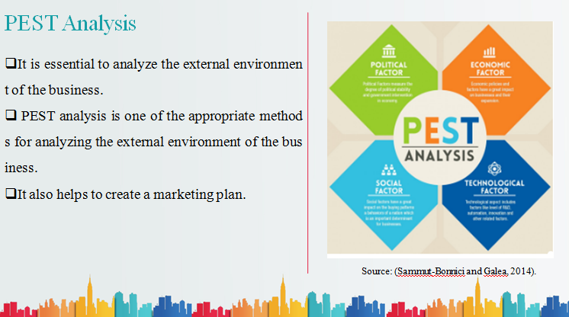
Source: (Sammut-Bonnici and Galea, 2014)

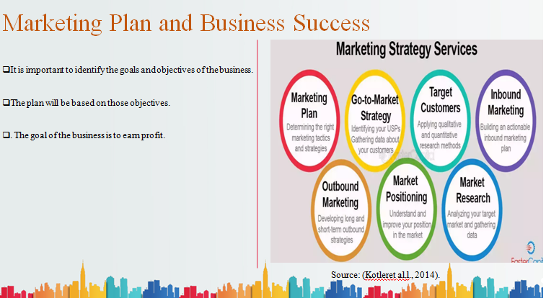
Source: (Kotler et, al.,2014)
References
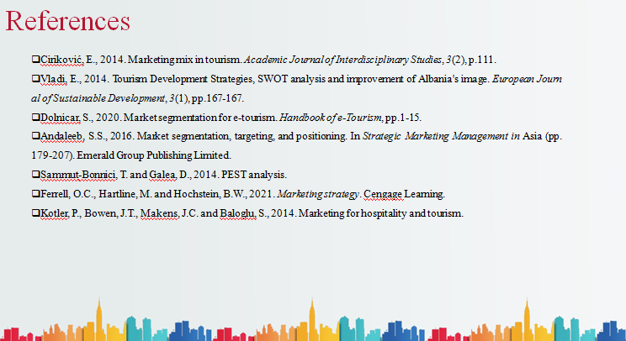
- Andaleeb, S.S., 2016. Market segmentation, targeting, and positioning. In Strategic Marketing Management in Asia (pp. 179-207). Emerald Group Publishing Limited.
- Ciriković, E., 2014. Marketing mix in tourism. Academic Journal of Interdisciplinary Studies, 3(2), p.111.
- Dolnicar, S., 2020. Market segmentation for e-tourism. Handbook of e-Tourism, pp.1-15.
- Ferrell, O.C., Hartline, M. and Hochstein, B.W., 2021. Marketing strategy. Cengage Learning.
- Kotler, P., Bowen, J.T., Makens, J.C. and Baloglu, S., 2014. Marketing for hospitality and tourism.
- Sammut-Bonnici, T. and Galea, D., 2014. PEST analysis.
- Vladi, E., 2014. Tourism Development Strategies, SWOT analysis and improvement of Albania's image. European Journal of Sustainable Development, 3(1), pp.167-167.

