DS 1 Template

My Screenshots/Photos
- Please add 4–6 screenshots or photos of your digital life.
- You can use your phone or laptop.
- For each screenshot, write one or two sentences explaining what it shows.

Screenshot/Photo 1
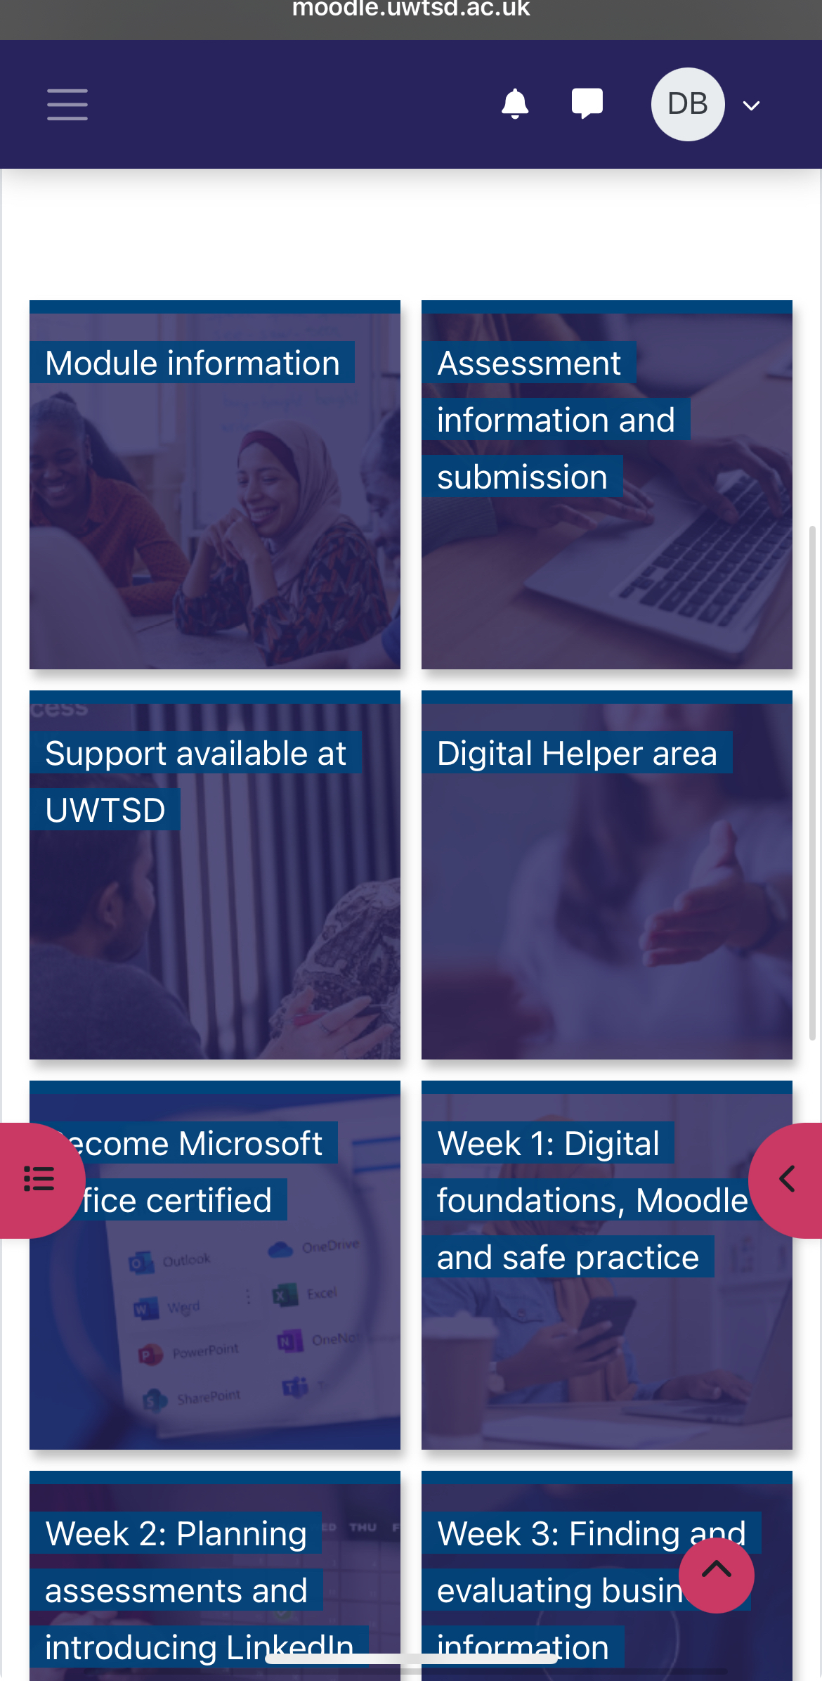
This a screenshot of my modules is very helpful in class and its guids you the task you need to do its very useful

Screenshot/Photo 2


This is Netflix I like to watch new films and series that are in trend and interesting on my phone on the tv ,etc

Screenshot/Photo 3

This is snapchat I use it to streak with friend and also take pictures and pictures video call my friend and family

Screenshot/Photo 4
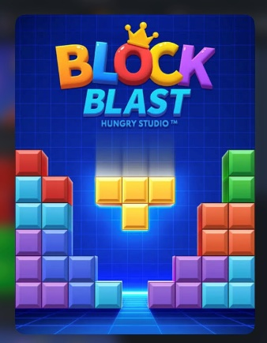
This is block blast I like to play on my free time and when im bord

Screenshot/Photo 5
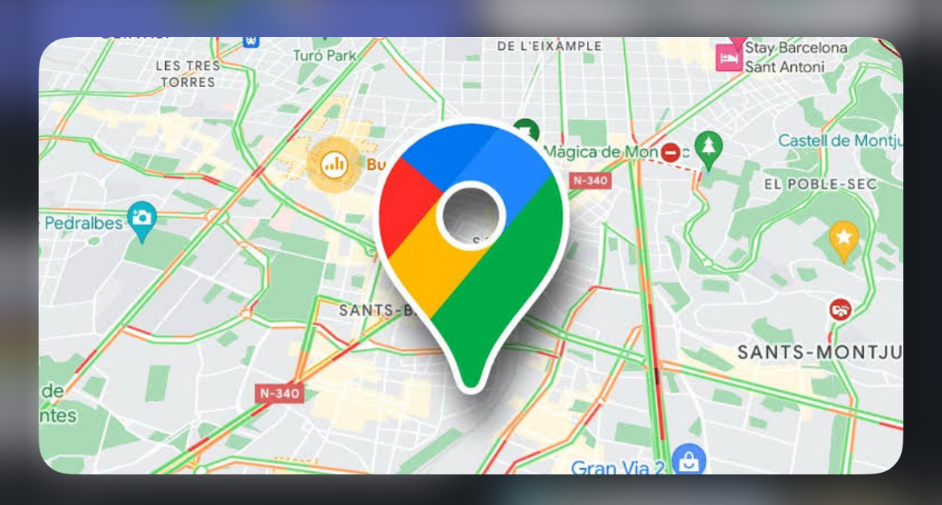
This is a screenshot if google maps I used it when I need to get somewhere and when im lost its helps you navigate different directions

Screenshot/Photo 6
[Insert Photo/Screenshot below]

[Write what this shows of your digital life]

My Short Reflection
- Write 5–8 simple sentences about your digital life.
- You can use the sentence starters below if helpful.
I use digital tools to ,check for the class work and tasks
I feel confident when I, use the modules and google to find information
I want to improve, my IT skills
I often use these tools, when I’m in class and to do homework
I sometimes feel nervous about, nothing
I hope this module helps me, improve my skills and make me understand more about it
Digital skills are important for me, because its very useful they enable me to access information, solve problems, and stay connected with others and everyday task

Sentence starters
- I use digital tools to …
- I feel confident when I …
- I want to improve …
- I often use these tools: …
- I sometimes feel nervous about …
- I hope this module will help me …
- Digital skills are important for me because …
You can write more if you want.

Submission Checklist
Before you submit, please check:
​​​ ☒ I added 4–6 screenshots
☐ I wrote short sentences for each screenshot
☐ I wrote my short reflection
☐ My work is my own
☐ My file opens correctly
​​☐ My file opens correctly

