

Managing Projects in the Organisation
Assessment 2 — Individual Report
Building the Bridge
Planning and Managing the ArtBridge Social Enterprise Gallery
A Critical Review of the Project Management Tools and Techniques Used to Plan and Deliver the Project
Programme: BA Developing Leadership and Management
Module: Managing Projects in the Organisation (BMSW5009)
Module Lecturer: Maggie Zhang
Group: Group 4 — ArtBridge
Student: Cristian Dinicuta
Student ID: 2323940
Project role: Stakeholder & Communication Lead
Submission date: 8 July 2026

Contents
Executive Summary 3
1. Introduction 3
2. Findings 3
2.1 Project management tools and techniques in general 3
2.2 How the tools were used in the ArtBridge project 5
2.3 Communication and stakeholders 7
3. Conclusion 8
4. Recommendations for future improvement 8
Reference List 10

Executive Summary
ArtBridge is a proposed small-scale social enterprise gallery designed to widen creative access for disadvantaged young people and emerging local artists. This report reflects critically on how our group planned and managed the project across its full lifecycle, from initiation through to evaluation. It examines the main tools we relied on — scope statements, a work breakdown structure, a Gantt chart, a risk matrix, stakeholder analysis and the Iron Triangle — and weighs what each contributed against its limitations. My overall judgement is that the planning tools gave the project a workable structure, and that stakeholder analysis and communication planning did more to hold it together than any scheduling tool. The report closes with honest lessons for managing such a project better.

1. Introduction
ArtBridge is a community arts gallery proposed by our six-person student group as a social enterprise: a venture with a genuine social mission, funded through a mix of income streams rather than a single grant (Clegg, Skyttermoen and Vaagaasar, 2020). The idea grew from a recognisable local problem. Many young people in the area face social isolation and have little access to affordable creative space, while emerging artists struggle to find somewhere to exhibit and connect with an audience. ArtBridge responds by offering inclusive workshops in visual art, music, poetry and performance, alongside exhibition and mentoring opportunities, delivered as a realistic twelve-month pilot rather than a finished organisation.
The project’s aim is to establish a financially sustainable gallery that improves creative access and inclusion for disadvantaged young people and local creatives. Its objectives are concrete: deliver at least twelve workshops, hold at least one community exhibition or open-mic event, secure two or three active partnerships, engage more than eighty participants, and build a mixed-income funding base. This report does not re-describe the proposal. Instead it assesses, critically, how well the tools and techniques we used served the plan, how we communicated with stakeholders, and what we would change. It follows the project across the whole lifecycle, from initiation through to delivery and evaluation.

2. Findings

2.1 Project management tools and techniques in general
Project management offers a familiar toolkit for turning an idea into a deliverable plan, yet every tool carries assumptions worth questioning. Heerkens (2015) describes the discipline as a structured way of organising unique, temporary work, and the individual tools are simply the means of doing so. Scope management is the natural starting point: a scope statement sets out what a project will and will not deliver, and Heagney (2016) treats this boundary-setting as the foundation on which realistic planning depends. The work breakdown structure (WBS) then decomposes the scope into manageable packages, widely regarded as the backbone of scheduling and cost estimation (Clegg, Skyttermoen and Vaagaasar, 2020); Meredith and Mantel (2009) see this breakdown as the point at which broad intentions become estimable, assignable work. From the WBS follows the Gantt chart, a bar-chart timeline that makes sequencing and dependencies visible. Its strength is clarity, but it assumes durations can be estimated reliably — an assumption that rarely holds for first-time projects (Hollister, 2017; Reiss, 2015).
Stakeholder analysis is a second pillar. The premise that an organisation is answerable to any group that can affect it, or is affected by it, has been adapted in project management into practical tools such as the power–interest grid. Mitchell, Agle and Wood (1997) sharpened this thinking through their model of stakeholder salience, arguing that power, legitimacy and urgency together determine whose claims managers actually attend to — a useful corrective to grids that treat influence as fixed. Bourne and Walker (2005) go further, warning that influence is relational and shifts over time, so a one-off mapping quickly dates and, as Aaltonen (2011) stresses, needs continual reinterpretation. Communication planning translates this analysis into action by matching message, channel and frequency to each group; Eskerod, Huemann and Savage (2015) note that the field has moved from merely managing stakeholders to engaging them as partners.
Risk management and the Iron Triangle complete the core set. A risk matrix scores threats by likelihood and impact so attention can be prioritised, though Willumsen et al. (2019) argue that risk work should create value, not merely satisfy governance. The Iron Triangle — time, cost and quality — remains the most recognised measure of project performance, yet Atkinson’s (1999) classic critique shows it is too narrow, capturing delivery efficiency while ignoring whether the project produced real benefit. This matters for a social enterprise, where success is measured as much in inclusion and engagement as in hitting a deadline. Methodologies package these tools differently: linear approaches such as PRINCE2 suit predictable work, whereas Agile favours iteration and responsiveness, with Wysocki, Kaikini and Sneed (2014) charting the full range from traditional to extreme. Serrador and Pinto (2015) find Agile can improve success, and Conforto et al. (2014) show its practices travel well beyond software, though not without cultural strain; Wells (2012) cautions that no methodology guarantees outcomes, because fit to context matters more than the label.
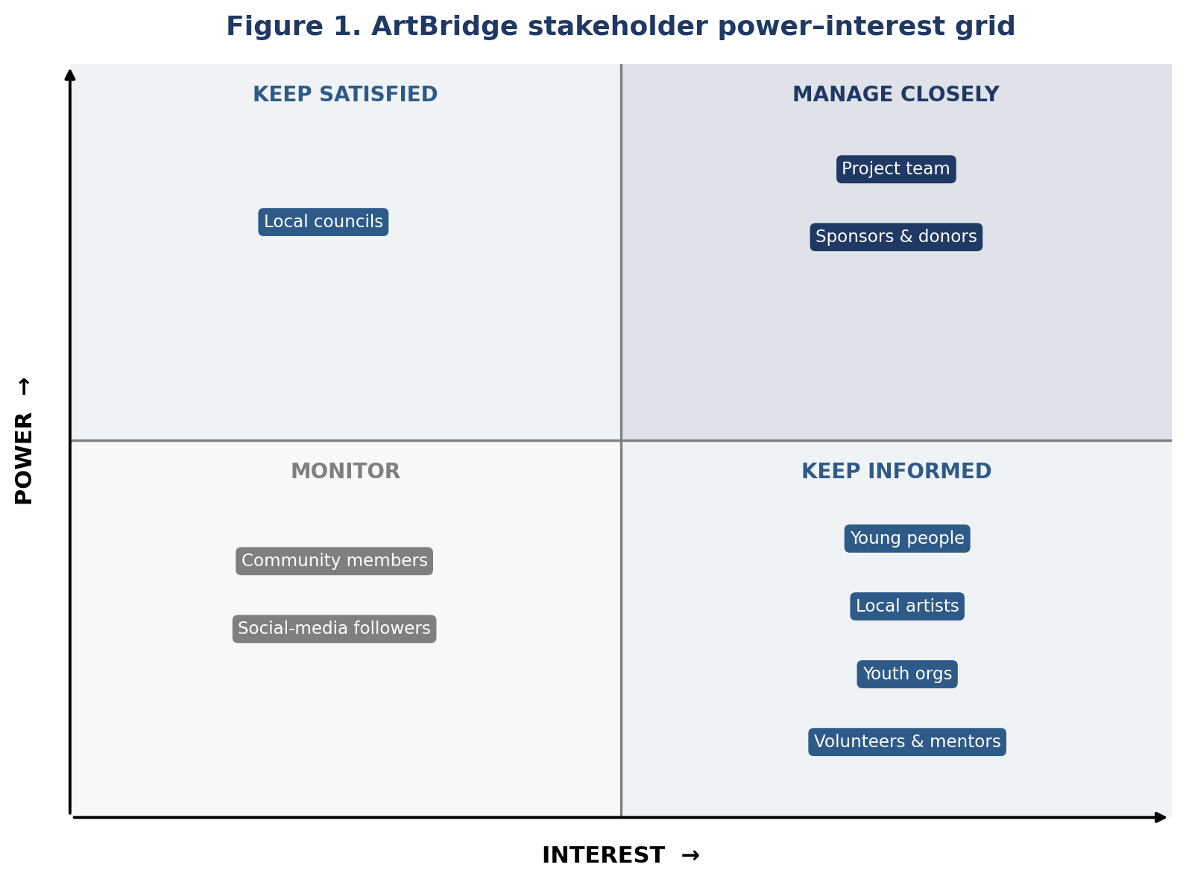
Figure 1. ArtBridge stakeholder power–interest grid.

2.2 How the tools were used in the ArtBridge project
Putting these tools to work on ArtBridge showed that some earned their place and others flattered the plan more than they helped it. We began with a scope statement and an in-scope / out-of-scope table — our single most valuable planning decision. Fixing early that the pilot would exclude counselling, housing support, formal education and a full café gave us a defensible line to hold when ambition crept in. Even so, we felt the pull of scope creep in practice: funding and partnership ideas kept expanding, and it took a deliberate return to the “top priorities” list to keep the pilot to a single gallery space and a small programme of monthly workshops. The scope tool worked only because we used it to say no — matching Cooke-Davies’ (2002) finding that success factors are behavioural as much as documentary.
The WBS was genuinely useful for dividing labour across six people. Breaking the project into eight stages let us map each stage to a named lead, so responsibility was visible rather than assumed. It was weaker at showing dependencies: the WBS lists packages but does not reveal that funding decisions gate marketing and event planning, which only the Gantt chart made clear, and controlling time and cost then depends on monitoring progress against that baseline (Kidston and Haward, 2015). The Gantt chart is where the gap between theory and practice was widest. It looked convincing — eight neat bars across twelve months — but the durations were guesses. We had no track record to estimate from, the weakness Hollister (2017) identifies, and the overlaps we drew assumed grants would be confirmed on schedule, which for a pilot is optimistic. As a planning artefact it organised our thinking; as a predictive tool it should be read with caution (Papke-Shields, Beise and Quan, 2010).
Risk management proved more valuable than we expected. Scoring fifteen risks across resource, participation and delivery categories forced us to confront the project’s real vulnerability: low turnout. That single red-zone risk shaped decisions elsewhere, pushing us to build participant referrals through partners before scheduling events rather than promoting into a vacuum. The matrix captures only the risks we thought of, so its true strength was less the scoring than the conversation it prompted — echoing the argument that risk management adds value through the thinking it provokes rather than the register it produces (Willumsen et al., 2019). The Iron Triangle (Figure 2) and a SWOT analysis helped us reason about trade-offs, accepting a modest scope to protect quality and stay within the £8,100 budget, but, as Atkinson (1999) predicts, they said little about whether ArtBridge would actually include and empower young people, which is the point of the project. Turner and Müller (2003) describe a project as a temporary organisation created to deliver benefit; judged that way, our tools measured the delivery vehicle better than the benefit. Overall, the lower-tech disciplines — holding the scope line and talking through risks — did more real work than the polished Gantt chart, echoing Ika’s (2009) point that project success is often mis-measured by the very tools meant to assure it.
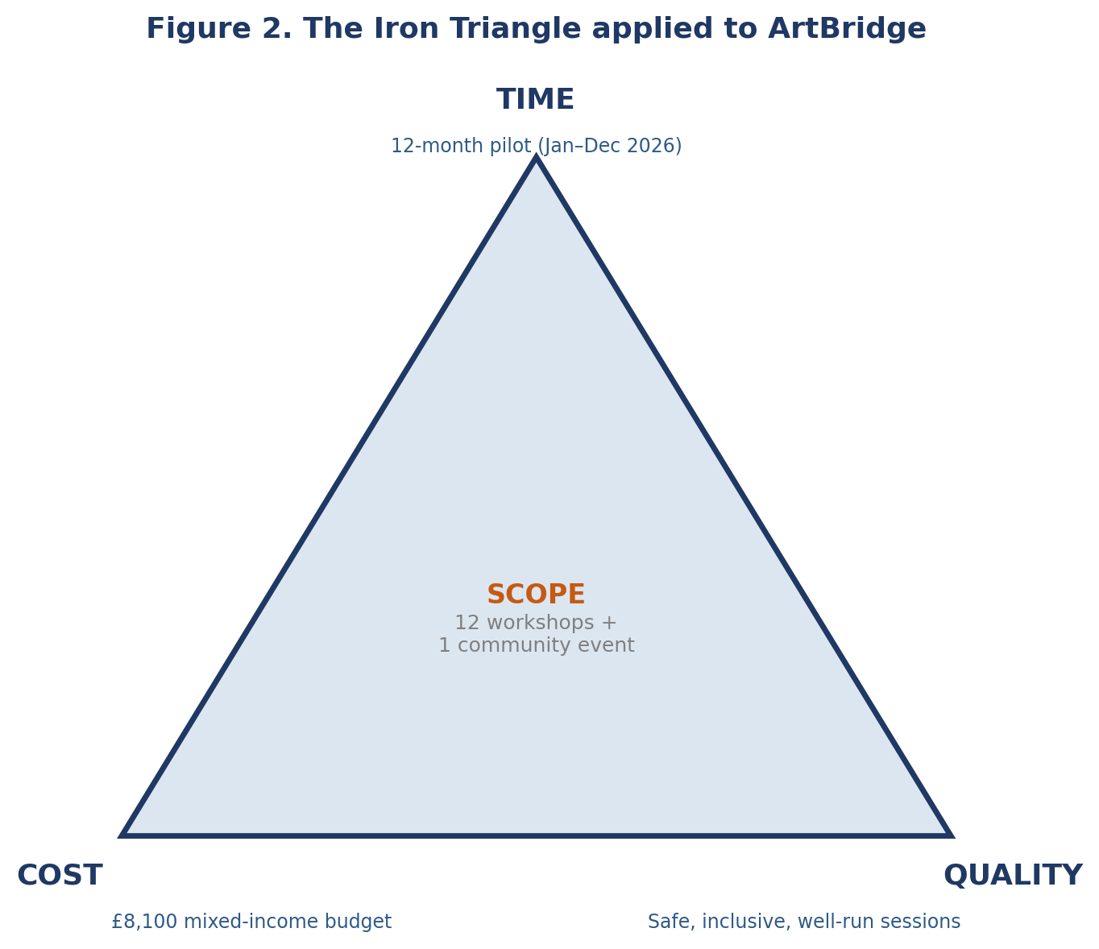
Figure 2. Iron Triangle for ArtBridge.

2.3 Communication and stakeholders
Because I led stakeholder and communication work, this is the part of the project I can speak to most directly. We identified twelve stakeholder groups and placed them on a power–interest grid (Figure 1), which turned an unmanageable list into four clear engagement strategies. Project team members, sponsors and donors sat in the “manage closely” quadrant because they held both the influence and the interest to shape the project, and the behaviour of such internal stakeholders bears directly on delivery (Beringer, Jonas and Kock, 2013); local councils were “keep satisfied”, holding power over approvals and funding but lower day-to-day interest; young people, artists, volunteers and youth organisations were “keep informed”, central to the mission but with limited formal power; and general community members and social-media followers were “monitor”. The grid’s value was that it stopped us treating every stakeholder the same. Its weakness, as Bourne and Walker (2005) warn, is that it freezes a moving picture: a sponsor’s interest could rise sharply once funding is committed, so the analysis needs revisiting rather than filing.
From the grid we built a communication plan (Figure 3) matching channel and frequency to each group — monthly email and meetings for sponsors, weekly WhatsApp and shared documents for the team, social media and posters for participants ahead of events. This is where our thinking was strongest and, honestly, where our follow-through was weakest. The plan suited a low-budget community project and sensibly used free channels, but we designed it more thoroughly for high-power stakeholders than for the young people the project exists to serve, whose engagement is fragile and easily lost after one or two sessions. Yang (2014) argues that in socially oriented projects the supposedly low-power beneficiaries are precisely the group whose engagement determines success, and Davis (2014) shows different stakeholder groups judge success by different criteria, so we under-planned for the people whose verdict matters most. Müller and Turner (2007) similarly link project success to how well managers communicate with, rather than merely inform, their stakeholders. Weighting the plan towards funders rather than participants was a real, if understandable, misjudgement. Getting the classification right mattered too: had we mislabelled councils or sponsors, our effort would have been aimed at the wrong people.
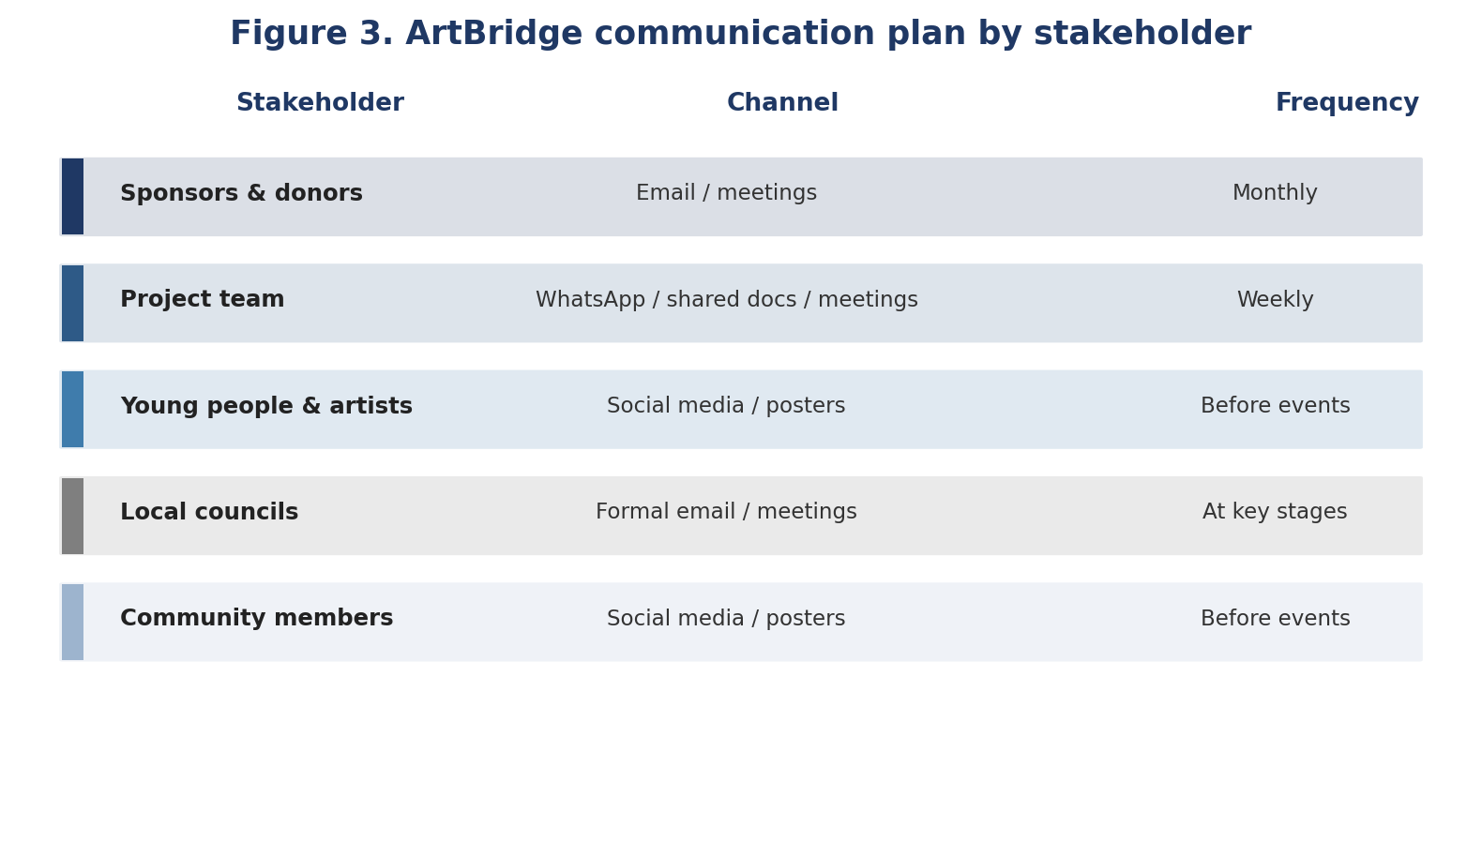
Figure 3. ArtBridge communication plan.

3. Conclusion
Assessed across its full lifecycle, ArtBridge was planned soundly rather than perfectly. The tools gave the project a coherent structure: scope discipline kept it realistic, the WBS shared the work fairly, and stakeholder analysis directed our energy sensibly. My overall judgement is that the tools were effective for a project of this size, but unevenly so. The most sophisticated-looking output, the Gantt chart, carried the least reliable information, while the simplest disciplines — scope control and honest risk talk — kept the plan grounded. Communication planning was a real strength in design, though our attention leaned too far towards powerful stakeholders and not far enough towards the young people at the centre of the mission. Judged by the Iron Triangle the plan is credible on time, cost and quality; judged by whether it would deliver inclusion, the honest answer is that our tools were better at organising the work than at guaranteeing the outcome (Atkinson, 1999).

4. Recommendations for future improvement
Several lessons would sharpen a second attempt. The one I feel most responsible for is mine as communication lead: I planned thoroughly for funders and too lightly for the young people the gallery is for. First, scheduling needs a firmer evidence base. Rather than guessing durations, we would set shorter milestones and add buffers where a task waits on an outside decision such as a grant (Kidston and Haward, 2015). Second, stakeholder communication should be rebalanced towards beneficiaries: young people would get the same care we gave sponsors — reminders, progression across sessions and feedback loops — because their retention is the project’s biggest single risk. Third, the stakeholder analysis should be a living document, revisited at each stage rather than fixed at the start, so shifts in interest and influence are captured (Eskerod, Huemann and Savage, 2015). Fourth, we would strengthen risk planning by giving each amber risk a named owner and a review date, making the matrix an active control rather than a snapshot. Finally, the group learned that the most impressive tool is not always the most useful. A realistic plan the team keeps using beats a detailed plan no one revisits, and fit to purpose matters more than methodological completeness (Wells, 2012).

Reference List
Aaltonen, K. (2011) ‘Project stakeholder analysis as an environmental interpretation process’, International Journal of Project Management, 29(2), pp. 165–183.
Atkinson, R. (1999) ‘Project management: cost, time and quality, two best guesses and a phenomenon, it’s time to accept other success criteria’, International Journal of Project Management, 17(6), pp. 337–342.
Beringer, C., Jonas, D. and Kock, A. (2013) ‘Behavior of internal stakeholders in project portfolio management and its impact on success’, International Journal of Project Management, 31(6), pp. 830–846.
Bourne, L. and Walker, D.H.T. (2005) ‘Visualising and mapping stakeholder influence’, Management Decision, 43(5), pp. 649–660.
Clegg, S.R., Skyttermoen, T. and Vaagaasar, A.L. (2020) Project Management: A Value Creation Approach. London: Sage.
Conforto, E.C., Salum, F., Amaral, D.C., da Silva, S.L. and de Almeida, L.F.M. (2014) ‘Can Agile project management be adopted by industries other than software development?’, Project Management Journal, 45(3), pp. 21–34.
Cooke-Davies, T. (2002) ‘The “real” success factors on projects’, International Journal of Project Management, 20(3), pp. 185–190.
Davis, K. (2014) ‘Different stakeholder groups and their perceptions of project success’, International Journal of Project Management, 32(2), pp. 189–201.
Eskerod, P., Huemann, M. and Savage, G. (2015) ‘Project stakeholder management — past and present’, Project Management Journal, 46(6), pp. 6–14.
Heagney, J. (2016) Fundamentals of Project Management. 5th edn. New York: AMACOM.
Heerkens, G. (2015) Project Management. 2nd edn. New York: McGraw-Hill.
Hollister, S. (2017) Project Management: A Quick Start Beginner’s Guide for Easily Managing Projects the Right Way. CreateSpace Independent Publishing Platform.
Ika, L.A. (2009) ‘Project success as a topic in project management journals’, Project Management Journal, 40(4), pp. 6–19.
Kidston, P. and Haward, K. (2015) Planning, Scheduling, Monitoring and Control: The Practical Project Management of Time, Cost and Risk. Princes Risborough: Association for Project Management.
Meredith, J. and Mantel, S. (2009) Project Management: A Managerial Approach. 7th edn. Hoboken: John Wiley & Sons.
Mitchell, R.K., Agle, B.R. and Wood, D.J. (1997) ‘Toward a theory of stakeholder identification and salience’, Academy of Management Review, 22(4), pp. 853–886.
Müller, R. and Turner, R. (2007) ‘The influence of project managers on project success criteria and project success by type of project’, European Management Journal, 25(4), pp. 298–309.
Papke-Shields, K.E., Beise, C. and Quan, J. (2010) ‘Do project managers practice what they preach, and does it matter to project success?’, International Journal of Project Management, 28(7), pp. 650–662.
Reiss, G. (2015) Project Management Demystified. 3rd edn. London: Routledge.
Serrador, P. and Pinto, J.K. (2015) ‘Does Agile work? A quantitative analysis of agile project success’, International Journal of Project Management, 33(5), pp. 1040–1051.
Turner, J.R. and Müller, R. (2003) ‘On the nature of the project as a temporary organization’, International Journal of Project Management, 21(1), pp. 1–8.
Wells, H. (2012) ‘How effective are project management methodologies? An explorative evaluation of their benefits in practice’, Project Management Journal, 43(6), pp. 43–58.
Willumsen, P., Oehmen, J., Stingl, V. and Geraldi, J. (2019) ‘Value creation through project risk management’, International Journal of Project Management, 37(5), pp. 731–749.
Wysocki, R.K., Kaikini, S. and Sneed, R. (2014) Effective Project Management: Traditional, Agile, Extreme. 7th edn. Indianapolis: Wiley.
Yang, R.J. (2014) ‘An investigation of stakeholder analysis in urban development projects’, International Journal of Project Management, 32(5), pp. 838–849.

