Academic and employment skills, IEEE Referencing & use of AI
Employment Skills
To grow jobs in software related field it takes diverse set of skill from technical to soft skills . An analysis of 500 IT job postings indicated that while soft skills were referenced, it was done to a limited degree, showing that there has been a lack of recognition of such skills by employers [1]. Technical competence may help get in the outer circle; collaboration and clear thinking will be the ones to determine how well one will perform in a team.
Technical aspects are still key. To illustrate it as simply as possible, Gemini described a system to track changes, who made them, when, and compares it to a notebook that everyone can share, then add their own notes on different pages without overwriting each other, and likens Git to that system [2]. Learning these tools enables you to work safely with your shared code post-graduation. Likewise, language-, framework- and methodology-independent programming advice promotes programming practices that can be adopted by different development tools rather than being specific to a particular one [3].AI literacy is an emerging skill within the employability domain. According to the Stack Overflow Developer Survey 2026, the most common use of AI was for code generation (69%) and debugging (64%), with 48% of the respondents indicating that they trusted AI most when the answers were easy to validate, and interest in its application waned quickly for tasks that required human communication [4]. So, building these skills during study, as part of group projects, versioned coursework, and critical use of AI builds capacity and capabilities to communicate effectively, solve problems step-by-step, and adapt to changes in tools in the future.

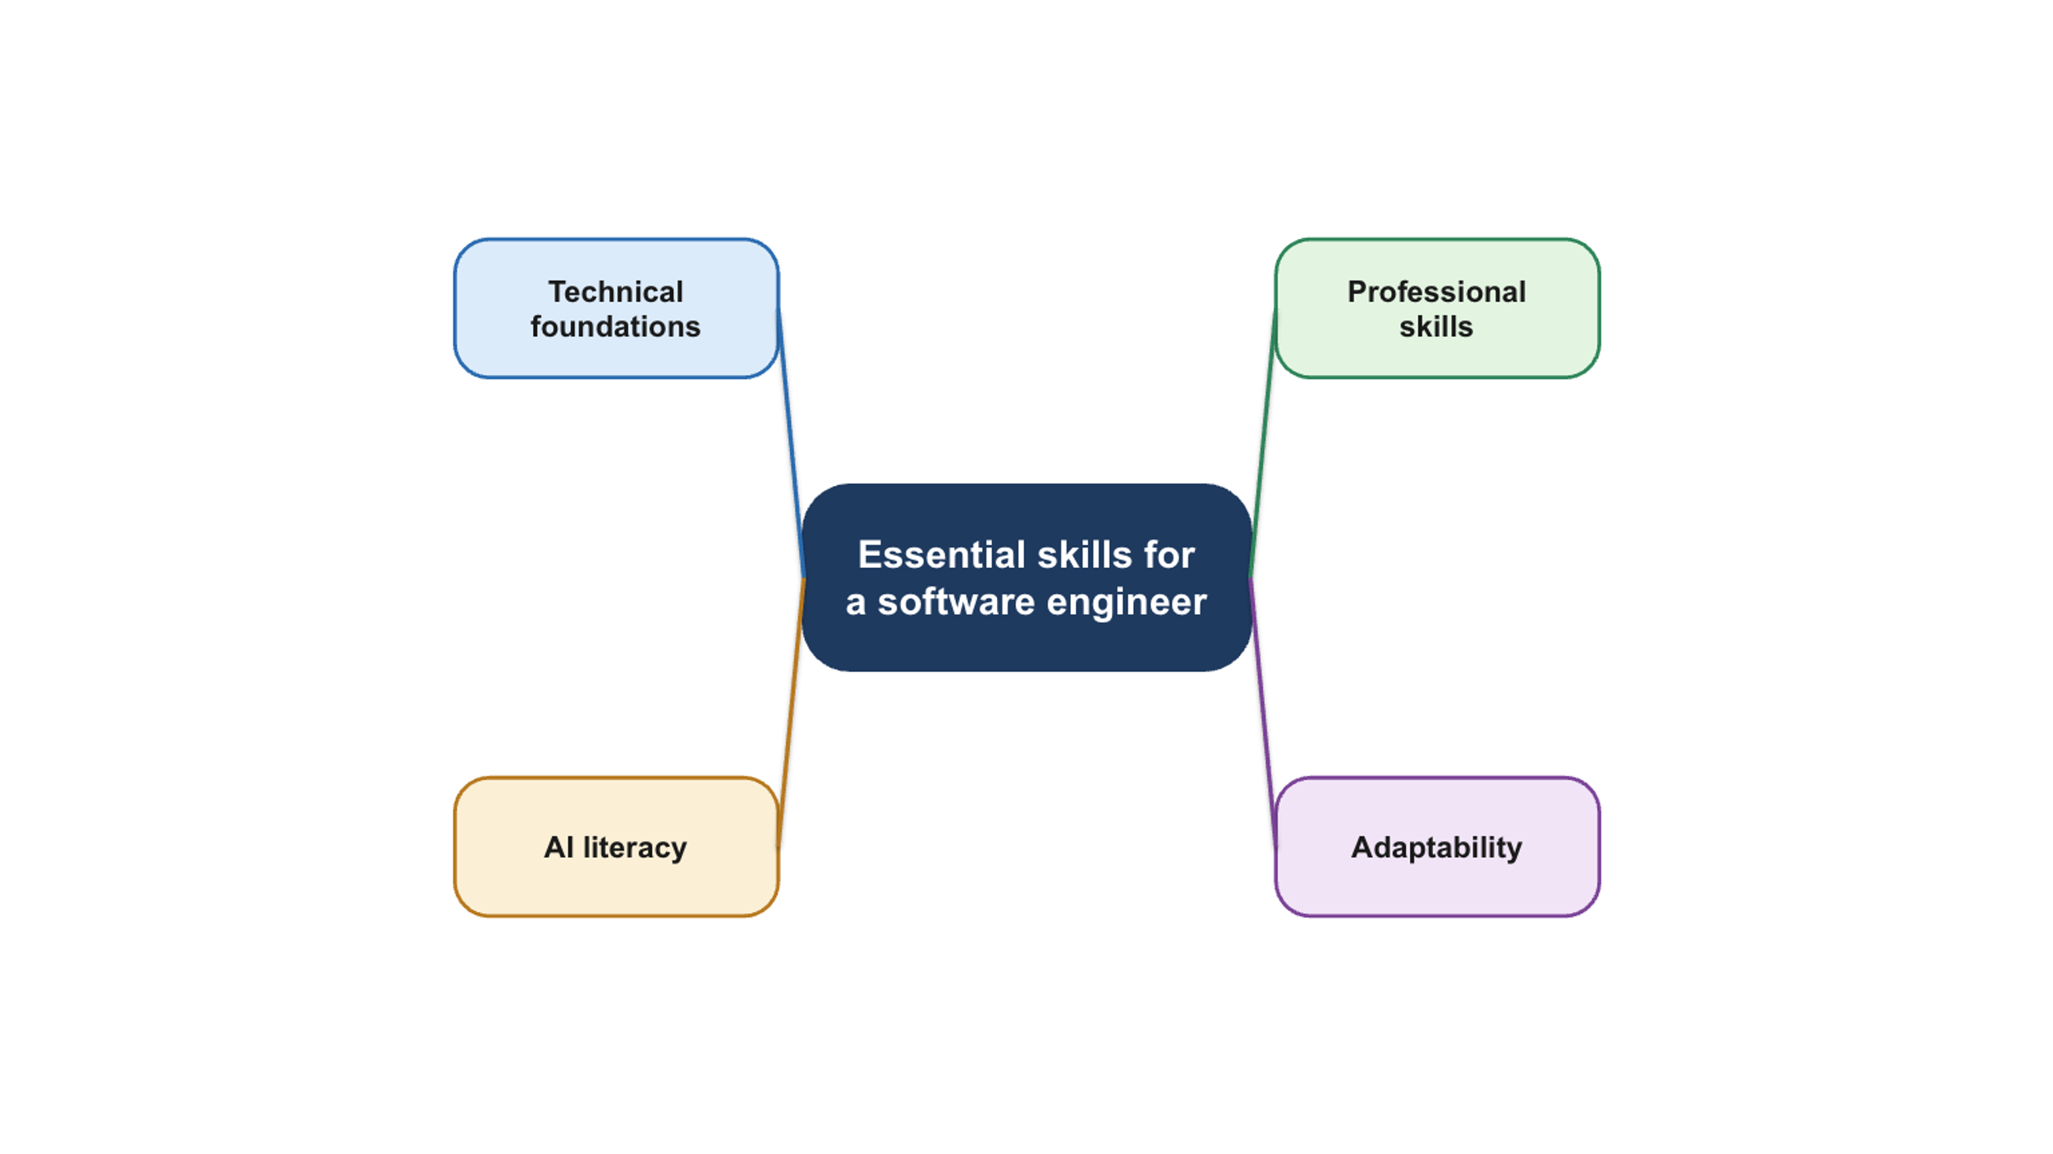
Figure: Software Engineer Skills
AI assistant and use of Tools
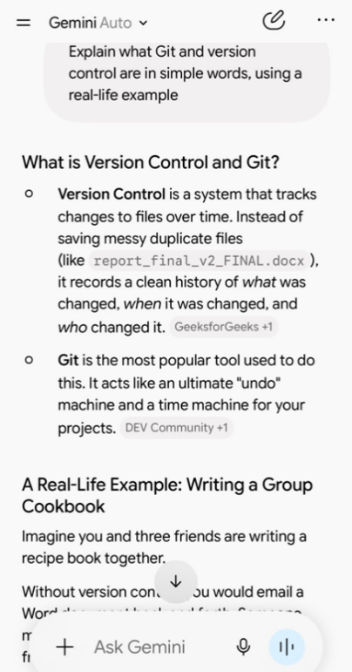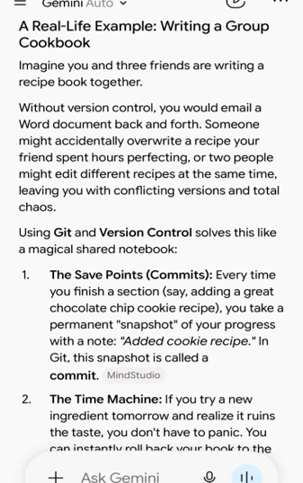
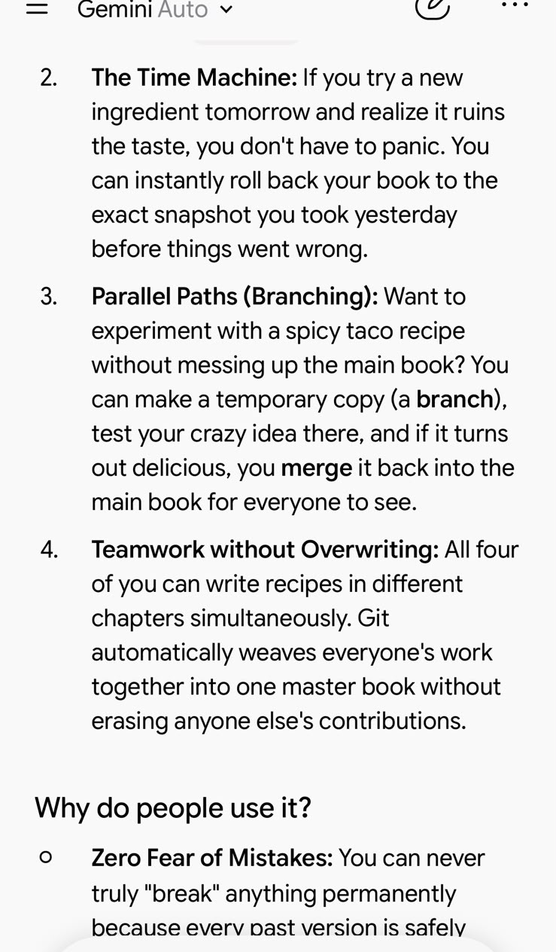
Figure – Use of AI Tool
A multimodal assistant, Gemini, can summarise lengthy texts, explain topics in simple terms and aid coding – but the developer warns that answers can be incorrect [5]. There are also some other tools, such as Claude, which can help with code; ChatGPT helps with writing and daily tasks. It was decided to use Gemini for recorded purposes. The prompt was to explain simple git and version control, and an example in real life was given. The answer described what Version Control is through a group-cookbook analogy and described how commits, rollbacks, branching and merging work [2]. This shows an explainable output piece in a context to aid learning of a basic engineering concept.
Also, to deepen the learning on AI, a learning course is selected which is informative for beginners, named “What Is Generative AI?”.
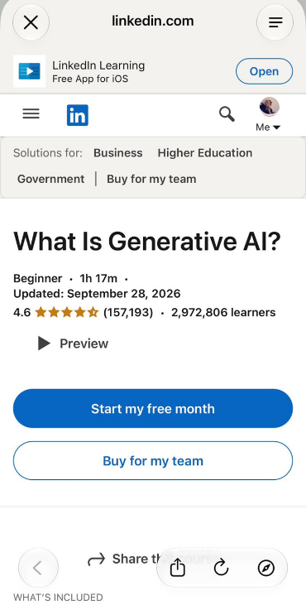
Figure – LinkedIn Learning course

Reference
[1] F. Ahmed, L. F. Capretz, and P. Campbell, "Evaluating the demand for soft skills in software development," IT Prof., vol. 14, no. 1, pp. 44–49, Jan. 2012.
[2] Google's Gemini, private communication, Oct. 2026.
[3] D. Thomas and A. Hunt, The Pragmatic Programmer: Your Journey to Mastery, 20th Anniversary ed. Boston, MA, USA: Addison-Wesley, 2020.
[4] Stack Overflow, "AI," Stack Overflow Developer Survey 2026, 2026. [Online]. Available: https://survey.stackoverflow.co/2026/ai (accessed Oct. 14, 2026).
[5] Google, "An overview of the Gemini app," Gemini. [Online]. Available: https://gemini.google/overview/ (accessed Oct. 14, 2026).

