

Assessment Component 1
Case study - Written Report

Student name: Dewan Ashrafi
Student ID: 1916230

Module name: Children, Young People and Families
Module code: (BMHP5004_LON)
Lecturer name: Bianca Sanfilippo
Word count: 2000

Table of Contents
Introduction: 3
Presentation of case study 2

Introduction
According to the Office of the Children's Commissioner, about 2.3 million children in England are growing up in vulnerable circumstances. (England, 2019) Child vulnerability is the result of the dynamic interplay of a variety of human and environmental variables throughout time. Child vulnerability comes in a variety of forms and degrees as these variables alter and develop. (OECD, 2019) "Vulnerable children" are defined as children who are unlikely to achieve or maintain, or who have the potential to reach or maintain, an appropriate standard of health or development in the absence of social care services, children whose health or development is probably considerably impaired, or further impaired, in the absence of social care services, and children who have a physical disability. (Parliament, 2008) This study investigates and analyses a case of a family with vulnerable children which is struggling to operate effectively. This family is subjected to emotional abuse and neglect, domestic violence, and alcohol addiction, parent’s mental health, making them very vulnerable.

Presentation of case study
The family
This case is about a family based in Norfolk, with Holly (37), a single mother of three children: Sarah (13), Mark (9) and Kylie (2). (Ministry of Housing, 2012) There are significant issues with this family which are very much related to children’s vulnerability.
The risk factors of vulnerability
Certain traits of the child and caregiver, as well as aspects of the family environment, have been related to child abuse and neglect in studies. (WHO, 2021)
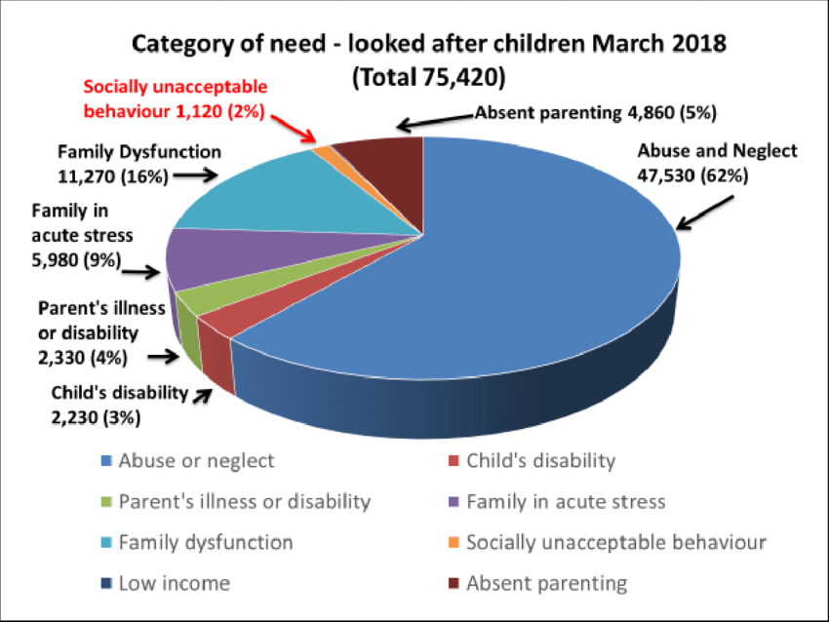
Looked after vulnerable children in England and types of maltreatment and background (Maginn, 2019)
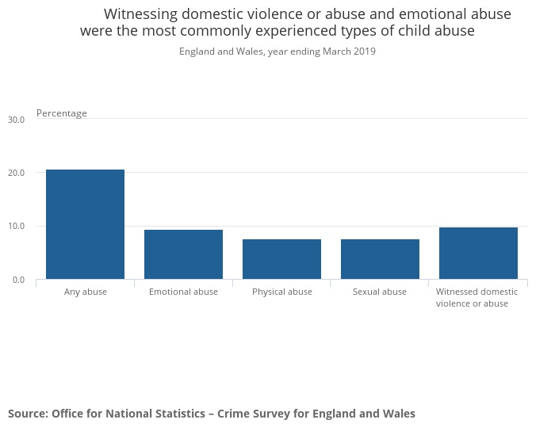
Most common types of child abuse (Statistics, 2020)

Emotional Abuse: In this case, the children of this family are living with a single mother who is failing to cope with parental duties. Consequently, her children are being neglected and emotionally abused. As of March 31, 2019, 18,460 children (15 per 10,000) in England were entitled to a CPP (Child Protection Plan) for emotional abuse. (Statistics, 2019)

Emotional abuse involves the followings (NSPCC, 2021):
- Threatening, yelling at, or calling a child names
- Targeting jokes towards a child or sarcasm to hurt
- Always victimising and scapegoating
- Having to make a child perform demeaning acts
- Not acknowledging a child's own individual identity or attempting to control their lives
- Failing to recognise their limitations and overworking a child
- Exposing a child to upsetting events or situations, such as domestic abuse or drug use
- Failing to promote a child's social development by not allowing them to have friends
- Constantly ignoring them
- Not being there when a child is in need
- Manipulating a child
- Never saying anything kind, expressing positive feelings, or congratulating a child on achievements
- Never displaying any emotions in interactions with a child
Neglect: Depriving a child of basic age-appropriate needs and which cause or have potential to cause physical or psychological harm is described as child neglect. (Today, 2019) Neglect was the most frequent kind of abuse for child protection plans (CPPs) in England (25,330 children as of 31 March 2019) and the second most common type of abuse for the child protection register (CPR) in Wales (1,005 children) (Statistics, 2019)
Neglect may happen in a variety of ways, making it difficult to identify. However, there are four kinds of neglect. Such as (NSPCC, 2021):
- Physical Neglect
- Educational Neglect
- Emotional Neglect
- Medical Neglect
Impacts of Emotional abuse and neglect: The followings are some of the most serious long-term consequences of emotional abuse and neglect (Taillieu, et al., 2016) (Angelakis , et al., 2019) (Zurbriggen, et al., 2010) (Riggs, 2010) (Morin, 2021):
Emotional maltreatment may hinder a child's ability to form and maintain healthy relationships.
Behavioural and social issues: Emotional abuse in childhood has been linked to juvenile crime and sexual aggression.
Those who were abused as children are more likely to abuse their children than those who were not mistreated as children.
Suicide and mental illness: Children who were emotionally abused as children are more prone to acquire mental illnesses like depression or anxiety that persist into adulthood. According to research on children in a range of contexts, extreme deprivation, or neglect (University, 2021):
- Impacts the way children's brains grow and absorb information, increasing the risk of learning and behavioural problems.
- Increases the risk of anxiety, depression, cardiovascular disease, and other chronic health problems later in life.
- Emotional and interpersonal problems are linked with high degrees of pessimism and low levels of enthusiasm, confidence, and assertiveness.
- Is related to significant risk of learning difficulties, poor school performance, low IQ, poor understanding, and low high school graduation rates.
In this family, children were subjects to emotional abuse and neglect. Holy was a single mother who was suffering from panic attacks and anxiety. She was incapable of solve problems as well. Single parent family is more likely to be abusive than the average families. (Daryanai, et al., 2016) This family also has history of domestic violence. All these factors are very much related to emotional abuse and neglect. (NSPCC, 2021) (NSPCC, 2021) Anti-social behaviour and children’s low school attendance are two profound results of these factors too. (Kerig & Becker, 2015)
Domestic Abuse
In the UK, one in every seven (14.2%) children and young people under the age of 18 experience domestic abuse. (Aid, 2021) This Norfolk based family has a long history of domestic violence or abuse. Witnessing domestic violence may have both immediate and long-term cognitive, behavioural, and emotional consequences for children. Domestic abuse in the United Kingdom is defined as any instance of controlling, coercive, or harassing conduct, violence, or abuse involving individuals aged 16 and up who are or have been domestic partners or family members, regardless of gender or sexual orientation. (Brown, 2021)
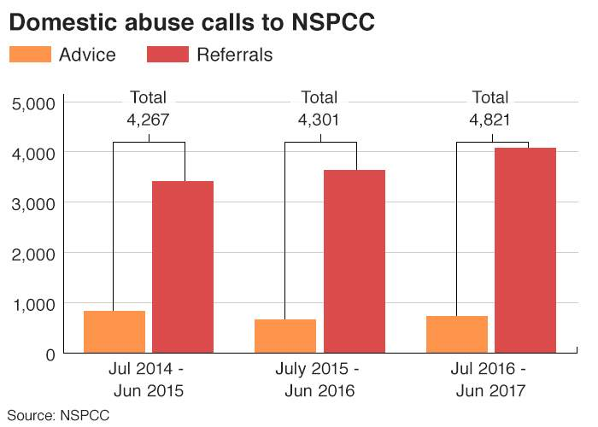
(Kendall & Cooke, 2017)
Impacts
Children see about three-quarters of violent events in relationships when there is domestic violence and abuse. Approximately half of the youngsters in such homes had been severely abused or hit. Sexual and emotional abuse is also more common in these households. (RCPSYCH, 2021)

Some common impacts of domestic abuse on children are (RCPSYCH, 2021) (Aid, 2021):
- Anxiety or depression.
- Trouble sleeping because of nightmares or flashbacks, wetting bed
- Bodily symptoms such as stomach pains
- Temper outbursts and academic difficulties
- May become violent, or they may internalise their pain and withdraw from others.
- Poor sense of self-worth
- Skipping school, use alcohol or drugs, self-harm by overdosing or cutting themselves, or develop an eating problem.
- 'Post Traumatic Stress Disorder' may affect children of any age. They may have nightmares, flashbacks, feel jittery, and have headaches and bodily discomfort.
- Children who have seen violence and abuse as children are more likely to get engaged in abusive and violent relationship as adults.
- Difficulties to interact with others emotionally and socially
- Children may also feel furious, guilty, insecure, alone, terrified, helpless, or perplexed.
Many of these effects can be found in this family. Holly's alcoholism and other mental problems may be traced back to her harsh home environment. Her addiction to substance use (Alcohol addiction) was indeed a major factor. Domestic abuse is linked to anti-social behaviour and inconsistent school attendance among children. (CDC, 2021)
Parent’s Alcohol Addiction
Alcoholism is the most severe type of alcohol consumption, characterised by an inability to control one's drinking habits. It is sometimes referred to as alcohol consumption disorder. (Galbicsek, 2021) The mother of this family, Holy, a single mother who was suffering from alcohol addiction. The use of alcohol and drugs by parents may have a detrimental effect on their children's physical and emotional well-being, development, and safety. Among the consequences for children are (Bellis, et al., 2014) (England, 2018):
- Physical abuse and neglect
- Development of health-harming behaviours later in life, which predicts more entrenched future usage.
- Inadequate school attendance as a result of unsuitable caregiving duties
- participation in anti-social or criminal behaviour due to a lack of knowledge
- It links many health-harming behaviours such as early sexual initiation, unplanned adolescent pregnancy, smoking, binge drinking, drug use, violence victimisation, violence victimisation, imprisonment, poor nutrition, lack of physical activity.
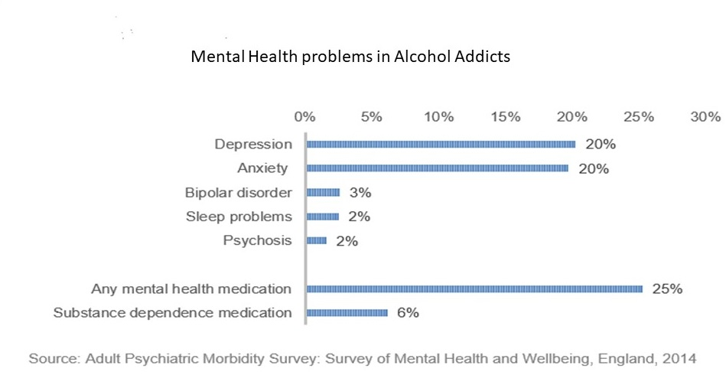
(O’Connor, 2020)
Holly was suffering from anxiety and other mental problems which are related to her alcohol addiction.
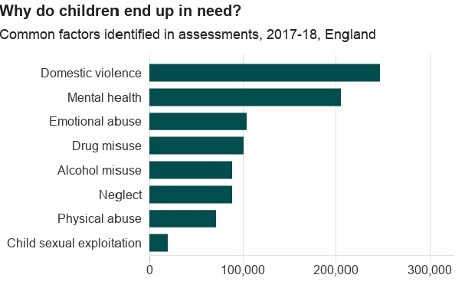
(Holt, 2018)
The mother of the children was suffering from anxiety and decision making incapability which are related to her alcohol addiction. In England, an estimated 589,000 individuals are dependent on alcohol, and about a quarter of them are likely to be taking mental health medication, mostly for anxiety and depression, but also for sleep difficulties, psychosis, and bipolar disorder. (O’Connor, 2020) According to the World Health Organization (WHO), about 55% of domestic abuse offenders were consuming alcohol before to the assault. (Smith, 2021) Therefore, domestic abuse in this house could be related to Holly’s alcohol addiction.
Family’s Involvement in Anti-Social behaviour
According to Metropolitan Police, ‘Antisocial behaviour is defined as 'behaviour by a person which causes, or is likely to cause, harassment, alarm or distress to persons not of the same household as the person' (Antisocial Behaviour Act 2003 and Police Reform and Social Responsibility Act 2011)’. (Police, 2021) The family was both the offender and victim of anti-social behaviour.
Impact: Parental antisocial experiences impacted the outcomes of young adults and worked via the adolescents' own emerging identities. Children whose parents have history of antisocial behaviour were more inclined to be troublemakers. Traditional parenting variables, such as parental support and severe parenting, also impacted respondents' antisocial behaviour trajectories. (Johnson, et al., 2016) Holly's participation in anti-social activities was a major contributor to the children's vulnerability. Her aggressive personal relationships and antisocial behaviour may land her in jail, which may have a significant impact on the health and well-being of her children.

Intervention
The local authorities sent the family to the unit, and the children were subject to a child protection plan (in which the local authority specifies what steps a family must take to improve how their children are cared for) due to emotional abuse and neglect. For 11 months, the Families Unit worked closely with the family, resulting in substantial changes. (Ministry of Housing, 2012)

The Children Act of 1989 guaranteed every child the right to be protected from abuse and exploitation, as well as the right to investigations to ensure their well-being. Its fundamental premise was that children are generally best cared for within the context of their family. The legislation went into effect in England and Wales in 1991, and in Northern Ireland in 1996, with certain exceptions. (UK, 1989) Therefore, the children of this family was under assessment to confirm if they are in vulnerable condition and they need help.
The Children Act 1989 governs child protection in England. Among the Act's key principles are: The importance of children's wellbeing and the expectations and regulations around child care. (UK, 1989) However, The Children Act 2004 reinforces this by: Requiring local authorities and their partners to work together to protect and promote the welfare of children and young people. (UK, 2004) In July 2018, the Department for Education (DfE) released an updated version of the essential statutory advice for anybody working with children in England. It outlines how organisations and people should collaborate, as well as how practitioners should perform children assessments. (Government, 2018) The practitioners performed a particular intervention since the family in this case study was at risk and a specialised evaluation was needed.
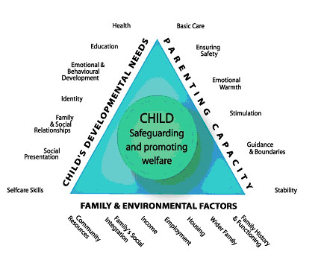
(Partnership, 2021)
The practitioners begin the strategy to assist the family based on this evaluation. Children Act 2004 requires local authorities and organisations dealing with children and young people under the age of 18 to protect them from all forms of abuse, injury, and neglect.

In this case practitioners were influenced and motivated by Maslow’s Hierarchy
of needs as well which is a five-tiered model of human needs that is frequently represented as a pyramid. (McLeod, 2020)
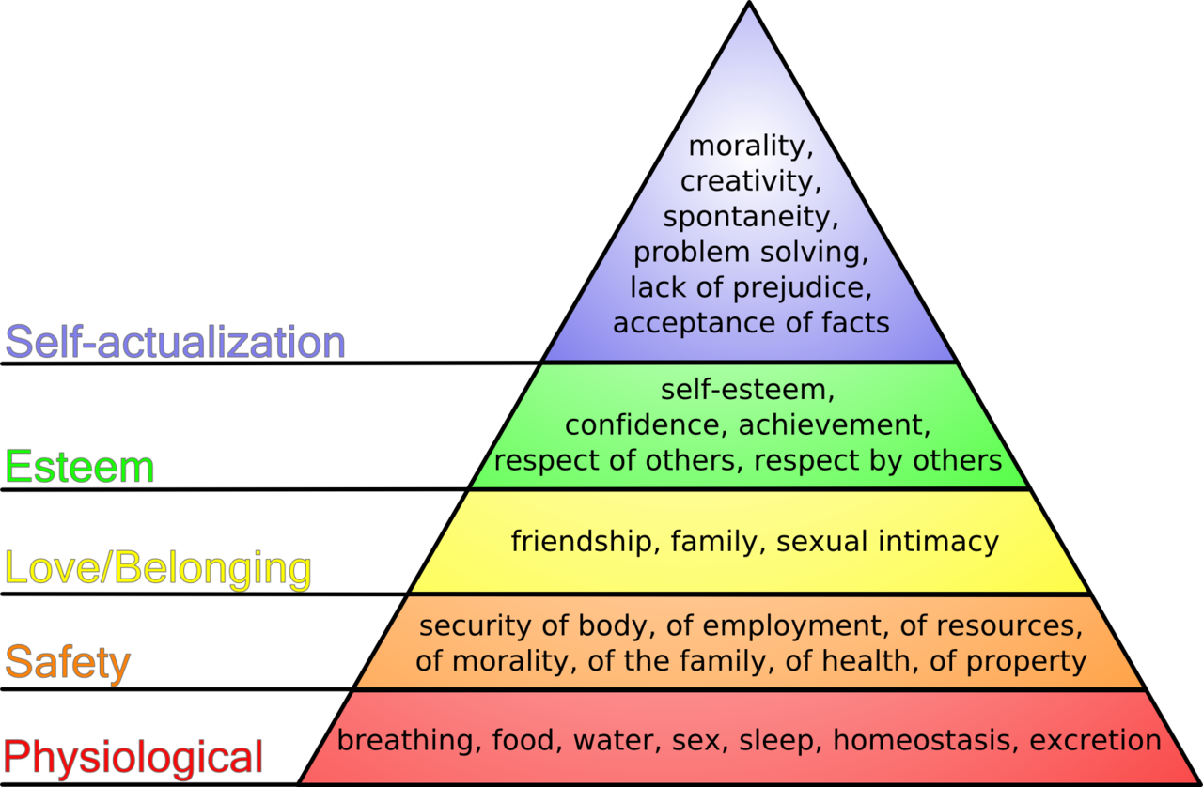
Maslow’s hierarchy of needs Pyramid
As required by the Children Act 2004 and the legislative guideline ‘Working Together to Safeguard Children' (2018), practitioners must operate in multi-agency. Police officers, juvenile offending teams, other social care sectors, educational institutes, rehabilitation offices are among the entities can get engaged.
The Practitioners' intervention in this case study was also influenced by the UNCRC article 2, 3, 4, 5, 9, 18, 19, 26, 27 and 28. (Unicef, 1991)
Article 2, 3, 4 confirm children’s right to non-discriminative care/ support, best interest, protection of their rights. Article 5 and 9 give them right o have parental guidance unless it is harmful for children in any manner. (Unicef, 1991)
Article 19, 26, 27 and 28 protects children from all types of violence, rights to have gives them social security, adequate standard of living, rights to have education. (Unicef, 1991)
Equality Act 2010 (UK, 2010) was followed by the professionals because this Act applies because the professional involvement was fair. The family and children were evaluated objectively and without bias. This Act guarantees that ALL children have EQUAL access to health and social services. This Act requires professionals to eliminate any barriers to equitable access.
The Data Protection 2018 gave this family confirmation that their identity and all relevant information would not be shared with any other organisations or public without their consent. (UK, 2018)
In this case study, Holy was supported by the Families unit to leave violent relationships, she was given advice and support on positive parenting, counselling to tackle anti-social behaviour, help to get access to a nursery for Kylie. Which of these eventually helped them to secure tenancy, getting rid of alcohol addiction of Holly, improved children’s confidence and self estem and improvement of children’s school attendance.

Evaluation of current policy
Among all the policies followed by the healthcare professionals, ‘Working Together 2018 Act’ is one of the most important ones. Working Together to Safeguard Children is legislative advice on inter-agency collaboration to safeguard and promote the welfare of children in accordance with the 1989 and 2004 Children Acts. (UK, 1989) (UK, 2004) (UK, 2018)The guideline summarises the legal obligations and expectations for particular services to protect and promote the welfare of children, and it establishes a comprehensive policy for Safeguarding Children Partnerships to assess the performance of local services.The advice is intended to assist professionals in determining what they must do to protect children and what they may expect from one another. It focuses on fundamental legal obligations, outlining what people and organisations should do to ensure the safety of children. It does so by emphasising the characteristics of a successful safeguarding system.
Conclusion
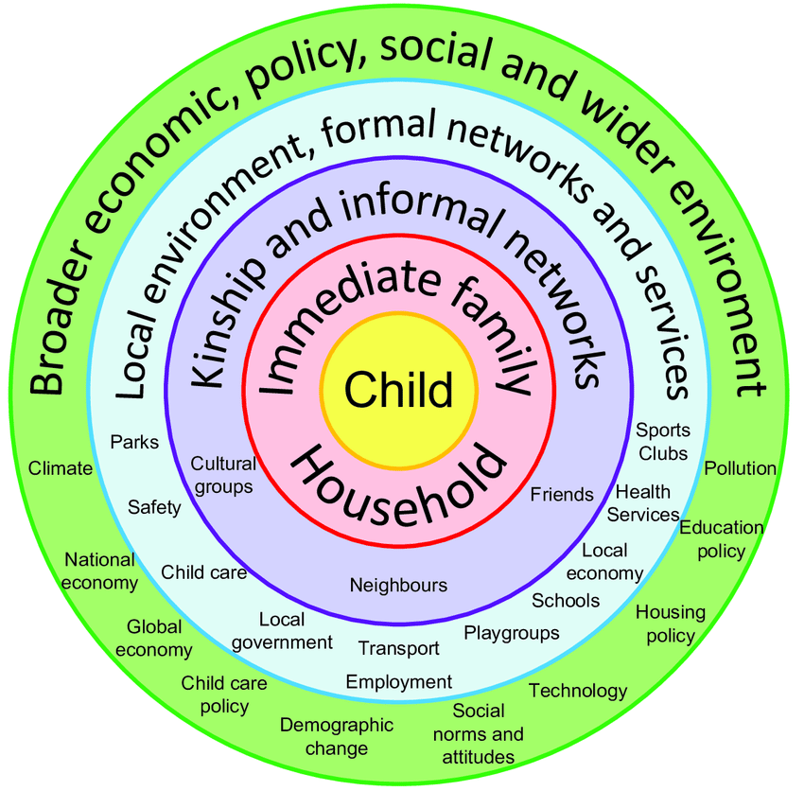
The Ecological Systems Theory was created by Urie Bronfenbrenner, an American psychologist. This theory emphasises the need of monitoring children in a range of ecological systems to understand their development. Theoretically, children are enmeshed in many ecosystems, from their own home to the larger educational system, to society and culture. Each of these natural systems affects and interacts with the children. (Guy-Evans, 2020)
A child’s life is influenced by various factors. Everything in a child's surroundings influences their growth and development is explained by Bronfenbrenner's ecological systems theory.
Therefore, we must improve universal care for children, including programmes to prevent problems and assist families in need.

