Emily Jones
2200404
Design Crafts
Word Count – 1563
Julia Lockheart

“Take only photos, leave only footprints”.
Exhibition celebrating abandonment and decay.

Introduction

The objective of this art exhibition is to stimulate appreciation for abandonment, decay and neglect. I want to alter the viewers perception of derelict places. Neglected spaces should be admired for its graffitied names and etched dates, which anchor memories and represent the past. From the layers of grime and dirt to the miscellaneous objects in obscure places, deserted buildings captivate timeless mystery.
The exhibition will feature the work of artists who celebrate the beauty of abandoned architecture, Joshua Smith, Julie Steel and Ryan Thomas Monohan. All artists work consists of miniatures and dioramic elements. They will be showcased in an authentic, local abandoned factory. Offering a thought-provoking experience altering the viewers perception of the space. Another perspective of this exhibition will be to encourage creativity in unsuspecting places and inspiring renewal of urban landscapes.
The exhibition will compel the audience to have a newfound fascination for decay. By showcasing the artwork in an authentic, local, abandoned, factory viewers will be motivated to delegate their admiration of the work to appreciate their authentic surroundings.
Its name comes from the known saying to emphasise the importance of leaving natural areas undisturbed when visiting them. It means that the viewers of the exhibition should come and enjoy the building, the work but leave no damage or take what’s already there to preserve the organic state. It’s also ironic as the state of the building wouldn’t be the way that it is if people had listened to this statement.

Location

I have chosen an abandoned factory in Briton Ferry as it is local to my home and holds meaning to me. I have always had an interest in neglected spaces, from exploring warehouses to war shelters. Living in Port Talbot, I would describe it as a gloomy place with minimal activity, causing an interest in the used and uncared for corners of the town. I want to encourage a new perspective starting with one of the most known local abandoned buildings in the area. This factory was built in the 1940’s and has been empty for more than 20 years, the walls are deteriorating and covered in graffiti. One of its proudest moments was creating aluminium material for the wings of Concorde, the first supersonic passenger carrying commercial airplane (Cooper 2020)

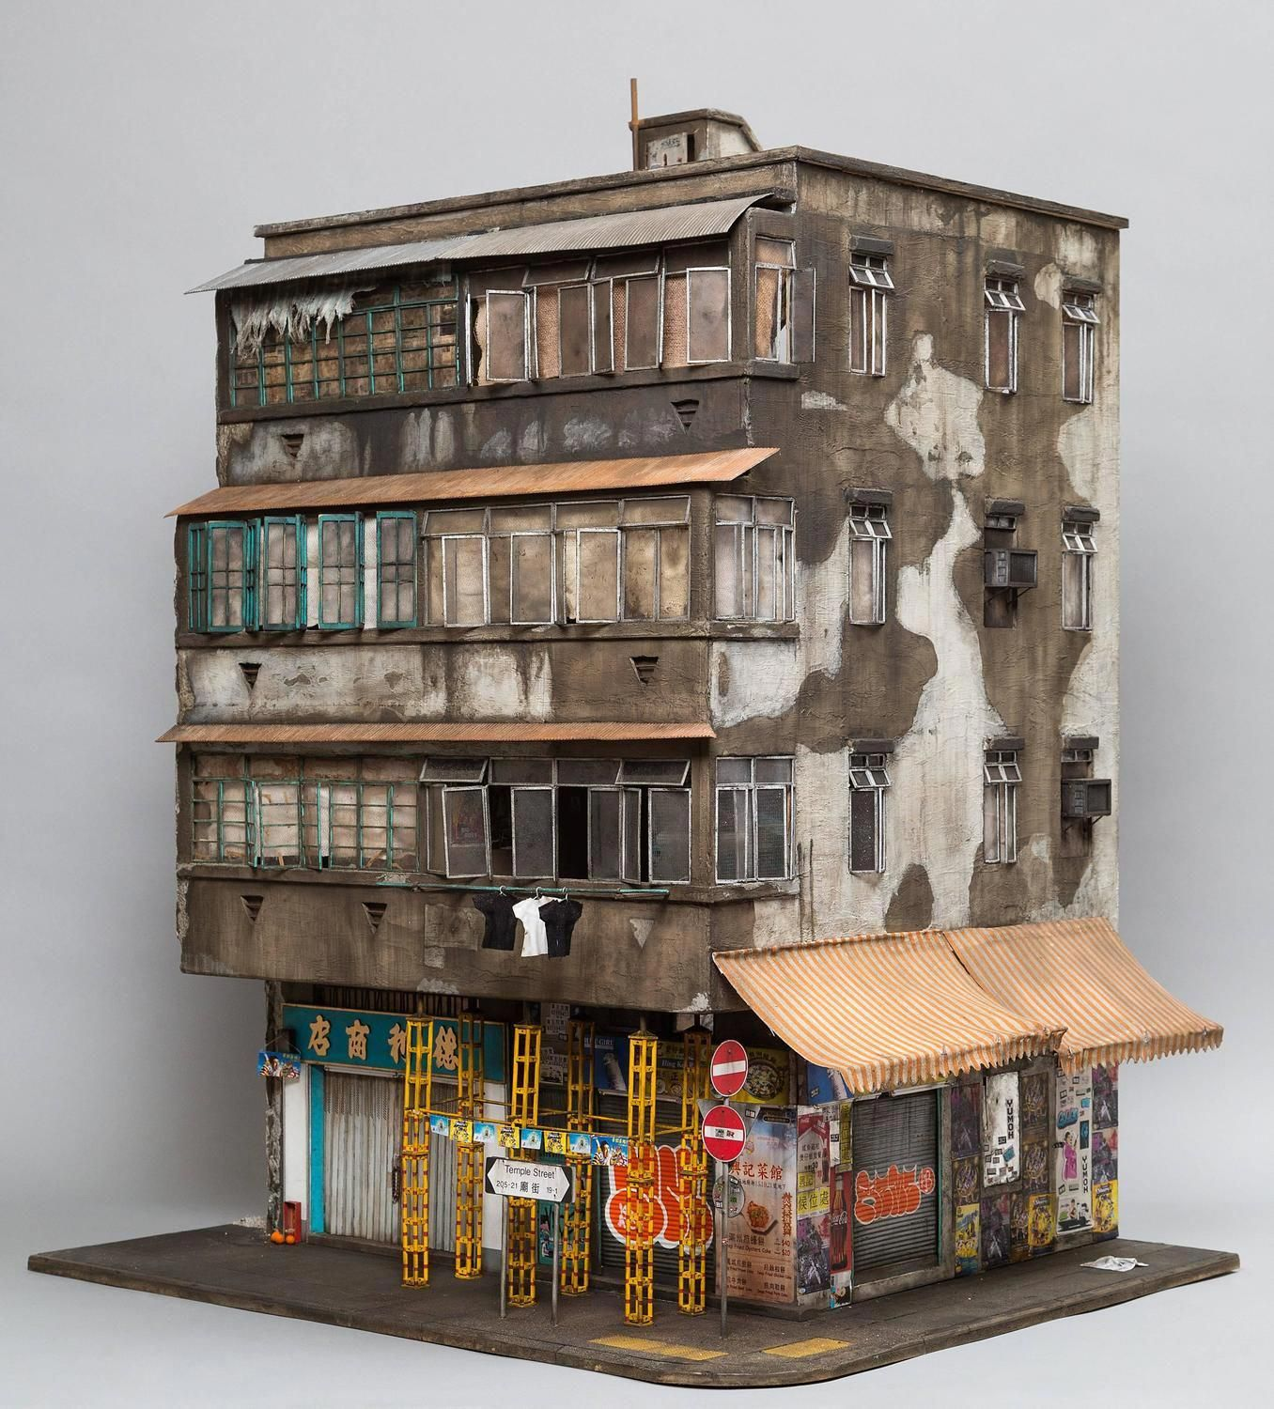
Fig 1. Smith, J. (2018) 23 Temple Street. (miniature sculpture)
The exhibition will showcase the meticulous attention to detail in Joshua Smith’s artwork. Through the juxtaposition of the piece with the genuine environment that surrounds it, viewers will be enticed to explore the comparison between the crumbling concrete walls to the art on display. Viewers will be evoked to inspect their own surroundings and drawn into the enjoyment of neglected corners of their local environment. I selected this piece because of its hyperrealism that admires decay. Smith says “The urban decay, grit and grime is what makes a building for me. It’s what I take the most inspiration from and really tells a story about the history of not only the buildings, but also of the people and the environment it is in.”(20 which I believe aligns with my ambitions of the display. The miniature scale of the piece creates a sense of curiosity for the audience to delve deeper into the intricate details compelling them to appreciate the overlooked elements of the building.
Hosting this exhibition in a town deprived of art, hopes to bring artists awareness of an opportunity to repurpose space or materials. The book The city of abandonment, suggests that urban spaces attract ‘growing attention from artist and architects interested in the material, spatial, cultural and social conditions of a city marked by depopulation, disinvestment and decay’ (Dewer 2013, P. 65). By exhibiting such a detailed piece in a place that could be viewed as a blank canvas, emphasises the possibility of recycling a space. Chairman of the National Endowment for the Arts, Rocco Landesman says ‘when you bring artists into a town, it changes its character, attracts economic development, makes it more attractive to live and renews the economics of that town’. Therefore, displaying art that celebrates abandonment in an environment that reflects its essence has the potential to stimulate artistic inspiration. However, critics argue that “the aesthetic does not need to be sacrificed at the alter of social change, as it already inherently contains this ameliorative promise” suggesting that aesthetics and social change go hand in hand and that we shouldn’t change a space in hopes for social change, that this should come as one.

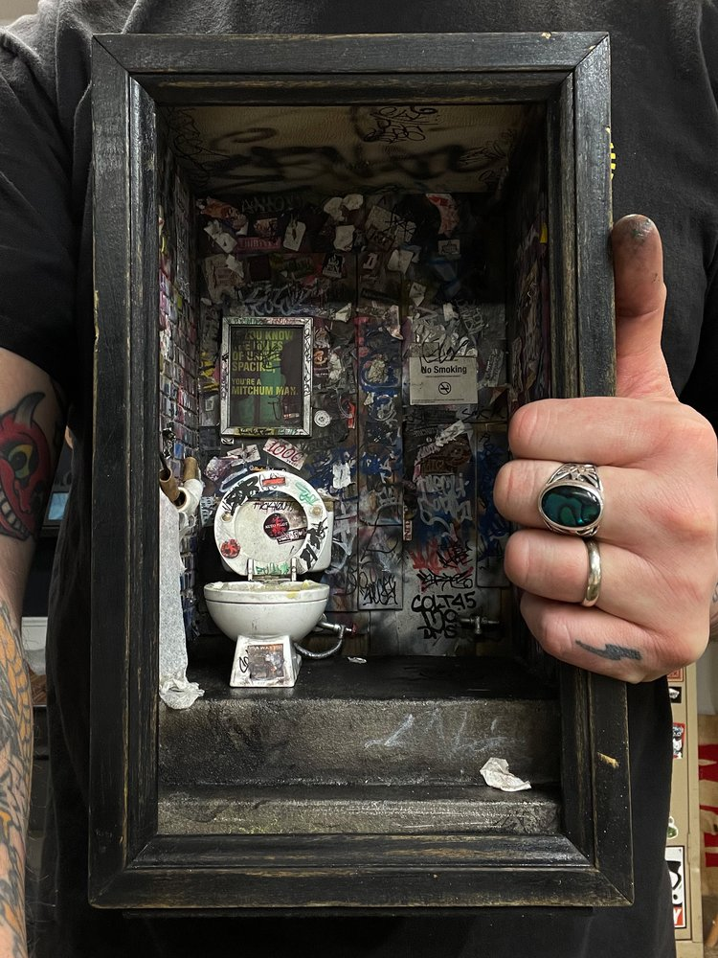
Fig 2. Thomas-Monohan, R. (2021) Public bathroom (Miniature sculpture)

I admire Ryan Thomas-Monohan’s work as he uses recycled litter that he finds on strolls through the urban areas which aligns with the statement made by Landesman, R. Chairman of the National Endowment for the Arts, that ‘Artists process the raw materials of urban decline into aesthetically and economically valuable forms’. (Dewar 2013). Monohan’s work emphasises the relations between aesthetic art and unsettling environments. It’s important in this exhibition for viewers to interact with the pieces on display, art theorists Nicolas Bourriaud founder of the term “relational aesthetics” suggest that relational art is about how people interact with each other in the context of the art (Dewer 2013,P. 66). It’s important for viewers to engage with the piece and others around them to inspect the details glorified in the work to transfer this admiration to their authentic environment. Dora Apel, Author of ‘Beautiful Terrible Ruins: Detroit and the Anxiety of Decline’ states ‘Urban explorations could be seen as a huge spontaneous archiving project’ (2015. P 59) Which has clearly been executed by Monohan with his ability to draw viewers into curiosity of a space they would normally be disregarded.

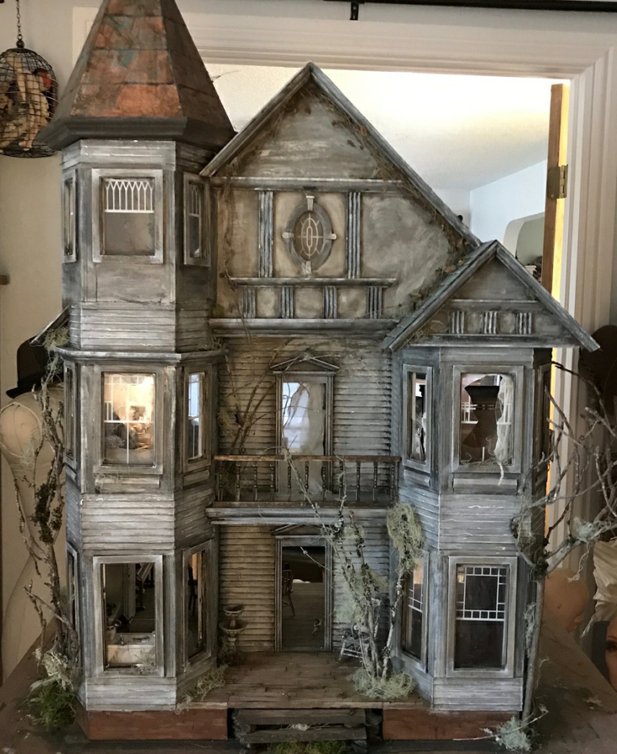
Fig 3. Julie Steel, 2020. Miniature haunted abandoned doll house.
Julie Steel is a miniature artists that uses doll houses and dolls to give a dark, haunted atmosphere. It is intriguing that Julie uses doll houses as they are often abandoned after childhood. We never tend to see what our childhood toys look like after abandonment; therefore, it could be said that Steel emphasises the existing neglect of the toys through realism and detail. “I have a deep attachment to the old, damaged, discarded and forgotten” (2020) Steel told Messy Nessy, in an interview. This passion for the discarded could spike similar emotions in the audience to reflect on their own forgotten posession.
This piece captures the excitement of exploring abandoned places where imagination takes over along with “the thrill of ghost in addition to the alure of nature, discovery, forbidden trespass and escape” Apel (2015). They decay of a dolls house can bring nostalgia, ‘something about decay suggests human endeavour. There’s something about the fallen majesty of human hope that has an eerie beauty. It makes you remember the things that are still around you.’ (Happer, 2015). This piece could evoke memories as its not the objects that create memories alone, it is their connection with human interaction that scaffold the moments into memories.(Carava, 2023) This relates as the majority of us have toys such as dollhouses that we’ve neglected yet the interactions are remembered, suggesting Steels’ work can resemble scaffolding to lost childhood memories.
Placements

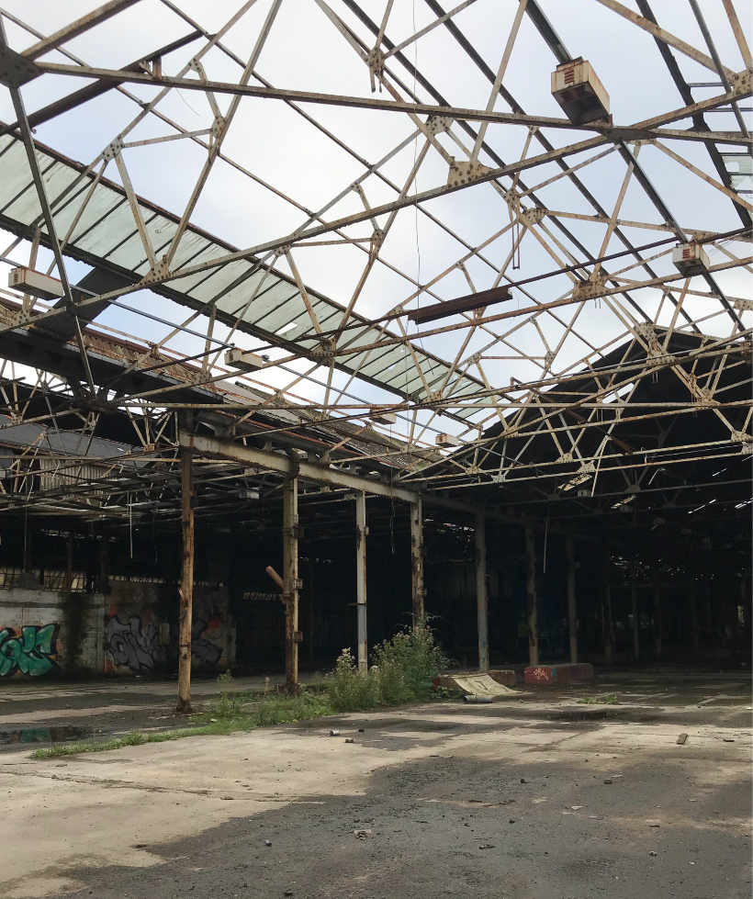
Fig 4, Inside abandoned factory. Exhibition plan. Taken by Emily Jones.
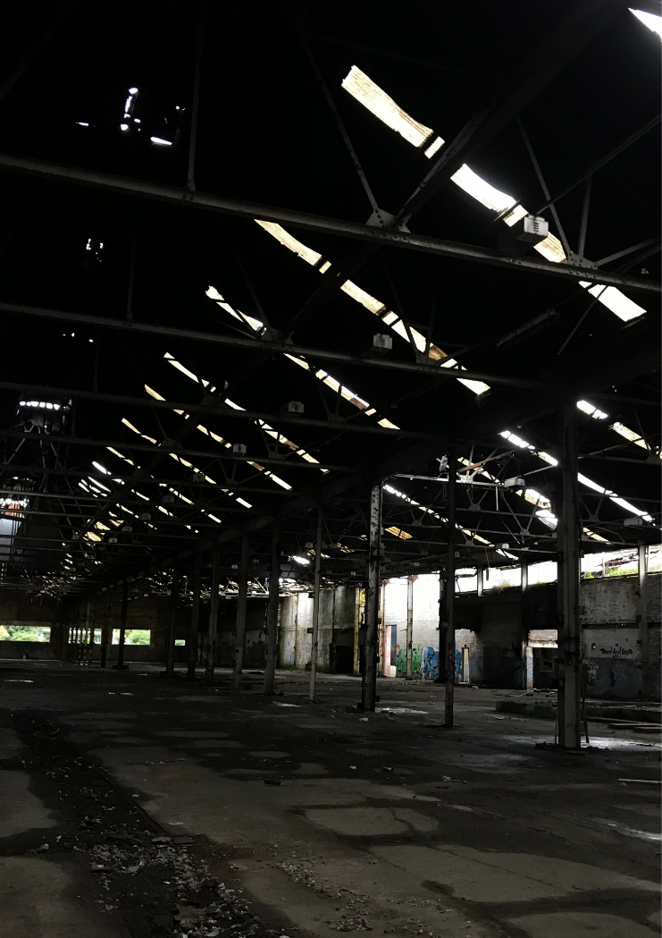
Fig 5, Jones. E. (2023) Inside abandoned factory. Exhibition plan. 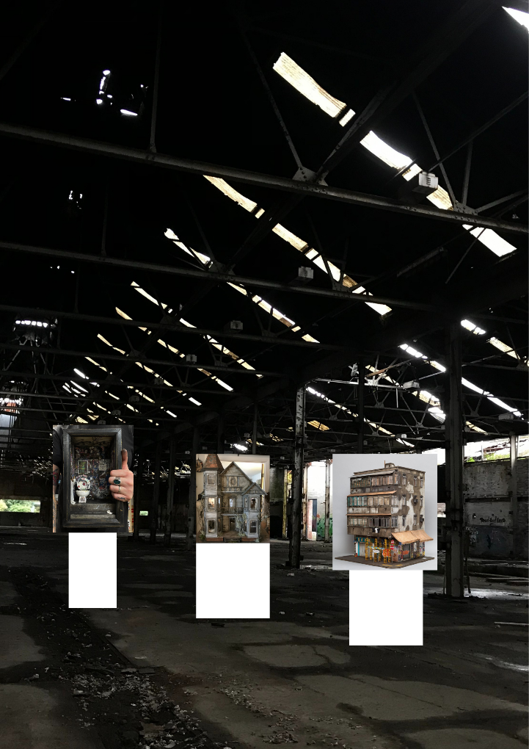
Fig 6, Jones. E. (2023) Inside abandoned factory. Exhibition plan Edited.

The plan for these three pieces is to have them centre of the warehouse, evenly spaced out. Figure 6 shows white boxes representing white pillars that I will place the work on top of. Each will be different hights as they are differently sized but will all be at a comfortable eye level. I would install spotlights over the artwork but no where else. The exhibition will be open between 10am and 10pm therefore people can come in the daylight or at night for an eerier experience of the abandoned environment. The purpose of placing the artwork in a line down the centre of the building is because the perimeter is a natural art itself that will be encouraged to explore, along with the other rooms in the building. Whether its interest in the graffiti or the natural decaying walls, ‘there is a strange beauty to seeing something made by a man slowly, but inexorably destroyed by the ravages of time. Notably, during the romantic period of art history, old medieval castles would be left to ruin, or ruined, only for their perceived aesthetics. (Lang 2021). This supports the idea that the organic elements of deterioration holds beauty and that the curiosity evoked from the artworks shall be shared with the architecture.

Conclusion

Through research of books and websites, I have a greater understanding of decay, neglect, grime and derelict spaces. I strongly believe that the artist’s work and passions align with my aims and objectives of this exhibition. I strongly believe that it is crucial to draw attention to a gradually decaying town, Port Talbot. Although the beauty of abandonment is preached it be beneficial to lure in artists that could see potential to transform them. Additionally, It may also hopefully inspire the children in the area who have minimal academic work ethic, to explore their creativity and consider the possibilities within the arts. Given Port Talbot lack of artistic opportunities, this exhibition has potential to serve as a catalyst for change in the community.

Bibliography –

Apel, D. (2015). Beautiful Terrible Ruins: Detroit and the Anxiety of Decline. Rutgers University Press. (PP.59)
Brown, C. (2019) Joshua Smith: Shrinking the Familiar. ArchitectureAU, Retrieved May 1, 2023, from Joshua Smith: shrinking the familiar | ArchitectureAU
Dewar. M and Thomas, J.M. (2013) The City After Abandonment. University of Pennsylvania Press. (PP. 58)
Happer. R (2015). Pretty Vacant: the glory of abandoned spaces. The Guardian. available at https://www.theguardian.com/lifeandstyle/2015/oct/11/pretty-vacant-glory-of-abandoned-spaces-richard-happer
Messy Nessy Chic. (2020). And Now, Abandoned Dollhouses for Your Inner Demon Child. Retrieved April 7, 2023, from https://www.messynessychic.com/2020/02/27/and-now-abandoned-dollhouses-for-your-inner-demon-child/
McCarroll, C. J. and Kirby, A. (2023). The Repair Shop of Memory. Cambridge University Press.
Lang, F. (2021). Why Are We So Attracted to Abandoned Places? Interesting Engineering. Retrieved April 10, 2023, from https://interestingengineering.com/culture/why-are-we-so-attracted-to-abandoned-places

Figures
Smith, J.. (2018) 23 Temple Street [miniature sculpture] Available at:
https://www.joshua-smith.com/23-temple-street (Accessed: May 1, 2023).
Monahan, R. (2021) Miniature Work. [Online image]. Ryan Thomas Monahan. Available at: https://www.ryanthomasmonahan.com/miniature-work/x72w1odxyj6po0315wfeq7y03n63za (Accessed: May 5, 2023).

