A comparison of the marketing methods of two multinational hotel brands.

Student name: Alexandru Badea.
ID: 2208275.
Module: Marketing Essentials BMIH4005.
Lecturer: Chris Wilkin.
Word Count: 1505 words.

Marketing is the process of creating and communicating value to customers, to encourage them to purchase a product or service. A company’s marketing strategy is the set of marketing objectives, activities, and decisions that aim to achieve those objectives. It includes the company’s vision, mission, core values, and objectives, as well as its target market and marketing mix. Six Senses is a luxury hotel brand that was founded in 1995 by Sonu and Eva Shivdasani. It has grown to become one of the leading luxury hotel brands in the world, with locations in Europe, the Middle East, Africa, and Asia. The brand has drawn on its Asian heritage to create a unique concept that combines modern design and technology with authentic local experiences. Moxy, on the other hand, is a budget hotel brand that was launched in 2014 by Marriott International (Clow & Baack., 2013). It offers stylish, modern accommodation at affordable prices, with a focus on providing the best value for money. Its marketing approach is based around its ‘play hard’ ethos, which encourages guests to ‘live like a local’ and explore the area around them. In this essay, I will compare the marketing methods of two multinational hotel brands, Six Senses, and Moxy.
Luxury and eco-friendly accommodations, unique and unforgettable experiences, personalized service, and a commitment to sustainability (Helms and Nixon., 2010). Limited presence in the global hospitality market, limited access to capital, and a lack of brand recognition. Expansion into new markets, partnerships with global hospitality brands, and the development of new experiences to attract more customers. Increasing competition from larger hospitality brands and a potential decrease in customer demand due to economic uncertainty.
Moxy Hotels has an advantage due to its modern, stylish, and affordable designs. Its smaller rooms and limited amenities may not appeal to all travelers, particularly those seeking more luxurious accommodations. There is a significant opportunity for Moxy Hotels to expand its presence in international markets, as well as to continue to capitalize on the Millennial generation’s interest in budget travel. Moxy Hotels faces competition from traditional hotel chains offering similar amenities but with more space and greater luxury. Additionally, companies like Airbnb and other forms of home-sharing have made it easier and more affordable for travelers to stay in private residences.
The hotel is in various countries across the world, so it must be aware of the political and legal differences between each nation. The economic situation in each country affects the demand and cost of services. The hotel must understand the economic environment in each destination. social media, customer reviews, and other feedback sources have a significant impact on the hotel’s reputation. The hotel must take advantage of new technology to improve customer experience and remain competitive. The hotel must comply with the laws and regulations in each country it operates in. The hotel must understand the local environment and use sustainable practices to reduce its impact on the environment (Ho., 2014).
Politically, the hotel must adhere to local regulations and safety standards, while economic factors such as inflation, exchange rates, and interest rates may affect its prices. Socially, Moxy must remain aware of any shifts in customer preference, as well as address any customer service issues that may arise (Lehr., 2015). Technologically, it must stay up to date on modern trends, such as with the implementation of digital marketing tactics and virtual customer experiences. Legally, the hotel must abide by all labor standards and industry regulations. Finally, the company must remain mindful of its environmental impacts, such as through the implementation of green practices and initiatives.
The marketing mix, also known as the 7 Ps, is a set of seven distinct marketing categories that are used to analyze and plan the marketing strategy of a product or service. These categories are product, price, promotion, place, people, process, and physical evidence (Kusumawati et & al., 2014). By understanding and analyzing each of these categories, companies can create a successful marketing mix that will help them reach their desired target audience. When comparing the marketing methods and strategies of two multinational hotel brands, Six Senses, and Moxy, it is important to consider each of the 7 Ps. Six Senses is a luxury, high-end hotel brand that provides an intimate, personalized experience. Moxy focuses on being a budget-friendly, fun, and vibrant hotel brand. Six Senses’ prices are generally higher than Moxy’s as it is a luxury brand. However, both brands offer a range of packages and room rates to cater to different types of customers. Both brands use a variety of promotional tactics, such as online advertisements, social media campaigns, and email marketing (Rafiq and Ahmed., 2015). Six Senses also uses influencers to promote its brand, while Moxy focuses on creating an online community. Six Senses properties are spread out across the world, from the Maldives to Seychelles. Moxy has a more limited global presence, with properties located in Europe and the US. Six Senses’ staff are trained to provide a luxurious customer experience. Moxy staff are expected to be friendly and helpful, but also to create a fun atmosphere for their guests. Six Senses’ process focuses on providing guests with a smooth, personalized experience. Moxy’s process is designed to be efficient and cost-effective. Six Senses provides its guests with physical evidence of its luxury brand, such as high-end amenities and elegant decor. Moxy’s physical evidence is more modern, with bright, colorful decor and fun amenities. Overall, Six Senses and Moxy have different marketing strategies that focus on different target audiences. Six Senses focuses on providing a luxurious experience for its guests, while Moxy focuses on providing a fun and budget-friendly experience. By understanding and analyzing the 7 Ps for each brand, companies can create an effective marketing mix to reach their desired target audience.
Any company relies on marketing, but hospitality businesses particularly do. To stay competitive, multinational hotel companies must use appealing, informative, and current marketing techniques. This article compares the marketing practices of Six Senses with Moxy hotels (Morgan et & al., 2012). Six Senses is a luxury hotel brand, owned by InterContinental Hotels Group, that offers guests an authentic, luxurious, and memorable experience with its distinct style and design. They have properties all over the world, from the Caribbean to Thailand. Moxy is a more modern, budget-friendly hotel brand owned by Marriott International. It offers a more playful and energetic experience for guests, with an emphasis on technology, comfort, and convenience. Using the Similar Web tool, the customer segment for both brands is made up of travelers from all around the world. However, Six Senses’ customers are more likely to be from higher-income countries and are looking for a more luxurious experience. On the other hand, Moxy’s customers are more likely to be from lower-income countries and are looking for a budget-friendly experience. The targeting strategies of both brands are very different. Six Senses targets affluent travelers who are looking for a luxury experience. They use a mix of traditional and digital marketing, such as advertising in print and on social media, to reach their customers (Schlegelmilch., 2022). Moxy, on the other hand, targets younger, budget-conscious travelers who are looking for a more modern and convenient experience. They primarily use digital marketing such as advertising on social media and Google, as well as partnering with travel companies and influencers. Using the positioning tools, Six Senses’ positioning is focused on luxury and exclusivity, while Moxy’s positioning is focused on modernity and convenience. Six Senses is positioned as a luxury hotel brand and is seen as a premium option for travelers who are looking for an unforgettable and luxurious experience. Moxy, on the other hand, is positioned as a modern and budget-friendly hotel brand and is seen as the perfect option for travelers who are looking for a convenient and comfortable experience. Six Senses and Moxy have different customer segments, targeting strategies, and positioning. Six Senses is a luxury hotel brand targeting affluent travelers who are looking for a luxurious experience, while Moxy is a budget-friendly hotel brand targeting younger, budget-conscious travelers who are looking for a modern and convenient experience (DeSarbo et & al., 2017). Their positioning also reflects their target customers, with Six Senses being positioned as a luxury hotel brand and Moxy being positioned as a modern and budget-friendly hotel brand.
In conclusion, Six Senses and Moxy are two multinational hotel brands that have implemented unique marketing strategies to target different consumer segments. Six Senses has focused on promoting its commitment to sustainability and social responsibility, while Moxy has embraced the idea of ‘playful living’, to target younger travelers. Both brands have taken into consideration environmental, social, and geopolitical issues when developing their marketing strategies, and have tailored them to ensure they are attractive and relevant to their target demographic. Both brands have also embraced digital technology to create engaging campaigns and stay connected with their customers. As a result, Six Senses and Moxy have been able to develop successful marketing strategies that have enabled them to remain competitive in the hospitality industry.

References
- DeSarbo, W.S., Blanchard, S.J. and Atalay, A.S., 2017. A new spatial classification methodology for simultaneous segmentation, targeting, and positioning (STP analysis) for marketing research. In Review of marketing research (pp. 75-103). Routledge.
- Schlegelmilch, B.B., 2022. Segmenting targeting and positioning in global markets. In Global Marketing Strategy: An Executive Digest (pp. 129-159). Cham: Springer International Publishing.
- Natter, M., Mild, A., Wagner, U. and Taudes, A., 2008. Practice prize report—Planning new tariffs at tele. Ring: The application and impact of an integrated segmentation, targeting, and positioning tool. Marketing Science, 27(4), pp.600-609.
- Andaleeb, S.S., 2016. Market segmentation, targeting, and positioning. In Strategic Marketing Management in Asia (pp. 179-207). Emerald Group Publishing Limited.
- Simões, E.N., 2020. A decision support system application module-for PESTLE analysis-competitive intelligence algorithm (Doctoral dissertation).
- Ho, J.K.K., 2014. Formulation of a systemic PEST analysis for strategic analysis. European academic research, 2(5), pp.6478-6492.
- Helms, M.M. and Nixon, J., 2010. Exploring SWOT analysis–where are we now? A review of academic research from the last decade. Journal of strategy and management, 3(3), pp.215-251.
- Oetomo, H.W. and Ardini, L., 2012. SWOT analysis in strategic management: a case study at Purabaya bus station. Journal of Economics, Business, & Accountancy Ventura, 15(2), pp.171-186.
- Lehr, D.D., 2015. An analysis of the changing competitive landscape in the hotel industry regarding Airbnb.
- Baršauskaitė, K., 2021. Trijų žvaigždučių viešbučio „Moxy Kaunas Center “teikiamų paslaugų pasiūlos gerinimas, atsižvelgiant į paklausą.
- Kusumawati, R.D., Oswari, T., Utomo, R.B. and Kumar, V., 2014. The influence of 7P's of marketing mix on buying intention of music product in Indonesia. Procedia Engineering, 97, pp.1765-1771.
- Rafiq, M. and Ahmed, P.K., 2015. Using the 7Ps as a generic marketing mix: an exploratory survey of UK and European marketing academics. marketing intelligence & planning, 13(9), pp.4-15.
- Jain, M.K., 2013. An analysis of marketing mix: 7Ps or more. Asian Journal of Multidisciplinary Studies, 1(4), pp.23-28.

Appendix

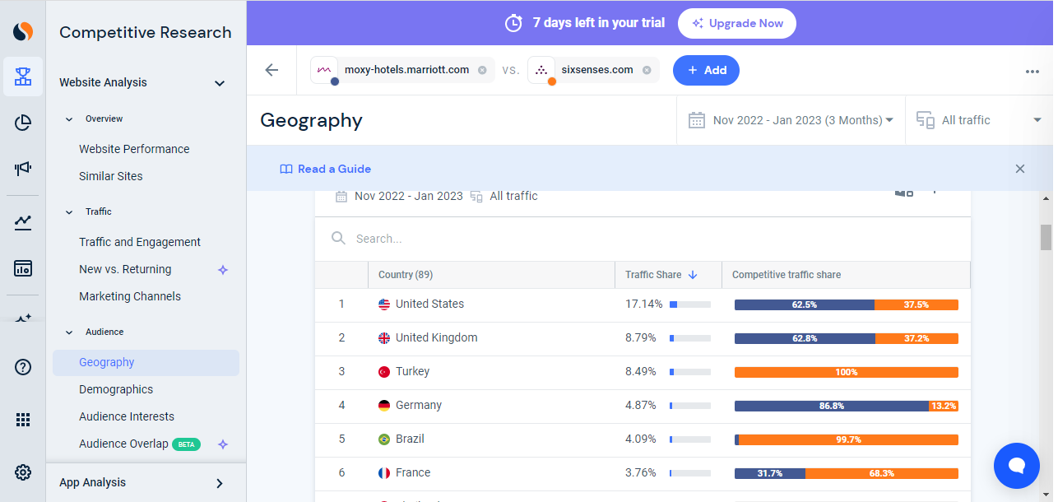
Figure: Geography (Six Senses & Moxy).
Source: (https://www.similarweb.com/).
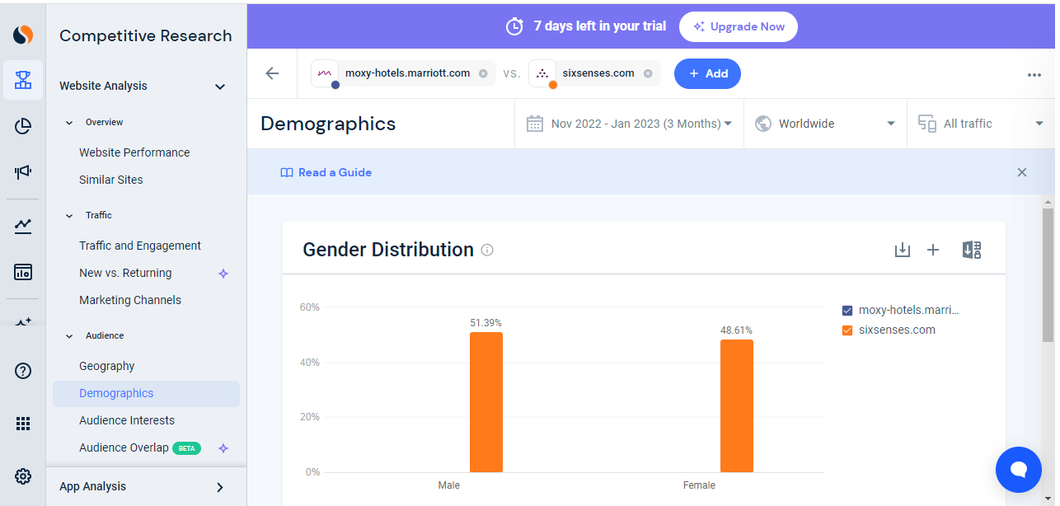
Figure: Gender distribution (Six Senses & Moxy)
Source: (https://www.similarweb.com/).
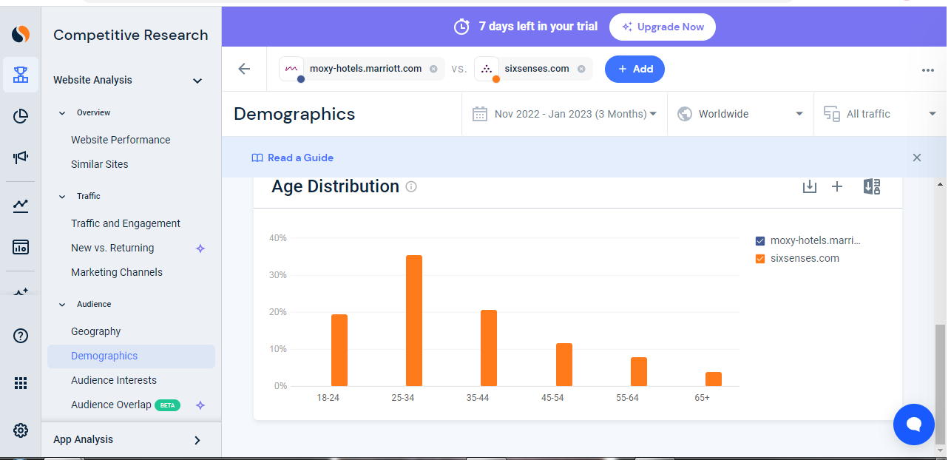
Figure: Age Distribution (Six Senses & Moxy).
Source: (https://www.similarweb.com/).
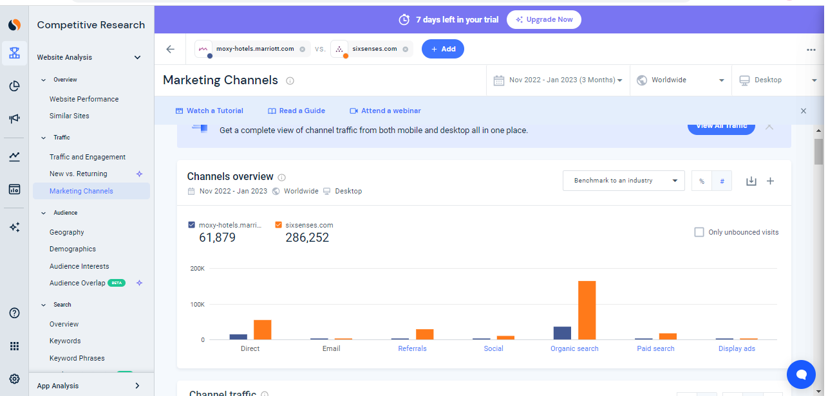
Figure: Marketing channels (Six Senses & Moxy)
Source: (https://www.similarweb.com/).
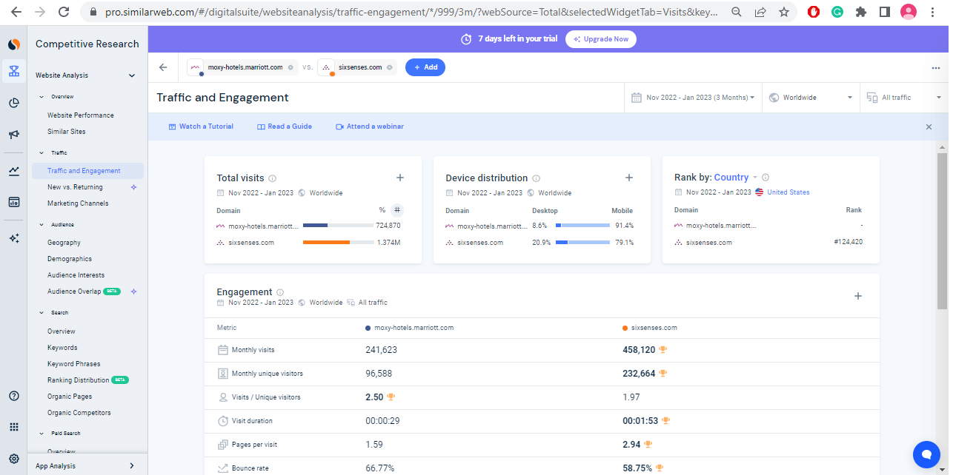
Figure: Traffic and engagement (Six Senses & Moxy)
Source: (https://www.similarweb.com/).
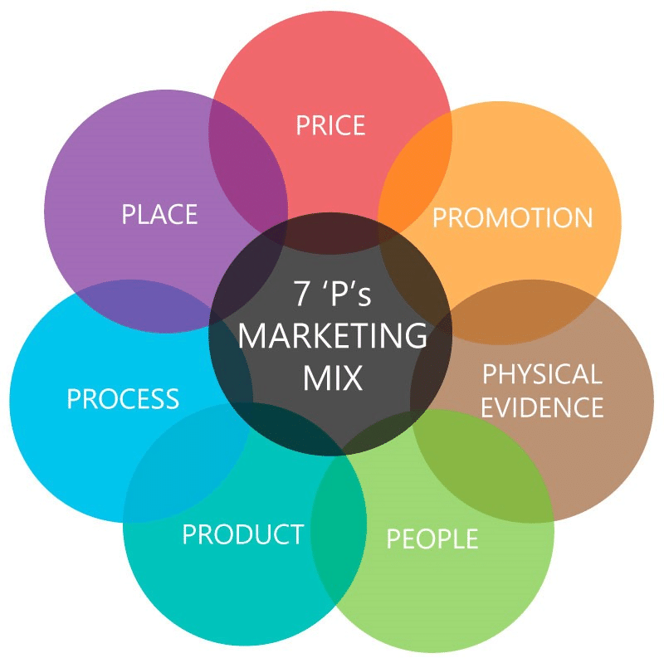

Figure: 7 Ps of Marketing
Source: (Jain., 2013).

