
MARKETING STRATEGY PORTFOLIO
Brand Extension Strategy for a Technology Company
Google Smart Energy System: A Sustainable Smart Home Brand Extension
Programme: Master of Business Administration (MBA)
Module Name: Marketing Management
Module Code: LCMB7024
Assignment Title: Assessment Component 2 – Marketing Strategies Portfolio
Lecturer's Name:Laila Maazouz

Student Name:Arjun Sanjaybhai Parmar
Student ID:2411725

Table of Contents
1. Introduction 3
2. Brand Extension Overview 3
3. STDP Analysis 4
3.1 Market Segmentation 4
3.2 Target Market 5
3.3 Differentiation Strategy 5
4. Marketing Mix Strategy (4Ps) 6
4.1 Product Strategy 6
4.2 Price Strategy 7
4.3 Place / Distribution Strategy 8
4.4 Promotion Strategy 8
5. Reflection 9
6. Conclusion 10
References 12
Appendix: Poster 14

1. Introduction
Google being a subsidiary of Alphabet Inc is one of the most powerful technology companies in the world. The company was established in 1998 and started as an internet search technology company but has now grown into many fields such as artificial intelligence (AI), cloud computing, digital advertising, as well as smart home technologies (Alphabet Inc., 2025). Google search, Android, Google mapping, and Google nest are only some of the products that have enabled the company to create an inclusive digital ecosystem which links billions of users worldwide (Alphabet Inc., 2025). With the ever changing technology, businesses such as Google are increasingly depending on innovation and brand development strategies to ensure their business competitiveness and sustainability.
As the smart home technology continues to grow rapidly and the world grows more concerned with the topic of energy efficiency and sustainability, there is also an emerging opportunity of technology companies to create solutions that will allow households to more effectively manage their energy consumption. As a reaction to this opportunity, this portfolio suggests brand expansion, the Google Smart Energy System, an artificial intelligence-based energy management system in homes that aims to track, analyse, and optimise domestic electricity consumption (Alsaigh et al., 2023).

2. Brand Extension Overview
Google has created a strong digital ecosystem of services, intelligent technologies that integrate users among a variety of platforms. Google Home devices, Android operating systems, and Google Nest smart home technology are some of the products that have enabled the company to become a market leader in artificial intelligence and connected living technology (Saleem et al., 2023). These inventions enable the user to manipulate home appliances, find information and automate their day to day activities using built in smart gadgets.
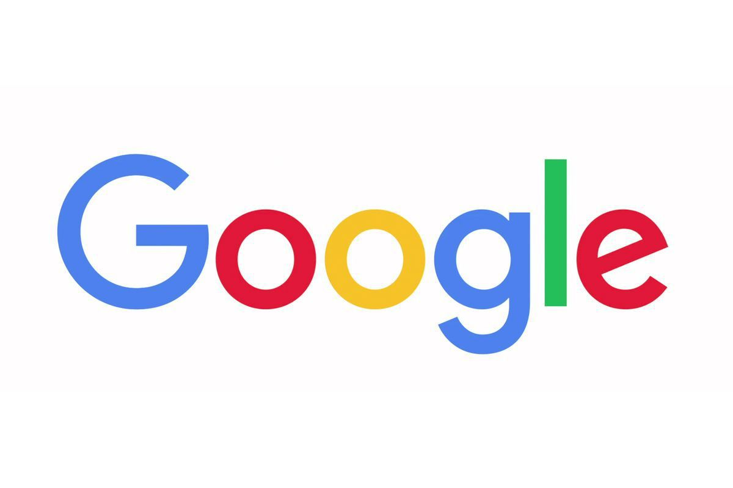
Figure: Logo of brand
Source: (Alphabet. Inc, 2025)
The proposed brand extension, which is based on this ecosystem, is the Google Smart Energy System, an energy management platform that is a smart home energy management solution aimed at assisting households to monitor and minimize their energy usage. The system would be integrated with the already existing Google technologies such as Google Nest, Google Home and Android devices (Alphabet Inc., 2025). The system would connect the pattern of energy usage by the household through the help of artificial intelligence and machine learning and automatically streamline the energy use through the control of heating systems, lights, and other appliances connected to the household (Sinha, 2025). The platform would also offer customers real-time energy consumption data and specific suggestions that will help to minimize energy bills and enhance efficiency.

3. STDP Analysis

3.1 Market Segmentation
Marketing strategies need the companies to determine and define various categories of consumers in the market. In the case of Google Smart Energy System, geographic, demographic, psychographic and behavioural variables can be used to analyse segmentation.
Geographically, the main market is represented by developed economies having a high level of smart home technology utilization and a rather high energy price (Saeidnia, 2023). Cities and smart cities are especially appealing markets since households there are likely to have a higher access to high-speed internet connectivity, as well as connected devices.
Demographically, the product best fits middle- to high-income households with the ability to spend financial resources on technologies of a smart house. An especially concerned population group is that of homeowners, who usually have more influence on household infrastructures and energy networks than tenants. Also, customers who are more technologically inclined and using the digital environment and smart equipment often tend to implement new technologies like AI-driven energy management systems.
Psychographic segmentation lies on consumer lifestyles and values. The Google Smart Energy System has a good target in the environmental conscious consumers who put the sustainability and energy conservation first. Likewise, people, who appreciate convenience, automation of house activities, and smart technologies in living will also find much value in a system which is able to automatically optimise the energy consumption in the house (Alphabet Inc., 2025).
Lastly, behavioural segmentation takes into account the consumer behavioural trends based on the adoption of technology and consumption of energy. Another segment that is very relevant is the users of smart home products, including Google Nest or smart thermostats, as they are already accustomed to connected home ecosystems (Kraus et al., 2022). Active consumers that control their power use actively or are interested in learning more about how to cut the cost of energy are also able to adopt an AI-driven energy management system with higher probability.

3.2 Target Market
The segmentation analysis shows that the major target market of the Google Smart Energy System includes urban homeowners aged 30-55 who are members of middle- and high-income brackets and already have smart home technologies. Such customers are usually technologically savvy and would be interested in solutions to enhance convenience, cost savings in the household and environmental friendly lifestyles (Alphabet Inc., 2025).
One of the target markets is a secondary market: property developers and smart city planners, eco-friendly millennials who have an interest in the incorporation of smart energy management solutions into residential buildings and on-campus housing projects.

3.3 Differentiation Strategy
Google Smart Energy System can distinguish itself among the competitors with the help of several main benefits (Sahani, 2025). To start with, the system would make use of high-tech AI-based energy optimisation, which would enable the platform to automatically examine the energy consumption trends and modify the use of the appliances optimally. Second, the system will be well integrated into the current Google system and will be able to connect with smart devices, including Google Home and Nest products, with ease (Mondal et al., 2023). Lastly, Google has a good brand name reputation and popularity across the world hence a high degree of consumer confidence over start-up firms.
3.4 Positioning
Google Smart Energy System would position itself as an AI-based, sustainable, and smart home energy management system that makes the control of energy easy and assists households in lowering energy expenses as well as their footprint on the environment.
One of the potential positioning statements is:
“Google Smart Energy System offers smart energy management system that is intelligent and powered by AI to help households save energy and decrease negative environmental impact, and it is fully compatible with the Google smart ecosystem.”
The positioning emphasizes the most important value propositions of the product, that is efficiency, sustainably, and easy connectivity within the existing Google smart home platform.

4. Marketing Mix Strategy (4Ps)

4.1 Product Strategy
The proposed Google Smart Energy System is a smart home energy management system that can assist the households in monitoring, controlling and optimising the utilisation of electricity by mean of artificial intelligence and smart devices (Noushad Yashan et al., 2024). The essence of the product is to ensure that the user has a more access to control the usage of the energy in their homes and enhance efficiency and environmental friendliness.
AI-based energy optimisation is one of the most important characteristics of the system. The platform would use machine learning algorithms to identify trends in energy consumption at households and then would automatically regulate the use of energy in order to achieve efficiency (Alphabet Inc., 2025). As an example, the system might decrease the amount of heating when the rooms are not used or optimize the use of appliances during the off-peak time of energy.
Smart device integration is another significant element. The Google smart energy system would integrate well with the other Google products like Google nest thermostats, Google home smart speakers, and android devices. Such integration enables users to manage home appliances and watch the energy use with voice or smartphone applications.
Sustainability-oriented design such as the use of energy efficient parts and environmental friendly materials where feasible would also be incorporated into the product (Cui et al., 2024). The system would be made of a few essential elements by incorporating a smart hub that would allow connecting the devices in the household, AI-driven software that would be used to optimise energy usage, a mobile app that would control and monitor the system, and IoT connectivity that would integrate the system with other smart home devices (Alphabet Inc., 2025).
In general, the product strategy is aimed at providing convenience, efficiency, and sustainability and enhance the presence of Google in the smart home ecosystem.

4.2 Price Strategy
The pricing of Google Smart Energy System would be centered on value-based pricing model, in which the cost would be related to the value which would be saved by the customer in terms of energy, automation and better efficiency. Given that the system can assist households to save on electricity and lower the bill payments, numerous consumers can view the product as a long-term investment, but not merely buying technology.
To attract various customer markets, Google may come up with a tiered pricing scheme which entails the provision of various packages with regard to functionality and user requirements. The Basic Package would offer the basic monitoring capabilities and enable users to monitor the consumption of household energy using the mobile application and obtain some basic energy saving tips. The package would also fit consumers that would prefer more visibility of their energy usage but might not necessarily need the full automation features (Aithal et al., 2024).
The Premium Package would have such advanced functionalities as a level of automated control of appliances, AI-assisted optimisation, and connection to Google Nest and Google Home devices. This would attract consumers of the smart home who desire a complete set up that automatically controls the use of power in the house.
To accommodate larger and larger scale applications, the Enterprise Package may be launched to accommodate smart city endeavors, property developers and mega residential developments. This package may combine energy management systems among the various homes or buildings and give the advanced analytics of energy providers and urban planners (Alphabet Inc., 2025).
This pricing technique enables Google to capture various categories of customers and at the same time make the product affordable to households as well as generate long term revenue through subscription services.

4.3 Place / Distribution Strategy
The marketing mix of the Google Smart Energy System would be based on the use of digital channels and strategic alliances to ensure the maximum availability on the global level (Pandya and Holia, 2023). Being a strong digital company that has a robust online infrastructure, Google has the ability to use its current online infrastructure to promote the product effectively.
The Google Store would be one of the main channels of distribution and the customers would be able to buy the system online. The product would also be sold in the leading e-commerce platforms like Amazon and other online stores worldwide where customers can easily access the product no matter where in the world they are.
Besides the online distribution, the system might be retail outlets at smart home providers and electronics stores. The retail would enter into an agreement with companies that specialise in smart home technologies where customers would be able to have a preview of the product in-store before buying it (Alphabet Inc., 2025). The areas of demonstration might feature the integration of the system into the current smart home devices.
Comprehensively, the distribution strategy is aimed at digital distribution at a worldwide level, e-commerce dominance, and strategic alliances in order to make sure that the product is distributed to a large number of consumers and organisations.

4.4 Promotion Strategy
The advertising approach of the Google Smart Energy System would revolve around the informing the product value in the form of sustainability, cost-saving, smart living (Cillo and Rubera, 2025). The marketing communications would be directed to inform the consumers of the advantages of energy optimisation and how the system enhances everyday life.
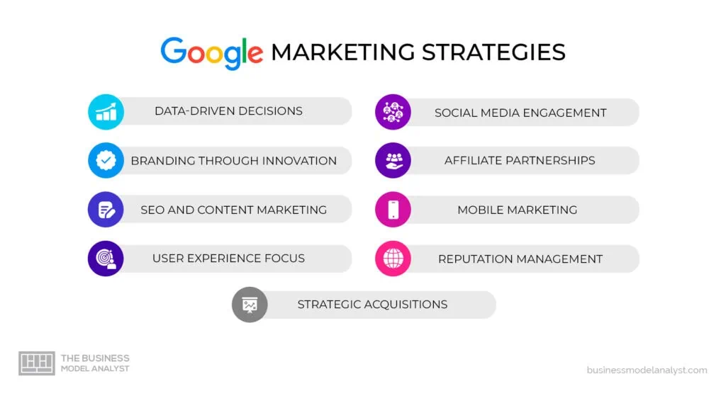
Figure: Marketing strategies of Google
Source: (Pereira, 2024)
The major part of the promotion would be digital marketing campaigns using the popular social media platforms like Instagram, Facebook, and LinkedIn. These campaigns would emphasize the advantages of smart energy management and demonstrate real-life examples of households that save money on electricity with the help of the system.
YouTube product demonstrations and tutorials might be important in educating the consumer on the functionality of the system (Kraus et al., 2022). Since Google has ownership in YouTube, the company can use this to make instructional videos, product demonstrations, and customer testimonials which will reflect the capabilities of the system.
The influencer marketing might also be employed to market the product, especially technology reviewers, sustainability advocates, and experts on the smart homes who would show the product to their followers (Alphabet Inc., 2025).
The general brand message would focus on three major topics, which are sustainability, cost savings, and smart living, and present Google Smart Energy System as a new technology that will not only help households save money but also help the environment.

5. Reflection
Creating this brand extension portfolio offered great knowledge of the marketing strategy and brand-development within the technology sector. During this project, I got to learn further about the application of brand extension strategy by companies to increase their product range by capitalizing on the existing brand equity.
Among the most important things that this assignment taught me is the ability of well-established brands to find their ways to new markets, developing their existing advantages. Google, in this context, has a great experience in the field of artificial intelligence, data analysis, and smart home technology and, as a result, would be well-placed to create an energy management system (Mondal et al., 2023). The marketing models (STDP and marketing mix) taught me how organisations study the market, define their target market and create successful marketing programs.
There are also some professional skills that I was able to develop through the project. Market analysis entailed critical thinking and research skills so that the behaviour of the consumer and market trends could be determined.
Another learning experience was to design the poster presentation. The development of a visual summary of the brand extension made me reduce complex ideas into straightforward and succinct messages that could be easily comprehended by a group of people. This exercise enhanced my understanding of visual communication and the need to communicate marketing concepts in a convincing and interesting way.
Although these are the benefits of learning in the project, there were also challenges. Time management was one of the issues that needed to be addressed during research and the development of various sections of the portfolio. Also, the consideration of consumer behaviour and industry trends was important in the process of identifying the right market segments, and creating a practical marketing plan.
To enhance my practice in the future, I would strive to accomplish better practices due to more extensive market research and more industry information to justify the strategic decisions (Pandya and Holia, 2023). I would also spend a better part of the time in analyzing data and improving marketing strategies.
On the whole, this assignment has reinforced my perception of the marketing management concept and showed that strategic marketing models can be implemented in practice to the business scenarios. Such competencies will be useful in my future as a marketer and business strategy.

6. Conclusion
This marketing plan has outlined the marketing plan of the proposed Google Smart Energy System which is a smart home energy management solution that is aimed at enabling the households to optimise on the amount of energy used and minimise environmental effects (Sahani, 2025). The product is a good illustration of a strategic brand extension by taking advantage of the existing ecosystem of smart devices and artificial intelligence technologies owned by Google.
The marketing mix approach also emphasises the importance of innovation of the products, price that is value based, online distribution and promotional campaigns to ensure the product is launched successfully. The competitive edge that Google has in the highly emerging smart home market is the strong brand reputation and technological capabilities (Alphabet Inc., 2025).
The Google Smart Energy System, in the long run, may not only contribute to the business expansion but also other sustainability objectives such as assisting households in decreasing their electricity use and carbon emissions (Sinha, 2025). As the development of smart technologies does not stop, these types of solutions will become even more significant in promoting sustainable lifestyles and energy efficiency on the global level.

References
Aithal, P. S., Saldanha, D., and Satpathy, C. J. (2024). Infosys: A pioneer in HR innovation. Poornaprajna International Journal of Teaching and Research Case Studies (PIJTRCS), 1(1), 255-307. https://poornaprajnapublication.com/index.php/pijtrcs/article/download/44/36
Alphabet Inc. (2025). Investor relations. https://abc.xyz/investor/
Alsaigh, R., Mehmood, R., and Katib, I. (2023). AI explainability and governance in smart energy systems: A review. Frontiers in Energy Research, 11, 1071291.https://www.frontiersin.org/journals/energyresearch/articles/10.3389/fenrg.2023.1071291/full
Cillo, P., and Rubera, G. (2025). Generative AI in innovation and marketing processes: A roadmap of research opportunities. Journal of the Academy of Marketing Science, 53(3), 684-701. https://link.springer.com/content/pdf/10.1007/s11747-024-01044-7.pdf
Cui, Y. G., van Esch, P., and Phelan, S. (2024). How to build a competitive advantage for your brand using generative AI. Business Horizons, 67(5), 583-594. https://digitalcommons.coastal.edu/cgi/viewcontent.cgi?article=1001andcontext=marketing-hrtm
Kraus, S., Kanbach, D. K., Krysta, P. M., Steinhoff, M. M., and Tomini, N. (2022). Facebook and the creation of the metaverse: radical business model innovation or incremental transformation?. International Journal of Entrepreneurial Behavior and Research, 28(9), 52-77. https://www.emerald.com/ijebr/article-pdf/28/9/52/848570/ijebr-12-2021-0984.pdf
Mondal, S., Das, S., and Vrana, V. G. (2023). How to bell the cat? A theoretical review of generative artificial intelligence towards digital disruption in all walks of life. Technologies, 11(2), 44. https://www.mdpi.com/2227-7080/11/2/44
Noushad Yashan, D. S. R. S., Kohli, N. K., Kalakumari, T., and Mistry, V. (2024). Innovative business models in the digital age: A comparative analysis. Cahiers Magellanes-NS, 6(2), 5170-5181. https://www.researchgate.net/profile/N-Yashan/publication/384065863_INNOVATIVE_BUSINESS_MODELS_IN_THE_DIGITAL_AGE_A_COMPARATIVE_ANALYSIS/links/66e8518001cba963bf2379e2/INNOVATIVE-BUSINESS-MODELS-IN-THE-DIGITAL-AGE-A-COMPARATIVE-ANALYSIS.pdf
Pandya, K., and Holia, M. (2023). Automating Customer Service using LangChain: Building custom open-source GPT Chatbot for organizations. arXiv preprint arXiv:2310.05421. https://arxiv.org/pdf/2310.05421
Pereira, D. (2024, December 17). Google marketing strategy. Business Model Analyst.
https://businessmodelanalyst.com/google-marketing-strategy/
Saeidnia, H. R. (2023). Welcome to the Gemini era: Google DeepMind and the information industry. Library Hi Tech News. https://www.emerald.com/lhtn/article-pdf/doi/10.1108/LHTN-12-2023-0214/9776060/lhtn-12-2023-0214.pdf
Sahani, T. (2025). Charting new horizons: Innovation meets sustainability in business. Journal of Next-Generation Research 5.0. https://jngr5.com/jngr/article/view/46/46
Saleem, M. U., Shakir, M., Usman, M. R., Bajwa, M. H. T., Shabbir, N., Shams Ghahfarokhi, P., and Daniel, K. (2023). Integrating smart energy management system with internet of things and cloud computing for efficient demand side management in smart grids. Energies, 16(12), 4835. https://www.mdpi.com/1996-1073/16/12/4835
Sinha, S. (2025). Fundamentals of Product and Pricing Management (for University of Calcutta). https://www.academia.edu/download/125089825/FundamentalofProductandPricingManagement_sample.pdf

Appendix: Poster


