MSc Public Health and Social Care in Practice
Health Care System Organization and Leadership
LCHS7003 | Component 1

Case study – 1
Report on Morphine Overdose in Infant

Student Name: Jenishkumar Hirani (2518576)

Table of Contents

1. Introduction (Case Study Report) 4
2. Main Body and Analysis 5
2.1 Problem Identification and System Context 5
2.1.2 Case Overview with global and national statistics 5
2.1.2 Patient Safety Problem with systematic weaknesses (UK Context) (communication, accountability, or leadership) 7
2.1.3 Problem relevant to UK Healthcare Governance 8
2.1.4 Underlying challenges 8
2.2 Centralisation vs Decentralisation in the Case Study 9
2.2.1 Understanding System Structure in the NHS 9
2.2.2 Centralisation in the Case Study 10
2.2.3 Decentralisation in the Case Study 10
2.2.4 Critical Comparison and Impact on the Incident 11
2.3 Leadership Theories and Application to the Case 12
2.3.1 Role of Leadership in Healthcare Systems 12
2.3.2 Transformational Leadership 12
2.3.3 Transactional Leadership 13
2.3.4 Situational Leadership 14
2.3.5 Servant and Distributed Leadership 15
2.3.6 Leadership Effectiveness: Data and Evidence 15
2.3.7 Critical Evaluation 15
2.3.8 Link to Patient Safety 16
2.4 Improvement and Lessons Learned 16
2.4.1 Overview of Failures and Need for Improvement 16
2.4.2 Problem 1: Communication Breakdown Across Care Settings 16
2.4.3 Problem 2: Weak Governance and Policy Implementation 17
2.4.4 Problem 3: Lack of Staff Knowledge and Training 17
2.4.5 Problem 4: Inadequate Patient and Caregiver Involvement 18
2.4.6 Integration of Leadership, Governance, and Systems 19
2.4.7 Lessons Learned 19
2.4.8 Continuous Improvement and Feedback 20
3. Recommendations 20
3.1 Strengthening Leadership for Sustainable Improvement 20
3.2 Improving Governance and Policy Enforcement 20
3.3 Enhancing Communication and System Integration 21
3.4 Investing in Staff Training and Education 21
3.5 Promoting Patient and Caregiver Engagement 21
3.6 Improving Efficiency and System Performance 22
3.7 Continuous Learning and Stakeholder Engagement 22
4. Conclusion 22
5. References 23

1. Introduction (Case Study Report)
Healthcare systems in the United Kingdom are complex, adaptive and highly interdependent, with involvement of multiple professionals, organisations, and processes working together to deliver safe and effective patient care. During this stage, patient safety is a fundamental priority due to the potential for harm when failures occur at any stage of care delivery. More than 237 million medication errors have been noticed every year in England, which is responsible for £98 million costs of the NHS and over 1700 lives every year (BMJ, 2025). Similarly, the World Health Organization identifies medication errors as one of the leading causes of preventable harm worldwide, which is highlighting the importance of the case study of Morphine Overdose [Refer to the Case Study 1]. The total death record due to drug misuse across England and Wales has increased from 3060 in 2021 to 3,618 in 2023 (Statista, 2025). Similarly, the case study of Morphine Overdose is highlighting the life-threatening incident of a 4 week-old baby [Refer to the Case Study 1]. Considering this aspect, case study 1 has been chosen for this report.
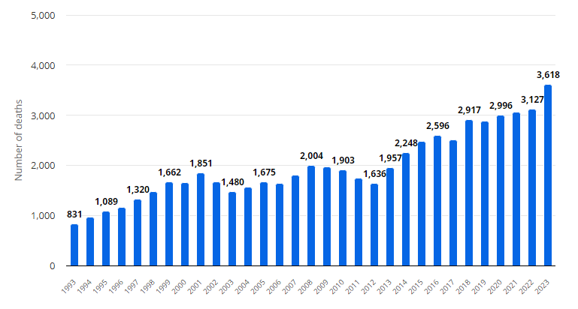
Figure 1: Death record due to drug misuse in England and Wales between 1993 and 2023
(Source: Statista, 2025)
According to the case study, the error occurred due to the prescribing of an incorrect formulation (10mg/5ml instead of 100 micrograms/ml), limited transparency during discharge, and insufficient verification at the pharmacy level. Similar incidents have been noticed in the previous record of patient safety within the NHS that supports the significance of the healthcare system issue. This incident supports the failure of the healthcare system of the UK due to lack of effective leadership style and working system.
Leadership plays a crucial role in shaping healthcare outcomes and ensuring patient safety. According to Northouse (2022), leadership is not limited to positional authority, even involves influencing behaviour and decision-making at all organisational levels. On the other hand, Nordholm et al. (2025) stated the significance of the centralised and decentralised leadership system with the leader's autonomy and working process. Supporting this argument, Khalilov (2023) demonstrated centralised and decentralised leadership approaches as two organisational management methods to achieve success with innovative changes. This argument supports the significance of right leadership styles to achieve organisational success, which can be analysed through the evaluation of different leadership theories, including, Transactional, Transformational, and Situational. According to Arfanaldy (2025), effective leadership styles, such as transformational, transactional, and situational leadership have significant impacts on organisational overall performance.

2. Main Body and Analysis

2.1 Problem Identification and System Context

2.1.2 Case Overview with global and national statistics
According to the case study 1, a 4-week-old infant was administered a significantly higher dose of morphine sulphate oral solution Specifically, the infant was supplied with a 10mg/5ml solution instead of the intended 100 micrograms/ml preparation. This resulted in a potentially life-threatening overdose, requiring emergency treatment with naloxone. Drug overdose has become a global-level health crisis, while the prevalence has increased significantly in the last 20 years. For example, 292 million or 5.6% of the global population aged between 15 and 64 years had already consumed a drug in the last 12 months, a 20% increase from 2012 (Overdose Day, 2026). In addition, overdose of opioids is responsible for more than 2 out of 3 or 69% of global drug overdose deaths (Overdose Day, 2026). On the other hand, the INCB Narcotic Drugs report of 2024 has highlighted the gap in the global supply chain of raw materials, which is responsible for unequal access to opioid analgesics, specifically among lower-income countries.
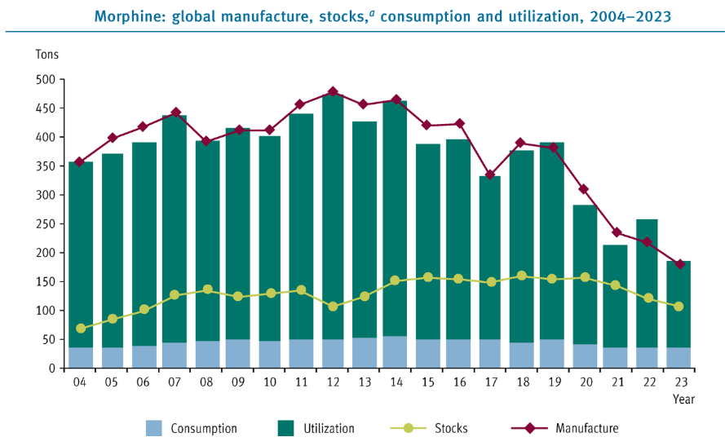
Figure 2: Global Supply Chain Status of Morphine
(Source: INCB, 2024)
According to the INCB Narcotic Drugs report of 2024, manufacturing, stock and utilisation of Morphine drug has reduced between 2013 and 2023 highly across the world (INCB, 2024). However, there is minimum change in consumption record, which is creating a healthcare system crisis by reducing patient safety. This situation has been observed in the case study of 1, while lack of organisational medication record, especially during the hospital discharge was responsible for the life threatening situation of an infant. Similarly, the UK-based healthcare system is failing to ensure patient safety due to poor Morphine drug management. For example, the death record for morphine drug poisoning across England and Wales has increased from 765 in 2013 to 1415 in 2024 (Statista, 2025). This statistics-based global and UK-based discussion supports the growing prevalence of Morphine-related death records, which is similar to the case study 1.
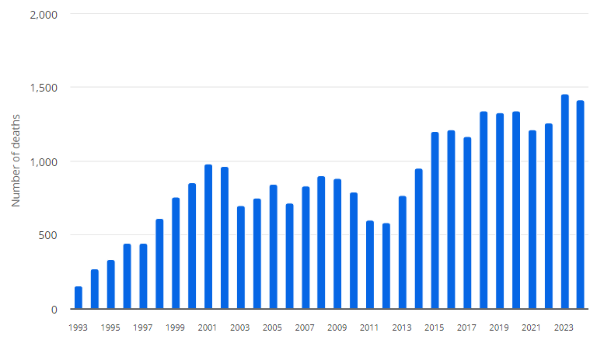
Figure 3: Death record due to drug poisoning by morphine and heroin across England and Wales between 1993 and 2024
(Source: Statista, 2025)

2.1.2 Patient Safety Problem with systematic weaknesses (UK Context) (communication, accountability, or leadership)
As per the discussion by Keshtkar et al. (2025), lack of effective communication and transparency has been identified as a systematic weakness of the UK-based healthcare process. This argument implies that the limited communication reduces transparency in the healthcare system and practices of the UK, which is not suitable for the maintenance of patient safety as outcome. On the other hand, Lockhart et al. (2025) described the internal relationship between the UK’s healthcare leadership style and healthcare outcomes in the context of patient safety. This argument implies the role of leadership style in managing healthcare performance in terms of maintaining patient safety, which was missing in the case study of 1. As a result, patient safety has been compromised, which is a failure of the UK-based healthcare system.
In the UK, medication incidents are among the most frequently reported patient safety events, with thousands of cases recorded annually through national reporting systems. According to the discussion by Alrowily et al. (2025), inadequate drug checking, limited communication between staff and patients, and high staff workloads are associated with the medication error in the UK-based healthcare system. This argument implies that medication error is another systematic weakness of the UK-based healthcare system, which is responsible for life-threatening conditions of the patients, even a 4 weak infant.

2.1.3 Problem relevant to UK Healthcare Governance
Governance structures play a critical role in ensuring patient safety by establishing clear policies, accountability, and oversight mechanisms. In this case, the failure to adhere to governance protocols related to “RED drugs” was a significant contributing factor. RED drugs are intended to be prescribed and managed within specialist settings, and their use in primary care should be restricted. However, this policy was not effectively enforced, allowing the error to occur. As opined by Olawade et al. (2025), information governance of the UK healthcare system is responsible for managing technological advancement in regular healthcare practices and operations to ensure expected outcomes. However, limited governance efficiency has been observed in the case study of 1. The incident also highlights weaknesses in clinical governance, including inadequate risk management, lack of standardised procedures, and insufficient training of staff. According to the Care Quality Commission, strong governance systems are essential for maintaining safety and quality in healthcare services. The failure to implement robust governance measures in this case suggests gaps in organisational leadership and oversight.

2.1.4 Underlying challenges
The patient journey involved several transitions, including hospital discharge, GP prescribing, pharmacy dispensing, and home administration by parents. As per the views of Jerjes and Majeed (2025), staff shortage is a significant challenging aspect for the NHS-based healthcare practices, which is also creating the budget constraints. On the other hand, the initial failure occurred at the hospital level of the case study 1, where a handwritten discharge summary was used instead of an electronic system. The lack of standardisation and clarity in the discharge documentation contributed to misinterpretation by the GP. The use of abbreviations such as “mcg” further increased the risk of confusion. At the primary care level, the GP was unaware of the availability of the lower-strength morphine formulation and prescribed a higher-strength product based on incomplete information. This highlights a gap in knowledge and system support for prescribing decisions.
At the pharmacy level, the error was not identified despite queries being raised. Communication between the pharmacy and GP occurred indirectly through non-clinical staff, which limited the effectiveness of the clarification process. As per the critical argument by Bolwell (2025), serious injuries and deaths caused by medical errors of the healthcare systems of developed countries, such as the UK and USA. Additionally, insufficient counselling was provided to the parents, who were not adequately informed about the correct dosage and administration method. As a result, the parents administered a significantly higher volume of the medication, leading to overdose. On the other hand, Mathew et al. (2025) highlighted the staff stress as a burden of the UK-based healthcare system in terms of maintaining patient safety. Systems thinking emphasises that outcomes are shaped by relationships between different components, including people, processes, and organisational structures. In this case, the lack of integration between hospital, primary care, and pharmacy systems created gaps in communication and accountability.
The above discussion highlighted multiple underlying challenges with the current UK-based and global healthcare systems. Similarly, there was no mechanism to ensure that parents fully understood the medication instructions before administration. According to the discussion by Onyejesi et al. (2026), staff shortage in the NHS is highly associated with poor healthcare practices, which is not suitable for the maintenance of patient safety. Another important factor is the fragmentation of healthcare delivery across different settings. While the NHS operates under a unified framework, care is delivered by multiple independent organisations, including hospitals, GP practices, and community pharmacies. Without strong coordination and shared information systems, this fragmentation can lead to inconsistencies and errors. The lack of electronic prescribing and integrated patient records in this case contributed significantly to the failure.

2.2 Centralisation vs Decentralisation in the Case Study

2.2.1 Understanding System Structure in the NHS
The healthcare system in the United Kingdom operates under a hybrid structure that combines elements of both centralisation and decentralisation. As per the discussion by Shishkin et al. (2025), the centralisation and decentralisation in the healthcare system is significantly relevant to the public healthcare outcomes through healthcare quality and care accessibility. The NHS England sets national policies, clinical guidelines, and safety standards, while local organisations such as NHS Trusts, General Practitioner (GP) practices, and community pharmacies are responsible for implementing these policies in practice. This structure aims to balance consistency in care delivery with flexibility in local decision-making. Centralisation refers to a system where decision-making authority is concentrated at higher organisational levels, ensuring uniform standards and control. In contrast, decentralisation distributes authority across different levels, allowing local teams to make decisions based on specific patient and contextual needs. In the context of this case study, both elements were present; however, the interaction between them contributed to system failure rather than supporting safe care delivery.

2.2.2 Centralisation in the Case Study
Centralisation within the NHS is evident through national policies related to medication safety, prescribing guidelines, and classification of high-risk drugs such as “RED drugs.” These drugs are intended to be prescribed and managed within specialist (secondary care) settings only. The existence of such policies reflects a centralised approach aimed at reducing risk and ensuring patient safety. According to the views of Fana and Mokhele (2025), healthcare systems of developing countries are facing quality, access, utilisation and cost-related challenges, which could be solved through the adoption of centralised structure. On the other hand, the classification of morphine sulphate 100 micrograms/ml as a RED drug represents a centralised governance control designed to prevent inappropriate prescribing in primary care in case study 1. However, despite this policy, the drug was indirectly prescribed through GP services, demonstrating a failure in policy enforcement. This highlights one of the key limitations of centralisation: policies alone are insufficient without effective implementation and monitoring.
The implementation of centralisation in healthcare organisations supports standardisation of clinical practices and safety protocols, by providing transparent guidelines for high-risk medications. In addition to these, the centralisation approach supports the enhancement of organisational accountability through a structured information governance system. According to the Care Quality Commission report of the NHS, overall performance is 4 out of 5 due to 122 responses for required improvement and inadequate approach in the NHS UK (CQC, 2026). However, limited flexibility in adapting policies at local level and weak enforcement of safety protocols, such as RED drug rule are the key disadvantages of the centralised approach. Moreover, over-reliance on policy without system integration is another issue of the centralised approach.

2.2.3 Decentralisation in the Case Study
Decentralisation is reflected in the autonomy given to healthcare professionals across different care settings. In this case, decision-making was distributed across hospital clinicians, GPs, pharmacists, and parents. Each stakeholder had a role in the medication process, including prescribing, dispensing, and administration. As opined by Matenga et al. (2025), the decentralisation approach of the healthcare firms supports improved quality of patient care. However, the GP in the case study 1 independently interpreted the discharge summary and issued a prescription based on available information. Similarly, the community pharmacists made dispensing decisions and communicated with the GP practice. This level of autonomy is a key feature of decentralised systems, allowing professionals to respond to patient needs efficiently.
According to the current research interpretation, the decentralisation approach is effective to develop faster decision-making at the local level with support of flexibility in responding to individual patient needs. In addition to these, decentralisation has efficiency to encourage healthcare professional autonomy and responsibility, which is required to enhance quality care. According to the National Institute for Health and Care Excellence, the NHS healthcare system needs to enhance its support system for patients to make informed decisions with improved communication between health professionals and patients (NIH, 2026). However, variability in knowledge and clinical expertise with limited communication between healthcare staff and patients are possible disadvantages of the decentralised approach. Apart from these, limited coordinated accountability across system levels are another disadvantage of the decentralised organisational approach.

2.2.4 Critical Comparison and Impact on the Incident
The interaction between centralisation and decentralisation in this case study reveals a misalignment that contributed significantly to the incident. While centralised policies existed to prevent such errors, decentralised implementation led to inconsistent application of these policies. According to the Red Drug Guidance, red drugs need to be prescribed by the hospital authority during the course or before discharge (NHS, 2026). However, limited follow of this guidance has been observed in the case study of 1. This demonstrates a failure of integration between centralised governance and decentralised practice. Furthermore, the absence of integrated electronic systems meant that information was not effectively shared across different levels of care. Data from NHS patient safety reports indicate that communication failures are a leading cause of medication errors in the UK. In this case, the lack of shared digital records and real-time verification systems allowed the error to pass through multiple stages without detection. Numerical evidence from UK healthcare reports highlights that medication errors contribute to thousands of preventable incidents annually, with a significant proportion linked to prescribing and communication issues. These findings support the argument that both centralised and decentralised systems must be effectively aligned to ensure safe healthcare delivery.

2.3 Leadership Theories and Application to the Case

2.3.1 Role of Leadership in Healthcare Systems
Leadership influences the way healthcare professionals communicate, manage risk and respond to the safety concerns across the healthcare sectors. The leadership failures were evident across the hospital, GP practice and community pharmacy in the neonatal morphine overdose case. Hence. The lack of coordination oversight allowed an unclear prescription to progress through several care settings without effective challenges. In line with this, NHS England (2022) identified leadership, teamwork and psychological safety as central to a positive patient-safety culture. These issues indicate not only operational weaknesses but also deeper leadership challenges within the system.

2.3.2 Transformational Leadership
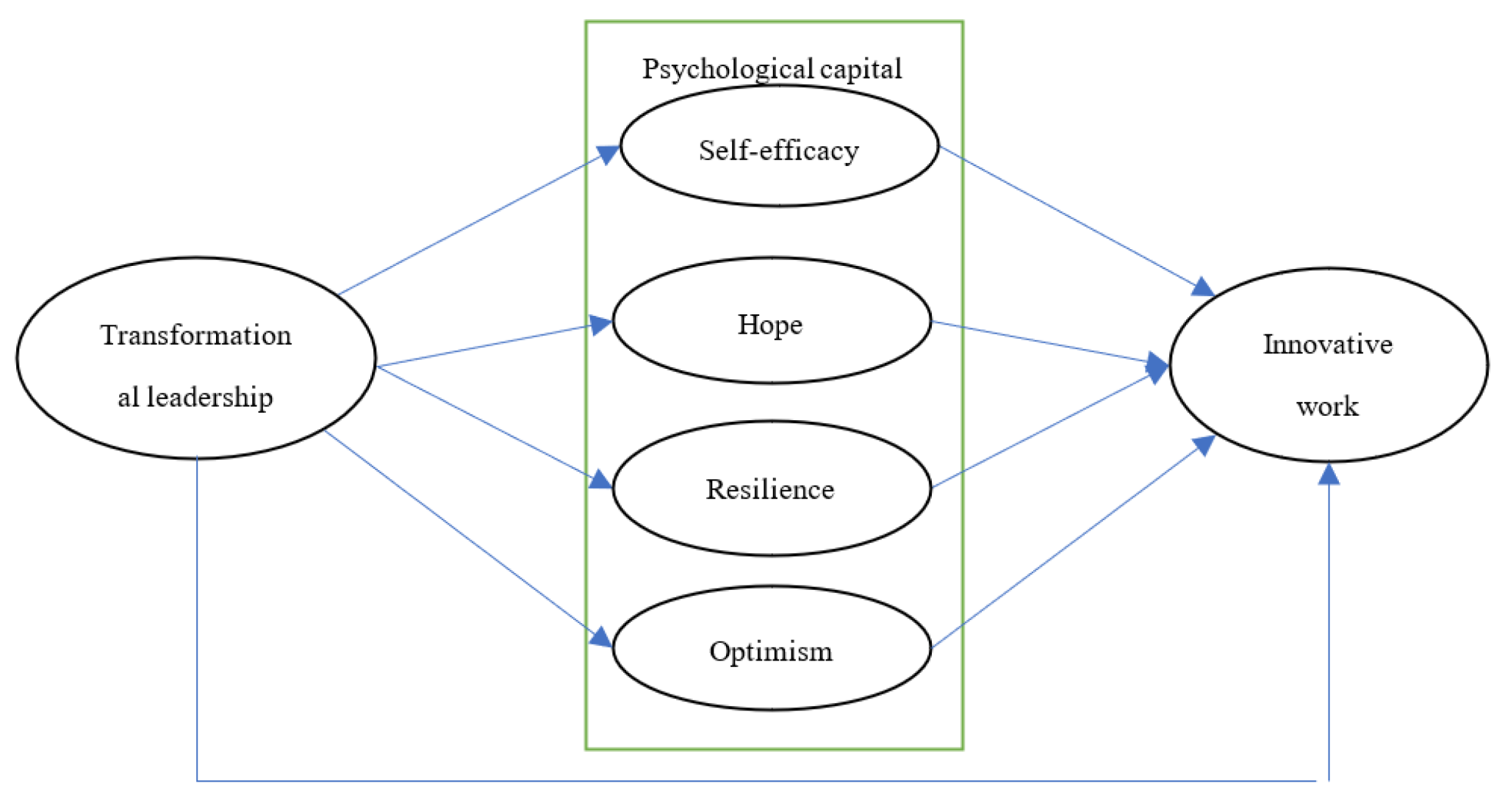
Figure 4: Transformational leadership
(Source: Karimi et al., 2023)
The transformational leadership promotes a shared vision, staff engagement and continuous improvements (Karimi et al., 2023). The application to this incident, these transformational leaders could have enhanced the organizational culture in which staff actively questioned on ambiguous discharge information, reported concerns and prioritised learning over blame. According to Northouse (2022), transformational leaders influence organisational change by aligning individual goals with organisational objectives. In supporting the previous view, Ystaas (2023) mentioned that transformational leadership can improve teamwork, organizational commitment and care quality as well. For example, the lack of awareness among healthcare professionals regarding high-risk “RED drugs” suggests insufficient training and engagement (World Bank Group, 2019). However, this leadership’s emphasis on motivation and culture may be insufficient when immediate procedural controls are needed.
Data from the Care Quality Commission indicates that organisations with strong safety cultures and leadership engagement report fewer patient safety incidents (CQC, 2023). This suggests that a more transformational approach could have reduced the likelihood of this error by promoting vigilance and shared responsibility. Therefore, transformational leadership needs to support, instead of replacing, formal medication-safety systems.

2.3.3 Transactional Leadership
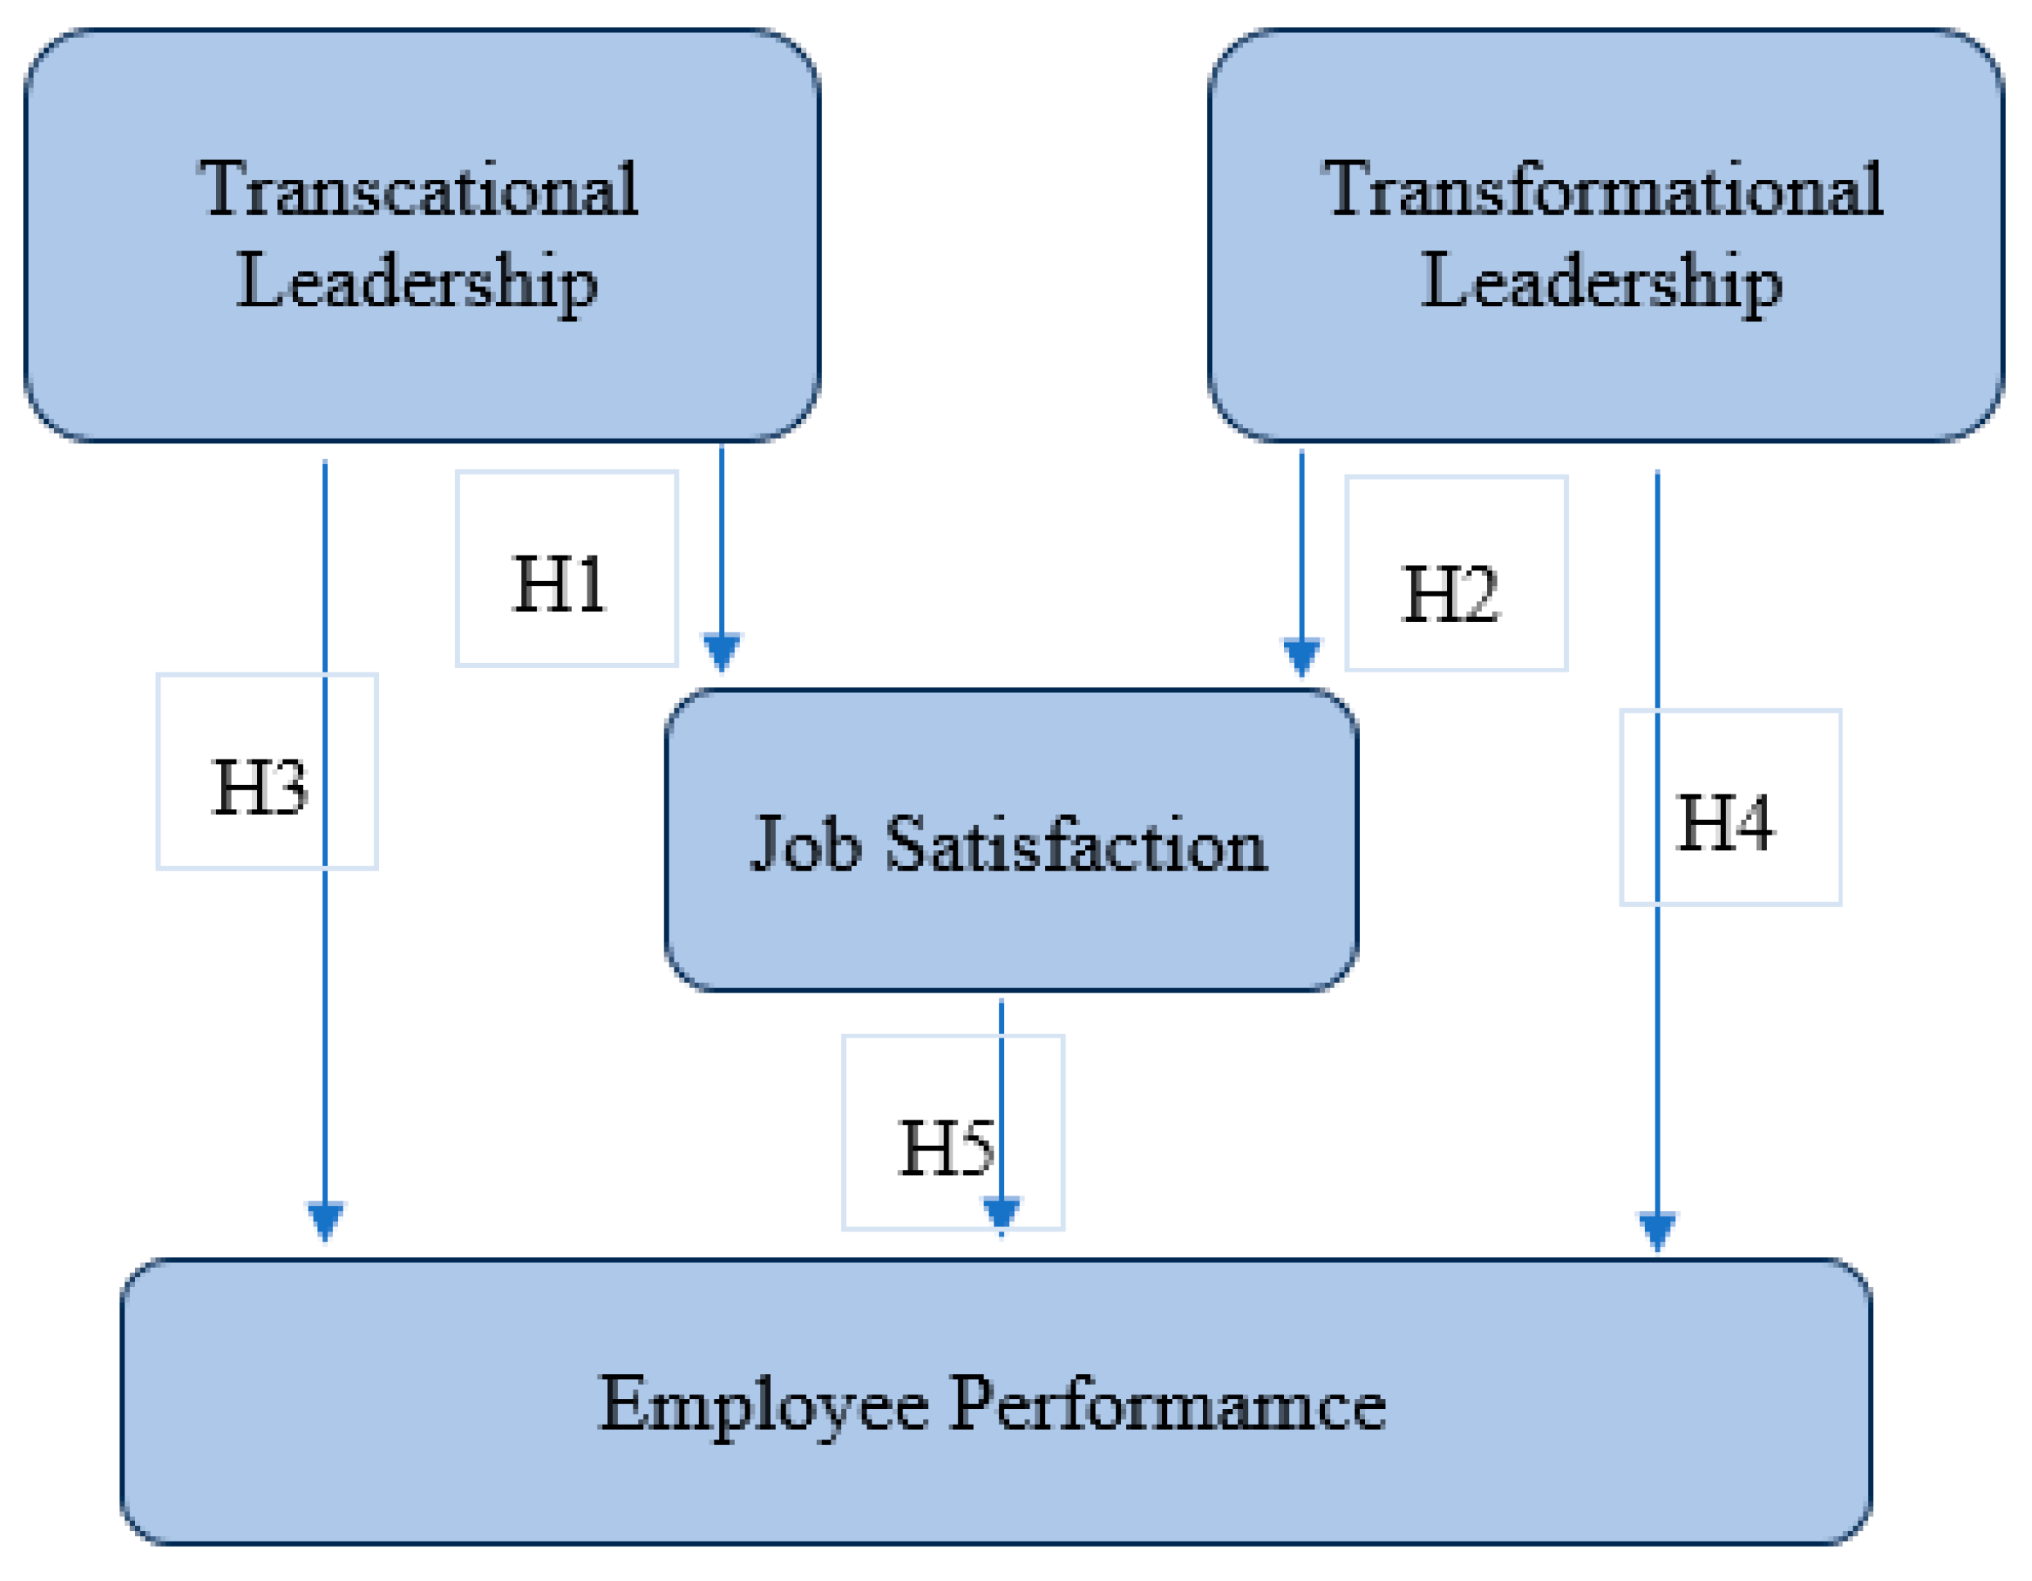
Figure 5: Transactional leadership
(Source: Salameh-Ayanian et al., 2025)
Transactional leadership focuses on the clear responsibilities, monitoring and compliance with established standards (Salameh-Ayanian et al., 2025). This approach was relevant because the case involved a high-risk medicine, a vulnerable neonate and multiple opportunities for verification. In this case, transactional leadership mechanisms were present but poorly implemented. Policies regarding RED drugs existed, but there were inadequate enforcement and monitoring. Hence, stronger transactional controls could have required standardised prescribing, mandatory confirmation of formulation and direct escalation when pharmacists found uncertainty. According to the NICE (2016), adherence to structured medication safety protocols is essential to reduce errors. However, excessive dependence on compliance may discourage professional judgement or make a ‘tick-box’ culture. Likewise, rules need to be followed by supportive leadership and opportunities to challenge unsafe practice.

2.3.4 Situational Leadership
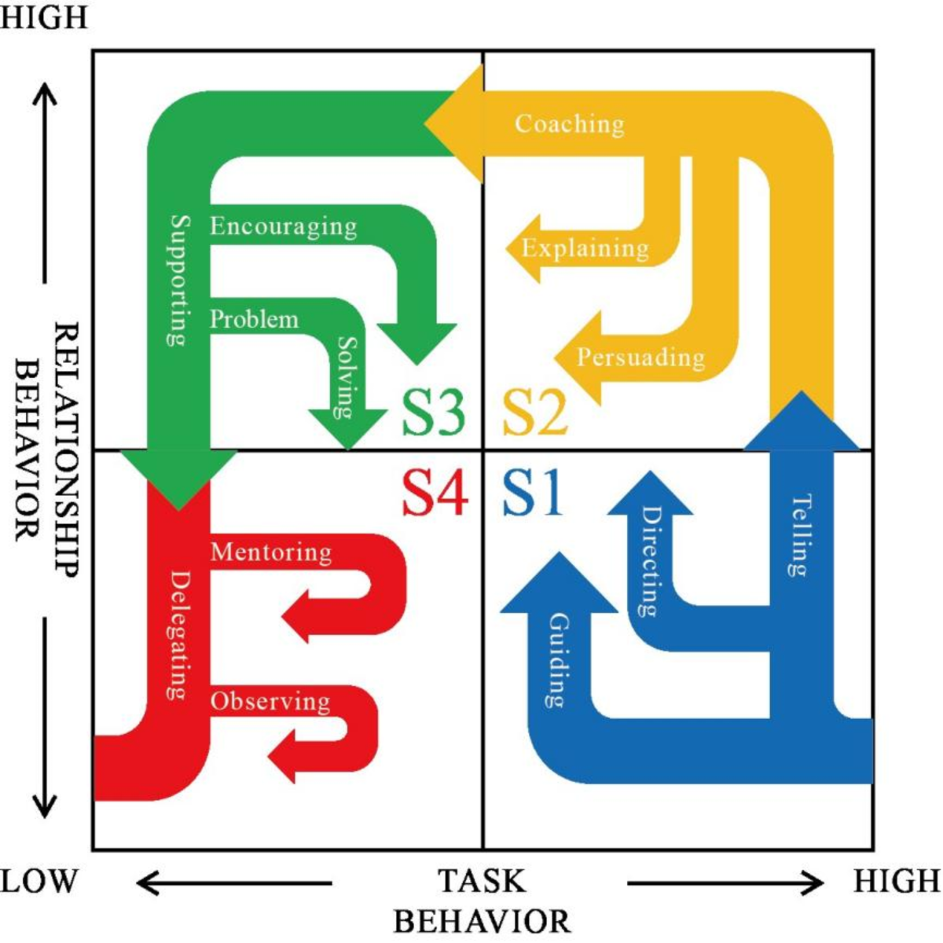
Figure 6: Situational leadership theory
(Source: Wang et al., 2024)
Situational leadership needs leaders to adapt their level of direction by supporting the competencies of staff and complexities of the situations (Wang et al., 2024). As per the case study, the neonatal context required higher supervision as morphine dosing involved unusual concentrations with narrow margin for error. For instance, prescribing a high-risk medication for a neonate requires heightened awareness and careful verification. In this regard, Percival et al. (2023) a situational approach would have influenced additional clinical review, direct prescriber-pharmacist communication by enhancing parental counselling. Their limitation is effectiveness depends on leaders properly evaluating staff capability and risk, inconsistent judgement may itself produce variations.

2.3.5 Servant and Distributed Leadership
Distributed leadership identifies that safety is a shared responsibility instead of the duty of one senior manager. In this case, clinicians, pharmacists and parents each possessed information which could have prevented harm. However, these aspects were not effectively integrated based on this case scenario. The Health Leaders (2017) highlighted Institute for Healthcare Improvement (IHI)’s insertion that collaborative leadership and teamwork are critical for reducing medical errors. Hence, servant leadership complements this approach by prioritising patient needs, staff support and compassionate communications. However, shared leadership can reduce accountability unless roles and escalation pathways are explicit. Thus, collaboration needs to operate across the clear governance arrangements.

2.3.6 Leadership Effectiveness: Data and Evidence
As per the view, Althobaiti (2026) the transformational, transactional and ethical leadership with improved communication, teamwork, organisational learning and patient-safety culture. The medication errors remain a significant concern, with national reports indicating around 240 million cases of medication error annually in the UK (GOV UK, 2026). However, leadership effectiveness needs not to be judged only by the absence of incidents. This needs to be evaluated through staff confidence to speak up, timely resolution of medication queries, adherence to safety controls and learning from near misses. NHS incident-response standards similarly need leaders to apply systems thinking and critically evaluate whether safety actions address underlying causes (NHS England, 2022). These outcomes suggest that leadership was neither proactive nor effective in managing risk.

2.3.7 Critical Evaluation
No single theory sufficiently addresses the issues of the case scenario in which each leadership has the quality to be used to manage the situation. Transformational leadership can make a learning-oriented safety culture, on the other hand, transactional leadership provides the standardisation necessary for high-risk medicines. Furthermore, situational leadership helps additional support when clinical complexity increases, while distributed leadership improves coordination across organisational boundaries. Their combined use is more appropriate than selecting one dominant leadership style. Therefore, leadership needs to be addressed based on system conditions instead of attributing the drug overdose to individual error.

2.3.8 Link to Patient Safety
An integrated leadership approach could have enhanced communication, verification and accountability throughout the medication pathways. Therefore, the leaders were able to reduce the risk that similar prescribing and dispensing failures reach patients by combining safety culture with strong controls and shared responsibility. This approach would also promote earlier escalation, clearer accountability and more reliable learning across the organisational boundaries following medication-related issues.

2.4 Improvement and Lessons Learned

2.4.1 Overview of Failures and Need for Improvement
The neonatal morphine overdose resulted from interconnected failures in communication, governance, professional competence and caregiver support instead of a single individual error.
According to the Hibbert et al. (2023), improving patient safety requires strengthening health systems through better leadership, governance, and continuous learning mechanisms. Hence, the improvement needs to address the entire medication pathway and enhance the conditions by enabling safe decision-making in the healthcare context.

2.4.2 Problem 1: Communication Breakdown Across Care Settings
Issue. The handwritten discharge summary made ambiguity regarding morphine formulation and doses.
Supporting Data
The information was transferred indirectly between the hospital, general practice and pharmacy to allow uncertainty in persistence.
Improvement
A key improvement is the implementation of electronic discharge summaries and integrated digital health systems. Standardised electronic discharge documentation and direct clinician communication would improve clarity. However, only technological utilisation cannot be enough to replace professional verification especially in the healthcare context. The NICE recommends structured communication tools and shared records to reduce errors during care transitions.

2.4.3 Problem 2: Weak Governance and Policy Implementation
Issue
Existing restrictions concerning high-risk medicines have been insufficiently translated into practice.
Supporting Data
The Care Quality Commission reports that weak governance systems are associated with increased patient safety risks, particularly when policies are not consistently enforced.
Improvement
Strengthening governance requires:
- Clear enforcement of prescribing restrictions for high-risk medications
- Improved monitoring and auditing systems
- Integration of alerts within electronic prescribing systems to flag RED drugs
The incident described that policies are ineffective without clear accountability, monitoring and escalation of the procedures. Hence, regular prescribing audits and electronic alerts could enhance compliance, however, excessive alerts may cause alert fatigue. Hence, controls need to be targeted based on the clinical relevancy.

2.4.4 Problem 3: Lack of Staff Knowledge and Training
Issue
The case revealed that healthcare professionals, including the GP and pharmacists, were unaware of the specific morphine formulation and its associated risks. Limited understanding of the morphine preparation enhanced the risk of prescribing and dispensing error for the patient.
Supporting Data
Research shows that inadequate training and lack of awareness are common contributors to medication errors. Staff education is particularly important for high-risk drugs and paediatric dosing.
Improvement
Regular training and education programmes should be implemented to improve staff knowledge of medication safety. These programmes should focus on:
- High-risk medications (e.g., opioids)
- Paediatric and neonatal dosing
- Safe prescribing and dispensing practices
Training needs to focus on neonatal dosing, medicine concentrations and escalation processes. However, one-off education is unlikely to produce sustained improvement, competency assessment and case-based learning are needed. The IHI emphasises that continuous staff education is essential for building a culture of safety and reducing preventable harm.

2.4.5 Problem 4: Inadequate Patient and Caregiver Involvement
Issue
The parents received insufficient guidance regarding administration. Hence, clear written instructions, appropriate measuring devices and tech-back methods could confirm understanding. However, caregiver involvement needs to complement professional protections.
Supporting Data
Patient involvement is recognised as a key factor in improving safety outcomes
Improvement
Healthcare providers should adopt a patient-centred approach, ensuring that:
- Clear and simple instructions are provided
- Demonstrations are given for medication administration
- Patients or caregivers are asked to repeat instructions to confirm understanding
This approach aligns with guidance from NHS England on improving patient engagement and safety.

2.4.6 Integration of Leadership, Governance, and Systems
This case demonstrates that leadership, governance, and system design are closely interconnected. Failures in one area can negatively impact the others. For example:
- Weak leadership resulted in poor enforcement of governance policies
- Poor governance allowed unsafe practices to continue
- System weaknesses (e.g., lack of digital integration) amplified communication failures
Effective improvement requires a systems-based approach, where all components work together to enhance patient safety. Leadership needs to be associated with governance, digital systems and frontline practice. The shared accountability across the organisational boundaries is significant as medication safety depends on the coordination actions.

2.4.7 Lessons Learned
The principal lesson is that ‘patient safety’ is a system responsibility. The reliable communication, effective controls and empowerments of the staff are required to reinforce the risk mitigations. Several key lessons can be drawn from this case:
- Patient safety is a system responsibility: Errors are rarely caused by individuals alone; they result from system failures.
- Communication is critical in healthcare delivery: Clear and direct communication between professionals is essential, especially during care transitions.
- Policies must be supported by implementation
Governance frameworks are only effective if they are actively enforced and monitored.
- Leadership influences safety culture: Strong leadership promotes accountability, learning, and continuous improvement.
- Patients and caregivers are part of the safety system: Engaging them effectively can prevent errors and improve outcomes.

2.4.8 Continuous Improvement and Feedback
The World Health Organization emphasises that learning from incidents is essential for building resilient healthcare systems (WHO, 2023). This includes:
- Regular audits of medication safety practices
- Reporting and analysing patient safety incidents
- Implementing feedback loops to learn from errors
The incident reviews need to find the underlying causes, monitor corrective actions and share learning across the services.

3. Recommendations

3.1 Strengthening Leadership for Sustainable Improvement
The organisation needs to adopt an integrated leadership model combining transformational, transactional and distributed strategies. A transformational leadership approach should be prioritised to create a strong culture of safety, where all healthcare professionals are motivated to prioritise patient wellbeing and actively engage in preventing errors. Leaders should promote psychological safety and near-miss reporting while assigning clear accountability for prescribing, dispensing and administration (Carson, 2025). At the same time, transactional leadership must be strengthened to ensure strict compliance with policies and clinical guidelines, particularly for high-risk medications such as opioids.
Additionally, adopting a distributed leadership model would improve coordination across healthcare settings. The multidisciplinary medication-safety lead needs to coordinate action across the hospital, primary care and pharmacy.

3.2 Improving Governance and Policy Enforcement
Governance leads need to review exceptions by ensuring RED-drug policies are consistently applied. Electronic prescribing systems should include automatic alerts and restrictions for high-risk medications, preventing inappropriate prescribing in primary care. In light of this, Cassidy et al. (2023) recommended that high-risk medicines need to be supervised through mandatory e-prescribing restrictions, pharmacist verification and quarterly compliance audits. The Care Quality Commission emphasises that strong governance frameworks are essential for maintaining safety and quality. Therefore, this would reduce variation between policy and frontline practices.

3.3 Enhancing Communication and System Integration
Standardised electronic discharge summaries need to replace handwritten documentations. The organisation should implement fully integrated electronic health record (EHR) systems to ensure that accurate and complete patient information is accessible to all healthcare providers. They should record the medicine name, formulation, concentration, dose, route and maximum on regular dose. These summaries must include:
- Full drug name and formulation
- Clear dosage instructions (both mg/micrograms and ml)
- Maximum dosage limits
Direct prescriber-pharmacist communication needs to be mandatory when neonatal prescriptions are unclear or clinically unusual (Alghamdi et al., 2026). Guidelines from National Institute for Health and Care Excellence support the use of structured communication and shared information systems to reduce medication errors.

3.4 Investing in Staff Training and Education
Annual competency-based training needs to cover neonatal opioid dosing, concentration calculations, safe prescribing and escalation. The organisation should implement regular training programmes focusing on:
- Safe prescribing and dispensing practices
- Awareness of high-risk drugs (e.g., opioids)
- Paediatric and neonatal dosing
- Use of electronic prescribing systems
Simulation exercises need to evaluate practical competence. The organisation needs to target at least 95% staff completion within 12 months supported by protected learning time. NHS England highlights that education and training are key components of patient safety improvement strategies.

3.5 Promoting Patient and Caregiver Engagement
Patients can receive plain-language instructions, an appropriate oral syringe and supervised tech-back descriptions before discharge.Practical steps include:
- Demonstrating how to measure and administer medication
- Providing appropriate tools (e.g., 1ml oral syringes)
- Asking patients or caregivers to repeat instructions to confirm understanding
Documented understanding and a direct contact route for medication queries would provide an additional safety barrier.

3.6 Improving Efficiency and System Performance
A monthly safety dashboard may monitor prescribing compliance, medication, reconciliation, near misses and incidents. Additionally, implementing continuous monitoring systems (safety dashboards and incident reporting tools) can be beneficial organisations track performance and identify areas for improvement. The organisation needs to aim for 100% reconciliation before community prescribing and a 20% reduction in preventable medication-relatable incidents within the next 12 months.

3.7 Continuous Learning and Stakeholder Engagement
A multidisciplinary medicines-safety group needs to review incidents quarterly including clinicians, pharmacists, digital teams and parent representatives (Zaij et al., 2023). Actions need to have named owners, deadlines and outcomes measures. The regular feedback would support organisational learning by ensuring that improvements remain sustainable.

4. Conclusion
This analysis has demonstrated that the incident was not the result of a single individual error but rather a complex failure involving multiple interconnected factors, including poor communication, weak governance, insufficient staff knowledge, and lack of system integration. The report has shown that leadership plays a central role in shaping healthcare outcomes. The overall discussion on the case study 1 highlighted the presence of multiple underlying challenges in the UK’s healthcare systems and practices. These findings reinforce the need for a holistic, system-wide approach to improving patient safety rather than focusing solely on individual performance. The recommendations provided emphasise the importance of strengthening leadership, improving governance frameworks, enhancing communication through digital integration, and investing in staff training and patient engagement.

5. References
Alghamdi, A.A., Khawagi, W.Y., Alshehri, A.A., Saif, R.I., Alasmari, B.A., Binjabi, E.M., Alamri, F.M. and Ahmad, A. (2026). ‘Prescribing errors and pharmacist interventions in paediatric primary health care in Saudi Arabia: A mixed-methods study’. Healthcare, 14(6), p.810. Available at: https://doi.org/10.3390/healthcare14060810 (Accessed: 31 July 2026).
Alrowily, A., Alfaraidy, K., Almutairi, S., Alamri, A., Alrowily, W., Abutaleb, M., Zaitoun, M., Sarawi, W. and Aljead, M., (2025). ‘High-risk medication errors: Insight from the UK National Reporting and learning system’. Exploratory Research in Clinical and Social Pharmacy, 17, p.100531. Available at: https://doi.org/10.1016/j.rcsop.2024.100531 (Accessed: 31 July 2026).
Althobaiti, F.M. (2026). ‘The Effects of Leadership on Patient Safety Culture in Health Care: A Systematic Review’. BMC nursing, 25(1), p.125. Available at: https://doi.org/10.1186/s12912-025-04263-7 (Accessed: 31 July 2026).
Arfanaldy, S.R., (2025). ‘Effective Leadership Styles in Project Management: A Literature Analysis of Their Impact on Project Success’. International Journal of Multidisciplinary Approach Research and Science, 3(02), pp.652-665. Available at:https://doi.org/10.59653/ijmars.v3i02.1544 (Accessed: 31 July 2026).
BMJ, (2025) 237+ million medication errors made every year in England. Available at:https://www.bmj.com/company/%20newsroom/237-million-medication-errors-made-every-year-in-england/ (Accessed: 31 July 2026).
Bolwell, J.S., (2025). ‘A review of healthcare challenges in the UK and the US: medical errors, aging, private healthcare and governance’. Health Sciences Review, 14, p.100211. Available at:https://doi.org/10.1016/j.hsr.2025.100211 (Accessed: 31 July 2026).
Carson, E.J. (2025). ‘Medication Safety Culture and Near-Miss Reporting in Hospital Pharmacies: A Cross-Sectional Survey and Thematic Analysis’. Journal of Pharmacist and Hospital Pharmacy, 2(2), pp.46–51. Available at:https://doi.org/10.33545/30790522.2025.v2.i2.a.22 (Accessed: 31 July 2026).
Cassidy, C.E., Boulos, L., McConnell, E., Barber, B., Delahunty-Pike, A., Bishop, A., Fatima, N., Higgins, A., Churchill, M., Lively, A., MacPhee, S.P., Misener, R.M., Sarty, R., Wells, R. and Curran, J.A. (2023). ‘E-prescribing and medication safety in community settings: A rapid scoping review’. Exploratory Research in Clinical and Social Pharmacy, 12(12), p.100365. Available at: https://doi.org/10.1016/j.rcsop.2023.100365 (Accessed: 31 July 2026).
CQC (2023) Rapid literature review: The Characteristics of Safety Cultures - Care Quality Commission. Available at: https://www.cqc.org.uk/about-us/transparency/external-reports-research/rapid-literature-review-safety-cultures (Accessed: 31 July 2026).
CQC, (2026) We're CQC, the independent regulator of health and social care in England. Available at: https://www.cqc.org.uk/ (Accessed: 31 July 2026).
Fana, T. and Mokhele, M.O., (2025). ‘Centralisation of financial decision-making on public hospitals in the Eastern Cape province’. Africa’s Public Service Delivery and Performance Review, 13(1), p.827. Available at: https://doi.org/10.4102/apsdpr.v13i1.827 (Accessed: 31 July 2026).
GOV UK (2026) Review of patient safety across the health and care landscape - GOV.UK.. Available at: https://www.gov.uk/government/publications/review-of-patient-safety-across-the-health-and-care-landscape/review-of-patient-safety-across-the-health-and-care-landscape#fn:11 (Accessed: 31 July 2026).
Health Leaders (2017) IHI: This Way to Patient Safety. Available at:https://www.healthleadersmedia.com/clinical-care/ihi-way-patient-safety (Accessed: 31 July 2026).
Hibbert, P.D., Stewart, S., Wiles, L.K., Braithwaite, J., Runciman, W.B. and Thomas, M.J., (2023). ‘Improving patient safety governance and systems through learning from successes and failures: qualitative surveys and interviews with international experts’. International Journal for Quality in Health Care, 35(4), p.0. Available at:https://pmc.ncbi.nlm.nih.gov/articles/PMC10656601/ (Accessed: 31 July 2026).
INCB, (2024) INCB Narcotic Drugs 2024 report notes unequal access to opioid analgesics in lower-income countries despite sufficient global availability of raw materials, increase in the use of fentanyl and cannabis. Available at:https://www.incb.org/incb/en/news/news_2025/incb-narcotic-drugs-2024-launch.html (Accessed: 31 July 2026).
Jerjes, W. and Majeed, A., (2025). ‘The unseen costs of medical training in the UK: a growing crisis’. Frontiers in Medicine, 12, p.1592010. Available at:https://doi.org/10.3389/fmed.2025.1592010 (Accessed: 31 July 2026).
Karimi, S., Malek, F.A., Farani, A.Y. and Liobikienė, G. (2023). ‘The Role of Transformational Leadership in Developing Innovative Work behaviors: the Mediating Role of Employees’ Psychological Capital’. Sustainability, 15(2), p.1267. Available at:https://doi.org/10.3390/su15021267 (Accessed: 31 July 2026).
Keshtkar, L., Bennett-Weston, A., Khan, A.S., Mohan, S., Jones, M., Nockels, K., Gunn, S., Armstrong, N., Bostock, J. and Howick, J., (2025). ‘Impacts of communication type and quality on patient safety incidents: a systematic review’. Annals of Internal Medicine, 178(5), pp.687-700. Available at: https://doi.org/10.7326/annals-24-02904 (Accessed: 31 July 2026).
Khalilov, E., (2023). ‘To Understand the Complexities of Centralized and Decentralized Approaches in Managing Organizational Change and Innovation’. Available at:https://www.researchgate.net/profile/Elmin-Khalilov/publication/371134602_to_Understand_the_Complexities_of_Centralized_and_Decentralized_Approaches_in_Managing_Organizational_Change_and_Innovation/links/64753af659d5ad5f9c8401a9/to-Understand-the-Complexities-of-Centralized-and-Decentralized-Approaches-in-Managing-Organizational-Change-and-Innovation.pdf (Accessed: 31 July 2026).
Lockhart, A., Walker, T. and Bowles, K.A., (2025). ‘A qualitative study on the relationship between leadership and clinical skills in paramedicine and the promotion of patient safety’. Paramedicine, 22(1), pp.6-18. Available at:https://doi.org/10.1177/27536386241259739 (Accessed: 31 July 2026).
Matenga, T.F.L., Chavula, M.P., Zulu, J.M., Silumbwe, A., Maritim, P., Munakampe, M.N., Habib, B., Liusha, N., Banda, J., Sinyangwe, N.N. and Mweemba, C., (2025). ‘The effects of decentralisation on patient and service outcomes: a case of the 2018 decentralisation of multidrug-resistant tuberculosis in Zambia’. Archives of Public Health, 83(1), p.193. Available at:https://doi.org/10.1186/s13690-025-01672-7 (Accessed: 31 July 2026).
Mathew, M., John, A. and Vazhakkalayil Ramachandran, R., (2025). ‘Nurse stress and patient safety in the ICU: physician-led observational mixed-methods study’. BMJ open quality, 14(2), p.e003109. Available at:https://doi.org/10.1136/bmjoq-2024-003109 (Accessed: 31 July 2026).
NHS England (2022) Patient Safety Incident Response Framework. Available at:https://www.england.nhs.uk/patient-safety/patient-safety-insight/incident-response-framework/ (Accessed: 31 July 2026).
NHS England (2022) Safety culture: Learning from best practice. Available at:https://www.england.nhs.uk/long-read/safety-culture-learning-from-best-practice/ (Accessed: 31 July 2026).
NHS, (2026) Red Drug Guidance. Available at:https://www.leedsformulary.nhs.uk/docs/sc/Generic%20red.pdf (Accessed: 31 July 2026).
NICE (2016) Overview | Medicines optimisation: the Safe and Effective Use of Medicines to Enable the Best Possible Outcomes. Available at: https://www.nice.org.uk/guidance/NG5 (Accessed: 31 July 2026).
NIH (2026) National Institute for Health and Care Excellence: Guidelines. Available at:https://www.ncbi.nlm.nih.gov/books/NBK11822/ (Accessed: 31 July 2026).
Nordholm, D., Jarl, M. and Wermke, W., (2025). ‘School leader autonomy–a systematic Review’. Educational Administration Quarterly, p.0013161X251349562. Available at:https://doi.org/10.1177/0013161X251349562 (Accessed: 31 July 2026).
Northouse, P.G. (2022) Leadership: Theory and Practice. 9th edn. Thousand Oaks: Sage Publications.
Olawade, D.B., Weerasinghe, K., Teke, J., Msiska, M., Boussios, S. and Hatzidimitriadou, E., (2025). ‘Evaluating AI adoption in healthcare: Insights from the information governance professionals in the United Kingdom’. International journal of medical informatics, 199, p.105909. Available at:https://doi.org/10.1016/j.ijmedinf.2025.105909 (Accessed: 31 July 2026).
Onyejesi, C.R., James, T. and Kharicha, K., (2026). ‘Understanding why health professionals are leaving the UK national health service (NHS)–a systematic review and narrative synthesis’. Journal of health services research & policy, 31(2), pp.125-139. Available at:https://doi.org/10.1177/13558196251384845 (Accessed: 31 July 2026).
Overdose Day, (2026) Facts & stats. Available at: https://www.overdoseday.com/facts-stats/(Accessed: 31 July 2026).
Percival, M., McMurray, A., Freeman, C. and Cottrell, N. (2023). ‘A Collaborative Pharmacist Prescribing Model for Patients with Chronic Disease(s) Attending Australian General Practices: Patient and General Practitioner Perceptions’. Exploratory Research in Clinical and Social Pharmacy, 9, p.100236. Available at: https://doi.org/10.1016/j.rcsop.2023.100236 (Accessed: 31 July 2026).
Salameh-Ayanian, M., Lakkis, P., Jabbour, N. and Makki, M. (2025). ‘Leading through uncertainty: How transformational and transactional leadership shape employee satisfaction and performance in Lebanese NGOs’. Administrative Sciences, 15(5), p.172. Available at:https://doi.org/10.3390/admsci15050172 (Accessed: 31 July 2026).
Shishkin, S., Sheiman, I., Potapchik, E., Vlassov, V. and Sazhina, S., (2025). ‘The impact of centralization on structural changes in healthcare: when it works’. Frontiers in Health Services, 5, p.1484225. Available at: https://doi.org/10.3389/frhs.2025.1484225 (Accessed: 31 July 2026).
Statista, (2025) Number of deaths from drug poisoning by heroin and morphine in England and Wales from 1993 to 2024. Available at:https://www.statista.com/statistics/470888/death-by-heroin-and-morphine-drug-poisoning-in-england-and-wales/?srsltid=AfmBOooPE3brzsQomc__X6R5Ha8JpXaNeoJDnN9gOWshlXzOwa0Vb8Bj (Accessed: 31 July 2026).
Statista, (2025) Number of deaths related to drug misuse in England and Wales from 1993 to 2023. Available at:https://www.statista.com/statistics/470779/drug-misuse-deaths-in-england-and-wales/ (Accessed: 31 July 2026).
Wang, X., Liu, Y., Peng, Z., Li, B., Liang, Q., Liao, S. and Liu, M. (2024). ‘Situational Leadership Theory in Nursing Management: A Scoping Review’. BMC Nursing, 23(1), p.930. Available at: https://doi.org/10.1186/s12912-024-02582-9 (Accessed: 31 July 2026).
WHO (2023) Patient Safety. Available at: https://www.who.int/news-room/fact-sheets/detail/patient-safety (Accessed: 31 July 2026).
World Bank Group (2019) Pulling Together to Beat Superbugs Knowledge and Implementation Gaps in Addressing Antimicrobial Resistance. Available at:https://documents1.worldbank.org/curated/en/430051570735014540/pdf/Pulling-Together-to-Beat-Superbugs-Knowledge-and-Implementation-Gaps-in-Addressing-Antimicrobial-Resistance.pdf (Accessed: 31 July 2026).
Ystaas, L.M.K., Nikitara, M., Ghobrial, S., Latzourakis, E., Polychronis, G. and Constantinou, C.S. (2023). ‘The impact of transformational leadership in the nursing work environment and patients’ outcomes: A systematic review’. Nursing Reports, 13(3), pp.1271–1290. Available at: https://doi.org/10.3390/nursrep13030108 (Accessed: 31 July 2026).
Zaij, S., MAIA, K.P., Leguelinel-Blache, G., Roux-Marson, C., Kinowski, J.-M. and Richard, H. (2023). ‘Intervention of pharmacist included in multidisciplinary team to reduce adverse drug event: A qualitative systematic review’. BMC Health Services Research, 23(1), p.927. Available at: https://doi.org/10.1186/s12913-023-09512-6 (Accessed: 31 July 2026).

