Critical Evaluation of The South Wales Police.

Despite its recognition as the largest policing service within the public sector of the United Kingdom (UK), the South Wales Police Service has faced significant challenge to its strategic management position. This is due to the long-term placement of austerity measures imposed by the government on public funding and the abrupt outbreak of the Coronavirus. Critical evaluation of the South Wales Police in its current state and plans for development of its service has indicated cohesive cooperation with communities and partner organisations to be the primary focus of addressing these issues and maintaining the quality of its service.

Shawn Roberts
1701382
Strategic Management for Public Organisations
BMPS6006
Contents
Introduction 2
Objectives 2
Scope 3
Findings 3
Literature Review 3
Policing Plans 3
Neighbourhood Policing 7
Austerity and Demand 8
Crime Rates 10
Covid-19 11
Discussion 12
Conclusion 14
Recommendations 14
References 16

Introduction
By their own description, the South Wales Police (2020) is described as the largest police service within Wales, encompassing 10% of Wales under its jurisdiction and providing their service to 42% of the country’s population, equating to 1.3 million people. The service is operated by a workforce of approximately 3000 officers and 2200 policing staff, including community support officers and volunteers. Responsibility for setting the priorities of the South Wales Police is held by the Chief Constable and the Police and Crime Commissioner, the roles of which are currently held by Matt Jukes and Alun Michael respectively.
This report has been written for the purpose of analysing and evaluation of the strategic position of the South Wales Police Service. In order to achieve this goal, this public sector organisation’s statement on its strategic positioning will be analysed, along with historic and predicted strategic positions. This analysis will be focused on the objectives outlined in strategic planning documents available for public viewing, the degrees of success in achieving these goals and other factors of potential influence to the service.

Objectives
The objectives of this report are to:
- Analyse the key points of the strategic management plans of the South Wales Police.
- Identify relevant factors which may potentially have an impact on the viability and effectiveness of the success of their plan.
- Evaluate the strategic position of the South Wales Police in consideration of their current and planned developments and external influences relevant to the benefit or hinderance of this position.

Scope
This report will examine the strategic plans of the South Wales Police, as presented within available documentation published by the service. Additionally, recent historical data and current factors relevant to the strategic position of the service will also be considered in this evaluation.

Findings

Literature Review

Policing Plans
According to Police and Crime Commissioner Michael and Chief Constable Juke (2018) in their five-year plan for the management of the South Wales Police, the strategic position of the service has been impacted by the reduction of funding provided by the government to the public sector. Because of this, the primary focus of the commissioner’s plan is the innovation of policing practices in order to maintain service efficiency, early intervention against criminal activity and working with partner organisations and communities to better address the issues of mental health and public well-being. The strategy of the South Wales Police is centred around the concept of neighbourhood policing. This is demonstrated by their stated intention to strengthen the legal capabilities of community support officers and better engage with local communities by involving them in the policing process. A planned method for this is cited to be through scheduled meetings with community and public service leaders to optimise local service provision and community safety.
Michael and Juke (2018) have identified the Well-being of Future Generations Act 2015 as a key legislation to support the accomplishment of the objectives set out in the South Wales Police Service’s five-year plan. As presented by the Future Generations Commissioner for Wales (2020), The intention of this Act is to ensure the accomplishment of seven wellbeing goals for the benefit of future generations of the Welsh population. These goals are to achieve:
- A prosperous Wales.
- A resilient Wales.
- A more equal Wales.
- A healthier Wales.
- A Wales of cohesive communities.
- A Wales of vibrant culture and thriving Welsh language.
- A globally responsible Wales.
In accordance with this act, the Police and Crime Commissioner (2018) has proposed, within the previously described management plan, an integration of the Act’s five wellbeing goals. These goals are identified as:
- diverse involvement from people living within affected areas.
- long-term planning balanced with short-term needs fulfilment.
- prevention of problems occurring or developing.
- integration of public wellbeing goals and their impact on those of the Act.
- collaboration with other individuals and/or groups sharing a common interest in these goals.
In the context of applying these goals to the strategic management of the South Wales Police, the goal of involvement refers to the engagement with and empowerment of community groups and partner agencies to deliver the priorities established with the service’s plan. Long-term planning of demand for the police and partner organisations may improve police flexibility and efficiency when working with communities. Early prevention of criminal activity and quick positive action in response to it is considered useful in preventing long-term harmful effects towards victims of crime. As the police service could not realistically resolve all crime by itself, integration of policy, strategy and delivery between partner organisations can improve education and youth services, which in turn can benefit public well-being and mental health. Collaboration between public services and communities has reportedly proven effective in countering adverse experiences among the public and is expected to continue to demonstrate this effectiveness due to the instinctive approach towards partnership described within the plan.

In their previous policing and crime reduction plan, Police and Crime Commissioner Michael and Chief Constable Vaughan (2017) have listed numerous priorities for policing within the four-year span between 2017 and 2021. These priorities are to:
- Reduce and prevent crime and anti-social behaviour against communities.
- Protect the most vulnerable community members.
- Successfully police major public events.
- Improve communication and involvement with communities.
- Ensure the effectiveness and efficiency of the criminal justice system.
- Invest effectively into community policing.
This plan also emphasises the importance of innovation to sustain the ability of police services to meet public demands, despite the challenges to achieving this posed by the ongoing restrictions of austerity measures. This is intended to be accomplished through early intervention of public issues to prevent crimes from developing or victimising individuals, and so removing the additional strain on the police to resolve potential consequences. The policing approach detailed within this plan also indicates prompt positive action on addressing the needs of the public and working with partner organisations within the public sector in order to meet such needs. Although this plan had yet to reach the end of its planned period of four years, policing practice has since implemented the more recent replacement of the 2019-2023 plan, which further demonstrates the focus of the services on community engagement and cooperation with partner organisations.

In a letter addressed to Councillor Mike Durke and all elected members within the , Police and Crime Commissioner Michael (2019) wrote that the previously described five-year plan of management proposed by the South Wales Police Service had received endorsement from the Police and Crime Panel. At the recommendation of this plan, effective prevention of criminal activity has been demonstrated through prompt positive intervention and a partnership with the public in protecting vulnerable individuals, supporting victims of crime and maintaining a policy of neighbourhood policing. However, due to the lack of a grant settlement between the police services and the government, funding for the police has become dependent on council taxpayers in order to compensate for the financial difficulties challenging the public sector. as a result of such difficulties, the police services have received a gradually declining provision of government funding to two thirds of what had been received since 2012, uncertainties are present in funding towards pensions and apprenticeship training, and policing organisations have faced a significant increase in demand for their services as they have seemingly become an agency of first resort in the event of an emergency.

Neighbourhood Policing
The significance of neighbourhood policing to the South Wales Police is supported by Grieg-Midlane (2014) who emphasises its contribution to providing effective and legitimate policing to every area and community within Wales. Neighbourhood policing is also indicated to be quite popular to the public because of the visibility provided to the service and the familiarity established between officers and members of the public. This form of policing is described to be primarily delivered by Neighbourhood Policing Teams (NPTs) comprised of community support officers, a system which provides a policing structure focused on the benefit of local communities. However, the implementation of austerity measures since 2010 has significantly weakened the effectiveness of neighbourhood policing across England and Wales, particularly the central government’s 20% reduction in police service funding. This is because as a means of conserving financial resources, police services throughout the UK have reduced their numbers of community support officers, although this reduction is reportedly varied between police forces. However, such reductions seem most prevalent within London, while police services within Wales seem to be maintaining their community support officers in accordance with their strategy of neighbourhood policing. Grieg-Midlane (2014) makes reference to an apparent decline in public confidence in the police services and its correlation with their reduced visibility stemming from the impact of austerity on neighbourhood policing. This indicates reduced visibility of the police service caused by the lessened availability of community support officers resulting from the restrictions of austerity measures, symbolically undermining the perceived commitment of police services to addressing local issues and concerns.

Austerity and Demand
Despite the efforts of policing organisations to adapt to austerity measures and maintain the efficiency of their services, Dodd (2019) reports that at least five renowned officers formerly in service to the Metropolitan Police service have demonstrated significant opposition to the current implementation of austerity measures. These officers have accused the conservative government of undermining the effectiveness of neighbourhood policing and the authority of policing powers, such as public stopping and searching, by removing over 30,000 staff from police services reducing resource provision to what is described as dangerously low levels. This is indicated to have severely reduced public confidence in police services and contributed to the growing prevalence of knife crime and county lines. In order to address these issues, recommendations were made not only on recruiting more policing staff, but also on innovation of policing technology and methods and reforming systems of rehabilitation of convicted criminals. In recognition of the difficulties faced by police services regarding their growing demand and declining numbers, the Home Office (2019) have pledged the recruitment of 20,000 new officers in order to restore public visibility and confidence of the police. Although the article by Dodd (2019) indicated that this recruitment target was welcomed by the public sector, concerns persisted on the potential affordability of diverting some of the focus and funding necessary to fulfil this pledge towards the development and innovation of policing equipment to improve the overall efficiency of their growing workforces.

The increasing difficulties faced by police services is further demonstrated by the College of Policing (2015) in their analysis of public demand for these services. In summary of their findings, they have found that although recorded criminal incidents had been declining since 2005, other incidents concerning public safety and welfare or involving a perpetrator suffering from mental illness have been increasing in frequency. They have also found that declining numbers of police officers employed within the public sector has led to individual officers assuming responsibility for up to 445 citizens. Overall, the increasing challenge placed on police services from increasing demand is found to primarily stem from statutory requirements of mutual aid requested by partner organisations, such as community groups or other public services, and declining public confidence resulting from reduced visibility of police officers directly monitoring local communities. Having analysed their gathered data, the College of Policing (2015) has determined that the contrast between declining crime rates and police demand may be due to the partial representation and resource expenditure of police work presented by the resolution of criminal conduct. Additionally, little recording is made on the emergence of new types of offences, such as cybercrime, due to the lack of applicable offence code. Preventative activity is also not typically considered by traditional performance management measures but may address public demands by preventing the occurrence of unlawful conduct which may impact local communities.

Crime Rates
According to the Office of National Statistics (ONS) (2020), criminal activity has been steadily declining throughout the recent past. Data acquired through the Crime Survey for England and Wales (CSEW) indicate:
- A 3% decrease in recorded offences involving the use of firearms.
- A 7% decline in criminal incidents involving knives or other blades implements.
- A 2% decline in the overall total of homicides.
However, the significance of this data is diminished by the British Broadcasting Company (BBC) (2019), who have reported 40,829 knife crimes being committed in Wales in 2018. Information acquired for this article from the ONS states that rates of this offence occurring had increased by 23% in Wales over the course of this last year, although only 3% of this increase has been present within South Wales. Despite this relatively minor rise in knife crime within South Wales, it still represents more than half of the country’s total of 250,104. Figure 1 below presents the total recorded knife crime offences committed throughout Wales and its comprising areas.
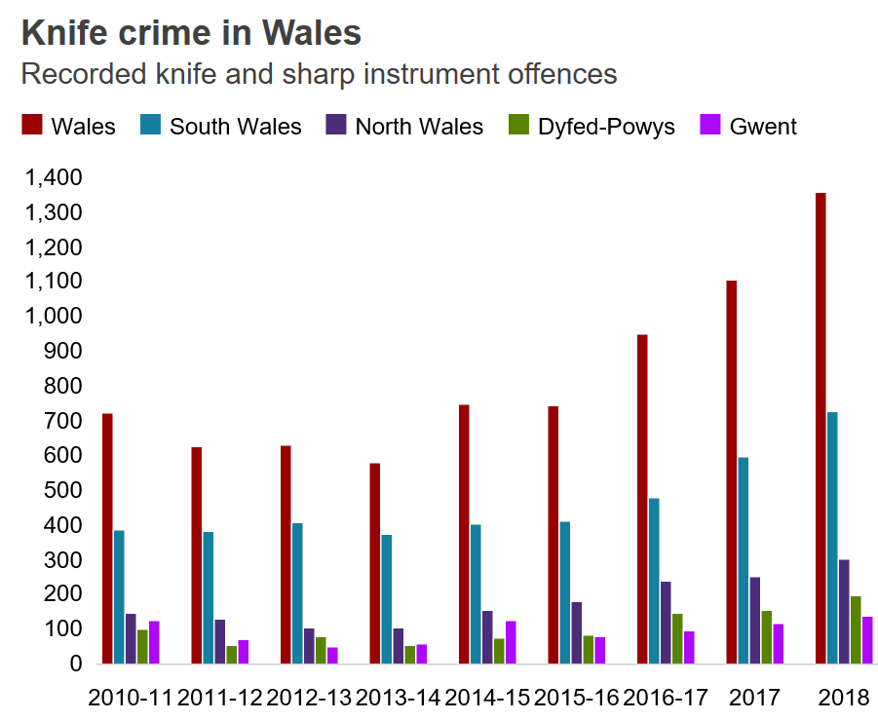
Figure 1
In recognition of the growing threat posed by violent crime utilising bladed articles, the South Wales Police have entered a collaborative effort with other UK police services, including the North Wales Police. This cooperation scheme is identified by the South Wales Police (2019) as Operation Sceptre, a combination of targeted operations and educational engagement to counter the threat of violent and drug-related crime and their associated issues. In pursuit of this objective, more than 6100 individuals were stopped and searched for prohibited articles such as knives or other similar weaponry. However, the primary method utilised under operation sceptre seems to be engagement with young people in order to educate them on the risks and consequences associated with carrying sharp objects on their person. Advice is also afforded to parents of young people on identifying possible signs of knife possession and how they could help to resolve the root causes of the problem and remove the risk posed by their child’s involvement.

Covid-19
In addition to austerity measures and increasing rates of knife crime, the strategic position of the South Wales Police faces additional difficulty from the recent onset of the Coronavirus epidemic. According to Hewitt (2020), the closure of businesses, placement of social distancing and lockdown restrictions on the public, little has changed concerning policing practices and duties. In addition to their usual conduct of preventing and resolving unlawful conduct, police services have expanded cooperative activity with local communities in better aiding individuals and other public services in coping with the difficulties bought on by the pandemic. Hewitt (2020) also gives a reminder that the authority of UK police services is dependent on the consent of the public. This has been demonstrated by the lack of requirement of legal powers in enforcing lockdown restrictions beyond verbal reminders and instructions in the majority of public breaches of such restrictions. Although 1,084 fines have been issued throughout England and Wales as of the 8th of April, the majority of citizens have reportedly abided by the lockdown rules. This consensual enforcement is emphasised by the South Wales Police (2020), who state that although they will primarily encourage and persuade members of the public to return to their household if outside of it for non-essential purposes, proportionate action may follow if necessary to deal with non-compliance. These powers include reasonable force exercised to remove an individual and direct them home, fines of up to £60, prohibition notices in areas of public gathering and exercising of licensing powers against businesses that fail to comply.

Discussion
In consideration of the financial restrictions imposed on the public sector by the government, the South Wales Police have prioritised innovation of policing methods and community engagement as a means of maintaining their strategic position and effectiveness of service delivery. Engagement with the public in accordance with this plan is accomplished through compliance with the Wellbeing of Future Generations Act 2015 and adapting its 7 wellbeing goals into to policing practice. Further success of the South Wales Police service’s strategic management plan is cited to be dependent on cooperative working with other partner services and community organisations. This is reportedly effective in early intervention and prevention of criminal conduct and minimising the consequential impact left on victims and others affected by the occurrence. Finally, the importance of cooperation with the public sector and local communities is demonstrated furthermore by their long-term consideration, as made evident in the previous plan of police management. The addition of the Wellbeing of Future Generations Act 2015 into the most recent plan may indicate the success of its predecessor if this approach is reimplemented into policing practice with further development.

Although neighbourhood policing is indicated to be of utmost importance to the effectiveness of the South Wales Police service, its effectiveness has evidently been hindered by the implementation of austerity measures. Declining numbers of police staff has reduced the visibility of the service represented by community support officers, which in turn has impacted public confidence in the capability of the service. However, recognition of the contribution neighbourhood policing makes to the effectiveness of UK policing has resulted in a government pledge of 20,000 new officers into the public sector to address the issue of police invisibility. Although this drastic provision of new personnel would be of significant benefit to the South Wales Police, investment of some of this new funding would need to be put towards training and equipment to ensure the optimal efficiency of these new officers.

Since the outbreak of the Coronavirus within the UK, the South Wales’ Police service’s primary focus on cooperative working with partner organisations and communities has become instrumental in maintaining the effectiveness of the public sector as a whole. This is due to the greater strain placed on health services and other responders of public emergency, something which police services have aided in relieving through working with communities to support their most vulnerable members, or through enforcement of lockdown restrictions to limit exposure and spreading of the virus, reducing the rate of potential cases for the National Health Service (NHS) to resolve.

Conclusion
In summary, the findings of this report indicate that the strategic position of the South Wales Police is dependent on a focus towards neighbourhood policing and cooperation with partner organisations within the public sector to achieve optimal effectiveness in providing its service to the public. The effectiveness of this community-focused approach is demonstrated in the response of police services towards the growing rate of knife crime, restrictions of financial resources imposed by austerity measures and public lockdown resulting from the Coronavirus pandemic. However, the effectiveness of such responses is limited by resource unavailability, particularly community support officers and the link they provide between police services and local communities. As such, the importance of innovating policing methods and strategies is emphasised by the need to minimise resource expenditure without compromising efficiency.

Recommendations
Based on the information analysed within this report, the strategic position of the south Wales Police could potentially be improved through further development of their ongoing strategy focused on public engagement and collaboration with other public organisations. In consideration of the 20,000 new police officers pledged by the government, some of these new editions may be assigned the role of community support officer to improve and maintain direct contact and interaction with local communities. Innovations on police practices and protocol may also continue development in order to maintain service efficiency during current or future resource limitations.

References
British Broadcasting Company (2019) Knife crime: Record levels in Wales in 2018, Available at: https://www.bbc.co.uk/news/uk-wales-48053575 (Accessed: 2nd May 2020).

College of Policing (2015) College of Policing analysis: Estimating demand on the police service, Available at: https://www.college.police.uk/News/College-news/Documents/Demand%20Report%2023_1_15_noBleed.pdf (Accessed: 5th May 2020).

Dodd, V. (2019) Police resources 'drained to dangerously low levels', say former top officers, Available at: https://www.theguardian.com/uk-news/2019/jul/04/police-watchdog-reforms-chief-inspector-constabulary (Accessed: 4th May 2020).

Future Generations Commissioner for Wales (2020) Well-being of Future Generations Act 2015, Available at: https://futuregenerations.wales/about-us/future-generations-act/ (Accessed: 1st March 2020).

Grieg-Midlane, J. (2014) Changing the Beat? The Impact of Austerity on the Neighbourhood Policing Workforce, Cardiff: School of Social Sciences, Cardiff University.

Hewitt, M. (2020) Daily UK Government Covid-19 briefing - Speech from the Chair of the NPCC, Martin Hewitt, Available at: https://news.npcc.police.uk/releases/daily-uk-government-covid-19-briefing-speech-from-the-chair-of-the-npcc-martin-hewitt (Accessed: 5th May 2020).

Home Office (2019) Home Office announces first wave of 20,000 police officer uplift, Available at: https://www.gov.uk/government/news/home-office-announces-first-wave-of-20000-police-officer-uplift (Accessed: 4th May 2020).

Michael, A. (2019). Letter to Mike Durke. 30 January.

Michael, A., Jukes, M. (2018) SOUTH WALES POLICE & CRIME PLAN 2019-23, Available at: https://www.apccs.police.uk/media/1446/south-wales-police-and-crime-plan-final-eng.pdf (Accessed: 20th April 2020).

Michael, A., Vaughan, P. (2017) SOUTH WALES POLICE & CRIME REDUCTION PLAN 2017-21, Available at: https://moodle.uwtsd.ac.uk/pluginfile.php/238163/mod_resource/content/2/SW%20Police%20%20Crime%20Reduction%20Plan%202017-2021.pdf (Accessed: 10th May 2020).

Office of National Statistics (2020) Crime in England and Wales: year ending December 2019, Available at: https://www.ons.gov.uk/peoplepopulationandcommunity/crimeandjustice/bulletins/crimeinenglandandwales/yearendingdecember2019 (Accessed: 2nd May 2020).

South Wales Police (2019) Knife crime: Operation Sceptre, Available at: https://www.south-wales.police.uk/en/knife-crime/ (Accessed: 2nd May 2020).
South Wales Police (2020) About Us, Available at: https://www.south-wales.police.uk/en/about-us/ (Accessed: 1st March 2020).

South Wales Police (2020) South Wales Police response to the Coronavirus pandemic, Available at: https://www.south-wales.police.uk/en/south-wales-police-response-to-the-coronavirus-pandemic/ (Accessed: 6th May 2020).

