University of Wales Trinity Saint David

Institute of Science & Art



Material Evaluation
Engineering Design And Materials (ACHA4001)

Elisha Atif
2003581

30/04/2021

Content

Question 1………………………………………………………………………………………………………3

Question 2……………………………………………………………………………………………………4-5

Question 3………………………………………………………………………………………………………6

Question 4………………………………………………………………………………………………………7

Question 5………………………………………………………………………………………………………8

Question 6………………………………………………………………………………………………………8

Question 1:
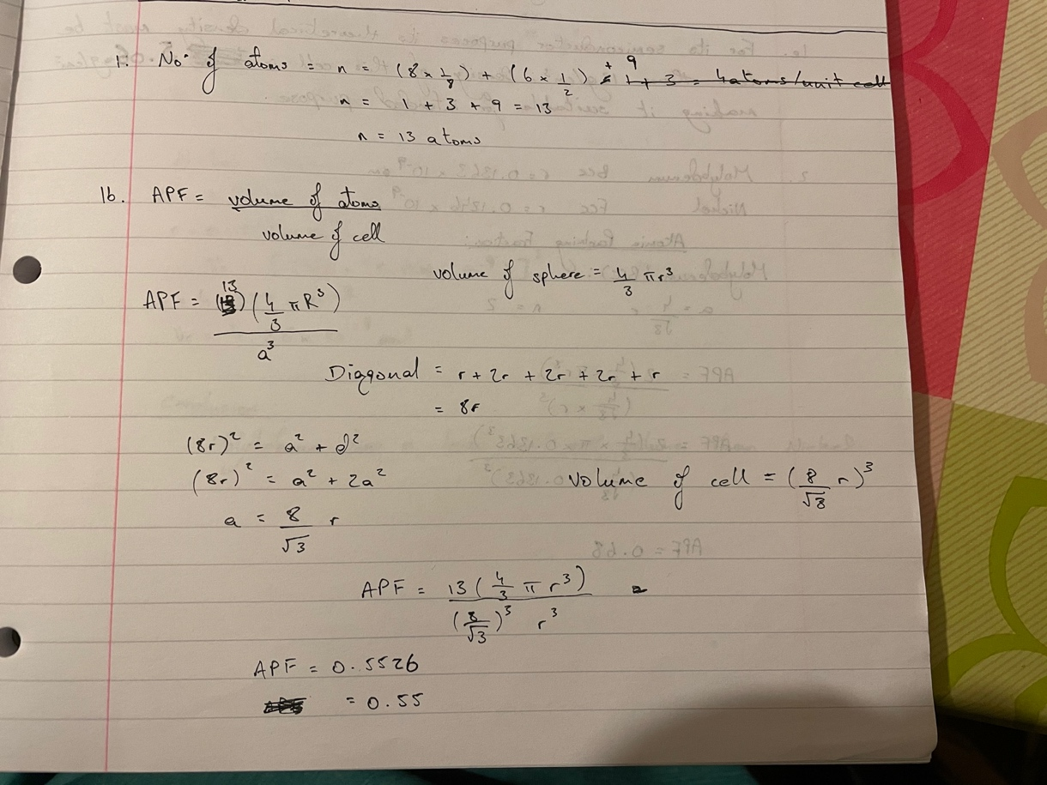

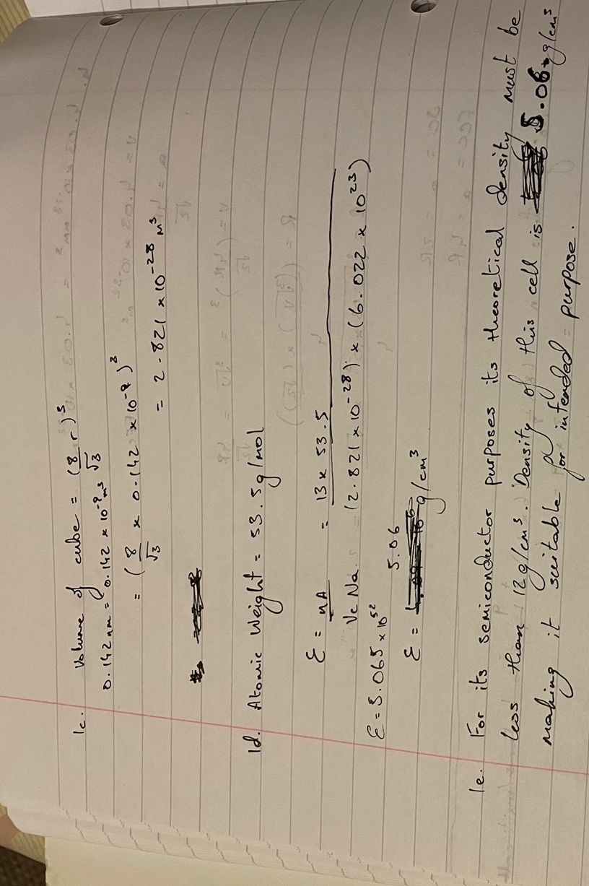

Question 2:
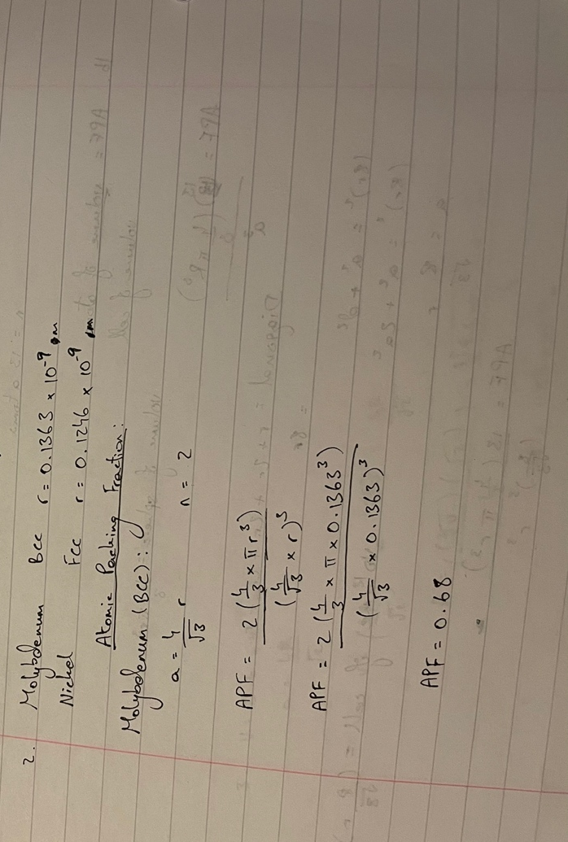

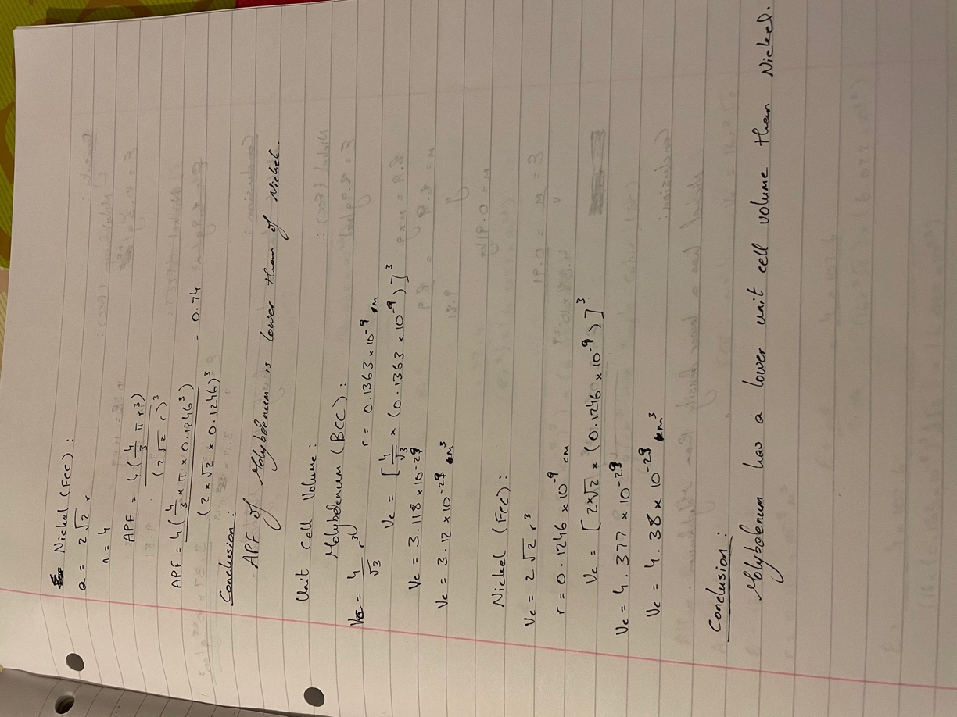

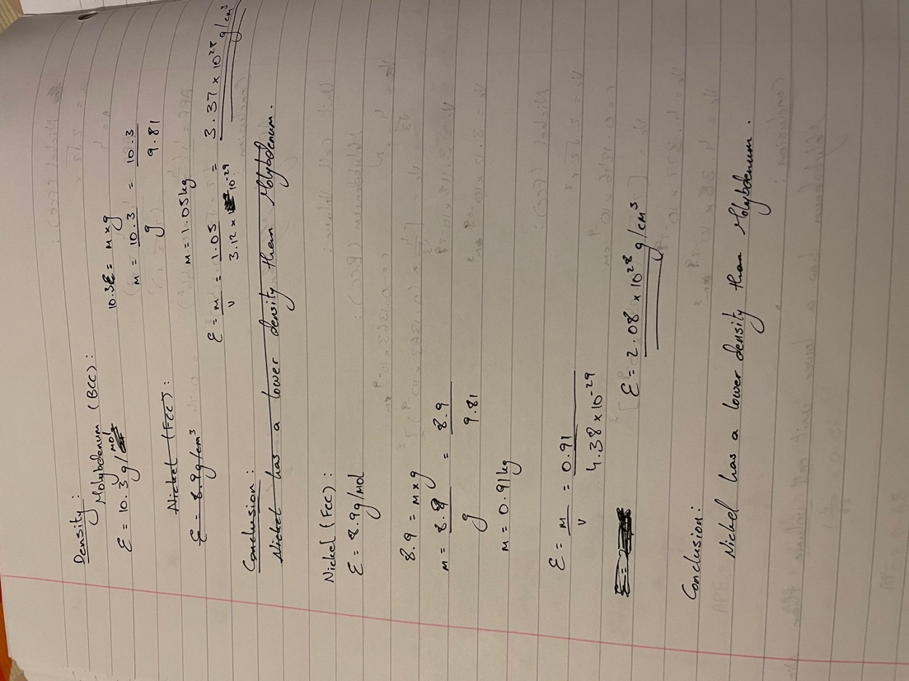

Question 3:
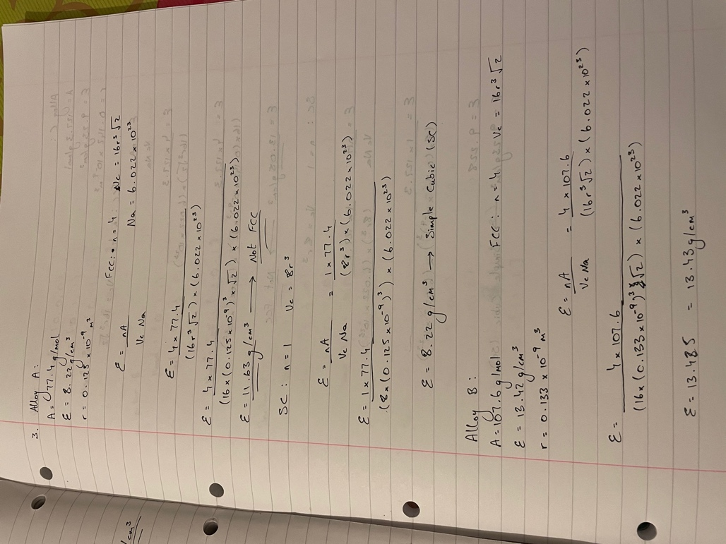

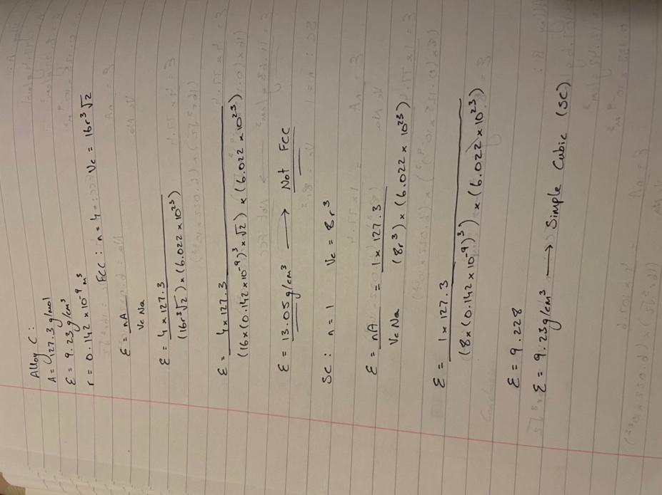
Question 4:
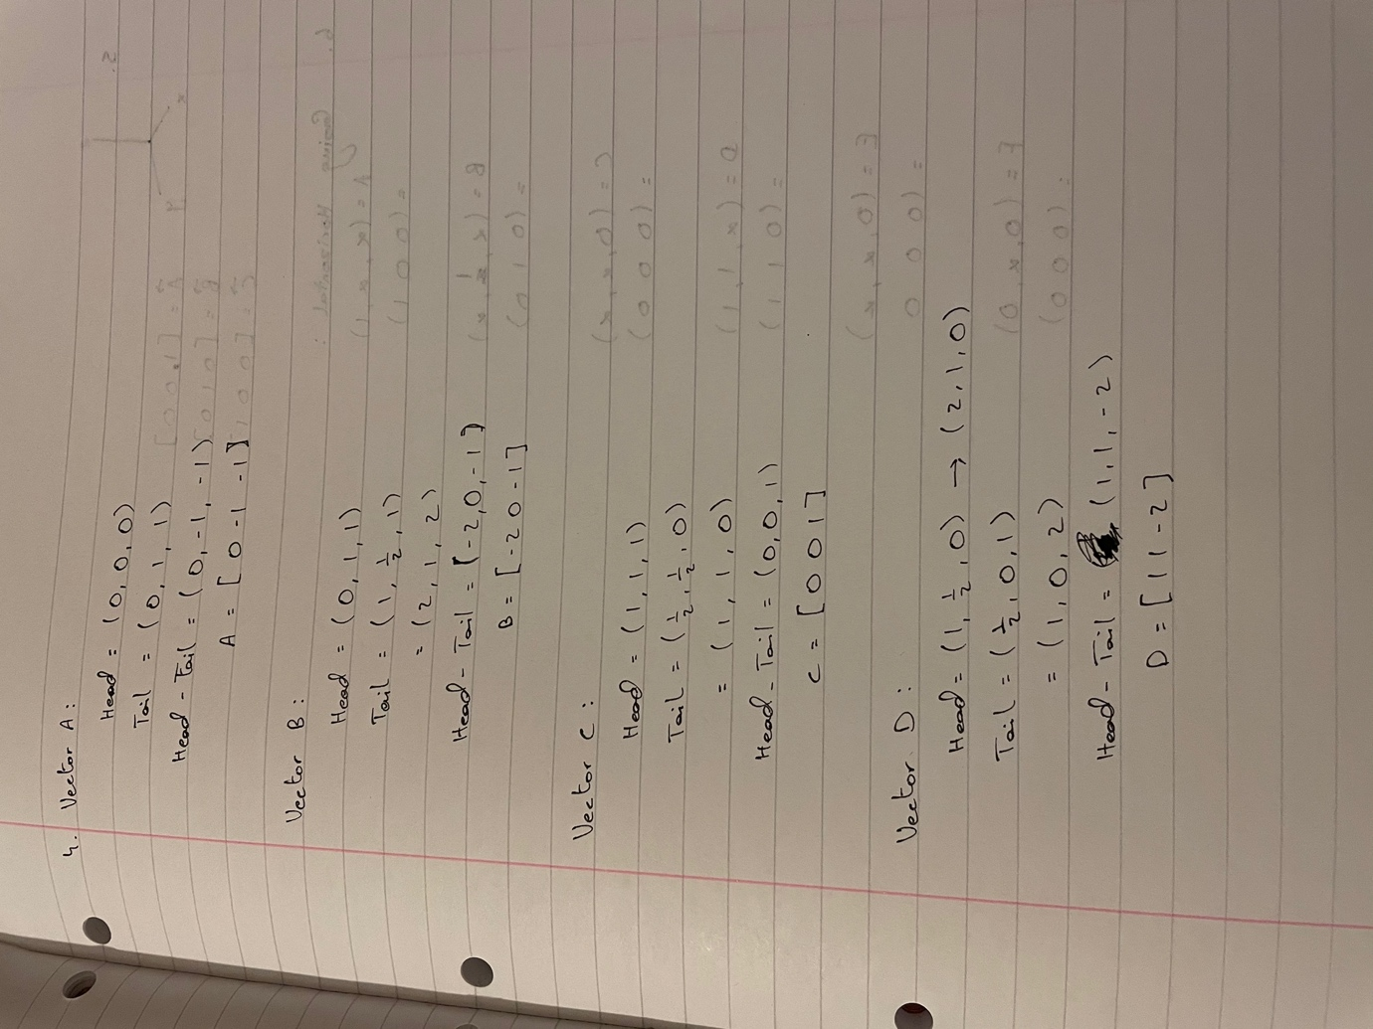

Question 5:
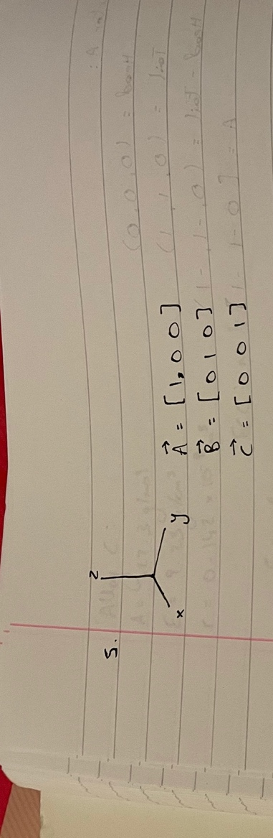

Question 6:


