
Academic Study SKILLS FOR STUDENTS
ECGE40002P

oLIVIA rEES
1900466

Contents Page

Mind Map – Page 2
Skills Audit – Page 3
Vision of success as a Student Teacher – Page 4
Summarising Critical Thinking Skills Book – Page 5
Summarising Critical Thinking Skills Book (continued) – Page 6
What I think about education in Wales – Page 7
What I think about education in Wales (continued) – Page 8
Reference List – Page 9

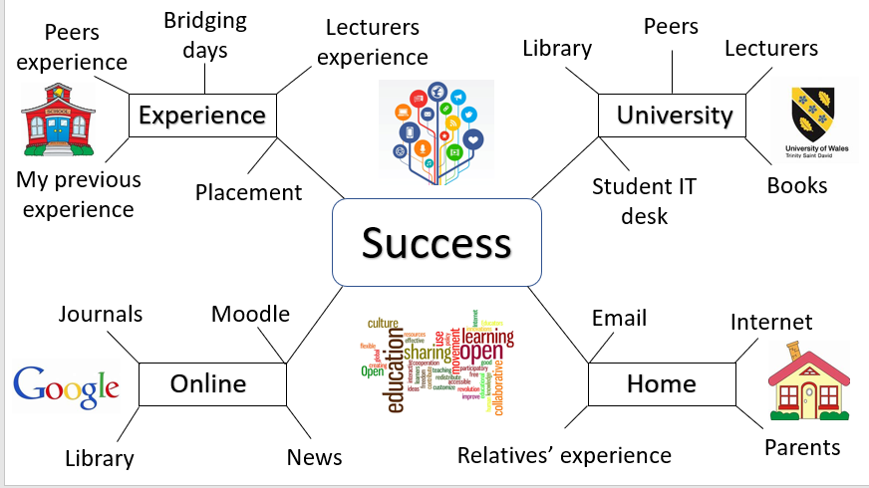
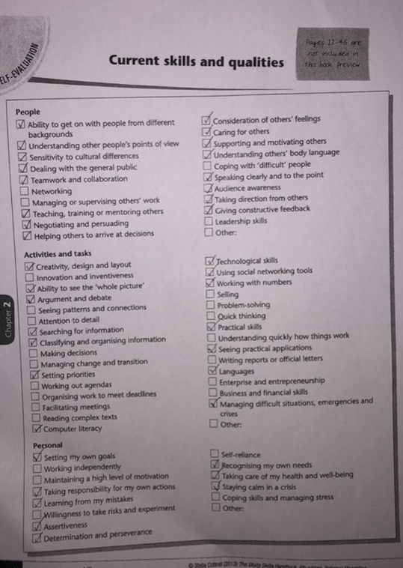

Vision of success as a Student-Teacher
The first step towards success is to have a positive mental attitude which will enable me to fully embrace and enjoy all aspects of my course. It will also allow me to complete all assignments set, to the best of my ability, and to be able to receive constructive criticism from my lecturers. This will hopefully increase my self-confidence and encourage me to aim for a first in my degree. I will give one hundred percent commitment to my course and all of my professional teaching experiences. This will provide me with increased knowledge and confidence within the teaching profession. I will learn how to overcome any obstacles I encounter and to know the correct procedures for solving any problems that I am faced with. This will benefit my stress management. As well as this, I hope to appreciate diversity by understanding and realising that all children and adults are different in their own ways by coming from different backgrounds with different cultures, allowing me to show empathy to all. Overall, I hope to gain and develop a wide range of skills such as organisation and time management which will be vital for managing workload in University and in employment. I will aspire to become the best teacher that I can be and hopefully secure a future job when I graduate from University.

Portfolio Task 2
Developing Critical Thinking – Summarising
‘Critical Thinking Skills’ by Stella Cottrell focuses on developing effective analysis and argument by discussing the following topics: What critical thinking is, the benefits of critical thinking, the underlying skills and attitudes of critical thinking, the barriers of critical thinking, and finally, why critical thinking is especially important as a student.
We have all used our critical thinking skills already just by living our everyday lives. For example, deciding whether to believe what we hear, discovering if it’s true or false, then debating our decision with others by giving reasons for our choice. However, the level of critical thinking that is required is task dependant. For example, our ability to use our critical thinking skills majorly differentiates between choosing whether to believe something a friend has said, and carefully selecting texts to use for evidence in an assignment. No matter at what level our critical thinking skills are currently at, we can still improve and develop these skills even further. Being a well-educated critical thinker, involves the ability to recognise when more information is needed in order to make a decision. It’s being able to appoint and extract the correct and relevant information required.
Critical thinking is a challenging process requiring an extensive variety of underlying skills and attitudes. The process encourages us to think rationally, inspiring us to think in depth by reading between the lines, as well as identifying the obvious message given. When we are completing a critical thinking task, we are advised to look at both strength and weaknesses. This allows consideration of other viewpoints as well as our own, to draw educated conclusions.
Critical thinking skills are highly beneficial to all in several ways. Not only does critical thinking increase our focus, attention and ability to observe, it allows us to identify key points and argue them effectively. This provides us with the chance to differentiate relevant and irrelevant information confidently and accurately. Critical thinking, without a doubt, improves and develops crucial skills such as: analysis, judgement, persuasion, observation, reasoning, and decision making.
People tend to associate critical thinking as a negative way of approaching a task. However, this isn’t always the case, since critical thinking tends to be positive and constructive. This is one barrier that prevents people from working on their critical thinking skills. Ohers refuse to improve and develop upon their critical thinking skills due to over-estimating their own abilities. This means they fail to see any room for improvement in their ability to think critically. This tends to be individuals that have insufficient focus and pay little attention to detail, resulting in vague analysis.
Critical thinking is a vital skill for students. Allowing them to discover the best resources available for evidence and pushing them to evaluate strengths and weaknesses with reason. It gives the opportunity to select useful examples and information to draw conclusions and present their findings. Given the above, it can be concluded that critical thinking is all about using our minds in an analytical and evaluative way, using judgment, selection, and categorisation.

Portfolio Task 3
Developing Critical Writing - ‘What I think about Education in Wales.’
This assignment will seek to analyse and review my thoughts about education in Wales. It will identify and critically discuss the main theories of the new curriculum in Wales and will explore and debate the strengths and weaknesses of its main elements. Finally, the assignment will aim to make recommendations and provide a personal view of the new curriculum.
After Graham Donaldson reviewed the current curriculum in 2014, he produced the new Welsh curriculum labelled ‘Successful Futures’. I feel that this decision was made due to the current curriculum being seen as narrow and inflexible which is limiting creativity. Donaldson (2015) said himself ‘assessment arrangements were not working to support children’s learning’. This shows the current curriculum is too subject specific, not allowing innovativeness. However, Donaldson (2015) has assured that the new curriculum will allow broader areas of learning by focusing on four purposes. In order to come up with the new curriculum, Donaldson (2015) stated that they ‘visited around 60 schools’. I feel that this was important because input was given from all schools including Nursery, Primary, Secondary, and Special schools. This granted schools the opportunity to propose their thoughts and ideas, discussing what is working well and what needs changing. This will ensure that the new curriculum meets all needs.
To ensure that the curriculum works as effectively as planned, I believe that teachers need to be a main focus. Curriculum reform: Lessons to be learned from Scotland (BBC,2018) states that teachers wish to be given ‘very clear guidance on expectations’. I feel that if guidance is given on what and how to teach, then children will reach their maximum potential. Similarly, Donaldson (2015) suggested ‘teachers need to be more directly engaged’. I agree, if teachers are more engaged then I think the involvement of children will increase. To assist teaching, key stages have been replaced with progression steps. I feel that progression steps will be an effective way of monitoring a child’s progress, allowing teachers to address developing needs. Donaldson (2015) states that the progression steps ‘each include a range of Achievement and Outcomes’. Personally, I feel this is a well thought out idea as it shows that teachers are more aware of children learning at different. This would be suitable for all children.
Donaldson (2015) stated the new curriculum is ‘shaped to meet local needs’. I feel this is vital because as a country, the Welsh language needs strengthening. Bilingualism will widen a child’s opportunities for the future when going into a workplace as they will be more advantaged over other applicants. Within schools, I feel that not only should the Welsh language be taught, but children should also be taught about the culture, history and heritage of the country. This should encourage the children to enjoy the subject rather than feeling like the language is forced upon them. Taylor, C and Rhys, M and Waldron, S (2016) agrees, as they’ve said that if something is forced upon a child then ‘they will lose both confidence and a love of learning’.
To conclude, I feel that the new curriculum intends and strives to build an exciting, yet successful future for the young people of Wales, providing them with a wide range of skills and abilities across all areas of learning. Before even reading the review, we can already see the aim of the new curriculum just by looking at the name, ‘Successful Futures’. Personally, I feel like we are about to experience a very exciting time within Education.

Reference List

BBC News (2018) Curriculum reform: Lessons to be learned from Scotland. Available at: https://www.bbc.co.uk/news/uk-wales-44522981 (Accessed: 1st November 2019).
Cortrell, S. (2005) Critical Thinking Skills: Developing Effective Analysis and Argument. Basingstoke, Hampshire: Palgrave Macmillan
Taylor, C and Rhys, M and Waldron, S (2016) Implementing curriculum reform in Wales: the case of the Foundation Phase, Oxford Review of Education. (Accessed: 1st November 2019) DOI: 10.1080/03054985.2016.1184872.
Welsh Government. (2015) Successful Futures. Crown Copyright.

