AI & Machine Learning

  - Name: Sarann Strange

Student Number: 1701763

University of wales Trinity saint David

Stream: B.Sc. Software engineering

Assignment code: ACCA6011
Lecturer: G Dickers

Table of Contents
1 Table of Contents 1
2 Table of figures 2
3 Introduction 3
4 Task 1 AI Agent 4
4.1 Important Algorithms & data Structures 4
4.2 User Guide 6
4.3 Working Program 8
4.4 Testing 11
5 Task 2 Hill Climbing 15
5.1 Alternative Approaches of the Hill Climb 16
5.1.1 Simple Hill Climb 16
5.1.2 Steepest Hill Climb 17
5.2 Disadvantages of Hill Climb 18
5.2.1 Local Minima and Local Maxima 18
5.2.2 Plateaus 19
5.2.3 Ridges 19
5.2.4 Solutions to the Disadvantages of Hill Climbing Search 20
6 Task 3 Eight Tile Problem 22
6.1 Critical Evaluation of Hill Climbing for 8-Tile Problem 23
6.1.1 8 Tile Problem Local Minima / Local Maxima 24
6.1.2 Plateau within 8-Tile Problem 25
7 Task 4 Alternative Distance Measure 26
7.1 Critical evaluation of Manhattan Priority Function 30
8 Conclusion 31
9 References 32
10 Appendices 34

Table of figures
Figure 1 stack of dfs 4
Figure 2 The Vectors used within the program 4
Figure 3 The readFiletoMaze function 4
Figure 4 the Search maze method 5
Figure 5 Display of maze options 6
Figure 6 Display of quit 6
Figure 7 Display of start again 6
Figure 8 Display of maze and press any key to continue 6
Figure 9 Display of maps that have been added to the program 6
Figure 10 Example of .txt file 7
Figure 11 Example of the Sarann Strange AI solution 7
Figure 12 Example of the solutions explorer 7
Figure 13 working code of user choosing a map 8
Figure 14 Working code of map being displayed and ‘R’ being placed in maze 8
Figure 15 Working code of ‘R’ moving through maze and ‘o’ being placed as breadcrumbs 8
Figure 16 A numerical character being successfully found 9
Figure 17 All numerical characters being found and the rout that the program took to find them. 9
Figure 18 Displays the quit and start option once the maze is fully explored 10
Figure 19 Displays a maze where the program is unable to collect all objects 10
Figure 20 Flow chart of Simple Hill Climb 16
Figure 21 Flow chart of steepest decent Hill Climb 17
Figure 22 Local Minimum & Maximum, Global Maximum & Minimum 18
Figure 23 Plateau within a graph 19
Figure 24 A ridge within a graph 19
Figure 25 Hill Climb search with random restart 20
Figure 26 8-Tile Problem unsolved 23
Figure 27 8-Tile Problem Solved 23
Figure 28 Hill Climb stuck in Local Maxima 24
Figure 29 Hill Climb stuck in Local Minima 24
Figure 30 Plateaus within 8 Puzzle problem 25
Figure 31 Diagram of the 8-tile problem from the starting position and the end goal, with each tile calculated from their desired location 26

Introduction
This report introduces a solution that uses a depth first search to solve the task of designing and creating a programmed solution to an AI agent searching a medical storage facility for objects. The final code for the solution is located within the appendices.
This report provides an explanation on what the hill climbing search is, its shortcomings and ways to overcome them.
An example of the “out-of-place” hill climbing search is shown being used to solve the 8-tile problem alongside an alternative distance measure known as the Manhattan priority function, that uses the heuristic function to solve the same 8-tile problem.

Task 1 AI Agent

Important Algorithms & data Structures

The data structures that were use include:
- Stacks
Figure 1 stack of dfs

- Vectors
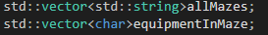
Figure 2 The Vectors used within the program

The image below outlines the algorithm used to read the text file into the maze data structure
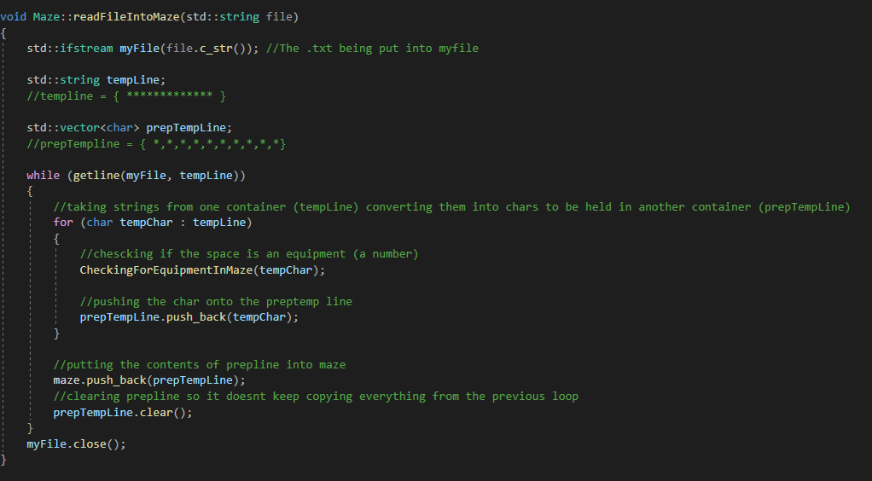
Figure 3 The readFiletoMaze function

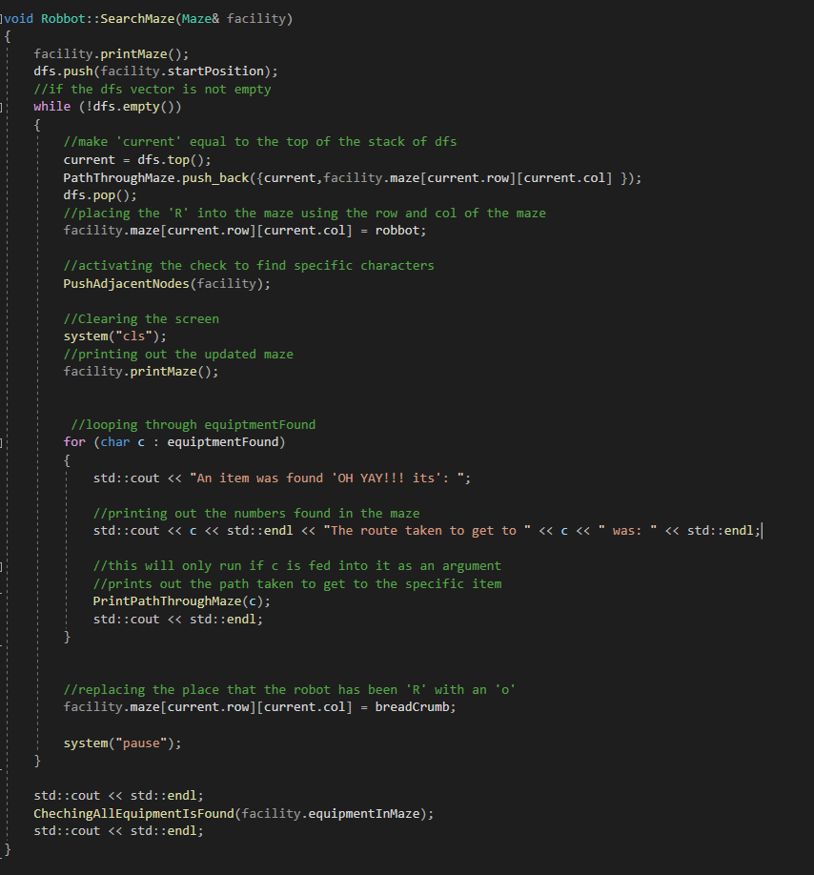
The image below outlines the algorithm used to travers the maze data structure with a Depth First Search (DFS) approach, using the stack data structure.
Figure 4 the Search maze method

User Guide
To select a maze | Select a maze of your choice from the list by selecting the number corresponding to the name of the maze you want tested. | Click a ‘number on your keyboard’ for the corresponding maze | 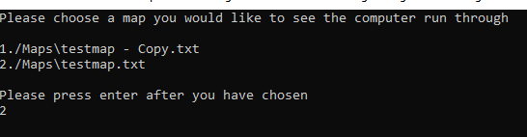  Figure 5 Display of maze options
To quite | To quit the program, you must once run through one maze until it is finished, and you will be presented with an option to quiet. | when the option to ‘quite’ presents itself:  Press lower case ‘q’ button on your keyboard | 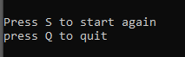  Figure 6 Display of quit
To start again | To run another maze, you must run through one maze until it finishes, and you will be presented with an option start again | when the option to ‘start again’ presents itself:  press the lowercase ‘s’ button on your keyboard | Figure 7 Display of start again
To run through a maze | To watch the robot run through the maze you must press ‘any button’ on the keyboard | Press ‘any button’ | 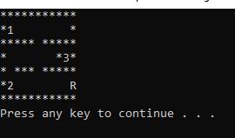  Figure 8 Display of maze and press any key to continue
To insert your own maze | To insert your own maze:  - You must ensure that the file you have structured your maze in is a .TXT file  - Next double click on the ‘Sarann Strange AI and Machine Learning’ solution  - Next drag and drop your .TXT file into the ‘Maps’ folder in the solutions explorer | After following the instructions, you do not have to do anything else.  when you run the code, your personal map should be displayed as a choice. | 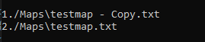  Figure 9 Display of maps that have been added to the program
To insert your own maze | 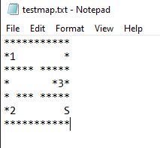  1.  Figure 10 Example of .txt file | 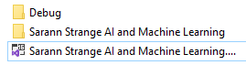  2.  Figure 11 Example of the Sarann Strange AI solution | 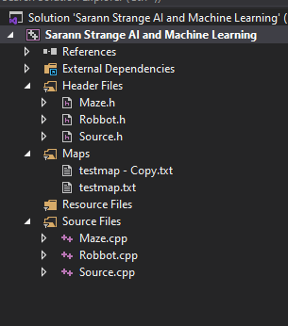  3.  Figure 12 Example of the solutions explorer

Working Program
The set of images display the working program of the AI agent:

- Figure 13 displays the start of the program where the user is asked to select a map.
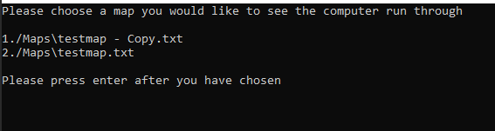

Figure 13 working code of user choosing a map

- Figure 14 displays the chosen maze being displayed to the screen.
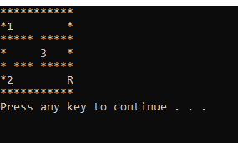

Figure 14 Working code of map being displayed and ‘R’ being placed in maze

- Figure 15 displays the ‘R’ character successfully moving through the maze when a key is pressed, and ‘o’ is being placed as a bread crumb.

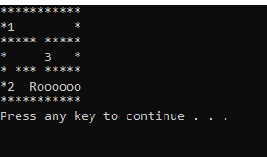

Figure 15 Working code of ‘R’ moving through maze and ‘o’ being placed as breadcrumbs

- Figure 16 displays the program discovering a numerical character, announcing its discovery, and displaying the route that was taken to get to the numerical character.
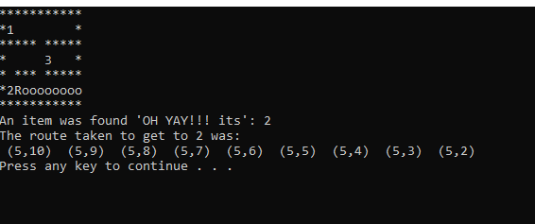

Figure 16 A numerical character being successfully found

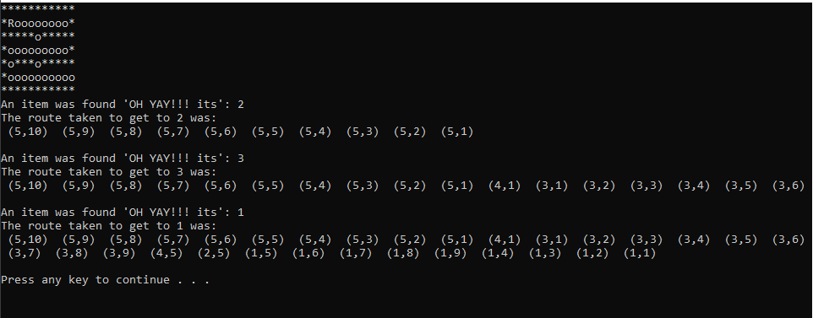
- Figure 17 displays the last numerical character being found with all the numerical characters being listed with their routes.
Figure 17 All numerical characters being found and the rout that the program took to find them.

- Figure 18 displays the choice of pressing ‘s’ to start again with another maze, displays the choice ‘q’ to quit the program

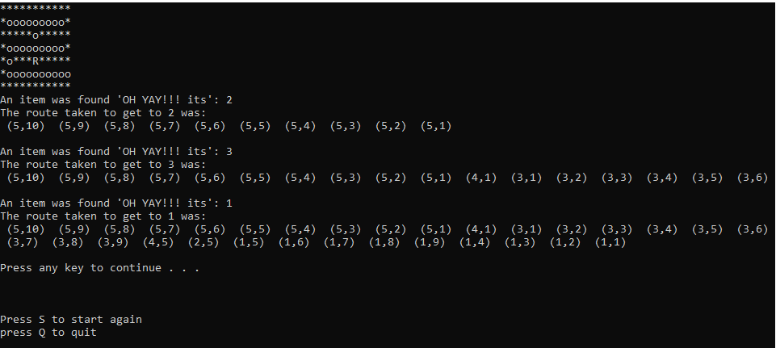
Figure 18 Displays the quit and start option once the maze is fully explored

- Figure 19 displays the program displaying a message when the system is unable to find all the numerical characters within a maze
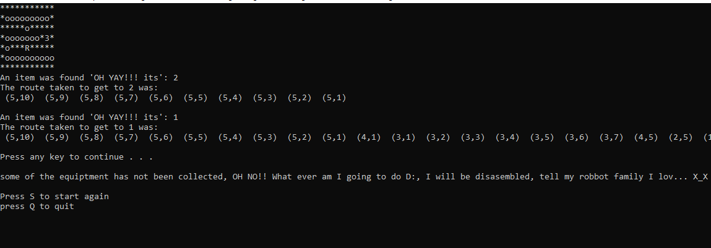
Figure 19 Displays a maze where the program is unable to collect all objects

Testing

Step Description  1 | Test 1.1: Test to choose between different mazes  Test 1.2: Testing the map is being printed to the screen  Test 1.3: Test that unacceptable inputs are not accepted
Test Step: A for 1
Input Data | - The user successfully inputs an integer value that is used to find a maze.  - The choice of the user corresponds to a maze stored within the Map folder and is correctly printed to the screen.  - Check that inputs other than the numbers that represent the available mazes to choose from, alphabetical and special characters are not accepted.
Expected Results | - For the user’s choice to be accepted  - For the correct maze to be chosen and displayed on to the screen  - That the system will reject the input and display a message telling the user ‘to try again’.
Actual Results | - The user’s input was successfully  - An incorrect map was displayed to the screen  - Unacceptable inputs were rejected, and the message was displayed on screen
Results Test Step: A | Pass/Fail: |  | Corrections Needed: |  | Fixed/Date:
Test 1.1 | Pass |  | No |  | N/A
Test 1.2 | Fail |  | Yes |  | No  10/12/2020
Test 1.3 | Pass |  | No |  | N/A
Identified Issue | - The vector begins at 0 while the user is beginning the selection at 1
Corrections | - Each of the integer values that the user enters must minus 1 to correspond to the vectors starting position of 0
Test Step: B for 1
Results Test Step: B | Pass/Fail: | Corrections Needed: |  | Fixed/ Date:
Test 1.2 | Pass | No |  | Yes  10/12/2020

Step Description  2 | Test 2.1: Testing the ‘R’ is printed to the screen.  Test 2.2: Testing the ‘o’ replacing the previous position of ‘R’.  Test 2.3: Test to ensure that all objects are collected, and user is told the order and the rout taken to find objects.  Test 2.4: If objects are not collected for the system to note it and display a message.
Test Step: A for 2
Input Data | 2.1 Press any button when maze is loaded and displayed on screen  2.2 Press any button when maze is loaded and displayed on screen  2.3 Press any button when maze is loaded and displayed on screen  2.4 Press any button when the maze is complete
Expected Results | 2.1 For the ‘R’ character to print to screen  2.2 For ‘o’ character to print to screen in the previous location of ‘R’ character  2.3 After the ‘R’ character encounters a number character, a message will display what number is found and the coordinates representing the route  2.4 For the system to recognise that an object was not collected after ‘R’ character has traversed the maze. For a message to inform the user ‘Failure to collect all objects’
Actual Results | 2.1 ‘R’ character was successfully printed to the screen.  2.2 ’o’ character successfully replaced the previous location of the ‘R’ character.  2.3 Once an object was collected a message is displayed to the user stating what object and the rout that was taken to find it.  2.4 The system is failing to register that an object has failed to be collected, a message is not being displayed.
Results Test Step: A | Pass/Fail: |  | Corrections Needed: |  | Fixed/Date:
Test 2.1 | Pass |  | No |  | N/A
Test 2.2 | Pass |  | No |  | N/A
Test 2.3 | Pass |  | No |  | N/A
Test 2.4 | Fail |  | Yes |  | No  10/12/2020
Identified Issue | 2.4 There is a fault in the code, the check for the number of objects in the maze is not correctly being compared to the number of objects being found.
Corrections | 2.4 Alterations in the code need to be made, to ensure that the check is comparing the length of vector holding the found objects, to the vector holding the objects within the maze.
Test Step: B for 2
Results Test Step: B | Pass/Fail: | Corrections Needed: |  | Fixed/ Date:
Test 2.4 | Pass | No |  | Yes  10/12/2020

Step Description  3 | Test 3.1: User can choose to quite the program  Test 3.2: User can choose to start the system again
Test Step: A for 3
Input Data | 3.1 Press ‘q’ to quite the program  3.2 Press any button to reset they program
Expected Results | 3.1 For the program to stop  3.2 For the user to be presented with the choice to select a maze
Actual Results | 3.1 Once ‘q’ was pressed the program successfully ended  3.2 The program was reset, and the user can choose another map
Results Test Step: A | Pass/Fail: | Corrections Needed: | Fixed/Date:
Test 3.1 | Pass | No | N/A
Test 3.2 | Pass | No | N/A
Identified Issue | N/A
Corrections | N/A

Task 2 Hill Climbing
Local searches are a type of algorithm within AI, some of these algorithms include Hill climbing, Tabu Search and A*. These algorithms work by taking inputs from their surroundings, which are used to calculate the optimal solution to an arbitrary solution to a problem [1][2][3][4][5].
An example of a local search being used is when an individual is traversing between cities to sell products, this is known as the “Travelling Salesman Problem”. A local search is used to discover the shortest route for the salesman to travel to all cities at least once and return to the starting position [6][7][8].
The hill climbing search uses a heuristic function, which is a type of function that calculates a cost. For example, a pathfinding algorithm such as A* would use the distance from the destination heuristic, while a sorting algorithm would use a heuristic value that describes the number of members out of place.
Hill climb is described as a greedy local search, it works by continually moving from one node to an adjacent higher positioned node, while disregarding the path that led to that solution, it continually does this until it is unable to move to a higher value/position. This algorithm can get caught in a false solution known as a local minimum/maximum [9][10][11].

There are disadvantages to the hill climb search they involve:
- Local minima & local maxima
- Peaks & plateaus
- Ridges

Alternative Approaches of the Hill Climb

Simple Hill Climb
The simple hill climb is when the algorithm chooses the first node that it finds that is closer to the optimal solution and selects it [12][13].
Figure 20 displays a diagram of the simple hill climb searching through a solution until it finds the optimal solution.
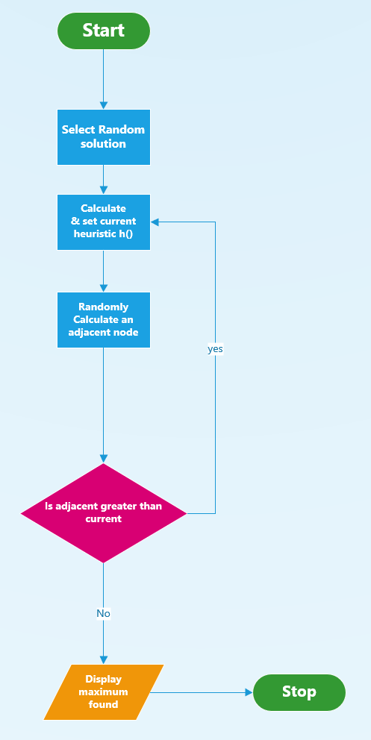
Figure 20 Flow chart of Simple Hill Climb

Steepest Hill Climb
The steepest assent hill climb is similar to the simple hill climb, the difference is that it checks all adjacent nodes then chooses the optimal one, in a similar fashion to the best-first search [12][13].
Figure 21 displays a flowchart of the steepest decent hill climb and how it calculates and works its way through a solution to find an optimal solution.
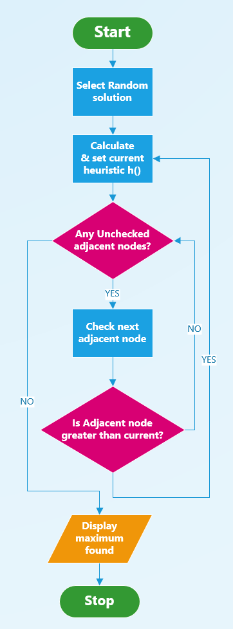
Figure 21 Flow chart of steepest decent Hill Climb

Disadvantages of Hill Climb

Local Minima and Local Maxima
Local maximums are when the hill climbing search has climbed to a certain node in the search and gotten stuck at a peak that is not the highest in the search (the global maxima). This happens due to all the adjacent nodes having a lower value than the node that the search is currently on, the hill climbing search is unable to see or navigate away from this local maximum to correctly find the global maxima. Local minima are like the local maxima but reversed. The hill climbing search becomes stuck in a trough that the search is unable to navigate away from to find the global minimum, as its current node has a lower value than all the adjacent nodes [14][15][16][11].

When the hill climbing search is caught in a local minimum or a local maximum it is unable to complete a problem to its fullest. The image within figure 22 shows an example of a local maximum/minimum and the global maximum/minimum.

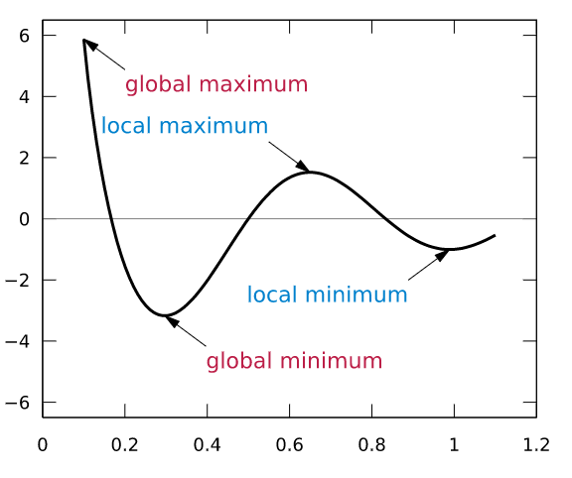

[17]
Figure 22 Local Minimum & Maximum, Global Maximum & Minimum

Plateaus
The hill climb search can encounter a plateau when its current node has the same value as all adjacent nodes. This can stall the progress of the search as it is unable to determine the best direction to progress, as seen within figure 23 [16][18].
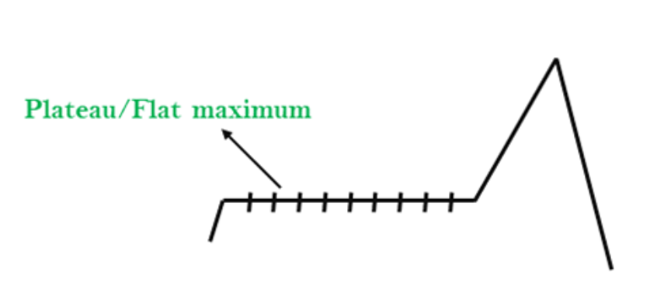

[19]
Figure 23 Plateau within a graph

Ridges
A ridge can be described as a local maximum with certain specific differences, such as having a slope that cannot be reached in one move. When on a ridge the algorithm will stop as movement in all possible direction is to a lower value, as seen within figure 24 [16][18].

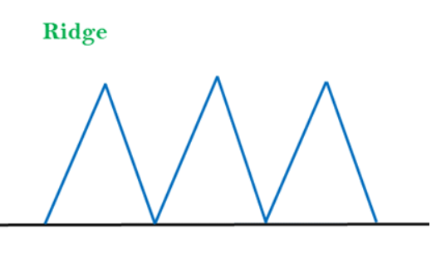

Figure 24 A ridge within a graph
[19]

Solutions to the Disadvantages of Hill Climbing Search
One method to overcome the shortcomings of the hill climbing search is the random restart. This continually restarts the search from randomised solutions until the search can find a path to the optimal solution [20][21]. For the algorithm to find the highest peak in this case it needs to know the value of the highest peak before it begins its search.
Figure 25 displays the original algorithm of the hill climb with a random restart included. The diagram displays how the search will continually loop until it can find the optimal solution.
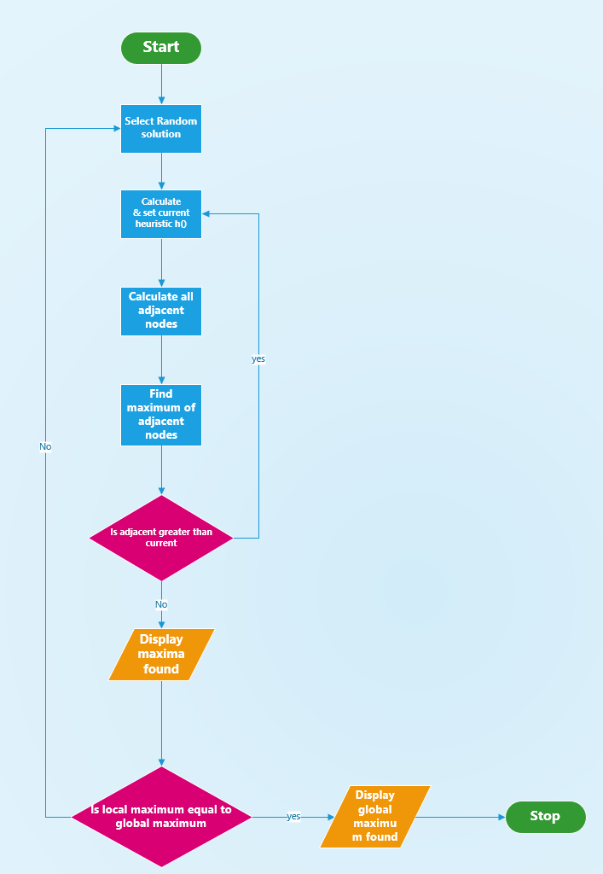
Figure 25 Hill Climb search with random restart

another method to overcome the drawbacks of the hill climb search, is to program the algorithm to check movement in all or numerous directions at the same time, to establish if it is on a peak or a ridge, by carrying out this check the algorithm can find a path to its destination whether that be a global maxima or global minima [13].

Task 3 Eight Tile Problem
1 | 2 | 5
3 | 4 | 8
6 |  | 7
Current:
h=5
h value for potential next positions:
h= 6, 6, 4

1 | 2 | 5
3 | 4
6 | 7 | 8
1 |  | 2
3 | 4 | 5
6 | 7 | 8
 | 1 | 2
3 | 4 | 5
6 | 7 | 8
1 | 2 | 5
3 | 4 | 8
6 | 7
1 | 2
3 | 4 | 5
6 | 7 | 8
Current:
h=1
h value for potential next positions:
h= 0, 2, 2
Current:
h=4
h value for potential next positions:
h=5, 3
Current:
h=3
h value for potential next positions:
h=4, 4, 2
Current:
h=2
h value for potential next positions:
h=3, 1
Current:
h=0
h value for potential next positions:
-

Critical Evaluation of Hill Climbing for 8-Tile Problem
The method used to solve the 8-tile puzzle is the “out-of-place” hill climb. This method sums all the tiles not in their correct position. For instance, within figure 26 tiles 1, 2, 5, 8 and 7 are out of place making the heuristic 5. The hill climb then begins to check each move that it can make and calculates the heuristic value for each potential move.
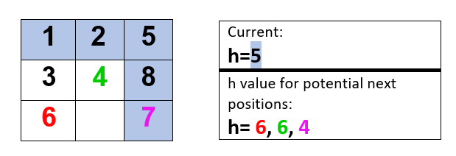
Figure 26 8-Tile Problem unsolved

The current heuristic value is checked against the potential heuristic values and a move will only be made if the potential heuristic value is less than the current heuristic value. The algorithm will stop when the current heuristic value is equal to zero as seen within figure 27

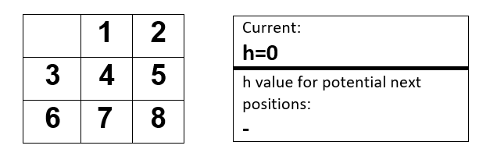
Figure 27 8-Tile Problem Solved

Although the hill climbing algorithm can be used to solve the 8-tile problem, there are some instances where it can fail due to the hill climbing algorithms drawbacks of plateaus, ridges or being stuck within a local minima or local maxima.

8 Tile Problem Local Minima / Local Maxima
When a hill climbing algorithm is in a local minima or local maxima it can get stuck in a loop as it does not remember where it has been, constantly moving a single tile back and forth never making progress towards the global minima as seen in figure 29, or global maxima as seen in figure 28.
As seen within both figure 29 and 28 the heuristic is stuck at 4 and with each move of the tile it remains at a 4, the numbers within the puzzle are no closer to its end goal and the hill-climb is unable to complete the puzzle.
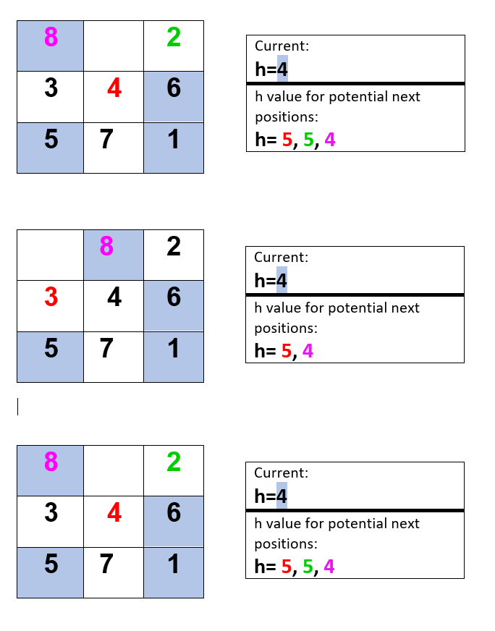
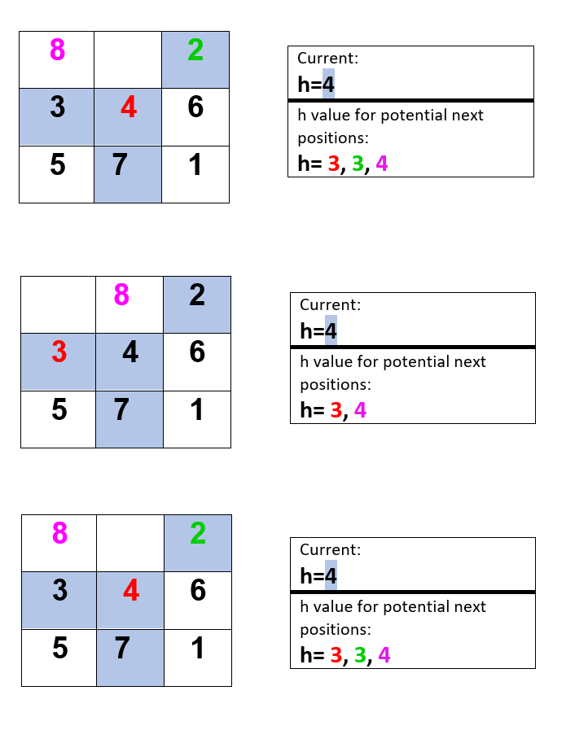
Figure 28 Hill Climb stuck in Local Maxima
Figure 29 Hill Climb stuck in Local Minima

Plateau within 8-Tile Problem
As seen within Figure 30 it displays a plateau within the 8-tile problem this has occurred because the current heuristic value is 6 while all the movements from the other tiles result in the same heuristic value causing the hill climb to be unable to make a decision of the next best move.

8 |  | 3
2 | 7 | 5
6 | 4 | 1
Current:
h=6
h value for potential next positions:
h= 6, 6, 6

Figure 30 Plateaus within 8 Puzzle problem

Task 4 Alternative Distance Measure
An alternative distance measure is the Manhattan priority function. The Manhattan calculates the number of moves that each of the tiles must make to get to their desired location. While calculating the distance of each individual tile, all other tiles between its start position and its destination are disregarded.
For instance, tile 1 is 1 move from its destination, tile 2 is 1 move from its destination, tile 3 is in the correct location so it is 0 moves from its destination. Each of the values are noted as seen within figure 31 and summed.
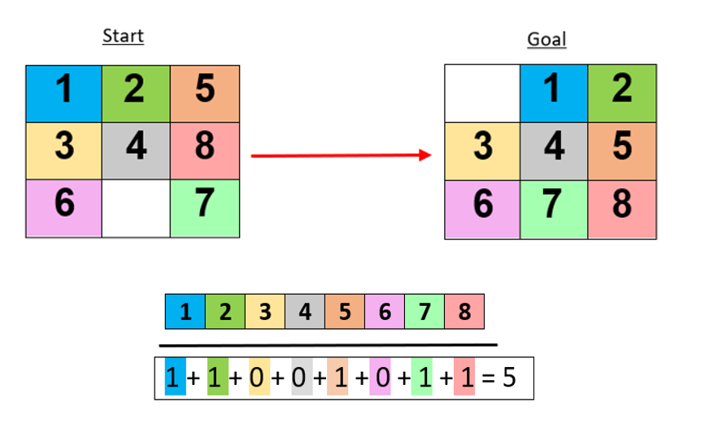
Figure 31 Diagram of the 8-tile problem from the starting position and the end goal, with each tile calculated from their desired location

Once the distances are identified and calculated this summed value becomes the heuristic of the Manhattan distance; M=5.
Each of the available tiles 6, 4 and 7 are tested individually and a new heuristic is calculated in the same fashion as figure 31. The minimum of the Manhattan values gets the priority, and the movement of that specific tile is explored. Then the process is repeated until the goal is met [22].

1 | 2 | 5
3 | 4 | 8
6 |  | 7
1 | 2 | 3 | 4 | 5 | 6 | 7 | 8
 | 1 | 2
3 | 4 | 5
6 | 7 | 8

M = 5

1 | 2 | 5
3 |  | 8
6 | 4 | 7
1 | 2 | 5
3 | 4 | 8
6 | 7
1 | 2 | 5
3 | 4 | 8
 | 6 | 7

1 + 1 + 0 + 0 + 1 + 0 + 0 + 1 = 4

1 + 1 + 0 + 1+ 1 + 0 + 1 + 1 = 6
1 + 1 + 0 + 0 + 1 + 1 + 1 + 1 = 6

1 | 2 | 5
3 | 4 | 8
6 | 7

M = 4

1 | 2 | 5
3 | 4
6 | 7 | 8
1 | 2 | 5
3 | 4 | 8
6 |  | 7

1 + 1 + 0 + 0 + 1 + 0 + 0 + 1 = 5
1 + 1 + 0 + 0 + 1 + 0 + 0 + 0 = 3

1 | 2 | 5
3 | 4
6 | 7 | 8

M = 3

1 | 2 | 5
3 | 4 | 8
6 | 7
1 | 2 | 5
3 |  | 4
6 | 7 | 8
1 | 2
3 | 4 | 5
6 | 7 | 8

1 + 1 + 0 + 0 + 0 + 0 + 0 + 0 = 2

1 + 1 + 0 + 1 + 1 + 0 + 0 + 0 = 4
1 + 1 + 0 + 0 + 1 + 0 + 0 + 1 = 4

1 | 2
3 | 4 | 5
6 | 7 | 8

M = 2

1 |  | 2
3 | 4 | 5
6 | 7 | 8
1 | 2 | 5
3 | 4
6 | 7 | 8

1 + 1 + 0 + 0 + 1 + 0 + 0 + 0 = 3
1 + 0 + 0 + 0 + 0 + 0 + 0 + 0 = 1

1 |  | 2
3 | 4 | 5
6 | 7 | 8

M = 1

1 | 4 | 2
3 |  | 5
6 | 7 | 8
 | 1 | 2
3 | 4 | 5
6 | 7 | 8
1 | 2
3 | 4 | 5
6 | 7 | 8
1 + 0 + 0 + 1 + 0 + 0 + 0 + 0 = 2
0 + 0 + 0 + 0 + 0 + 0 + 0 + 0 = 0
1 + 1 + 0 + 0 + 0 + 0 + 0 + 0 = 2
 | 1 | 2
3 | 4 | 5
6 | 7 | 8
0 + 0 + 0 + 0 + 0 + 0 + 0 + 0 = 0

M = 0

Critical evaluation of Manhattan Priority Function
Because the Manhattan priority function calculates the distance that each of the tiles are form their correct end goal positions, the heuristic value of the Manhattan can be different to that of the “out-of-place” heuristic. This difference allows the Manhattan to work through some problems where the “out-of-place” hill climb search becomes stuck.
The Manhattan still suffers from the same drawbacks of the “out-of-place” hill climb for instance it becomes stuck within plateaus, local maxima, and local minima, this is a symptom of the search being the uninformed steepest decent approach.

Conclusion
The final solution for the AI agent searching a medical storage facility for objects was successfully created, although the developer recognises that improvements could be made to its display and the code that was created.
The report successfully uses the hill climbing algorithm to solve an 8-tile problem while recognising that there are a few drawbacks to its us when attempting to solve certain combinations of the 8-tile problem. This investigation found that there were several issues found when using the hill climb algorithm to complete the 8-tile problem they include, local maxima, local minima, and plateaus.
To overcome these drawbacks a more complex version of the algorithm would have to be created that randomises the solution each time it does not find the global maxima. An alternative solution to the issue is to create a check that analyses its surroundings and identifies if it has successfully found the correct path to the global maxima.
An alternative known as the Manhattan distance was identified and used to successfully solve the same 8-tile problem, once again issues were identified and a comparison of the two local search algorithms was made, identifying that they both suffer from the same drawbacks and disadvantages.

References

[1] M. A. Al-Betar, “β-Hill climbing: an exploratory local search,” Neural Comput. Appl., vol. 28, no. 1, pp. 153–168, Dec. 2017, doi: 10.1007/s00521-016-2328-2.
[2] Z. A. A. Alyasseri, A. T. Khader, M. A. Al-Betar, and M. A. Awadallah, “Hybridizing β-hill climbing with wavelet transform for denoising ECG signals,” Inf. Sci. (Ny)., vol. 429, pp. 229–246, Mar. 2018, doi: 10.1016/j.ins.2017.11.026.
[3] E. K. K. Rich, Artificial Intelligence , 2nd ed. New York ; London: McGraw-Hill, 1991.
[4] M. A. Al-Betar, M. A. Awadallah, A. L. A. Bolaji, and B. O. Alijla, “β-Hill Climbing Algorithm for Sudoku Game,” in Proceedings - 2017 Palestinian International Conference on Information and Communication Technology, PICICT 2017, Sep. 2017, pp. 84–88, doi: 10.1109/PICICT.2017.11.
[5] I. Sohn, “A robust complex network generation method based on neural networks,” Phys. A Stat. Mech. its Appl., vol. 523, pp. 593–601, Jun. 2019, doi: 10.1016/j.physa.2019.02.046.
[6] F. Greco, Traveling Salesman Problem. InTech, 2008.
[7] C. Doppstadt, A. Koberstein, and D. Vigo, “The Hybrid Electric Vehicle—Traveling Salesman Problem with time windows,” Eur. J. Oper. Res., vol. 284, no. 2, pp. 675–692, Jul. 2020, doi: 10.1016/j.ejor.2019.12.031.
[8] Y. Marinakis, A. Migdalas, and P. M. Pardalos, “Expanding neighborhood search-GRASP for the probabilistic traveling salesman problem,” Optim. Lett., vol. 2, no. 3, pp. 351–361, Jun. 2008, doi: 10.1007/s11590-007-0064-3.
[9] K. Mahdavi, M. Harman, and R. M. Hierons, “A Multiple Hill Climbing Approach to Software Module Clustering,” in IEEE International Conference on Software Maintenance, ICSM, 2003, pp. 315–324, doi: 10.1109/ICSM.2003.1235437.
[10] E. K. Burke and Y. Bykov, “The late acceptance Hill-Climbing heuristic,” Eur. J. Oper. Res., vol. 258, no. 1, pp. 70–78, Apr. 2017, doi: 10.1016/j.ejor.2016.07.012.
[11] M. Wiggins, A. Saad, B. Litt, and G. Vachtsevanos, “Evolving a Bayesian classifier for ECG-based age classification in medical applications,” Appl. Soft Comput. J., vol. 8, no. 1, pp. 599–608, Jan. 2008, doi: 10.1016/j.asoc.2007.03.009.
[12] baeldung, “Example of Hill Climbing Algorithm in Java | Baeldung,” baeldung, Oct. 03, 2020. https://www.baeldung.com/java-hill-climbing-algorithm (accessed Dec. 06, 2020).
[13] S. Sakamoto, K. Ozera, M. Ikeda, and L. Barolli, “Implementation of Intelligent Hybrid Systems for Node Placement Problem in WMNs Considering Particle Swarm Optimization, Hill Climbing and Simulated Annealing,” Mob. Networks Appl., vol. 23, no. 1, pp. 27–33, Feb. 2018, doi: 10.1007/s11036-017-0897-7.
[14] B. H. Abed-alguni and F. Alkhateeb, “Intelligent hybrid cuckoo search and β-hill climbing algorithm,” J. King Saud Univ. - Comput. Inf. Sci., vol. 32, no. 2, pp. 159–173, Feb. 2020, doi: 10.1016/j.jksuci.2018.05.003.
[15] K. K. GHOSH, S. AHMED, P. K. SINGH, Z. W. GEEM, and RAM SARKAR, “Improved Binary Sailfish Optimizer Based on Adaptive β-Hill Climbing for Feature Selection,” IEEE ACCESS, vol. 8, 2020.
[16] Tanuja Bahirat, “Hill Climbing Algorithm in Artificial Intelligence | An Overview of Hill Climbing,” greatlearningblog, May 22, 2020. https://www.mygreatlearning.com/blog/an-introduction-to-hill-climbing-algorithm/ (accessed Dec. 06, 2020).
[17] Wikipedia, “Maxima and minima - Wikipedia,” Oct. 10, 2020. https://en.wikipedia.org/wiki/Maxima_and_minima (accessed Nov. 07, 2020).
[18] GeeksforGeeks, “Introduction to Hill Climbing | Artificial Intelligence - GeeksforGeeks,” GeeksforGeeks, Aug. 21, 2019. https://www.geeksforgeeks.org/introduction-hill-climbing-artificial-intelligence/ (accessed Dec. 07, 2020).
[19] java T point, “Hill Climbing Algorithm in AI - Javatpoint,” java T point, 2018. https://www.javatpoint.com/hill-climbing-algorithm-in-ai (accessed Nov. 07, 2020).
[20] E. R. R. Kato, G. D. de A. Aranha, and R. H. Tsunaki, “A new approach to solve the flexible job shop problem based on a hybrid particle swarm optimization and Random-Restart Hill Climbing,” Comput. Ind. Eng., vol. 125, pp. 178–189, Nov. 2018, doi: 10.1016/j.cie.2018.08.022.
[21] P. P. Selvam and R. Narayanan, “Random Restart Local Search Optimization technique for sustainable energy-generating induction machine,” Comput. Electr. Eng., vol. 73, pp. 268–278, Jan. 2019, doi: 10.1016/j.compeleceng.2018.11.023.
[22] S. Karki and H. S. Ranjitkar, “Comparison of A*, Euclidean and Manhattan distance using Influence Map in Ms. Pac-Man,” Karlskrona Sweden, Apr. 2016. Accessed: Nov. 08, 2020. [Online]. Available: www.bth.se.

Appendices

Maze.h
#pragma once
#include <fstream> // this gives the ability to read and write from a file
#include <iostream>
#include <string>
#include <stack>
#include <vector>
#include <filesystem> // this gives the ability to read the file directory
using std::filesystem::directory_iterator;

struct Position
{
int col;
int row;
};

class Maze
{
//Attributes
public:
char start = 'S';
std::string chosenMaze;
Position startPosition;
std::vector<std::vector<char>> maze;
Position mazeSize;
std::vector<std::string>allMazes;
std::vector<char>equipmentInMaze;

//construtor
Maze()
{
ReadFolder();
PrintingMapOptions();
SettingChosenMaze();
readFileIntoMaze(chosenMaze);
findStartPosition();
mazeSize.col = maze[0].size() - 1;
mazeSize.row = maze.size() - 1;
}

~Maze()
{

}

//methods
void findStartPosition();
void printMaze();
void readFileIntoMaze(std::string file);
void ReadFolder();
void PrintingMapOptions();
void SettingChosenMaze();
void CheckingForEquipmentInMaze(char tempChar);

};

Robbot.h
#pragma once
#include <fstream> // this gives the ability to read and write from a file
#include <iostream>
#include <string>
#include <stack>
#include <vector>
#include "Maze.h"

class Robbot
{
public:
//Attributes
char robbot = 'R';
char breadCrumb = 'o';
std::vector<char>equiptmentFound;

//the stack to check for movement and finding numbers withn the maze
std::stack<Position>dfs;
Position current;
Position nextNode;
char charicterInMaze;
std::vector<std::pair<Position,char>>PathThroughMaze;

//construtor
Robbot()
{

}

Robbot(Maze& facility)
{
SearchMaze(facility);
}

~Robbot()
{

}

//methods
void SearchMaze(Maze& facility);
void PushAdjacentNodes(Maze& facility);
void PushViableNode();
void PrintPathThroughMaze(char value);
void ChechingAllEquipmentIsFound(std::vector<char>equipmentInMaze);
};

Maze.cpp
#include "Maze.h"

void Maze::findStartPosition()
{
int col = 0, row = 0;

for (auto line : maze)
{
//finding the start position of the maze
if (std::find(line.begin(), line.end(), start) != line.end())
{
//setting the position of the start
col = std::distance(line.begin(), std::find(line.begin(), line.end(), start));
break;
}
row++;
}

//saving the position of the S from the maze into start position
startPosition.col = col;
startPosition.row = row;
}

void Maze::printMaze()
{
//looping throught the rows within the maze
for (auto row : maze)
{
//looping through the col of the maze
for (auto col : row)
{
//printing the maze to the screen
std::cout << col;
}
std::cout << "\r\n";
}
}

void Maze::readFileIntoMaze(std::string file)
{
std::ifstream myFile(file.c_str()); //The .txt being put into myfile

std::string tempLine;
//templine = { ************* }

std::vector<char> prepTempLine;
//prepTempline = { *,*,*,*,*,*,*,*,*,*}

while (getline(myFile, tempLine))
{
//taking strings from one container (tempLine) converting them into chars to be held in another container (prepTempLine)
for (char tempChar : tempLine)
{
//chescking if the space is an equipment (a number)
CheckingForEquipmentInMaze(tempChar);

//pushing the char onto the preptemp line
prepTempLine.push_back(tempChar);
}

//putting the contents of prepline into maze
maze.push_back(prepTempLine);
//clearing prepline so it doesnt keep copying everything from the previous loop
prepTempLine.clear();
}
myFile.close();
}

void Maze::ReadFolder()
{
std::string path = "./Maps";
//for each file in the directory of path(in the maps folder)
for (const auto& file : directory_iterator(path))
{
//pushing the names of the maps into the allMaze vector
allMazes.push_back(file.path().string());

}
}

void Maze::PrintingMapOptions()
{
int i = 1;
std::cout << "Please choose a map you would like to see the computer run through" << std::endl << std::endl;
for (auto s : allMazes)
{
//printing out each of the maps names
std::cout << i << s << std::endl;
//setting the number to be displayed before the map name
i += 1;
}

std::cout << std::endl << "Please press enter after you have chosen" << std::endl;
}

void Maze::SettingChosenMaze()
{
std::string temp;
int mazeNumberChosen;
while (true)
{
std::cin >> temp;
try
{
mazeNumberChosen = stoi(temp);
}
catch (std::exception& err)
{
mazeNumberChosen = 0;
}

//checking to see if the number chosen is the same number as one of the maps
if (mazeNumberChosen <= allMazes.size() && mazeNumberChosen > 0)
{
//setting the chosenMaze to be the same as the name of the map chosen
chosenMaze = allMazes[mazeNumberChosen - 1];
break;
}
std::cout << "Try again fool ;D." << std::endl;
}
}

void Maze::CheckingForEquipmentInMaze(char tempChar)
{
switch (tempChar)
{

case '0':
case '1':
case '2':
case '3':
case '4':
case '5':
case '6':
case '7':
case '8':
case '9':
{
//if the temp char is a number then temp char will be pushed onto equiptmentInMaze vector
equipmentInMaze.push_back(tempChar);
break;
}

default:
break;
}
}

Robbot.cpp
#include "Robbot.h"
#include "Maze.h"

void Robbot::SearchMaze(Maze& facility)
{
facility.printMaze();
dfs.push(facility.startPosition);
//if the dfs vector is not empty
while (!dfs.empty())
{
//make 'current' equal to the top of the stack of dfs
current = dfs.top();
PathThroughMaze.push_back({current,facility.maze[current.row][current.col] });
dfs.pop();
//placing the 'R' into the maze using the row and col of the maze
facility.maze[current.row][current.col] = robbot;

//activating the check to find specific characters
PushAdjacentNodes(facility);

//Clearing the screen
system("cls");
//printing out the updated maze
facility.printMaze();

//looping through equiptmentFound
for (char c : equiptmentFound)
{
std::cout << "An item was found 'OH YAY!!! its': ";

//printing out the numbers found in the maze
std::cout << c << std::endl << "The route taken to get to " << c << " was: " << std::endl;

//this will only run if c is fed into it as an argument
//prints out the path taken to get to the specific item
PrintPathThroughMaze(c);
std::cout << std::endl;
}

//replacing the place that the robot has been 'R' with an 'o'
facility.maze[current.row][current.col] = breadCrumb;

system("pause");
}

std::cout << std::endl;
ChechingAllEquipmentIsFound(facility.equipmentInMaze);
std::cout << std::endl;
}

void Robbot::PushAdjacentNodes(Maze& facility)
{

//checking position up
nextNode.row = current.row - 1;
nextNode.col = current.col;
//if the nextNode doesnt exceed the top direction of the maze
if (nextNode.row >= 0)
{
charicterInMaze = facility.maze[nextNode.row][nextNode.col];
//check if the charicterInMaze is equal to specific charicters, if it is, push the node onto the stack
PushViableNode();
}

//checking position down
nextNode.row = current.row + 1;
nextNode.col = current.col;
//if the nextNode doesnt exceed the bottom direction of the maze
if (nextNode.row <= facility.mazeSize.row)
{
//make the charicterinmaze equal to the charicter found in facility.maze row and the col of the nextNode
charicterInMaze = facility.maze[nextNode.row][nextNode.col];
//check if the charicterInMaze is equal to specific charicters, if it is, push the node onto the stack
PushViableNode();
}
//checking position left
nextNode.row = current.row;
nextNode.col = current.col - 1;
//if the nextNode doesnt exceed the left direction of the maze
if (nextNode.col >= 0)
{
//make the charicterinmaze equal to the charicter found in facility.maze row and the col of the nextNode
charicterInMaze = facility.maze[nextNode.row][nextNode.col];
//check if the charicterInMaze is equal to specific charicters, if it is, push the node onto the stack
PushViableNode();
}

//checking position right
nextNode.row = current.row;
nextNode.col = current.col + 1;
//if the nextNode doesnt exceed the right direction of the maze
if (nextNode.col <= facility.mazeSize.col)
{
//make the charicterinmaze equal to the charicter found in facility.maze row and the col of the nextNode
charicterInMaze = facility.maze[nextNode.row][nextNode.col];
//check if the charicterInMaze is equal to specific charicters, if it is, push the node onto the stack
PushViableNode();
}
}

void Robbot::PushViableNode()
{
switch (charicterInMaze)
{
//the PushViableNode is checked if it is a 'number' charicters
case '0':
case '1':
case '2':
case '3':
case '4':
case '5':
case '6':
case '7':
case '8':
case '9':
{
//pushing the 'number' charicters found onto the equiptment vector
equiptmentFound.push_back(charicterInMaze);

}
//the PushViableNode is checked if it is a 'space' charicter
case ' ':
{
//the 'number' and 'space' charicters that are found are pushed onto the stack
dfs.push(nextNode);
break;
}
//if the pushviableNode is neither a 'number' or a 'space' charicter than it is not pushed into the stack but ignored
default:
break;
}
}

void Robbot::PrintPathThroughMaze(char value)
{
for(auto p : PathThroughMaze)
{
//this is printing out the row and column of the position
std::cout << " (" << p.first.row << "," << p.first.col << ") " ;
//this is stopping the loop if the char argument is found
if (p.second == value)
{
std::cout << std::endl;
break;
}
}

}

void Robbot::ChechingAllEquipmentIsFound(std::vector<char>equipmentInMaze)
{
if (equiptmentFound.size() != equipmentInMaze.size())
{
std::cout << "some of the equiptment has not been collected, OH NO!! What ever am I going to do D:, I will be disasembled, tell my robbot family I lov... X_X";
}
}

Source.cpp
#pragma once
#include <fstream> // this gives the ability to read and write from a file
#include <iostream>
#include <string>
#include <stack>
#include <vector>
#include "Robbot.h"
#include <filesystem> // this gives the ability to read the file directory
#include "Source.h"
using std::filesystem::directory_iterator;

int main()
{

std::string question = "1";
bool keepgoing = true;

//Loop so the user can choose to quit
while (keepgoing)
{
Maze facility = Maze();
Robbot bob = Robbot(facility);

std::cout << std::endl << "Press S to start again" << std::endl << "press Q to quit" << std::endl;
std::cin >> question;

if (question == "q")
{
keepgoing = false;

}
system("cls");
}

std::cout << "\r\n" << "\r\n" << "\r\n" << "\r\n" << "\r\n";
return 0;
}

