Marketing Fundamentals

Student: Maria Diana Patarlageanu
Student ID: 1917704
Module: Marketing Fundamentals
Lecturer: Tushara Balendran

Blog 1 - What is Zara?
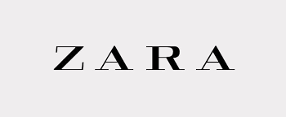

Zara is an international retailer with over 2,000 stores around the world. We specialise in a range of products such as clothing, accessories, shoes, swimwear, beauty, and perfumes and are the largest company in the Inditex group, the world's largest retailer conglomerate. Zara manages up to 20 clothing collections every year, including for all four seasons.
Originally, we were founded in Galicia, Spain in 1975 and the company is still based there to this day. By 1985, we had grown and engaged in global expansion and by 1990, there were Zara stores across the globe, in countries such as the USA, UK and France. By 2010, we launched online website and cemented our place as one of the biggest fashion retailers in the world.
Zara is an award-winning company that is place in the top thirty in Interbrand’s list of best global brands. We also strive to maintain high ethical standards and ensure materials sourced from our clothing are recyclable and of the highest quality. We are an innovative company that continues to grow as and of May 2021, we launched Zara Beauty, our first beauty range.
Make sure you read next weeks blog to find out where your local Zara store is based and contact us on @Zara or use #Zara if you’d like any questions answered in any upcoming blogs!
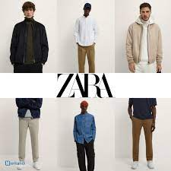

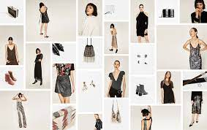
Blog 2 - What does Zara Sell?

In our first blog, we covered an overview of Zara as a company, but what specifically do we sell?
Zara caters to all shapes and sizes, men, and women as well as dedicated children’s clothing, Zara Kids. We even have a home section in our European stores! We produce 450 million items of clothing each year, all being distributed from our main distribution centre in Spain. Furthermore, at Zara, you can find an extensive range of shoes for men and women as well as swimwear and clothes for every season.
In our new beauty line “Zara Beauty”, we have now introduced perfumes and aftershaves as well as a range of make-up products such as lipstick and foundation. Any Zara product makes the perfect gift for Christmas and with Spring approaching, make sure you keep an eye of all our new range. Find all this and more on in store or on Zara.com. Finally, in the Zara home range, you can find all the furniture you could possibly need.
Be sure to show off all your latest Zara purchases on Twitter and Instagram using #Zara !

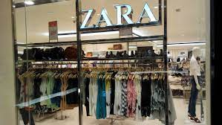
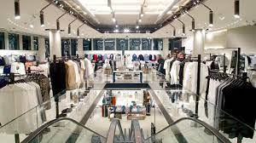
Blog 3 – Where can you find Zara?

In our previous blog, we covered what you can expect to find in a Zara store and online, but where can you find us?
Zara have a strong online presence. You will regularly see adverts on TV as well as online marketing. In addition, we are present on major social media platforms such as Facebook, Instagram, and Twitter where you can find all our latest deals.
Due to the rapid expansion of the business in the 1990s and early 2000s, you can now find Zara stores across the globe on all seven continents! In 1989, it entered the United States, and then France in 1990. During the 1990s, stores were opened in several locations including Mexico and Greece, Belgium, and Sweden. While in the early 2000s, Zara expanded to South America and Asia when it opened stores in Brazil, Japan, Russia, and China.
More recently, the company has improved its online presence, extending Zara Online to countries such as Austria and Ireland. So, even if you do not have a Zara store nearby, you are never too far from being able to access top quality fashion! If you do want the full in-store experience, then make sure to log on to Zara online where you can use our useful store finder to identify which one is closest to you. With 68 stores in the UK alone, you shouldn’t have to travel far!
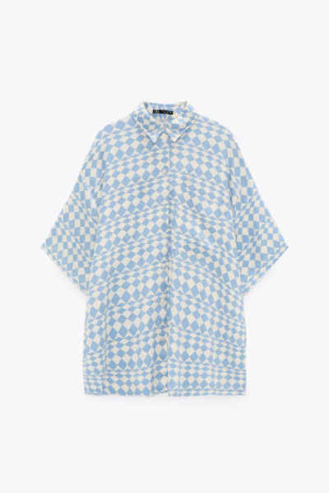
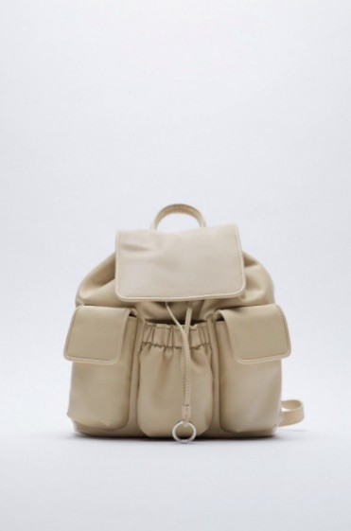
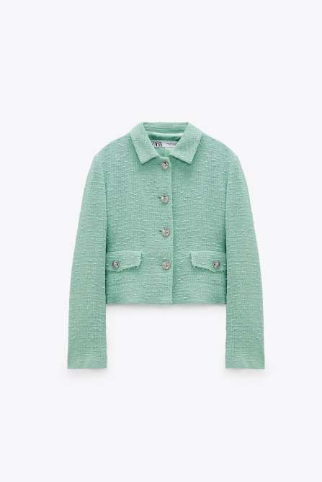
Blog 4 – Our Best Looks

When you shop at Zara, it’s a marathon not a sprint. With so many great looks to achieve, it’s important to find the items right for you. The easiest way of doing this is to look at our most trendy and best-selling items. This can be done by logging on to the Zara online store and navigating to the “best-sellers” page. Here you’ll find the hottest items across all ranges, including jackets, jeans, and beauty.
Our Zara green jacket see above is out best seller this winter. It combines modern and retro style at the same time and is sure to sell out fast, so make sure you get yours soon before they’re gone. However, if you fancy something practical to use when out and about, look no further than this Zara backpack seen above. Finally, just to prove that we have something for every type of occasion, this blue/white satin effect t-shirt has just dropped and is proving popular with those already planning for the warmer days ahead. This oversized silk tee is ideal for looking great while on long walks along the beach on a hot summer’s day.
What item is your favourite? Make sure you tweet your favourite piece of clobber on Twitter using #Zara !


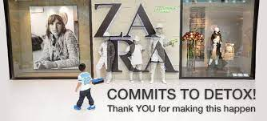
Blog 5 – Buying ethical

At Zara, we are committed to ensuring the selling of nothing but the highest quality garments. However, we are also aware of our environmental responsibilities. This is why we have committed to work alongside Greenpeace and have produced a "zero discharge" pledge committing the company to phasing out the use of a variety of hazardous chemicals present in our products. We will achieve this by ordering all Zara suppliers to disclose all releases of toxic chemicals from their facilities to surrounding communities, with the end aim to achieve zero hazardous discharge. In 2001, the company also signed the United Nations Global Compact, a series of initiatives to use ethically and sustainably produced fabric, recycled packaging, and implementation of an in-store clothes recycling donation program.
Therefore, when buying from Zara, you are not just investing in clothes, but a company that prioritises. We even have a line of clothes and items designed with the specific purpose of being as sustainable as possible. The “Join Life” sustainability line. The Join Life campaign allows shoppers to bring clothing they no longer wear to a Zara location. They then distribute the clothing to organizations that will recycle, donate, sell, or transform used clothes so that they are given a longer lifespan, not just thrown out and put in landfills. So, when you buy from Zara, you can rest assured that all clothes are being sourced with the highest ethical and environmental standards in mind.
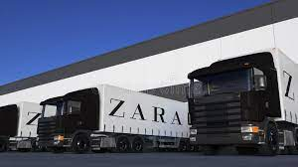
Blog 6 – Keeping up with demand
At Zara, we aim to deliver to customers and stores to maintain healthy service levels as frequently as possible. But how does this journey from manufacturing to your wardrobe happen?
Zara’s value chain is vertically integrated, creating many advantages that help us keep up with customer demands. This is because we can react quickly due to having high control over the entire process from design to final product. Therefore, the supply chain is efficient through a smooth use of distributions centres and warehouses. Our strategy also allows for the distributing of products within a wide geographic range within a very short time. This is so that products are never too far from our customers.
Generally, all Zara products made in limited editions; consequently, we market our products on sale for short period of time so they can be sold at full price without having them returned. Doing this creates further advantages for Zara as this responsive approach involves both lower marketing costs, and higher profit margins for the company.
IT integration is also an important aspect of Zara’s strategy which is significant as it enables information sharing between different joints within the company.
Inditex-owned Zara has launched its Store Mode functionality across all UK stores, connecting its physical shops with its website and app. Store Mode allows UK customers to check into any UK store online. This customises the digital experience to only show the products and sizes that are physically available in that specific store, allowing shoppers to check stock in their local branch in real time through the Zara app and website. Shoppers can purchase items via Store Mode and pick up in store on the same day via Store Mode’s Click & Go function. These items can be collected in store using a QR code after 11.30am and are ready within 30 minutes. Store Mode also features a Click & Find function, which uses geolocation to allow shoppers to find specific items in store using Store Mode maps.



Blog 7 – The Winter collection

In our final blog of the series, we will take a look at our latest winter collection as the festive season approaches. In our Zara winter collection, there is something for everyone. Weather it’s Christmas shopping or treating yourself to that designer jacket you’ve been desperate, everything can be found online and in store this festive season! Make sure you cop a bargain in our Black Friday sale as well, with over 100 items reduced by up to 60%
As well as the standard winter range, Zara has just introduced the exciting new Atelier range which will focus on quality design and craftsmanship. Products drop on 09/12/2021 and consists of six outerwear styles with couture touches, including marabou-trimmed collars and sequin-embroidered lapel detailing. Highlights include an ankle-length cape coat embroidered with oriental-inspired floral designs and velvet appliqué, an A-line dressing-gown style in lurex and candlewick jacquard with a removable faux-fur shearling shawl collar and antique gold pyramid studs. The collection also includes a selection of jackets and ponchos in a variety of colours and styles. With demand high, these are sure to sell out fast, so make sure you act now to avoid disappointment!

References
- Wikipedia Contributors. (2019, January 25). Zara (retailer). Wikipedia; Wikimedia Foundation. https://en.wikipedia.org/wiki/Zara_(retailer)
- Zara. (2021). ZARA United Kingdom | New Collection Online. Zara.com. https://www.zara.com/uk/
- Zara commits to detox after Greenpeace dressing down | Greenbiz. (n.d.). Www.greenbiz.com. Retrieved December 10, 2021, from https://www.greenbiz.com/article/zara-commits-detox-after-greenpeace-dressing-down
- Zara’s Join Life Campaign Strives for Sustainability ⋆ Bombshell By Bleu. (2019, August 8). Bombshell by Bleu. https://bombshellbybleu.com/zara-join-life/
- Zara unveils premium in-house label, Zara Atelier | The Industry Fashion. (n.d.). Https://Www.theindustry.fashion/. Retrieved December 10, 2021, from https://www.theindustry.fashion/zara-unveils-premium-in-house-label-zara-atelier/
- Moran, G. (2021, July 9). Zara launches Store Mode technology in UK. Drapers. https://www.drapersonline.com/news/zara-launches-store-mode-technology-in-uk

