Strategic Plan - Task 1

Module Title: Strategic Management for SMEs

Module Code: BMSW6104
Lecturer Name : Abdallah Naser
Student Name : Mihai Alexandru Netoi
Student Number : 2026780

Table of Contents
Introduction 3
Current Strategic Direction of The Rude Health Company 4
PESTLE Analysis of The Rude Health Company 4
SWOT Analysis 6
Stakeholder Analysis 7
Critical Evaluation of the Expectations of Different Stakeholders and their Relative Power 8
Strategic Growth Choices for SMEs in Markets 10
Long-term Sustainable Growth Strategy for The Rude Health Company 10
Strategic Recommendations for Future Developments and Implementation 12
Conclusion 13
References 14

Introduction
Small and Midsize Enterprises generally refer to a business that effectively maintains its assets and revenues below a specific threshold which consists of working employees of not more than 500. There are numerous different SMEs operating within the United Kingdom that hold a huge influence over the economy and also drive innovation and productivity alongside contributing towards the employment rate in the country (Team, 2023). One such SME is the Rude Health Company which mainly deals in manufacturing and selling multiple categories of beverages and foods where some of the crucial products include oats, puffs, drinks and coconut drinks along with other products. The firm was mainly established in the year 2005 with an Ultimate Muesli that was initially started as a small kitchen service (Rudehealth, 2024). In context to these factors, the following report aims to effectively appraise the current strategic direction of the firm along with a PESTLE and SWOT analysis. This will be followed by conducting a stakeholder analysis along with a critical evaluation of the expectations of the stakeholders. Moreover, different strategic growth choices for SMEs along with a new strategy will also be formulated within the report.

Current Strategic Direction of The Rude Health Company
Strategic Direction in simpler terms can be defined as a group of decisions and activities in a firm to seamlessly achieve the goals and objectives. It crucially ensures that the different owners, employees and managers majorly focus on the core objectives of the firm (Emerald Publishing, 2019). In context to the strategic direction of the Rude Health Company, the firm mainly emphasises fostering innovation within the different products and services that seamlessly tend towards the needs and demands of the customer. This seamlessly ensures that the different products also tend towards the normal standards of health. On the other hand, Rude Health is also highly dedicated towards ethical practices and sustainability which mainly ensures that the different materials used for manufacturing the products are sourced in a sustainable way. Moreover, the strategic direction of this SME also focuses on investing in different eco-friendly materials for packaging their products and also aims to achieve zero waste within the industry. This is considered to be an extremely important factor due to the rapidly rising awareness of sustainability across the globe making the majority of the individuals highly inclined towards businesses integrating sustainable practices.
On the other hand, the Rude Health company is also heavily focused on diversifying the streams of revenue alongside expanding its operations within different corners of the globe which holds a huge influence over the profitability and success of the industry (‌Foodnavigator, 2023). The firm crucially emphasises fostering crucial partnerships with different organisations and suppliers that assist in ensuring a wide range of market reach along with a vast portfolio of products towards the customers. In context to these different factors, the strategic direction of the Rude Health company majorly revolves around the innovation of products and services along with sustainability that seamlessly assists the firm in tending towards the needs and demands of health-conscious consumers across the globe.

PESTLE Analysis of The Rude Health Company
Political: In context to this factor, the different rules and regulations present within the food and beverage industry of the United Kingdom are among the crucial factors that hold a huge influence over the growth and success of the food industry within the country. This political factor also forces the Rude Health company to comply with the different rules and regulations set specifically by the Food Standards Agency (FSA) that directly pose a huge impact on the regular operations and pricing structure of the products of the firm (Food Standards Agency, 2024).
Economical: Concerning this aspect, the rising inflation rate is among the core economic factors that hold a huge influence over the profitability and operating cost of the food and beverage industry of the United Kingdom. This factor also directly impacted the success of the Rude Health company as during the span of 2021 to 2022 the inflation rate of the country reached a peak of 11% directly influenced the cost of sustainable materials used for reducing the product resulting in the form of increase in the price of the product in order to maintain its profitability (Statista, 2024).
Social: The rapidly rising awareness of sustainability among individuals across the globe is among the core social factors that had a huge impact on the food and beverage industry of the United Kingdom. This is mainly due to the fact that the majority of the consumers demanded eco-friendly and healthy food products produced with the help of sustainable practices requiring the majority of the organisations within the industry to abide by these factors. The presence of this factor effectively provided the Rude Health Company with immense benefits as the firm is heavily inclined towards sustainable practices resulting in a wide range of inflow of customers into the business.
Technological: With regard to technological factors, a crucial one includes the utilisation of different advanced technological tools that significantly simplify the regular operations and processes of the organisations within the food and beverage industry. The implementation of this factor also had a crucial impact on the Rude Health Company where technological tools such as CRM software seamlessly assisted in simplifying the checkout process for the customers while gaining crucial insights into the needs and demands of the customers due to this tool.
Legal: The food and beverage industry of the United Kingdom also possesses a wide range of rules and regulations that hold a huge influence over the regular operations of the firms within the industry. This factor also significantly imposes the Rude Health company in abiding by the complex regulations in order to maintain its operations within the industry.
Environmental: The food and beverage industry is among the major contributors towards the degrading environment which is mainly due to the high amount of waste generated from the production process. This significantly increases the importance for the Rude Health Company in integrating different strategies for reducing the impact on the environment that will also seamlessly assist in enhancing the brand reputation of the firm within the industry.

SWOT Analysis
Strengths: With regards to the strengths of the Rude Health Company, a major one includes a high level of brand reputation as the firm has been operating within the country for more than 15 years and also offers its consumers high-quality and healthy food products. On the other hand, the firm also highly emphasises sustainability which is its major strength as it has allowed the Rude Health Company to gain access to avoid a range of consumers who are highly inclined towards healthy and sustainable products.
Weaknesses: Concerning the weaknesses, due to the majority of the emphasis of the Rude Health company on sustainable products, the operating cost is significantly higher due to the high level of cost of the sustainable materials that directly poses a huge impact on the pricing structure of the products offered towards the consumers.
Opportunities: The presence of a high level of brand reputation and identity within the country significantly provides the Rude Health company with an immense expansion opportunity across different corners of the country that will directly enhance the profitability and growth of the firm. On the other hand, sustainability is also consistently rising at a rapid pace which significantly enhances the success criteria within the food and beverage industry as the firm is highly inclined towards sustainable practices. Another crucial opportunity revolves around the rise of online e-commerce platforms that effectively assist the Rude Health company in increasing its market reach across different corners of the globe.
Threats: With regard to the different threats that can hinder the regular operations of the Rude Health Company, a major one includes a high level of competition within the food and beverage industry that consists of numerous different competitors that offer a similar range of services towards the consumers. The presence of this factor significantly hinders the inflow of customers into the business and negatively impacts the generation of revenue. Another major threat includes disruptions within the supply chain that pose a huge impact on the production process of the products.

Stakeholder Analysis
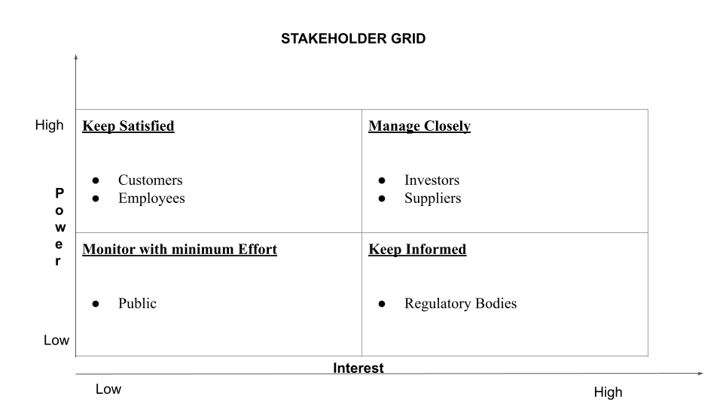
Figure 1: Stakeholder’s Grid
Source: (Created by the learner)
With regard to the above figure, some of the crucial stakeholders of the Rude Health Company significantly include the customers, employees, suppliers, investors and different regulatory bodies. These different stakeholders of the firm comprise contrasting interests and demands which will effectively be analysed within this section. In context to these factors, customers are major stakeholders where the major interest lies in gaining access to premium quality and healthy food products that have been produced with the help of Sustainable practices which does not pose any harm to the environment (BBC Bitesize, 2019). The key strategy that can be used tending towards the interest of this stakeholder includes imposing transparency in the regular business operations of the firm along with its sourcing. The utilisation of this new strategy is also extremely important to adopt as it will assist the good health company in gaining a competitive edge within the food and beverage industry.
On the other hand, the working employees of the firm are also the major stakeholders that pose a huge interest in the regular operations. Some of the major interests of this stakeholder include flexibility within the working hours, a positive working environment and effective wages where these factors play a huge role in the performance and productivity that provides immense benefits for the Rude Health Company. This factor significantly increases the importance of formulating a new strategy in order to tend towards the interests of this stakeholder. In this context, offering the working employees an effective reward system on the basis of performance. Additionally, providing the employees with immense career advancement opportunities will also similarly assist in tending towards the interest of this stakeholder. Moreover, the Rude Health company also heavily relies on its suppliers making them crucial stakeholders. Some of its major interests include positive partnerships over a longer span of time along with the implementation of transparent business practices of business. In order to tend towards the interest of the suppliers the Rude Health Company can focus on utilising effective practices for Sourcing the products while seamlessly abiding by the principles of fair trade. This will seamlessly assist the firm in reducing the risk from disruptions within the supply chain that also directly provides immense benefits towards the growth and success of the Rude Health company within the highly competitive food and beverage industry of the United Kingdom.
Another major stakeholder of this SME includes the regulatory bodies that significantly increase the importance of complying with the different regulations and laws with increased efficiency. According to the interest of this stakeholder, formulation of a new strategy is also extremely important where a strategy that tends towards the needs and demands of the regulatory bodies while fostering a positive form of relationships can significantly assist in tending towards the interests of these stakeholders. On the other hand, the investors are also crucial stakeholders for the firm that hold a huge influence and interest in the success of the firm. The major interest of this stakeholder majorly includes achieving an effective and positive financial performance along with success within the long term which can be done with an effective strategy. In this context, A new strategy that emphasises the development of a product for the firm in an innovative way can significantly be done by the Rude Health company to attract investors into the firm. This will significantly assist in tending towards the interest of this stakeholder and seamlessly enhance its success criteria within the highly competitive food and beverage industry of the United Kingdom.

Critical Evaluation of the Expectations of Different Stakeholders and their Relative Power
With regard to this aspect, the different stakeholders connected to the Rude Health Company also possess their own set of expectations and relative power that directly influences the regular operations of the firm within its industry. In context to the customers who are a major stakeholder, some of the major expectations from the Rude Health company mainly include access to a wide range of products that are healthy and organic which have been effectively sourced and produced through sustainable practices. Moreover, the customers also expect the firm to gain different forms of nutritional benefits from their products; it does not pose any harm towards the environment. The customers as stakeholders for the Rude Health Company hold a high power as they play a huge role in the profitability aspect as the purchasing decisions directly have an impact on the generation of revenue within the firm.
The working employees of the firm are also crucial stakeholders; they majorly expect the rude health company to provide them with effective wages along with a safe and positive working environment that does not pose any harm to both their physical and mental health. Additionally, the employees also expect the firm to provide them with immense growth and career advancement opportunities through the implementation of different training and development programmes. The relative power of the employees is also generally considered to be moderate which is mainly due to the fact that the performance of the employees has an immense impact on the productivity of the firm. This significantly increases the importance for Rude Health in integrating effective strategies to maintain their performance as a lack of satisfaction among the employees can result in a low level of productivity.
Another major stakeholder for the firm includes the suppliers where some of the general expectations mainly include positive forms of trade practices along with a long-term partnership. The suppliers also expect the firm to implement transparency within the business practices that assist in enhancing the level of Trust within this stakeholder. The suppliers also hold a high power as the Rude Health Company mainly emphasises gaining access to sustainable materials that are generally considered to be complex and may result in constraints within the resources. With regard to this factor, disruptions within this aspect can significantly hinder the regular operations of the firm within the industry. This significantly increases the importance for the Rude Health company in seamlessly tending towards the needs and demands of the suppliers as it holds a huge influence over the success in growth of the firm within its industry.
On the other hand, the different regulatory bodies who are core stakeholders for the firm mainly expect the firm to seamlessly comply with the different regulations regarding food safety where the main aim is to protect the public from different forms of health hazards. Concerning the relative power of this stakeholder, it is generally high which is mainly due to the presence of a high level of authority that is bound by the legal authority. This significantly increases the importance of tending towards the expectations of this stakeholder in order for the Rude Health Company to avoid any legal consequences.

Strategic Growth Choices for SMEs in Markets
In context to these factors, there are numerous different strategic growth choices for small and midsize enterprises within the market and some of the crucial ones will effectively be discussed within this section. Implementation of different data-driven insights is an effective growth choice which significantly imposes the SMEs heavily relying on different data and information before making a decision. This also effectively involves the utilisation of different tools for data analysis that simplifies the process of gathering crucial insights and information about the behaviour of the customers along with the ongoing trends within the market. This strategic growth choice seamlessly enables the Rude Health Company to formulate crucial customised strategies that assist the firm in tending towards the needs and demands of the customers driving growth within the food and beverage industry.
On the other hand, another crucial strategic growth choice includes the expansion of the reach within the market which is considered to be a vital factor in gaining access to its new opportunities. The implementation of this strategic growth choice will seamlessly allow Rude Health to gain access to new opportunities for growth within the highly competitive market. This seamlessly involves the firm in highly focusing on the online aspect of its business and utilisation of different social media platforms that consist of a huge user base allowing the firm to enhance its market reach within different corners of the globe. Moreover, due to the rapidly evolving advancements in technology, it is also considered to be an effective strategic growth choice for SMEs as the use of different technological tools significantly simplifies business operations. This directly allows the firm to improve its performance within the industry which directly drives the firm towards its growth within the industry.

Long-term Sustainable Growth Strategy for The Rude Health Company
As the core focus of the firm is on sustainability, it is extremely crucial for the firm to focus on the implementation of different growth strategies that revolve around sustainability. This form of business growth also seamlessly involves the combination of economic progress that abides by different social and ethical practices where the main focus is on long-term growth. Moreover, the implementation of a sustainable growth strategy will also significantly offer the Rude Health company immense benefits where some of the crucial ones include an enhancement in profitability along with an improvement in the brand reputation and identity among the customers. In context to these factors, some of the crucial sustainable growth Strategies for the firm will effectively be formulated with the help of an Ansoff Matrix which mainly comprises four elements, market penetration, market development, product development and diversification (Mindtools, 2024).
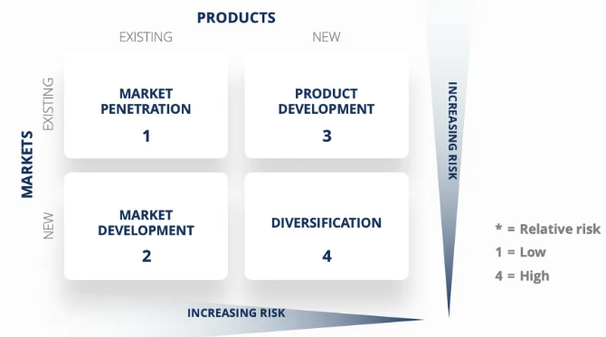
Figure 2: Ansoff Matrix
Source: (Thestrategyinstitute, 2024)
Market penetration: This aspect of the Ansoff matrix mainly involves increasing the sales of the existing products within an existing market. Concerning this aspect, the Rude Health Company needs to effectively focus on enhancing its different efforts of marketing the products within the market in order to enhance the brand identity to attract a new group of customers (Admin, 2024). A crucial strategy concerning this aspect seamlessly includes the utilisation of different loyalty programs that directly assist the firm in increasing the retention level of the customers within the market. Moreover, a seamless expansion of different channels of distribution within the market can also be done by the Rude Health company which will assist in improving the availability of products towards the customers within the market.
Market Development: This factor includes selling existing products towards new markets which significantly imposes Rude Health in expanding its operation within new regions that possess a high amount of demand for sustainable food products. This can effectively be implemented with the help of partnering with the local retailers which will simplify the process of entering the new market. Moreover, the implementation of this strategy is extremely important for the long-term sustainable growth of the firm as it reduces the dependency on a single market.
Product Development: This mainly emphasises introducing a new range of products and services into an existing market where a crucial strategy involves Rude Health in focusing on the development of new and innovative food products that highly tend towards the needs and demands of the customers. On the other hand, the implementation of eco-friendly packaging of the products also seamlessly assists in enhancing the growth of the reputation among the customers driving its long-term growth.
Diversification: It refers to a concept of entering a new market with a new product which is considered to be highly risky which increases the importance of in-depth research on this aspect. A crucial strategy concerning this aspect significantly involves the introduction of a newer range of products aside from food products that align with sustainability. The utilisation of this strategy will significantly assist in the diversification process of the business while maintaining long-term growth and success in a sustainable way.

Strategic Recommendations for Future Developments and Implementation
The modern-day business environment is rapidly changing throughout the passing span of time directly increasing the importance of implementing different strategies and methods for future developments which will effectively be formulated within this section.
- A low market share is among the major challenges faced by small and mid-size enterprises within the industry where it is extremely important for the Rude health company to increase its market share to achieve immense success and growth. Concerning this aspect, it is highly recommended that Rude Health diversify its streams of revenue and move its operations towards other segments of the markets that will effectively assist in reducing the risks from different factors such as market vulnerability and economic fluctuations.
- The Rude Health Company should also focus on expanding its operations both domestically and internationally which will seamlessly assist in achieving immense success concerning future developments. This can effectively be done by fostering effective partnerships with local firms that simplify the process of operating within the new market.

Conclusion
To conclude, the above report has effectively analysed the current strategic direction of the Rude Health company which is an SME operating within the food and beverage industry of the UK. A PESTLE and SWOT analysis in order to evaluate the micro and macro environment of the business. This has been effectively followed by conducting a stakeholder analysis along with a critical evaluation of the expectations of the stakeholders. Moreover, different strategic growth choices for SMEs along with a new strategy have also been formulated within the report.

References
‌Admin (2024) 6 Growth strategies for small business, Financials and Accounting Blog. Available at: https://www.123financials.com/insights/6-growth-strategies-for-small-business/ (Accessed: 4 July 2024).
‌BBC Bitesize (2019). Customers - Stakeholders - Higher Business Management Revision - BBC Bitesize. [online] BBC Bitesize. Available at: https://www.bbc.co.uk/bitesize/guides/znf7nrd/revision/5#:~:text=Customers%20have%20an%20interest%20in,value%20for%20money [Accessed 4 Jul. 2024].
‌Emerald Publishing. (2019). Strategic Direction. [online] Available at: https://www.emeraldgrouppublishing.com/journal/sd [Accessed 4 Jul. 2024].
‌Food Standards Agency. (2024). Key regulations. [online] Available at: https://www.food.gov.uk/about-us/key-regulations [Accessed 4 Jul. 2024].
‌Foodnavigator, F. (2023). ‘We’re not trying to mimic milk’: Rude Health backs nutrition-forward strategy amid plant-based ‘shakedown’. [online] foodnavigator.com. Available at: https://www.foodnavigator.com/Article/2023/09/21/rude-health-backs-nutrition-forward-strategy-amid-plant-based-shakedown [Accessed 4 Jul. 2024].
Mindtools, M. (2024). MindTools | Home. [online] Available at: https://www.mindtools.com/a2gy5ya/the-ansoff-matrix [Accessed 4 Jul. 2024].
Rudehealth.com. (2024). About Us. [online] Available at: https://rudehealth.com/pages/about-us#:~:text=We're%20Rude%20Health, Quality%20ingredients. [Accessed 4 Jul. 2024].
Statista. (2024). UK inflation rate 2024 | Statista. [online] Available at: https://www.statista.com/statistics/306648/inflation-rate-consumer-price-index-cpi-united-kingdom-uk/ [Accessed 4 Jul. 2024].
‌Team, C. (2023). Small and Medium-sized Enterprises (SMEs). [online] Corporate Finance Institute. Available at: https://corporatefinanceinstitute.com/resources/accounting/small-and-medium-sized-enterprises-smes/ [Accessed 4 Jul. 2024].
‌Thestrategyinstitute.org. (2024). The Ansoff Matrix: A Powerful Tool for Business Strategy and Growth. [online] Available at: https://www.thestrategyinstitute.org/insights/the-ansoff-matrix-a-powerful-tool-for-business-strategy-and-growth [Accessed 4 Jul. 2024].

