A Critical Essay about a piece of architecture after 1945
Geraint Davies
2003381
M5X019981
18th March 2022

To what extent is Gehry’s Nationale-Nederlanden design contrasting to the surrounding context?

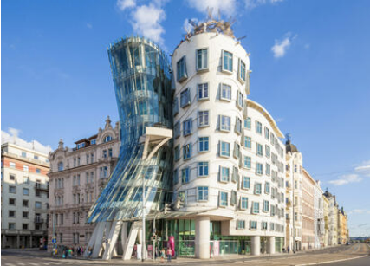
Figure 1 (Alamy Stock Photo, 2018)
A photograph of the Dancing House

The apparent contrast between the Nationale-Nederlanden and the nearby surroundings has been the source of an ongoing debate since its construction in 1996. In 1945 as a result of warfare a Neo-Renaissance house, situated on the corner of Jirasek Square and Raisin Quay along the Vltava River in Prague, was inadvertently decimated. The subsequently vacant site became one of only three sites in the historic district of Prague to receive approval for construction, a site currently occupied by the Nationale-Nederlanden office building. Consequently, the office building resides within a complex array of historic building fabric, in a neighbourhood consisting of renaissance, baroque, gothic, and art nouveau architectural stylings, all of which bare limited resemblance to Gehry's design (Vojcak 2017, P.2). It is this lack of resemblance through the form and structure as well as Gehry’s reputation for having an apathetic approach to contextuality, that initiates the question, is Gehry’s Nationale-Nederlanden ignorant to the surrounding context?
Upon first glance, the aesthetic of the Nationale-Nederlanden can be perceived as “contrasting [in its] approach towards the street line of the other buildings” (Riza et al., 2012, P.296) in the surrounding area, as the large, warped aesthetic challenges the elegant ornamentation and rigid verticality of the nearby historical architecture. This perception of Gehry’s building is one that presumably originates from the “dynamic character and the overwhelming scale of the building” (Forrester et al., 2004. P.121) which towers over the surrounding structures in a bold fashion. Furthermore, with its monolithic columns and assertive concrete façade, it could be argued that Gehry’s design is vaguely reminiscent of the brutalist architectural style, a style known to dominate the surrounding landscape.
However, alternative interpretations suggest that, consequential to further analysis, certain characteristics from buildings within the immediate vicinity can be seen echoed in the appearance of the Nationale-Nederlanden office building. This interpretation is supported by Riza (2012, P.296) who implores that “considering the use of material and proportions of the windows, the building is integrated in a contextual manner.” It could be argued that this statement carries varying degrees of credibility, as the mullions and muntins used within the windows, potentially mirror the delicate and slender glass panel aesthetic featured in the adjacent historical buildings. Therefore, it is implied that the Nationale-Nederlanden is a modern interpretation on the historic fabric of the surrounding context, and that “the building is successfully integrated [and] tailor-made for this site.” (Riza et al., 2012, P.296) Alternatively, this interpretation is juxtaposed by the fact the during the latter stages of design, the building was in breach of “significant variances in zoning ordinances” and consequently was required “to be set back to the edge of the sidewalk.” (Forrester et al., 2004. P.121) Furthermore, the correction of the “significant variances in zoning ordinances,” was for the majority, only allowed to pass due to the bias and authority “of President Vaclav Havel-who inspired the original … proposal” (Forrester et al., 2004. P.121) for the site’s construction. Therefore, this creates the impression that the building is not “tailor-made for this site” as previously suggested by Riza as the need for the correction of a mistake as blatant as the disregard for the zoning ordinances, implies that a certain degree of ignorance was instilled within the design, with regards to the surrounding context.
Despite the high regard for the Nationale-Nederlanden throughout architects and the general public, the building is more often recognised through its colloquial appellations as either ‘The Dancing House’ or ‘The Fred and Ginger Building’. Characterised by Gehry as ‘Fred and Ginger’ as a homage to Fred Astaire and Ginger Rodgers. The Nationale-Nederlanden is personified through the anthropomorphic shape and the use of “contrasting…forms to exaggerate the different functions and characters.” This interpretation from Vojcak (2017. P.5) suggests that personification is exaggerated through contrasting forms, however given the incongruity between Gehry's building and the historic architecture within its immediate vicinity, it can be argued that the contrasting forms are not only limited to the shapes within the design but rather the contrasting holistic shape of the design, with regards to the existing architectural fabric, further enhancing the argument that the Nationale-Nederlanden is contrasting to the surrounding context.
Furthermore, in contrast to the common misconception the Nationale-Nederlanden, was not designed to resemble the iconic dancing duo, as the building was retroactively titled ‘Fred and Ginger.’ Instead, the design was influenced by the sculptural artwork of Claes Oldenburg, known as the ‘London Knees.’ Gehry admits “that he obviously was influenced by the ‘Knees’”, (Nas and Brakus, 2004, P. 261) however claims that he did not directly echo Oldenburg’s design. The parallels between Oldenburg’s sculpture and Gehry’s building could be construed as a ramification of their collaboration on the Chiat building, from 1985-91. (Stungo and Books, 2000, P.18) The idea that Nationale-Nederlanden was influenced by Oldenburg implies that Gehry used external sources of inspiration within the design rather than embracing the architectural and historical context of the site, which arguably reveals a source to the incompatible nature of the Nationale-Nederlanden its surrounding context. However, a contradictory theory is that the Nationale-Nederlanden was not solely influenced by Oldenburg’s sculpture as the building’s design was intended to reflect the velvet revolution due to the fact that it is “composed of two parts, static and dynamic, just like a society.” ‌ (dancing house hotel, 2022) Therefore, this creates the impression that Gehry’s design does respond to context, although responds to the historical context as opposed to the physical context of the site.

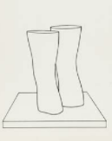
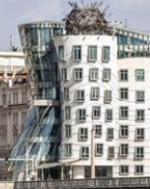
Figure 2 (Breeze, 2017)
A photograph of the Nationale-Nederlanden exterior
Figure 3 (Oldenburg, 1966)
A drawing of the ‘London Knees’

In addition, an alternate interpretation of the building can be created through the visual aesthetic as despite the contrasting nature of the glass and concrete, the shape in which they are formed allows the towers to “appear…fused together rather than as two distinctly separate … entities.” (Vojcak. 2017. P.1) The concept of making forms and elements “appear…fused together” is not uncommon for the work of Gehry as an observation from the Walker Arts Center (1986, quoted in Vojcak, 2017, P.2) alludes to the fact that “the idea of collision has figured prominently in his work since the early 1970s,” which can be seen through the deconstructivist style of the Gehry Residence. Similarly, to the Nationale-Nederlanden the Gehry Residence was also met with debate towards the contextual compatibility of surrounding landscape as within a period of five years “70 percent of Gehry’s neighbours had moved away,” (Stungo and Books, 2000, P.15) strengthening the notion that Gehry does create a contrast to the surrounding context of his designs, including the Nationale-Nederlanden.
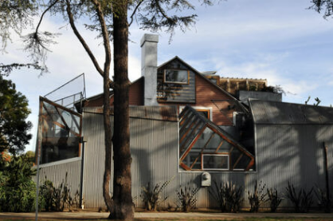
Figure 4 (Alamy Stock Photo, 2017)
A photograph of the deconstructivist style of the Gehry Residence

An alternate interpretation as to why Gehry’s design appears to contrast the surrounding context is as a result of the client, a Dutch insurance firm known as Nationale-Nederlanden. Vlado Milunic, a Croatian designer who was the initial project architect, was approached by the insurance firm and was asked “to collaborate with a world renowned architect “such as Gehry, who was given “an almost unlimited budget” and the request “that the site could become a cultural icon.” (Bleeckere and Gerards, 2017. P.48) Gehry’s flourishing reputation and deconstructivist style coupled with the freedom of design and budget is one interpretation as to why the design is contrasting to the surrounding context as Gehry’s western influence as well as his developing modern style was incorporated into the dissimilar historic district of central Prague. furthermore, a similar interpretation argued by Dal Co (2003, P.508) is that Gehry’s influence extended to the advanced technology utilized in the design, which allowed him to create, “refine and elaborate [the]… irrational, and nonrepetitive geometries” used within the Nationale-Nederlanden. Consequently, this creates the impression that Gehry was not constrained by the same structural and physical limitations faced by the buildings located within the neighbouring area, which were bound by the technological constraints and architectural ideology at the time of construction. Consequently, this interpretation further strengthens the reason as to why Gehry’s design is contrasting to the surrounding context as a combination of his modern style and modern technology contrast the historic design and traditional development of the surrounding context.

Despite the unique aesthetic of the Nationale-Nederlanden, the building exhibits a simplicity with regards to the materials that form the exterior. In true Gehry style the building appears “to rely upon the natural colors of the materials that were used,” as suggested by Vojcak. (2017, P.5) This technique is a common feature in Gehry’s work, a technique that stems from his entrenched interest of the characteristics of materials, which originated from time spent in his grandfather’s store as a child. Gehry’s use of a natural finish for the aesthetic is arguably the source of an alternate interpretation that suggests that the Nationale-Nederlanden is not contrasting to the surrounding context, as the additional buildings located on Jirasek Square also contain a natural façade finish and therefore creates a sese of unison between the architecture within the surrounding vicinity.
In addition to the honest nature of the materials used the Nationale-Nederlanden the building also conveys a sense of structural authenticity with regards to the glass façade of the exterior. The use of this façade protects the internal structure whilst simultaneously exposing it to the view of the public, allowing people to gaze upon the concrete framework of the Nationale-Nederlanden. The glass tower featured within the building “consists of two layers of [a] steel-supported glass curtain wall” (Vollers, 2001, P.66), an architectural feature that materialised during the 1950s and 1960s. One interpretation that stems from the structure of the design, expressed by Elkadi, (2016, P.12) is that Gehry’s use of the curtain wall enhances the ability of the Nationale-Nederlanden to embody a “different image from that of pre-war architecture.” This interpretation is potentially credible as the curtain wall is conveyed as a key element of the structural ability of the building to distinguish itself from the surrounding context in which it resides, and therefore strengthens the statement that Gehry’s design is contrasting to the surrounding context.
In addition to this, it could be argued that Gehry uses his architectural initiative to adapt and enhance the structure of the curtain wall to make it unique to his style. This interpretation as supported by Friedman and Ragheb (2001, cited by Vojcak, P.4) is based on the fact Gehry manipulates the structural elements through adapting both the vertical and horizontal steel T-members of the glass facade in a successful attempt to continue the “rhythmic effect” created by the adjacent concrete aesthetic. However, a contrasting understanding implies that the use and position of the curtain wall is arguably, an additional method used by Gehry, in designing a building that will be accepted into the surrounding context as residents of neighbouring buildings expressed an interest in being able to “maintain their view of … the historic buildings across the river,” (Vollers, 2001, P.66), a constraint overcome and achieved by the specific contortions and form of the building, which enhances the notion that Gehry’s design is successfully integrated into the surrounding context.
The predominant concrete façade of the Nationale-Nederlanden, as stated by Friedman and Ragheb (2001, cited by Vojcak, P.4) consists of ninety-nine “unique precast panels made possible with computer aided manufacturing.” The concrete element of the exterior is broken up by the gentle organic layering of the panels to create a “rhythmic effect.” The use of this effect reduces the high proportion of concrete from presumably overwhelming and unforgiving and transforms it into a playful and enticing façade that contradicts the intricate formality of the surrounding historical architecture. Furthermore, the dominance of the concrete façade is diluted by the frequent and organic placement of the windows, an alternative interpretation from Vojcak (2017, P.4) suggests that “staggered windows across both of the two towers provides an aesthetic wave pattern.” The unique wave pattern aesthetic, which is arguably a response to the close proximity of the building to the Vltava River, further creates a sense on cohesion between Nationale-Nederlanden and the adjacent environment and consequently challenges the proposal that the building is contrasting to the surrounding context.
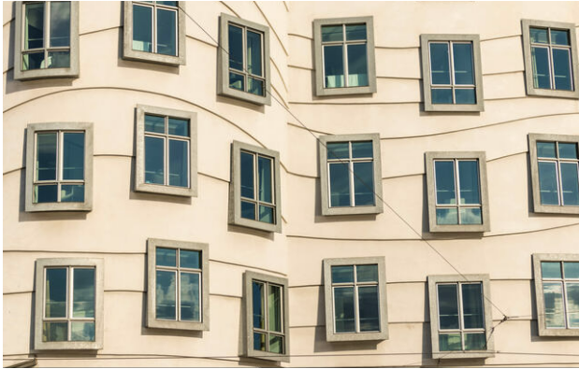
Figure 5 (Alamy Stock Photo, 2018)
A photograph showing the Nationale-Nederlanden wave facade

In addition to the concrete and glass aesthetic, it could be argued that the Nationale-Nederlanden also uses steel in an attempt to fit into the surrounding landscape. Located upon the roof of the concrete tower lies a stainless-steel dome that is questionably Gehry's attempt to associate his design with the “baroque and art nouveau layers of the city”. Vojcak’s (2017, P.7) belief that the dome creates “an affinity” with the historic fabric of the wider context of the site derives from the parallels it creates with similar domes that are located on the Wilson station as well as the Municipal Station located in Prague. It is this level of detail and observation that helps to combat questions surrounding Gehry’s capabilities in designing contextually as it implies that the Nationale-Nederlanden “clearly draws from the architectural layers of the city”. (Kurosu, 2009, P.998)
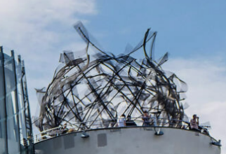
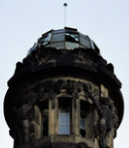
Figure 6 (Keene, 2019)
A Photograph of the steel dome upon the Nationale-Nederlanden
Figure 7 (Alamy Stock Photo, 2022)
A photograph of the dome upon the Wilson Station
In contrast to this, the similar fashion in the design and shape of the exterior and internal layout of the Nationale-Nederlanden can also be considered contrasting to the surrounding context. The organic natural shape of the building’s exterior is integrated into the layout of Gehry’s design as curved walls and irregular shaped rooms create a holistic approach to the buildings overall aesthetic. However, it could be argued that, similarly to the nature in which the building’s exterior contrasts the external aesthetic of the surrounding context, that the interior follows the same contradiction as the traditional symmetrical styling of the baroque architecture that is found with the nearby vicinity is a stark contrast to Gehry’s design. However, a parallel can be drawn between Gehry’s design and the surrounding context. Despite the curvature of the interior rooms the Nationale-Nederlanden has an aesthetical emphasis on the exterior of the building in comparison to the internal design. The idea that the external aesthetic of a building should be emphasised is arguably seen through the intricate detailing of the ornamentation that resides of the façade of the surrounding architectural fabric. Therefore, this implies that despite the alternate method in which it is achieved, both the Nationale-Nederlanden and the surrounding context consist of an aesthetically emphasised exterior, in comparison to the interior, that arguably creates a cohesion between Gehry’s design and the existing architecture.
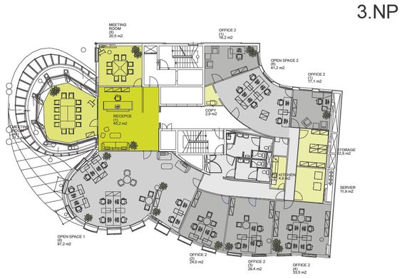
Figure 8 (Nowshin, 2022)
A plan of the Nationale-Nederlanden showing the third floor

To conclude, since the construction of the Nationale-Nederlanden in 1996, in the historic district of Prague, there has been substantial controversy over whether the design effectively responds to the heritage of the site on which it resides. For the most part the Nationale-Nederlanden has a contrast, which implies that it is ignorant to the surrounding context, a contrast that can be seen in the digital technology utilised in the design, as well as the modern structural techniques, that sets it apart from the historic fabric of the landscape, and the overall deconstructivist style. However, it cannot be said that the design is unwaveringly ignorant as details such as the proportion of the windows, the curved wave aesthetic and the stainless-steel dome, all exhibit an intention to make the Nationale-Nederlanden site specific. Therefore, it is only to a certain extent that the Nationale-Nederlanden is contrasting to the surrounding context, a result that arguably led to the bold and assertive yet partially integrated façade of the building, which allowed it to become the world-famous architectural icon that stands today.

Word Count: 2453

References

Elkadi, H. (2016). Cultures of Glass Architecture. [online] Google Books. Routledge. Available at: https://books.google.co.uk/books?id=xhMpDAAAQBAJ&pg=PA55&source=gbs_selected_pages&cad=2#v=onepage&q=curtain%20wall&f=false [Accessed 17 Mar. 2022].

Francesco Dal Co, Gehry, F.O., Kurt Walter Forster and Hadley Soutter Arnold (2003). Frank O. Gehry: the complete works. Milano: Electaarchitecture ; [London] ; [New York.

Kurosu, M. (2009). Human Centered Design: First International Conference, HCD 2009, Held as Part of HCI International 2009, San Diego, CA, USA, July 19-24, 2009 Proceedings. [online] Google Books. Springer Science & Business Media. Available at: https://books.google.co.uk/books?id=G7pRydLj7wMC&pg=PA998&dq=nationale+nederlanden+office&hl=en&newbks=1&newbks_redir=1&sa=X&ved=2ahUKEwjC1Lvmy472AhXUoFwKHep4BHQQ6AF6BAgKEAI [Accessed 17 Mar. 2022].
‌ Forrester, S., Forrester, S.E.S., Zaborowska, M.J. and Gapova, E. (2004). Over the Wall/after the Fall: Post-communist Cultures Through an East-West Gaze. [online] Google Books. Indiana University Press. Available at: https://books.google.co.uk/books?hl=en&lr=&id=WE6ctaqbVwMC&oi=fnd&pg=PA120&dq=From+the+outset [Accessed 17 Mar. 2022].

Nas, P.J.M. and Brakus, C. (2004). A Note on Anthropomorphic Architecture. Space and Culture, 7(3), pp.260–264.

Riza, M., Doratli, N. & Fasli, M., 2012. City branding and identity. Procedia - Social and Behavioral Sciences. Available at: https://www.sciencedirect.com/science/article/pii/S187704281200403X [Accessed March 17, 2022].
Sylvain De Bleeckere and Sebastiaan Gerards (2017). Narrative architecture: a designer’s story. New York; London Routledge.

Vojcak, D. (2017) Gehry’s Nationale-Nederlanden Office Building (Dancing House/Fred & Ginger). Minnesota: Academia
Vollers, K. (2001). Twist & Build: Creating Non-orthogonal Architecture. [online] Google Books. 010 Publishers. Available at: https://books.google.co.uk/books?id=nLBAB01NjmwC&pg=PA66&dq=nationale+nederlanden+office&hl=en&newbks=1&newbks_redir=1&sa=X&ved=2ahUKEwjC1Lvmy472AhXUoFwKHep4BHQQ6AF6BAgLEAI [Accessed 17 Mar. 2022].

www.dancinghousehotel.com. (2022). Design Hotel Prague | Dancing House Hotel | Official Website. [online] Available at: https://www.dancinghousehotel.com/en/design-hotel-prague/. [Accessed 17 Mar. 2022].

‌
Figure 1 | Alamy Stock Photo (2018) RC6680. Available at: https://c7.alamy.com/zooms/3/97389bbd11694654acefee3ddc339d94/rc6680.jpg
Figure 2 | Breeze, C. (2018) 2EA3M9F. Available at: https://c7.alamy.com/zooms/3/893bb918624445b59c91dcff534f2886/2ea3m9f.jpg
Figure 3 | Oldenburg, C. (1966) Untitled. [photolithograph]. Available at: Claes Oldenburg. Untitled (Some Positions of the Knees) from London Knees 1966. 1966, published 1968 | MoMA
Figure 4 | Alamy Stock Photo (2022) A72GND. Available at: https://c7.alamy.com/zooms/3/ad14d4d27cb54e30a81a6707f694bc3d/a72gnd.jpg
Figure 5 | Alamy Stock Photo (2018) RC6685. Available at: https://www.alamy.com/prague-dancing-house-or-ginger-and-fred-tanc-dm-by-frank-gehry-and-vlado-milunic-prague-bohemia-czech-republic-europe-image231247301.html
Figure 6 | Keene, B. (2019) T8AX4C. Available at: https://c7.alamy.com/zooms/3/4c3bd9071fb14cceb42a6639fe6bcb72/t8ax4c.jpg
Figure 7 | Alamy Stock Photo (2017) M6XT4X. Available at: https://c7.alamy.com/zooms/3/d93c8e050f644fbaa17ad5e20176f6d6/m6xt4x.jpg
Figure 8 | Nowshin, N (2022) Dancing House floor plan. [Digital drawing]. Available at: https://pin.it/75GfBYW

