3/24/2025
University of Wales Trinity Saint David
London campus
E-Portfolio Link:
Module Name: Learning In the Digital Era
Module Code: ACCA 4025

Student Name:
Student ID:
Group: 1

Lecturer’s Name: Koushik Modak

LDE Assignment 1
E-Portfolio
Table of Contents
Introduction 2
Main Body 2
Task 1: Essential Academic and Employment Skills for the future career Path 2
Task 1 (a): Report on Essential Academic and Employment Skills 2
Task 1 (b): Evaluation of Task 1 (a) based on Similarity report 2
Task 2: Collaborative Mind Map and Individual Poster 2
Mind Map (Collaborative) 2
Poster (Individual) 2
Task 3: Virtual Collaboration and RefWorks 2
Report on Virtual Collaboration 2
Step-by-step process of using RefWorks with visuals 2
Task 4: E-Portfolio Creation and Evaluation 2
Task 4 (a): E-Portfolio Creation 2
Task 4 (b): Illustrative Review of E-Portfolio tool Selection 2
Conclusion 2
References 2
Task 1 References: 2
Task 3 References: 2

Introduction

Main Body

Task 1: Essential Academic and Employment Skills for the future career Path

Task 1 (a): Report on Essential Academic and Employment Skills
A step-by-step approach of finding a skill is a sources 0f writing, listening speaking and researching within a university by understanding complete instruction contributing your own ideals, and on how to avoid an act of presenting another person ideal words or creative work as your own without proper credit. To see clearly future career, we need combination of foundation academic knowledge and high demand employment skills that are adaptable to rapid technological. Essential Academic Knowledge Future proof career paths increasingly rely on Higher Education level skills. Key academic areas with high projected growth by 2035 include Stem and Technology the is a projected need for 1.9 million professionals in computing and engineering [1].
Specific expertise in AI and Machine Learning, Data Science Cybersecurity are very important because its help the companies to see things clearly how the AI machines work. Essential Employment skills Adaptability and Flexibility thes ability to learn continuously and adapt to new technologies and roles is paramount, as workers May have15- 20 different roles in their lifetime [2].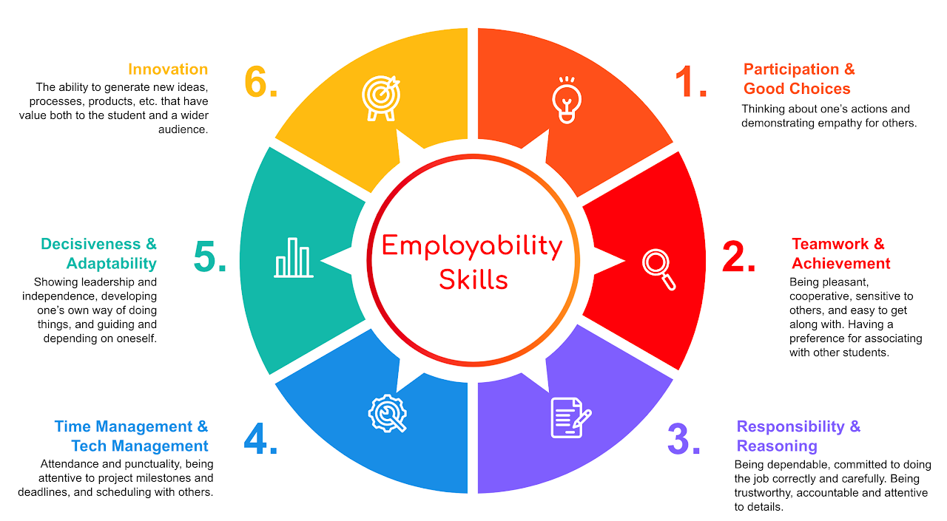Figure: 1 Employability skills.
Reference from jobs of the future universities UK. Based on recent reports, particularly from the National Foundational research NFERF and the skills Builder partnership, there is a growing, critical need to bridge the essential skills required for the 2035 labour market. As automation and AI reshape the economy, essential employment skill (skills EES)- often referred to as soft skills or transferable skills- are becoming just as vital as technical, subject-specific knowledge [3].

Figure: 2 Picture
Core Essential Employment Skills (EES) Research identifies six key transferable skills that will be in the highest demand by 2035 for exempt collaboration working well with others. Contributing to discussions and motivating, Problem- Solving and Decision- Making identifying problems, analysis them, and developing solutions, Organising and Planning &prioritising; Managing time resources, and tasks effectively creative thinking & Innovation: Generating, new ideas and adapting to changing situations. references Skills Builder Global htt://www.skisbuilder.uk Preparing for the future career landscape require a blend of advanced technical proficiency, specifically in AI and digital tools, alongside essential “human” skills like complex problem solving, creativity [3].

Task 1 (b): Evaluation of Task 1 (a) based on Similarity report

Task 2: Collaborative Mind Map and Individual Poster

Mind Map (Collaborative)

Poster (Individual)

Task 3: Virtual Collaboration and RefWorks

Report on Virtual Collaboration
Put your Chosen topic here

Step-by-step process of using RefWorks with visuals

Task 4: E-Portfolio Creation and Evaluation

Task 4 (a): E-Portfolio Creation

Task 4 (b): Illustrative Review of E-Portfolio tool Selection

Conclusion

References

Task 1 References:

Task 3 References:

