VINTNERS ANTIQUES
Module: Project Planning and Management in the workplace

TABLE OF CONTENTS

Vintners Antiques 3
Challenges Associated with Vintners Antiques Project 3
Project Roles and Responsibilities 4
Project Steering Group 4
User Stories 5
Estimates 6
Schedule 6
Project Communication 7
Risks Associated with the Project and Mitigation Strategies 7
Conclusion and Recommendations 8
References 9
Appendix 11
Appendix A: User Stories 11
Appendix B: Gantt Chart 12
Appendix C : Tasks 14
Appendix D : Tasks 15

Introduction
Vintners Antiques is a family-owned retail business on high street in Shirley existing for over thirty years with the current owners being in the third generation to run it. Vintners Antiques received an offer to sell their shop to TESCOS which is attractive to them and an opportunity for the business to take a new turn and improve having not been performing as it used to be. The new model of business that they want to adopt will be identical to TV series Salvage Hunters (Pritchard, 2011) which involves collecting the antiques from all over the country using the company van, taking the stock to their warehouse for restoration, then selling their finished products both in the warehouse and on a business website. The project is focused on moving Vintners Antiques business from the traditional shop in Shirley to their storage warehouse in Sparkhill which will act as their offices, restoration Centre, and their selling location. Thus, the business made it critical for the refurbishment of the warehouse, provide an internet connection, electricity, and phone, improving and adding office spaces for the management, and most importantly, developing a business website for marketing, and sales operations.

Challenges Associated with Vintners Antiques Project
Risk is the uncertainty of events, situations, existences, experiences, or occurrences that may influence an organizational project either positively or negatively (Srinivas, 2019). Risk management is the organizational plan that initiates the strategies to reduce the uncertainty, hence noted by Roberts (2007) that successful project managers must ensure identification and mitigation of the risks to reduce the likelihood of risks occurring as well as minimize the assumptions made in a project.
Vintners Antiques operates a traditional shop which they are selling and establishing their base a new in a warehouse at Sparkhill owned by the family. However, the warehouse is just a shell and needs an extreme makeover for the business to begin operations. According to Harvard Business Review many projects budget end up costing 200% more than estimated, 70% projects are delayed and other issues such as lack of clarity, lack of communication, lack of accountability are some of the other risks facing projects (Matta and Ashkenas, 2009). Thus, it is responsibility of project managers to prevent such mishaps.
The following steps and techniques will be employed as a project manager to minimise or prevent such risks taking place.

Project Roles and Responsibilities
Assigning the roles will consider the project needs as well as the stakeholder capabilities. The responsibilities are divided into; managerial, technical, execution, communication, and stakeholders. According to Roberts (2011), for a project to be successful; planning, assigning roles and responsibilities to stakeholders of the project is vital. Hence, for the Vintners project to be successful, we will create a steering group and assign roles and responsibilities accordingly to facilitate success.

Project Steering Group

The project sponsor is Doreen Vintner a senior member of Vintner Antiques, she has a deep comprehension of the business operations and all its strategic objectives. Further, she has the authority to allocate resources and approve budgets for the project. The role of the project sponsor will include securing the project funding, having a vested interest in a positive project outcome, confirm proper alignment of project goals and objectives, approve major scope changes, and provide final approvals for major scope changes.
The steering group provides advice required, ensure the delivery of project requirements as well as the project outcome (Kasvi, Vartiainen, and Hailikari, 2003). The group will be made up of the Vintners Antiques team led by the project sponsor. They will provide their input in different matters during the implementation of the project such as the evaluation strategy. Also, advise the project sponsor and the team on the budget and help in achieving the project outcome. Other roles include risk identification, monitoring the risks, timeliness, quality of the project as well as advice on project changes during its development (McGrath and Whitty, 2019).
The project manager is essential for the success of the transformation of the warehouse because she will be responsible for the control, planning, organization, and communication of the project information at every phase (Mossalam and Arafa, 2016). The project manager will collaborate with stakeholders, the sponsor, and the business analyst to identify a suitable way to initiate and implement the project; this will be followed by the creation of the project plan with the team including allocating the tasks (Mossalam and Arafa, 2016).
The project team is a key part of the completion of the project and will be made up of people with different skill sets with different responsibilities including masons, electricians, plumbers, web developers, movers, and carpenters, among others. The team will support the project manager in planning the work packages, scheduling, and the estimations of different costs (Roberts, 2011). They will also complete all the assigned tasks within the scheduled time as well as within the defined budget to ensure the success of the project. Each team member will identify the opportunities and risks in their tasks and recommend possible remedies. Lastly, they will participate in team meetings with proper and timely communication of emerging issues (Heagney, 2016).

User Stories
To establish a better and conducive working environment clarity is vital for the success of the project. For stakeholders’ satisfaction, the project manager will use user stories to capture all the needs and the clarity of the project. According to Lucassen et al (2016), often people know what they want in their mind but cannot explain, user stories are a technique that provides clarity on the requirements of the project. The user stories technique will involve asking short questions from all the stakeholders especially on poster notes to provide strategic answers. The answers to the questions will involve three segments including.
- AS a (who the stakeholder is or user role)
- I want (what is the need or goal)
- Because of (The reason or the need) (Patton and Economy 2014).
All the stakeholders of Vintners Antiques will use user stories involving short messages with simple descriptions of what they require from the warehouse and the reasons behind that; this will help the project team to collect all the requirements and ensure all stakeholders are catered for (Cohn, 2004). (See appendix A)
The steering committee has worked within the organization for a while and is more aware of the requirements necessary for the establishment of the warehouse hence making user stories the best approach.
Furthermore, the project visibility and status and feedback process will also be communicated through Trello. Trello is a project management tool proven for tracking project development phases and Trello is easy and flexible. Trello is an online project management tool that can be used on a smart device such as Laptop Computer, Smart mobile phones, etc. from anywhere. Trello board will be used to show the activities involved in the project development process. Trello board has a list of cards or user stories each card or story represents a task to be performed. These cards are transitioned across the board as the completion level changes. Another technique that will be used to keep the steering group informed will be The Chevron Technique. The Chevron Technique is used to priorities requirements in order of Must have (the stories or requirements that must be included), Want (the stories or requirements that we want) and Nice (the stories or requirements that would be nice to have) (Heagney, 2016). The Vintners steering group will have access to Trello where they can add user stories, see the Chevron list, and track the project phases.

Estimates
To accurately estimate the project costs and timeline, the steering committee will first divide the project into individual tasks (See Appendix D); then the individual task cost and timeline will be established. Cost of quality will also be established; this will ensure that all the specifications for the new warehouse are met.
The cost estimations will be performed using the Estimation tool Wisdom of Crowd to guarantee a more accurate result as compared to a single person decision. Wisdom of The Crowd is a theory first introduced and experimented with by Surowiecki (2005) and the result was strangely accurate, the theory proves that the aggregate estimate of the group provides more accuracy than most individual estimates. The wisdom of crowd technique will reduce the risk of under or overestimating the budget. The approach is essential due to the diversity of the committee members with different opinions and experiences. For the approach to be effective, all the cost opinions of different members including their research will be independent of each other with opinions made according to individual perspectives. For better accuracy, all the individual answers will be considered by taking an aggregate of the opinions.
The average cost of the project calculated from the individual estimates is £206,250 (See Appendix B); The figure will be used to set the budget for the project, the organization will provide a contingency budget to facilitate any hidden costs that may arise during the entire process.

Schedule
The project will use an attached Gannt chart to describe the schedule. The Gantt chart is a chart of project schedules that represents all the tasks in the project visually over the defined time (Petersen, 1991). The chart will represent attributes such as the set of tasks in the project, the start and end dates of the project, the different task owners, the length of each task, the association, and the grouping of the tasks (Robles, 2018). (See Appendix C)
The project spans 14 weeks making it ideal for the organization to become ready for the movement from the traditional shop and establish the new facility in the warehouse. (See appendix C for major tasks)

Project Communication
Communication is essential for the success of the project because it will help in transferring information about the progress and all the issues arising within the project to all the stakeholders (Heagney, 2016). For efficiency and effectiveness, different types of communication will be established throughout the project. These include start of the project meeting, which will involve all the team members meeting face to face to launch the project.
Task progress updates will be communicated via emails and will share the daily progress on each task scheduled. Project status reports will also be shared via emails weekly to establish any delays or issues as well as indicate the project status. Lastly, project reviews will be conducted through physical meetings at the end of each major task to present feedback to the project manager and establish the way forward.
The initial meeting will involve the creation of a Chevron list highlighting the tasks needed for the completion of the project. The list will guide the team in identifying the individual gaps and devise methods to eliminate them. Furthermore, the project visibility and status, and feedback process will also be communicated through Trello.

Risks Associated with the Project and Mitigation Strategies
Smaller warehouse space to fit the new business model, with the Vintners Antiques focusing on restoring items for resale, having a showroom as well as office spaces, all these may not properly fit in the new warehouse hence they will end up crumbled in smaller spaces. The issue can be mitigated by leasing an offsite storage facility to accommodate items that may take longer to get customers. A long-term solution will involve the construction of an extra storage facility within the Sparkhill compound.
There are also business risks including financial loss due to extensive renovation based on the current warehouse condition hence leading to instability. Vintners Antiques will engage a promotional campaign aimed at notifying consumers about their plan to move to a new location; this will ensure that the return customers are well informed. The activity will include mobile calls to regular customers and a poster at the traditional shop indicating the plan to move. Better offers will also be made on the items on sale to ensure more purchases to cater to the costs in the transition process.

Conclusion and Recommendations
It is manageable to carry out the implementation of the project to the excellent distribution of resources as described in the Gantt Chart, and presence of a case study that create an elaborate image of the final expected result of the project. Similarly, the management goodwill considering the shown commitment in involvement in carrying out different tasks in project implementation and clear explanation of the facilities to be provided for the excellent performance of their respective departments. It is additionally important for the manager to carry out the project to breakdown the Gantt chart and allocate resources for each activity to reduce the cost and performance risk in carrying out the project. Similarly, it is crucial for the manager to recruit qualified and experienced personnel to carry out the activities to ensure strategies are implemented as guided by the management.

.

References

Cohn, M., (2004). User stories applied: For agile software development. Addison-Wesley Professional.
Heagney, J., (2016). Fundamentals of Project Management. 5th ed. New York: American Management Association.
Kasvi, J., Vartiainen, M. and Hailikari, M., (2003). Managing knowledge and knowledge competences in projects and project organisations. International Journal of Project Management, 21(8), pp.571-582.
Lucassen, G., Dalpiaz, F., van der Werf, J.M.E. and Brinkkemper, S., (2016), March. The use and effectiveness of user stories in practice. In International working conference on requirements engineering: Foundation for software quality (pp. 205-222). Springer, Cham.
Matta, N. and Ashkenas, R., 2009. Why Good Projects Fail Anyway. [online] Harvard Business Review. Available at: <https://hbr.org/2003/09/why-good-projects-fail-anyway> [Accessed 11 March 2021].
McGrath, S.K. and Whitty, S.J. (2019), "Do steering committees really steer?", International Journal of Managing Projects in Business, Vol. 12 No. 3, pp. 785-807. https://doi.org/10.1108/IJMPB-04-2018-0064.
Mossalam, A. and Arafa, M., (2016). The role of project manager in benefits realization management as a project constraint/driver. HBRC Journal, 12(3), pp.305-315.
Petersen, P.B., (1991). The evolution of the Gantt chart and its relevance today. Journal of Managerial Issues, pp.131-155.
Patton, J. and Economy, P., (2014). User story mapping: discover the whole story, build the right product. " O'Reilly Media, Inc.".
Pritchard, D., (2011). [online] Discoveryplus.co.uk. Available at: <https://www.discoveryplus.co.uk/show/salvage-hunters> [Accessed 15 November 2020].
Roberts, P., (2011). Effective project management: Identify and manage risks plan and budget keep projects under control. Kogan Page Publishers.
Robles, V.D., (2018). Visualizing Certainty: What the Cultural History of the Gantt Chart Teaches Technical and Professional Communicators about Management. Technical Communication Quarterly, 27(4), pp.300-321.
Srinivas, K., 2019. Process of Risk Management. In: Perspectives on Risk, Assessment and Management Paradigms. Maharashtra, India: National Institute of Construction Management and Research, pp. 1-16.
Surowiecki, J., (2005). The Wisdom Of Crowds. New York: Anchor Books.

Appendix

Appendix A: User Stories
- Doreen Vintner
As the chief accountant and the business manager of Vintners Antiques, I need an ample office with proper lighting, telephone, internet connection, and water because I spend most of the time running the business and handling the accounts which involve recording and reporting the cashflow transactions of the business, including the accounts payable and receivables, maintaining all financial controls, payroll as well as financial reporting.
As the business manager, I need a large name board with the words Vintners Antiques on it in the front of the business because the business needs to be labelled to attract potential customers and sellers of antiques.
- Denis Vintner
As the Antique hunter and business driver, I need a medium storage room so that I will be able to store the incoming merchandise before I sort them for either selling or repairing.
As the antique collector, I need a small office fully equipped with stationery, furniture, electricals, and water to be able to handle communication with potential antique sellers all over the country before I set to collect them.
As the antique collector, I need a section added to the website detailing the type of antiques we collect and my contacts because people may need to sell their antiques and lack a direct line for verification.
- Suha Madani
As the customer service coordinator, I need a large showroom with proper lighting and labels because the customers will need to see the business's latest antiques as well as older pieces for them to easily select their favourites and purchase.
As the customer service attendant, I require a canteen close to the showroom so I can entertain potential buyers with snacks and water when they have spent some time looking at our antiques.
As the customer service attendant, I need lockable glass cabinets in the showroom because the small and most valuable items in the business portfolio need to be locked to avoid possible theft or misplacement.
As the customer service coordinator, I require a company website to be developed with a segment of ‘about us’ detailing the business activities, directions to the warehouse, and customer service contacts to advance the Vintners Antiques reach in the country.
- Omar King
As the antique restorer, I need a large repair room with proper lighting, hard flooring, electrical sockets for the tools, and water for cleaning because all the antiques that have been damaged or need some repairs and maintenance will need to be kept there while I work on them.
- Paul Ranson
As a business consultant, I need an office area with a computer, telephone, and broadband because I will need to perform much research on the antiques which are available and new ones to gain more understanding before sharing with the other stakeholders including customer service.

Appendix B:
The estimates are based on answers from the project manager and the steering committee. The members were provided with the different requirements (construction costs, web development costs, moving costs, wages, purchases, and miscellaneous) for the completion of the project and through the estimation of individual components, the following figures were presented.
Project Manager ----------------- £223,000
Doreen Vintner ------------------ £200,000
Denis Vintner ------------------- £124,000
Suha Madani -------------------- £323,500
Omar King ---------------------- £250,000
Paul Ranson -------------------- £117,000
Average ------------------------- £206,250

Appendix C: Gantt Chart

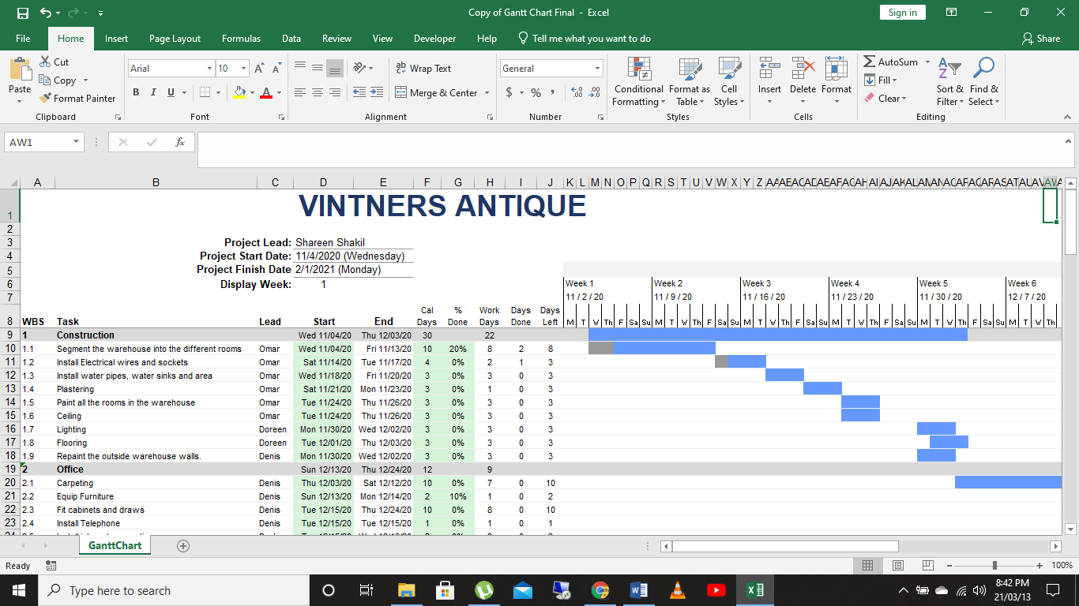
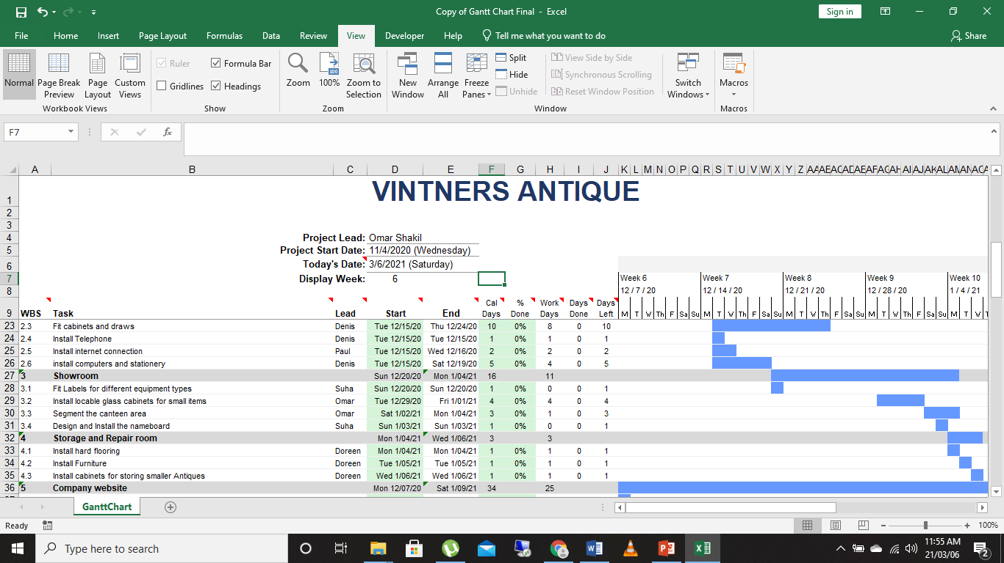

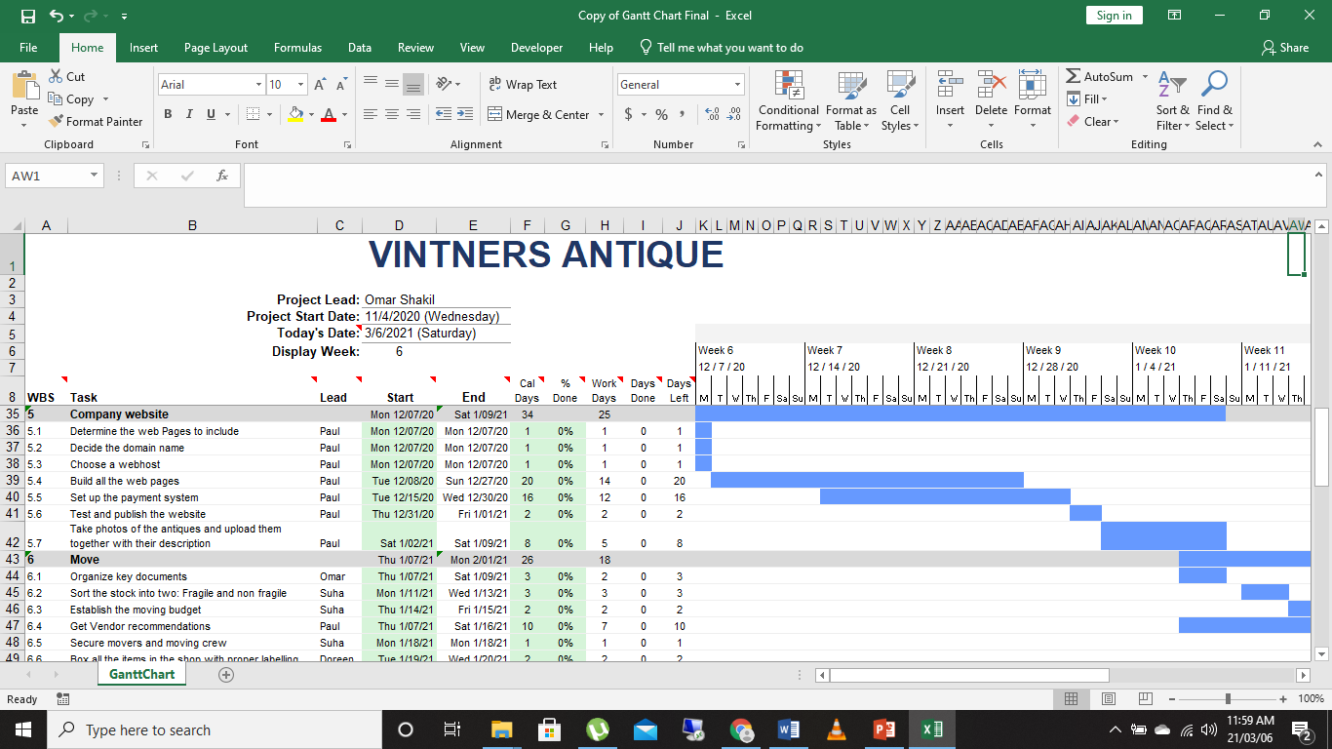

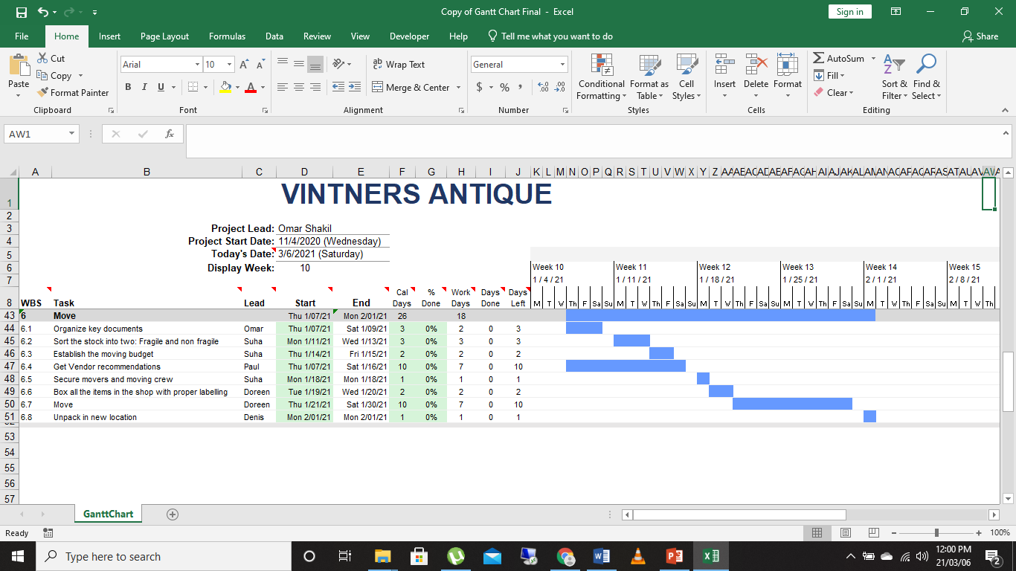

Appendix D: Tasks
Task | Lead | Start | End
Construction |  | Wed 11/04/20 | Thu 12/03/20
Segment the warehouse into the different rooms | Omar | Wed 11/04/20 | Fri 11/13/20
Install Electrical wires and sockets | Omar | Sat 11/14/20 | Tue 11/17/20
Install water pipes, water sinks and area | Omar | Wed 11/18/20 | Fri 11/20/20
Plastering | Omar | Sat 11/21/20 | Mon 11/23/20
Paint all the rooms in the warehouse | Omar | Tue 11/24/20 | Thu 11/26/20
Ceiling | Omar | Tue 11/24/20 | Thu 11/26/20
Lighting | Doreen | Mon 11/30/20 | Wed 12/02/20
Flooring | Doreen | Tue 12/01/20 | Thu 12/03/20
Repaint the outside warehouse walls. | Denis | Mon 11/30/20 | Wed 12/02/20
Office |  | Sun 12/13/20 | Thu 12/24/20
Carpeting | Denis | Thu 12/03/20 | Sat 12/12/20
Equip Furniture | Denis | Sun 12/13/20 | Mon 12/14/20
Fit cabinets and draws | Denis | Tue 12/15/20 | Thu 12/24/20
Install Telephone | Denis | Tue 12/15/20 | Tue 12/15/20
Install internet connection | Paul | Tue 12/15/20 | Wed 12/16/20
install computers and stationery | Denis | Tue 12/15/20 | Sat 12/19/20
Showroom |  | Sun 12/20/20 | Mon 1/04/21
Fit Labels for different equipment types | Suha | Sun 12/20/20 | Sun 12/20/20
Install lockable glass cabinets for small items | Omar | Tue 12/29/20 | Fri 1/01/21
Segment the canteen area | Omar | Sat 1/02/21 | Mon 1/04/21
Design and Install the nameboard | Suha | Sun 1/03/21 | Sun 1/03/21
Storage and Repair room |  | Mon 1/04/21 | Wed 1/06/21
Install hard flooring | Doreen | Mon 1/04/21 | Mon 1/04/21
Install Furniture | Doreen | Tue 1/05/21 | Tue 1/05/21
Install cabinets for storing smaller Antiques | Doreen | Wed 1/06/21 | Wed 1/06/21
Company website |  | Mon 12/07/20 | Sat 1/09/21
Determine the web Pages to include | Paul | Mon 12/07/20 | Mon 12/07/20
Decide the domain name | Paul | Mon 12/07/20 | Mon 12/07/20
Choose a webhost | Paul | Mon 12/07/20 | Mon 12/07/20
Build all the web pages | Paul | Tue 12/08/20 | Sun 12/27/20
Set up the payment system | Paul | Tue 12/15/20 | Wed 12/30/20
Test and publish the website | Paul | Thu 12/31/20 | Fri 1/01/21
Take photos of the antiques and upload them together with their description | Paul | Sat 1/02/21 | Sat 1/09/21
Move |  | Thu 1/07/21 | Mon 2/01/21
Organize key documents | Omar | Thu 1/07/21 | Sat 1/09/21
Sort the stock into two: Fragile and non fragile | Suha | Mon 1/11/21 | Wed 1/13/21
Establish the moving budget | Suha | Thu 1/14/21 | Fri 1/15/21
Get Vendor recommendations | Paul | Thu 1/07/21 | Sat 1/16/21
Secure movers and moving crew | Suha | Mon 1/18/21 | Mon 1/18/21
Box all the items in the shop with proper labelling | Doreen | Tue 1/19/21 | Wed 1/20/21
Move | Doreen | Thu 1/21/21 | Sat 1/30/21
Unpack in new location | Denis | Mon 2/01/21 | Mon 2/01/21

