Electronics I Traffic Light crossroad.

The task set was to build a traffic light control system that is situated on a crossroads, that included a parallel green light and opposite parallel red lights. I have modelled this idea on a busy financial district city centre, where there would be more pedestrians than vehicles using the crossing so that the pedestrian flow would enable the workplace to proceed in their daily lives with minimum amount of fuss. This model I believe to work the best for maximum pedestrian and vehicle flow. The following video [1] was filmed in Tokyo in Japan, I based my traffic light control system around this model, and I have converted it to UK government regulations.
After doing some background reading, I found out that the city of Edinburgh had answered a query from a member of the general public on traffic light timings, (forum in [2]. The city of Edinburgh had quoted the UK legislation [3] which reads “when going from a green signal to a red signal, amber is fixed at three seconds. When going from red to green, amber is fixed at 2 seconds. It was important that I researched this, to ensure my traffic light system conforms to UK standards.
This system has been designed for uk city centre traffic, but could easily be adapted to low income countries with poorer traffic and pedestrian infrastructure that is not up to the needs of today’s society.
In the uk traffic light signals are in the order of illumination
a: red: which conveys the prohibition that vehicular traffic must not stop beyond the stop line.
b: red and amber together: which conveys an impending change to green but conveys the prohibition as the red signal.
c: green: which conveys that vehicular traffic may proceed beyond the stop line straight on left or right.
d: amber: which conveys the same prohibition as red except any vehicle close to the stop line that cannot stop safely would convey the same indication as green.
The pedestrian lights are red and green illuminated lights incorporated into a sign at the pedestrian crossing.
The significance of the red signal when illuminated is that pedestrians should not use the crossing.
The significance of the green signal when illuminated is that pedestrians may use the crossing.

Aims
In my scenario, state 1 would see east/west traffic lights on green and north/south on red and all pedestrian crossing on red, cars going straight over or left would proceed as normal and vehicles wanting to turn right would proceed into a central lane and give way until opposite carriageway is clear.
State 2 would start with red light on east/west route to give time for vehicles waiting to turn right, then north/south traffic lights would turn green , following same sequence as state 1, when all traffic lights have turned to red and vehicles turning right have proceeded , the next task(state 3) would be to check for operation of the pedestrian crossing, if one of eight buttons has been activated all pedestrian crossing lights will turn to green and pedestrians could proceed to cross, giving them plenty of time to reach their destination , bearing in mind because of the locality there are likely to be more pedestrians than vehicles. After x amount of time which will be guided by a visible countdown timer on each crossing all pedestrian lights will return to red, which would then go back to state 1 and start the sequence again from state 1.
In state1 traffic density will be monitored by an ultrasonic sensor that will placed on the approaching traffic light, an ultrasonic sensor detects oncoming traffic by soundwaves, if no traffic is detected the sequence will move to state 2 (north/south traffic) and the next ultrasonic sensor will operate and turn traffic lights to green , if no detection on that route the system will move on to state 3 and check to see whether the pedestrian button has been operated , if not all traffic and pedestrian lights will remain on red until either the traffic sensors detect movement or a pedestrian operates the button

Methods
[4] is a flow chart I produced to attempt to link the processes above and the code. To commence the flow chart I used a start block, this represents what would happen when the microprocessor is first turned on. The start block is linked to a data block that states “turn all four traffic and pedestrians lights to red”. I did this for two reasons.
1. It is crucial to make all lights red to prevent any accidents
2. I could later go back to this point in the chart, therefore making a never-ending cycle, which is very useful when the lights would be on all the time. The next couple of processes are allowing for the pedestrian to cross the crossing safely and displaying the time they have left to cross.
Once the pedestrian has crossed safely the task for the PIC is to determine whether there is a high or low density of traffic going east to west. In the scenario where a high density of traffic is present the sequence will turn the red light to a green light this will happen for both the east and west bound traffic. In the scenario where a low density traffic is present it will skip straight to the decision that determines the state of traffic going north to south.
Once the traffic going east to west had seen a green light for 15 seconds, the traffic density going north and south is checked. If it is determined that there is a high density of traffic waiting to use the crossing, the sequence will turn the lights of the traffic going east to west to red, then subsequently turning north to south traffic lights to green. When a low density of traffic is present it jumps to the decision block responsible for checking the button.
If the button is pressed, then one of two things will happen either the lanes going east to west lights will turn to red or the lanes going north to south will change to red, either way the process after that is to turn all lights to red starting the whole process again. If it is determined that the button wasn’t pressed, it will then see if traffic going east and west has a high density of vehicles waiting. When a high density of vehicles are waiting, lights going north and south turn red and lights going east and west will turn to green. If it is found that a low density of vehicles are there, it jumps back to see if the button was pressed
Following my research into the task, I designed a circuit as shown in [5]. I have used a PIC microprocessor PIC16F877A, the reason I chose this PIC was due to the number of pins, having a total of 40 pins allowed me to ensure I would only use one microprocessor and not having to link some together. The reason I used one was due to ease, as linking microprocessors and making them communicate correctly can be problematic and isn’t required for the task.
To simulate a traffic control system on a crossroads I made four sections identical circuits. On each section I placed two push button one for each crossing entrance. I linked all eight buttons together to make one input to be read by the microprocessor, this means they will work simultaneously, so that when one the buttons is pushed all traffic lights start their sequence to turn red to stop the traffic and all the pedestrian lights will the turn to green. To show the pedestrians the time they would have to cross, I have used two seven segment displays, I could have used four sets of two pairs of seven segment displays but due to how the pedestrian crossing has been designed it only needs one set as it would all display the same information.
[6] is a website where Jeremy describes how an ultrasonic senor works and how to integrate it into Arduinos. Although I am not using an Arduino this was still useful for this project, this is because PICs are very similar, giving me some extra knowledge which I could use. Figure 6 also helped me understand how ultrasonic sensors work and there main application in robotic navigation and under water range finder, this was useful because it allows me to understand that ultrasonic sensors are very good at finding distances, so I could calculate the density by determining how far way the last car was to the lights, thus giving how many cars would be there by using the average length of a car.
I have included four ultra-sensors that would be placed on each approaching carriageway traffic lights, this would detect approaching cars to use the crossroads in a timely manner. The traffic lights are situated at the entrance of the crossroad of each carriageway.
To make the push button trigger, it will register only once no matter how many times it is pressed, I used a D-Type flip flop. I made it so that when the button is pressed both the set and clock get triggered, this means that the out Q is set to at all times, until it D-type is reset. I added a LED to the output to simulate a light on the button to show users it has been pressed. To reset I used the pedestrian green light output to reset the D-type.
To begin coding I needed to set up some integer, which allows me to store the values of the ultrasonic sensors analogue output used later, to determine which way the traffic will flow based on the density of traffic waiting for the light to change. Next in line was the subroutine “main” this is used to make a0 to a3 analogue inputs used to read the ultrasonic sensor.
Buttonpress is the subroutine involved in making the pedestrian light turn from red to green and is also used to reset the buttons d-type. Buttonpress is also involved in showing a 15 second timer to the pedestrian to ensure they cross safely. GETWG (going east to west green) controls the traffic light and makes it turn green following the UK legislation, then waiting 35 seconds before doing the next process. GETWR (going east to west red) is the opposite of GETWG as it turns the light from red to green in both east and west directions. GNTSG (going north to south green), this will turn the lights for traffic going north and south green. GNTSR (going north to south red), this is the last of the changing lights subroutine and makes north and south bound traffic lights turn red.
WGF () this is the main body of the traffic light control system and is responsible from determining which traffic pair is let go first. It does this by adding the total of north and south and the total of east and west together, then letting through whoever has the highest total of traffic. If more cars are going west and east than north and south then the code runs the subroutine p1 this uses GETWG to turn the green light on going east and west. It then tests to see if there is any traffic going north and south, if there is then p4 is used which swaps the light of green to red and red to green, if no traffic is present then it checks the buttons status. If more cars are going north and south than east and west the opposite happens, p2 is used and traffic going north and south are let out whist east and west have to wait, its done by using GNTSG turning the light green. Once again after 35 seconds it looks to see how much traffic is in the other lanes if there is any, it is let go before the button status is checked. In the unlikely event of both having the same amount of traffic then east and west lights will go green first.
BC (button check) is used to see if the button was pressed. This is done by checking bit 4 of register A, if the button was pressed it will be high and if no one had pressed it, A4 will be low. When A4 is low the code will run the subroutine WGF. If A4 is high then a process to see which green light is on. Once found the system will, subsequently turn it to red and then proceed to the buttonpressed operation.
I differed from my flow chart whist writing the code because I felt like it was more practical to write subroutines rather than have it all repeat every time I wanted to do a same task, this not only saves a few lines but also allowed me to understand and work my code correctly. When writing the countdown display timers code there was a better way of doing it by setting a variable to 15, printing it, wait 1 second then dropping the value by 1 and repeating the process until it reaches 0. I didn’t produce my code this way because I felt like it was harder to understand and I didn’t think I would change the time they had to cross at any point so didn’t need to make it complicated.

Results
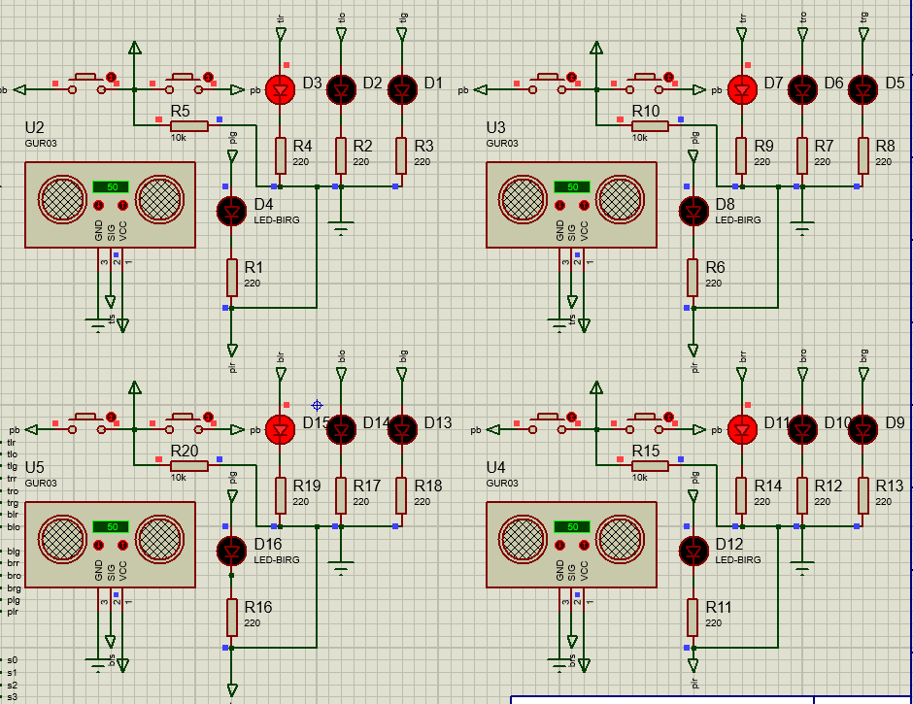
[7]
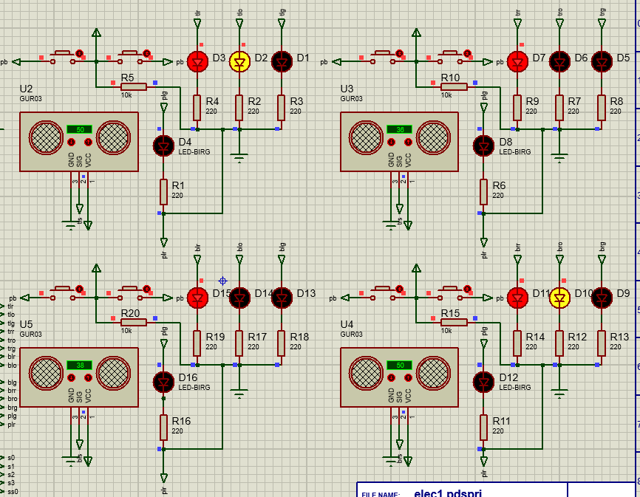
[8]
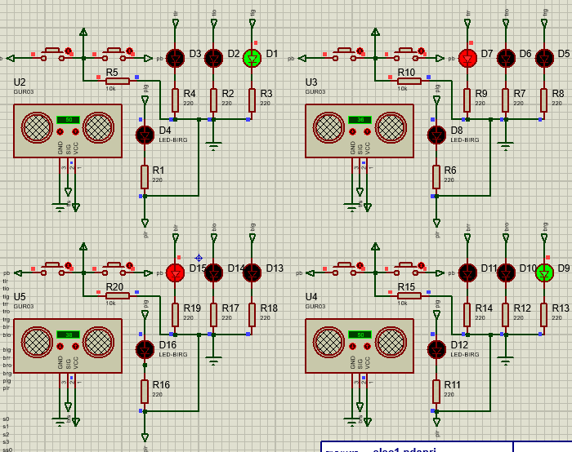
[9]
[10]
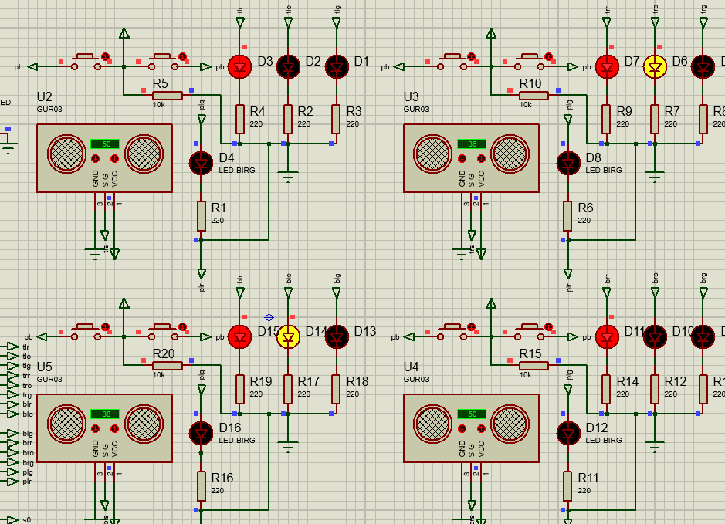
[11]
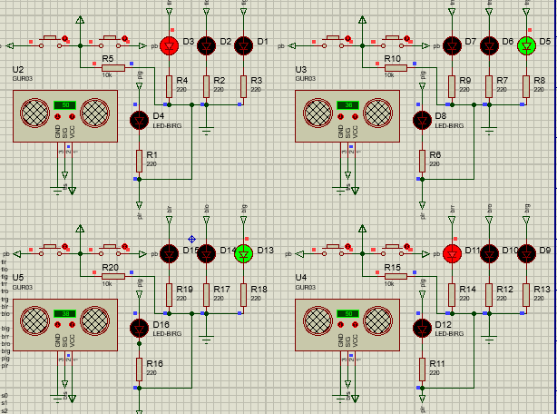
[12]
To test my code I thought of a few scenarios and tested to see whether my code would work correctly and give the correct output. Scenario 1. More traffic going east bound than both north and south. In this example after the pedestrian light turns red, the east and west traffic lights should follow the sequence and turn green shown in [7,8,9], this was successful, the light changed colour and after 35 seconds it swapped to red and let the north south traffic through the crossing. Scenario 2. If there is more north traffic than east, in this example the traffic lights should turn green for the both north and south lanes, this was successful as seen in [10,11,12] and traffic flow happened in the way previously described. The last scenario is where the button was never pressed, in this case then traffic would flow by each side being let though the crossing in a timely manner. Again my code proved successful as the button was never pushed, the pedestrian section of the sequence was not activated.

conclusions
My Conclusion to this project is ultrasonic sensors in a traffic light control system is unique. Although in some scenarios it is great, i think for a crossroads it doesn’t work. My reason for my belief is when people drive routes they know well, they know the traffic pattern and know which light will turn green next. I believe this is better because it allows the user to see how long until their light is green making people more prepared. However, where a road narrows and traffic lights are required for pedestrians to pass safely it would be a better system than the current PIR setups.
[1] The famous Shibuya crossing - 90 seconds (2017) YouTube. Available at: https://www.youtube.com/watch?v=Od6EeCWytZo (Accessed: April 28, 2023).
[2] City of Edinburgh Council (2018) Traffic light timing sequence and calibration,maintenace of Traffic Signal Edinburgh - A Freedom of Information request to City of Edinburgh Council, WhatDoTheyKnow. Available at: https://www.whatdotheyknow.com/request/traffic_light_timing_sequence_an (Accessed: April 28, 2023).
[3] (2019) Traffic signs manual chapter 6 traffic control (2019). tech. Available at: https://assets.publishing.service.gov.uk/government/uploads/system/uploads/attachment_data/file/851465/dft-traffic-signs-manual-chapter-6.pdf (Accessed: April 28, 2023).
[4] flowchart
[5] circuit desgin
[6] Cook Jeremy S. (2022) All about Ultrasonic Sensors & how they work with Arduino, Arrow.com. Available at: https://www.arrow.com/en/research-and-events/articles/ultrasonic-sensors-how-they-work-and-how-to-use-them-with-arduino (Accessed: April 28, 2023).
[7]-[12] circuit running.
Code
#include <main.h>
unsigned int blstn=0;
unsigned int tlwte=0;
unsigned int trnts=0;
unsigned int bretw=0;
unsigned int cgwe=0;
unsigned int cgns=0;
unsigned int analog(int);

void main()
{

setup_adc_ports(AN0_AN1_AN2_AN3_AN4);
setup_adc(ADC_CLOCK_INTERNAL);
}
void p1()
{
goto getwg
if((cgns > 0)) p4;
goto bc
}
void p2()
{
goto gntsg
if((cgwe >0)) p5;
goto bc
}
void p3()
{
goto getwg
goto getwr
goto gntsg
goto bc
void p4()
}
goto getwr
delay_ms(2000);
goto gntsg
goto bc
}
void p5()
{
goto gntsr
delay_ms(2000);
goto getwg
}
void bc()
{
if((outpt_high(pin_A1))) cs;
goto wgf()
}
void cs()
{
if((output_high(pin_B2))) ns;
if((output_high(pin_B5))) ew;
}

void ns()
{
goto gntsr
goto buttonpress
goto wgf
}
void ew()
{
goto getwr
goto buttonpress
goto wgf
}
unsigned int analog(int chan)
{
set_adc_channel(chan);
delay_us(30);
return(read_adc());
}
void buttonpress(void)
{
output_b(0x01001001);
output_c(0x00100010);
delay_ms(2000);
output_c(0x00010010);
output_d(0x00010101);
delay_ms(1000);
output_d(0x00010100);
delay_ms(1000);
output_d(0x00010011);
delay_ms(1000);
output_d(0x00010010);
delay_ms(1000);
output_d(0x00010001);
delay_ms(1000);
output_d(0x00010000);
delay_ms(1000);
output_d(0x00001001);
delay_ms(1000);
output_d(0x00001000);
delay_ms(1000);
output_d(0x00000111);
delay_ms(1000);
output_d(0x00000110);
delay_ms(1000);
output_d(0x00000101);
delay_ms(1000);
output_d(0x00000100);
delay_ms(1000);
output_d(0x00000011);
delay_ms(1000);
output_d(0x00000010);
delay_ms(1000);
output_d(0x00000001);
delay_ms(1000);
output_d(0x00000000);
output_c(0x00100010);
delay_ms(2000);
}
void getwg()
{
output_c(0x00100110); //amber on
output_b(0x01011001);
delay_ms(2000);
output_c(0x00101000); // amber and red off green on
output_b(0x01100001);
delay_ms(35000);
}
void getwr()
{
output_c(0x00100110); // green off amber on
output_b(0x01011001);
delay_ms(3000)
output_c(0x00100110); // amber off red on
output_b(0x01011001);
}

void gntsg()
{
output_c(0x00100110); //amber on
output_b(0x01011001);
delay_ms(2000);
output_c(0x00101000); //green on abmer and red off
output_b(0x01100001);
delay_ms(35000);
}
void gntsr()
{
output_c(0x00100110); // green off amber on
output_b(0x01011001);
delay_ms(3000)
output_c(0x00100110); // amber off red on
output_b(0x01011001);
}

void wgf()
{
blstn=analog(0);
tlwte=analog(1);
trnts=analog(2);
bretw=analog(3);
cgwe=tlwte+bretw
cgns=trnts+blstn
if((cgwe > cgns)) p1; //if more cars are going west and east than north and south
if((cgwe < cgns)) p2; //if more cars are going norht and south than east and west
if((cgwe = cgns)) p3; //if more cars are going west and east than north and south
}

