Uses of Music in Games

Music is a powerful creative tool for games that can be used in many ways. This exhibition will help demonstratethe numerous ways music can influence the players experience in games giving them a more interesting and fulfilling experience. I will be going into how it can be used to create ambiance or set the mood for certain events as well as how it can be used as a mechanic in games.

Music is often used in games traditionally as a mood setter tapping in to one of the players most dominant senses to try and engage them with the narrative and theme of the games.
Zelda is a game franchise that is notorious for its sound in games and has used music in many ways over the years. Each of the Zelda games has had their own theme of music as stated in Mark Browns The music of Breath of the Wild video where he points out that “Ocarina of Time is heroic, Wind Waker is optimistic and Majora’s Mask is foreboding”. I think it is especially interesting to point out the differences music makes between ‘Ocarina of time’ and ‘Majora’s Mask’ since these games share a lot of the same assets but despite this they feel distinctly different.
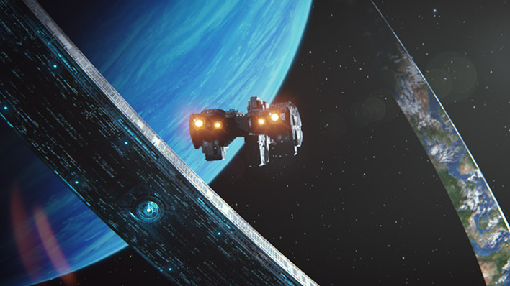
Another notable game would be ‘Halo’ which despite being a futuristic shooter uses a traditional orchestral and almost angelic soundtrack. This gives the game a very distinct feeling from any of its competitors while also making the player feel the vast emptiness of space and the weight of the universe on their shoulders as they embark on their quest to save it.
Then there are games such as ‘Metal Gear Rising’ that use music that use music to empower the player and create dramatic tension. It can also lead to more cinematic experiences. ‘Doom’ also does this by using tense rock music in fight to create a sense of urgency which encourages the player to be as mobile as possible as more and more enemies are thrown the players way forcing them to adapt as they battle their way though each encounter.

Games can also use music mechanically as a tool for the player to use. It can be used in a verity of different ways as tools for the players.
Some of the most popular games use music as their core mechanic. These games are generally rhythm based meaning that players must hit certain imputes in relation to they are given. One of the most popular rhythm based games in band hero. These types of games are often score based and players are giving more points for pressing the imputes at the right times which also give the games a competitive aspect.
Band hero is an interesting game in which players using purpose built controllers pretend to be and band and play songs. This also allows players to fulfil their fantasies of playing in a band. The simplistic style of this game allows for wide accessibility so practically anyone can play it making it an excellent party game. Players generally have a choice between guitarist, bass, drummer and singer and have to play their respective instruments in time with the music based on the prompts given on screen as well as cooperate to try and complete the song.
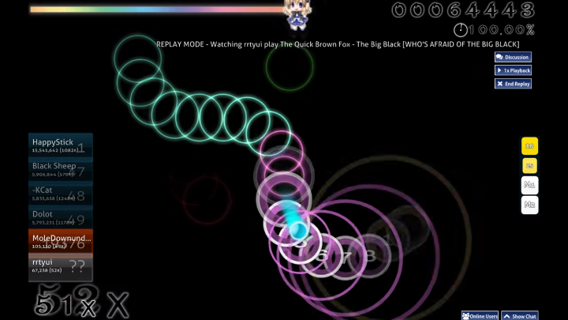
Another popular rhythm based game is OSU! a highly popular game that is community driven meaning that a lot of it’s content is actually made by other players. Unlike band hero which requires players to simply have good timing OSU! requires players to have fast response times and tracking skills. It in only available on PC since controllers lack the precision to be able to keep up with this oven very fast pace game that often gives the player a mere second to see where they have to move their curser meaning that they have to move pretty much on instinct. Like Band Hero this game is also driven by high scores as players challenge each other not only to their favourite songs but to their personal “mapping” of it meaning that players create the paths that each other will need to follower. This can lead to some incredibly complex maps that require almost inhuman reactions in order to complete.
Some games try to use games a bit more creatively and blend it with other genres such as shooters for example. Warframe has a character called Octavia whose abilities revolve around music to create “a concert of musical mayhem”. She has four unique abilities that each represent a different aspect of music being percussion, bass, melody and volume respectively. Players are also given the ability to customise their music which changes the way that Octavia’s abilities work and gives the player a more personal experience with the character. Her first ability ‘Mallet’ absorbs enemy damage and redistributes it back to the enemies based on the players custom music making her potentially one of the most powerful characters in the game.
One of the first instances of using music mechanically is the bard class from Dungeons and Dragons a make belief board game that relies heavily on the players imagination their scenarios. “In the worlds of D&D, words and music are not just vibrations of air, but vocalisations with power all of their own.” (D&D players handbook) The bard is generally a class that is design to support the other players by giving the players helpful boosts or confusing the enemy however due to Dungeons and Dragons very open gameplay it is entirely up to the player how they want to use the power of music to play the game.
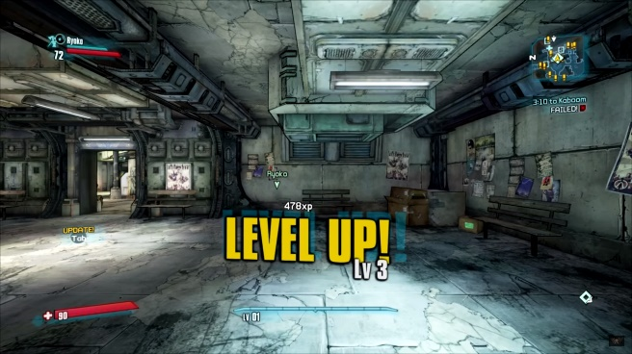
Games can also use sound to reward or encourage players. This is often done by playing a certain choon when a player does something or achieves something. Borderlands does this both visuals and audibly by having a ‘ding’ sound each time a player levels up in the game which although being minor feels rewarding. This ‘ding’ is also heard by other players which can create a bit more comradery between players since it also prompts congratulations from other players which again furthers the sense of achievement

Sound in general plays an important part in games one instances in particular being that a blind man by the name of Paul Liotta was able to complete the 3D game The Legend of Zelda: Ocarina of Time. Although it took five years to complete the game I believe that this shows off the true strength of sound design where a player was able to navigate a full 3D environment with a single one of his five senses.

Bibliography

343 Industries. Halo Waypoint. https://www.halowaypoint.com/en-us/universe/locations (Accessed 23 April 2018)
Mark Brown. (2017) The music of Breath of the Wild | GMTK Extra https://www.youtube.com/watch?v=3FWVKu1gnWs&ab_channel=MarkBrown (Accessed 23 April 2018)

Digital Extremes. (2017) Warfrme Profile: Octavia. https://www.youtube.com/watch?v=v2kzd1OCHXw&ab_channel=PlayWarframe (Accessed 23 April 2018)

Mole Downunder. (2014) [OSU!] MOST INSANE PLAY IN THE WORLD! 100% ACCURACY The Quick Brown Fox - The Big Black. https://www.youtube.com/watch?v=p3cWTxvyKpA&ab_channel=MoleDownunder (accessed 29 April 2018)

Wizards of the Coast. (2014) Dungeons & Dragons Player's Handbook page 51

Paul Liotta. (2016) Blind man uses sound to beat 'The Legend of Zelda: Ocarina of Time http://www.nydailynews.com/news/national/blind-man-beats-legend-zelda-ocarina-time-article-1.2485783 (Accessed 23 April 2018)

