Module Name: International Meetings Management for the Hotel Industry

Module code: BMIH6007

Student Name: Sylvester Egbueri

Student ID: 1714548

Table of Contents
Introduction 3
Market factors 4
Market factors (Cont’d) 5
Market factors (Cont’d) 6
Operational factors 7
Financial factors 8
SWOT 11
SWOT (Cont’d) 12
PESTLE 13
PESTLE (Cont’d) 14
PESTLE (Cont’d) 15
Conclusion 16
References 17

Introduction
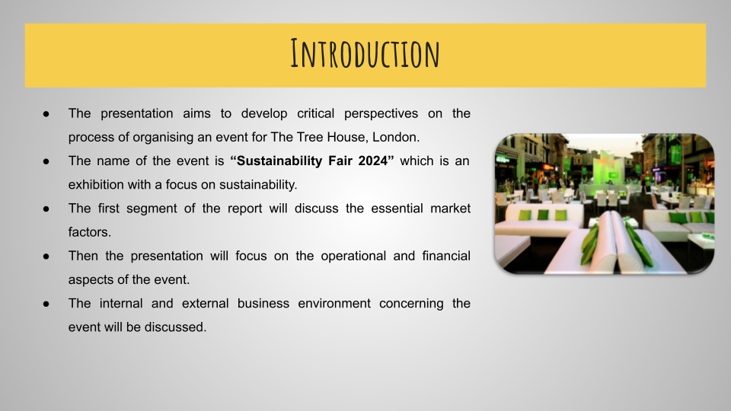
The presentation aims to develop critical perspectives on the process of organising an event for a hospitality company. The name of the event is “Sustainability Fair 2024”. The role of the event planner for the Tree House, London is assumed and a feasibility study ahead of a prospective event taking place will be explained. The first segment of the report will discuss the essential market factors. Then the presentation will focus on the operational and financial aspects of the event where the focus will be kept on operating efficiency and effective budgeting. Further, the internal and external business environment with respect to the event will be discussed.

Market factors
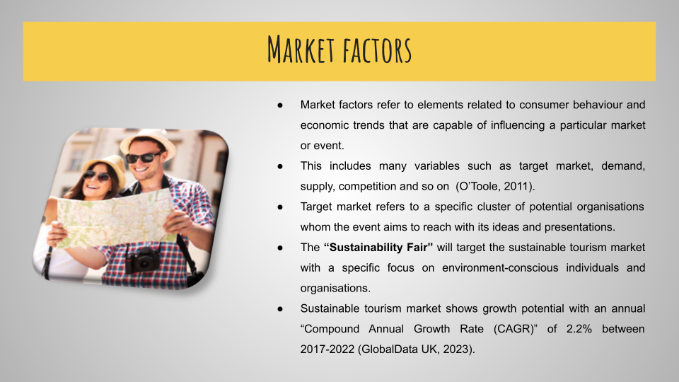
Market factors refer to elements related to consumer behaviour and economic trends that are capable of influencing a particular market or event. This includes many variables such as target market, demand, supply, competition and so on. It is important to properly evaluate the market factors that impact a market or event such as the “Sustainability Fair 2024”, as it aids in making better-informed business decisions (O’Toole, 2011).
Target market
Target market refers to a specific cluster of potential organisations whom the event aims to reach with its ideas and presentations. The “Sustainability Fair” will target the sustainable tourism market with a specific focus on environment-conscious individuals and eco-friendly organisations. In the UK, the sustainable tourism market is expanding and will have $9.0 billion in revenues in 2022. Apart from that it shows growth potential with an annual “Compound Annual Growth Rate (CAGR)” of 2.2% between 2017-2022 (GlobalData UK, 2023).

Market factors (Cont’d)
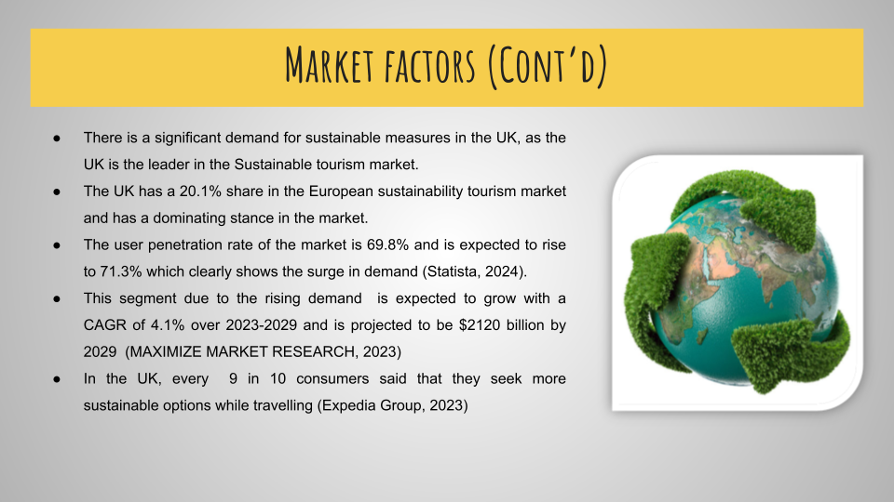
Demand
The UK is the leader in the Sustainable tourism market. The UK has a 20.1% share in the European sustainability tourism market and has a dominating stance in the market. The user penetration in the travel and tourism market is 69.3% in 2024 and is expected to rise to 71.3% by 2028, which clearly shows the surge in demand (Statista, 2024). Apart from that the Global Event tourism market is valued at $1600 billion in 2022, which is expected to grow with a CAGR of 4.1% over 2023-2029 and is projected to be $2120 billion by 2029 (MAXIMIZE MARKET RESEARCH, 2023). Market surveys also show an increase in travellers' interest in sustainable tourism options. Travellers around the world are now more conscious and interested in visiting historical sites, using eco-friendly transportation, and travelling to less-known destinations. 9 in 10 consumers said that they seek more sustainable options while travelling (Expedia Group, 2023)

Market factors (Cont’d)
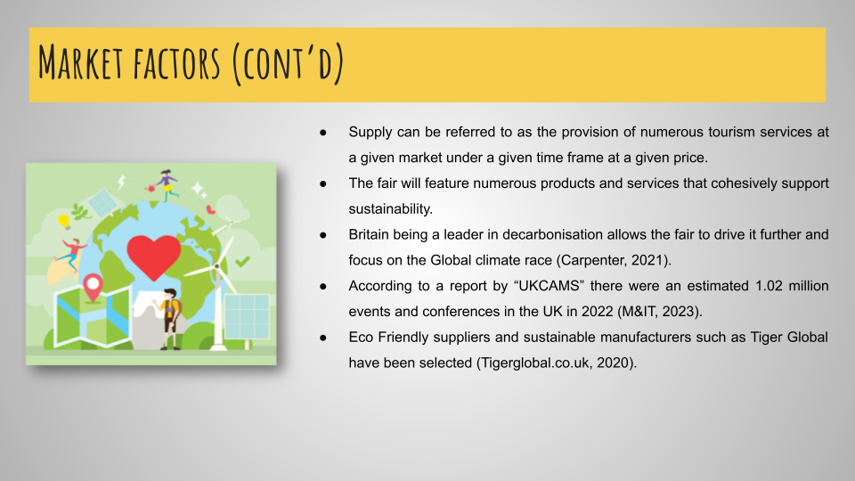
Supply
Supply in the tourism sector can be referred to as the provision of numerous tourism goods and services at a given market under a given time frame at a given price. The fair will feature numerous products and services that cohesively support sustainability. The UK being a potential leader in sustainable supply chains will be a big aid for the sustainability Fair. As Britain is a leader in decarbonisation, it allows the fair to drive it further and focus on the Global climate race (Carpenter, 2021). Further, the fair will also feature sustainable products which will include suppliers of sustainable travel merchandising and packaging options which is possible with the help of global sustainable manufacturers such as Tiger Global (Tigerglobal.co.uk, 2020).
Competition
Competition in the travel events industry is relatively high. With an increasing number of event travellers and tourism events, event tourism is growing in the UK. According to a report by “UKCAMS” there were an estimated 1.02 million events and conferences in the UK in 2022. Which shows a substantial comeback from 2020 and 2021 (0.2 million and 0.44 million events respectively) (M&IT, 2023).

Operational factors
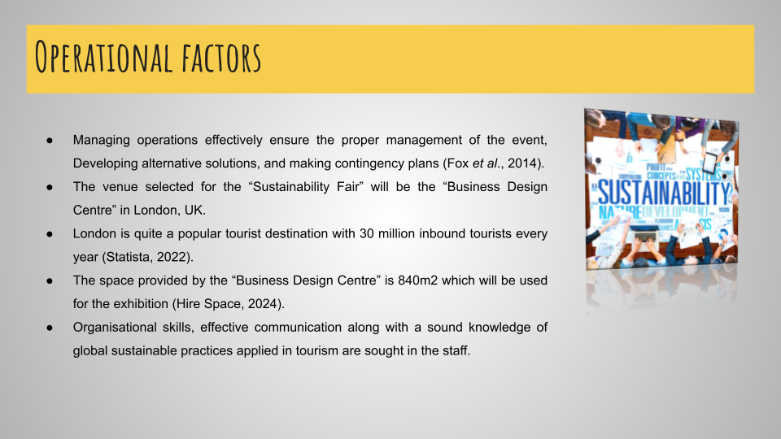
It is important to plan and manage events as it helps in analysing the budget properly, ensuring the proper management of the event, Developing alternative solutions, making contingency plans, and promoting the theme of the event (Fox et al., 2014).
The venue will be London, UK. The reason behind selecting this as the venue is that London is quite a popular tourist destination with 30 million inbound tourists every year (Statista, 2022). Apart from that London also accounts for receiving 40% of international tourist arrivals. The exact venue for the event will be the “Business Design Centre” which is spread over 840m² which will be used for the exhibition and has an additional 550m² for growing the event (Hire Space, 2024). The venue is suitable as it has ample space to accommodate exhibitions of products and can handle the influx of tourists. Organisational skills, Problem-solving, and effective communication along with a sound knowledge of global sustainable practices applied in tourism are sought in the staff handling the event. The other important resources that will be needed include parking facilities for the individuals who attend the fair. Seating facilities will be required as well to ensure the comfort of the individuals who wish to take part in dialogues and presentations. Lighting facilities are also important to ensure the proper display of the products being showcased. Apart from that an invitation will be sent to all of the major organisations in the UK who believe in sustainable practices, requesting their presence in the event.

Financial factors
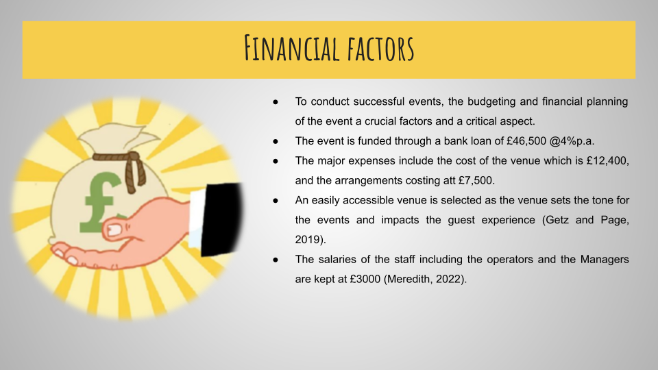
(B) Cash out-flows
Cash out-flows | Description (as required) | Values
Existing assets for event purposes | - | 0
Rent or premises cost | Business design centre | £12,400
Business rates for your business premises | Hotels and lodging for important guests | £2000
Utilities (gas, electricity, water) | Electricity and basic amenities | £1000
Accounting and legalities | Bookkeeping and permits | £1000
Telephone and internet | Internet services and tele support | £500
Marketing and advertising expenses | Website designing search optimisation and social media marketing | £3000
Vehicle running costs | Fuel, drivers | £5000
Equipment purchases or leasing | Seating, lightning, tents and catering | £7500
Postage, printing, stationery | Banners pamphlets, brochure and magazines | £3000
Transport and delivery | Renting Transport vehicles o receive guests | £6000
Professional fees (legal, accounting, etc.) | Permits and book-keeping | £1000
Loan monthly repayment – First Loan amount | EMI | £1000
Staff costs | Salaries of the staff | £3000
 | Total cash out-flows: | £46,400

(B) Cash in-flow
Cash in-flows | Description (as required) | Values
Total anticipated sales | Products and Services | £60,000
Value of your Start Up Loan | EMI | £1,000
Other sources of cash or equity | Merchandising | £10,000
 | Total cash in-flows: | £71,000

Net cash flow (A-B)
Total cash in-flows | Total cash out-flows | Net cash flow
£71,000 | £46,400 | £24,600

When it comes to conducting successful events, the budgeting and financial planning of the event a crucial factors and a critical aspect. Financial planning of an event lays the base for the given event, and it also makes sure that the entire event is planned accordingly and the resources are allotted efficiently. The event is funded through a bank loan of £46,500 @4%p.a. It is important to set clear goals and objectives to financially plan an event effectively, as it ensures the desired outcomes and resource allocation match. The major expenses in planning the “Sustainability Fair 2024” event are the expenses of the venue and the seating, catering and other arrangements. Extreme care is shown while selecting the venue and it is made sure a popular and easily accessible venue is selected as the venue sets the tone for the events and impacts the guest experience (Getz and Page, 2019). The total costs in selecting the venue fall at £12,400. The cost of the arrangements ranging from chairs and tables, catering, lighting and the cost of other equipment falls at £7500. It also ensured that the event stands to its theme and electrical vehicles were used in transporting the important guests the costs of vehicle rentals being at £6000 and the running expenses being at 5000 which includes the cost of charging and the salaries of the drivers. The salaries of staff which will include F&B associates, salespersons and managers are at £3000 (Meredith, 2022). For marketing websites are created and social optimisation of search engines and social media marketing is also strategically used which costs around 3000 in total. Basic amenities at the hall, lodging of the guests, basic internet and telephone services at the venue costs 3500. Accounting and legal aspects cost £1000 in total.

SWOT
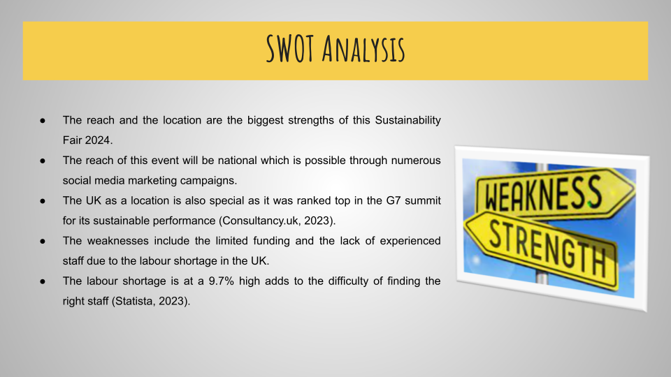
Strengths: The reach and the location are the biggest strengths of this event. The reach of this event will be national which is possible through numerous social media advertisement campaigns that will be used to promote “Sustainability Fair 2024”. The location of the event London, UK also gives it a positive base as London accounts for 40% of international tourists arriving in the UK. The UK as a location is also special as it was ranked top in the G7 summit for its sustainable performance (Consultancy.uk, 2023).
Weaknesses: In an experienced team, a limited budget is a major weakness. “Sustainability Fair 2024” being a one-of-a-kind fair that exhibits sustainable products along with business dialogues and presentations makes it hard to find the right and qualified staff. Apart from that the UK labour market condition, where the labour shortage is at a 9.7% high adds to the difficulty of finding the right staff (Statista, 2023). A limited budget limits the size and grandeur of the event.

SWOT (Cont’d)
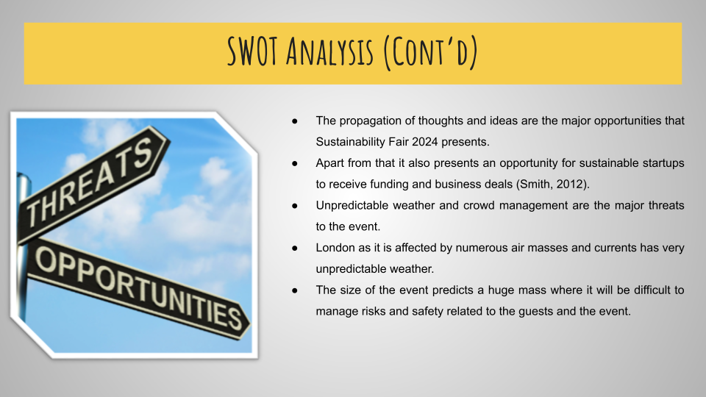
Opportunities: The propagation of thoughts and ideas are the major opportunities that this event presents. As this event is expected to receive a number of organisations and individuals it presents an opportunity to propagate the thoughts and concerns regarding sustainability. Apart from that it also presents an opportunity for sustainable startups to receive funding and business deals (Smith, 2012).
Threats: Unpredictable weather and crowd management are the major threats to the event. London has very unpredictable weather as it is influenced by several air masses and currents. Bad weather such as rain affects attendance as it affects the reachability of the destination. The size of the event predicts a huge mass where it will be difficult to manage risks and safety related to the guests and the event.

PESTLE
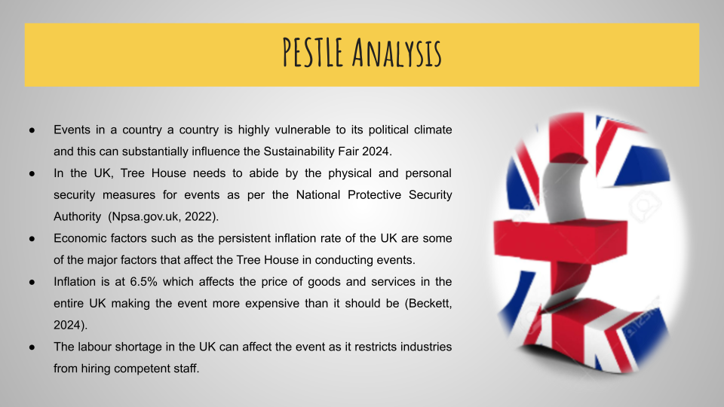
Political: Events in a country a country is highly vulnerable to its political climate. The events hosted by organisations can be influenced by government policies. In the UK, Tree House needs to abide by the physical and personal security measures for events as per the National Protective Security Authority. Agreement with protective security governance, roles and responsibilities is important for the Tree House to make this event a reality (Npsa.gov.uk, 2022).
Economic: Economic factors such as the persistent inflation rate of the UK are some of the major factors that affect the Tree House in conducting events. The core CPIH annual inflation was at 6.5% which affects the price of goods and services in the entire UK making the event more expensive than it should be (Beckett, 2024). The labour shortage in the UK is another economic event affecting the event as it prohibits industries from hiring competent staff.

PESTLE (Cont’d)
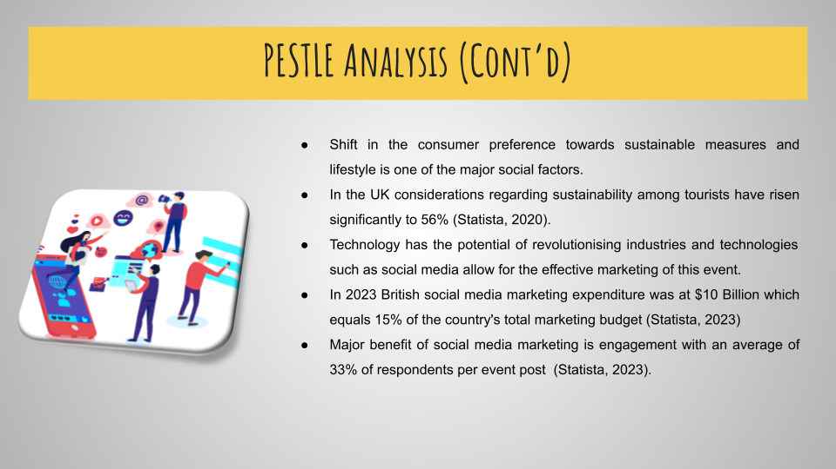
Social: The shift in the attitudes of consumers towards more sustainable options is a good thing that can potentially influence the success of the event. In the UK considerations regarding sustainability among tourists have risen significantly to 56% (Statista, 2020). This like-mindedness of individuals is a good thing as it projects positive attendance rates and success at the event.
Technological: Technology such as social media can positively affect the event. The reach of social media allows the Tree House to effectively market the event and ensure good engagement and awareness. In 2023 British social media marketing expenditure was at $10 Billion which equals 15% of the country's total marketing budget (Statista, 2023). Potential audience reach is the major benefit of social media marketing and engagement is another important feature a survey shows social media event advertisement receives 33% of respondents from the target audience (Statista, 2023).

PESTLE (Cont’d)
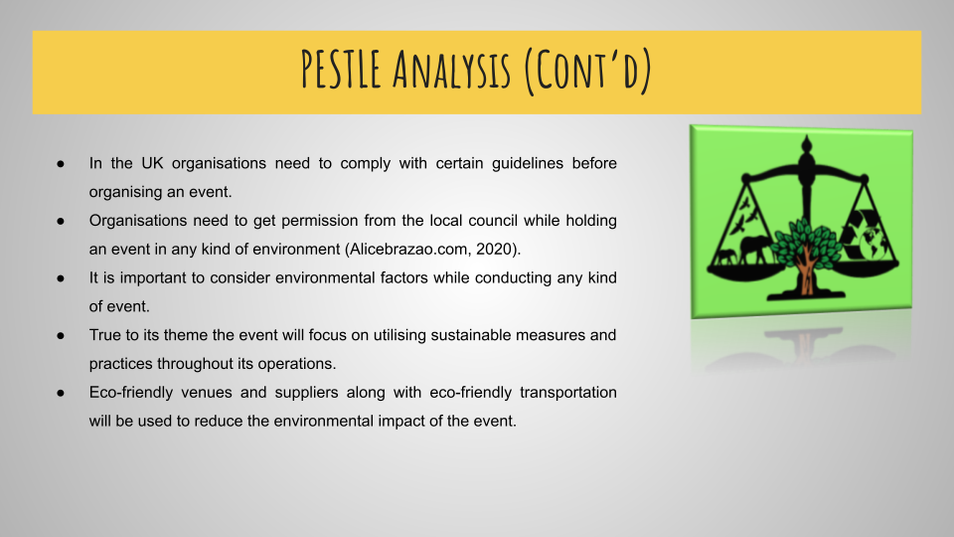
Legal: In the UK organisations need to comply with certain guidelines before organising an event. In the UK, organisations need to get permission from the local council while holding an event in any kind of environment (Alicebrazao.com, 2020).
Environmental: It is important to consider environmental factors while conducting any kind of event. Since the theme of the event is sustainability, the event will focus on sustainable practices while conducting the event. Measures such as serving organic and locally produced food, using eco-friendly venues and suppliers along with eco-friendly transportation will be used to reduce the environmental impact of the event.

Conclusion
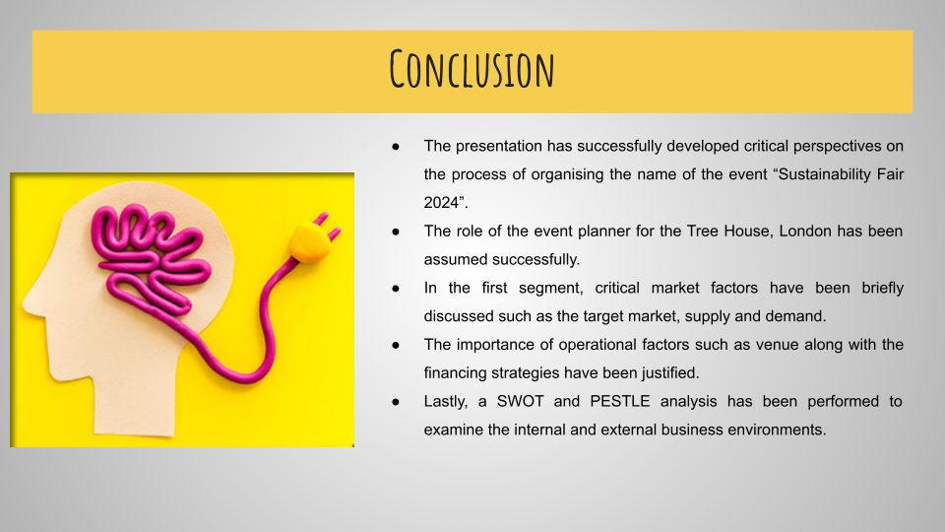
The presentation has successfully developed critical perspectives on the process of organising the name of the event “Sustainability Fair 2024”. The role of the event planner for the Tree House, London has been assumed successfully and the major aspects regarding the event have been justified accordingly. In the first segment, critical market factors have been briefly discussed such as the target market, supply and demand and the competition. The presentation was also justified. Operational factors such as the importance of the venue, the skills and staff required and the financial aspects of the event have been explored as well. Further, a Swot analysis is performed to assess the strengths, weaknesses, opportunities and threats with regard to the event. Lastly, a PESTLE analysis has been performed to assess the external factors that can potentially influence the event.

References
Alicebrazao.com. (2020). Government Policies for Public Space Events – Alice Brazão. [online] Available at: https://alicebrazao.com/government-policies-for-public-space-events/ [Accessed 29 Jan. 2024].
Beckett, D., (2024). Consumer price inflation, UK. [online] Ons.gov.uk. Available at: https://www.ons.gov.uk/economy/inflationandpriceindices/bulletins/consumerpriceinflation/december2023#:~:text=The%20core%20CPIH%20annual%20inflation,in%20the%20constructed%20historical%20series. [Accessed 29 Jan. 2024].
Carpenter, S., (2021). SAP BrandVoice: How The UK Can Lead The World In Sustainable Supply Chains. Forbes. [online] 12 May. Available at: https://www.forbes.com/sites/sap/2021/05/12/how-the-uk-can-lead-the-world-in-sustainable-supply-chains/?sh=6a62ab4455ad [Accessed 29 Jan. 2024].
Consultancy.uk (2023). UK ranks top out of G7 for sustainability in 2023. [online] Consultancy.uk. Available at: <https://www.consultancy.uk/news/36122/uk-ranks-top-out-of-g7-for-sustainability-in-2023#:~:text=The%20UK%20has%20been%20identified,in%20terms%20of%20sustainable%20performance.> [Accessed 29 Jan. 2024].
Expedia Group., (2023). Travelers’ interest in sustainable tourism options increases - Expedia Group Media Solutions. [online] Expedia Group Media Solutions. Available at: <https://advertising.expedia.com/blog/sustainability/sustainable-tourism-demand-rises/> [Accessed 29 Jan. 2024].
Fox, D., Gouthro, M.B., Morakabati, Y. and Brackstone, J., (2014). Doing events research: From theory to practice. Routledge.
Getz, D. and Page, S. (2019) Event studies: theory, research and policy for planned events. 3rd Edition. Routledge: Oxford.
GlobalData UK., (2023). United Kingdom (UK) Sustainable Tourism Market Summary, Competitive Analysis and Forecast to 2027. [online] Market Research Reports & Consulting | GlobalData UK Ltd. Available at: <https://www.globaldata.com/store/report/uk-sustainable-tourism-market-analysis/#:~:text=%E2%80%93%20The%20UK%20sustainable%20tourism%20market,2.2%25%20between%202017%20and%202022.> [Accessed 29 Jan. 2024].
Hire Space. (2024). Gallery Hall/Atrium at Business Design Centre. [online] Available at: https://hirespace.com/Spaces/London/96313/Business-Design-Centre/Gallery-Hall-Atrium/Business [Accessed 29 Jan. 2024].
M&IT., (2023). UK events topped 1m in 2022 as sector bounces back. [online] Mitmagazine.co.uk. Available at: https://mitmagazine.co.uk/Meetings/UK-events-topped-1m-in-2022-as-sector-bounces-back#:~:text=The%20UKCAMS%20report%20shows%20that,and%200.44%20million%20events%20respectively). [Accessed 29 Jan. 2024].
MAXIMIZE MARKET RESEARCH., (2023). Tourism Event Market: Travel and tourism industry to boost the market growth. [online] Available at: <https://www.maximizemarketresearch.com/market-report/tourism-event-market/214462/#:~:text=Tourism%20Event%20Market%3A%20Travel%20and%20tourism%20industry%20to%20boost%20the%20market%20growth&text=Global%20Tourism%20Event%20Market%20size,period%20(2023%2D2029).> [Accessed 29 Jan. 2024].
Meredith, J., (2022). Project management: a managerial approach
Npsa.gov.uk. (2022). National Protective Security Authority. [online] Available at: https://www.npsa.gov.uk/protection-major-events-0 [Accessed 29 Jan. 2024].
O’Toole, W., (2011). Events feasibility and development: from strategy to operations. Elsevier: Oxford
Smith, A., (2012). Events and urban regeneration: the strategic use of events to revitalise cities. Routledge: Oxford
Statista. (2020). Tourism sustainability concern by age UK 2020 | Statista. [online] Available at: https://www.statista.com/statistics/1135568/uk-tourism-sustainability-concern-by-age/ [Accessed 29 Jan. 2024].
Statista. (2022). Inbound tourist visits to London 2022 | Statista. [online] Available at: https://www.statista.com/statistics/487467/overseas-visits-to-london-united-kingdom/ [Accessed 29 Jan. 2024].
Statista. (2023). Topic: Social media advertising and marketing in Europe. [online] Available at: https://www.statista.com/topics/9005/social-media-advertising-and-marketing-in-europe/#topicOverview [Accessed 29 Jan. 2024].
Statista. (2023). Top reasons marketers invested in new social media 2023 | Statista. [online] Available at: https://www.statista.com/statistics/1372281/top-reasons-marketers-invest-new-social-media-platforms/ [Accessed 29 Jan. 2024].
Statista. (2023). UK worker shortages 2023 | Statista. [online] Available at: <https://www.statista.com/statistics/1369207/uk-worker-shortage/#:~:text=Percentage%20of%20businesses%20experiencing%20a%20worker%20shortage%20in%20the%20UK%202021%2D2023&text=As%20of%20October%202023%2C%20approximately,14.9%20percent%20in%20October%202022.> [Accessed 29 Jan. 2024].
Statista. (2024). Travel & Tourism - UK | Statista Market Forecast. [online] Available at: https://www.statista.com/outlook/mmo/travel-tourism/united-kingdom [Accessed 29 Jan. 2024].
Tigerglobal.co.uk. (2020). Sustainable Product Manufacturing UK | Sustainable Merchandise UK - Tiger Global. [online] Available at: https://tigerglobal.co.uk/our-work/sustainable-product-manufacturing [Accessed 29 Jan. 2024].

‌

‌

‌

‌

‌

‌

‌

