

LCBB4014

Introduction to Business

Student Name:
Student ID:

Table of Contents
Slide 1: Cover Page 3
Slide 2: Table of Contents 3
Slide 3: Company Overview 4
Slide 4: SWOT Analysis - Strength 5
Slide 5: SWOT Analysis - Weaknesses 6
Slide 6: SWOT Analysis - Opportunities 7
Slide 7: SWOT Analysis – Threats 8
Slide 8: PEST Analysis - Political Factors 9
Slide 9: PEST Analysis - Economic Factors 10
Slide 10: PEST Analysis - Social Factors 11
Slide 11: PEST Analysis - Technological Factors 12
Slide 12: Impact of Globalisation - Market Expansion 13
Slide 13: Impact of Globalisation - Workforce & Culture 14
Slide 14: Impact of Globalisation - Supply Chains 15
Slide 15: Influence of Innovation - Product Innovation 16
Slide 16: Influence of Innovation - Business Model Innovation 17
Slide 17: Influence of Innovation - Sustainability 18
Slide 18: Recommendations 19
Slide19: Conclusion 20
Slide 20: References 21

Slide 1: Cover Page
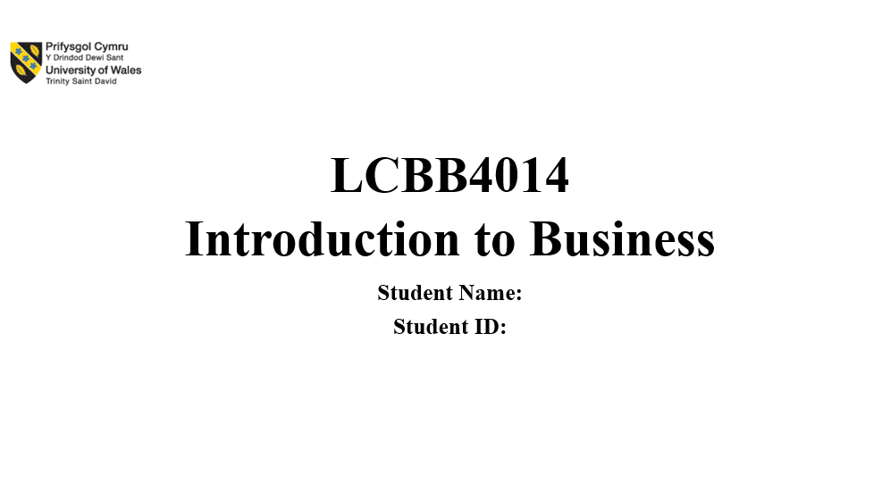

Slide 2: Table of Contents
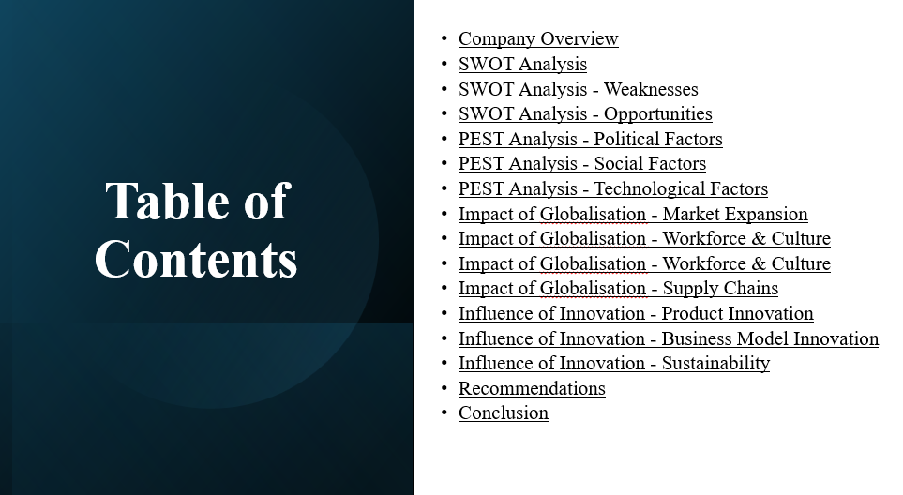

Slide 3: Company Overview
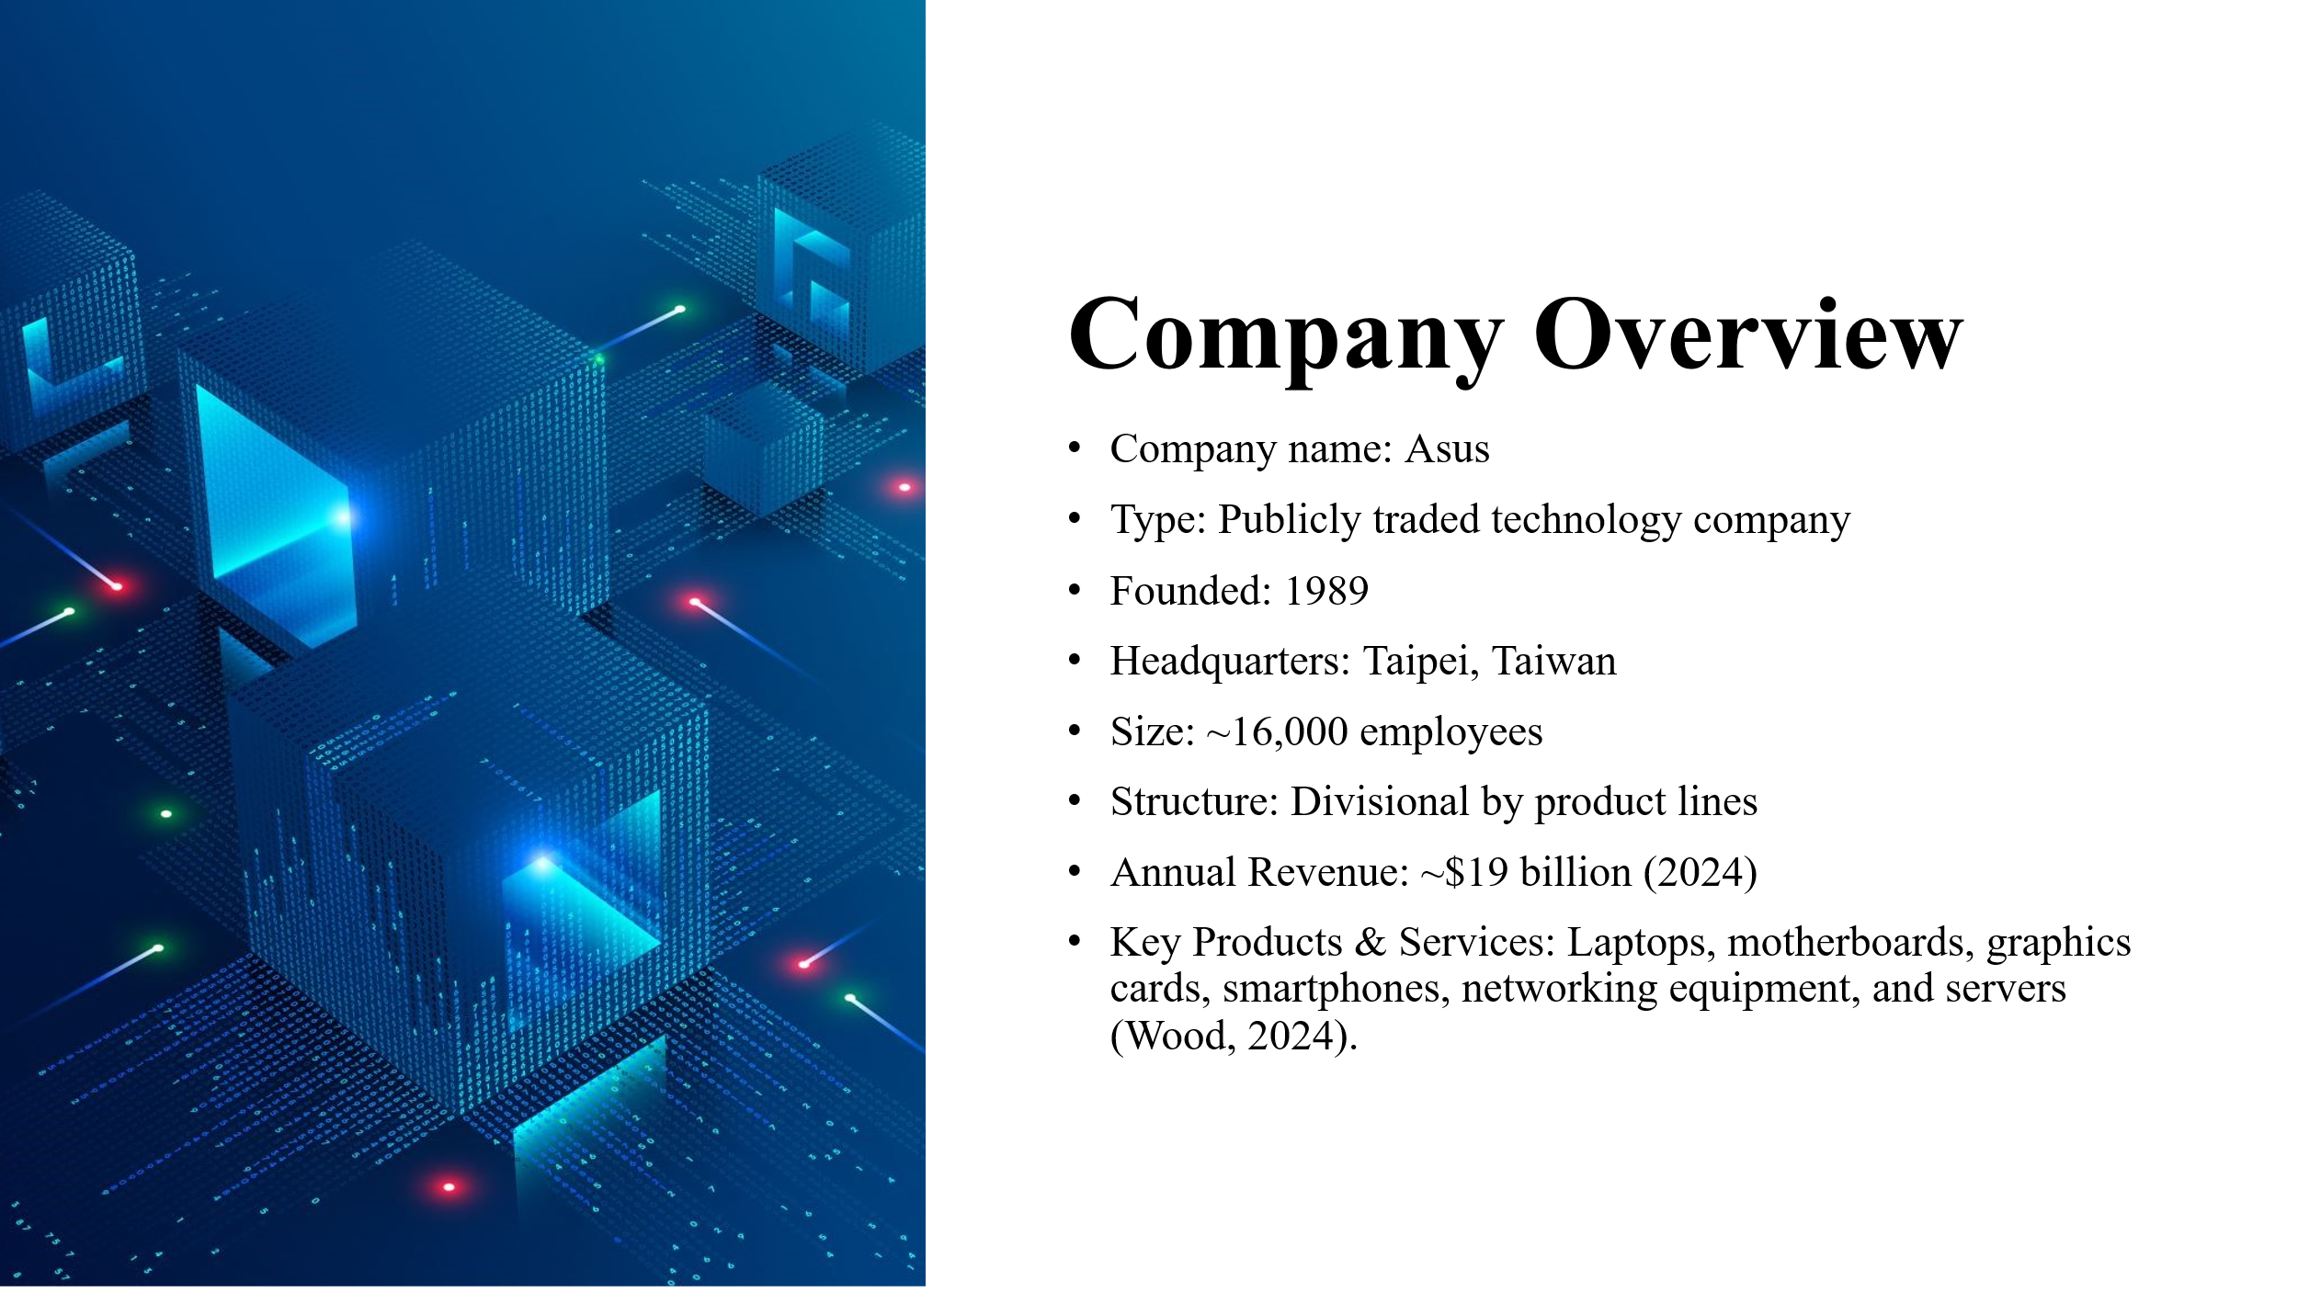
Content
- Company name: Asus
- Type: Publicly traded technology company
- Founded: 1989
- Headquarters: Taipei, Taiwan
- Size: ~16,000 employees
- Structure: Divisional by product lines
- Annual Revenue: ~$19 billion (2024)
- Key Products & Services: Laptops, motherboards, graphics cards, smartphones, networking equipment, and servers (Wood, 2024).
Speaker Notes:
ASUS is a global giant within the tech industry, known for its innovation and quality products. Established in 1989 in Taipei, Taiwan, ASUS originally manufactured motherboards, but quickly expanded its portfolio. Today, ASUS has generally transitioned to a divisional structure, built around key product lines. Its primary means of generating revenue are through laptops, PC components (motherboards, graphics cards), gaming, under its very popular ROG (Republic of Gamers) brand, smartphones, networking equipment, servers, and IoT devices; thus making ASUS a global company with quite the business diversity.

Slide 4: SWOT Analysis - Strength

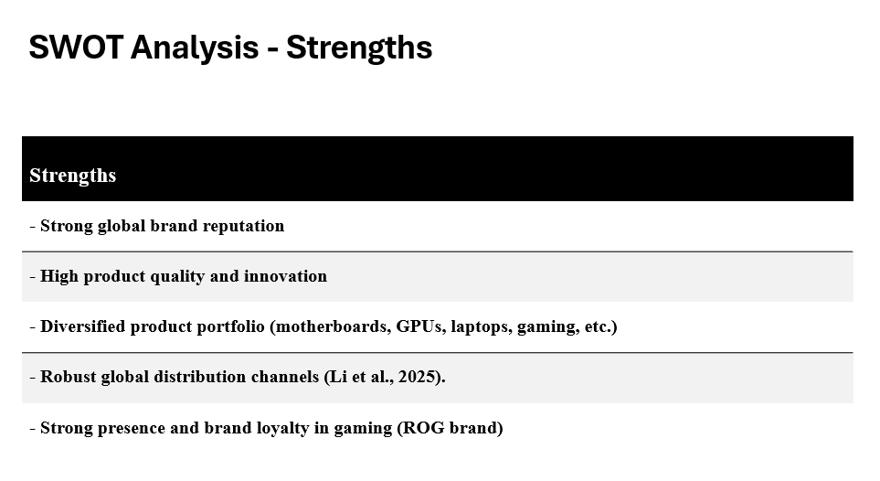
Strengths
- Strong global brand reputation
- High product quality and innovation
- Diversified product portfolio (motherboards, GPUs, laptops, gaming, etc.)
- Robust global distribution channels (Li et al., 2025).
- Strong presence and brand loyalty in gaming (ROG brand)
Speaker Notes:
Notable strengths ASUS possesses include its solid global brand reputation for innovation and high-quality products, along with a full range of product categories like motherboards, GPUs, laptops, and gaming devices, covering various customer segments, robust global distribution channels, and the successful creation of loyalty around its gaming-focused ROG (Republic of Gamers) brand which gave ASUS a competitive edge in the large growth sector of gaming while enhancing brand equity in the consumer electronics market.

Slide 5: SWOT Analysis - Weaknesses
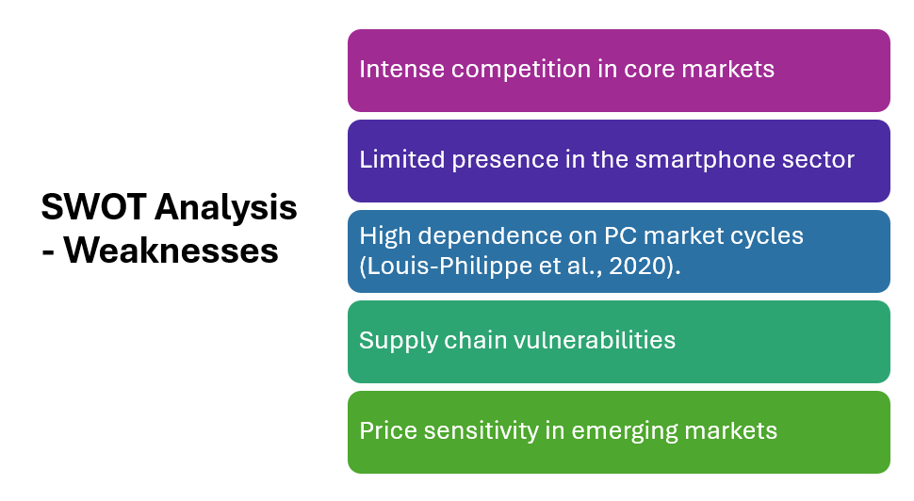
Content
- Intense competition in core markets
- Limited presence in the smartphone sector
- High dependence on PC market cycles (Louis-Philippe et al., 2020).
- Supply chain vulnerabilities
- Price sensitivity in emerging markets
Speaker Notes
Despite these various strengths, ASUS has a few significant weaknesses. The biggest one is that competition in all of its key markets is fierce. The technology industry is very saturated, and there are currently very few players who are not dominant. Players like Apple, Samsung, Lenovo and Dell are in every category ASUS operates in, and they each exert a lot of pressure. ASUS's performance in the smartphone segment has only brought limited success, meaning it cannot position itself as a major player in this crucial market.

Slide 6: SWOT Analysis - Opportunities

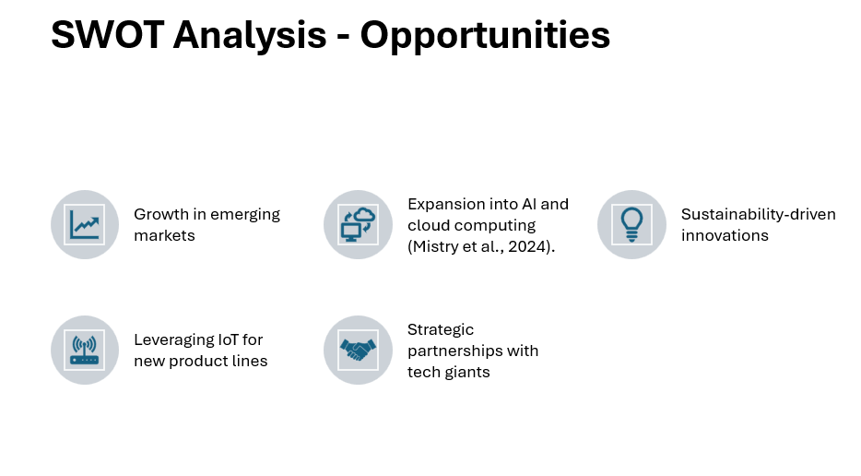
Content
- Growth in emerging markets
- Expansion into AI and cloud computing (Mistry et al., 2024).
- Sustainability-driven innovations
- Leveraging IoT for new product lines
- Strategic partnerships with tech giants
Speaker Notes:
ASUS has many fantastic opportunities for future growth. One of the biggest opportunities is the expansion into emerging markets. The emerging market is creating demand for affordable but quality technology products. ASUS now has new revenue opportunities with their products. ASUS can also take advantage of developments in Artificial Intelligence, the Internet of Things (IoT), and cloud services to create innovative solutions for changing consumer and business needs.

Slide 7: SWOT Analysis – Threats
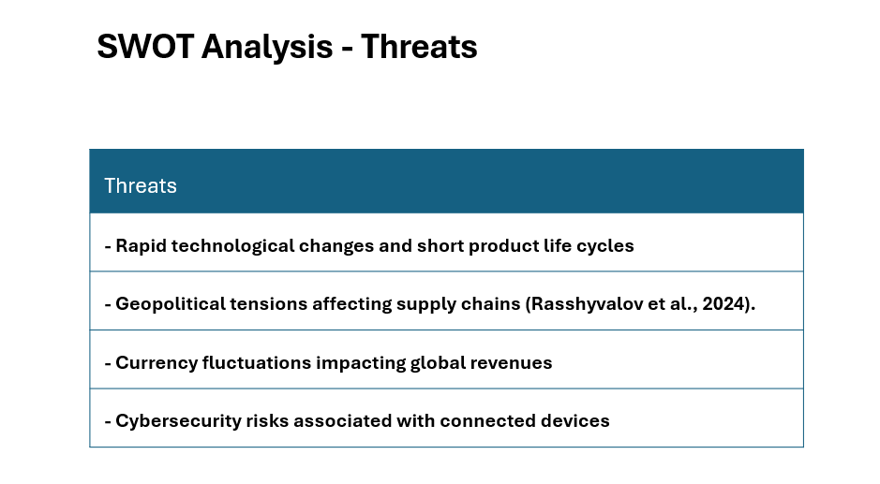
Threats
- Rapid technological changes and short product life cycles
- Geopolitical tensions affecting supply chains (Rasshyvalov et al., 2024).
- Currency fluctuations impacting global revenues (Kang, Ratti, and Vespignani, 2020).
- Cybersecurity risks associated with connected devices
Speaker Notes:
ASUS faces competition from a variety of areas in the technological landscape. Rapid advancements in technology alongside shorter product life cycles require constant innovation. Furthermore, geopolitical strife can disrupt a global supply chain that is at its peak, considering the multinational presence of ASUS. Currency fluctuations can affect revenues from international sales, and cybersecurity issues can be monumental as ASUS continues to expand its tech portfolio, particularly in connected devices.

Slide 8: PEST Analysis - Political Factors
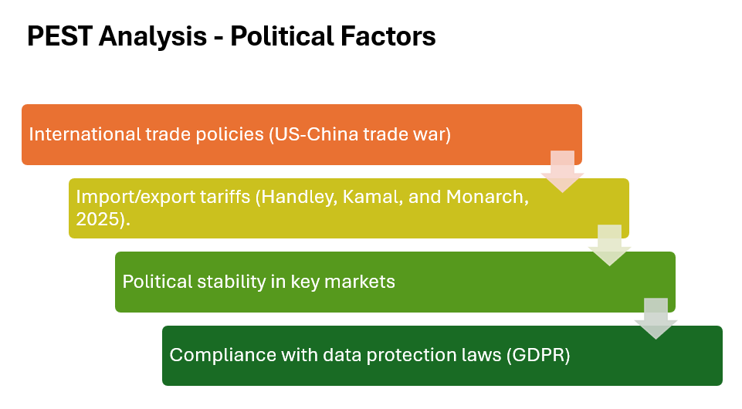
Content
- International trade policies (US-China trade war)
- Import/export tariffs (Handley, Kamal, and Monarch, 2025).
- Political stability in key markets
- Compliance with data protection laws (GDPR)
Speaker Notes:
The world in which ASUS operates is politically complicated and uncertain. There are even trade relations to consider, which complicate things even more. The ongoing tension, bundled under the umbrella of the US-China trade war, has led to volatility in tariffs and regulatory requirements, as well as market and supply chain context. ASUS must respond to changing trade policies as it needs to minimise the impact of trade-related constraints so that it can operate effectively and gain access to new markets.

Slide 9: PEST Analysis - Economic Factors
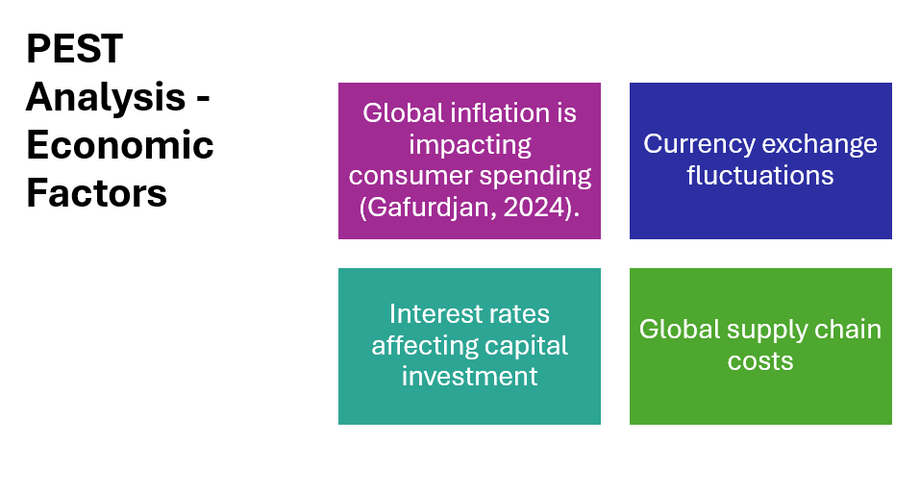
Content
- Global inflation is impacting consumer spending (Gafurdjan, 2024).
- Currency exchange fluctuations
- Interest rates affecting capital investment
- Global supply chain costs
Speaker Notes:
Economic conditions are significant factors in helping ASUS achieve profitability and adjust its operating strategy. The global inflationary environment has caused substantial increases in production and distribution costs will hurt profit margins. Additionally, currency fluctuations in each of its markets will impact pricing and revenue forecasts, given that ASUS's revenue will derive in large part from international sales. Along with inflationary pressures, the company faces rising supply chain costs, caused by a shortage of raw materials and increased transportation costs in the post-COVID-19 environment.

Slide 10: PEST Analysis - Social Factors
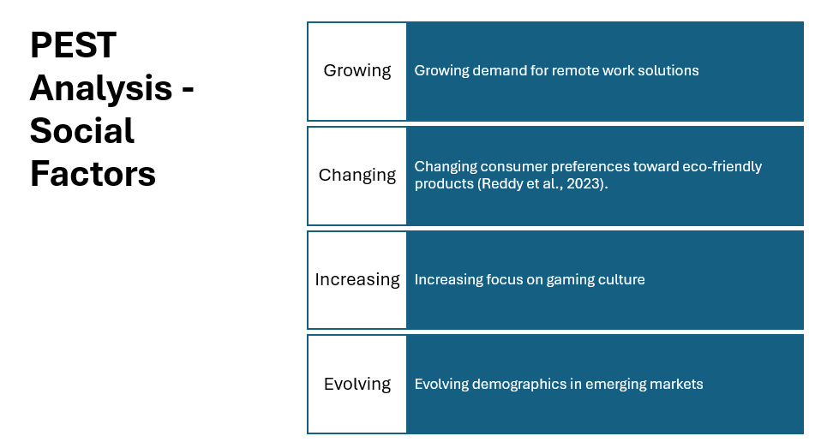
Content
- Growing demand for remote work solutions
- Changing consumer preferences toward eco-friendly products (Reddy et al., 2023).
- Increasing focus on gaming culture
- Evolving demographics in emerging markets
Speaker Notes:
Social dynamics posed new and immediate opportunities and challenges to ASUS. The global shift to working remotely/hybrid working models has created immediate increases across multiple product categories: laptops, monitors, networking devices, etc, a landscape ASUS would be used to being well-placed. Changing consumer awareness about environmental sustainability and the mass market proliferation of green technologies will demand more energy-efficient products. This will ultimately push ASUS to create more design sensible around greener designs.

Slide 11: PEST Analysis - Technological Factors
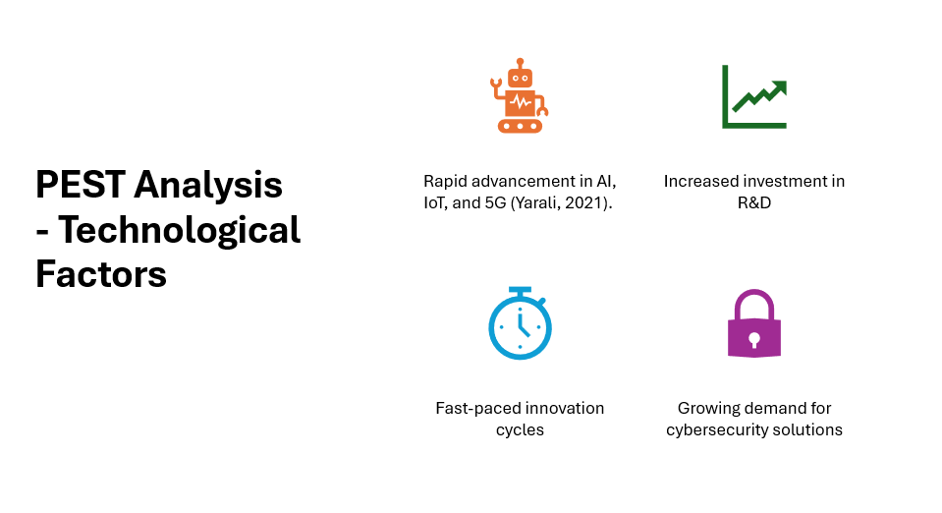
Content
- Rapid advancement in AI, IoT, and 5G (Yarali, 2021).
- Increased investment in R&D
- Fast-paced innovation cycles
- Growing demand for cybersecurity solutions
Speaker Notes:
Technological elements are changing the competitive environment for ASUS. Rapid developments in Artificial Intelligence (AI), Internet of Things (IoT), and 5G connectivity are impacting product innovation and customer expectations. ASUS must continually refresh its product offer (niche) from smart laptops, gaming devices, to network appliances. ASUS must continue to capture innovation space by investing heavily in Research and Development (R&D) to stay ahead of competitors.

Slide 12: Impact of Globalisation - Market Expansion
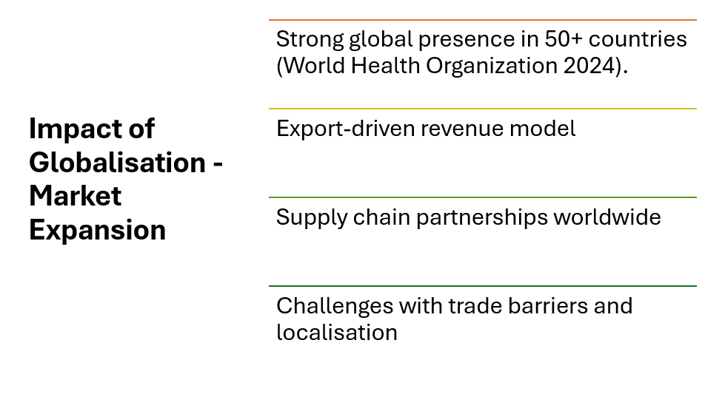
Content
- Strong global presence in 50+ countries (World Health Organisation 2024).
- Export-driven revenue model
- Supply chain partnerships worldwide
- Challenges with trade barriers and localisation
Speaker Notes:
Globalisation has opened up tremendous opportunities for ASUS as a company, given that it can now do business in over 50 countries and achieve considerable global sales. The downside of a global business is the complexity this presents. ASUS will have to remain nimble in responding to the constantly changing local markets, varying consumer tastes, different local regulations and other local subtleties. To remain relevant, ASUS will have to factor in local conditions for marketing and branding and focus on local marketing strategies or product offerings. Additionally, staying nimble or resilient will always apply when maintaining a widespread global supply chain.

Slide 13: Impact of Globalisation - Workforce & Culture
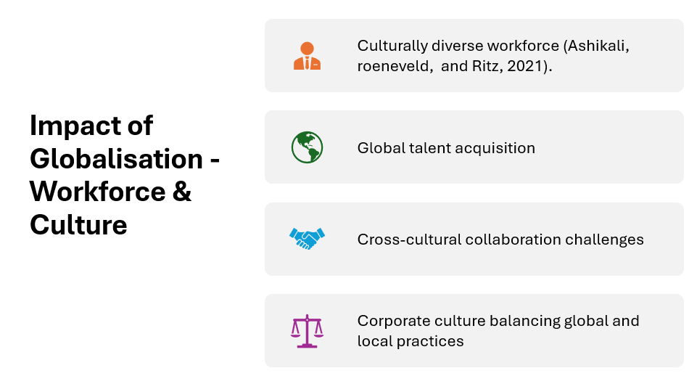
Content
- Culturally diverse workforce (Ashikali, Roeneveld, and Ritz, 2021).
- Global talent acquisition
- Cross-cultural collaboration challenges
- Corporate culture balancing global and local practices
Speaker Notes:
Let’s talk about how globalisation is also a very important factor for ASUS’s employees. Because ASUS is present and operates in various countries, there is a diverse and cross-cultural workforce. Work like this means creating structures to involve and connect regularly and effectively across employees from different cultural backgrounds, but this is incredibly important for the success of the organisation. ASUS needs to invest in cross-cultural training and continue to develop a culture of inclusiveness where different perspectives are embraced.

Slide 14: Impact of Globalisation - Supply Chains
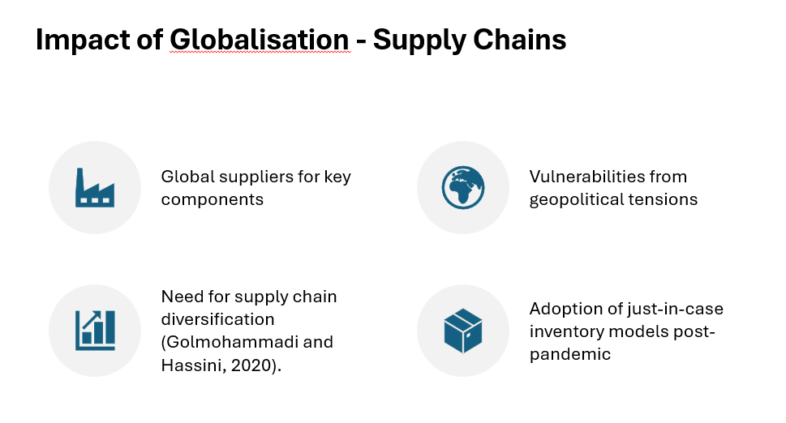
Content
- Global suppliers for key components
- Vulnerabilities from geopolitical tensions
- Need for supply chain diversification (Golmohammadi and Hassini, 2020).
- Adoption of just-in-case inventory models post-pandemic
Speaker Notes:
ASUS's global supply chains are a great strength, but they are also a risk. The company has a great, widespread supplier base to source parts in an economic manner, which supports ASUS's larger product mix. The global supply chains also expose ASUS to certain vulnerabilities like, geopolitical instability, trade embargoes, and logistical challenges; the post-pandemic world has featured greater levels of all of these vulnerabilities.

Slide 15: Influence of Innovation - Product Innovation
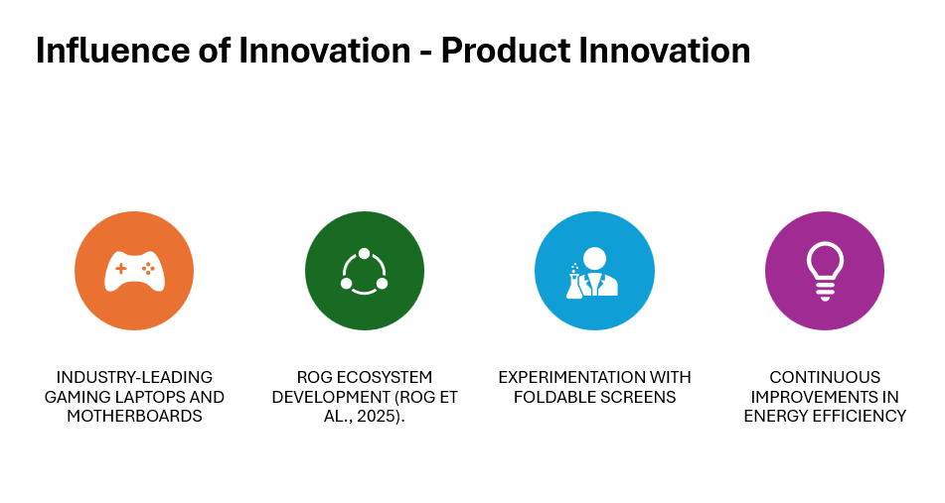
Content
- Industry-leading gaming laptops and motherboards
- ROG ecosystem development (Rog et al., 2025).
- Experimentation with foldable screens
- Continuous improvements in energy efficiency
Speaker Notes:
ASUS's business strategy centres on innovation, with innovation being a large part of its global success. ASUS' lead product line, Republic of Gamers (ROG), dominates the competitive gaming arena, with the best performance products available to casual and professional eSports players. The examples of ROG lead the competitive gaming space. ASUS also develops technology and looks to implement new form factors such as dual-screen laptops and foldable displays, which are industry-leading and improve the user experience.

Slide 16: Influence of Innovation - Business Model Innovation
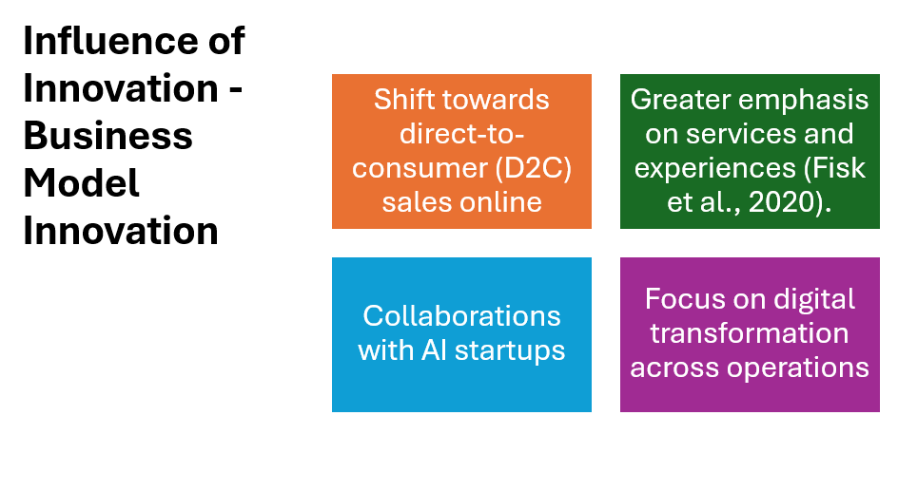
Content
- Shift towards direct-to-consumer (D2C) sales online
- Greater emphasis on services and experiences (Fisk et al., 2020).
- Collaborations with AI startups
- Focus on digital transformation across operations
Speaker Notes:
In addition to the innovative products, ASUS also believes it is dramatically changing its business model to adapt to the changing market. One significant change ASUS has made is the diversification of the Direct-to-Consumer (D2C) channels to drive deeper customer engagement, foster brand loyalty, and gather valuable insights about customers. Likewise, ASUS is creating more digital experiences that will include tailored online services, virtual events, and integrated support.

Slide 17: Influence of Innovation - Sustainability
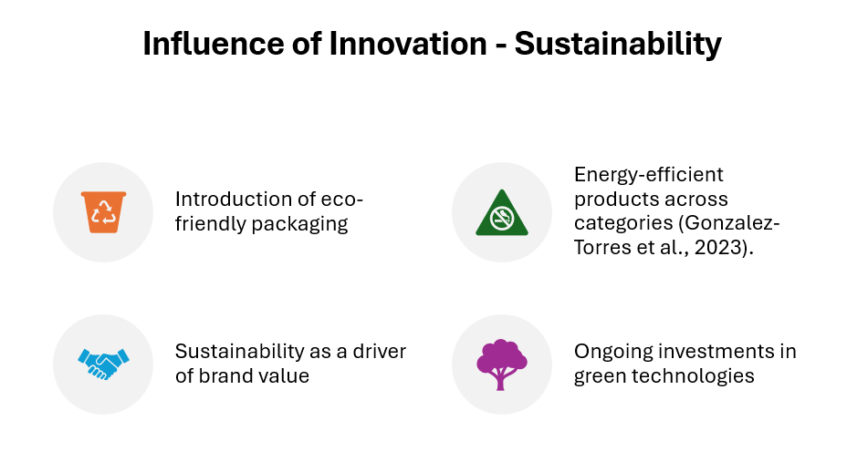
Content
- Introduction of eco-friendly packaging
- Energy-efficient products across categories (Gonzalez-Torres et al., 2023).
- Sustainability as a driver of brand value
- Ongoing investments in green technologies
Speaker Notes:
Innovation that embraces sustainability is becoming a central tenet of ASUS's strategic process. Specifically, ASUS is trying to incorporate environmentally sustainable practices with workers both in a business and societal context to reduce environmental impact while ensuring high quality throughout the stages of product development, design, packaging, and manufacturing.

Slide 18: Recommendations
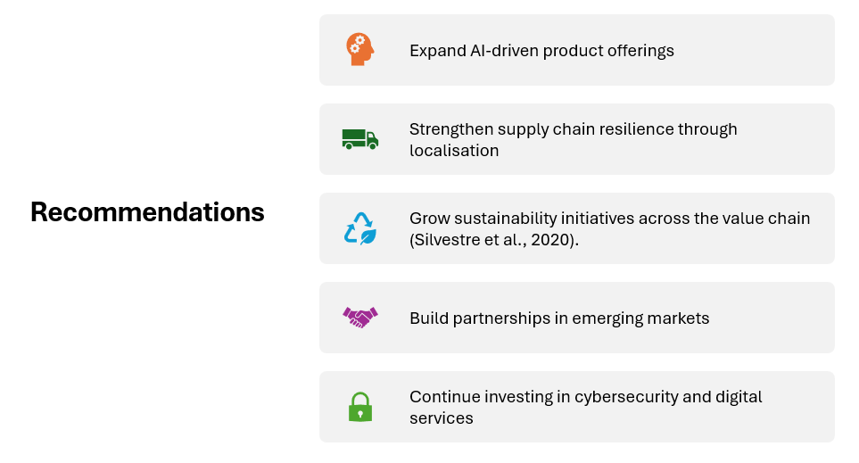
Content
Expand AI-driven product offerings
Strengthen supply chain resilience through localisation
Grow sustainability initiatives across the value chain (Silvestre et al., 2020).
Build partnerships in emerging markets
Continue investing in cybersecurity and digital services
Speaker Notes:
Evolving our key recommendations for ASUS into three overarching strategies can help to achieve growth now and in the future and to stay competitive. First, to realise any potential product in the product line, based on leading current technology trends and growing customer demand for intelligent and smart devices. Second, to undertake increased sustainability measures through eco-design, renewable energy and circular economy initiatives, to enhance ASUS's position as a leader in sustainability and provide an opportunity for environmentally conscious consumers. And establish trust in a hyper-connected world.

Slide19: Conclusion
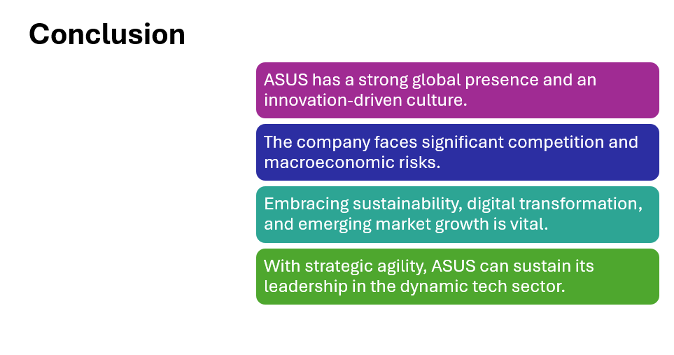
Content
- ASUS has a strong global presence and an innovation-driven culture.
- The company faces significant competition and macroeconomic risks.
- Embracing sustainability, digital transformation, and emerging market growth is vital.
- With strategic agility, ASUS can sustain its leadership in the dynamic tech sector.
Speaker Notes:
Thus, unlike many firms in the current unpredictable and difficult economy, ASUS is well-placed to capitalise on its strengths. It has made a strong commitment to move towards sustainability to show it's responsible, capable of innovation as it continues to embrace and transform new ways of thinking about innovation, while simultaneously investing in more digital innovation in the areas of and advanced technologies to continue acquiring the needed capabilities for market readiness in the future.

Slide 20: References
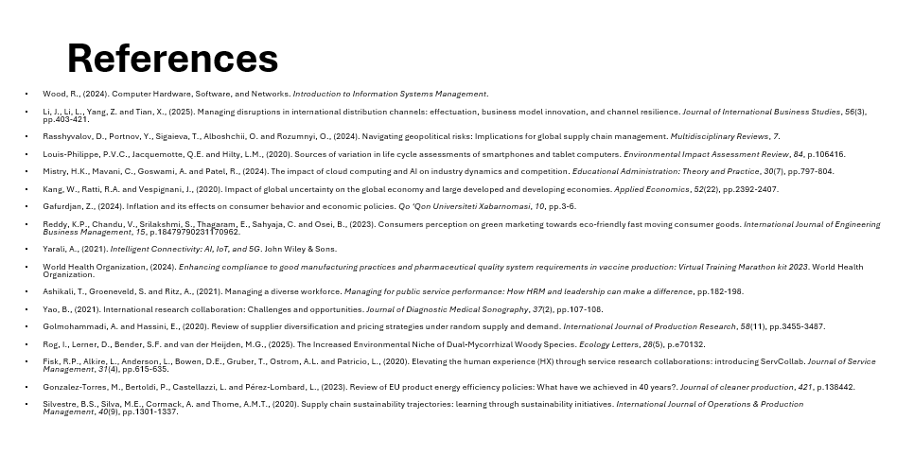
Ashikali, T., Groeneveld, S. and Ritz, A., (2021). Managing a diverse workforce. Managing for public service performance: How HRM and leadership can make a difference, pp.182-198.
Fisk, R.P., Alkire, L., Anderson, L., Bowen, D.E., Gruber, T., Ostrom, A.L. and Patricio, L., (2020). Elevating the human experience (HX) through service research collaborations: introducing ServCollab. Journal of Service Management, 31(4), pp.615-635.
Gafurdjan, Z., (2024). Inflation and its effects on consumer behavior and economic policies. Qo ‘Qon Universiteti Xabarnomasi, 10, pp.3-6.
Golmohammadi, A. and Hassini, E., (2020). Review of supplier diversification and pricing strategies under random supply and demand. International Journal of Production Research, 58(11), pp.3455-3487.
Gonzalez-Torres, M., Bertoldi, P., Castellazzi, L. and Pérez-Lombard, L., (2023). Review of EU product energy efficiency policies: What have we achieved in 40 years?. Journal of cleaner production, 421, p.138442.
Kang, W., Ratti, R.A. and Vespignani, J., (2020). Impact of global uncertainty on the global economy and large developed and developing economies. Applied Economics, 52(22), pp.2392-2407.
Li, J., Li, L., Yang, Z. and Tian, X., (2025). Managing disruptions in international distribution channels: effectuation, business model innovation, and channel resilience. Journal of International Business Studies, 56(3), pp.403-421.
Louis-Philippe, P.V.C., Jacquemotte, Q.E. and Hilty, L.M. (2020). Sources of variation in life cycle assessments of smartphones and tablet computers. Environmental Impact Assessment Review, 84, p.106416.
Mistry, H.K., Mavani, C., Goswami, A. and Patel, R., (2024). The impact of cloud computing and AI on industry dynamics and competition. Educational Administration: Theory and Practice, 30(7), pp.797-804.
Rasshyvalov, D., Portnov, Y., Sigaieva, T., Alboshchii, O. and Rozumnyi, O., (2024). Navigating geopolitical risks: Implications for global supply chain management. Multidisciplinary Reviews, 7.
Reddy, K.P., Chandu, V., Srilakshmi, S., Thagaram, E., Sahyaja, C. and Osei, B., (2023). Consumers perception on green marketing towards eco-friendly fast moving consumer goods. International Journal of Engineering Business Management, 15, p.18479790231170962.
Rog, I., Lerner, D., Bender, S.F. and van der Heijden, M.G., (2025). The Increased Environmental Niche of Dual‐Mycorrhizal Woody Species. Ecology Letters, 28(5), p.e70132.
Silvestre, B.S., Silva, M.E., Cormack, A. and Thome, A.M.T., (2020). Supply chain sustainability trajectories: learning through sustainability initiatives. International Journal of Operations & Production Management, 40(9), pp.1301-1337.
Wood, R., (2024). Computer Hardware, Software, and Networks. Introduction to Information Systems Management.
World Health Organizationsssssss (2024). Enhancing compliance to good manufacturing practices and pharmaceutical quality system requirements in vaccine production: Virtual Training Marathon kit 2023. World Health Organization.
Yao, B., (2021). International research collaboration: Challenges and opportunities. Journal of Diagnostic Medical Sonography, 37(2), pp.107-108.
Yarali, A., (2021). Intelligent Connectivity: AI, IoT, and 5G. John Wiley & Sons.

