University of Wales Trinity Saint David
School of Engineering



Application of Automation in Wastewater Treatment

Control & Automation ACMA5001

Ifeoluwa Grace Ekhator
2418900
April 2026

Abstract
Automation has become integral to contemporary municipal wastewater treatment plants (WWTPs), enabling tighter process control, improved energy efficiency and consistent regulatory compliance. This report critically evaluates the deployment of sensors, programmable logic controllers (PLCs), supervisory control and data acquisition (SCADA) platforms and advanced process control (APC) across primary, secondary and tertiary treatment. Evidence from the literature is synthesised with engineering analysis to assess performance gains—particularly in aeration, the dominant energy consumer. Diagrammatic figures illustrate typical control architectures. While automation delivers measurable benefits in stability and cost efficiency, it introduces dependencies on instrumentation integrity, cyber resilience and operator competence. Overall, automation is shown to be essential for high-performing, sustainable WWTPs, provided that design, maintenance and governance are robust.
Contents
Abstract 1
1 Introduction 1
2 Literature Review 1
3 Historical Development of ICA in Wastewater Treatment 1
4 Wastewater Treatment Process and ICA Demands 1
5 Field Instrumentation and Sensors 1
6 Process Controllers 1
6.1 Programmable Logic Controllers 1
6.2 PID Control and Its Practical Limitations 1
6.3 Distributed Control Systems 1
7 Supervisory Control and Data Acquisition 1
8 Regulatory and Standards Framework 1
9 Advanced Technologies and Energy Performance 1
9.1 Control Strategy and Energy Savings 1
9.2 Artificial Intelligence, IoT and Digital Twins 1
10 Conclusion 1
11 References 1

No table of figures entries found.

Introduction
Municipal WWTPs protect receiving waters by removing solids, organic matter and nutrients from sewage prior to discharge. Rising urban populations and increasingly stringent discharge consents in the UK have elevated expectations for reliability and effluent quality. Historically, plants depended on periodic sampling and operator judgement; such approaches are inherently reactive and susceptible to variability.

Automation addresses these limitations by enabling continuous measurement, closed-loop control and data-driven optimisation. Sensors quantify key process variables; PLCs execute deterministic control logic; SCADA systems provide visibility, alarms and historical analytics; and APC layers optimise setpoints using models or heuristics. Collectively, these systems shift operations from reactive to proactive control, reducing excursions and improving compliance margins.

This report examines automation across treatment stages, evaluates benefits and trade-offs, and considers practical constraints affecting real-world performance.

Literature Review
A consistent finding across the literature is that automation enhances process stability and energy efficiency. Real-time sensing—dissolved oxygen (DO), pH, oxidation-reduction potential (ORP), turbidity, ammonia and flow—underpins effective control (Olsson, 2022). Improvements in sensor robustness and anti-fouling design have increased data reliability in aggressive wastewater environments (Rieger et al., 2019).

PLCs remain the industry standard for executing control logic due to determinism and resilience, while SCADA platforms enable supervisory oversight, alarm management and data logging. Integration of these layers improves situational awareness and facilitates trend analysis and fault diagnosis (Rieger et al., 2019).

Energy optimisation is most evident in aeration. Studies report that aeration can account for 40–60% of plant electricity use, and that feedback control using DO sensors and variable-speed blowers can yield substantial savings without compromising treatment (Gao et al., 2020). More advanced strategies—such as model predictive control (MPC)—use process models to anticipate disturbances and optimise control actions, particularly valuable under highly variable influent loads.

Limitations are also documented. Sensor drift and fouling can degrade control performance; increased connectivity expands the cyber-attack surface; and successful deployment requires skilled operators capable of interpreting data and maintaining instrumentation. Nonetheless, the consensus is that benefits outweigh risks when systems are properly engineered and maintained.

Historical Development of ICA in Wastewater Treatment
The development of instrumentation, control and automation (ICA) in wastewater treatment reflects broader industrial automation trends, although it has been shaped by sector-specific challenges such as variable influent characteristics and strict environmental regulations. Early wastewater treatment facilities, established in the late nineteenth century, relied entirely on manual observation and intermittent sampling. While experienced operators could develop process understanding, this approach was reactive and often resulted in inconsistent treatment performance, with limited ability to detect gradual system deterioration before regulatory breaches occurred.
From the mid-twentieth century, the introduction of pneumatic and analogue electronic instrumentation improved monitoring capabilities by enabling continuous measurement of key parameters such as flow, pH and dissolved oxygen. However, these systems remained largely open-loop, meaning operator intervention was still required to implement corrective actions.
A significant advancement occurred in the 1970s with the introduction of programmable logic controllers (PLCs), which enabled automated feedback control and reduced reliance on manual operation. By the 1980s, PLCs were widely used, though typically in isolated applications.
The emergence of SCADA systems in the 1980s and 1990s allowed centralised monitoring and control, while later networking technologies enabled remote operation of multiple sites. More recently, digital innovations such as IoT, cloud computing and machine learning have supported predictive maintenance and enhanced process optimisation. This evolution is summarised in Figure 1.
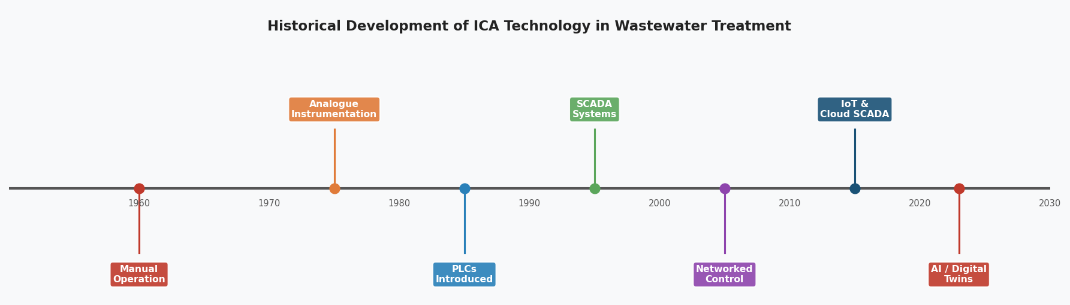
Figure 1: Historical Development of ICA Technology in Wastewater Treatment (1960–Present)

Wastewater Treatment Process and ICA Demands
Wastewater treatment comprises four sequential stages, each imposing distinct ICA requirements that ensure stable, compliant and energy-efficient operation. Preliminary treatment removes coarse solids using mechanically raked bar screens and grit channels, with electromagnetic flow measurement (FT-101) providing the mass-balance reference for downstream dosing and enabling automated storm-flow diversion. Primary sedimentation relies on sludge blanket level transmitters (LT-201) to regulate sludge withdrawal and maintain hydraulic retention. The secondary biological stage is the most instrumentation-intensive: dissolved oxygen (DO) must be controlled within a narrow band to sustain microbial activity, avoid filamentous bulking and prevent excessive aeration energy use, which typically represents 50–70% of total site consumption. Additional measurements – pH, temperature and MLSS (AT-302/303) – support sludge age control and biological stability. Tertiary treatment employs turbidity monitoring (AT-401) to govern filter backwash cycles and UV dose control to ensure pathogen inactivation within energy constraints. Across all stages, ICA provides continuous measurement, automated adjustment and early fault detection, enabling treatment works to maintain compliance despite fluctuating influent conditions.

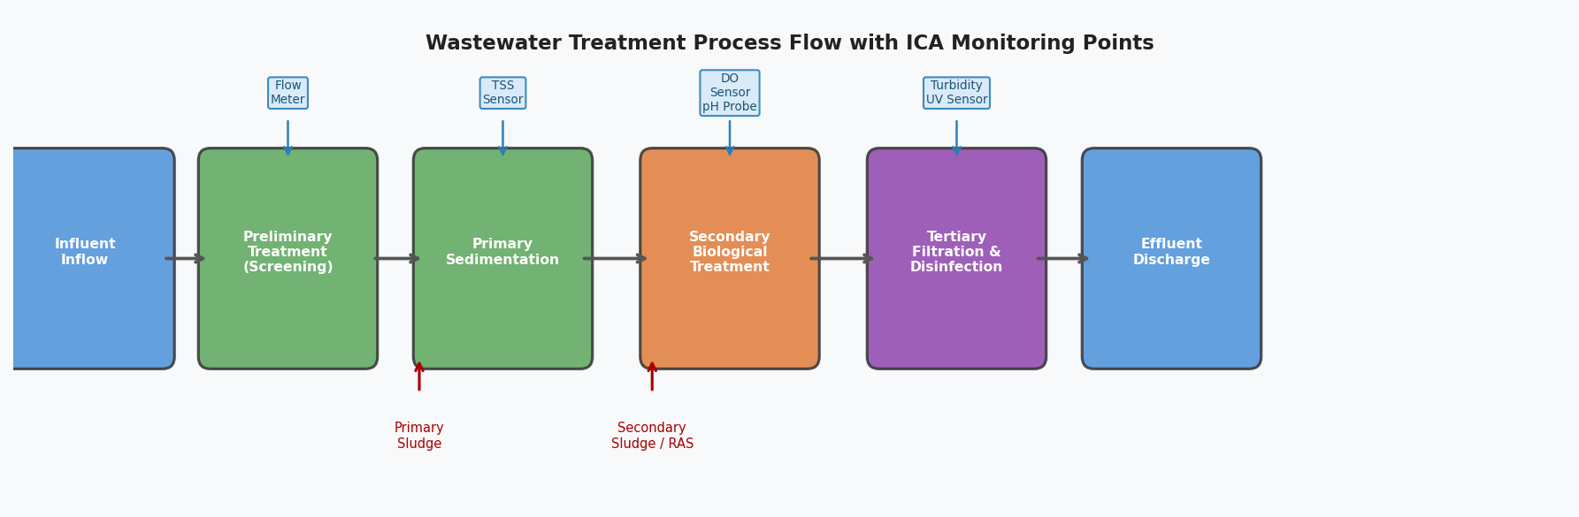
Figure 2: Wastewater Treatment Process Flow Showing Key ICA Monitoring Points

Field Instrumentation and Sensors
The performance, stability and safety of any ICA architecture are ultimately constrained by the quality, reliability and maintainability of its field instrumentation. In wastewater treatment, where biological and hydraulic conditions fluctuate continuously, sensors must deliver accurate, drift‑resistant measurements despite immersion in chemically aggressive, biofouling‑prone environments. A control loop can only ever be as good as the data it receives; consequently, instrumentation selection and lifecycle management represent core engineering decisions rather than peripheral procurement choices.

Dissolved oxygen (DO) measurement is the most critical parameter in activated sludge control, and two sensing technologies dominate current practice. Polarographic (Clark‑type) electrodes operate by reducing oxygen at a cathode behind a semi‑permeable membrane. Although well‑established and relatively inexpensive, they require periodic electrolyte replenishment, membrane replacement and frequent calibration, with drift accelerating in mixed liquor due to fouling and membrane degradation. Optical (luminescent) DO sensors infer oxygen concentration from the quenching of a phosphorescent dye layer. They eliminate electrolyte maintenance, exhibit superior long‑term stability and respond more rapidly to concentration changes. Their higher capital cost is offset by reduced maintenance burden and improved control fidelity, making them the preferred choice for modern installations. Both technologies, however, require automated cleaning systems—typically air‑blast or ultrasonic—to maintain measurement integrity.

Flow measurement underpins mass‑balance calculations, storm‑flow management and chemical dosing control. Electromagnetic flow meters remain the industry standard due to their ±0.3–0.5% accuracy, insensitivity to suspended solids and absence of moving parts. Their reliability in high‑solids wastewater makes them indispensable at inlet works and sludge transfer points. pH measurement, essential for chemical phosphorus removal and digestion stability, is typically achieved using glass‑membrane electrodes. Combined pH/ORP probes extend diagnostic capability by characterising redox conditions, providing insight into nitrification and denitrification performance. Online ammonium (NH₄‑N) ion‑selective electrodes are increasingly deployed to support ammonium‑based aeration control (ABAC), enabling aeration to respond directly to biological oxygen demand rather than relying solely on DO as a proxy.

The operational value of instrumentation depends not only on sensor technology but also on calibration strategy, redundancy, environmental protection and integration with cleaning systems. Biofouling, temperature variation, chemical attack and hydraulic shocks all degrade sensor performance over time. Consequently, robust maintenance regimes—including scheduled calibration, validation against laboratory samples and automated cleaning—are essential to sustaining control accuracy. As advanced control strategies such as MPC and AI‑assisted optimisation become more prevalent, the requirement for high‑fidelity, low‑drift instrumentation becomes even more pronounced. Reliable measurement is therefore not merely a supporting function but a foundational prerequisite for modern wastewater automation.

Process Controllers

Programmable Logic Controllers
PLCs remain the dominant control platform across UK WwTFs. Their value lies in deterministic execution — the control program runs to completion within a guaranteed, repeating scan cycle, typically 10–100ms — providing the timing precision required for safe process control. Programming follows IEC 61131-3 standard languages, with Ladder Diagram (LD) widely used for discrete sequential logic (pump sequencing, valve interlocking) and Function Block Diagram (FBD) or Structured Text (ST) preferred for continuous PID loop implementation ^{[22]}. Communication with field instruments and actuators is accomplished via analogue 4–20 mA signals for continuous variables and digital inputs/outputs for status and command signals, increasingly supplemented by HART, PROFIBUS-PA or Foundation Fieldbus digital protocols that enable additional diagnostic data to be extracted from intelligent field devices without additional wiring.

PID Control and Its Practical Limitations
The Proportional-Integral-Derivative (PID) algorithm is the near-universal choice for continuous closed-loop control in WwTFs. Its three terms address complementary control objectives: the proportional gain provides a response scaled to the current error magnitude; the integral term eliminates steady-state offset by continuously accumulating the error over time; and the derivative term provides predictive damping by responding to the rate of error change ^{[23]}. In DO control, a PID controller compares the measured DO concentration against the operator-configured setpoint and modulates blower speed or air valve position to minimise the error. Figure 3 illustrates this closed-loop architecture.
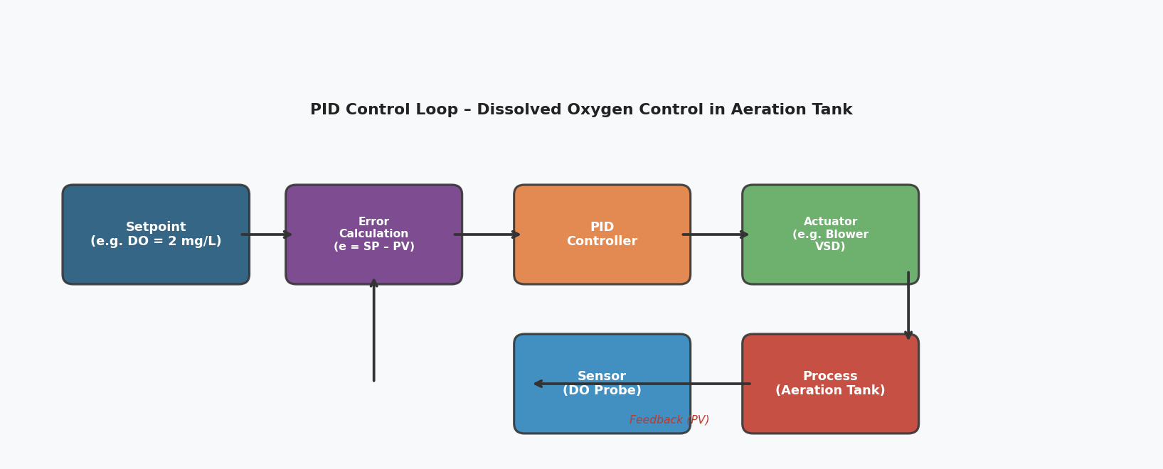
Figure 3: PID Closed-Loop Control Schematic for Dissolved Oxygen Control in an Aeration Basin
However, it is essential to critically appraise the limitations of standard PID control in the WwTF context. Biological treatment processes are inherently non-linear — the relationship between aeration rate and DO concentration is not fixed but varies with organic loading, temperature and biomass activity — and exhibit significant dead time between control action and measured response. Standard PID tuning methods (Ziegler-Nichols, IMC) assume linear, time-invariant process behaviour and produce suboptimal performance when these assumptions are violated ^{[24]}. Additionally, WwTFs contain multiple interacting control loops: aeration control affects the biological nitrogen removal kinetics that determine the nitrification rate, which in turn influences DO demand. Single-loop PID controllers cannot account for these interactions, leading to oscillatory behaviour or poor disturbance rejection during high-loading events. These limitations motivate the adoption of cascade control architectures, feedforward compensation and, increasingly, model predictive control (MPC) strategies, as discussed in Section 7.

Distributed Control Systems
For larger, more complex WwTFs or those employing advanced treatment processes, a Distributed Control System (DCS) may supplement or replace the PLC-based architecture. DCS platforms distribute I/O and control processing across a network of intelligent field controllers, reducing cabling costs and improving fault tolerance through redundancy. They typically offer more sophisticated process control functionality than standard PLCs, including native multivariable control blocks and integrated historian capabilities. However, their higher capital and engineering cost means they are predominantly deployed in industrial water treatment, desalination and large urban WwTF applications rather than smaller municipal sites.

Supervisory Control and Data Acquisition
SCADA systems occupy Level 3 of the ISA-95 / Purdue Reference Model (Figure 4), consolidating data from all site PLCs into an HMI that delivers real-time visualisation, alarm management, historical trending and remote setpoint authority (Boyer, 2010). The data historian archives process values at high frequency, providing the evidential record for the Environment Agency’s Operator Self-Monitoring scheme (Environment Agency, 2022) and enabling automated compliance reporting.

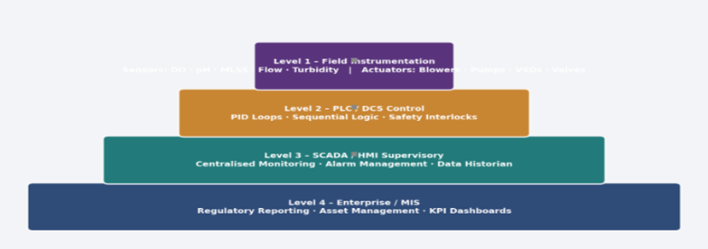
Figure 4: ICA System Architecture: Purdue Reference Model (ISA-95 / Purdue Model)

SCADA connectivity with corporate IT networks introduces cybersecurity risk; the 2021 Oldsmar incident showed remote compromise can threaten public safety (Dragos, 2021). The NIS Regulations 2018 mandate network segmentation, access controls and incident response (NCSC, 2022). Balancing operational openness with security isolation remains a key governance challenge.

Regulatory and Standards Framework
Wastewater treatment works operate under Environmental Permits issued by the Environment Agency, specifying concentration or load‑based discharge limits. ICA systems provide the continuous monitoring, automated adjustment and evidential data required to demonstrate compliance. ISO 14001 establishes the environmental management framework adopted by most utilities, while IEC 61511 governs safety instrumented systems, including SIL assessment of high‑risk functions such as chemical dosing shutdowns. Together, these standards ensure that automated control supports safe, auditable and environmentally responsible plant operation.

Advanced Technologies and Energy Performance

Control Strategy and Energy Savings
The progressive sophistication of aeration control strategy delivers quantifiable and substantial energy savings, as shown in Figure 4. Conventional DO PID control reduces aeration energy by approximately 21% relative to manual operation by eliminating gross over-aeration. Ammonium-based aeration control (ABAC) – which uses online NH₄-N measurement as the primary control signal, with DO as a secondary constraint – delivers a further 14 percentage points of saving by responding directly to biological oxygen demand rather than relying on the DO proxy (Amand, Olsson and Carlsson, 2013). Model Predictive Control (MPC), which optimises control actions over a future prediction horizon using a mathematical process model, achieves additional gains by anticipating diurnal and storm-induced load variations rather than responding reactively to disturbances (Flores-Alsina et al., 2018). The combined deployment of AI/ML optimisation and digital twins, whilst still at an early commercial stage, projects total savings of up to 60% against the manual baseline, with commensurate reductions in carbon emissions – of direct relevance to Ofwat's net zero operational target for 2030 (Ofwat and Environment Agency, 2022).

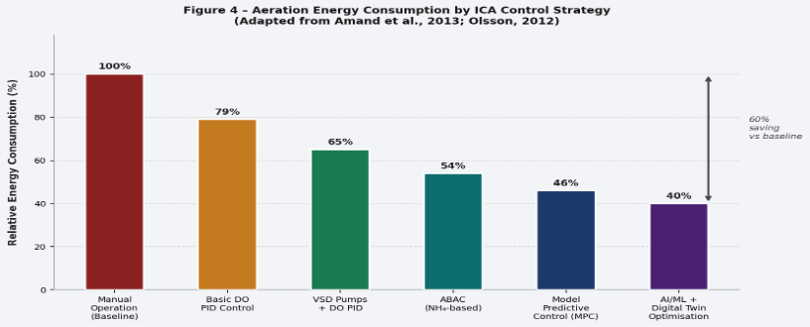
Figure 5: Aeration Energy Consumption by ICA Control Strategy (adapted from Amand et al., 2013; Olsson 2012)

Artificial Intelligence, IoT and Digital Twins
Machine learning models trained on historical SCADA data have demonstrated capability to predict effluent quality parameters several hours ahead, enabling pre-emptive rather than reactive control (Hao et al., 2022). However, three limitations must be critically acknowledged. First, model performance is bounded by training data quality; sparse, noisy or sensor-failure-corrupted SCADA archives – common in older works – severely limit generalisation. Second, neural networks and ensemble models are inherently opaque, raising legitimate concerns from both operators and regulators about the auditability of control decisions made by 'black-box' algorithms (Alex et al., 2020). Third, transfer learning between sites with different configurations and loading profiles remains an unsolved problem. Explainable AI (XAI) methods are an active research frontier that may address the auditability barrier.
Low-Power Wide-Area Network (LPWAN) technologies – particularly LoRaWAN – enable battery-powered IoT sensors to transmit data over several kilometres without cellular infrastructure, extending real-time monitoring to combined sewer overflow (CSO) structures, remote pumping stations and sewer network assets (Xu et al., 2014). Digital twins couple IWA Activated Sludge Models (ASM1, ASM2d) with live SCADA data feeds to maintain a continuously synchronised virtual replica of the physical plant, enabling operators to simulate process responses to proposed changes before live implementation and underpinning MPC strategies (Flores-Alsina et al., 2018). United Utilities and Southern Water have both piloted digital twin deployments with reported improvements in process stability and predictive maintenance capability. Widespread adoption is constrained principally by the computational infrastructure and data governance investment required, rather than by technical maturity.

Conclusion
ICA technology has transformed wastewater treatment from a reactive, manually managed process into a sophisticated automated system capable of delivering consistent regulatory compliance at industrial scale. The progression from basic PLC-based discrete control through closed-loop PID, SCADA supervision, ABAC and MPC to AI-driven predictive optimisation represents not merely a sequence of technological substitutions but a qualitative shift in what automated systems can achieve: from control of known disturbances to anticipation of unknown ones.
The quantitative evidence presented in this report is unambiguous: appropriate ICA investment reduces aeration energy by up to 60%, directly mitigating both operating cost and carbon emissions. However, three critical challenges must be addressed for the sector to fully realise this potential. First, sensor reliability – particularly in biofouling-prone environments – remains a practical constraint that limits the fidelity of all higher-level control strategies; investment in self-cleaning instrumentation and robust calibration regimes is therefore a prerequisite rather than an option. Second, the cybersecurity risks introduced by networked SCADA and cloud integration require governance commensurate with the safety-critical nature of the infrastructure they control; NIS Regulations provide a minimum framework, but leading practice demands proactive OT security architecture. Third, the deployment of AI in safety-critical control must be accompanied by advances in explainability sufficient to satisfy both operator acceptance and regulatory scrutiny. The convergence of these conditions – reliable measurement, secure architecture, explainable intelligence – defines the engineering frontier of autonomous wastewater treatment.

References
- Alex, J. et al. (2020) 'Machine learning in wastewater treatment: Current status and future perspectives', Water Science and Technology, 81(3), pp. 441–457.
- Amand, L., Olsson, G. and Carlsson, B. (2013) 'Aeration control – a review', Water Science and Technology, 67(11), pp. 2374–2398.
- Astrom, K.J. and Hagglund, T. (2006) Advanced PID Control. Research Triangle Park, NC: ISA.
- Boyer, S.A. (2010) SCADA: Supervisory Control and Data Acquisition. 4th edn. Research Triangle Park, NC: ISA.
- Crittenden, J.C. et al. (2012) MWH's Water Treatment: Principles and Design. 3rd edn. Hoboken, NJ: Wiley.
- Dragos (2021) ICS/OT Cybersecurity Year in Review 2021. Available at: https://www.dragos.com).
- Endress+Hauser (2022) pH Measurement in Wastewater Treatment: Application Note. Reinach: Endress+Hauser.
- Environment Agency (2022) Environmental Permitting Guidance: Water Discharge Activities. Bristol: Environment Agency.
- Flores-Alsina, X. et al. (2018) 'Modelling, simulation and control of a wastewater treatment plant', Water Science and Technology, 77(5), pp. 1158–1164.
- Gray, N.F. (2010) Water Technology: An Introduction for Environmental Scientists and Engineers. 3rd edn. Oxford: Butterworth-Heinemann.
- Hach (2022) Dissolved Oxygen Measurement Technology Selection Guide. Loveland, CO: Hach Company.
- Hao, X. et al. (2022) 'Artificial intelligence for wastewater treatment: A review', Bioresource Technology, 348, 126879.
- IEC (2016) IEC 61511: Functional Safety – Safety Instrumented Systems for the Process Industry Sector. Geneva: IEC.
- ISA (2012) ISA-75.01.01: Flow Equations for Sizing Control Valves. Research Triangle Park, NC: ISA.
- ISO (2015) ISO 14001:2015 Environmental Management Systems – Requirements with Guidance for Use. Geneva: ISO.
- Liptak, B.G. (ed.) (2003) Instrument Engineers' Handbook: Process Measurement and Analysis. 4th edn. Boca Raton, FL: CRC Press.
- NCSC (2022) Operational Technology Cyber Security Guidance. London: National Cyber Security Centre.
- Ofwat and Environment Agency (2022) Net Zero and the Water Industry: Joint Statement. Birmingham: Ofwat.
- Olsson, G. (2012) 'ICA and me – a subjective review', Water Science and Technology, 65(4), pp. 673–682.
- Omega Engineering (2023) Electromagnetic Flow Meter Technology Guide. Available at: https://www.omega.co.uk.
- Petruzella, F.D. (2017) Programmable Logic Controllers. 5th edn. New York: McGraw-Hill Education.
- Tchobanoglous, G., Burton, F.L. and Stensel, H.D. (2014) Wastewater Engineering: Treatment and Resource Recovery. 5th edn. New York: McGraw-Hill.
- Water UK (2023) Water and Wastewater Industry Overview. Available at: https://www.water.org.uk (Accessed: 10 April 2025).
- WEF (Water Environment Federation) (2010) Design of Municipal Wastewater Treatment Plants. 5th edn. Alexandria, VA: WEF Press.
- Xu, L.D., He, W. and Li, S. (2014) 'Internet of Things in industries: A survey', IEEE Transactions on Industrial Informatics, 10(4), pp. 2233–2243.

