Qualification: CIPD Diploma in Applied Human Resources

Module Name: Developing Professional Practice in Human Resources

Word Count: 996

Student Name: Stephanie Rayner
Student Number: 1907192
CIPD Membership Number: 55478507

By signing below, I confirm that the work/evidence presented is my own, unaided work. I understand the regulations pertaining to candidate malpractice and the action that may be taken as a result.

Signed:

Date: 13th January 2020

Developing Professional Practice in Human Resources

LO2 - Understand the range of HR Roles and behavioural requirements of HR professionals

It is important for an organisation to understand the valued contribution that HR Professionals makes to the overall aims and objectives.

HR professionals are at the centre of driving change within an organisation by understanding and communicating the value of its employees and empowering people to thrive within their specific roles. Providing opportunities to support all professionals to champion better work and working lives, (CIPD, 2019).

The CIPD Profession Map outlines the activities, knowledge and behaviours required to become a successful HR professional, (CIPD, 2015). The eight behaviours that support good practice within professionalisms are outlined within the Profession Map below. The level of responsibility within the role and area of work will determine what behaviour to focus on.
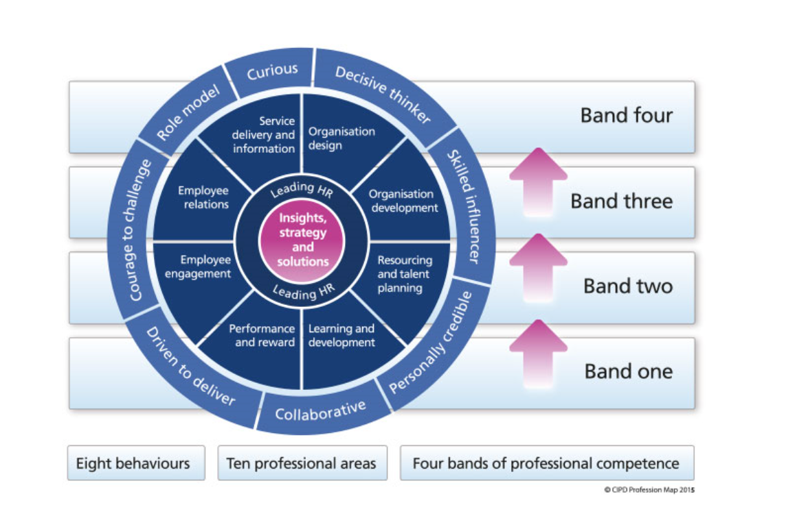

Linked to the behaviours are the four bands identifying career progression when structuring HR capability within an Organisation for individuals, teams and at a strategic level. Band 1 being the start of a career in HR to Band 4 working at a strategic level and having an influence on the organisation as a whole.

At the centre of the Profession Map sits two core professional areas, ‘Insights, Strategy and Solutions and Leading HR’ which are applicable within any HR career whether that being within band 1 or band 4. In addition, there are eight technical professional areas which will link to a core area dependant on the specialism i.e. employee engagement. People are the main asset within an organisation and therefore need to understand the contribution they make to their work, colleagues and the organisation. Encourage good leadership and management led from a strategic level.

All eight behaviours are required at any stage of a career within HR and allows people to be professional within their field.

- Curious – Needs to be eager to learn, finding out information about the organisation, and how HR can add value. It would be good practice to have an understanding or the organisation, ask questions about the customers, going to speak to them face to face to have an understanding of the product and how it sells. This would enable HR to lead the organisation in serving those customers, HR Magazine, (2014).
- Decisive thinker – Required to analyse data and understand information in addition to making decisions quickly.
- Skilled influencer – Influencing people to gain the required commitment and support. Being ‘business savvy’ to enhance credibility within the organisation and therefore have the ability to influence rather than react, Johns and Perkins (2016).
- Personally credible – Providing advice and support to the Organisation, building trust to recognise the value of HR.
- Collaborative – Proving how working with a range of people both internal and external to the Organisation can be successful. Undertake research to increase professional knowledge to identify ‘new thinking’.
- Driven to deliver – Demonstrating the purpose of HR to meet the aims and objectives of the Organisation.
- Courage to challenge – Have confidence in own ability to competently challenge in confrontational situations. HR professionals are required to review their practices to determine whether the work is or isn’t adding value to the organisation. This will require courageous conversations and difficult decisions, People Management (2018).
- Role model – Act professionally in line with the CIPD Code of Professional Conduct having an impartial view in line with legislation.

It is important to recognise that the HR function has evolved over the years from being an administrative role to taking responsibility for strategic elements including Organisational Development, Talent Management etc. The change of direction for HR requires different kinds of management having varying levels of impact on an organisation, Personnel Today (2018). HR professionals act as differentiators, making people feel valued, respected and providing feedback so employees feel stimulated within their roles.

As a result of this change, the CIPD have introduced a new Profession Map 2018 including three new professional values to improve workplace decisions. Two new specialist knowledge areas to learn from: people analytics and diversity and inclusion. 14 core knowledge and behaviour areas to develop expertise on people, work and change.

‘The new Profession Map enables HR professionals to take a fresh, critical look at people functions within the Organisation’ (CIPD, 2019).

‘According to Lester (2010), as cited in Perkins and Woodhams (2016)’ a professional does not need to be a member of a professional body, they are recognised as an expert with specialist knowledge within their area of work having an independent view and making a commitment to a set of principles.

Other professionals have a formal membership structure, controlled by a Governing Body and are required to adhere to specific criteria’s i.e. Teaching Profession must be registered with the Education Workforce Council. If professionals fail to meet the standards as set out within the professional body, they will fail as a member and will be subject to disciplinary action and required to leave.

With regard to HR, CIPD is the recognised professional body within the UK and as such, individuals practicing in HR should act in accordance with both the CIPD Code of Conduct and ACAS Code of Practice, which set the minimum standard of fairness that workplaces should follow, ACAS (2019).

In addition to the above, professionalism can also be defined in relation to an individual’s work ethic and someone who carries out their duties and responsibilities to a high standard.

According to Johns, T Perkins, G (2016), there are four elements to consider in relation to HR professionalism:

- Managing self – Ability to manage your own skills, knowledge and behaviour
- Managing in groups/teams – Working with other stakeholders to resolve problems
- Managing upwards – Work closely with senior managers within an organisation
- Managing across the organisation – Communication skills to influence Managers, outlining the value to be added from HR activity.

HR professionals should continue to use the HR profession map to develop professional practice which drives at the heart of what it means to be an HR professional.

Bibliography

ACAS (2019) Codes of Practice. Available at: https://www.acas.org.uk/codes-of-practice (Accessed 27th December 2019).

CIPD (2015) Profession Map 2013. Available at: https://www.cipd.co.uk/learn/profession-map/2013-profession-map (Accessed 26th December 2019).

CIPD (2019) Profession Map 2018. Available at: https://peopleprofession.cipd.org/profession-map (Accessed 27th December 2019).

CIPD (2019) Why work in the people profession. Available at: https://www.cipd.co.uk/careers/why-work (Accessed: 26th December 2019).

HR Magazine (2014) HR needs to harness curiosity. Available at: https://www.hrmagazine.co.uk/article-details/hr-needs-to-harness-curiosity (Accessed 27th December 2019).

Johns, T Perkins G. (2016) ‘Developing Professional Practice’, in Taylor S, Woodhams C. (ed.) Studying Human Resource Management. 2nd Edition, London:CIPD.

People Management (2018) HR urged to have ‘courageous conversations’ to help businesses achieve goals. Available at https://www.peoplemanagement.co.uk/news/articles/hr-urged-courageous-conversations-help-businesses-achieve-goals (Accessed 27th December 2019).

Personnel Today (2018) How HR has evolved. Available at: https://www.personneltoday.com/hr/how-hr-has-evolved/ (Accessed 27th December 2019).

Qualification: CIPD Diploma in Applied Human Resources

Module Name: Developing Professional Practice in Human Resources

Word Count: 1072

Student Name: Stephanie Rayner
Student Number: 1907192
CIPD Membership Number: 55478507

By signing below, I confirm that the work/evidence presented is my own, unaided work. I understand the regulations pertaining to candidate malpractice and the action that may be taken as a result.

Signed:

Date: 13th January 2020

LO4 – Be able to work collaboratively with others, as a member of a team or working group

HR Professionals are required to work with individuals within their immediate team as well as individuals and groups within other areas of work. According to Johns and Perkins (2016), it is important to recognise that poor teamwork can result in a decrease in productivity within an organisation and lack of motivation for individuals. It is therefore important to understand the different dynamics within group situations.

‘According to Huczynxki and Buchanan (2010), as cited in Johns and Perkins (2016)’, there are various forms of teams within an organisation including the following:

- Advice teams e.g. review committees
- Action teams – e.g. negotiating teams
- Project teams – e.g. planning or research teams
- Production teams – e.g. assembly teams, operational teams

A team involves a number of individuals sharing knowledge and working towards a common goal. Organisations should utilise the different personalities, knowledge and life experiences that individuals bring to the team, acknowledging different views and approaches, which could have a positive impact on the organisation, but also recognising that these differences could lead to confusion and conflict within a team, Watson (2014).

HR professionals could be required to work within a number of different teams at any one time in addition to liaising with relevant stakeholders when undertaking day-to-day duties.

There are a number of similarities between teams and groups including the requirement to undertake different tasks, identify specific roles and mainly the fact that both are making a contribution to the overall aims and objectives of the Organisation, Watson (2014).

Group Dynamnics
A definition cited on Mindtools Website (No date) states “Kurt Lewin, a social psychologist and change management expert, is credited with coining the term "group dynamics" in the early 1940s. He noted that people often take on distinct roles and behaviors when they work in a group. "Group dynamics" describes the effects of these roles and behaviors on other group members, and on the group as a whole.”

Two well-known theories are ‘Tuckman’s theory of team development and Belbin’s theory of team roles, which are briefly explained below:

Tuckman’s theory as cited on Mindtools (no date), outlines the 4 stages of team development:

- Forming – This is the initial stage when the team is formed, individuals are getting to know and understand each other. The Manager plays a vital role at this stage as roles and responsibilities are unclear which results in some uncertainty within the Team.
- Storming – People may have different working styles/methods, which could cause conflict within the team. Some people may resist undertaking tasks, which could cause stress to others.
- Norming – Going along smoothly, roles and responsibilities defined. Relationships start to form building trust within the team and people willing to ask for help.
- Performing – Team performs without guidance, Manager can delegate the work and concentrate on developing team members.

Belbin’s Team Roles Belbin (2020), identifies nine clusters of role behaviours required within a high performing team as described below:

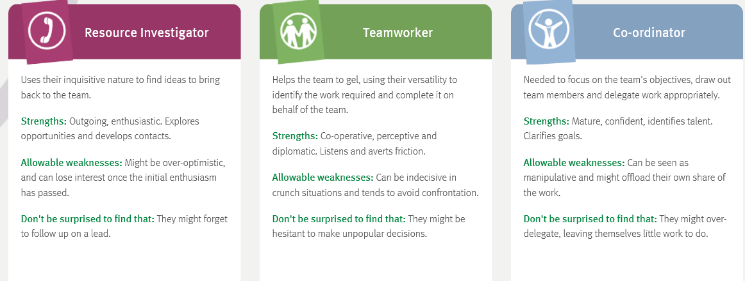
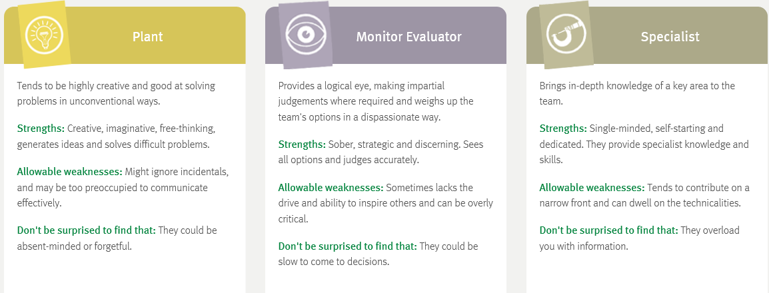
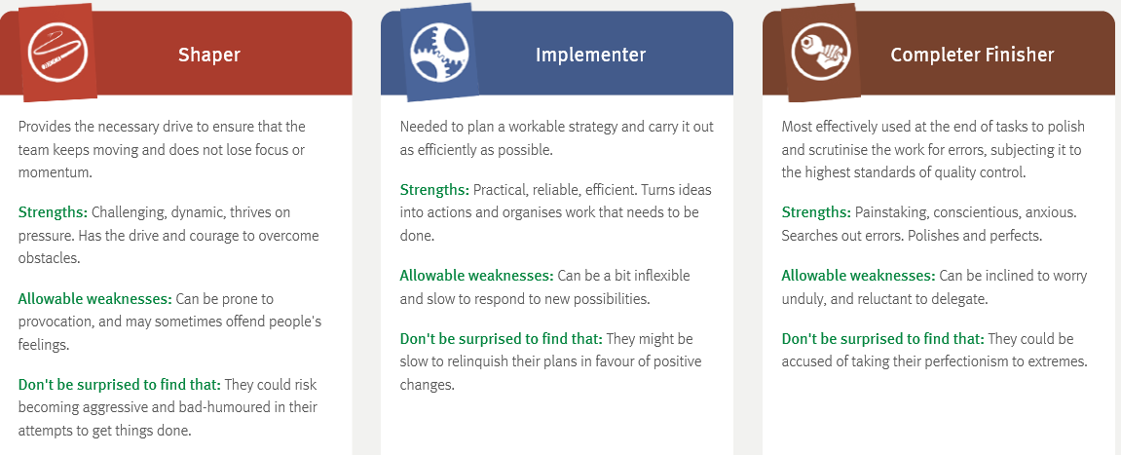

It is important for a team to understand the level of involvement required from the team manger during the various stages.

A group with positive dynamics take accountability for decisions made within the group, they have trust in one another and work together to reach the end result. Whereas a group with poor dynamics, brings disruption and therefore may not agree, making the wrong choices because individuals could not work together to explore all avenues.

According to Johns and Perkins (2016), there are a number of factors that HR professionals should be aware of which affected the dynamic of group environments including:

- Nature of individuals within the group
- Leadership
- Structure of the group
- Power and status issues
- Communication structures or processes

Groups are influenced by leaders within an organisation which can affect the effectiveness of the group Huczynxki and Buchanan (2010). HR professionals need to recognise that people have different agendas which will influence the decision making process.

Managers should define aim and objectives and ensure roles and responsibilities are established from the outset so there is a clear direction for the group. Another key factor is to discuss effective communication methods i.e. meetings, emails, shared folders to ensure a consistent approach from all members of the group.

One of the strengths within my immediate team has always been working together and the work ethic of individuals however, following a restructure, new roles were created and roles downgraded with resulted in us being required to compete against each other via interview. The outcome of this caused animosity and friction within the Team. After going through the change process, new roles have now been defined with clear direction from Management and the Team is at a position where relationships have been re-established and individuals have accepted the outcome of the restructure.

Political behaviour and impact
The definition of Politics by Horn (2009) is ‘Taking a particular view or position with the intention of personally gaining from that position’.

It is therefore important for HR Professionals to recognise that people can act in their own self-interest, come from different perspectives, and therefore need to find out who can help them.

According to Owen, J (2017), managers exist in three dimensions:

- EQ, Emotional – Having empathy and dealing with sensitive situations
- IQ Intellectual – Measuring Intelligence
- PQ, Political – Understanding power and political influences

Having an understanding of how power and influence works within political environment e.g. Local Government is crucial to being successful as a HR professional as political influence is more visible. However, this could be seen as a disadvantage as it is more difficult to overcome the subversive and less tangible elements of political influence.

Within Local Government, political influence is never far from the surface and this can be seen in the need to involve Unions in all areas of HR i.e. contractual policy development.

Knowing who has power and influence at a decision making level can be advantage to HR specifically where HR doesn’t have a seat at a strategic level. Therefore, a need to develop influencing techniques is necessary but this can also be a disadvantage as if the individual with power may have a specific view, it is more difficult to influence and change the way of thinking.

In summary, HR professionals require a wide range of skills, competencies and behaviours to work in a complex environment. Power and influence are key management concepts within all organisations whether you are a manager or a leader.

Bibliography

Belbin (2020). ‘The Nine Belbin Team Roles’. Available at: https://www.belbin.com/about/belbin-team-roles/ (Accessed 7th January 2020).

Huczynski, A. A and Buchanan, D. A (2010) Organisational behaviour. 7th Edition, London:FT/Prentice Hall.

Johns, T Perkins G. (2016) ‘Developing Professional Practice’, in Taylor S, Woodhams C. (ed.) Studying Human Resource Management. 2nd Edition, London:CIPD.

MindTools (no date). ‘Forming, Storming, Norming and Performing’. Available at: https://www.mindtools.com/pages/article/newLDR_86.htm (Accessed 2nd January 2020).

MindTools (no date). ‘Improving Group Dynamics: Helping Your Team Work More Effectively’. Available at: https://www.mindtools..com/pages/article/improving-group-dynamics.htm (Accessed 2nd January 2020).

Owen, J. (2017) ‘How to Manage’. 5th edn. London: Pearson.

Watson, G. (2014) ‘Effective Team-building and Communication’, in Watson G, Reissner S. Developing skills for business leadership. CIPD.

