

Marketing Management Assessment 2

Student Name:HASHIL AMBALAPARAM BAN
Student ID:2241163
Lecturer Name: TUSHARA BALENDRAN
Submission Date:01/09/23

Executive Summary
The report is based on the concept of marketing management and in this regard, Rolex has been chosen for conducting the report. The overview of the organisation has been detailed in the first part of the report. The external factors have been discussed with the help of PESTLE analysis. Porter's five forces have been analysed in the next part of the report. Along with that, the SWOT analysis has been done to analyse the internal factors of the company. Extended analysis regarding STP has been done including the extended marketing mix strategies including 7Ps. Along with that, the strategies of the Ansoff matrix and the stages of the product life cycle model have been discussed in the context of the company. Some recommendations are also provided in terms of improving the marketing strategies of the company along with avoiding possible threats.
Table of Contents
1.0 Introduction 4
2.0 Question A 4
2.1 Overview of Organisation 4
2.2 PESTLE Analysis 5
2.3 Porter’s Five Forces Model 7
2.4 SWOT Analysis 7
2.5 Extended STP Analysis 9
2.6 Extended Marketing Mix 9
3.0 Question B 10
3.1 Ansoff Matrix 10
3.2 Product Life Cycle Model 11
4.0 Recommendations 12
5.0 Conclusion 12
6.0 Reference List 13

1.0 Introduction
Marketing management is one of the most necessary factors of an organisation in which it can promote its business, products, services as well and brands. Appropriate promotional tactics, attractive advertisements as well and digital marketing all are included in the concept of marketing management (Amin and Priansah, 2019). To conduct the report, Rolex is chosen and the detailed overview of the organisation will be explained in the initial section of the report. The SWOT and PESTLE analysis will also be done to evaluate the internal and external factors. Porter's five forces analysis will be done as the external environment analysis of the company. Along with that, extended strategies of the marketing mix including 7Ps and extended STP strategies will be explained in the report. Strategies of the Ansoff matrix and the stages of the product life cycle will also be detailed in the context of the company. Some recommendations will also be provided in terms of improving marketing strategies as well as avoiding possible threats to the company.

2.0 Question A

2.1 Overview of Organisation
Rolex is one of the most effective as well as leading wristwatch manufacturing organisations in the world. It is mainly based in Switzerland and the headquarters of the company is situated in Geneva (Rolex, 2023). The company has nearly 4,000 manufacturers in over 100 international countries and the organisation also manufactures nearly 800,000 watches per year (Forbes, 2023). It also introduced a waterproof watch in the year 1926 for the first time in the world. Roger Federer, Phil Mickelson and Tiger Woods are some of the athletes who prefer Rolex watches.
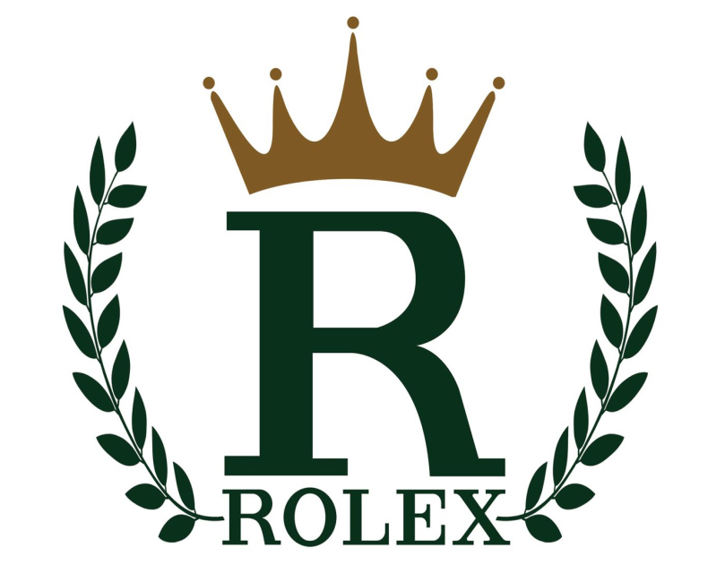
Figure 1: Logo of Rolex
(Source: Rolex logo, 2023)

2.2 PESTLE Analysis
Political: Switzerland is a democratic country and it has 26 federated states. The government of the country allows its citizens to give their opinions on their personal affairs through national referendums. The government has been helpful to medium and small-sized organisations by providing them with financial support (Zabolotskaya, 2020). It is known as the safest nation in the world and the government is supportive towards business organisations as well. The political factor of Switzerland has impacted Rolex positively.
Economical: Switzerland is an economically strong country and it represented 58% of the economy of the world in 2022. The GDP rate of Switzerland in 2022 was $807.71 billion (Trading Economics, 2019). The country has a well-maintained and highly developed infrastructure with a macro environment. Undoubtedly the strong economic culture has helped to flourish Rolex’s business.
Social: The country has an estimated 8.6 million citizens mostly wealthy people. Rapid modernisation has been witnessed by the citizens of Switzerland. People from outside often experience difficulties coping with the local citizens. Asylum seekers and refugees work in the labour market without any decent work opportunities (‌Udayar et al., 2021). The social situation has affected Rolex badly as the organisation cannot embrace cross-cultural environments in its workplace.
Technological: Switzerland is technically very much evolved and the country has been the winner of several Nobel prizes for its technology innovation. The country has access to various social media such as Facebook and Twitter. The other active digital platforms are Instagram and YouTube. Undoubtedly the technical advancements have been helpful for Rolex to prosper in its digital marketing procedures and the company has gained a lot of customers through social media (Nuseir and Aljumah, 2020). With the help of advanced technology, the company has been able to manufacture high-quality watches.
Legal: The country has an independent judiciary and Switzerland is known for its federal government system. The citizens are always protected by the law and the foreign affairs are maintained properly. However, as per the gender equality act, both male and female workers get equal pay which has boosted the confidence of female employees. The legal regulations for the employees have affected Rolex positively. The female workers feel safe and they get the same amount of money for working the same hours as their male colleagues.
Environmental: The country is seriously concerned about its environment and most of the citizens are eco-friendly. Organisations also follow this and try their level best to manufacture environment-friendly products. Rolex needs to follow environment-related policies to attract eco-friendly customers.
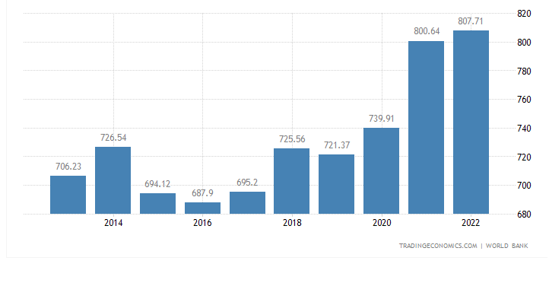
Figure 2: Switzerland's Gross Domestic Product
(Source: Trading Economics, 2019)

2.3 Porter’s Five Forces Model
Threat of new entrants: Rolex’s products have high demand in the market. The brand image of Rolex is quite impressive and for any new organisation to earn this position is difficult which means the threat of new entrants is very low.
Competitive rivalry: Rolex has very few competitors in the market such as Omega, Breitling and Longines but they are equally reputed like Rolex which results in fierce competition.
The threat of new substitutes: Rolex produces high-quality watches by understanding the recent fashion trends (Team, 2023). The customers are highly satisfied with the products which means the threat from substitutes is significantly less.
Bargaining power of consumers: The consumers of Rolex are keen to buy luxurious products from the organisation and they have no problem paying large amounts for it. The bargaining power of the customers is low in Rolex.
Supplier’s bargaining power: The suppliers feel proud when they get associated with a brand like Rolex. It enhances their reputation in the market and thus, they do not want to switch to other companies (Team, 2023). The bargaining power of suppliers in Rolex is quite low.
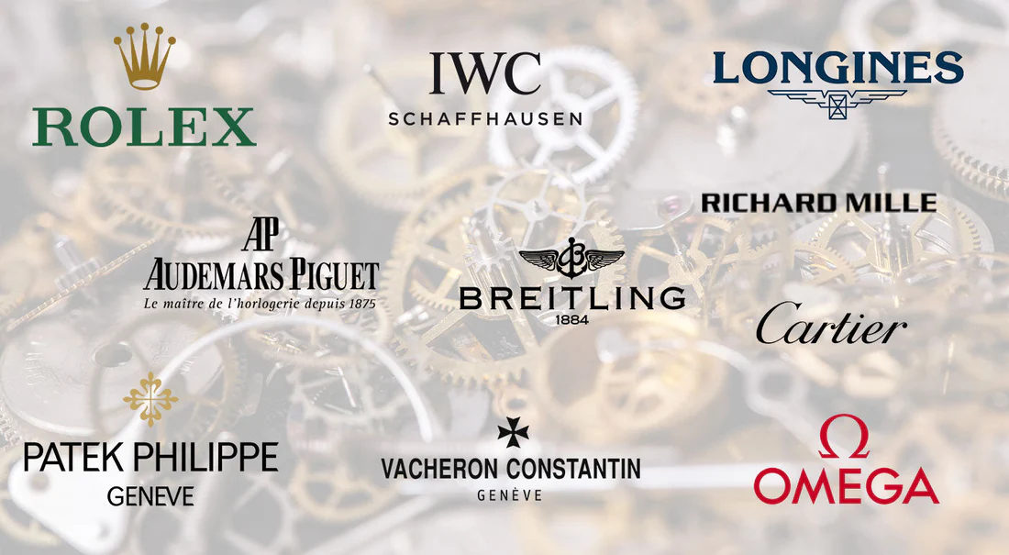
Figure 3: The Competitors of Rolex
(Source: DevIFLW, 2023)

2.4 SWOT Analysis
Strengths: Rolex is a leading industry in the sector of watch manufacturing in the world. The company has a great global presence in the world of sports including endorsements in motorsports, golf, yachting and tennis (Forbes, 2023). The company has more than 14,000 staff all over the world. The strong brand image and reputation of the company majorly influence customer satisfaction and loyalty among both the general people as well as the watch enthusiasts. The brand value of the company is valued at nearly 8.35 billion dollars in the year 2022 and it is constantly increasing every year (Strategyfinders, 2023). Moreover, it also produces classic designs which help the organisation to increase customer engagement.
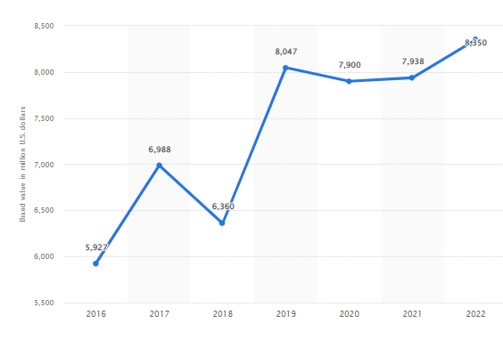
Figure 4: Brand Value of Rolex
(Source: Strategyfinders, 2023)
Weaknesses: Rolex mainly focuses on manufacturing mechanical wristwatches and it creates a limit for the brand to appeal to customers who now prefer smartwatches and other affordable watches in recent times. Along with that, the watches of the company belong to a high price range that can create barriers for some potential consumers to buy expensive items (Ukhanov, 2022). Therefore, it creates a lack of transparency that drives the company to face uncertainty issues with stakeholders and it also reduces the ability of the organisation to build trust and strong relationships with its customers.
Opportunities: The company has great opportunities to expand its business in the fastest growing and emerging countries such as China, Hong Kong, Germany and many more. The countries are seeking luxury watches and, in that case, Rolex can easily achieve significant success by doing business in these countries. Moreover, the company has the ability in terms of focusing on product diversification and it can also develop smartwatches which will be more appealing to the people of the digital era.
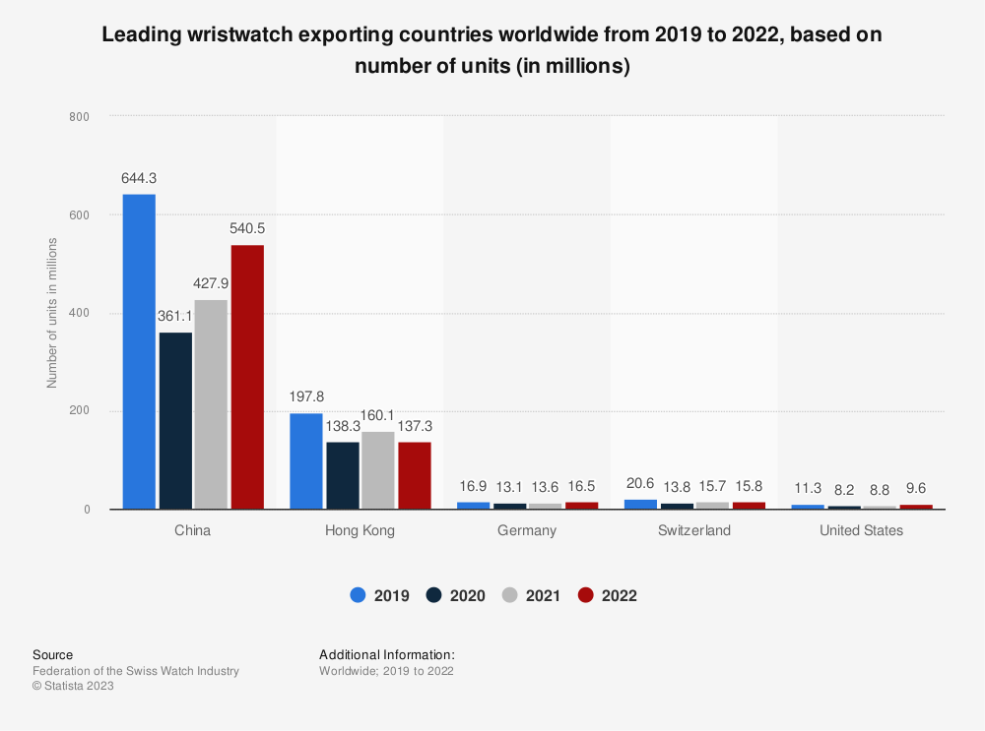
Figure 5: Expanding Opportunity of Rolex in Emerging Countries
(Source: Statista, 2019)
Threats: The company may face several threats due to high competition in the global business market. Along with that, economic uncertainty and downturns also affect its business. Changes in consumer purchasing behaviour and technological disruption can also impact the business of Rolex.

2.5 Extended STP Analysis
STP marketing is known as a three-step model where the three steps are segmentation, targeting and positioning. Rolex has its business in more than 116 countries such as the UK, Germany, USA and India. The organisation has divided its consumers with the help of demographic factors such as age, social class and income. The company mainly targets those people who are traditional and love to buy elegant products (Tashfia, 2021). Also, Rolex has focused on delivering high-quality products and they do not focus on price that much. The positioning of the brand has the main purpose of creating interest in people’s minds who are still unaware of the watch. The positioning of the brand has been possible by advertisements on digital media.

2.6 Extended Marketing Mix
Rolex follows mainly a 7P’s marketing mix which includes product, price, promotion and place whereas the other extended marketing mixes are people, process and physical evidence. The organisation has a good customer base who are based everywhere in the world. The employees of Rolex are hard-working and they are keen to produce high-quality and technically advanced watches (Schultz and Seele, 2022). It helps the company to obtain more customers who are not concerned about investing large amounts of money to get good products. Rolex has sold its products in many countries so globalisation is its strategy to expand its business in new places. The physical stores are beautifully decorated so that the consumers can see the products on display and can attract more customers.

3.0 Question B

3.1 Ansoff Matrix
Market penetration: The strategy of market penetration includes the sale of existing products and services to existing markets. In this regard, Rolex focuses on increasing the capacity or production, marketing investment, large distribution, competitive pricing strategy as well and reducing operational costs.
Market development: With the strategy of market development, Rolex can increase its business growth by selling its existing products into new markets (Donahue, 2022). In this regard, the company can strengthen the sector of R&D, enhance regional and international expansion, categorise new segments of customers as well as increase brand awareness.
Product development: The strategy of product development includes the selling of new products into the existing markets. In this regard, the company can modify its existing products, introduce new products, make strategic partnerships and enhance product quality.
Diversification: Diversification refers to the process of selling new products and services to the new targeted markets (Ansoff Matrix, 2023). In this regard, the company can do vertical and horizontal diversification including diversification towards new businesses to remain competitive, innovative as well as effective in the global business market.
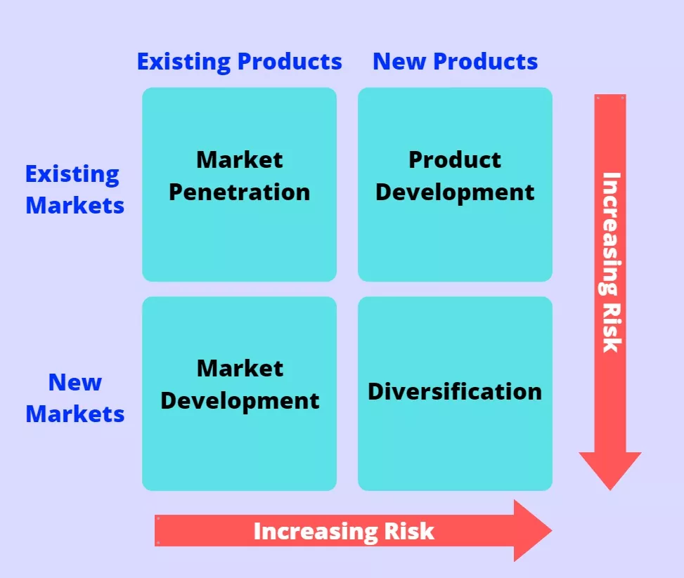
Figure 6: Ansoff Matrix
(Source: Ansoff Matrix, 2023)

3.2 Product Life Cycle Model
The model of the product life cycle includes four stages such as maturity, introduction, decline as well and growth. In the stage of introduction, customers are introduced to the new products. Rolex gains impactful financial outcomes at this stage as the process of selling tends to be minimal, and promotional pricing may be minimal to lead to customer engagement. In the stage of growth, the demand for new products is noticed including the rise in production, expansion as well and availability. During this stage, the products and services become more recognisable and popular. After that, in the maturity stage, the amount of profit can be evaluated in terms of the costs of product manufacturing as well as market decline. Rolex can start to innovate its products in this stage. In the stage of decline, it is evaluated whether the products may lose or not. Therefore, the decline starts from here if the market share of the product is reduced.
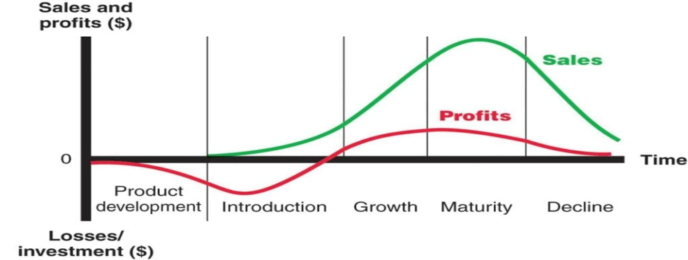
Figure 7: Stages of Product Life Cycle Model
(Source: Product Life Cycle Model, 2019)

4.0 Recommendations
Enhancing adaptability of changes in consumer behaviour: In the recent era of modern businesses, people are likely to go with current trends. Therefore, it impacts their purchasing behaviour. In this regard, Rolex must enhance its ability to handle the changes and manufacture watches that are preferable to customers. Therefore, it will enhance customer engagement and satisfaction within the organisation (Roggeveen, Schweiger and Grewal, 2023). Moreover, it will also help the company to increase revenue and hold its strong brand image.
Implementing affordable price ranges: Customers of the recent era are very aware in terms of purchasing affordable products. Therefore, the high price range of Rolex creates several barriers to enhancing sales profit and customer engagement within the organisation. In this regard, the company needs to implement an affordable pricing strategy in terms of running both manufacturing processes and marketing. Therefore, it will help the organisation to develop its potential customer base and the interest level of the customers to buy its products.

5.0 Conclusion
Therefore, in conclusion, it can be stated that marketing management is beneficial for making useful strategies. It is used as a powerful tool for every business organisation and helps to promote a business. Rolex is a Swiss watch-producing company and the report gave a small overview of it. The external factors were described with the help of PESTLE analysis. External environment analysis such as Porter’s five forces is done in the next part of the report. The internal factors of Rolex were discussed by reflecting on the SWOT analysis. Along with that, strategies of extended STP analysis and marketing mix are also discussed. The Ansoff matrix is detailed in the context of the company including detailing all the stages of the model of product life cycle. In the end, a few suggestions for further business development were recommended here.

6.0 Reference List
Amin, M. and Priansah, P., (2019). Marketing communication strategy to improve tourism potential. Budapest International Research and Critics Institute-Journal (BIRCI-Journal), 2(4), pp.160-166. Available at: https://pdfs.semanticscholar.org/5563/334c881bb2a151493ffdc805c7e0a8915281.pdf
Ansoff Matrix., (2023). Ansoff Matrix: 4 main strategies. [online] EconPosts. Available at: https://www.econposts.com/business-management/ansoff-matrix/.
DevIFLW., (2023). Top Swiss Watch Brands 2022 - A Report By Morgan Stanley. [online] IFL Watches. Available at: https://iflwatches.com/blogs/news/top-swiss-watch-brands-2022-a-report-by-morgan-stanley.
Donahue, K., (2022). Marketing: An Introductory Text. Available at: https://scholarworks.iupui.edu/bitstream/handle/1805/30367/Donahue_Marketing_An_Introductory_Text.pdf?sequence=1&isAllowed=y
Forbes., (2023). Rolex | Company Overview & News. [online] Available at: https://www.forbes.com/companies/rolex/?sh=369ed0f95a26 [Accessed 18 Aug. 2023].
Nuseir, M.T. and Aljumah, A., (2020). The role of digital marketing in business performance with the moderating effect of environmental factors among SMEs of UAE. International Journal of Innovation, Creativity and Change, 11(3), pp.310-324. Available at: https://www.researchgate.net/profile/Mohammed-Nuseir/publication/340874998_The_role_of_digital_marketing_in_business_performance_with_the_moderating_effect_of_environmental_factors_among_SMEs_of_UAE_International_Journal_of_Innovation_Creativity_and_Change_wwwijiccnet_Volume/links/5eb4716c299bf1287f750cf0/The-role-of-digital-marketing-in-business-performance-with-the-moderating-effect-of-environmental-factors-among-SMEs-of-UAE-International-Journal-of-Innovation-Creativity-and-Change-wwwijiccnet-Volum.pdf
Product Life Cycle Model., (2019). Product Life Cycle Stages. [online] Advergize. Available at: https://www.advergize.com/marketing/product-life-cycle-stages/.
Roggeveen, A.L., Schweiger, E.B. and Grewal, D., (2023). In-Store Communications: Understanding the Mundane, the Bright Sides, and the Unexpected. Australasian Marketing Journal, p.14413582231189896. Available at: https://journals.sagepub.com/doi/pdf/10.1177/14413582231189896
Rolex., (2022). How many Rolex Authorized Dealers are There in the World? [online] Millenary Watches. Available at: https://millenarywatches.com/how-many-rolex-authorized-dealers-in-the-world/.
Rolex., (2023). Official Rolex Website. [online] Available at: https://www.rolex.com/en-us.
Rolexlogo., (2023). Available at: https://1000logos.net/wp-content/uploads/2017/05/Color-Rolex-Logo.jpg [Accessed 18 Aug. 2023].
Schultz, M.D. and Seele, P., (2022). " Some of my Customers […] Take off Their Rolex Before a Client Meeting" Luxury Display at Work and the Social (Re) Construction of the Organizational Image. Luxury, 9(1), pp.5-34. Available at: https://www.tandfonline.com/doi/pdf/10.1080/20511817.2022.2045544
Smith, P., (2022). Rolex: brand value worldwide 2016-2019 | Statista. [online] Statista. Available at: https://www.statista.com/statistics/980735/rolex-brand-value-worldwide/.
Statista., (2019). Leading watch exporting countries worldwide by number of units 2017 | Statistic. [online] Available at: https://www.statista.com/statistics/288265/leading-watch-exporting-countries-based-on-number-of-units/.
Strategyfinders., (2023). Rolex Swot Analysis - Swot Analysis By Marketing Experts. [online] Available at: https://www.strategyfinders.com/rolex-swot-analysis/.
Tashfia, R., (2021). Internship Report on" Marketing Strategies and Activities of eWorld Brands". Available at: http://dspace.uiu.ac.bd/bitstream/handle/52243/2299/Marketing%20Strategies%20and%20Activities%20of%20eWorld%20Brands.pdf?sequence=1&isAllowed=y
‌Team, M.S., (2023). Rolex Porter Five Forces Analysis. [online] MBA Skool. Available at: https://www.mbaskool.com/five-forces-analysis/companies/18294-rolex.html.
Trading Economics., (2019). Switzerland GDP. [online] Tradingeconomics.com. Available at: https://tradingeconomics.com/switzerland/gdp.
‌Udayar, S., Fedrigo, L., Durante, F., Clot-Siegrist, E. and Masdonati, J., (2021). Labour market integration of young refugees and asylum seekers: A look at perceived barriers and resources. British Journal of Guidance & Counselling, 49(2), pp.287-303. Available at: https://drive.google.com/file/d/1sR-TmVRBHhPtGerY8scz7bq9uenV9HQG/view
Ukhanov, D., (2022). Omnichannel experience in the luxury segment with a focus on watches and jewellery markets (Doctoral dissertation, Technische Hochschule Ingolstadt). Available at: https://opus4.kobv.de/opus4-haw/files/3602/I001318972Thesis.pdf
Yannick., (2023). Rolex OYSTER PERPETUAL DAY-DATE 40. [online] Watches News. Available at: https://www.watches-news.com/oyster-perpetual-day-date-40/ [Accessed 18 Aug. 2023].
Zabolotskaya, V.V., (2020). Government financial support and SME development in Switzerland. Available at: https://www.um.edu.mt/library/oar/bitstream/123456789/75520/1/Government%20Financial%20Support%20and%20SME%20Development%20in%20Switzerland.pdf

