Student Name | Dapaah Tweneboah
Module Code | LCMB 7003
Assignment Title | Strategic management
Lecturer Name | Amare Desta

Contents
Introduction 3
Emergence of Virtual Organisations 3
Planning among Virtual Organisations 4
Designing among Virtual Organisations 5
Leading in Virtual Organisations 6
Virtual Management Practices at Amazon 8
Conclusion 9
References 10
Appendix 12

Introduction
Since its conception, the idea of virtual organisations has been widely embraced, especially in the developed world. Even more, technological and internet advancements have overseen a continuous evolution of the concept, with more organisations adopting the idea of decentralised operations and becoming dependent on digital communication. The trend towards, and confidence in virtual organisations is best demonstrated by Amazon, which boasts as a leading e-commerce organisation. Amazon is considered a technological behemoth globally and continues to utilise virtual tools to sustain and enhance its competitiveness. In this regard, this paper provides a critical evaluation of the rise and existence of virtual organisations, with a special focus on Amazon, exploring the obstacles and opportunities associated with planning, designing, and leading in the increasingly competitive business world.

Emergence of Virtual Organisations
Virtual organisations are commonly regarded as a notable transition from the traditional business framework to the modern use of virtual technology in the business environment. In line with this, a virtual organisation can be defined as a network of entities or individuals who are geographically dispersed and collaborate using digital technologies to meet set goals and objectives (Shekhar 2006). Over the years, virtual organisations have grown in popularity due to technological and internet advancements that have helped enable seamless use across multiple locations. Amazon best exemplifies this aspect of virtual organisations, a fact that is best evidenced by its status as a leading e-commerce organisation not only in the US but also globally. As an e-commerce giant, Amazon boasts expansive operations across continents, characterised by a vast network of suppliers, branches, partners, and consumers (Flamand, Wisher, and Riley 2020). This network is coordinated via a complex digital infrastructure that allows the company to oversee virtual transactions and service delivery.

Planning among Virtual Organisations
Like most other virtual organisations, Amazon encounters distinct opportunities and challenges during its planning processes. This is contributed to by different factors, including technological demands and market demands.
Opportunities
To begin with, virtual organisations provide companies, such as Amazon, with significant opportunities when it comes to planning. Among these opportunities is the chance to recruit from a larger talent pool, as recruitment can be done globally (Nami 2008). For example, Amazon often takes this opportunity to recruit talent from across the globe, which offers access to a large pool of talent (Kantor and Streitfeld 2015). This ability comes with significant advantages that include the opportunity to enhance diversity, consequently strengthening creativity and innovation, considering that new employees come with varied skills, talent, and knowledge that benefit the organisation’s planning process.
On the other hand, virtual organisations have the advantage of employing advanced technologies such as artificial intelligence (AI) and complex data analytics tools that contribute towards informed and accurate planning (Nami 2008). This is evidenced by how Amazon employs AI technologies along with its numerous data resources to explore and evaluate market trends, consumer behaviour, and organisational performance to inform its planning (Kantor and Streitfeld 2015). It is through valuable data-driven AI insights that the company is able to acquire consumer and market information, thereby ensuring effective plans to enhance customer experiences. Thus, the organisation’s data-based strategy enables it to engage in proactive and strategic planning that allows it to meet the needs of the changing market dynamics, therefore remaining competitive.
Challenges
Virtual organisations also encounter planning challenges. For instance, organisations may find it challenging to establish and sustain effective and efficient communication. This is because virtual teams tend to be comprised of individuals from varied cultural backgrounds and regions, which may create obstacles to proper communication (Dulebohn and Hoch 2017). On the other hand, differences in time zones may hinder the synchronisation of communication, ensuring that it becomes a challenge to engage in real-time communications (Nami 2008). In line with this, Amazon commonly experiences communication challenges, especially when it comes to sourcing from the international market. Often, sellers encounter a language barrier when sourcing products overseas. At the same time, new employees from other regions may also experience communication challenges (Global Product Sourcing n.d). Nonetheless, the organisation addresses this challenge by ensuring the implementation of comprehensive communication technologies such as Amazon Web Services (AWS) or Amazon Chime, which are critical in promoting efficient communication across its platforms.
Another notable planning challenge is establishing an aligned planning process. Often, virtual organisations allow organisational teams to function with some level of freedom, often without significant supervision (Nami 2008). The problem with this is that it creates the risk of poor alignment of goals and objectives, as well as organisational strategies. To prevent this misalignment, Amazon has implemented comprehensive and elaborate standards of operations and guidelines that align with the key objectives and goals (Kantor and Streitfeld 2015). Besides, the organisation ensures regular updates, crucial in maintaining alignment and efficiency within the company.

Designing among Virtual Organisations
Opportunities
Virtual organisations have different design related opportunities at their disposal. Among the significant opportunities is the chance of enhanced flexibility and adaptability (Nami 2008). This can be demonstrated by Amazon’s “two-pizza teams’ that function as small, yet autonomous parts of the company employed to serve small groups of consumers (AWS n.d). This approach fastens the decision-making process for the company, while also promoting the innovation that supports organisational operations, enabling it to meet its goals and objectives (AWS n.d). Besides, virtual organisations have the opportunity to utilise technological advancements to establish more inclusive and accessible workplace environments (Nami 2008). For instance, Amazon often employs augmented reality (AR) as well as virtual reality (VR) to support its training and development programs (Sliver 2021). This enables the company to provide its employees with learning experiences that are increasingly engaging and that they can access from any location (Sliver 2021). This is strategic as it also promotes organisational efficiency, allowing the running of other operations without interfering with the others.

Challenges
Despite the opportunities, virtual organisations also commonly encounter design challenges. Primary among these, is establishing an inclusive and cohesive organisational culture (Nami 2008). Often, traditional organisations easily foster organisational culture via shared experiences and physical interactions. However, this can be challenging in virtual organisations, a fact that may be attributed to the absence of a traditional setting that allows for physical interactions, that support familiarity, which helps to create a considerate organisational culture (Nami 2008). This may explain why Amazon is considered to have a stringent organisational culture that is increasingly demanding and inconsiderate of its employees (Matthews, Harbin, and Daigle 2018). Nonetheless, Amazon addresses these issues by emphasising the significance of its demanding culture, noting that it is the reason behind its competitiveness and positive performance.
Virtual organisations are also often faced with the challenge of managing their complex workflows. In essence, ensuring efficient and effective coordination between different teams from different geographical locations can be complex and challenging (Nami 2008). This explains why, while Amazon remains a leading e-commerce organisation, it commonly encounters delivery issues caused by unexpected logistical issues, higher order volumes, or lost packages (Kantor and Streitfeld 2015). Despite this, the company employs advanced management tools and strategies such as cloud-based collaboration platforms, including AWS, to streamline its operations.

Leading in Virtual Organisations
Virtual organisations require highly competent leadership to help manage associated complexities. In line with this, Amazon employs effective, talented, and experienced leadership. Regardless of its nature, leadership in virtual organisations still comes with its opportunities and challenges.
Opportunities
For one, virtual organisations are characterised by distinct leadership development opportunities. This is because the virtual nature of their operations encourages global accessibility and leaves leaders exposed to varied perspectives, practices, experiences, and cultures (Nami 2008). For instance, the leadership at Amazon is constantly exposed to diverse situations and perspectives critical to developing innovative and creative leadership (Denning 2019). At the same time, the company continuously leverages this exposure to develop culturally competent and inclusive leadership. In essence, it trains its leaders to manage cultural differences better and develop inclusive workplace environments (Denning 2019). Besides, virtual organisations provide organisational leaders with the technological tools and platforms that empower them to make informed decisions. At Amazon, the leadership employs AI and technology-based analytical tools to develop informed decisions and enhance organisational operations (Denning 2019). Moreover, the organisation encourages its leadership to explore emerging technologies to help drive performance.
Challenges
Leaders in virtual organisations are likely to find challenges in establishing trust with their team members, especially in the absence of face-to-face interactions. In certain situations, leaders may be forced to lead teams from distant geographical locations, compelling them to develop creative approaches to gaining trust (Gwebu, Wang and Troutt 2007). In this regard, Amazon advocates for transparent and efficient communication that also considers the significance of feedback (AWS n.d). Besides, the company also emphasise the importance of recognising employee achievements to help establish trust and reinforce the sensitivity that will sustain the same.
Another notable challenge is the issue of promoting accountability. Often, it can be challenging to track progress and timely attend to emerging performance issues (Wasson 2012). However, Amazon attends to these issues by establishing comprehensive performance measures and ensuring regular monitoring for associated issues (Kantor and Streitfeld 2015). Besides, the reliance on data-based performance management tools empowers the leadership to monitor overall performance and determine areas of weakness, enabling appropriate responses.

Virtual Management Practices at Amazon
Despite the challenges of virtual organisation, Amazon remains a successful e-commerce organisation. The organisation’s performance is hinged on its strategic approach to virtual management. In this regard, organisations employ different strategies that enable effective planning, designing, and leadership in virtual management. For one, Amazon employs strategies in its planning that are informed by data analytics (Woo and Mishra 2021). Here, the organisation analyses market trends and consumer behaviour using diverse data resources (Woo and Mishra 2021). This strategy enables the company to estimate and plan for market changes as appropriately as possible. Besides, Amazon also leverages machine learning and AI technology to promote accurate and efficient planning that enhances its competitiveness.
Secondly, Amazon ensures increased investment in its organisational design, which works to enhance its operations. The company particularly reiterates the significance of investment in innovation and agility as part of its organisational design (Denning 2019). The “two-pizza teams” idea is a perfect example of the organisation’s innovation, which is geared towards promoting organisational efficiency (AWS n.d). This idea encourages agility by encouraging the autonomy that empowers employees and organisational teams to remain responsible and accountable for their decision-making and projects. On the other hand, the organisation similarly invests in other forms of technology that promote continuous learning among its employees (Kantor and Streitfeld 2015). Some of these technologies include AR and VR, which work to enhance employee experience, consequently ensuring a competent workforce that promotes positive organisational performance.
Lastly, Amazon’s success is also hinged on its effective leadership and organisational culture, highlighting the significance of strategic leadership for virtual organisations. The company employs a culture of innovation through which it develops innovative ideas (Solanki 2019). The innovative culture is data driven, with the company leveraging advanced analytics and employing data to enhance its efficiency, agility, and decision-making. Amazon’s data driven culture exemplifies the nature of virtual organisations to use data analytics technology to understand their market and performance (Solanki 2019). Ideally, virtual organisations like Amazon leverage such approaches to enhance operational efficiency. On the other hand, the use of AI technologies and advanced analytics remains critical in providing leaders at the company with the right market and performance insights to inform strategic decision-making (Kantor and Streitfeld 2015). Leadership decision making also remains tied to the idea of virtual organisation, with associated decisions aimed at strengthening Amazon’s e-commerce performance and competitiveness. This reiterates the need for virtual organisations to employ the right type of leadership that is innovative and transformative.

Conclusion
From the discussions above, it is apparent that virtual organisations present a significant shift from the traditional mode of business operations. As seen in Amazon, virtual organisations remain increasingly reliant on virtual technologies, which come with challenges and opportunities. For instance, they tend to be characterised by individuals from diverse geographical and cultural backgrounds, which is likely to cause communication barriers, thereby hindering effective planning. However, there are also opportunities, such as access to a wide talent pool, which can also benefit planning. Amazon’s virtual management offers a perfect example of the nature of virtual organisations, including the advantages of virtual organisations. The company leverages different technological tools and strategies to ensure it maintains effective and efficient operations. Amazon’s utilisation of virtual organisation tools is not only evidence of the advantages of virtual organisations but also demonstrates how best organisations should leverage technological tools to achieve success.

References
AWS., (n.d). Communication and collaboration: Two-Pizza Teams. https://docs.aws.amazon.com/whitepapers/latest/introduction-devops-aws/two-pizza-teams.html
Denning, S., (2019). How Amazon practices the three laws of Agile management. Strategy & leadership, 47(5), 36-41.
Dulebohn, J. H., & Hoch, J. E. (2017). Virtual teams in organisations. Human resource management review, 27(4), 569-574.
Flamand, O. J., Wisher, A., and Riley, S., (2020). Strategic Plan: Amazon.
Global Product Sourcing., (n.d). Common challenges that Amazon sellers face when sourcing products from overseas. https://zignify.net/common-challenges-that-amazon-sellers-face-when-sourcing-products-from-overseas/
Gwebu, K. L., Wang, J., and Troutt, M. D., (2007). A conceptual framework for understanding trust building and maintenance in virtual organisations. Journal of Information Technology Theory and Application (JITTA), 9(1), 5.
Kantor, J., and Streitfeld, D. (2015). Inside Amazon: Wrestling big ideas in a bruising workplace. The New York Times, 15(08), 1-19.
Matthews, B. L., Harbin, J., and Daigle, J., (2018). The New York Times Versus Amazon: Is Jeff Bezos' head still in the clouds?. Journal of Organizational Psychology, 18(3).
Nami, M. R., (2008). Virtual organisations: An overview. In Intelligent Information Processing IV: 5 th IFIP International Conference on Intelligent Information Processing, October 19-22, 2008, Beijing, China 5 (pp. 211-219). Springer US.
Shekhar, S., (2006). Understanding the virtuality of virtual organisations. Leadership & Organization Development Journal, 27(6), 465-483.
Sliver, A., (2021). Learning as an Experience: Innovative Training for the Future of Work. Jobs for the Future.
Solanki, K. (2019). ‘To what extent does Amazon. com, Inc success be accredited to its organisational culture and ND Jeff Bezos's leadership style?. Archives of Business Research, 7(11), 21-40.
Wasson, C., (2012). Virtual organisations. A Companion to Organizational Anthropology, 346-361.
Woo, J., and Mishra, M. (2021). Predicting the ratings of Amazon products using Big Data. Wiley Interdisciplinary Reviews: Data Mining and Knowledge Discovery, 11(3), e1400.

Appendix
Precis of the selected paper
"The Future of Commerce," co-authored by Adrian Slywotzky, Clayton M. Christensen, Richard S. Tedlow, and Nicholas G. Carr, published in the Harvard Business Review in January 2000, examines the transformative impact of the internet on the business landscape as the world entered the 21st century. The article brings together perspectives from four distinguished observers of e-commerce, each exploring different facets of this transformation.
Purpose: The article aims to explore the rapid changes in commerce driven by internet technologies and to provide insights into how businesses can adapt to these changes. The authors analyze the evolving dynamics between suppliers and customers, the shift in business models, and the strategic implications for companies aiming to thrive in the digital era.
Methodology: The authors employ a multi-faceted analytical approach, combining theoretical insights with practical examples to illustrate the impact of e-commerce. Each author brings a unique perspective:
- Adrian Slywotzky contribution centers on the inefficiency of the traditional push model in supplier-customer interactions, where suppliers dictate the terms of product offerings. He predicts a shift towards a pull model facilitated by the internet, where customers will actively engage in designing their own products through "choiceboards"—interactive online systems that allow customization of attributes, prices, and delivery options. Slywotzky argues that this transformation will fundamentally alter the competitive dynamics of various markets as companies adapt to the new, empowered role of customers as active designers rather than passive recipients​.
- Clayton M. Christensen & Richard S. Tedlow focus on the historical context of retail evolution to project future trends. They assert that while the core mission of retail—delivering the right product at the right place, price, and time—remains unchanged, the methods of achieving this have continually evolved through disruptive technologies. By analyzing past retail transformations, they identify patterns that suggest how retail may continue to evolve in the internet era. Their analysis highlights the importance of understanding these disruptive cycles to anticipate and navigate the ongoing changes in retail​.
- Nicholas G. Carr challenges the prevalent belief that the internet will lead to "disintermediation," where producers bypass wholesalers and retailers to connect directly with customers. Instead, Carr argues that the opposite phenomenon, which he terms "hypermediation," is occurring. Transactions over the web increasingly involve various intermediaries who add value at different stages of the transaction process. These middlemen, Carr posits, are well-positioned to capture significant profits in the evolving e-commerce landscape. This perspective underscores the complexity of the digital economy and the critical role of intermediaries in facilitating efficient and profitable transactions​.

Findings: The article collectively provides a comprehensive examination of how the internet is reshaping commerce. It emphasizes the need for businesses to adapt to new customer roles, understand historical patterns of retail disruption, and recognize the evolving role of intermediaries in the digital marketplace. As a whole, it presents a forward-looking analysis that prepares businesses to navigate the challenges and opportunities presented by the internet-driven transformation of commerce. "The Future of Commerce" is not just a speculative piece but a strategic guide for businesses aiming to thrive in the new economy. It highlights the critical importance of leveraging technology to empower customers, adapt to disruptive changes, and strategically position within the network of intermediaries that define modern commerce. The insights offered by Slywotzky, Christensen, Tedlow, and Carr provide valuable foresight for businesses poised to compete in the rapidly evolving e-commerce landscape.

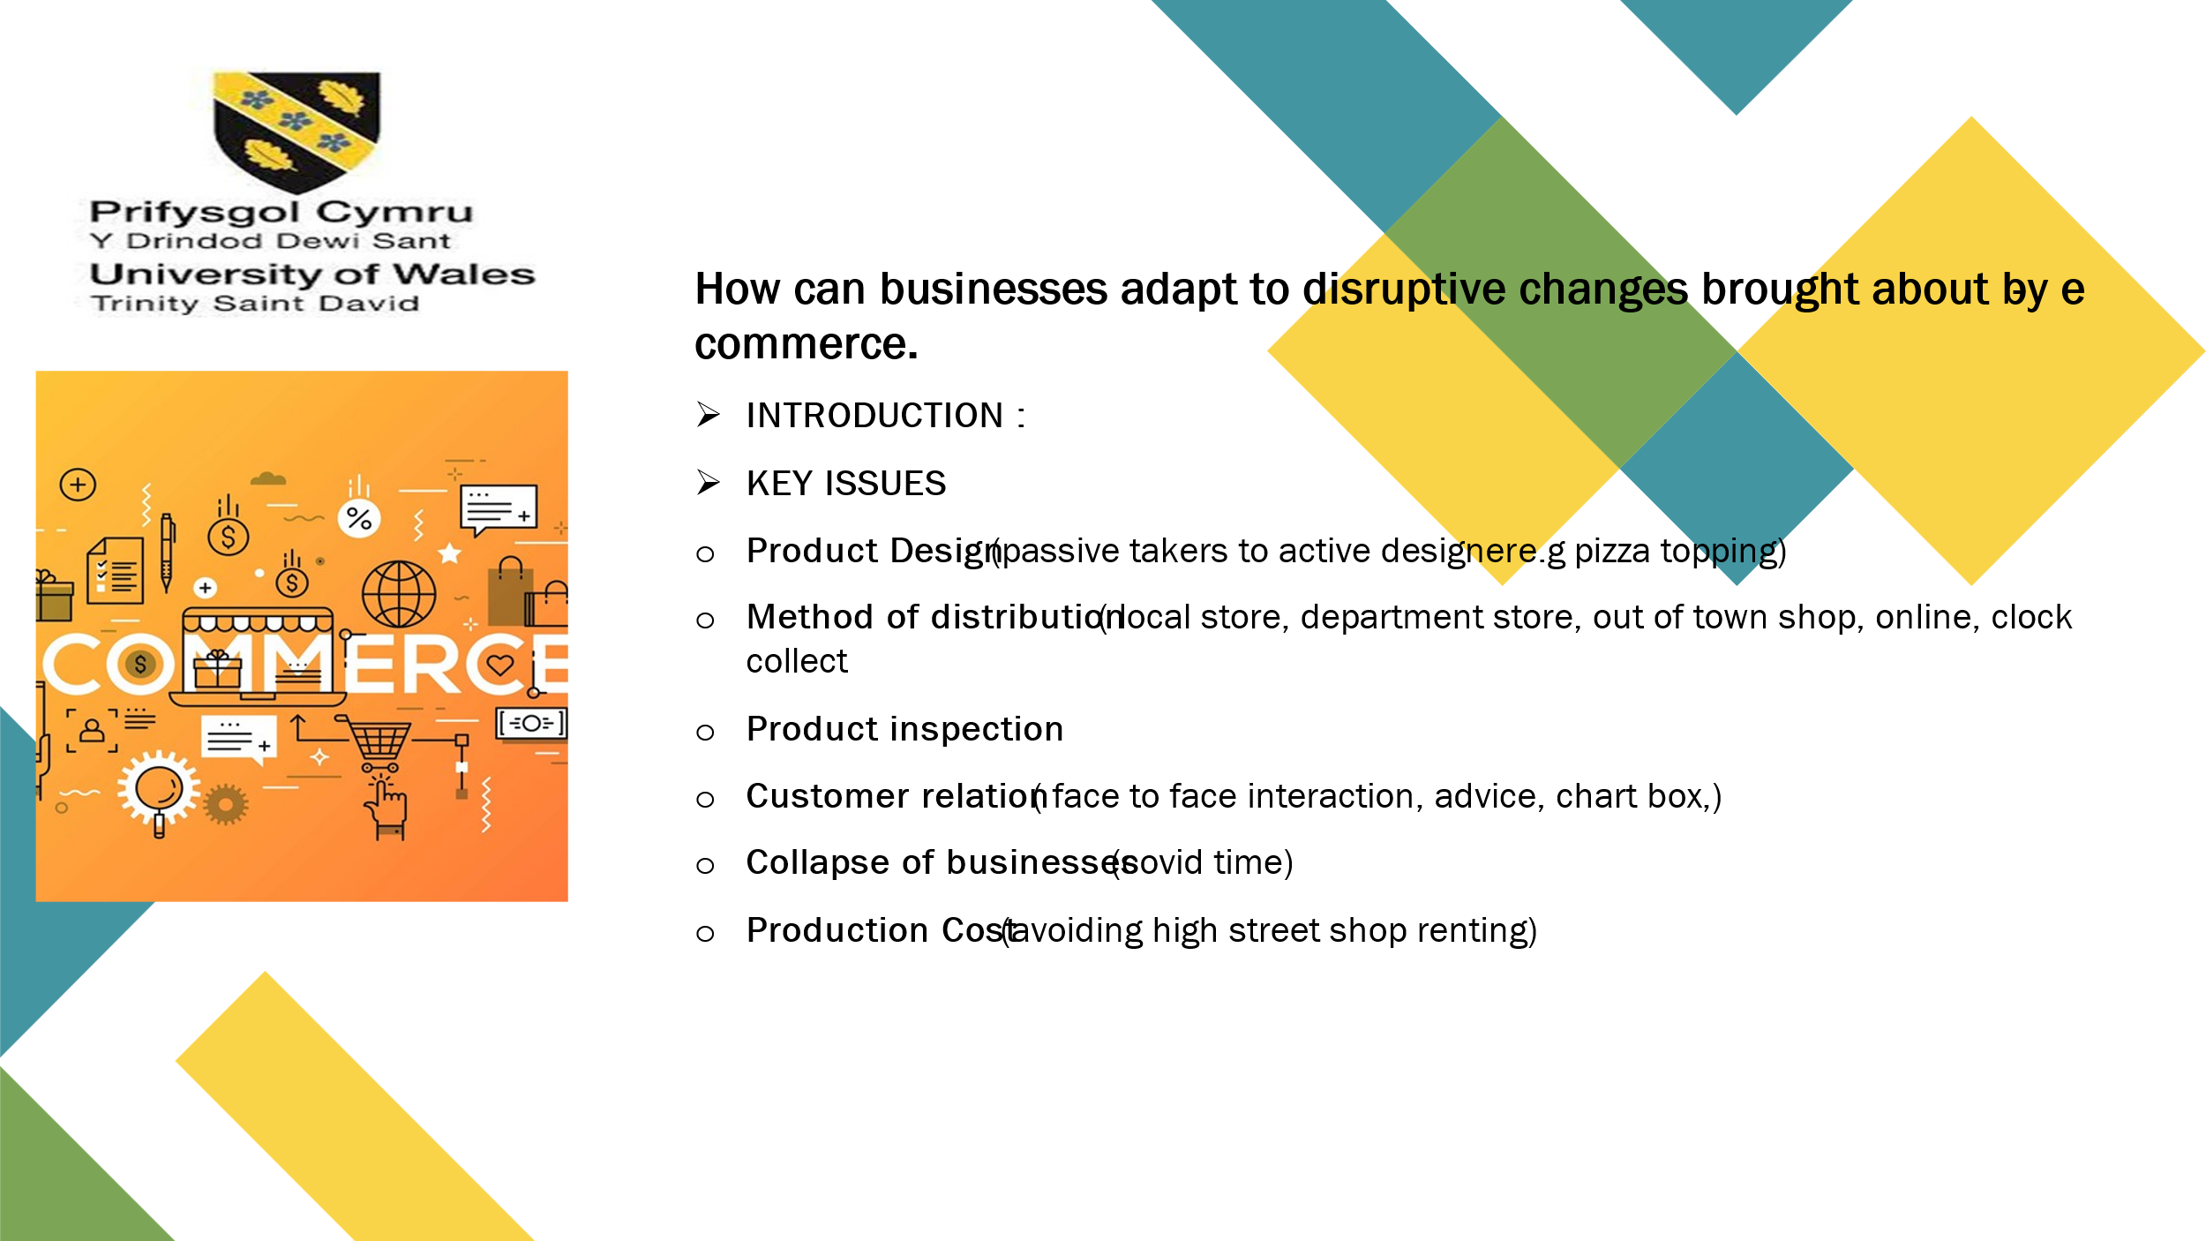

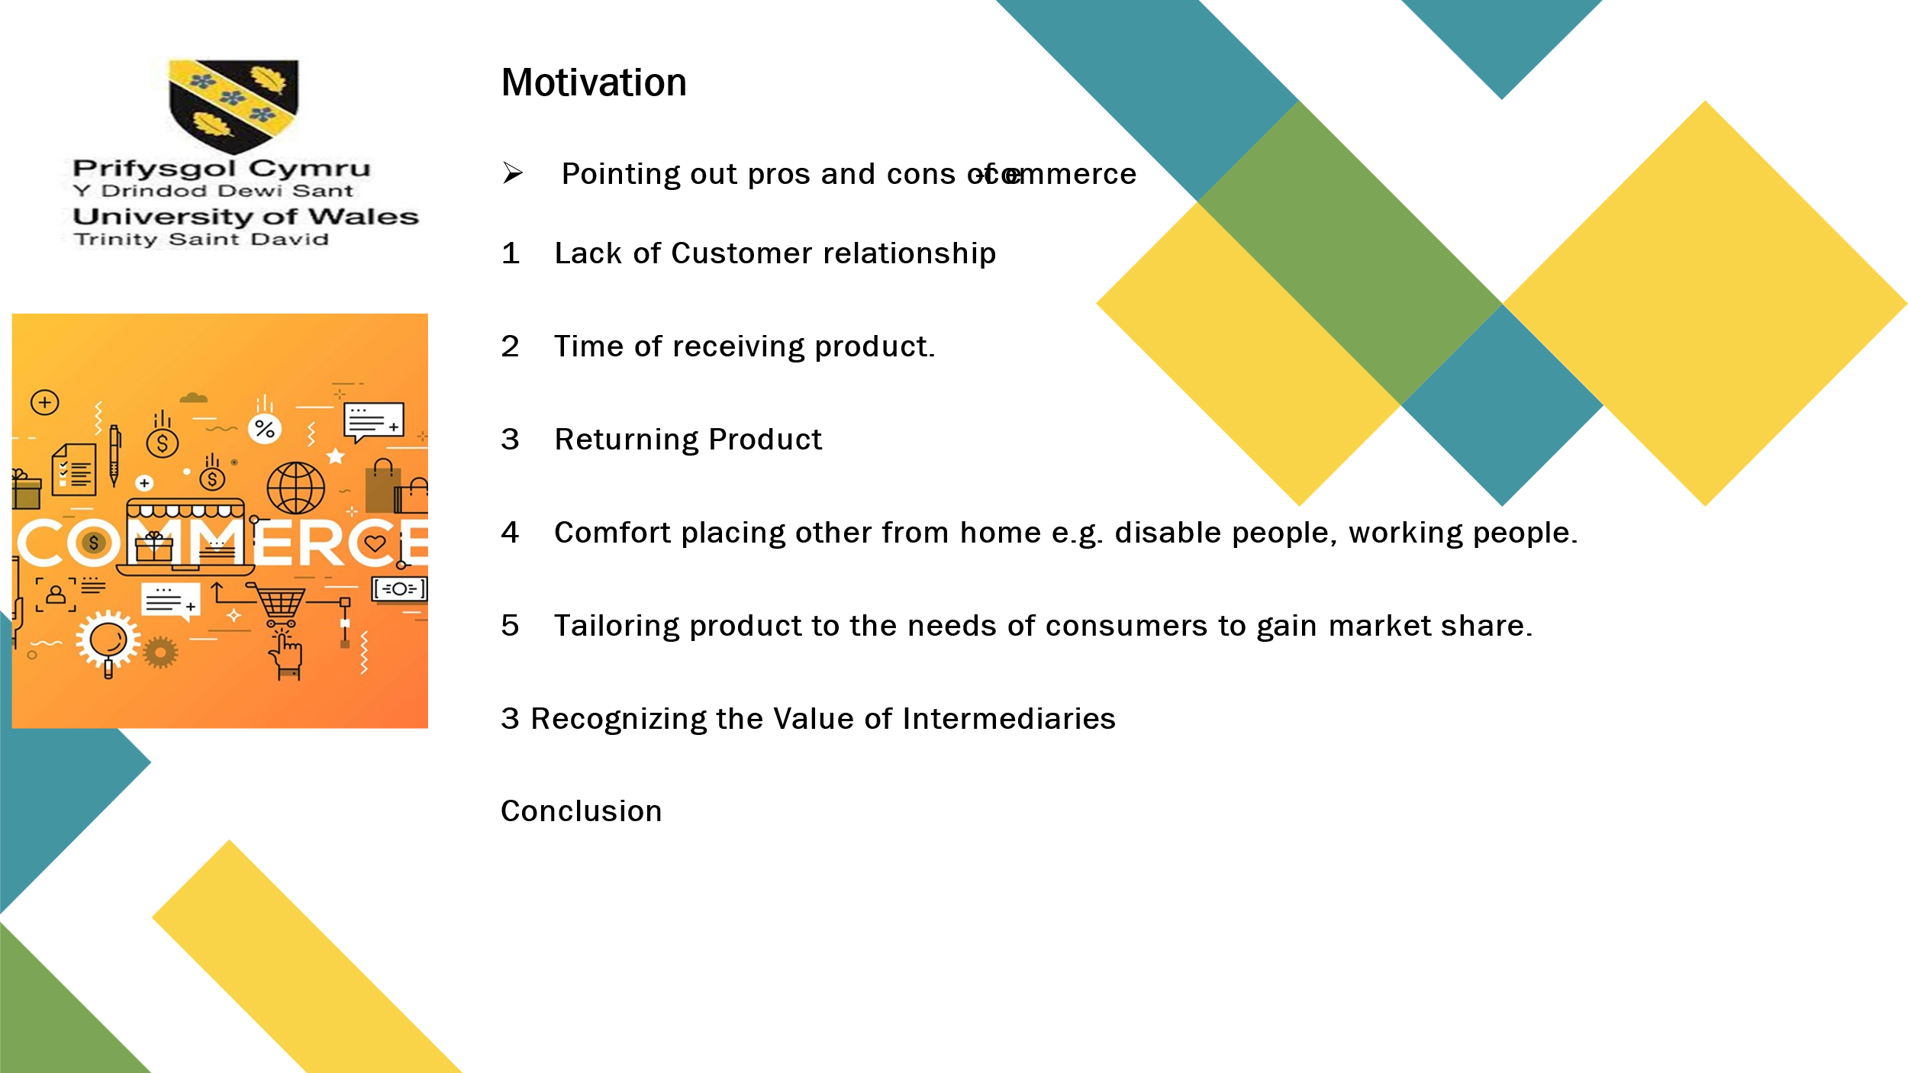

PART A
Introduction
E-commerce is now a vital component of the world economy, changing both how consumers and businesses make purchases. The goal of this field's research is to address the opportunities and challenges presented by the digital marketplace. This synopsis looks at the main issues that e-commerce research aims to address as well as the underlying goals and motivations that spur this work. We can better appreciate the importance of e-commerce research in influencing the direction of online business by comprehending these factors.

"The Future of Commerce," authored by Adrian Slywotzky, Clayton M. Christensen, Richard S. Tedlow, and Nicholas G. Carr and published in the Harvard Business Review, addresses the transformative impact of e-commerce on business models and retailing. The article aims to elucidate the significant changes in the commercial landscape brought about by digital advancements, focusing on how businesses can adapt to remain competitive. This report analyzes the core problems and issues the article seeks to resolve, exploring the motivations behind the research and the broader implications for the field of commerce.

Identifying the Problem and Issues
The primary issue the article addresses is the rapid and profound transformation of commerce due to the advent of e-commerce. Each author tackles different aspects of this transformation, collectively providing a comprehensive analysis. The article's central problem can be summarized as follows: How can businesses adapt to and leverage the disruptive changes brought about by e-commerce to maintain and enhance their competitive advantage?
Adrian Slywotzky: Empowering Customers through Choice boards
Adrian Slywotzky identifies the shift from a traditional supplier-driven model to a customer-driven model facilitated by the Internet. Historically, businesses operated on a "push" model, where suppliers determined what products were available, and customers had limited choice. The rise of e-commerce has flipped this model, empowering customers to design and customize products through interactive online platforms known as choice boards (Slywotzky et al., 2000).
Motivation and Agenda: Slywotzky's motivation appears to be driven by the need to highlight the importance of customer empowerment in the digital age. By examining the shift towards personalization, he aims to show how businesses must adapt their strategies to meet the demands of increasingly active and discerning customers. The research underscores the necessity for businesses to innovate and adopt customer-centric approaches to stay relevant.
Clayton Christensen and Richard Tedlow: Navigating Disruptive Technologies
Clayton Christensen and Richard Tedlow focus on the disruptive nature of e-commerce and its impact on the competitive dynamics of retailing. They argue that while the core mission of retail—delivering the right product at the right place, time, and price—remains unchanged, the methods of achieving this have evolved significantly due to technological advancements (Christensen & Tedlow, 2000).
Motivation and Agenda: Their research is motivated by a desire to understand how historical patterns of retail transformation can inform future strategies. By identifying parallels between past disruptions and current technological changes, they aim to provide a framework for businesses to anticipate and adapt to the ongoing evolution of retail. Their agenda is to equip businesses with the knowledge and tools needed to navigate the disruptive forces of e-commerce effectively.
Nicholas Carr: The Role of Intermediaries in E-commerce
Nicholas Carr challenges the common notion that e-commerce will lead to disintermediation, where producers bypass intermediaries to sell directly to consumers. Instead, he argues that the Internet has resulted in hypermediation, where multiple intermediaries are involved in transactions, adding value and efficiency to the process (Carr, 2000).
Motivation and Agenda: Carr's motivation lies in correcting a widespread misconception about the nature of e-commerce. By highlighting the role of intermediaries, he seeks to provide a more nuanced understanding of the e-commerce landscape. His agenda is to emphasize the importance of recognizing and leveraging
the value that intermediaries bring to the digital marketplace, rather than viewing them as redundant entities.

Synthesis and Broader Implications
The collective insights from the article address several critical issues:
- Adapting to Customer Empowerment: Businesses must transition from a supplier-driven model to a customer-centric approach. The rise of choice boards and personalized products requires companies to innovate and offer tailored solutions to meet individual customer needs (Slywotzky et al., 2000).
- Navigating Technological Disruptions: Understanding historical patterns of retail disruption can provide valuable lessons for adapting to current and future changes. Businesses must remain agile and innovative to maintain their competitive advantage in a rapidly evolving market (Christensen & Tedlow, 2000).
- Recognizing the Value of Intermediaries: Contrary to the belief that e-commerce will eliminate intermediaries, the Internet has created new layers of intermediation. Recognizing and leveraging the value that these intermediaries bring is crucial for optimizing e-commerce operations (Carr, 2000).
Motivation and Agenda of the Research
The overarching motivation behind the research presented in "The Future of Commerce" is to provide businesses with a comprehensive understanding of the transformative impact of e-commerce and to offer strategic insights for navigating this new landscape. The authors aim to address the uncertainties and challenges that businesses face as they transition to digital models, emphasizing the need for innovation, adaptability, and a customer-centric approach.
Conclusion
"The Future of Commerce" presents a multifaceted analysis of the impact of e-commerce on business models and retailing. By examining the shift towards customer empowerment, the disruptive nature of technological advancements, and the role of intermediaries, the article provides valuable insights into the evolving commercial landscape. The research is motivated by a desire to equip businesses with the knowledge and tools needed to navigate these changes effectively, ensuring they can maintain and enhance their competitive advantage in the digital age.
By understanding the motivations and agendas behind the research, it becomes clear that the article aims to address the critical challenges and opportunities presented by e-commerce. The insights provided by Slywotzky, Christensen, Tedlow, and Carr collectively offer a blueprint for businesses seeking to thrive in the future of commerce, highlighting the importance of innovation, adaptability, and customer-centric strategies.

References
Carr, N. G. (2000). The Future of Commerce. Harvard Business Review.
Christensen, C. M., & Tedlow, R. S. (2000). The Future of Commerce. Harvard Business Review.
Slywotzky, A. (2000). The Future of Commerce. Harvard Business Review.
Slywotzky, A. J., Christensen, C. M., Tedlow, R. S., & Carr, N. G. (2000). The Future of Commerce. Harvard Business Review

