Principles of Health and Social Care Practice
BMHP5002
A2
Jahanara Begum

Table of Contents
1. Introduction 3
2. Discussion & Analysis 4
2.1 The Underlying Concept of Person-Centred Care 4
2.2 Theoretical Underpinning of Person-Centered Care 6
2.3 The Ethical Underpinning of Person-Centered Care 7
2.4 Benefits and Limitations of Person-Centered Care 8
2.5 Application of Theoretical Principles of Person-Cantered Care in Health and Social Care Practice 8
3. Recommendations 10
4. Conclusion 12
5. Reference 13
6. Appendix 14

Introduction
In recent years, there has been a movement toward person-centred care. The goal is to live a meaningful and independent life. It's possible to make personal care work for patients and healthcare providers. There are some issues, but it's worth the effort. During the past decade, health and social services have become increasingly person-centred. The following are the objectives of person-centred care: Improvements in service quality, if medical care is required, help in obtaining it, helping people improve their self-care is one method to do this, freeing up our health and social services.
Cancer is characterized by uncontrolled cell proliferation that may infiltrate or spread to other body regions. Benign tumours may grow and spread a popular myth. Symptoms include a strange lump, a persistent cough, unexplained weight loss, and changed bowel habits. Other reasons with comparable symptoms are also conceivable, in addition to cancer. More than 100 types of cancer have been identified in humans.
Cancer Research UK is trying their best to coping with cancer. They are coping with Adjustment of the mind. Therapy or psychological counselling to help with cancer-related emotions The capacity to react realistically. The capacity to react realistically. For foreign visitors, this site offers information on money, travel, and medical care. Families, friends, and caretakers are all involved in the process. Family and acquaintances of cancer patients are affected as well. This lesson will cover how to assist a cancer patient and how to take care of yourself.

Figure 01: Cancer Research UK Logo
Source: (LoveLove Films,2015)

Discussion & Analysis
Cancer Research UK was established in 2002 as a cancer research and awareness organization in the United Kingdom and Isle of Man (Ally Kennen, 2015). It is the world's biggest privately financed cancer research organization on a global level. In addition to grant-funded research, the charity's own personnel conducts research. The organization also disseminates cancer-related information and conducts awareness campaigns as part of its operations and programs.
The government provides the majority of funding for the organization's activities. The organization may also raise money via contributions, legacies, community fundraisers, special events, retail outlets, and corporate partnerships. The American Red Cross has about 40,000 regular volunteers (Ally Kennen, 2015).

2.1 The Underlying Concept of Person-Centred Care
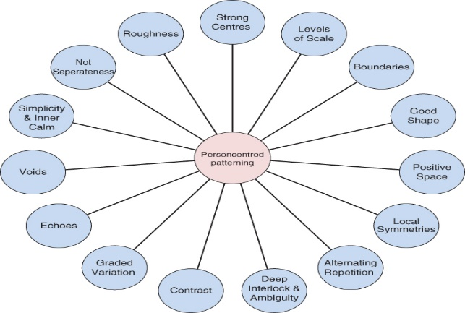
Figure 02: Underlying concept of person-centred care
Source: (Nursekey,2013)
This is a relatively new concept in today's culture, but one that is gaining in importance as time goes on. Many different viewpoints, concepts, and conceptual frameworks are covered in this book (McCormack et al., 2015). The meaning of person-centred care and how it should be delivered is becoming more confusing to a rising number of healthcare professionals. This must be done (Morgan and Yoder, 2012). There is a good chance that the idea will wind up back where it all started. Patient-centred treatment became widespread after World War II. Patient-centeredness is a popular nursing paradigm, but it's not practice-driven. About it, McCormack and McCance go into some detail.
There are mutually advantageous links between them. It goes beyond a collection of laws and regulations to define good governance. Transformational practice development is a method that is part of the framework. Action research paradigm (McCormack et al.) McCance's has it in print (2016). Empirical investigations that seek to shed light on specific issues benefit greatly from the simplicity of the paradigm. Individualizing care is a talent that must be developed. Aside from that, the building was entirely re-built. Since it was a good match with our research goal, it was selected as the theoretical framework for inquiry. The organization's mission statement is, "Our goal is to improve the lives of older people via innovation." Patient participation and empowerment are key. Before the ideas were given to the public, they were subjected to a comprehensive analysis of their development and clarity. The frame is constructed from (McCormack et al., 2015). A lesser number of empirical studies supports Person-centered care in the Netherlands. Every day. The need for a practical understanding of person-centred care is evident among nurses, practitioners, and care organizations.
Additionally, they would want to learn more about the specifics of person-centred care and how to overcome barriers. The reason for this is a combination of time limitations and a lack of capacity to communicate in a person-centred way. In what ways does this affect nurses' behaviour and interactions with patients? But what about the natives? It is also important to clarify the ideas in order to teach them (Abushousheh and Brush, 2016). They need to be turned into actual abilities before they can be used. Also, they must be translated into concrete attitudes and behaviours. Person-centered care requires this. These changes are beginning to be recognized in nursing competence descriptions and nurse education programs. A framework for measuring competence in Canmeds (Canadian Medical Education Directives for Specialists, 2015). In 2013, the research group started a person-centred research project based on this understanding. As part of this study, researchers will examine empirical data to understand better how care is defined in the United States.
In the past several years, nursing science masters' students conducted a large number of research projects. Their professors supervise researchers. Even though their study participants, topics, and methods differed (Charity., Author of Ruth Levison. and Leathes, 2014). All of this research used this framework as a theoretical foundation. Husband-and-wife duo McCormack and McCance (2010). In five of the investigations, there was a disparity in the results. A broad conclusion must be made from a study, in addition to any noteworthy results. Overall, this is a great outcome. Inductively 'infuse' the ideas with new information (Abushousheh and Brush, 2016). As a consequence, an examination of the framework was conducted

2.2 Theoretical Underpinning of Person-Centered Care
Being in Relation focuses on relations and the interpersonal processes that enable their development. Relationships are of utmost importance in person-centred nursing, and nurses, their patients, and their loved ones put a great value on them. Humans are made up of a variety of constituent parts. Location is becoming more important to nursing and health care workers. A comprehensive study of the impact of location on patient experience is still pending. It is not enough to just collect stories when using biographical and narrative techniques as part of the assessment (Hughes, 2015). Humans have a fundamental need to be acknowledged as individuals. Our personalities are revealed as a result of our recognition and regard for others. They must be aware of their own values and beliefs, as well as how they may affect their own decisions.
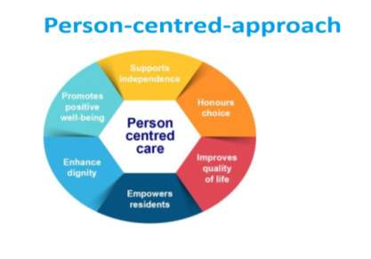
Figure 03: Theoretical Underpinning of Person-Centered Care
Source: (Nursinganswers.com,2013)

2.3 The Ethical Underpinning of Person-Centered Care
Our current health care discussion is aided by the 1981 pastoral letter of the American Bishops on health care and the 1993 Framework for Health Care Reform from the U.S. Catholic Bishops of the United States. Reforming Health Care Through an Integrated Methodology, Those points were reiterated in CCK's 1992 Statement. Criteria for reforming health care A list of health care requirements are provided below (Hughes, 2015). The vitality of our religion motivates us to alter public policy ideas. When it comes to neighbours in need,
- From conception to natural death, human life should be protected and encouraged.
- The healthcare needs of less affluent people should be prioritized
- The greatest quality of patient treatment is a primary focus.
- Fourth and last, we must ensure that everyone has equitable access to all of their options.
There are many advantages to maintaining or improving physical or mental health. It implies embracing and promoting pluralism, as well as pursuing the common good. Religious and volunteer sectors and all other areas of health care should respect ethical and religious beliefs (Peter Kingsley, 2014). While minimizing increasing costs related to expanding rivalry, commercialism, administration, or legal expenses, use ways to minimize waste and inefficiency and encourage consumers and suppliers to make efficient use of limited resources. Because a system based on their capacity to pay allows poor and vulnerable individuals to obtain health care, they have full access. Services in health care are being evaluated for appropriateness, improved and evaluated.

Figure 04: The Ethical Underpinning of Person-Centered Care
Source: (newhealthadvisor.com,2011)

2.4 Benefits and Limitations of Person-Centered Care
Benefits | Limitations
A person-centred approach to care helps to improve the relationship between you and your loved one. It also creates a deeper emotional bond with older people's health. (Peter Kingsley, 2014). Oakland Care offers person-centred care for the elderly. The aim is to provide personalized, tailored care to our residents. All residents are treated with respect and dignity by a team of staff who care for them. | The greatest obstacle to personal care is the inadequate capacity of councillors to understand the worsening of cross-cultural counselling and the misinterpretation of certain standards and customs, which limit their capacity in building consistency (Wessel, Manthey and Manthey, 2013.). The therapist needs cross-cultural understanding and continued flexibility in customer cultures as the (even) culturally trained consultant can prevent issues with delicate social environments and different living standards.
Table 1: Benefits and Limitations of Person-Centered Care
Source: (Wessel, Manthey and Manthey, 2013)

2.5 Application of Theoretical Principles of Person-Cantered Care in Health and Social Care Practice
Although various organizations may significantly change their principles, they all have the same ideals. Here is a breakdown of these important concepts:
- Respect for the person
It is essential to identify and recognize the patient as a person (Wessel, Manthey and Manthey, 2013.). They have their own different thoughts, beliefs, limits and views. The individual's characteristics must be comprehended and comply with, and integrated into the care plan.
- Treating human dignity
This includes polite interaction with the patient, hearing what they have to say and taking note of it. They should also maintain their dignity and avoid shame or disgrace.
- Understand your experiences and objectives
For a successful long-term care plan, the history, the current state and future objectives of the patient must be known. This helps you to know the person better and enables you to personalize further the treatment (Mezzich et al., 2016).
- Confidentiality preservation
Confidentiality should be preserved, as with all other treatment methods, when appropriate. Not just for the wellbeing of the patient but to develop confidence and a productive connection. This issue may be dealt with by choosing what information they wish to share with friends, family or other experts.
- Responsibilities
The patient may do as many daily activities as possible using a personal approach. This is important if the patient's capacity to grow and establish greater trust on the road to recovery. Although the limits of individuals need to be recognized and using this technique is not pushed too far.
- Care Coordination
To make the recuperation as easy and productive as possible, all medical personnel must coordinate the care of the individual (Mezzich et al., 2016). This applies particularly to caregivers since an unstructured approach may lead to confusion, stress, concern or rehabilitation.

Recommendations
They all share the same values, even though their opinions may differ considerably. As an example, consider the following:
- The person's dignity must be respected.
The patient must be identified and recognized as a person. Ideas, beliefs, and limitations are different amongst them. The individual's traits must be recognized, respected, and included in the care plan.
- Treating people with respect
As part of this, you should make eye contact with the patient, listen to what they say, and take notes. In addition, they must preserve their dignity and prevent embarrassment or humiliation.
- Have a clear understanding of your goals and experiences
For a long-term care plan to be effective, the patient's history, present health, and future goals must be understood. In this way, you may get to know the individual better and customize their care.
- Protection of confidentiality
As with all other therapy techniques, confidentiality should be preserved wherever possible. To establish confidence and a constructive relationship with the patient, not only for the patient's wellbeing, decide on the facts you wish to share with your friends, family and other specialists (Barnsteiner, Disch and Walton, 2014).
- Responsibilities
When adopting a customized strategy, the patient may engage in as many everyday activities as feasible. Patient growth and trust are essential for the recovery process. This method should not, however, be pushed to its extremes.
- Coordination of health care services
All medical professionals must coordinate individual treatment for rehabilitation to be simple and effective. On the other hand, an unstructured approach may lead to confusion, tension, worry, or even rehabilitation.

- Patients' happiness and treatment quality
- Promote a better lifestyle by encouraging individuals to exercise or eat healthfully.
- They can best assist people by encouraging them to take an active role in determining their own healthcare choices.
- In the case of blood pressure, for example, this has an impact.
- People should use fewer services. Statistics do not support this.
A literature study suggests that care focusing on the person is more likely to be successful. A personalized approach to healthcare may be enhanced by teaching patients about their diseases, encouraging them to engage in consultations and training healthcare professionals to facilitate patient treatment. Experts may produce greater outcomes when care is provided more personally (Barnsteiner, Disch and Walton, 2014). According to a review of seven research papers, nursing professionals who utilized a caring approach for people reported greater job satisfaction and success. Research shows that personal care is most successful when specific components or basic principles are utilized. Although the data suggest that personal care may make a difference, there are currently few findings, and other studies have mixed results (DEWHURST, 2021). Personal care involves various aspects for different people, which is why contradictory outcomes may occur. This makes it even more important to consider how people-centred care may be evaluated and used to better understand the benefits of this approach.

Conclusion
Health and social care services Users should be involved in the planning, creating, and monitoring of care to ensure that it fulfils their requirements on an equal basis. It's a family affair. The individual makes decisions, working with professionals to get the best possible outcome. When it comes to delivering person-centred care, just giving people what they want or providing them with knowledge is not enough. A collaborative effort is made to find suitable solutions in addition to evaluating goals and values. Compassion, the capacity to understand things from another person's point of view, and respect for others are all important. Personal care includes more than just educating patients about their choices and helping them take control of their own health.
Along with the quality of services, it's also essential to consider how professionals and patients see the care and how they interact with one another. Healthcare needs in the United Kingdom are increasing, yet there is a shortage of available resources. Health issues are more prone to occur in elderly individuals with longer life expectancy. According to studies, personalised therapy improves people's health and reduces the burden on healthcare systems. It follows that patients must be heard to be taken seriously in government policy. Person-centred care is one of the seven basic ideas of the NHS in England. This idea is reflected in the national service frameworks, monitoring standards, and legislation of all four countries of the United Kingdom.

5. Reference
Ally Kennen.,2015. Person-centered care. 4th ed. Washington: U.S. G.P.O.
Abushousheh, A. and Brush, J., 2016. Person-centered care. 5th ed. Cardiff: Bloomsbury.
Barnsteiner, J., Disch, J. and Walton, M., 2014. Person and family-centred Care. 3rd ed. Indianapolis: Sigma Theta Tau International.
Bradbury, R. and Angibaud, P., 2016. Cancer. Berlin: Springer.
Charity., Author of Ruth Levison. and Leathes, M., 2014. Charity at home. A tale. 2nd ed. London: John Wiley & Sons.
Dewhurst, M., 2021. Charity. 5th ed. Manchester: Lightning Books.
Hughes, R., 2015. Rights, risk and restraint-free care of older people. 3rd ed. London: Jessica Kingsley Publishers.
Mezzich, J., Botbol, M., Christodoulou, G., Cloninger, C. and Sallaum, I., 2016. Person-centred psychiatry. 4th ed. London: Penguin Random House.
Peter Kingsley, 2014. Person- and family-centred care. 3rd ed. Manchester: HarperCollins.
Wessel, S., Manthey, M. and Manthey, M., 2013. Primary nursing. 5th ed. London: Hachette Livre (UK).

Appendix

Figure 01: Cancer Research UK Logo
Source: (LoveLove Films,2015)

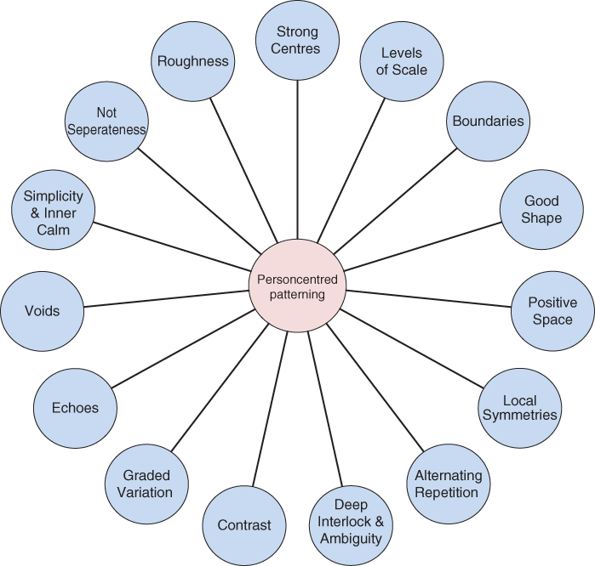
Figure 02: Underlying concept of person-centred care
Source: (Nursekey,2013)

Figure 03: Theoretical Underpinning of Person-Centered Care
Source: (Nursinganswers.com,2013)

Figure 04: The Ethical Underpinning of Person-Centered Care
Source: (newhealthadvisor.com,2011)

