Utilising the Entrecomp Framework, critically evaluate your own creativity and enterprise and consider how you might be able to develop the creative and enterprising skills of primary learners through your own pedagogy. (5000 Words)
Creativity, this is a word that is banded around by so many people every day. However, each person has a different thought behind what the word actually means, I believe this is because creativity or the ability to be creative can be expressed in such a variety of different ways. Ofsted use the National Advisory Committee on Creativity, Culture and Education (NACCE, 2003) definition of creativity. They state that creativity is ‘Imaginative activity fashioned so as to produce outcomes that are both original and of value’. Many definitions of creativity seem to follow the same suit, imagination and outcomes that are original and produce value, (DfES 2006, pg4) (Wegerif 2010) (Blandford and Knowles 2009). However, I would question whether creativity always needs to have a specific end in mind, are we only creative when we need to solve a problem or create something? Or can we be creative ‘just because’. To me creativity is doing something in a certain way because you are curious as to how it will end up, thinking ‘what if?’ or how can this be accomplished? The ability to express yourself in a way that other people may not be able to do.
Within the teaching profession it is said that to teach creative thinking you have to do creative thinking (Wegerif 2010) but do you have to be creative to teach creativity, should creativity be taught, can creativity be taught?
The word enterprise can really be interpreted in different ways, an enterprise can be a business or venture, or it can mean your ability to use your own initiative or resourcefulness in a way to further what you are doing. Entrepreneurship is the ability to put this enterprise into action to add value to your predicted end product. Entrepreneurship is defined by the EU Commission for the Entrecomp Framework (2016) is turning opportunities and ideas into value for other people, whether that value be cultural, social or financial.
Within the 2015 Successful Futures document Professor Graham Donaldson shares his four purposes with one of them being children should leave education as enterprising, creative contributors, ready to play a full part in life and work. He also discusses how as practitioners we are equipping children for jobs that do not currently exist, but that they are likely to need creativity and enterprise skills.
There are many benefits and limitations to creativity as a teacher. As a teacher, especially of younger children, many people expect you to be creative. You are expected to be able to use your imagination to think up a craft or make up a story on the spot. Now this can be both a benefit and a limitation. If you are a naturally creative person then you may find that teaching drama, music and the arts an easier task than someone who does not have so much expertise in these fields. For classrooms that follow the foundation phase or are aimed towards being more themed then personal creativity may help you here also. Having the ability to change a classroom to suit your theme or subject may help children engage with the theme and encourage their own creativity. That is not to say that if you class yourself as a person who is less creative that your classroom cannot be an engaging and encouraging space, it is important to remember that as a practitioner we have a team around us to support with both the children’s learning and the preparation for the learning. If you are lucky enough to have staff within your class or within your school that excel in creativity, then enlist their expertise. Both other staff and students alike will find it inspiring to see another school family member sharing what they love.
The Entrecomp Framework was published in 2016 by the European Commission Science and Knowledge Service. As it is widely known the world is moving forward at a faster pace each year, technology is forever transforming, and jobs of the future are yet to exist. To allow people to be ready for the future the European Commission (2016) says that we need to start challenging mainstream thinking and start to use our own creativity and entrepreneurship to forge our paths ahead. The framework was designed to break down boundaries between education, research and the workplace to allow and encourage entrepreneurship and creativity to flow and build. The EU Commission initiative (2016) to create this framework was a partnership across many professionals and agencies to aid with the development of one of the key policy objectives for the EU and other member states. In 2006 the European Parliament released a report detailing key competences for lifelong learning with one of these being a ‘Sense of initiative and entrepreneurship’, all of these competences are considered equally important. This I believe is very important as along side entrepreneurship the European Parliament (2006) also list, digital competence, mathematical competence and communication in both a mother tongue and foreign languages. This brings to the forefront how important creativity and entrepreneurship really is. The framework was designed to be used to evaluate a person’s competence across three main areas. These areas are Ideas and Opportunities, Resources and Into Action and these three areas cover fifteen competencies against which you can decide which level is a ‘best fit’. Each level has a descriptor to allow you to place the person being evaluated, there are statements to allow this to happen. As the levels progress the statements become more and more specific, with Levels 7 and 8 aimed at entrepreneurs within a business. As just mentioned, you are able to use a best fit when using this framework. This allows for a decision to be made as to where you should place yourself even if you do not fully fit with the statement.
As with anything there are both benefits and limitations to the Entrecomp framework (2016). Some of the benefits being that it can be widely used, across any platform, from school to the work place, with there being such a wide audience it is written in a fairly simple way that most people would be able to access and understand it. Another benefit is that it covers such a wide variety of competences that any profession could hand pick any part out of it to use, allowing for a wider spread audience and hopefully the ability for the framework to fulfil why it was commissioned in the first place. One of its limitations is that it is mainly aimed towards business and enterprise so for evaluating creativity you are only able to use a small amount of the framework, you are however able to pick and choose which themes you look at. The Framework itself has stated that it has its own limitations, the EU Commission (2016) state that the framework has yet to be tested out in real settings and adapted, they do however say that they will amend if they need to after feedback from practitioners and users. Another limitation is that the framework may not be accessible to younger children for self-assessment purposes, whereas testing divergent thinking can be done simply without the need for large frameworks and more complicated tables.
For this essay I will be using some of the competencies to evaluate my own creative and entrepreneurial skills. Within the creativity area, I will be evaluating all five competences against my own personal creativity. I will also be looking at a few strands from the ideas and opportunities area of the framework. I will state where I believe I fall within the framework for each competence, why I believe this and how I feel I could start to move onwards to the next level. Within the creativity area of the Entrecomp Framework (EU Commission, 2016) the five threads are as follows; be curious and open, develop ideas, define problems, design value and be innovative. For the first thread of ‘be curious and open’ I levelled myself at a level four stating I can actively search for new solutions that meet my needs. I feel like this is a skill that you actively improve on as you work through university, for each assignment or assessment. This then transfers across to our teaching practice as for each lesson I teach I need to actively seek out or think of an activity that will fit for the point I am covering, each lesson will be different depending on the class you have so there is the need to actively seek out how best to deliver to your class. Through PTE2 in my second year I was constantly trying to plan and deliver creative lessons to keep the class engaged. If not a whole creatively taught lesson, then using creativity to enhance provision around the classroom. Appendix 1 shows the planning sheet used for my mixed year 1 and 2 class when we were covering a pirate theme topic, I wanted each child to be able to access topics previously covered in class and enjoy replicating or practising, seeking out ideas to keep the pirate theme across all provision. Using old tea bags from the staff room children were able to stain their own paper to create messages in bottles, using materials from around the classroom and outdoors environment children were able to make prototypes of ships and discuss floating and sinking or create and build their own large scale ships outside. To progress onward to the next step, I will need to make sure my solutions are adding value to the end outcome. This comes with refining ideas early on and being able to accept when a certain idea does not work for that situation, working on accepting that it is ok to have a ‘bad’ idea and the concept of acceptance that it is not a failure just something that wont work. This is a personality trait that can sometimes be difficult to overcome, working on self-development and well-being will help me overcome this boundary.
The second thread ‘develop ideas’ I levelled myself at a level three. Within this level I am able to experiment with different techniques to generate alternative solution to problems, using available resources in an effective way. Within Appendix 2, a formative assessment from my university tutor while out on placement, he mentions the use of the rhyming word games. Within this lesson a group a children with the accompaniment of another member of staff were down in the hall using the room to find the matching rhyming words, in my original plan this activity was to take place outside, however on the day this was not possible due to weather restrictions. Appendix 3 shows the plan for what the children were doing. Knowing the children within the class I knew I needed to find fun, exciting and creative ways to engage them in the task at hand. Along with the class teacher I sat and discussed the best ways to keep the children engaged and we decide that an activity that allowed them to be on the move while still completing the rhyming activity, which is where the treasure hunt came into the task. To allow myself to progress on to the next steps I believe that it is more about communication within the classroom, the next level up for this thread is testing the value of my solutions with end users. Within teaching this may not be easy to test with a classroom setting as you do not often get to repeat the same lessons time and time again with the same class, however you do have a support team around you in the shape of class teachers while on teaching practise, teaching assistants and other members of staff throughout the school to test and refine your ideas on. On a more long-term scale, you may be able to test and refine an idea over different classes across different years.
The next thread in the Entrecomp Framework (EU Commission 2016) is ‘to define problems. Within this thread I put myself at a Level three because I find myself very able to work within a group dynamic to define open ended problems. Working within a group is something I have always enjoyed; I find it easier to be creative when the pressure is not solely on me to come up with an idea. Outside of teaching practise and the school environment I am involved with Messy Church in St Marys Church in Tenby. This is one afternoon a month where a group of volunteers get together to run a drop-in session based around a certain theme. Although it is not strictly teaching, it involves using creativity to work as a group to define the activities we will be running each month, within Appendix 4 you can see my brief meeting notes from the December and January planning meeting. As a group we sit and discuss all feasible ideas and decide who will run each activity, it is then up to that person to resource the activity and run it during the session. While I have children sat at the table with me, I try to discuss the message or theme for the months meeting. In December we had the Christmas story as a theme running throughout the afternoon. I was running an activity making Angels for children to take home and also to display with our crib for the church’s crib festival. Throughout the activity children and I discussed the importance of the Angels throughout the Christmas story and how that story can relate to today. Moving forward I need to improve my ability to use the skills I already have to solve a problem. Being aware of functional fixedness, will allow me to remember that you do not have to use a product in the way it was intended to get full use out of it. By training my brain to think of objects not just as what we are told they are but what they could be used for will open my mind to new ideas. Personally, I find functional fixedness (German and Defeyter, 2000) more difficult to overcome with some objects than others, I am able to use others in a more crafty sense without sticking to their original use but struggle to use objects to solve problems. German and Defeyter (2000) discuss across their article how as you age your functional fixedness increases. As a young child you are able to take an object and shape it to allow you to solve the problem in front of you, this ability decreases as you get older. As we become more ‘grown up’ and ‘sensible’ our ability to see other uses decreases. Older children and adults will try to reshape the problem to fit the object rather than changing the objects use to fit the problem. Our response also differs depending on whether we have seen and used the objects previously, appendix 5 is a graph to support. If we have seen or used an object in a certain way, then we are more unlikely to use it in a different way.
Thread number four is discussing design value and the level I have placed myself at is Level four, ‘I can assemble, test and progressively refine prototypes that simulate the value I want to create’. Towards the end of my first teaching practise in first year with a reception class I was required to try and implement my own Assessment for Learning strategy (see appendix 6 for action plan), the children already within class had the system of placing their name on how they were feeling in the morning as they came into the classroom, however the children did not seem to do this regularly. Having recognised this, I wanted to try a slightly different system, using a similar idea I decided to trial using name pegs on a stick to find out how each student felt the lesson had gone. Each individual working group had their own bamboo stick split into three different colours, where they could then place themselves at the end of a lesson or session. This ultimately did not work overly well for the younger children. When I then moved up the school into a mixed year 2 and 3 class, I changed the design up slightly to make it smaller and able to fit tidily on the side at the back of the class, see appendix 7 for photograph. This iteration made the design itself smaller and more compact, moving two groups onto one set, keeping them off the tables themselves to ensure they students were not fiddling and playing with them during the lesson but keeping them next to when the students left their books at the end of the lesson to remind them to move their names to where they felt the lesson had gone for them. This allowed quite positive and honest feedback as it was almost tucked out of the way of first glance of others. To allow progress here I will need to fully create products to serve my needs or problems, using original ideas to do so. This boils down to being able to fully see a project through from start to finish. This builds also on your ability to think if a creative solution to a problem you may have, finding the expertise to help you along the way if you do not have it yourself. I will in future make sure I fully utilise the team around me and try to think creatively being aware of my functional fixedness.
The last thread around creativity is being innovative, this thread I have levelled myself at a level two so ‘I can describe how some innovations have transformed society’. This thread I have found really difficult to evidence, through my own schooling and general knowledge I can discuss how people like Thomas Edison, Marie Curie and Amelia Earhart have affected our lives today by actions they took in the past. The world of science particularly interests me, and I enjoy furthering my own knowledge by reading articles across many different publications, whether those be books, magazines, journals or web platforms. I feel that I have a sound enough subject knowledge of enough innovations, inventions and discoveries to hold a discussion with students in school should the subject come up. Although I have not yet had the chance to cover such material in school, I really do look forward to it when it may come up. Moving forward I will need to educate myself further on the different types of innovations there can be and how each one affects society and the world around them.
Another area that I looked at is the Resources Area, more specifically the competence of Self-awareness and self- efficacy and the thread of ‘identify your strengths and weaknesses’. As a trainee teach you are constantly evaluating your own performance, constantly nit-picking at what you have done well and what could have gone better, this ability to judge yourself in a good light as well as a not so good light is extremely important. Appendices 8 and 9 are just an example of some ARC reflections completed while out on placement across both year one and two. My use of the ARC’s is also mentioned across Appendix 2 also. I am a believer that being able to delegate tasks to the people who can best accomplish them is a great strength. If you yourself are not able to complete a task to the highest level and have someone who can then it is always best to work to your own strengths. Having the ability to ask for help can also be a strength, it is better to ask and succeed sooner rather than not ask and As a person I am aware that I can be fairly stubborn and at times not very open to change, these are some of my weaknesses that I work on improving on a daily basis. As mentioned earlier I feel that I work well in a team situation, being able to take a leadership role when necessary which comes very naturally. To progress onwards I nee to evaluate my real strengths and weaknesses, looking at myself with an open-mind and not judging.
In his TED Talk in February 2016 Dr Brian Little discusses personality traits under the acronym of O.C.E.A.N; open-mindedness, conscientiousness, Extraverted, Agreeable, Nervous/high-strung. He discusses how every person will fall on a scale with each of these five traits and from those scales you can make a fairly accurate judgement of their character and talents. People who are open-minded tend towards creativity, originality and curiosity whereas more closed-minded people tend towards conventionality and being more down to earth. People who are more Conscientious are more reliable, better organised and self- disciplined. Extraverted people are more sociable, and talkative and people who score high on the agreeableness are better natured, forgiving and courteous. Within the last trait, how highly strung you are as a person will affect your nervousness, insecurity and worrying. After taking a number of tests online, the general personality described seems to be fairly true to life. As a person I am on the lower end of the creativity scale, down to earth and conventional, I am mid-point within the conscientiousness meaning I am neither organised or unorganised and reliable, I am an extraverted person, highly social and outgoing, willing to get involved. I am able to express my views of annoyance with others but am still forgiving and sympathetic and lastly am neither nervous nor calm. I seem to sit nearly exactly at a midpoint there. I personally believe that this affects how I view creativity. I am able to think creatively when it is a situation I am invested in or care about but in my day to day life I tend to live conventionally. I fell like this is a good way of understanding alongside the Entrecomp framework why each individual has certain personality traits and why and how they all link together.
Another way of evaluating a person’s creativity is the Torrance Test. The Torrance Test was created in 1989, developed by Paul Torrance and measures the user’s ability to perform divergent thinking. Divergent thinking is the ability to create lots of ideas when given a situation or starting point, divergent thinking is all about gathering as many ideas as possible before refining. This test was designed solely to test creativity so may be more suited for specific testing needs.
Creativity is paramount to education in schools, it is proven that children learn best by doing, both through play (Pound 2006, Estyn 2018) and real-life meaningful experiences (Barnes 2015). For the learner, creativity is every school day. In nearly every single lesson each child will use their imagination to think about something, they will plan out in their minds how they will accomplish each task, they will use their imagination to save the princess from the tower at lunchtime. Imagination and creativity and therefore enterprise plays a huge role in a child’s development.
Children think of and use creativity in a far simpler way than adults do, as we grow older, we tend to complicate things more. For children imagination or creativity can be second nature if they are allowed to be in an encouraging environment, an environment where there are no wrong answers or silly questions. This is the kind of environment that I will strive to make my classroom.
Children’s creativity can be developed through play and imagination, allowing free and structed play or challenge time can allow students to express their creativity. Within a classroom I will strive to work as a facilitator to allow this to happen. This is supported by Pound (2006, 2008) and Kolb (2015) who both argue that it is vital that children play when they are young to support the development of proper brain function. This is also supported by Piaget in his work on Cognitive development in 1970, (Kolb 2015, pg. 34). I would ensure that I took care with my approach to this as it is important that there is still some structured time across children’s learning. There are certain skills which need to be explicitly taught to children to allow them to develop. It is also important that children spend time around adults, allowing them to learn and model from things they see, supported by Grigg (2015) and Hattie (2012).
Pound (2006) makes note that it is important to remember that creativity is not restricted solely to the arts. Children can excel creatively and in an enterprising way in mathematics, the sciences, languages or even socially. This is a point that really resonates with me as a person, not just as a teacher. When I was younger, I excelled at maths and always thoroughly enjoyed the sciences and was offered a place at ‘Buzz Club’ where more able children met and did higher grade activities of their choice. I will aim to allow children to express their creativity in any way they should so wish and not just confine creativity to the arts. This would have to be monitored by myself and other staff members to ensure children were getting the most out of this time but ensuring high level questioning and conversation between staff and students within the class would ease this pressure.
Morris (2003) in Hewitt and Tarrant (2015) states: “Creative teaching may be defined in two ways; firstly, teaching creatively and secondly, teaching for creativity.” Each child will accept each of these things in a different way, children generally enjoy a practitioner teaching creatively, it is exciting and engaging but not all children will enjoy a practitioner teaching for creativity. I am aiming for my next teaching practise to teach creatively as often as is possible for myself, to allow children to take as much knowledge and enjoyment from each lesson and to teach creativity in a way that will also engage and share knowledge. This often can bring in the practice of a meaningful shared experience for the children to use as a stimulus and this is supported by Barnes (2015), Wilson (2015) and Donaldson in his Successful Futures Document (2015).
To conclude, it is important that we remember that creativity can take many forms. Children will express both their enterprise and creativity in many different ways. However, it is important to remember that there can be many limitations to both teaching creativity, teaching creatively and being creative. As adults we learn to be less creative if we feel that it is not one of our strengths, functional fixedness can hinder creativity as we are unable to see past what we already know to be creative and find new and exciting uses for objects. Within his Successful futures document Donaldson (2015) gives one of the four purposes of the new curriculum as children being enterprising, creative contributors who are ready to play a full part in work and life. Moving forward it is vital that we all work on our own personal creativity to allow us as practitioners to give children the creative learning situations they need to live full lives in jobs that are yet to exist.

References
Barnes, J. (2015). Cross-curricular learning 3-14. 3rd ed. London: Sage.
Blandford, S and Knowles, C. (2009). Developing Professional Practice 0-7. Harlow: Pearson.
Donaldson, G. (2015). Successful Futures: Independent Review of Curriculum and Assessment in Wales. Cardiff: Welsh Government.
Estyn.gov.wales. (2018). Learning through play in a real-life context | Estyn. [Online] Available at: https://www.estyn.gov.wales/effective-practice/learning-through-play-real-life-context
European Commission (2016) Entrecomp Framework. European Commission. Available at: https://ec.europa.eu/jrc/en/entrecomp
European Parliament. (2006) Recommendation of the European Parliament and The Council on key competences for life. European Parliament: Brussels. Available at : https://eur-lex.europa.eu/legal-content/EN/TXT/?uri=celex%3A32006H0962
German, T and Defeyter M. (2000) Immunity to functional fixedness in young children. University of Essex: Colchester. Available at: https://link.springer.com/content/pdf/10.3758%2FBF03213010.pdf
Grigg, R. (2015). Becoming an Outstanding Primary School Teacher. 2nd ed. London: Routledge
Hattie, J. (2012). Visible Learning for Teachers. London: Routledge.
Hewitt, D and Tarrant, S. (2015) Innovative Teaching and Learning in Primary Schools. London: Sage.
Kolb, D. (2015). Experiential learning. New Jersey: Pearson.
Pound, L. (2006). How Children Learn. London: MA Education Ltd.
Pound, L. (2008). How Children Learn - Book 2. London: MA Education Ltd.
Pound, L. (2009). How Children Learn - Book 3. London: MA Education Ltd.
Wegereif, R (2016). Mind Expanding: Teaching for Thinking and Creativity in the Primary School. Maidenhead: Open University Press.
Wilson, A. (2015) Creativity in Primary Education. 3rd ed. London: Sage.
Unknown Author, Torrance Testing. Available at: http://curtbonk.com/bobweb/r546/modules/creativity/creativity_tests/torrance_test.html
Who are you, really? The puzzle of Personality, Brian Little (2016) YouTube Video, Added by TED [Online]. Available at: https://www.youtube.com/watch?v=qYvXk_bqlBk
Big 5- OCEAN Personality test [Online] Available at: https://www.outofservice.com/bigfive/

Appendices - Appendix 1

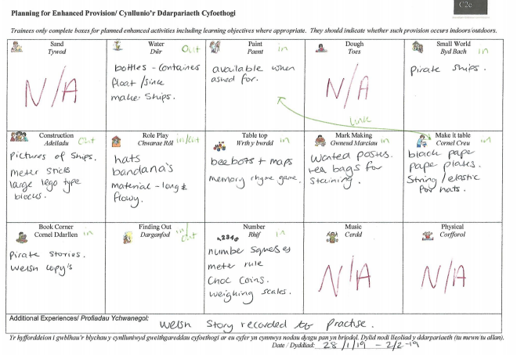

Appendix 2
Trainee: Bethan Rogers |  |  | School: Sageston Primary School |  |  | Headteacher: Mrs. Morris
Class Mentor: |  |  | Senior Mentor: Nathan
Observer/s: Mr. T Cox |  |  | Class/Set: 22 pupils |  |  | Additional Adults: 1
BA Ed: |  |  | PGCE: |  |  |  | MA:
Y1 | Y2 | Y3 | 1st Obs. | 2nd Obs. | Other (please state) |  | FP | KS2 | Final practice
Lesson Focus & Context:
To develop pupil’s understanding and use of rhyming words within poetry.

Focus for Observation (target/s agreed with trainee):

PART 1 LESSON OBSERVATION (Areas of strength/Areas for development):

S1: Professional Values and Practice: Good
Bethan, it was lovely to hear from the class teacher that you have gone over and above with regards to your engagement and support for the school throughout the school inspection period. This demonstrated excellent professional values throughout this phase of your experience. It was reported that you were in early and stayed late (sometimes til 7pm!) helping to enhancing the classroom with displays and areas of continuous provision.
You have definitely made an impact to the learning environment. You ensure that all allocated classroom responsibilities are completed. Bethan, I’m so pleased to see that you have managed the balance between home and school life more effectively this phase. You are highly motivated and I’m so pleased to see that this positive approach to your experience is resulting in consistent effective teaching to a good standard. You demonstrate a clear drive to want to be the best practitioner you can, and you are now striving to do so. You continue to ask for and act on advice immediately and there has been consistent improvement in your pedagogy. Today’s resources were extremely well made, and your teaching approaches were innovative and creative which hooked the children into their learning experiences. Again, it is clearly evident that you have established good working relationships with both staff and children. Children come to you for support in both task related problems and wellbeing issues. You are professional and demonstrate a real care for your children’s learning. Bethan, you take on the role of the class teacher with confidence, conducting sessions with a warm friendly authority. Support staff report that you are one of the team, jumping in and helping out whenever needed and demonstrating good class control.
S2: Knowledge and Understanding: Good
Bethan, you demonstrate very good knowledge and understanding of what is required for an effective Foundation Phase learning experience, ensuring where possible, very good pedagogy is utilised. You were able to demonstrate good knowledge of rhyming today. This was evidenced today with the inclusion of activities that utilised the outdoor environment, collaborative tasks, hands on creative approaches and appropriate differentiation. I was very impressed with both your knowledge and understanding of the importance of reinforcing concepts and understanding in a variety of different contexts. Children practiced rhyming in a range of different scenarios. This aided the engagement and understanding. Again, I was extremely impressed by your understanding that pupil’s need to be ‘hooked’ into a learning experience and you made every effort for this to happen today with the locked box and challenge tasks.

S3.1: Teaching: Planning, Expectations and Targets: Good
Bethan, I was very pleased to see the improvement with your planning and organisation. You are now planning and preparing plan very well, you are able to work collaboratively with class teacher in planning and also display the ability to generate your own ideas and learning experiences independently. I was extremely pleased to see that today’s session included some creative play with the children created their own treasure chest in collaboration with each other with large outdoor building blocks. This child centered approach to teaching is very positive and in line with foundation phase philosophy. The amount of planning and preparation in terms of resources for your children was very good. This session would have taken a much time to prepare! One group had 4 different challenge tasks to choose from! The planned range of activities was lovely. Children engaged in Rhyming treasure hunts around the hall, making outdoor chests, used iPads to find rhyming words and even programmed Beebots to match rhyming words. I would encourage you to continue to move forward with the use of your tracking. This appropriate evaluation of the learner’s performance and you are starting to identify the specific next steps for pupils, this now needs to impact future short-term planning to meet individual learners needs within sessions. Today’s short-term plan was completed with good detail. You clearly identified all the activities being undertaken today within the class and planned an appropriate LO and SC for each activity. Plans require timings. You have taken time to identify both the Framework skills to be developed and also the key skills linked. Plans contain aspects such as key questions and simple AfL strategies. To move forward ensure that you consider the bilingual key vocabulary that the children will learn today. Bethan You are able to plan valuable experiences across a wide range of areas of learning.
Again, you clearly demonstrate an understanding of the importance of good quality resources. I was very pleased to see that each week you have also planned for incidental welsh development/use with the weekly welsh planner and also the planned enhancement of the continuous provision.
S3.2: Teaching: Monitoring and Assessment: Good

Bethan I was particularly pleased to see that your overall monitoring of the learning environment has improved considerably. Well done! Your completed tracking RAG is good. Bethan, your file is well organised including all relevant aspects required e.g. policies, groupings and simple detailed mid-term plans are present. However, no class map? I was particularly pleased that you have completed an audit of the current continuous provision within the classroom environment. Weekly action plans are being created from review meetings. The continued completion of all your ARC reflective writing has aided your ability to develop your ability to be a highly self-reflecting practitioner. You are starting to clearly identify what is a positive aspect of your teaching and can articulate the aspects that you wish to develop further. During debriefing, you were able to articulate why children engaged in certain ways and can offer solutions to classroom problems.

Good use of global observation today. I was particularly impressed with the way you engage children in 1-1 discussions probing their understanding and consistently ensuring the children return to the aims of the session.

I was very pleased to see how ARC reflections directly link to chosen pedagogy in sessions.

General Comment(s), Trainee Progress (including progress against previous targets):
Bethan, quite simply I’m so pleased today went well for you and your learners. You have made tremendous progress with your teaching and now we can see the evidence of all the potential we have been talking about!
You are a natural teacher who is now demonstrating their true capabilities.

Appendix 3
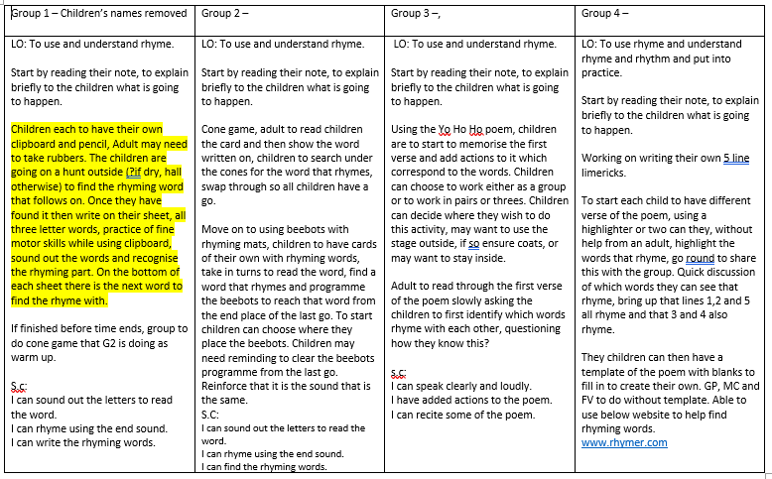
Appendix 4
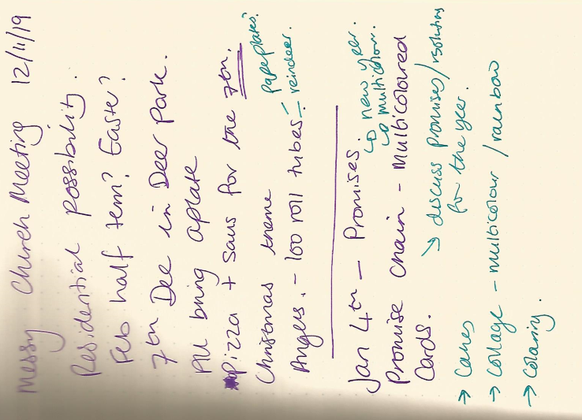

Appendix 5
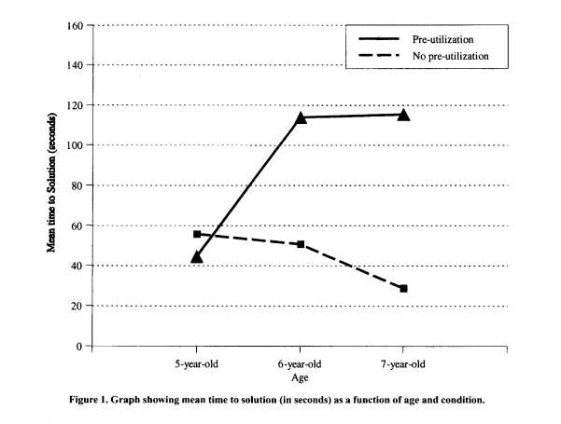
Taken from : https://link.springer.com/content/pdf/10.3758%2FBF03213010.pdf

Appendix 6
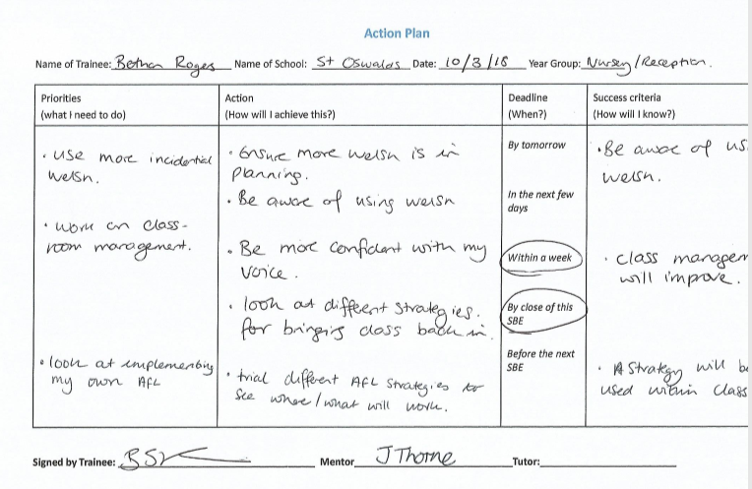
Appendix 7
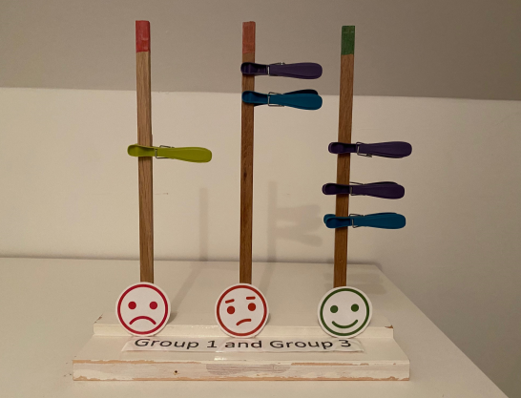

Appendix 8
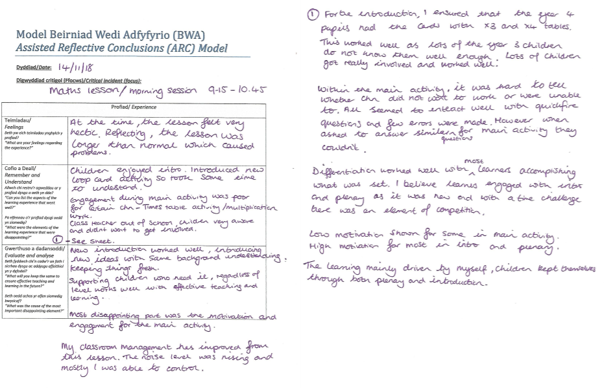

Appendix 9


